Atchayam (Tamil Morphological Generator) 1.0
Resource Centre for Indian Language Technology Solutions – Tamil,
School of Computer Science and Engineering,
Anna University, Chennai - 600025, India.
rctamil@annauniv.edu

Objective:

The Tamil Morphological Generator (TMG) generates words when the Tamil morphological and syntactical components are given as input. The identification is necessary for a wide range of practical applications like Spell checker, Machine translation etc.

- Introduction

A Morphological Generator generates words when its root word and associated morphemes are given. A morpheme is defined as the smallest part of a language that can be regularly assigned a meaning. Tamil is a morphologically rich language in which most of the morphemes coordinate with the root words in the form of suffixes. The verbs can have tense markers, PNG (Person, gender and number) markers, auxiliary verbs and clitics. PNG agrees with the subject of the sentence. The nouns can take plural markers, case markers, postposition, adverbial/adjectival suffix and clitics.

- Tamil Morphology

Before describing a Morphological Generator for Tamil, it is necessary to study the morphology of Tamil in detail. The morphology of Tamil can be described based on different parts of speech.

2.1 Noun Morphology
In Tamil, noun is a word, which is capable of taking a case suffix and/or a plural suffix and/or a postposition suffix and/or a clitic suffix.

2.1.1 Number
Tamil distinguishes a singular and a plural number. Only plural number is morphologically marked by means of the plural suffix 'è÷¢', 'è¢è÷¢', ‘ñ£ó¢’ or ‘ñ£ó¢è÷¢’ to the noun stem.

'è÷¢' has some allomorphs viz.

'é¢è÷¢':
If the noun ends with 'ñ¢' then 'ñ¢' is removed and the plural marker 'é¢è÷¢' is added.
ñóñ¢ + è÷¢: ñóé¢è÷¢

'ì¢è÷¢':
If the noun ends with '÷¢' then '÷¢' is removed and the plural marker 'ì¢¢è÷¢' is added.
ï£÷¢+ è÷¢: ï£ì¢è÷¢

'ø¢¢è÷¢':

If the noun ends with 'ô¢' then 'ô¢' is removed and the plural marker 'ø¢¢è÷¢' is added.
èô¢ + è÷¢: èø¢è÷¢

In all other cases 'è÷¢' is added as the plural marker.
ªê® + è÷¢: ªê®è÷¢

'è¢è÷¢' occur with all nouns
(i) ending in a long vowel or
Ì + è¢è÷¢: Ìè¢è÷¢
(ii) consisting of two short syllables and ending in ' à'
ªî¼ + è¢è÷¢: ªî¼è¢è÷¢

‘ñ£ó¢’ or ‘ñ£ó¢è÷¢’
The nouns which are relations such as father, mother, sisters and all relations takes the plural marker ‘ñ£ó¢’ or ‘ñ£ó¢è÷¢’.

Üè¢è£ + ñ£ó¢ = Üè¢è£ñ£ó¢
Üñ¢ñ£ + ñ£ó¢è÷¢ = Üñ¢ñ£ñ£ó¢è÷¢

    - Cases
The category of case indicates the syntactic and semantic relationship between (i) either a noun or a noun phrase and a verb, or (ii) two nouns or noun phrases. We have considered ten cases and the list along with their suffixes is given in the ‘Table 1’.

Table 1. Case Markers
S.No. | Case | Suffix | Example
1 | Accusative | ä | õ¦ó¬ù
2 | Dative | °(Þø¢°,è¢°,àè¢°,Üè¢°) | õ¤î¢îèÂè¢°
3 | Benefacative | àè¢è£è, è¢è£è | õ£êèÂè¢è£è
4 | Instrumental | Ýô¢ | ²ìó£ô¢
5 | Sociative | æ´, àìù¢ | ó£ü°ñ£ó«ù£´
6 | Locative | Þìñ¢, Þô¢ | ¹ôõù¤ìñ¢
7 | Ablative | Þìñ¤¼ï¢¶, Þô¤¼ï¢¶ | áó¤ô¤¼ï¢¶
8 | Genetive | à¬ìò, Þù¢ | ñ¦ù¤ù¢
9 | Nominative | - | ó£ñù¢ ñèù¢

    - Postpositions
Morpho syntactically case marking in Tamil in realized in two ways: (i) by case suffixes, (ii) by postpositions. In case of postpositions, case marking is actually realized by a combination of both a case suffix and a postposition. Since most postposition governs a certain case suffix on the preceding noun phrase, the postpositions are classified into five according to the case suffixes as indicated in ‘Table 2’.
Table 2. Postpositions
S.No. | Postpositions | Suffix | Example
1 | Accusative | õ¤ì, «ð£ô, ªè£í¢´, «ï£è¢è¤ | õ¦ó¬ùè¢ªè£í¢´
2 | Dative | ºù¢, ð¤ù¢ | õ¤î¢îèÂè¢°ºù¢
3 | Locative | Þ¼ï¢¶ | ¹ôõù¤ìñ¤¼ï¢¶
4 | Genetive | «ñô¢, ñ¦¶ | ñ¦ù¤ù¢«ñô¢
5 | Nominative | Ãì,õêñ¢ | Üõ÷¢õêñ¢
    - Fillers or Obliques
Some morphemes which help to link two or more adjacent forms and to cement them are called Obliques. Normally the fillers can occur between a noun stem and a case suffix.
î¢î¢ : ñóñ¢ + î¢î¢ + ä: ñóî¢¬î
Üø¢Á : ðô + Üø¢Á + ä: ðôõø¢¬ø

    - Clitics
There are about seventeen clitics and are categorized into eight categories.
The combinations of these clitics are framed in to seventy-nine rules.
The clitics categorized are as follows.
Clitic1
Ý, ã, æ
Clitic2
î£ù¢
clitic3
ñì¢´ñ¢, ñ£î¢î¤óñ¢
clitic4
âù¢Âñ¢, Ýè¤½ñ¢, Ýò¤Âñ¢
clitic5
Ãì
Clitic6
àñ¢
clitic7
Ýõ¶
Clitic8
Üì£, Ü®, Üñ¢ñ£, Üð¢ð£, Üò¢ò£

The rules are as follows:
1,2,3,4,5,6,7,8,7+1+8,7+1,7+2+1+8,7+2+8,7+2+1,7+2,7+3+2+1+8,7+3+8,7+3+2,7+3+1,7+3+1+8,7+3+2+1,7+3,6+1+8,6+1,6+2+1+8,6+2+8,6+2+1,6+2,6+5+2+1,6+5+2,6+5+1,6+5,5+1+8,5+1,5+2+1+8,5+2+8,5+2+1,5+2,5+3,5+3+1,5+6,5+6+1,5+7,5+7+1,5+8,4+1,3+1+8,3+8,3+1,3+2+1+8,"3+2+1","3+2+8","3+2","3+4+1+8","3+4+8","3+4+1","3+4","3+5+1","3+5","3+5+2","3+5+2+1","3+5+3","3+5+3+1","3+5+6","3+5+6+1","3+5+7","3+5+7+1","3+5+8","3+7+1+8","3+7+8","3+7+1","3+7","3+8","2+1+8","2+1","2+8","1+2", "1+3","1+8"

Adverbial Suffix:
The nouns that adverbial suffixes such as Ýè, Üø¢Á, Ýò¢, Ý are adverbs.

  - Verb Morphology
Verbs area defined as those words, which can take tense suffixes, person-number-gender suffixes, and a few other verbal suffixes. It also takes Auxiliary verb and Clitic

2.2.1 Tense Marker
Tense Marker | Example
Past Tense Marker
Þù¢ | Ýò¤ù£ù¢
î¢î¢ | ªêôõö¤î¢î£ù¢
î¢ | ªêò¢î£ù¢
ò¢ | Ýè¤ò¶
ï¢î¢ | õï¢î£ù¢
ù¢ù¢ | ªê£ù¢ù£ù¢
ù¢ | «ð£ù£ù¢
ì¢ | ðì¢ì£ù¢
Present Tense Marker
ø¢ | ªðø¢ø£ù¢
è¢è¤ø¢ | õ¼è¤ø¶
è¢è¤ù¢ø¢ | õ¼è¤ù¢øù
è¤ø¢ | èø¢è¤ø£ù¢
è¤ù¢ø¢ | èø¢è¤ù¢ø£ù¢
Future Tense Marker
ð¢ð¢ | ð£ó¢ð¢ð£ù¢
õ¢ | ªê£ô¢õ£ù¢
ð¢ | «èì¢ð£ù¢
Modern Tamil distinguishes between three tenses: past, present and future. Each tense morpheme is realized by a number of tense suffixes or allomorphs.

Table 4. Tense Markers

2.1.2 PNG Marker
Personal pronouns | PNG Marker | Example
Üõó¢è÷¢ | Üùó¢ | õï¢îùó¢
Üõó¢è÷¢ | Ýó¢è÷¢ | «ð£ù£ó¢è÷¢
Üõó¢, 'Üõù¢,Üõ÷¢(hon)' | Ýó¢ | õï¢î£ó¢
Üõó¢, 'Üõù¢,Üõ÷¢(hon)' | Üó¢ | õï¢îó¢
Üõù¢ | Ýù¢ | õï¢î£ù¢
Ü¶ | Ü¶ | õï¢î¶
Ü¬õ | Üù | õï¢îù
Ü¬õ | Ü¬õ | õï¢î¬õ
ï¦é¢è÷¢ | ßó¢è÷¢ | ªê£ù¢ù¦ó¢è÷¢
ï¦é¢è÷¢ | ßó¢ | «ññ¢ð´î¢î¤ù¦ó¢
ï£ù¢ | ãù¢ | õï¢«îù¢
Ï¦ | Ýò¢ | õï¢î£ò¢
Üõ÷¢ | Ý÷¢ | õï¢î£÷¢
ï£é¢è÷¢, ï£ñ¢ | æñ¢ | õï¢«î£ñ¢
This suffix represents a pronominal morpheme with the feature content (Person, Number, Gender). By means of this suffixes the subject noun phrase codes agreement on the verb. See the following table of person-number-gender suffixes and their corresponding personal pronouns that is the pronouns they agree with.
2.2.3. Auxiliary Verb
The predicate of a Tamil clause may consist of a compound verb construction. The compound construction has a verb in verbal participle or infinitive form- as a first element and a verb inflected according to the syntactic context of the compound word construction for the various finite and non-finite verbal categories, e.g tense and person-number-gender, or conditional or adjectival participle. In this compound word construction, the first verb element has a lexical function, that is denotes action, event or state and is therefore called the main verb. The second verb element does not have a lexical function. Instead, it expresses grammatical categories, such as aspect, mood, passive, causation, negative polarity, etc. For this reason, the second verb is referred to as auxiliary verb.

<Auxiliary Category1>
õ¤´
ªè£÷¢
èì¢´
è£ì¢´
ªî£¬ô
Ü¿
ªè£´
è¤ì
è¤ö¤
î÷¢À
«ð£´
î¦ó¢
<Auxiliary Category2>
ð´
ñ£ì¢´
<Auxiliary Category3>
Þ¼
«ð£
õ£
¬õ
º®
ð£ó¢
<Auxiliary - Verbal Participle>
Ýò¤ø¢Á
«ð£ò¤ø¢Á
<Auxiliary - Infinitive>
Ã´ñ¢
Ãì£¶
«õí¢´ñ¢
«õí¢ì£ñ¢
Þô¢¬ô

3.1 Sandhi Rules

‘Sandhi’ rules are the morpho-graphemic rules describing changes that occur due to concatenation of different morphemes. There are 12 vowels in Tamil viz. ‘a’, ‘aa’, ‘i’, ‘ii’,’u’,’uu’, ‘e’,’ee’,’ai’,’o’,’oo’, and ’au’. Most sandhi rules involve different combinations of vowels.
    - U removal rule: This rule states that when one morpheme ends in the vowel ‘u’ and the previous letter ends with consonant ‘t’ then that letter ‘t’ is doubled and combined with the morpheme, then the ‘u’ would be removed from the combination.
S₁u + vS2 → S₁vS₂ where S₁,S₂ are parts of the morpheme, v is any vowel.
    - VY adding rule: This rule states that when one morpheme ends with a vowel and the morpheme to join it starts with a vowel then the morpheme ‘y’ or ‘v’ would be added to the end of the first morpheme.
S₁x + vS₂ → S₁xzvS₂ where S₁,S₂ are parts of the morpheme, v is any vowel and z is ‘y’ if x belongs to {‘i’,’ii’’ai’,’y’}, z is ‘v’ if x belongs to {‘a’,’aa’,’uu’,’oo’,’au’}

Morphological generator can be broadly divided into two modules one that handles nouns and the other that handles verbs.

  - Noun Handling
Nouns can occur in isolation or can take plural, oblique suffix, case suffixes, and postpositions. In this generator each suffix is dealt with separately.

In the noun module, the following rules are framed as per the structure of Tamil.
1) N1+Plural Marker
2) N1+Pl+CM or N1+CM
3) N1+Pl+CM+PP or N1+CM+PP or N1+PP
4) N1+Adjectival Suffix.
5) N1+Adverbial Suffix.

3.2.1 Postposition Handling There are about 46 postpositions and it is defined that these postpositions will take certain case markers before the postpositions. "
The postpositions such as
"õ¤ì","õ¤ì¾ñ¢","«ð£ô","«ð£ô¢","«ð£ù¢Á","ªè£í¢´","«ï£è¢è¤",
"ðø¢ø¤","°ø¤î¢¶","²ø¢ø¤","²ø¢ø¤½ñ¢","õ¤ì¢´","îõ¤ó","ºù¢ù¤ì¢´",
"«õí¢®","åì¢®","ªð£Áî¢¶","ªð£Áî¢îõ¬ó" take accusative casemarker.
The postpositions "àìù¢","Ãì","à¬ìò","õêñ¢","Þìñ¢","õ¬ó","«î£Áñ¢","Ýó"
take nominative case marker.
The postpositions "õ£ò¤ô£è","Íôñ£è","õö¤ò£è","«ðó¤ô¢","ªð£¼ì¢´"
take genitive case marker.
The postpositions
"âù¢Á","ºù¢","ð¤ù¢","à÷¢","Þ¬ì«ò","ï´«õ","ñî¢î¤ò¤ô¢", "ªõ÷¤«ò","«ñô¢","è¦ö¢","âî¤ó¤ô¢","ðè¢èî¢î¤ô¢","Ü¼è¤ô¢","°Áè¢«è"
"ðî¤ô£è","ðî¤ô¢","ñ£ø£è","«ïó£è","àó¤ò", "à÷¢÷","î°ï¢î" takes both the
accusative and dative case markers.
General flow of the Tamil Morphological Generator(TMG):
    - 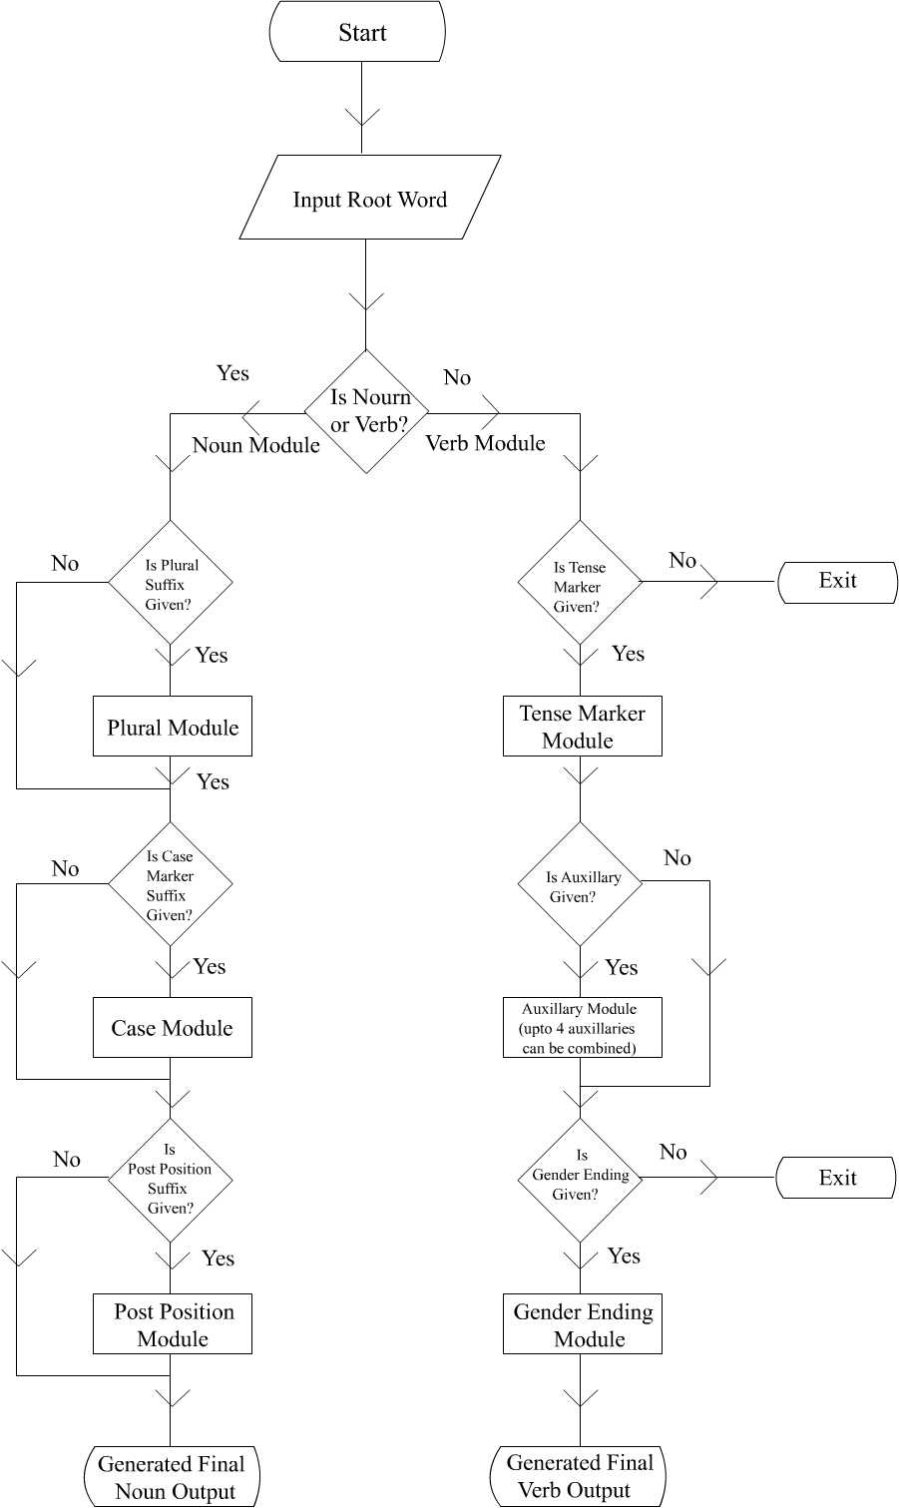

3.2.2 Case Marker Handling:
Tamil has eight case suffixes entries. But some case suffixes have many variants. For example the dative case ‘ku’ has other allomorphs like ‘kku’, ’akku’, ’ukku’, ‘iRRku’,etc. All the accusative, dative case markers are generated with the root noun incorporated with certain sandhi rules.

3.2.3 Adjectives handling:
The root noun adds “aana” adjectival suffix, combined with the sandhi rules.
The numbers, which are adjectives, do not take any suffixes.

    - Oblique Suffix
The system considers only three oblique suffixes ‘ththu’, ‘tt’ suffix. For adding each oblique suffix the root has to be adjusted. The “m” ending word takes the oblique suffix ‘ththu’,
e.g. maram + ththu → maraththu → mara-ththu (oblique form)
For the oblique suffix ‘tt’, the root word requires a ‘t’ to be doubled at the end and ‘u’ is to be removed from it.
e.g. kaatu → kaat → kaat-t → kaatt
(oblique form)
Normally oblique forms are followed by cases.

    - Plural Markers Handling
In Tamil ‘kaL’ is the major plural suffix. It has variants like ‘tkaL’, ’RkaL’, ‘nkal’, ‘kkaL’, and ‘maar’.The suffix ‘maar’ is also a plural marker but used rarely. The suffix ‘ kal’ is the main plural marker for Tamil. Removing the morpheme is little bit complex because some root nouns may end with ‘kaL’, for example ‘makkaL’,’makaL. Adding the ‘kal’ suffix the system should modify the root word to get the generated form.

  - Verb Handling
The major components of the verb handling can be depicted in the flow chart. The simplest form of the verb is obtained by the addition of tense marker and person, number, gender (PNG) marker. The verbs in Tamil are classified into nine classes depending upon the present, past and future tense markers they take. The markers also depend on the PNG feature that the verb takes and is shown in the table 2. Normally the PNG features of the verb depend on the subject given.

.  No. | Subject | Present Tense | Past Tense | Future Tense | S.No. | Subject | Present Tense | Past Tense | Future Tense
1. | Neuter Singular | KiRu | th | -- | 6. | Neuter Singular | KiRu | T | ---
1. | Neuter Plural | KintRu | th | -- | 6. | Neuter Plural | kintRu | T | --
1. | Others | KiRu | th | v | 6. | Others | KiRu | T | v
2. | Neuter Singular | KiRu | nth | -- | 7. | Neuter Singular | KiRu | *nr | --
2. | Neuter Plural | KintRu | nth | -- | 7. | Neuter Plural | KintRu | *nr | --
2. | Others | KiRu | kth | v | 7. | Others | kiRu | *nr | v
3. | Neuter Singular | KkiRu | khth | kk | 8. | Neuter Singular | kiRu | *nt | --
3. | Neuter Plural | KkinRu | thth | kk | 8. | Neuter Plural | kintRu | *nt | --
3. | Others | KkiRu | thth | pp | 8. | Others | kiRu | *nt | v
4. | Neuter Singular | KkiRu | nth | kk | 9. | Neuter Singular | *rrkiRu | *rrrr | *rrk
4. | Neuter Plural | KkintRu | nth | kk | 9. | Neuter Plural | *rrkintRu | *rrrr | *rrk
4. | Others | KkiRu | nth | pp | 9. | Others | *rrkiRu | *rrrr | *rrpp
5. | Neuter Singular | KiRu | i | --
5. | Neuter Plural | KintRu | i | --
5. | Others | KiRu | in | v
* - The last letter of the root verb will be removed

Table 2. Verb classification and corresponding Tense Markers

In Tamil, auxiliaries indicating aspect, mood etc. are added to the main verb to form a compound form of the verb. The main verb occurs as the first part of the compound form and is in either verbal participle or infinitive form depending upon the auxiliary that occurs immediately after it. The same is true for all auxiliaries except the last one. The last auxiliary takes on the appropriate PNG markers. In the case of some auxiliaries, the PNG markers are not added since the auxiliary occurs in a neutral form. In the design of the generator nearly thirty auxiliaries are tackled.

Before adding the auxiliary suffix to the verb/auxiliary, the verb/auxiliary have to be changed into either verbal participle form or an infinitive form, which is decided by the next auxiliary. The verbal participle is the tense less non-finite verb form. It has both a positive and a negative form. The positive verbal participle is formed by the affixation of the verbal participle suffix to the verb stem. The verbal participle suffix is either the combination of the past tense marker of the verb and the enunciative vowel ‘u’ or the past tense marker alone. The infinitive is formed by the affixation of the infinitive suffix to the verb stem either ‘a’ in case of weak verb, or ‘ka’ in case of middle verb, or ‘kka’ is case of strong verb [2].
e.g. avan sappiTTukkonTirunthirukkiRaan ( He has been eating )
avan sappiT-Tu-k-kon-Tu-iru-nth-u-iru-kkiR-aan
Here avan is the subject and aan is the corresponding gender marker. kkir is the tense marker. saappiTu is the main verb and its participle form is got by adding its past tense marker and a ‘u’. ‘konTu’ and ‘irunthu’ are the verbal participle forms of the auxiliaries ‘koL’ and ‘iru’.
The adjectival participle is the only non-finite verb form that distinguishes tense. Tamil has a past, present and future adjectival participle. Adding either the past or present tense allomorph to the verb stem and then adding the adjectival suffix ‘a’, forms the past or present adjectival participle.
Grouping them into five categories depending on the suffixes that precede them does the dealing of auxiliaries. The main verb is added with the tense marker and then each of the auxiliaries is added along with it, finally the PNG marker is added according to the subject chosen.

  - Sentence Generator:
Using this word generator, an interactive sentence generator has been designed. In this sentence generator, to generate a sentence, a subject, a verb, and the tense marker should be given. The other inputs are optional. This generator can take subject, verb, tense marker, adverb and two inputs of adjectives and nouns. The nouns can combine with case markers, postpositions and plural markers. The verb can combine with maximum of four auxiliaries.

The general flow of the sentence generator is given as follows:

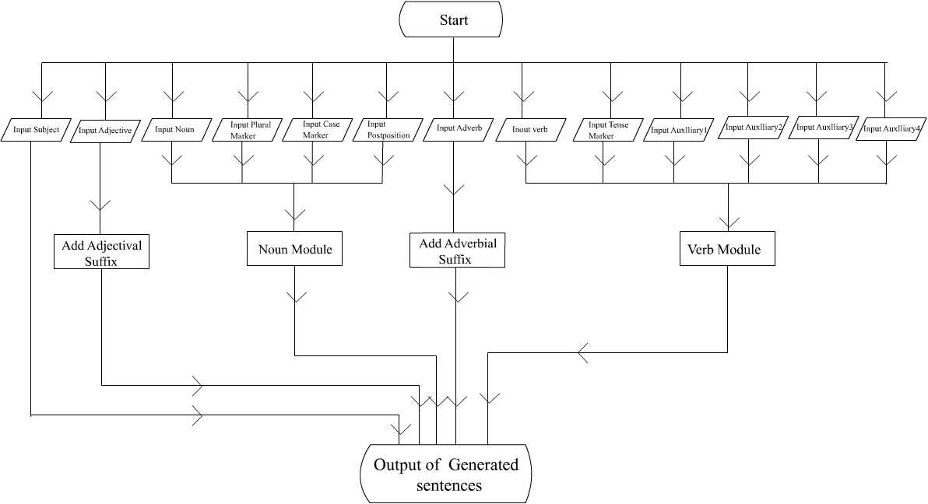

4. Implementation:

4.1.Classes and Methods:

4.1.1 Class Main
The class main is the interface for the sentence generator in which all the inputs for the word generation is selected from the different combo boxes, and it has three instance variables. The combo boxes are for selecting,
4.1.1.2 Member Functions:

4.1.1.2.1 CorporateDemo()
This method is the constructor in which the variables are initialized and the components are fixed on the lay out and panels.

4.1.1.2.2 addComboBox: The panel and the string components are passed .The string array that is passed is displayed on the combo box. This function returns the combo boxes that are to be displayed on the panel.

4.1.1.2.3 addButton :
This function returns buttons after creation. The name of the button and the panel is passed as arguments.

4.1.1.2.3 actionPerformed
In this function the action of the buttons are captured and on clicking
the ok _button the generatesentences() method is called.

4.1.1.2.4 generateSentences
This function takes the inputs like subject, adjectives, plural markers, case markers, verb, auxiliaries and the tense markers. It returns the generated sentence in an array.
4.1.1.2.5 reset()
This function resets all the combo boxes to their initial positions.

    - CaseMethods:

The CaseMethods add cases with that of the root noun.

4.1.2.2 Member functions:

4.1.2.2.1 addCase
In this method, the noun cases and the plural marker are passed.
It identifies whether the noun is plural or non plural and the corresponding sandhi rules are applied for combining the root noun with the case markers.
If singular, ñóñ¢ + ä = ñóî¢¬î (The athu oblique is added while joining.)
If plural, ñóñ¢ + è÷¢ + ä = ñóé¢è¬÷

    - AdjectiveMethods:

      - Member functions:
        - addAdjective
This adds the adjective with the noun input given.
Üö°(noun) + Ýù(adjectival suffix) = Üöè£ù

    - PostPositionMethods:
      - Member functions:
        - addPostPositions
This method combines the root noun with the postpositions and it defines which case markers the postpositions can take for generation.
If singular,
ñóñ¢(noun) + «ð£ô(postposition) = ñóî¢¬îð¢«ð£ô (output)
It takes the case marker ' ä ' by default.
If plural,
ñóñ¢ + è÷¢ + «ð£ô = ñóé¢è¬÷ð¢«ð£ô (output )
after adding the plural marker it takes the case marker ' ä ' by default.

    - VerbMethods:
      - Member Functions:
        - CallAll
This function combines the verb with the tense marker, PNG marker, and the four auxiliaries
ð® + ï¤èö¢è£ôñ¢ + ªè£÷¢ + Þ¼ + õ¤´ + «ð£ + Ýù¢ =
(Mainverb) (Tense marker) (aux1) (aux2) (aux3) (aux4) (PNG marker)
ð®î¢¶ªè£í¢´Þ¼ï¢¶õ¤ì¢´«ð£è¤ø£ù¢.(output)
        - add tense :
This function selects the tense according to the tense marker and the category of the verb chosen.
For eg: If ï¤èö¢è£ôñ¢ is chosen then either è¤Á or è¤ù¢Á is chosen as tense.
        - genderEndings :
In accordance with the subject chosen, the gender endings are added with the tense marker.
If Üõù¢ is chosen as subject then the PNG marker "Ýù¢" is combined with the tense marker such as
"è¤ø£ù¢".
        - addAuxi :
This method combines the auxiliaries, maximum of four auxiliaries are chosen. The auxiliaries are classified in to six categories according to that categories the verbal participle, infinitives, relative participle are selected and combined.

4.1.5.1.5 addAdverb :
This method combines the adverbial suffix with that of the input given.
There are about four types of adverbs defined according to which the suffixes are combined.
õ¤¬ó¾(input) +Ýè(adverbial suffix) = õ¤¬óõ£è (generated adverb)

    - File read:
This class is used for reading the files for easy access.
    - TabMethods:
This class has two functions revert and convert. This class is used for easy processing of Tamil string.
The convert function converts the Tamil string in to internal bytes.
The revert function converts the internal byte codes in to Tamil string
    - Constants:
This class consists of all variables which are constants used in all classes.
    - ByteMethods:
This class consists of different methods for byte operations like, adding the two bytes, to print, to check whether two bytes are equal, to check the byte ends with or starts with some given byte, to remove vowel from the given byte and get the sub byte when the initial and starting positions are given.

- Future Enhancements:

    - In the verb and noun module, clitic module can be added.
    - A particular noun cannot combine with all case markers. Hence it has to be refined.
    - More sandhi rules should be added.
    - Generation of sentences with out the verb must be handled.
    - To generate a valid sentence, syntactic and semantics should be taken care.
    - Proper nouns, some of the common nouns and the demonstrative pronouns should be handled.
    - "âùè¢° Üï¢î ¬ðò¬ùð¢ ð¤®è¢°ñ¢” -these type of sentences are of issues.
    - Ambiguous words and sentences are of issues and to be handled.

References
- Thomas Lehmann ( 1989 ), A Grammar of Modern Tamil, Pondicherry Institute of Linguistics and Culture, Pondicherry, India.

