Vaanavil – Syntactic Parser for Tamil

1. Name of the Technology : Vaanavil
2. Nature of Technology : Linguistic tool
3. Level: (Product / Technology / Sub-system) : Sub-system

4A. Technical Description

Vaanavil identifies the syntactic constituents of a Tamil sentence. It outputs the parse tree in a list form. The free word order feature of Tamil makes parsing a challenging task, since there is a need to associate and link syntactic components that are not always adjacent to each other. This is done by associating positional information with the words. The parser tackles both simple sentences having a verb, a number of noun phrases, simple adverbs and adjectives, and complex sentences with multiple adjectival, adverbial, and noun clausal forms.
The processing uses a phrase-structure grammar together with a limited amount of look-ahead to handle free word order.
The overall parsing process consists of four phases as follows.
- Part of Speech Tagging
- Part of Speech Tagging for unidentified and ambiguous words
- Constituent formation
- Tree generation

Part of Speech Tagging
The words of the sentence are first analysed using the Morphological Analyser, and the root word along with the part-of-speech tag and suffix information obtained is input to the next phase.

Part of Speech Tagging for unidentified and ambiguous words
The analyser does not give the part-of-speech information for all words. For example, it may not have a particular word in its dictionary or it may be proper noun etc. In these cases, linguistic based heuristic rules are used to obtain the associated tags. Currently, 15 heuristic rules are used.

Constituent Formation
For the simple sentence first adjectives and adverbs are attached with their corresponding words irrespective of the presence of adverb anywhere in the sentence prior to the verb.
For sentences with multiple clauses, the parser first identifies the cue words of the clauses and syntactically groups the clauses based on the cue words and phrases.

Tree Generation
The noun clauses are considered as noun constituents, the adjective clauses are attached with their corresponding nouns and the adverb clauses are attached with their corresponding verbs. Finally, all the noun and verb constituents are attached with the root of the tree so as to form the overall tree structure of the input sentence.

4B. Block Diagram

Tamil Sentence

Parser

POS tagging
Morphological Analyser
POS tagging for unidentified and ambiguity words
Heuristic rules

Constituent formation
Phrase structure grammar

Tree generation

Input Sentence in Tree structure

4C. User Interface
Vaanavil has a user interface in which, one can give a Tamil sentence and get the parsed output of that sentence. The Tamil sentence can be directly typed using any keyboard driver or input file can be selected for parsing using ‘File’ button. ‘Next Sentence’ button extracts sentence from the selected file one by one. ‘Parse’ button parses the input sentence and shows the output. ‘Help’ button shows the help in the output field. ‘Clear’ button is used to clear all the text fields. ‘Exit’ button is used to exit the software.

4D. Specification
Vaanavil was developed using Java.
Vaanavil requires J2RE 1.3 or above to run.
It requires any external keyboard driver to type Tami.
At present, the required font encoding scheme is TAB. Code converters for other font encoding schemes can be provided.

5. Representative Snapshot / screenshot of the Technology / Product:

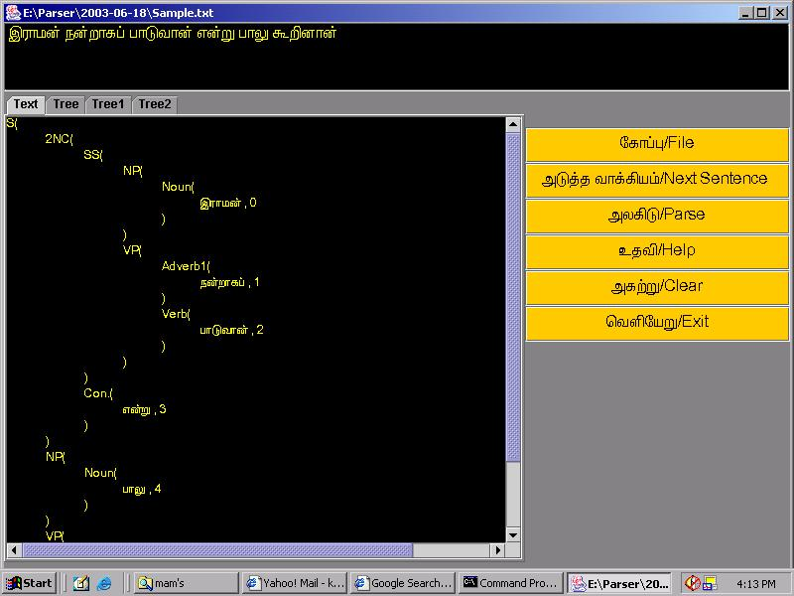

6.A Scalability / Expandability : Yes

6.B Portability : Yes

7. Readiness of Transfer of Technology (ToT) :Yes

8. Availability of document : User and Technical manuals are available.
9. Testing of the Product / Technology : Tested with sentences from corpus.
10. IPR / Open-source : Not a open source

11. Potential beneficiaries : NLP students and researchers, basic tool for grammar checker and machine translation systems.
12. User-agency tie-up : No
13. Name and address of the Resource Person :
Dr. T. V. Geetha, Dr. Ranjani parthasarathi,
Resource Centre for Indian Languages Technology Solutions – Tamil,
School of Computer Science and Engineering,
Anna University,
Chennai – 25

