# Business-Requirement:

## Problem Statement:

The purpose of this application is to allow the users to create and order a customized Corona Prevention Kit.

### User Module:

**The User Module** allows you to:

1. Access Portal’s home page
2. Will be required to login using predefined/in-memory credentials before creating the kit.
3. Allow to enlist multiple items available to be added to kit (eg: Face mask, Sanitizers, immunity boosters medicines etc )
4. Allow to create the kit and add selected items in kit
5. Calculation of total amount for kit will be done automatically
6. User shall be able to place order of the kit by providing his/her address
7. User shall be able to view the order summary

### Admin Module:

**The AdminModule of application** allows you to:

1. Login with predefined/in-memory credentials
2. Admin will be able to add new items (with description, cost, name etc) to be shown to visitors, which they will use to create the prevention kit.
3. Admin will be able to delete product as well

# 2. Resources Available :

|  |  |  |  |
| --- | --- | --- | --- |
| Description | View Pages Name | Remarks | |
| Common UI |  |  | |
| Home Page | index.jsp | Contains link to login page | |
| Error Page | Error-page.jsp | Custom error page for un-authorized access | |
| Header | header.jsp |  | |
| Footer | footer.jsp |  | |
| Main-Menu | main-menu.jsp | Landing page after login, contains link to access User and Admin dashboard | |
| Login Page | login-form.jsp |  | |
|  |  |  | |
| Admin Services UI |  |  | |
| Dashboard for Admin | admin-home | Shall contain link to add new product and list all product | |
| Shall contain Entry Form for new product entry | add-new-item.jsp | On successful addition of product should redirect to show all product | |
| Shall use to show all products | show-all-item-admin.jsp | Shall contain link to delete any product and a link to get to add new product page | |
|  |  |  | |
|  |  |  | |
| User Services UI |  |  | |
| Dashboard for User | user-home.jsp | Shall contain links to show kit details and list of all products | |
| Shall show list of all products added by admin | show-all-item-user.jsp | Shall contain a link to add a product to kit. After adding product to kit, should redirect to show kit | |
| Shall show the kit details | show-cart.jsp | Shall contain link to show list of all products added by admin and a links to remove items from kit. After removal from kit it should redirect to show kit details. Shall also contain a link to checkout | |
| Shall allow user to add address to place order | checkout-address.jsp | Shall allow user to get to summary page after providing address. Shall also contain a link to get back to kit listing page | |
| Shall show final summary of order | show-summary.jsp |  | |
|  |  |  | |
|  |  |  | |
|  | | |
|  | | |

# Page Flow :

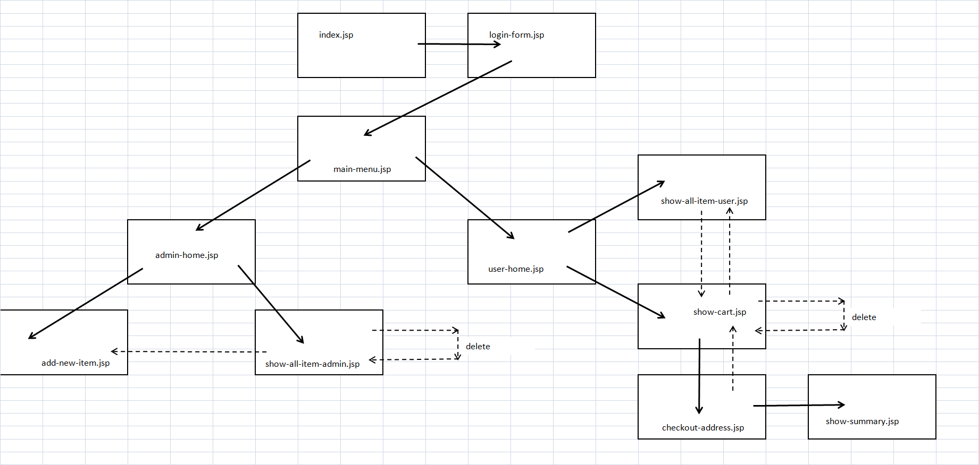

# Points to remember

Followings are the point to consider and remember during implementation:

* + - 1. Database used is H2 Embedded whose console is exposed on url /console
      2. Security config contains in-memory authentication with predefined credentials for ADMIN and USER
      3. Some basic security config is already present. Participant need to add additional as per application requirement
      4. Login controller contains mapping for custom-login page and custom error page for un-authorized access (config of the same need to be added in security config class)
      5. Home Controller contains mapping for home page and main-menu page after login.
      6. Admin and User mapped urls must be accessed by authorized person only or else it should revert back with error-page.
      7. Kit details are to be maintained in session, and needed to be saved in database when it is finalized by providing address.
      8. Participants are not allowed to change, add, remove any Controller mapping.
      9. View pages are already in place, need to place UI login in them
      10. Do not go and access test resources as they will be used for evaluations, any changes there would severely affect final result.

# Validation constraints

Following validation constraints must be introduced:

* Product name must not be empty and should have min 2 chars
* Product cost must be more then equals to 10
* Product Description must not be empty and should have min 5 chars