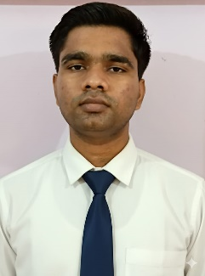

Adarsh Pandey
Mobile No: +91 81888 85128
Email: adarshsomeshwaralok@gmail.com

OBJECTIVE Computer Application learner and MCA student with basic skills in python programming and PostgreSQL database. Web Developer using Django framework, enthusiast and learning about Machine Learning.

EDUCATION
Qualification | Board/University | Institution  Name | Year of  Passing | Percentage  Secured
MCA | AKTU, Lucknow | BBS College of Engg. & Technology, Prayagraj | Pursuing | NA
Graduation (BCA) | Prof. Rajendra Singh (Rajju Bhaiyaa) University, Prayagraj | Shambhunath College of Education, Prayagraj | 2025 | 77.6%
Intermediate | UP | Urmila Devi Inter College, Jhunsi Prayagraj | 2022 | 66.6%
High School | CBSE | Dawn the Higher, Andawa Prayagraj | 2020 | 66.6%

TECHNICAL SKILLS

COMPUTER SKILLS
- Python Programming Language
- SQL(PostgreSQL)
- Django (Python Framework)

- MS Word, MS PowerPoint, Web Browsing, Emailing, Social Media Handling

WORKSHOP • Attended Soft Skills Development Program by
Placementors 2024.

CERTIFICATION AND ADDITIONAL COURSES

EXTRACURRICULAR ACTIVITIES

ACHIEVEMENTS

HOBBIES
- Python Training Certificate from Softronic Automation training institute.
- College Codefest Winning Certificate

- Web Design Competition Organizer: Techfest, Shambhunath College of Education
- Served as Coordinator, managed in Tech Fest Shambhunath College of Education. (2024).

- College Codefest winner

- Teaching
- Listening to music
- Listening to podcasts

PERSONAL DETAILS • Father’s Name - Mr. Someshwar Pandey
  - Mother’s Name- Mrs. Kiran Pandey
  - Date of Birth - 2nd August 2004
  - Nationality - Indian
  - Marital Status - Unmarried
  - Languages Known - Hindi, English
  - Address - Krishna Vihar Colony,
Jhunsi Prayagraj (U.P.) PIN - 211019

DECLARATION I hereby declare that the above mentioned details are true to the best of my knowledge.

Date:
Place: Prayagraj Adarsh Pandey

