PROJECT REPORT ON

CAMPUS SELECTION PROCESS

ABSTRACT

The project titled “**Campus Selection Process**” describes the corporate recruit students who are about to graduate from the educational systems. This process consists of a student login, company login and an admin login. The selection process varies from company to company, may have pre-placement talk , written test, group discussion and interviews. Students and the recruiting companies are considered to be the major stakeholders in a campus selection process. The software systems allows the students to create their profiles and upload all their details including their marks on to the system. The admin can check each student details. Entry level salaries and the recruitment season are considered to be the important parameters in a campus selection process. The study analyses the perception of students and the human resources manager on the entry level salaries and the recruitment season.

# TABLE OF CONTENTS

1. Requirement Study...................................................1

2.1. Introduction......................................................2

2.2. Purpose.............................................................3

2.3. Objective...........................................................3

2.4. Scope.................................................................3

2.5. Merits................................................................4

2.5. Demerits............................................................4

1. Class Diagram.............................................................5
2. E-R Diagram................................................................6
3. Design Document.......................................................7
4. Program Specification................................................12
5. Functional Study.........................................................15

# REQUIREMENT STUDY

# I.INTRODUCTION

Now days we all are using the internet to do multiple things like booking, academic search, blogging, apply for any job, etc. This system can be used as an application to manage student information to related placement. The system handles student as well as company data and efficiently displays all this data to respective sides. This System do all work regarding placement like collecting student records, Authenticate & activate the student profiles, Notifying eligible students via automated E-mail message, Check the number and percentage of placed & unplaced students. Proper login with time & role based secured access is provided to Placement Officer, Company, College staff and students. Students logging should be able to upload their information in the form of a Resume. Placement Officer can access, view information of the users and prepare schedule of all activities regarding placements. Company can give their own application procedure by providing link. College staff can see the registered students and their status.

Since the automated system is demanded now-a-days, educational infrastructures like colleges needed their manual system to function on computer system. One of such system which is of major importance is placement automation for campus recruitment. This project is aimed at developing a web application for the Placement Department of the college. This system can be used as an application for the Placement Officer of the college to manage the student information with regards to placement. Students logging should be able to upload their information in the form of a resume. So, all the information will store the details of the students including their background information, educational qualification, personal details, and all the information related to their resume.

This system helps Company to access the student information with regards to placement. Computer based information system are designed to improve existing system. Company can notify the students about the recruitment online via sending e-mail.

# II.PURPOSE

Computer based information system are designed to improve existing system. Our application

has friendly interface having quick authenticated access to documents. It provides the facility

of maintaining the details of the students. It will reduce the paper work and utilize the

maximum capabilities of the Setup and organization. This method will save time and money

which will be spent in making reports and collecting data. It can be accessed throughout the

organization with proper login provided. The information stored are encrypted end to end.

# III.OBJECTIVE

Development of rich web based Campus Selection System for Universities and any companies. Online Campus Selection System is developed for smooth working of Human Resource Departments. Universities and companies can get benefited through this system. This software is fully integrated with Student and Company Relationship Management and developed in a manner that is easily manageable, time and cost saving that shows relieving one from manual works. Online Campus Selection provides automated technical screening, intellectual evaluation, electronic mail integration to conduct recruitment.

# IV.SCOPE

This project has a large scope as it has the following features which help in making it easy to use, understand and modify it:

* Students can maintain their information,
* Notifications are sent to students email address about the companies,
* Students can access previous information about recruitment.

• Automation of Placement Procedure

• No Need to do Paper Work

• To save the environment by using paper free work

• To increase the accuracy and efficiency of placement procedure

• Management of Student Data

• Analysis of overall Placement

# V.MERITS

1. There will be no need of putting up notice or emailing every student about the upcoming placements on a particular date. The students can keep track of all the updates through this software.
2. The company can view all student’s detail and system can shortlist students according to their criteria instead of doing manually.
3. There is admin login that can view and manage both students and company’s account and also can put up notifications.

4. Student can register online instead of going to placement department for registration.

5. This system saves time and efforts.

# VI.DEMERITS

1. Student can’t edit the database information. It would require admin to change the data.

2. It requires large database.

# CLASS DIAGRAM

Company criteria

Company Name

Job id

Qualification

Branch

Percentage

DisplayEligibleStudents()

Admin

Admin user name

Password

manages()

maintains()

Login

O

User type

User name

password

Search

student id

college name

search by()

Student Details

Name

Student id

Gender

Percentage x

Percentage xii

Graduation

Contact no

Mail id

College name

edit()

Commit()

Recruiter

Company name

Recruiter id

Student id

Status

Date

checkStatus()

# E-R DIAGRAM

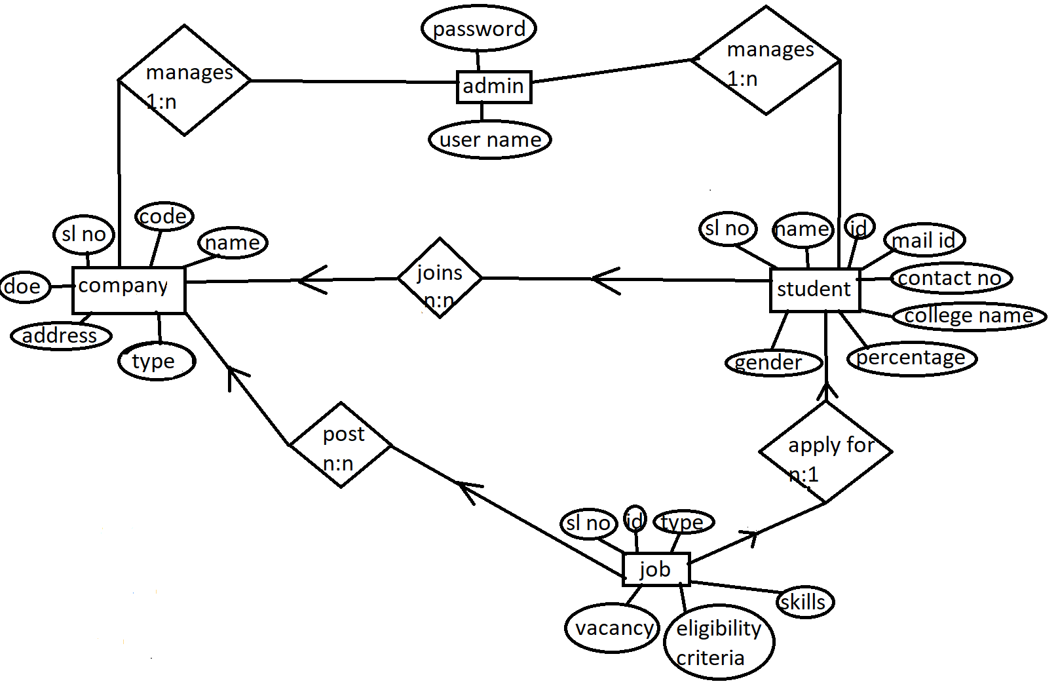

# DESIGN DOCUMENT

TABLE_NAME:COMPANY_INFO

PK:Company_code

DESCRIPTION:Company Information

|  |  |  |  |  |
| --- | --- | --- | --- | --- |
| Field Name | Data Type | NULL | KEY | Description |
| SL_NO  Company_code  Company Name  Type of Org.  Address  DOE | INT  VARCHAR(10)  VARCHAR(10)  VARCHAR(10)  VARCHAR(20)  DATE | NOT NULL  NOT NULL  NOT NULL  NOT NULL  NOT NULL  NOT NULL | PK | Serial No  Company code  Company Name  Type of Organisation  Address of the company  Date of Establishment |

TABLE_NAME:JOB_DETAILS

PK:Job_ID

FK:Company_code

DESCRIPTION:Job Information

|  |  |  |  |  |
| --- | --- | --- | --- | --- |
| Field Name | Data Type | NULL | KEY | Description |
| SL_NO  Company_code  Job_ID  Job Description  No. Of Vacancy  Eligibility Criteria  Skill  Salary | INT  VARCHAR(10)  VARCHAR(10)  VARCHAR(10)  INT  VARCHAR(20)  VARCHAR(10)  VARCHAR(20) | NOT NULL  NOT NULL  NOT NULL  NOT NULL  NOT NULL  NOT NULL  NOT NULL  NOT NULL | FK  PK | Serial No  Company code  Job ID  Job Description  Number of vacancies  Eligibility Criteria  Skill Required  Salary |

TABLE_NAME:STUDENT_INFO

PK:Student_ID

FK:Job_ID

Description:Student Information

|  |  |  |  |  |
| --- | --- | --- | --- | --- |
| Field Name | Data Type | NULL | KEY | Description |
| SL_NO  Student Name  Student_ID  Mail Id  Contact No.  College Name  10th percentage  12th percentage  Graduate  Gender  Job_ID | INT  VARCHAR(30)  VARCHAR(10)  VARCHAR(20)  VARCHAR(10)  VARCHAR(20)  DECIMAL(1,2)  DECIMAL(1,2)  DECIMAL(1,2)  VARCHAR(10)  VARCHAR(10) | NOT NULL  NOT NULL  NOT NULL  NOT NULL  NOT NULL  NOT NULL  NOT NULL  NOT NULL  NULL  NOT NULL  NOT NULL | PK  FK | Serial No  Student Name  Student ID  Mail ID  Contact Number  College Name  10th Mark  12th Mark  Graduate Percentage  Gender  Job_ID |

TABLE_NAME:CAMPUS_DETAILS

PK:Company_code

FK:Event_ID

Description:Campus Event Details

|  |  |  |  |  |
| --- | --- | --- | --- | --- |
| Field Name | Data Type | NULL | KEY | Description |
| SL_NO  Company_code  Event_ID  Interview Process  Venue  Reporting Time  Contact No. | INT  VARCHAR(10)  VARCHAR(10)  VARCHAR(10)  VARCHAR(20)  DATE  VARCHAR(10) | NOT NULL  NOT NULL  NOT NULL  NOT NULL  NOT NULL  NOT NULL  NOT NULL | PK  FK | Serial No  Company code  Event_ID  Interview Process  Venue Details  Reporting Time  Contact Number |

TABLE_NAME:Student_Result

PK:Student_ID

FK:Job_ID

Description:Student Result History

|  |  |  |  |  |
| --- | --- | --- | --- | --- |
| Field Name | Data Type | NULL | KEY | Description |
| SL_NO  Student Name  Job ID  Mail ID  Contact No.  College Name  Status | INT  VARCHAR(20)  VARCHAR(20)  VARCHAR(20)  VARCHAR(20)  VARCHAR(10)  VARCHAR(10) | NOT NULL  NOT NULL  NOT NULL  NOT NULL  NOT NULL  NOT NULL  NOT NULL | FK  PK | Serial No  Student Name  Job ID  Mail ID  Contact Number  College Name  Status |

# PROGRAM SPECIFICATION

# Admin Login

|  |  |
| --- | --- |
| **Screen Name** | Login |
| **Module** | Admin |
| **Menu Reference** | Login |
| **Dependency on Module** | NA |
| **Inputs** | |
| * User Name * Password | |
| **Validation** | |
| * Username should not blank. * Password should. * Invalid Username or password. * System locked for three wrong password entered. * Password should expire in 60 days * Password has expired ,change the password | |
| **Process Logic** | |
|  | |
| **Output** | |
| * Redirect to Admin Dashboard | |

# User login

|  |  |
| --- | --- |
| **Screen Name** | Login |
| **Module** | User |
| **Menu Reference** | Login |
| **Dependency on Module** | NA |
| **Inputs** | |
| * User Name * Password | |
| **Validation** | |
| * Username should not blank. * Password should. * Invalid Username or password. * System locked for three wrong password entered. * Password should expire in 60 days * Password has expired ,change the password | |
| **Process Logic** | |
|  | |
| **Output** | |
| * Redirect to Admin Dashboard | |

# FUCTIONAL REQUIREMENT

# Registration:

A student can sign up with his/her personal information with username and password. Each field should be filled.

# Authentication:

**Login-**

The student can login with his/her unique username and

password and the home page should be displayed.

If the student doesn’t enter the username and password, then the system should redirect to the admin dashboard page.

If the student enter wrong username/password, then also

the system should redirect the admin dashboard page.

**Logout-**

The student can logout from the system.

**Login Failure-**

If the student record is not available.

Account got locked due to 3 times wrong password entered.

If the student enter 60days before username and password.

# Process Data:

**Display-**Student or admin can fetch all the table data. A student can see his/her status followed by Job_ ID.

**Edit-**A student can only edit his/her personal information until placement starts. But the admin can’t edit the personal information of the student. The admin can edit the all table data except student information but the student can’t.

**Search-**Admin can search all the student’s information in the database. Search features showing student’s percentage, skills etc.

# Report Generation:

Admin should be able to generate a report for each student based on the student result.