**Food Nutrition Analyser**

Food Nutrition Analyser is a Python script designed to perform comparative analysis of food’s nutritional content utilizing the nutritional information from the [FoodData Central database](https://fdc.nal.usda.gov/download-datasets.html) curated by the United States Department of Agriculture (USDA).

**FUNCTIONALITIES**

The program includes a script for data transformation which allows any dataset from the FoodData Central database to be used for the analysis, provided it is in JSON format. The comparative nutrient analysis can be performed in two ways. The ‘Rank Foods’ option ranks all of the selected foods based on their nutritional content of the selected nutrients (Figure 1). The ‘Compare Nutrients’ option produces a table which summarises the nutritional content of selected foods as percentages of Recommended Daily Allowance (RDA) of selected nutrients per 100 grams of food (Figure 2).

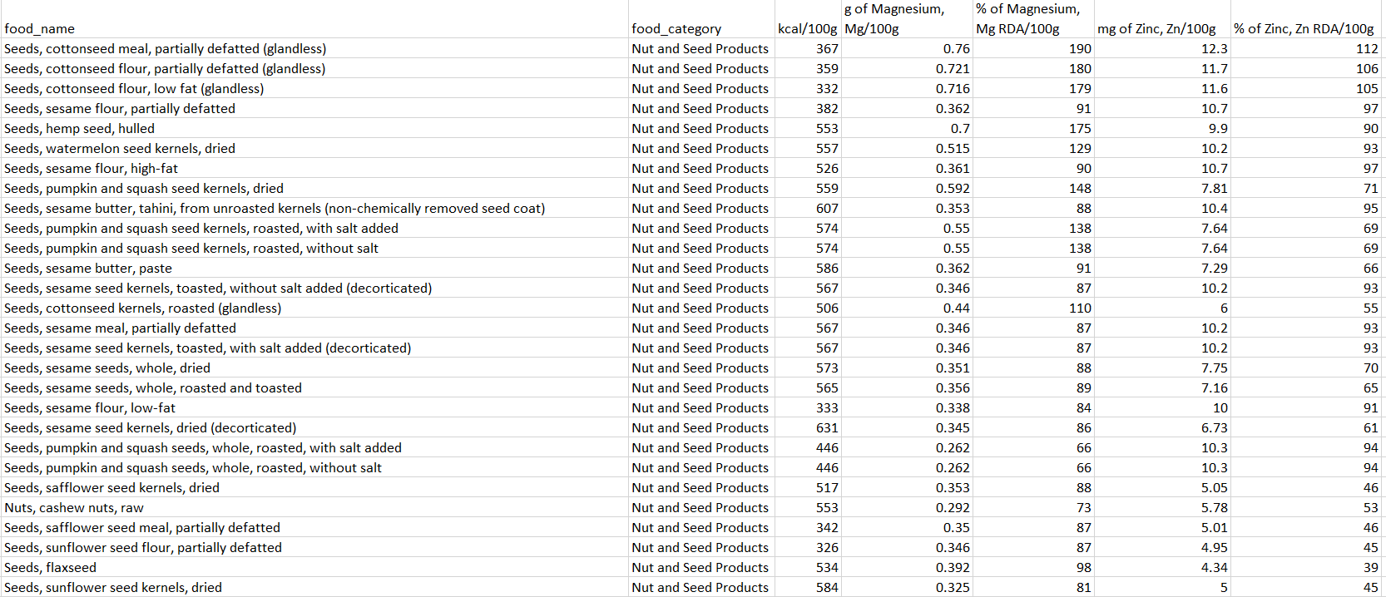Figure 1. An example output of the ‘Rank Foods’ program. Ranking foods from the 'Nut and Seed Products' category based on their magnesium and zinc content (RDA values for a 25-year-old male).

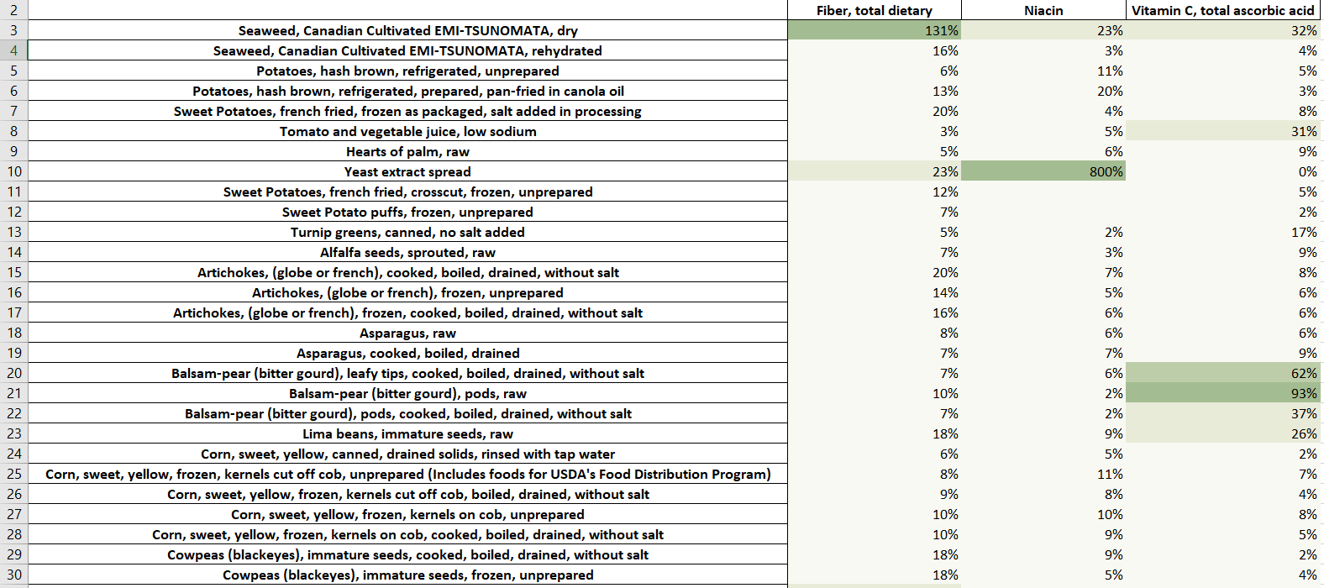Figure 2. An example output of the ‘Compare Foods’ program. Comparing foods from the 'Vegetables and Vegetable Products' category based on their content of fibre, niacin and vitamin C expressed as percentages of daily RDA per 100 grams of food (RDA values for a 25-year-old male).

**HOW TO USE**

A demo version of the program can be run on [Replit](https://replit.com/@tadasandriuske/Food-Nutrition-Analyzer-Demo-Version). Instead of creating a CSV or Excel file, demo version displays the results on the screen. The full program can be downloaded [here](https://replit.com/@tadasandriuske/Food-Nutrition-Analyzer-Full-Version?v=1). To run the program:

* Choose between ‘Rank Foods’ and ‘Compare Foods’ options (Figure 3A);
* Select the foods, food categories, and nutrients of interest (Figure 3B);
* Provide additional information (Figure 3C):
  + ‘Rank Foods’ program accepts an ‘additional argument’ which can be used apply a filter on food records based on a word or phrase, if desired;
  + ‘Rank Foods’ program can rank foods by nutrients per 100 grams or nutrients per 1 kcal of food;
  + RDA values are adjusted based on gender and age;
* Run the program and explore the results.

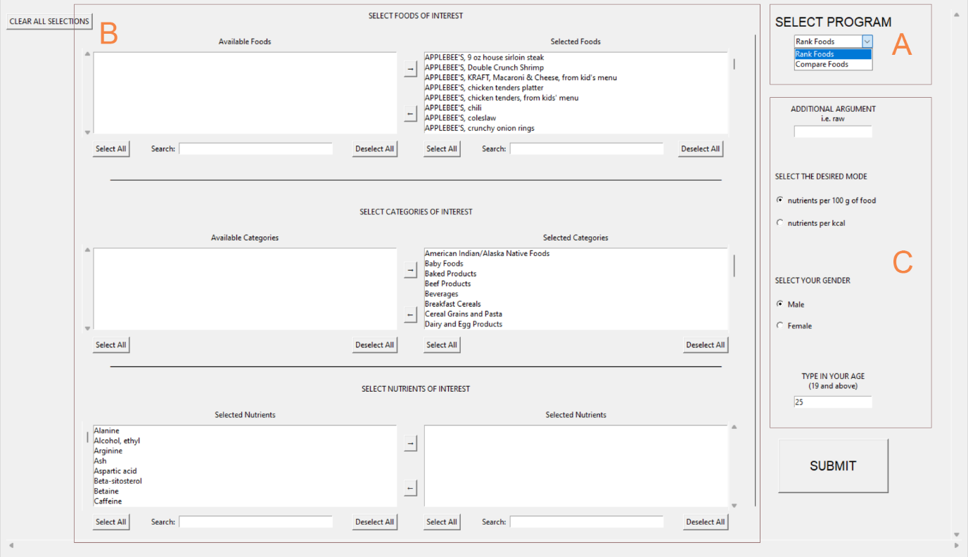Figure 3. The user interface of the Food Nutrition Analyser.

**FOOD RANKING**

The ‘Rank Foods’ program ranks foods using the following algorithm:

* For each selected nutrient, all selected foods are sorted from the highest to the lowest based on their nutritional content for that particular nutrient;
* All foods are given a rank with the highest number being assigned to the food with the highest content of a particular nutrient;
* Once ranks for all selected nutrients are determined, the average rank is calculated for each food;
* Foods are then sorted based on their average rank.

Important considerations:

* Only food records that contain information on all selected nutrients are used for the analysis. Consequently, higher number of selected nutrients means a higher chance of more foods being excluded from the analysis.
* All nutrients are assigned equal importance and equally contribute to the final result.