Swagger / OpenAPI in a .NET API
Lab guide: documenting, testing and consuming SimpleStudentApi
Course: Heterogeneous systems
Group: PSe-5
Autumn 2026
Lecturer: Tadas Bulis
Kauno kolegija, Faculty of Technologies
Contents
1. Purpose
2. Key terms
3. The two lab projects
4. Running the labs
5. Adding Swagger to a .NET 8 Minimal API
6. Working in Swagger UI
7. Integrating the frontend
8. Troubleshooting
9. Practice tasks
10. OpenAPI in your project documentation

1. Purpose
This guide accompanies the lecture "Swagger / OpenAPI in a .NET API". It explains how Swagger was added to the two Docker lab projects, what you can do with Swagger UI, and how the frontend uses the API contract through a generated client. After working through it you should be able to:
- add Swagger (Swashbuckle) to a .NET 8 Minimal API and describe its endpoints;
- test every endpoint, including error responses, from Swagger UI;
- generate a typed C# client from swagger.json and use it from Razor Pages;
- keep the frontend in sync when the API changes;
- use the OpenAPI document as the interface specification in your project documentation.

2. Key terms
Term | Meaning
OpenAPI Specification (OAS) | Vendor-neutral standard for describing HTTP APIs in JSON or YAML: paths, parameters, request bodies, responses and data schemas. Our API produces OAS 3.0.
Swagger | Original name of the specification (until 2015); today the family of tools around it. Swagger UI is the web page that renders an OpenAPI document.
swagger.json | The OpenAPI document of our API, served at /swagger/v1/swagger.json. This file is the contract.
Swashbuckle.AspNetCore | NuGet package that generates swagger.json from .NET endpoints and hosts Swagger UI.
NSwag | Tool that reads swagger.json and generates a typed C# (or TypeScript) API client.
operationId | Unique name of an operation in the contract (set with .WithName). Generated clients use it as the method name.

3. The two lab projects
Both projects are in the course folder code-examples. They are deliberately different steps of the same story:
Folder | What it shows | How the frontend calls the API
student-docker-lab-with-additional-endpoint-and-page | Two containers (API + frontend). Read-only endpoints /api/info and a deliberately slow /api/getStudent. Swagger documents both. | Hand-written HttpClient calls with hand-written response classes.
student-docker-lab-plus-mssql | Three containers (API + frontend + SQL Server 2022). Full CRUD on students, /api/faculty, input validation with 400 responses. Swagger documents everything. | Typed client StudentApiClient generated from swagger.json with NSwag.

3.1 What changed in this version
- Swagger UI at http://localhost:6001/swagger in both APIs (also inside Docker); / redirects there.
- Every endpoint has an operationId, tag, summary and documented response codes; models have XML comments and examples.
- plus-mssql: the API validates input and returns 400 with field errors; the frontend shows them.
- plus-mssql: all pages use the generated client; new Student details page (/Student?id=1); delete errors are shown instead of being lost.
- with-additional-endpoint: /api/getStudent now returns environment and delay, and the page shows both; pages link to each other and to Swagger.
- .dockerignore in every project (host bin/obj are no longer copied into the image), launchSettings.json for dotnet run, a development connection string, and platform: linux/amd64 for SQL Server on Apple Silicon.

4. Running the labs

4.1 Lab A — with-additional-endpoint-and-page
docker compose up --build
Open http://localhost:6001/swagger (API) and http://localhost:6011 (frontend).

4.2 Lab B — plus-mssql
# 1. SQL Server (once; it keeps running)
docker compose -f docker-compose.infra.yml up -d
docker logs mssqlserver --tail 20 # wait for "ready for client connections"

# 2. API + frontend (after every code change)
docker compose up --build
What | URL
Frontend | http://localhost:6011 (students: /Students)
Swagger UI | http://localhost:6001/swagger
OpenAPI document | http://localhost:6001/swagger/v1/swagger.json
SQL Server (SSMS, Azure Data Studio) | localhost,1433 · login sa · password 1Secure*Password1

Note: Apple Silicon Mac (M1–M4): the SQL Server image exists only for Intel/AMD. Enable Docker Desktop → Settings → General → "Use Rosetta for x86_64/amd64 emulation". The compose file already sets platform: linux/amd64.

4.3 Running without Docker
SQL Server must be running (step 1 above). Then, in two terminals:
cd SimpleStudentApi && dotnet run # http://localhost:6001/swagger
cd SimpleStudentFrontend && dotnet run # http://localhost:6011

5. Adding Swagger to a .NET 8 Minimal API

5.1 Package and XML documentation
Add the package (dotnet add package Swashbuckle.AspNetCore) and switch on the XML documentation file so that Swagger can read /// comments:
<PropertyGroup>
<TargetFramework>net8.0</TargetFramework>
<GenerateDocumentationFile>true</GenerateDocumentationFile>
<NoWarn>$(NoWarn);1591</NoWarn>
</PropertyGroup>
<ItemGroup>
<PackageReference Include="Swashbuckle.AspNetCore" Version="10.2.3" />
</ItemGroup>

5.2 Register the generator
AddEndpointsApiExplorer lets ASP.NET Core discover Minimal API endpoints (controllers get this automatically). AddSwaggerGen builds the OpenAPI document from them.
using System.Reflection;
using Microsoft.OpenApi;

builder.Services.AddEndpointsApiExplorer();
builder.Services.AddSwaggerGen(options =>
{
options.SwaggerDoc("v1", new OpenApiInfo
{
Title = "SimpleStudentApi",
Version = "v1",
Description = "Student CRUD API used in the Docker lab."
});

var xmlFile = Path.Combine(AppContext.BaseDirectory,
$"{Assembly.GetExecutingAssembly().GetName().Name}.xml");
options.IncludeXmlComments(xmlFile);
options.SupportNonNullableReferenceTypes();
});

5.3 Serve the JSON and the UI
var app = builder.Build();

app.UseSwagger(); // JSON: /swagger/v1/swagger.json
app.UseSwaggerUI(o => // UI: /swagger
{
o.SwaggerEndpoint("/swagger/v1/swagger.json", "SimpleStudentApi v1");
});

app.MapGet("/", () => Results.Redirect("/swagger"))
.ExcludeFromDescription();
Note: In the labs Swagger is enabled in every environment because containers run as Production. In a real product, wrap UseSwagger/UseSwaggerUI in if (app.Environment.IsDevelopment()) or protect them with authentication.

5.4 Describe each endpoint
var students = app.MapGroup("/api/students").WithTags("Students");

students.MapPost("/", async (Student student, AppDbContext db) =>
{
var errors = StudentValidator.Validate(student);
if (errors.Count > 0) return Results.ValidationProblem(errors);

student.Id = 0;
db.Students.Add(student);
await db.SaveChangesAsync();
return Results.Created($"/api/students/{student.Id}", student);
})
.WithName("CreateStudent")
.WithSummary("Create a new student")
.WithDescription("The id in the request body is ignored.")
.Produces<Student>(StatusCodes.Status201Created)
.ProducesValidationProblem();
Method | Effect in Swagger / generated client
.WithName("CreateStudent") | operationId; becomes CreateStudentAsync() in the generated client
.WithTags("Students") / MapGroup(...).WithTags | group heading in Swagger UI
.WithSummary / .WithDescription | short text next to the route and longer text under it
.Produces<T>(status) | documents a response code and its JSON schema
.ProducesValidationProblem() | documents 400 with HttpValidationProblemDetails (field errors)
.ExcludeFromDescription() | hides an endpoint from the document

Note: Return named classes (InfoResponse, Student) rather than anonymous objects. Swagger cannot describe the schema of an anonymous object, and a generator cannot create a model for it.

5.5 Models, XML comments and examples
/// <summary>A student stored in the SQL Server table Students.</summary>
public class Student
{
/// <summary>Database ID (generated by SQL Server).</summary>
/// <example>1</example>
public int Id { get; set; }

/// <example>Jonas</example>
public string FirstName { get; set; } = string.Empty;

/// <summary>Year the student started studying (2000-2100).</summary>
/// <example>2024</example>
public int EnrollmentYear { get; set; }
}
<summary> becomes the description and <example> the example value in Swagger UI. SupportNonNullableReferenceTypes() marks string (not string?) as non-nullable in the schema.

6. Working in Swagger UI
- Open http://localhost:6001/swagger. Endpoints are grouped by tag and coloured by HTTP method (GET blue, POST green, PUT orange, DELETE red).
- Expand an endpoint to see its description, parameters, request body schema and every documented response.
- Click Try it out, edit the example body or parameters and press Execute.
- Read the result: status code, response body, response headers, the request URL and a ready-made curl command.
- Open the Schemas section at the bottom to see every model, or follow the /swagger/v1/swagger.json link to see the raw contract.

Note: Swagger UI sends real requests. Data you create with POST is really stored in SQL Server; DELETE really deletes.

Suggested checks: create a student (201), create one with an empty name and year 1990 (400 with field errors), get a missing id such as 9999 (404), delete a student (204).
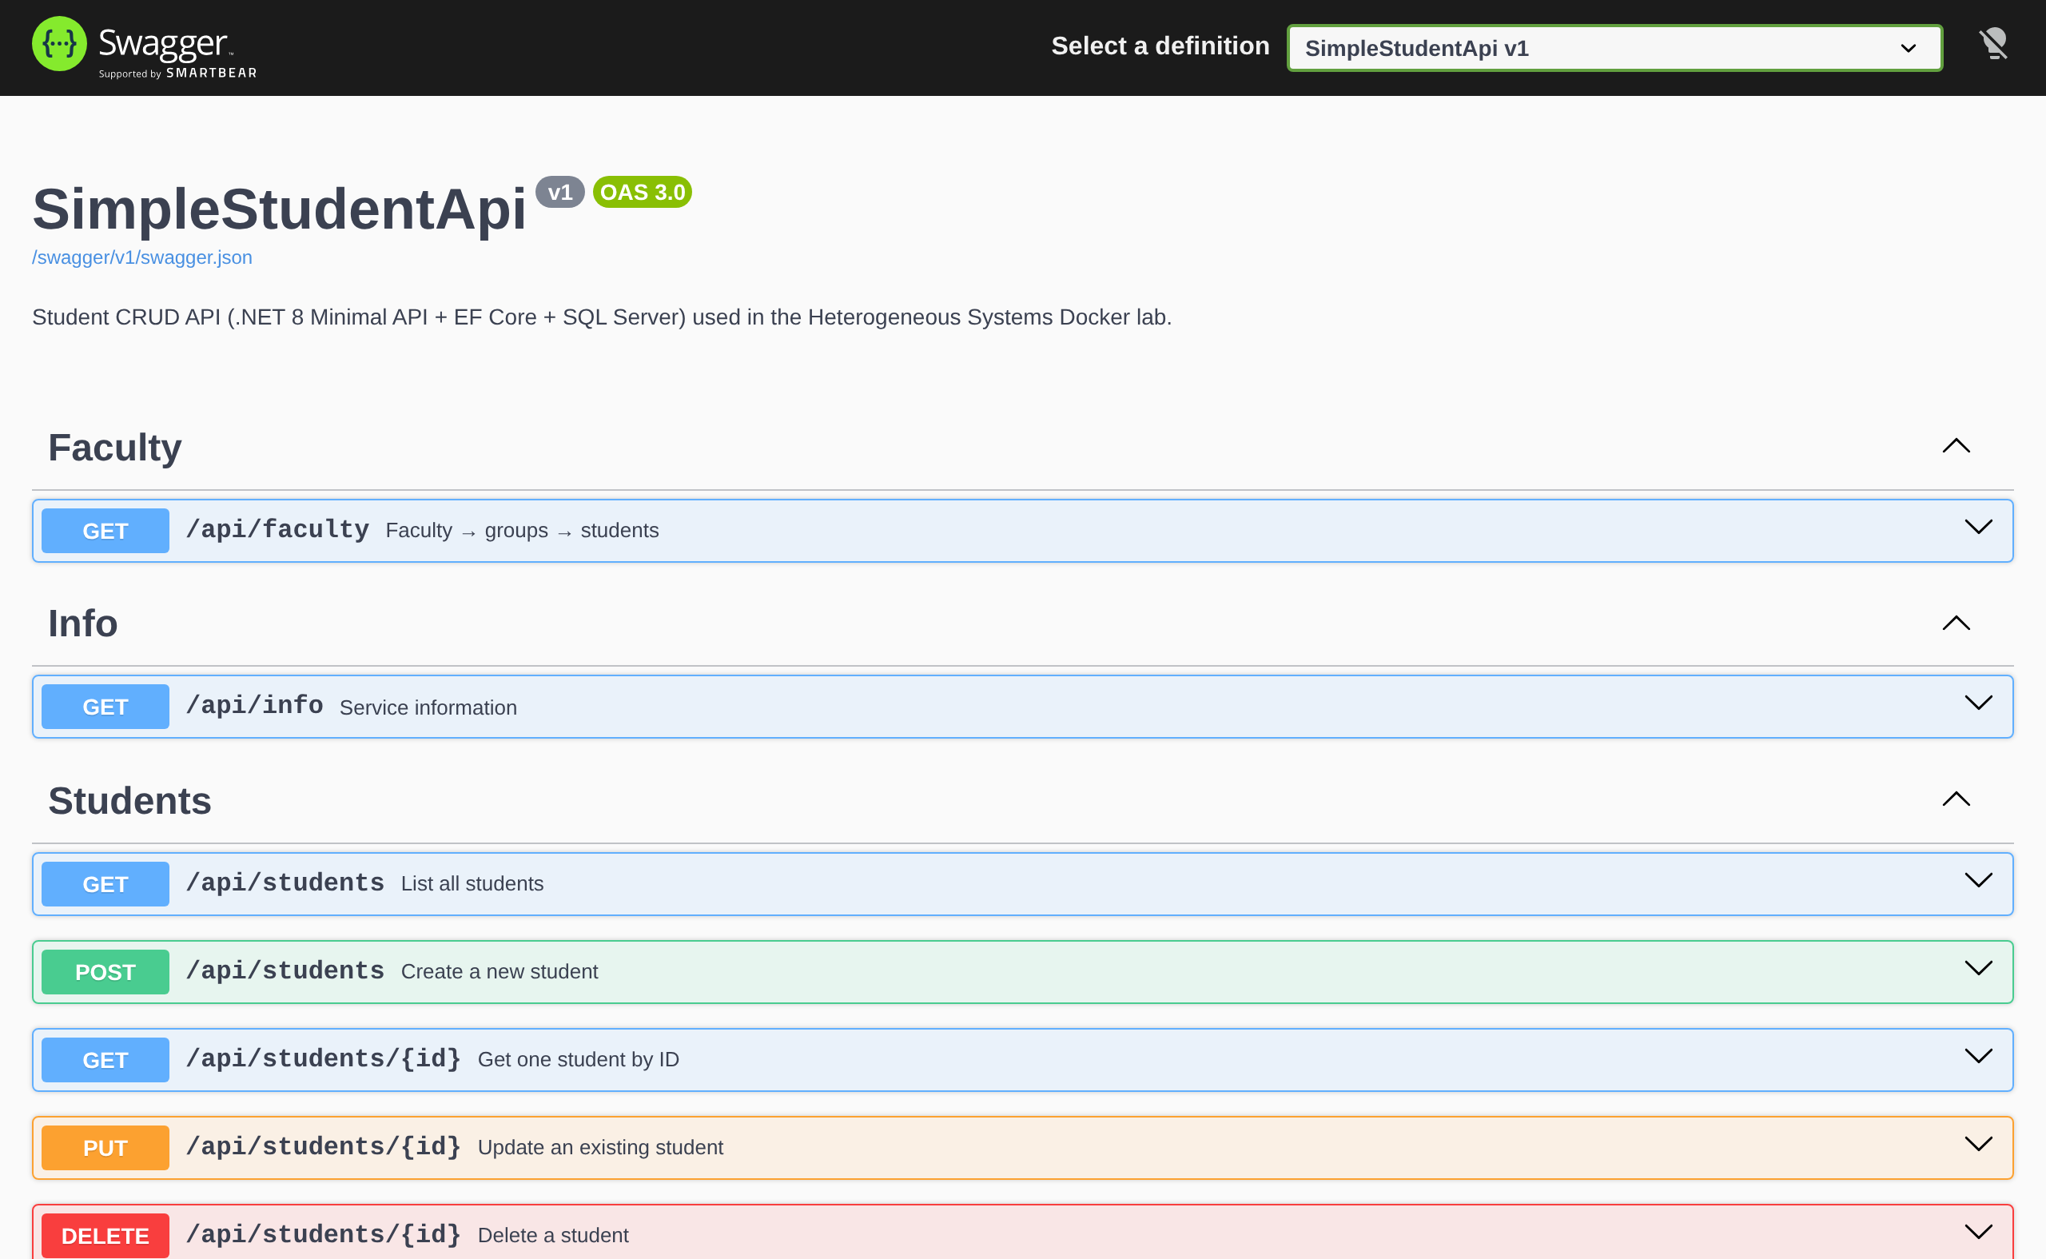
Figure 1. Swagger UI of SimpleStudentApi (Lab B)
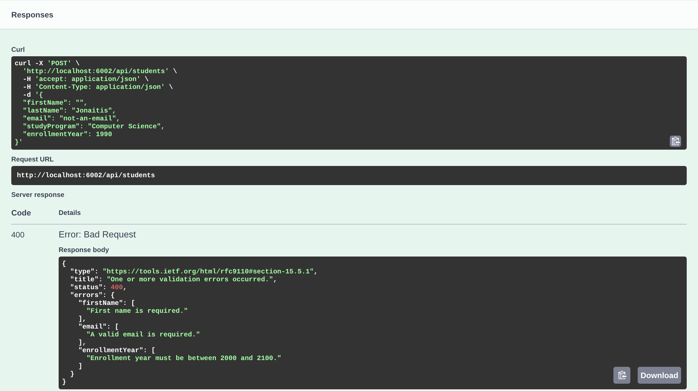
Figure 2. Try it out: POST with invalid data returns 400 and field errors

7. Integrating the frontend

7.1 Options
Approach | Pros | Cons | Used in
Hand-written HttpClient | Simple, no extra tools | URLs and DTOs typed by hand; mistakes appear only at runtime | Lab A
Generated typed client (NSwag) | Methods and models come from the contract; the compiler checks every call | Must be regenerated when the API changes | Lab B
JavaScript fetch in the browser (SPA) | Natural for React/Angular; a TypeScript client can be generated the same way | API must allow CORS; not used in our labs | —

7.2 Generating the client
The API must be running. The script downloads the current swagger.json and runs NSwag through npx (Node.js required):
cd SimpleStudentFrontend/ApiClient
bash generate-client.sh # macOS / Linux
.\generate-client.ps1 # Windows PowerShell

# what the script runs:
npx --yes nswag@14 openapi2csclient /runtime:Net80 \
/input:swagger.json /output:StudentApiClient.g.cs \
/namespace:SimpleStudentFrontend.ApiClient /className:StudentApiClient \
/jsonLibrary:SystemTextJson /useBaseUrl:false \
/generateClientInterfaces:true /injectHttpClient:true \
/disposeHttpClient:false /operationGenerationMode:SingleClientFromOperationId
The result is ApiClient/StudentApiClient.g.cs with the interface IStudentApiClient, the class StudentApiClient, the models (Student, InfoResponse, FacultyResponse, GroupResponse, HttpValidationProblemDetails) and ApiException. Do not edit this file by hand; it is overwritten on every generation. It is committed to the repository, so the frontend builds even when the API is not running.

7.3 Registering and using the client
// SimpleStudentFrontend/Program.cs
builder.Services.AddHttpClient<IStudentApiClient, StudentApiClient>(client =>
{
var apiBaseUrl = builder.Configuration["ApiSettings:BaseUrl"]
?? "http://localhost:6001";
client.BaseAddress = new Uri(apiBaseUrl);
});
ApiSettings:BaseUrl is http://simplestudentapi:8080 inside Docker (container-to-container) and http://localhost:6001 when running locally. ApiSettings:PublicUrl is the address your browser uses for the Swagger link.
public class StudentsModel : PageModel
{
private readonly IStudentApiClient _api;
public StudentsModel(IStudentApiClient api) => _api = api;

public List<Student> Students { get; private set; } = new();

public async Task OnGetAsync()
=> Students = (await _api.GetStudentsAsync()).ToList();

public async Task<IActionResult> OnPostDeleteAsync(int id)
{
await _api.DeleteStudentAsync(id);
return RedirectToPage();
}
}

7.4 Handling API errors
Non-success responses become exceptions. A documented 400 arrives as ApiException<HttpValidationProblemDetails> with the field errors in Result.Errors. ApiClient/ApiErrors.cs converts them into readable messages:
public static string ToMessage(Exception ex) => ex switch
{
// 400 – validation errors documented in Swagger
ApiException<HttpValidationProblemDetails> v
when v.Result?.Errors is { Count: > 0 } errors
=> "Validation failed: "
+ string.Join("; ", errors.SelectMany(e => e.Value)),

ApiException api when api.StatusCode == 404
=> "Student not found (404).",
ApiException api
=> $"API returned {api.StatusCode}.",
HttpRequestException http
=> $"Cannot reach the API: {http.Message}",
_ => ex.Message
};
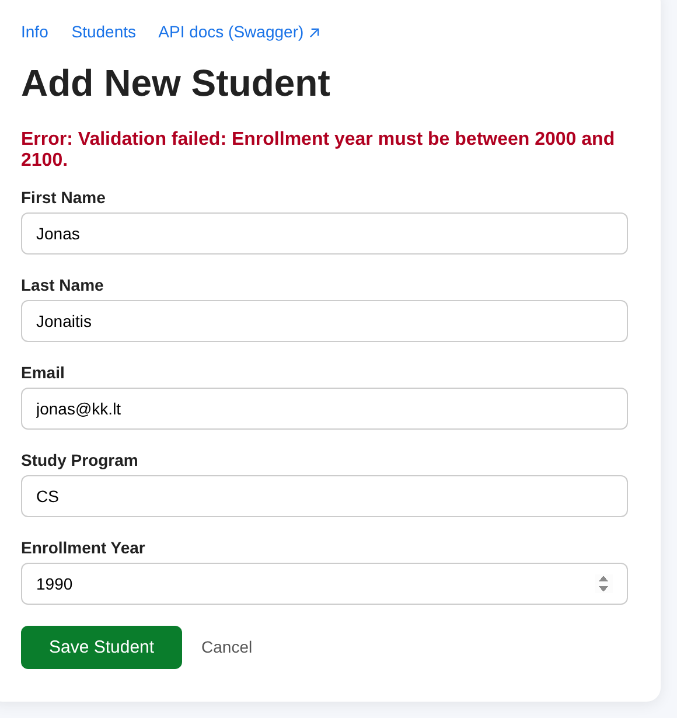
Figure 3. The same 400 error shown in the frontend form

7.5 When the API changes
- Change the API (for example rename Email to EmailAddress or add an endpoint).
- Rebuild and run the API; swagger.json now describes the new contract.
- Run generate-client to regenerate StudentApiClient.g.cs.
- Build the frontend. The compiler reports every place that no longer matches the contract.
- Fix the pages and redeploy with docker compose up --build.

8. Troubleshooting
Symptom | Likely cause | Fix
/swagger returns 404 | Old image without Swagger, or UseSwaggerUI is missing | docker compose up --build; check Program.cs
API stops at start-up with FileNotFoundException …SimpleStudentApi.xml | IncludeXmlComments without GenerateDocumentationFile | Add <GenerateDocumentationFile>true</GenerateDocumentationFile> to the .csproj
Endpoint shows no response schema | It returns an anonymous object or has no Produces<T> | Return a named class and add .Produces<T>(status)
"Cannot reach the API" in the frontend | API container not running or wrong ApiSettings__BaseUrl | docker ps; check docker-compose.yml
Swagger link in the frontend does not open | PublicUrl points to the container name | PublicUrl must be http://localhost:6001
API log repeats "DB not ready yet" | SQL Server is still starting | Wait; check docker logs mssqlserver. After 10 attempts the API stops
SQL Server container exits on a Mac | amd64 image on Apple Silicon without Rosetta | Enable Rosetta in Docker Desktop settings
New endpoint is missing in the generated client | Client generated from an old swagger.json | Rebuild the API, then run generate-client again
npx: command not found | Node.js is not installed | Install Node.js LTS from nodejs.org

9. Practice tasks
- Run Lab B and open Swagger UI. Using Try it out, create three students in two study programs. Check them in the frontend and in GET /api/faculty.
- Send invalid data with Swagger and through the frontend form (switch off the browser check with the developer tools or use year 1990). Compare the 400 response with the message on the page.
- Add a search endpoint (below), rebuild the API and find it in Swagger UI. Notice that the query parameter program is documented automatically.
- Regenerate the client. Add a search box to the Students page that calls SearchStudentsAsync(program).
- Download swagger.json and add it, with a Swagger UI screenshot and a table of endpoints and status codes, to your project documentation.

students.MapGet("/search", async (string program, AppDbContext db) =>
Results.Ok(await db.Students
.Where(s => s.StudyProgram.Contains(program))
.ToListAsync()))
.WithName("SearchStudents")
.WithSummary("Search students by study program")
.Produces<List<Student>>(StatusCodes.Status200OK);

10. OpenAPI in your project documentation
For the "Heterogeneous system" project, the OpenAPI document is the most precise description of the interface between your components. Use it as follows:
- Interface specification: attach swagger.json (or the YAML version) as an appendix and reference it from the architecture description (ISO/IEC/IEEE 42010 interface/information view).
- Interoperability: cite the published contract as evidence for compatibility and interoperability (ISO/IEC 25010) and for technical and semantic interoperability (European Interoperability Framework).
- Readability: include a Swagger UI screenshot and a table of endpoints with status codes, like the one below.
- Versioning: record the API version (v1) and describe what counts as a breaking change.

Method | Route | Responses
GET | /api/info | 200
GET | /api/students | 200
GET | /api/students/{id} | 200, 404
POST | /api/students | 201, 400
PUT | /api/students/{id} | 200, 400, 404
DELETE | /api/students/{id} | 204, 404
GET | /api/faculty | 200

