WD-Activity-Based-Learning
Case-Study-1
1. Introduction
Campus Hub is an Engineering Student Dashboard website developed using HTML and CSS. The main purpose of this website is to help engineering students access and manage their academic information in one place.
This website provides important student details such as attendance percentage, semester GPA, subject information, examination schedules, semester results, and latest announcements. It has a simple, attractive, and user-friendly design that helps students easily navigate through different sections.
The website is designed using HTML for creating the structure and CSS for styling and layout.

2. Explanation of the Website
The CampusHub website contains the following sections:
1. Sidebar Navigation:
- Displays the CampusHub logo and student menu.
- Contains links to Dashboard, My Subjects, Attendance, Semester Results, Exam Schedule, and Announcements.
- Helps students navigate between different sections.
2. Student Dashboard:
- Displays a welcome message.
- Shows the student profile and academic details.
- Includes student name, course, roll number, and academic year.
3. Academic Statistics:
- Displays overall attendance percentage.
- Shows semester GPA.
- Displays the total number of subjects.
- Shows the number of upcoming examinations.
4. Attendance Overview:
- Displays subject-wise attendance percentages.
- Uses progress bars to represent attendance visually.
- Helps students understand their attendance status.
5. Subject Information:
- Displays subject names, subject codes, and faculty details in a table.
6. Semester Results:
- Displays subject-wise marks and grades.
- Helps students view their academic performance.
7. Examination Schedule:
- Displays examination dates and timings.
- Helps students plan their examination preparation.
8. Latest Announcements:
- Displays important academic updates.
- Includes assignment reminders, examination updates, and coding practice information.
9. Footer:
- Displays the copyright information and website name.
3.HTML Code
<!DOCTYPE html>
<html lang="en">
<head>
<meta charset="UTF-8">
<meta name="viewport" content="width=device-width, initial-scale=1.0">
<title>Engineering Student Dashboard</title>
<link rel="stylesheet" href="file.css">
</head>
<body>

<div class="dashboard">

<aside class="sidebar">
<h2>🎓 CampusHub</h2>
<p class="menu-title">STUDENT MENU</p>
<a href="#home">🏠 Dashboard</a>
<a href="#subjects">📚 My Subjects</a>
<a href="#attendance">📊 Attendance</a>
<a href="#results">📝 Semester Results</a>
<a href="#exams">📅 Exam Schedule</a>
<a href="#announcements">📢 Announcements</a>
<p class="sidebar-note">Learn today, lead tomorrow!</p>
</aside>

<main class="main-content" id="home">

<header class="topbar">
<div>
<h1>Student Dashboard</h1>
<p>Welcome back! Here's your academic overview.</p>
</div>
<div class="profile-icon">ST</div>
</header>

<section class="student-card">
<div class="avatar">ST</div>
<div>
<h2>Student Name</h2>
<p>B.Tech - First Year | CSM</p>
<p>Roll Number: 26CSM001</p>
<p>Academic Year: 2026–2027</p>
</div>
</section>

<section class="stats">
<div class="stat-card">
<p>Overall Attendance</p>
<h2>85%</h2>
<span>Good progress</span>
</div>
<div class="stat-card">
<p>Semester GPA</p>
<h2>8.6</h2>
<span>Semester 1</span>
</div>
<div class="stat-card">
<p>Total Subjects</p>
<h2>6</h2>
<span>Current semester</span>
</div>
<div class="stat-card">
<p>Upcoming Exams</p>
<h2>3</h2>
<span>Check schedule</span>
</div>
</section>

<section class="panel" id="attendance">
<h2>Attendance Overview</h2>

<p>Mathematics <span>90%</span></p>
<div class="progress"><div class="fill" style="width:90%"></div></div>

<p>Python Programming <span>85%</span></p>
<div class="progress"><div class="fill" style="width:85%"></div></div>

<p>Physics <span>78%</span></p>
<div class="progress"><div class="fill" style="width:78%"></div></div>

<p>English <span>88%</span></p>
<div class="progress"><div class="fill" style="width:88%"></div></div>
</section>

<section class="panel" id="subjects">
<h2>Subject Information</h2>
<table>
<tr><th>Subject</th><th>Code</th><th>Faculty</th></tr>
<tr><td>Mathematics</td><td>MA101</td><td>Faculty A</td></tr>
<tr><td>Python Programming</td><td>CS101</td><td>Faculty B</td></tr>
<tr><td>Physics</td><td>PH101</td><td>Faculty C</td></tr>
<tr><td>English</td><td>EN101</td><td>Faculty D</td></tr>
</table>
</section>

<section class="panel" id="results">
<h2>Semester Results</h2>
<table>
<tr><th>Subject</th><th>Marks / 100</th><th>Grade</th></tr>
<tr><td>Mathematics</td><td>88</td><td>A</td></tr>
<tr><td>Python Programming</td><td>92</td><td>A+</td></tr>
<tr><td>Physics</td><td>81</td><td>A</td></tr>
<tr><td>English</td><td>85</td><td>A</td></tr>
</table>
<p class="note">Sample results for demonstration only.</p>
</section>

<section class="panel" id="exams">
<h2>Examination Schedule</h2>
<table>
<tr><th>Subject</th><th>Date</th><th>Time</th></tr>
<tr><td>Mathematics</td><td>10 Dec 2026</td><td>9 AM</td></tr>
<tr><td>Python</td><td>12 Dec 2026</td><td>9 AM</td></tr>
<tr><td>Physics</td><td>15 Dec 2026</td><td>9 AM</td></tr>
</table>
<p class="note">Sample dates only. Replace with your official timetable.</p>
</section>

<section class="panel" id="announcements">
<h2>Latest Announcements</h2>
<div class="announcement">
<strong>📢 Assignment Reminder</strong>
<p>Submit your programming assignment before the deadline.</p>
</div>
<div class="announcement">
<strong>📅 Examination Update</strong>
<p>Check the official timetable for examination details.</p>
</div>
<div class="announcement">
<strong>💻 Coding Practice</strong>
<p>Practice Python programs regularly to improve your skills.</p>
</div>
</section>

<footer>
<p>© 2026 CampusHub | Student Academic Dashboard</p>
</footer>

</main>
</div>

</body>
</html>
4.CSS Code
* {
margin: 0;
padding: 0;
box-sizing: border-box;
}

body {
font-family: Arial, sans-serif;
background-color: #f3f6fc;
color: #253047;
}

.dashboard {
display: flex;
min-height: 100vh;
}

.sidebar {
width: 240px;
background-color: #172554;
color: white;
padding: 25px 15px;
flex-shrink: 0;
}

.sidebar h2 {
font-size: 23px;
margin-bottom: 35px;
}

.menu-title {
font-size: 12px;
color: #a5b4fc;
margin: 20px 10px;
}

.sidebar a {
display: block;
color: #e0e7ff;
text-decoration: none;
padding: 13px 10px;
margin-bottom: 8px;
border-radius: 8px;
}

.sidebar a:hover {
background-color: #334b87;
}

.sidebar-note {
margin-top: 45px;
font-size: 13px;
color: #c7d2fe;
}

.main-content {
flex: 1;
min-width: 0;
padding: 25px;
}

.topbar {
display: flex;
justify-content: space-between;
align-items: center;
margin-bottom: 25px;
}

.topbar h1 {
font-size: 28px;
}

.topbar p {
color: #64748b;
margin-top: 8px;
}

.profile-icon, .avatar {
background-color: #dbeafe;
color: #1d4ed8;
border-radius: 50%;
display: flex;
align-items: center;
justify-content: center;
font-weight: bold;
}

.profile-icon {
width: 45px;
height: 45px;
}

.student-card, .stat-card, .panel {
background-color: white;
padding: 22px;
border-radius: 12px;
margin-bottom: 22px;
box-shadow: 0 3px 12px #00000008;
}

.student-card {
display: flex;
align-items: center;
gap: 20px;
border-left: 5px solid #2563eb;
}

.avatar {
width: 70px;
height: 70px;
font-size: 23px;
}

.student-card p {
color: #64748b;
margin-top: 6px;
}

.stats {
display: grid;
grid-template-columns: repeat(4, 1fr);
gap: 18px;
}

.stat-card p, .stat-card span {
color: #64748b;
font-size: 14px;
}

.stat-card h2 {
color: #2563eb;
font-size: 30px;
margin: 12px 0;
}

.panel h2 {
font-size: 20px;
margin-bottom: 20px;
}

.progress {
height: 9px;
background-color: #e2e8f0;
border-radius: 10px;
margin: 8px 0 20px;
overflow: hidden;
}

.fill {
height: 100%;
background-color: #2563eb;
border-radius: 10px;
}

.panel p span {
float: right;
color: #2563eb;
font-weight: bold;
}

table {
width: 100%;
border-collapse: collapse;
text-align: left;
}

th, td {
padding: 13px 10px;
border-bottom: 1px solid #e2e8f0;
}

th {
background-color: #eff6ff;
color: #1e40af;
}

.note {
color: #64748b;
font-size: 12px;
margin-top: 12px;
}

.announcement {
background-color: #f8fafc;
border-left: 4px solid #2563eb;
padding: 15px;
margin-bottom: 12px;
border-radius: 5px;
}

.announcement p {
color: #64748b;
margin-top: 7px;
}

footer {
text-align: center;
color: #64748b;
font-size: 13px;
padding: 20px 0;
}

@media (max-width: 900px) {
.stats {
grid-template-columns: repeat(2, 1fr);
}

.sidebar {
width: 200px;
}

.main-content {
padding: 15px;
}
}

@media (max-width: 600px) {
.dashboard {
flex-direction: column;
}

.sidebar {
width: 100%;
}

.sidebar h2 {
margin-bottom: 15px;
}

.sidebar-note {
margin-top: 15px;
}

.stats {
grid-template-columns: 1fr;
}

.topbar h1 {
font-size: 23px;
}

.panel {
overflow-x: auto;
}

table {
min-width: 450px;
}
}
5.Output
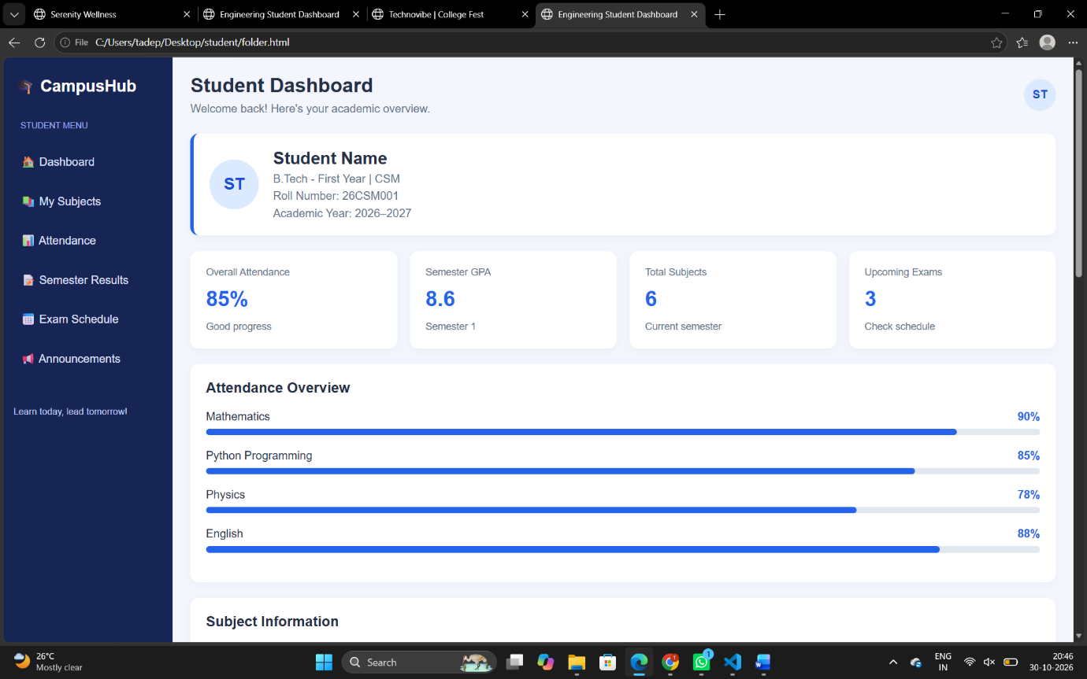
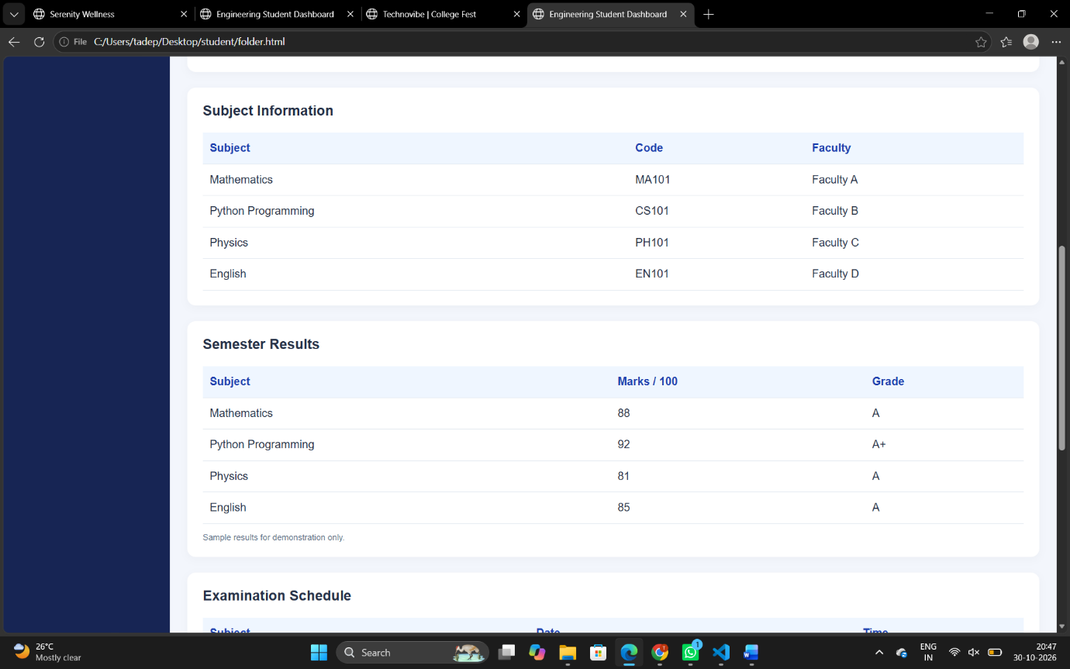

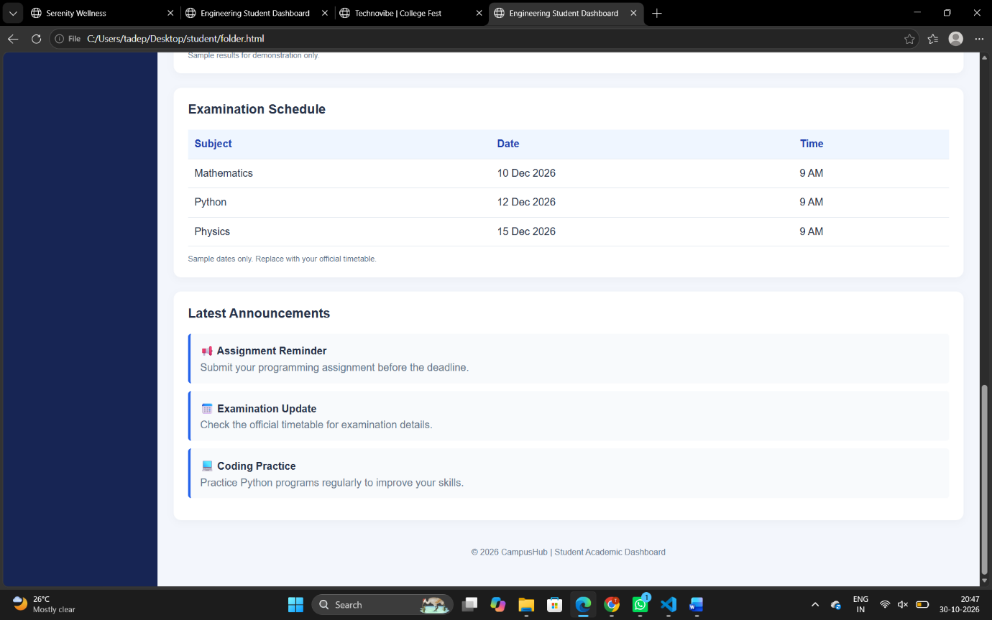
6. Conclusion
The CampusHub – Engineering Student Dashboard project was successfully developed using HTML and CSS. This project helps students view their academic information in an organized and user-friendly manner.
Through this project, I learned how to create webpage structures using HTML and improve website appearance using CSS. I also gained practical knowledge of Flexbox, Grid, tables, progress bars, and responsive web design.
This project improved my frontend web development skills and provided a foundation for developing more advanced student management websites in the future.

Case-Study-2
1. Introduction
TECHNOVIBE 2026 is a College Fest Website developed using HTML and CSS. The main purpose of this website is to provide complete information about a college festival in one place.
The website provides details about various technical events, cultural events, workshops, event schedules, coordinators, festival rules, and registration. It helps students easily explore different activities and participate in the college fest.
The website is designed with an attractive user interface, colourful sections, navigation links, event cards, and a registration form. HTML is used to create the structure, while CSS is used to design and style the webpage.
2. Explanation of the Website
The TECHNOVIBE website contains the following sections:
1. Header Section:
- Displays the title TECHNOVIBE 2026.
- Shows the tagline "Innovation • Creativity • Celebration".
- Provides the identity of the college festival.
2. Navigation Bar:
- Contains links to Events, Schedule, Coordinators, Rules, and Register.
- Helps users navigate easily between different sections.
3. Hero Section:
- Displays the welcome message "Unleash Your Talent!".
- Contains a Register Now button.
- Attracts visitors to participate in the festival.
4. Events Section:
- Displays different categories of events.
- Includes Technical Events, Cultural Events, Workshops, and Fun Zone.
- Uses separate cards to display event information.
5. Event Schedule:
- Displays the event timings, event names, and venues in a table.
- Helps students understand the festival schedule.
6. Event Coordinators:
- Displays the names of event coordinators.
- Provides information about their responsibilities and contact details.
7. Festival Rules:
- Displays important instructions for participants.
- Helps maintain discipline during the festival.
8. Registration Section:
- Provides a registration form for students.
- Collects name, email, college name, and event selection.
- Includes a submit button.
9. Footer Section:
- Displays copyright information.
- Shows the festival tagline.
3.HTML Code
<!DOCTYPE html>
<html lang="en">
<head>
<meta charset="UTF-8">
<meta name="viewport" content="width=device-width, initial-scale=1.0">
<title>Technovibe | College Fest</title>
<link rel="stylesheet" href="vibe.css">
</head>
<body>

<header>
<h1>⚡ TECHNOVIBE 2026</h1>
<p>Innovation • Creativity • Celebration</p>
</header>

<nav>
<a href="#events">Events</a>
<a href="#schedule">Schedule</a>
<a href="#team">Coordinators</a>
<a href="#rules">Rules</a>
<a href="#register">Register</a>
</nav>

<section class="hero">
<h2>Unleash Your Talent!</h2>
<p>One Campus. Endless Possibilities.</p>
<a href="#register" class="btn">Register Now →</a>
</section>

<section id="events">
<h2>Explore Our Events</h2>
<div class="cards">
<div class="card tech">
<h3>💻 Technical Events</h3>
<p>Hackathon, Coding Contest, Project Expo</p>
</div>
<div class="card culture">
<h3>🎤 Cultural Events</h3>
<p>Dance, Singing, Drama and Fashion Show</p>
</div>
<div class="card workshop">
<h3>🧠 Workshops</h3>
<p>AI, Web Development and Robotics</p>
</div>
<div class="card fun">
<h3>🎮 Fun Zone</h3>
<p>Quiz, Gaming and Treasure Hunt</p>
</div>
</div>
</section>

<section id="schedule" class="light">
<h2>Event Schedule</h2>
<table>
<tr><th>Time</th><th>Event</th><th>Venue</th></tr>
<tr><td>9:00 AM</td><td>Inauguration</td><td>Main Stage</td></tr>
<tr><td>10:00 AM</td><td>Coding Contest</td><td>Computer Lab</td></tr>
<tr><td>11:30 AM</td><td>AI Workshop</td><td>Seminar Hall</td></tr>
<tr><td>1:30 PM</td><td>Cultural Show</td><td>Open Auditorium</td></tr>
</table>
<p class="note">Sample schedule — replace with official details.</p>
</section>

<section id="team">
<h2>Event Coordinators</h2>
<div class="cards">
<div class="card person">
<h3>Arjun Kumar</h3>
<p>Technical Events</p>
<p>Contact: coordinator@example.com</p>
</div>
<div class="card person">
<h3>Priya Sharma</h3>
<p>Cultural Events</p>
<p>Contact: culture@example.com</p>
</div>
</div>
</section>

<section id="rules" class="light">
<h2>Festival Rules</h2>
<ul>
<li>Bring your valid college ID card.</li>
<li>Register before the event deadline.</li>
<li>Follow the instructions of coordinators.</li>
<li>Respect all participants and keep the campus clean.</li>
</ul>
</section>

<section id="register">
<h2>Register for the Fest</h2>
<form>
<input type="text" placeholder="Your Full Name" required>
<input type="email" placeholder="Your Email" required>
<input type="text" placeholder="College Name" required>
<select required>
<option value="">Choose an Event</option>
<option>Technical Event</option>
<option>Cultural Event</option>
<option>Workshop</option>
<option>Fun Zone</option>
</select>
<button type="submit">Submit Registration</button>
</form>
<p class="note">Demo form only; submissions are not stored.</p>
</section>

<footer>
<p>© 2026 TECHNOVIBE | Designed by Engineering Students</p>
<p>Dream Big. Build Bigger. Celebrate Together!</p>
</footer>

</body>
</html>
4.CSS Code
body {
font-family: Arial, sans-serif;
background-color: #f4f3ff;
color: #25234a;
margin: 0;
}

header, footer {
background-color: #201747;
color: white;
text-align: center;
padding: 20px;
}

header h1 {
color: #00d9bd;
}

nav {
background-color: #493382;
text-align: center;
padding: 15px;
}

nav a {
color: white;
text-decoration: none;
margin: 10px;
font-weight: bold;
}

nav a:hover {
color: yellow;
}

.hero {
background-color: #a044c4;
color: white;
text-align: center;
padding: 50px 10px;
}

.hero h2 {
font-size: 32px;
}

.btn, button {
background-color: #00d9bd;
color: #201747;
padding: 10px 20px;
border: none;
border-radius: 5px;
text-decoration: none;
cursor: pointer;
}

section {
padding: 30px;
text-align: center;
}

section h2 {
color: #493382;
}

.cards {
display: flex;
justify-content: center;
flex-wrap: wrap;
gap: 15px;
}

.card {
background-color: white;
width: 230px;
padding: 20px;
border: 2px solid #a044c4;
border-radius: 8px;
}

.tech {
border-color: blue;
}

.culture {
border-color: deeppink;
}

.workshop {
border-color: purple;
}

.fun {
border-color: orange;
}

.person {
border-color: green;
}

.light {
background-color: #e8e5ff;
}

table {
width: 100%;
border-collapse: collapse;
background-color: white;
}

th, td {
padding: 12px;
border: 1px solid gray;
}

th {
background-color: #493382;
color: white;
}

ul {
display: inline-block;
text-align: left;
line-height: 2;
}

form {
max-width: 400px;
margin: auto;
padding: 20px;
background-color: white;
border: 1px solid #cccccc;
}

input, select {
width: 100%;
padding: 10px;
margin: 8px 0;
box-sizing: border-box;
}

button {
width: 100%;
}

.note {
font-size: 12px;
color: gray;
}

@media (max-width: 600px) {
nav a {
display: inline-block;
margin: 5px;
}

.hero h2 {
font-size: 25px;
}

.card {
width: 100%;
}
}
5.Output
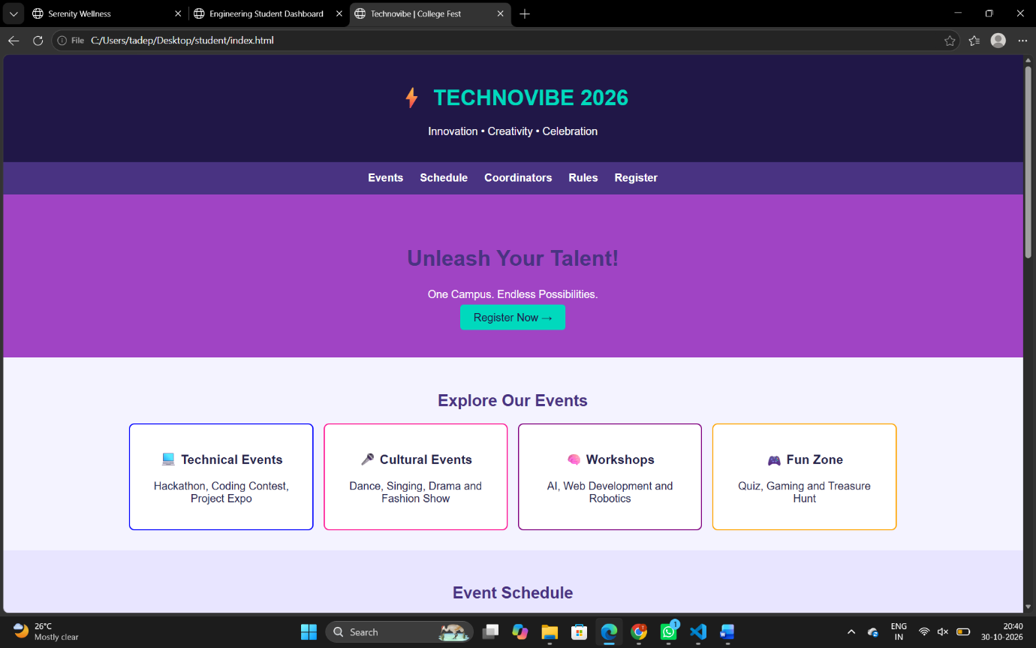
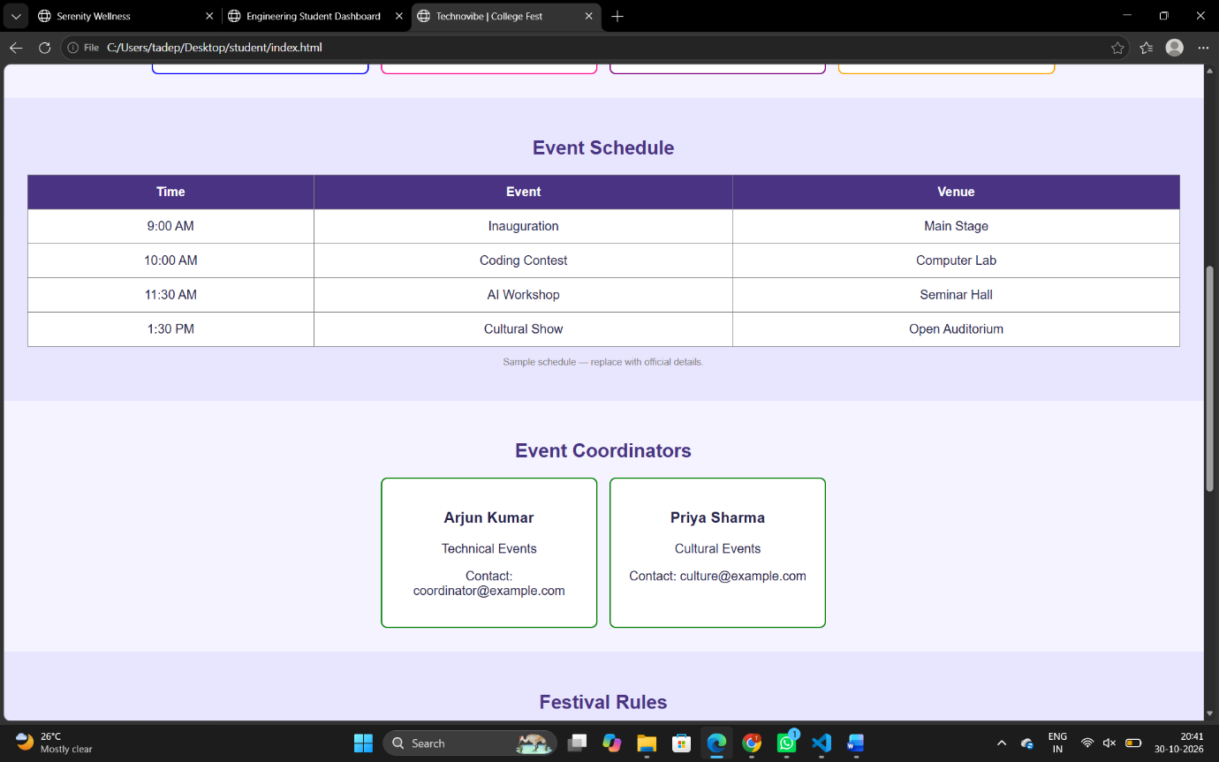

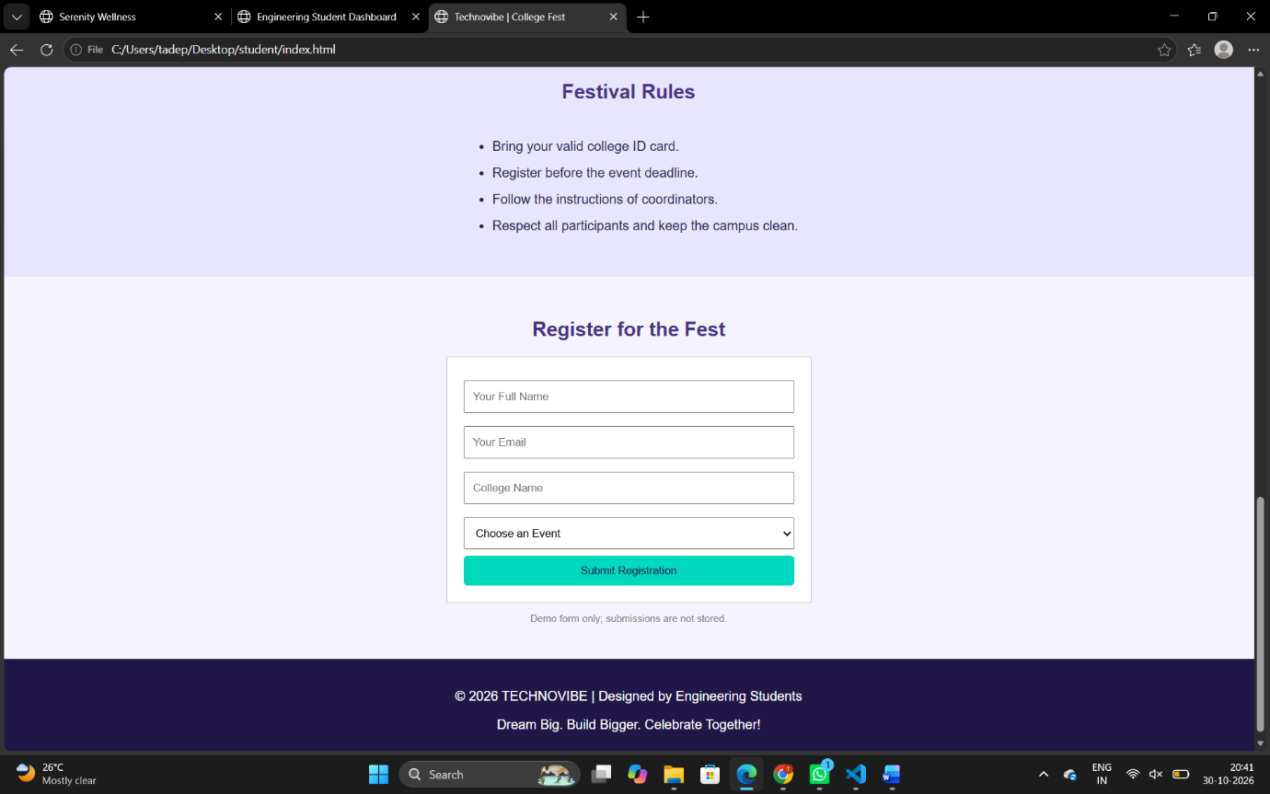
6. Conclusion
The TECHNOVIBE 2026 College Fest Website was successfully developed using HTML and CSS. This project provides a simple and attractive platform to display college festival information and event details.
Through this project, I learned how to create webpage structures using HTML and design attractive layouts using CSS. I also gained practical knowledge of navigation bars, event cards, tables, forms, buttons, hover effects, and responsive web design.
This project helped me improve my frontend web development skills and understand how to develop an informative and user-friendly website

Case-Study-3
1. Introduction
Serenity Wellness is a Yoga and Meditation Website developed using HTML and CSS. The main purpose of this website is to provide information about yoga, meditation, and healthy lifestyle practices in one place.
The website provides details about popular yoga poses, meditation techniques, instructors, weekly class schedules, membership plans, and wellness articles. It helps visitors explore different wellness activities and learn about maintaining a peaceful and healthy lifestyle.
The website is designed with a simple, attractive, and user-friendly interface using natural colours, images, cards, navigation links, and responsive layouts. HTML is used to create the structure, while CSS is used to improve the appearance and design of the website.
2. Explanation of the Website
The Serenity Wellness website contains the following sections:
1. Header Section:
- Displays the website name Serenity Wellness.
- Shows the tagline "Your journey to a peaceful mind and healthy life".
- Provides the identity of the website.
2. Navigation Bar:
- Contains links to Home, Yoga, Meditation, Instructors, Schedule, Membership, and Articles.
- Helps users easily navigate between different sections.
3. Home Section:
- Displays the welcome message "Find Your Inner Peace".
- Provides a short introduction about wellness.
- Includes an Explore Classes button.
4. Popular Yoga Poses:
- Displays different yoga poses with images.
- Includes Mountain Pose, Downward Dog, and Warrior Pose.
- Provides a short explanation of each pose.
5. Meditation Techniques:
- Displays different meditation methods.
- Includes Mindful Breathing, Body Scan, and Guided Meditation.
- Explains simple relaxation techniques.
6. Instructors Section:
- Displays instructor names and photographs.
- Provides their roles, such as Yoga Instructor, Meditation Coach, and Wellness Guide.
7. Weekly Class Schedule:
- Displays the weekly class timings and activities in a table.
- Helps visitors understand the available class schedules.
8. Membership Plans:
- Displays three membership plans: Basic, Premium, and Family.
- Provides sample prices and plan details.
- Includes Choose Plan buttons.
9. Wellness Articles:
- Displays articles about daily yoga, mindfulness, and creating a calm routine.
- Provides useful information about wellness practices.
10. Contact Section:
- Displays a message encouraging visitors to begin their wellness journey.
- Includes a Back to Top button.
11. Footer Section:
- Displays copyright information.
- Shows the tagline "Breathe • Move • Be Well".
3.HTML Code
<!DOCTYPE html>
<html lang="en">
<head>
<meta charset="UTF-8">
<meta name="viewport" content="width=device-width, initial-scale=1.0">
<title>Serenity Wellness</title>
<link rel="stylesheet" href="page.css">
</head>
<body>

<header>
<h1>🌿 Serenity Wellness</h1>
<p>Your journey to a peaceful mind and healthy life</p>
</header>

<nav>
<a href="#home">Home</a>
<a href="#yoga">Yoga</a>
<a href="#meditation">Meditation</a>
<a href="#instructors">Instructors</a>
<a href="#schedule">Schedule</a>
<a href="#membership">Membership</a>
<a href="#articles">Articles</a>
</nav>

<section id="home" class="hero">
<h2>Find Your Inner Peace</h2>
<p>Relax your mind, strengthen your body, and live mindfully.</p>
<a href="#schedule" class="button">Explore Classes</a>
</section>

<section id="yoga">
<h2>Popular Yoga Poses</h2>
<p>Explore simple poses for balance, flexibility, and relaxation.</p>
<div class="container">
<div class="card">
<img src="https://images.unsplash.com/photo-1506126613408-eca07ce68773?auto=format&fit=crop&w=500&q=80" alt="Yoga and meditation">
<h3>Mountain Pose</h3>
<p>Improve posture and body awareness.</p>
</div>
<div class="card">
<img src="https://images.unsplash.com/photo-1544367567-0f2fcb009e0b?auto=format&fit=crop&w=500&q=80" alt="Yoga practice">
<h3>Downward Dog</h3>
<p>Practice balance and gentle stretching.</p>
</div>
<div class="card">
<img src="https://images.unsplash.com/photo-1599447421416-3414500d18a5?auto=format&fit=crop&w=500&q=80" alt="Yoga outdoors">
<h3>Warrior Pose</h3>
<p>Build focus and body stability.</p>
</div>
</div>
</section>

<section id="meditation" class="soft-bg">
<h2>Meditation Techniques</h2>
<div class="container">
<div class="card">
<h3>Mindful Breathing</h3>
<p>Pay gentle attention to your natural breathing.</p>
</div>
<div class="card">
<h3>Body Scan</h3>
<p>Notice different parts of your body without judgment.</p>
</div>
<div class="card">
<h3>Guided Meditation</h3>
<p>Follow a recorded or instructor-led relaxation session.</p>
</div>
</div>
</section>

<section id="instructors">
<h2>Meet Our Instructors</h2>
<div class="container">
<div class="card">
<img src="https://images.unsplash.com/photo-1544005313-94ddf0286df2?auto=format&fit=crop&w=500&q=80" alt="Yoga instructor">
<h3>Ananya Rao</h3>
<p>Yoga Instructor</p>
</div>
<div class="card">
<img src="https://images.unsplash.com/photo-1500648767791-00dcc994a43e?auto=format&fit=crop&w=500&q=80" alt="Meditation instructor">
<h3>Arjun Kumar</h3>
<p>Meditation Coach</p>
</div>
<div class="card">
<img src="https://images.unsplash.com/photo-1551836022-d5d88e9218df?auto=format&fit=crop&w=500&q=80" alt="Wellness teacher">
<h3>Priya Sharma</h3>
<p>Wellness Guide</p>
</div>
</div>
</section>

<section id="schedule" class="soft-bg">
<h2>Weekly Class Schedule</h2>
<table>
<tr><th>Day</th><th>Class</th><th>Time</th></tr>
<tr><td>Monday</td><td>Hatha Yoga</td><td>7:00 AM</td></tr>
<tr><td>Tuesday</td><td>Meditation</td><td>6:00 PM</td></tr>
<tr><td>Wednesday</td><td>Vinyasa Yoga</td><td>7:00 AM</td></tr>
<tr><td>Friday</td><td>Mindfulness</td><td>6:00 PM</td></tr>
<tr><td>Saturday</td><td>Relaxation Yoga</td><td>8:00 AM</td></tr>
</table>
<p class="note">Sample schedule for demonstration.</p>
</section>

<section id="membership">
<h2>Membership Plans</h2>
<div class="container">
<div class="card plan">
<h3>Basic</h3>
<h2>₹499/month</h2>
<p>Access to 4 online classes monthly.</p>
<a href="#contact" class="button">Choose Plan</a>
</div>
<div class="card plan featured">
<h3>Premium</h3>
<h2>₹999/month</h2>
<p>Access to weekly classes and articles.</p>
<a href="#contact" class="button">Choose Plan</a>
</div>
<div class="card plan">
<h3>Family</h3>
<h2>₹1499/month</h2>
<p>Wellness sessions for the whole family.</p>
<a href="#contact" class="button">Choose Plan</a>
</div>
</div>
<p class="note">Illustrative prices only; no payments are processed.</p>
</section>

<section id="articles" class="soft-bg">
<h2>Wellness Articles</h2>
<div class="container">
<div class="card">
<h3>Benefits of Daily Yoga</h3>
<p>Learn how regular, comfortable movement can support wellbeing.</p>
</div>
<div class="card">
<h3>Mindfulness for Beginners</h3>
<p>Discover simple ways to pay attention to the present moment.</p>
</div>
<div class="card">
<h3>Creating a Calm Routine</h3>
<p>Explore small habits that help make time for relaxation.</p>
</div>
</div>
</section>

<section id="contact">
<h2>Start Your Wellness Journey</h2>
<p>Make time for yourself. Breathe, move, and feel refreshed.</p>
<a href="#home" class="button">Back to Top</a>
</section>

<footer>
<p>© 2026 Serenity Wellness | Breathe • Move • Be Well</p>
</footer>

</body>
</html>
4.CSS Code
* {
margin: 0;
padding: 0;
box-sizing: border-box;
}

html {
scroll-behavior: smooth;
}

body {
font-family: Arial, sans-serif;
background-color: #f8faf5;
color: #34463b;
line-height: 1.6;
}

header {
background-color: #dce9dc;
text-align: center;
padding: 30px;
}

header h1 {
color: #285943;
font-size: 32px;
}

nav {
background-color: #285943;
text-align: center;
padding: 15px;
}

nav a {
color: white;
text-decoration: none;
margin: 10px;
font-weight: bold;
}

nav a:hover {
color: #f2d7a0;
}

.hero {
background-color: #e8f0e5;
text-align: center;
padding: 65px 20px;
background-image: url("https://images.unsplash.com/photo-1470252649378-9c29740c9fa8?auto=format&fit=crop&w=1400&q=80");
background-size: cover;
background-position: center;
color: white;
}

.hero h2 {
font-size: 38px;
margin-bottom: 12px;
}

.hero p {
font-size: 18px;
margin-bottom: 25px;
}

.button {
display: inline-block;
background-color: #39795b;
color: white;
text-decoration: none;
padding: 10px 22px;
border-radius: 25px;
margin-top: 12px;
}

.button:hover {
background-color: #204b37;
}

section {
padding: 40px 6%;
text-align: center;
scroll-margin-top: 15px;
}

section h2 {
color: #285943;
margin-bottom: 15px;
font-size: 27px;
}

.container {
display: flex;
justify-content: center;
flex-wrap: wrap;
gap: 22px;
margin-top: 25px;
}

.card {
background-color: white;
width: 280px;
padding: 18px;
border: 1px solid #e0e8df;
border-radius: 12px;
text-align: center;
box-shadow: 0 4px 12px #294d3610;
}

.card img {
width: 100%;
height: 180px;
object-fit: cover;
border-radius: 8px;
margin-bottom: 12px;
}

.card h3 {
color: #39795b;
margin-bottom: 8px;
}

.card p {
font-size: 15px;
}

.soft-bg {
background-color: #eaf2e8;
}

table {
width: 100%;
max-width: 800px;
margin: 20px auto;
border-collapse: collapse;
background-color: white;
}

th, td {
border: 1px solid #d5e2d4;
padding: 13px;
text-align: center;
}

th {
background-color: #39795b;
color: white;
}

tr:nth-child(even) {
background-color: #f0f6ef;
}

.plan h2 {
font-size: 23px;
margin: 12px 0;
}

.featured {
border: 2px solid #39795b;
background-color: #f1f7ee;
}

.note {
font-size: 13px;
color: #647568;
margin-top: 10px;
}

#contact {
background-color: #dce9dc;
}

footer {
background-color: #204b37;
color: white;
text-align: center;
padding: 22px;
}

@media (max-width: 650px) {
header h1 {
font-size: 25px;
}

nav a {
display: inline-block;
margin: 6px;
}

.hero h2 {
font-size: 29px;
}

.container {
flex-direction: column;
align-items: center;
}

.card {
width: 100%;
max-width: 350px;
}

table {
font-size: 13px;
}

th, td {
padding: 8px 4px;
}
}
5.Output
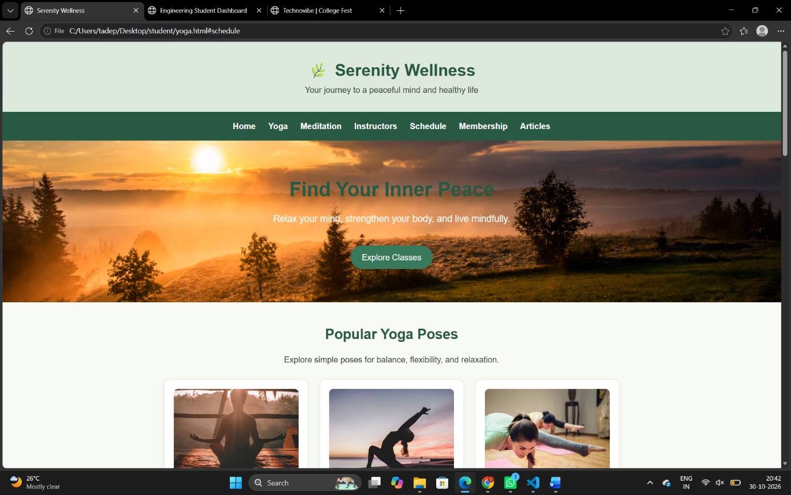

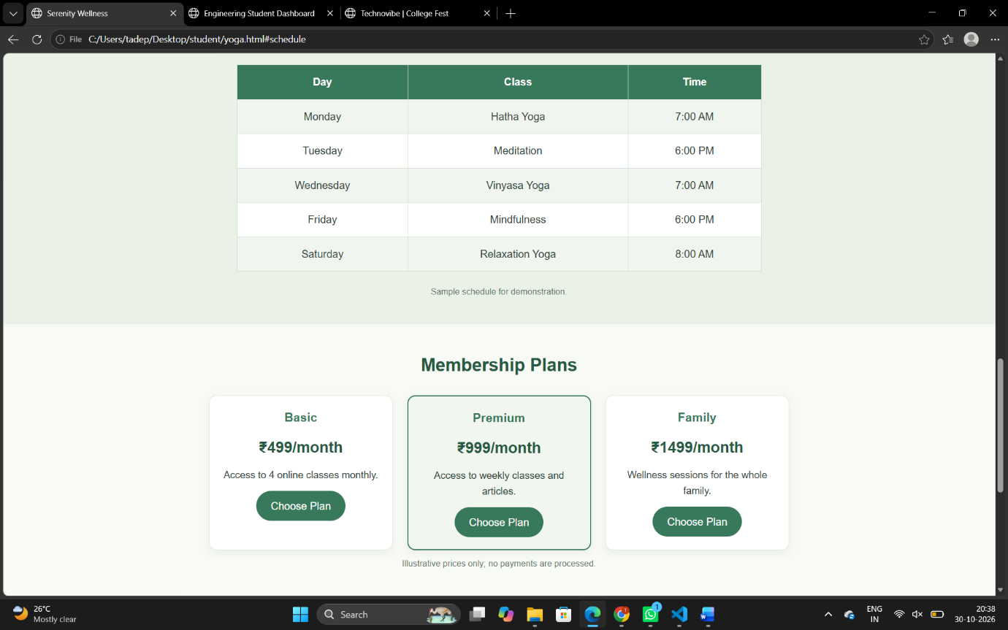

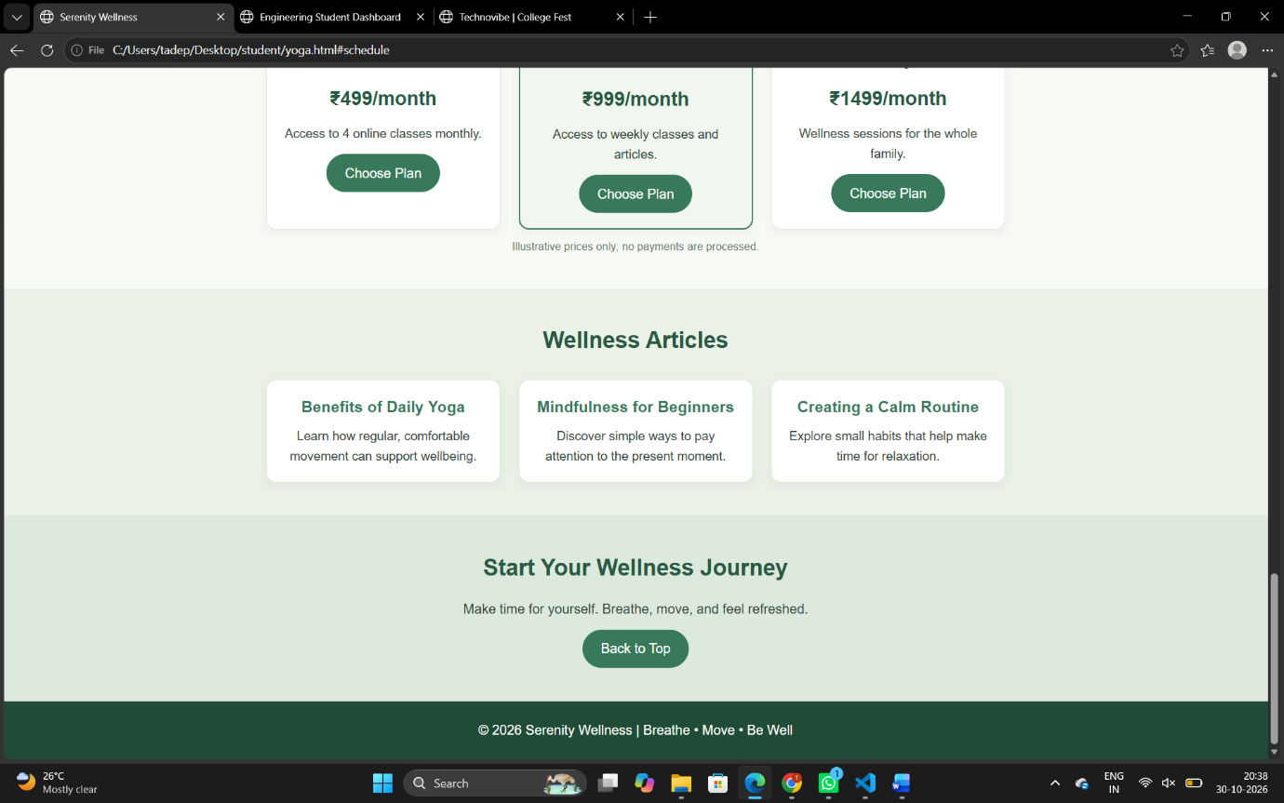

6. Conclusion
The Serenity Wellness – Yoga and Meditation Website was successfully developed using HTML and CSS. This project provides an informative platform to explore yoga, meditation, wellness activities, and membership details.
Through this project, I learned how to create webpage structures using HTML and design attractive layouts using CSS. I also gained practical knowledge of navigation bars, images, cards, tables, buttons, background images, hover effects, and responsive web design.
This project improved my frontend web development skills and helped me understand how to develop a well-organized, attractive, and user-friendly website.

