**DISTANCE READING**

# Sonar

Several methods were considered to give the robot the ability to calculate distance traveled. One approach involves using a sonar range finding device. This device determines distance by timing sound pulses to a receiving unit (which was to be mounted on the robot). This method wasn’t implemented due to the difficulty in interfacing the range finder to the microprocessor.

# Odometry

Odometry is the process of measuring distances by using an odometer. An odometer is a device which calculates wheel revolutions. The measured wheel revolutions are used to calculate the distance traveled. An incremental encoder is often used as a type of odometer on robots. An incremental encoder changes its output from low to high as the wheel (or shaft) spins.

A variety of techniques are used for reading wheel revolutions. Reflective encoders use either an IR or LED to emit light onto a pattern. This pattern is attached to the rotating wheel and consists of light and dark areas. When a light area (white) passes in front of the phototransistor a high signal is registered. These signals are then used to calculate the number of revolutions of the wheel. The figure below shows examples of encoders and reflective photo sensors.

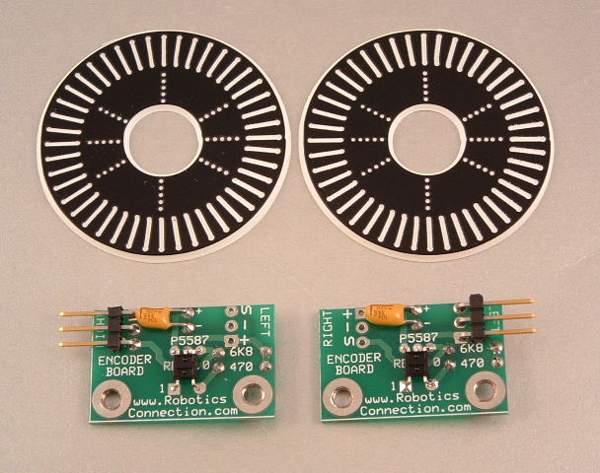

Reflective Photo Sensor

(with supportive circuitry)

Encoder Disk

Fig X from: www.roboticsconnection.com

Beam interruption encoders use a different approach. These encoders are arranged so that an LED shines onto a photodiode or transistor with a short space in between. The encoder wheel has several notches or holes causing an interruption in the beam. These interruptions are counted as the wheel spins. The schematic below displays samples of how

Detector

Emitter

.

FigX Beam interruption encoder

Photointerrupter Disk

FORMULAS FOR CALCULATING DISTANCE

There are several ways to translate the input from the encoder into distance. Here is the method we followed. In this example “tick” refers to a positive signal from the encoder.

1. First take the diameter of the rotating wheel = d
2. Calculate the circumference (C) of the wheel.

C = d * Π

1. Calculate the number of ticks per unit of measure T (mm in this example)

Let t = number of ticks per turn (read off the encoder disk)

T = t / C

Dividing the current ticks by T yields the distance traveled.

Distance Traveled = Current Ticks / T

These formulas are used to determine when the robot has reached a three-meter interval. The following diagram helps explain how calculations will be made.

Y

Y Distance from top interval to where robot stops

Z =Number of ticks when robot stops

X distance from ground to staring point of robot

8N

3N

7N

6N

5N

4N

2N

N

27 M

24 M

18 M

15 M

12 M

9 M

6 M

3 M

Ground

30.48m (100ft)

Fig X Robot travel diagram

N in the diagram above represents the number of ticks to travel three meters. Since all of our measurements are relative to the ground we need to initialize the robots tick counter to X. X is the distance from the ground to the starting point of the robot.

After initialization every multiple of N ticks indicates another three meters has been traveled.

Going down is a little trickier. The robot cannot travel more than 30.48 (100ft) up so it must stop and turn around somewhere between 27 and 30.48 meters. Z represents maximum height the robot reaches. Since we do not know this value ahead of time we use a contact switch to signal when the top has been reached. Taking this value minus 8n(number of ticks at 27meter interval) we get the distance the robot traveled above the top interval (Y).

Y = Z - 8N

After the robot travels Y ticks we know that it is 27 meters above the ground. After that we can continue checking for multiples of N.