**Tutorial-4**

1. **JAVA SCRIPT TO CHECK WHETHER A GIVEN NUMBER IS PRIME OR NOT.**

**Ans.**

      <html>

    <script type = text/javascript>

     var a=prompt("Enter a value : ");

      alert(a);

      var c=0;

for(var i=2;i<a;i++)

         {

     if(a%i==0)

         {

    c=i;

         }

         }

    if(c==0)

   {

   Alert (i+ "  is  Prime Number");

   }

   else

   {

   alert(i+ “ is not Prime Number");

   }

   </script>

  </html>

**Output  1 :**

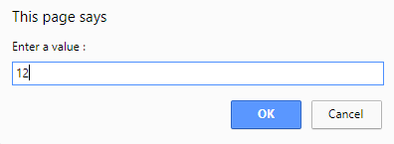

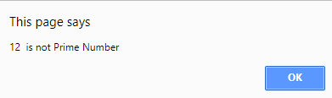

**Output  1 :**

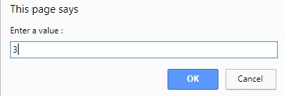

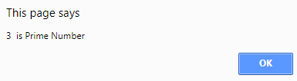

**2. JAVA SCRIPT TO SEARCH AN ELEMENT IN AN ARRAY OF SIZE “N”**

<html>

<head>

<title>Finde_Element</title>

<script type="text/javascript">

<!--

function Finde_Element()

{

var n=parseInt(prompt("Enter the size of an array"));

var a=new Array(n);

var t=0;

for(var i=0; i<a.length; i++)

{

a[i]=parseInt(prompt("Enter array elements"));

}

var k=parseInt(prompt("Enter the key element to search: "));

for(var i=0; i<a.length; i++)

{

if(k==a[i])

{

t=1;

break;

}

}

if(t==1)

{

document.writeln("Element "+a[i]+ " Found at Position:"+i);

}

else

{

document.writeln("Element Not Found");

}

}

</script>

</head>

<body onLoad="Finde_Element()"></body>

</html>

**Output:-**

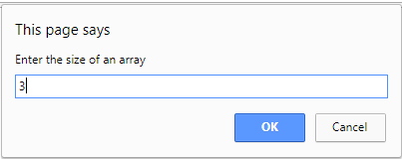

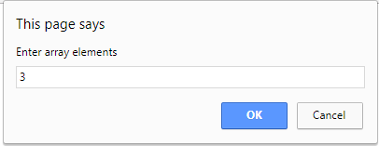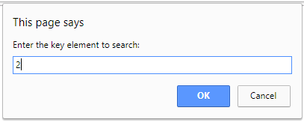

**3. JAVA SCRIPT TO COMPUTE THE GCD OF 2 NUMBERS USING FUNCTION.**

<html>

<head>

 <meta charset="utf-8">

</head>

<body>

<form name="frm" align = "center">

Enter No X:<input type="text" name="n1"><br><br>

Enter No Y:<input type="text" name="n2"><br><br>

<input type="button" value="GCD" onclick="gcd_two_numbers()">

</form>

<p id = "demo" align = "center"></p>

<script>

function gcd_two_numbers()

{

a=parseInt(document.frm.n1.value);

b=parseInt(document.frm.n2.value);

x=a;

y=b;

if ((typeof x !== 'number') || (typeof y !== 'number'))

return false;

x = Math.abs(x);

y = Math.abs(y);

while(y) {

var t = y;

y = x % y;

x = t;

}

document.getElementById("demo").innerHTML = "GCD no is : "+x;

}

</script>

</body>

</html>

**Output :**

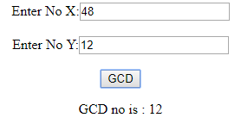

**4. JAVA SCRIPT TO FIND THE SECOND LARGEST NUMBER IN AN ARRAY.**

Code:-

<!DOCTYPE html>

<html>

<head>

<title></title>

<script type="text/javascript">

var n=parseInt(prompt("Enter the size of an array"));

var myArray =new Array(n);

function Show2ndLargeNumber()

{

for(var i=0; i<myArray.length; i++)

{

myArray[i]=parseInt(prompt("Enter array elements"));

}

document.write("List of Array <br><br>");

for(var i=0; i<myArray.length; i++)

{

document.write(myArray[i]+"<br>");

}

document.writeln("<br>SECOND LARGEST NUMBER IN AN ARRAY : "+findSecondLargeNumber(myArray));

}

function findSecondLargeNumber(arr)

{

var fLargeNum = 0;

var sLargeNum = 0;

for(var i=0; i<arr.length; i++)

{

if(fLargeNum < arr[i])

{

sLargeNum = fLargeNum;

fLargeNum = arr[i];

}

else if(sLargeNum < arr[i])

{

sLargeNum = arr[i];

}

}

return sLargeNum;

}

</script>

</head>

<body onload="Show2ndLargeNumber()">

</body>

</html>>  
**Output:-**

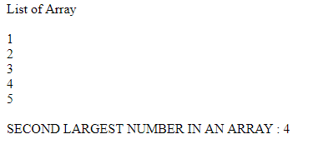

**5. TO CHECK WHETHER THE GIVEN INTEGER IS PALINDROME OR NOT**

Ans.

<!doctype html>

<html>

   <head>

   <script>

   function palin()

   {

   var a,no,b,temp=0;

   no=Number(document.getElementById("no_input").value);

   b=no;

   while(no>0)

   {

   a=no%10;

   no=parseInt(no/10);

   temp=temp*10+a;

   }

   if(temp==b)

   {

   alert(" This is Palindrome number");

   }

   else

   {

   alert(" This is  Not Palindrome number");

   }

   }

   </script><br>

   </head>

   <body>

   Enter any Number: <input id="no_input"><br>

   <button onclick="palin()" align = "center">Check</button></br></br>

   </body>

</html>

**Output  :**

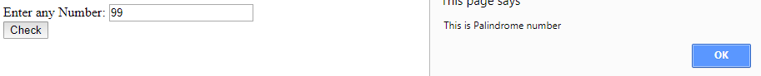

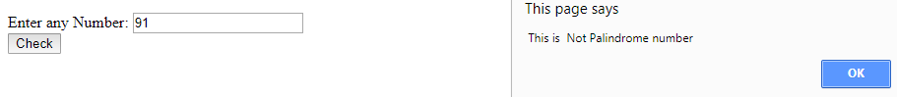

**6. JAVA SCRIPT TO ILLUSTRATE DIFFERENT IN-BUILT STRING FUNCTIONS.**

<html>

<body>

<center>

<div style="font-size:20px; border:solid black; border-width:3px;">

<script type="text/javascript"> ;

str="Hello World";

document.write(str.big()+"<br><hr>");

document.write(str.small()+"<br><hr>");

document.write(str.bold()+"<br><hr>");

document.write(str.italics()+"<br><hr>");

document.write(str.fixed()+"<br><hr>");

document.write(str.strike()+"<br><hr>");

document.write(str.sup()+"<br><hr>");

document.write(str.sub()+"<br><hr>");

document.write(str.blink()+"<br><hr>");

document.write(str.link("p1.html")+"<br><hr>");

document.write(str.fontcolor("green")+"<br><hr>");

document.write(str.fontsize(6)+"<br><hr>");

</script>

</div>

</center>

</body>

</html>

Output:-

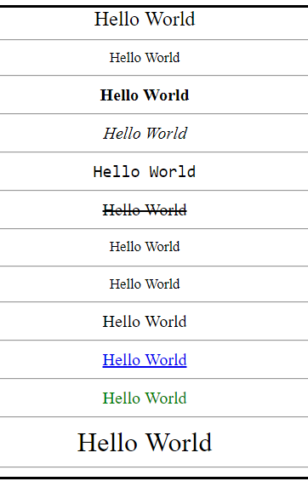

**7. DESIGN USER LOGIN FORM WITH USER NAME AND PASSWORD TO CHECK USER ARE SUCCESSFULLY LOGIN OR NOT?**

<!DOCTYPE html>

<!DOCTYPE html>

<html>

<head>

<script type="text/javascript">

function validate()

{

var username = document.getElementById("username").value;

var password = document.getElementById("password").value;

if ( username == "Hiren" && password == "Hiren@")

{

alert ("Login successfully");

window.location = "P10.html";

return false;

}

else

{

alert("Plese Enter valid Login information");

}

}

</script>

</head>

<body>

<center>

<div style="margin-top: 200px;

border: solid black; border-width: 2px; background-color: yellow;">

<form name="frm" style="font-size: 20px; color: blue;">

<table border="0" style="padding: 50px;">

<tr>

<td><label for="userid">User id:</label></td>

<td><input type="text" name="text1" id="username"></td>

</tr>

<tr>

<td><label for="passid">Password:</label></td>

<td><input type="password" name="p1" id="password"></td>

</tr>

<tr>

<td rowspan="1" colspan="2"><input type="button" name="button1" value="Login" id="submit" onclick="validate()" style="margin-left: 110px;margin-top: 10px; "></td>

</tr>

</table>

</form>

</div>

</center>

</body>

</html>

Output:-

