**Tutorial 5**

1. **Create PHP Program to find odd and even number from given input.**

<!DOCTYPE html>

<html>

<body style="text-align: center; font-size: 2rem; background-color: gray;">

<?php

$a=101;

if(($a % 2) == 0){

echo "You entered an Even number";

}else{

echo "You entered an Odd number";

}

?>

</body>

</html>

**Output:**



1. **Write a PHP Program to find maximum number from three number.**

<!DOCTYPE html>

<html>

<body style="text-align: center; font-size: 2rem; background-color: gray;">

<?php

$a = 15;

$b = 68;

$c = 60;

if($a>$b && $a>$c)

{

echo "a is greater no";

}

elseif($b>$a && $b>$c)

{

echo "B is greater no";

}

else

{

echo "C is graeter no";

}

?>

</body>

</html>

**Output:**



1. **Write a PHP Program to swap two numbers.**

<!DOCTYPE html>

<html>

<body style="text-align: center; font-size: 2rem; background-color: gray;">

<?php

$a = 15;

$b = 27;

echo "The number before swapping is:"."<br>";

echo "Number a =".$a." and b=".$b."<br>" ;

$temp = $a;

$a = $b;

$b = $temp;

echo "The number after swapping is: "."<br>";

echo "Number a =".$a." and b=".$b;

?>

</body>

</html>

**Output:**

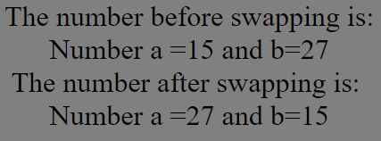

1. **Write a PHP Program to demonstrate the variable function Set type.**

<!DOCTYPE html>

<html>

<head>

<title></title>

</head>

<body style="text-align: center; font-size: 2rem; background-color: gray;">

<?php

$var1='98';

$var2='01';

settype($var1, "integer");

settype($var2, "integer");

echo ($var1.'<br>');

echo ($var2.'<br>');

echo ($var1+$var2.'<br>');

?>

</body>

</html>

**Output:**

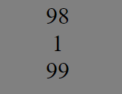

1. **Write a PHP Program to demonstrate the variable function Get type.**

<!DOCTYPE html>

<html>

<body style="text-align: center; font-size: 2rem; background-color: gray;">

<?php

$data = array(1, 1.1, NULL, new stdclass, 'Hello');

foreach ($data as $value) {

echo gettype($value), "<br>";

}

?>

</body>

</html>

**Output:**

