**1. Entered the two numbers and find the range between two numbers?**

Ans:- The Code For The Above Program:**-**

<html>

<body style="background-color:gray;">

<h2> Range Between the number and the sum</h2>

<?php

$a=1;

$b=30;

echo "Enter The First Number:".$a."</br>";

echo "Enter The Second Number:".$b."</br>";

$ans=0;

for($a=1;$a<=30;$a++)

{

$ans=$ans+$a;

}

echo "Answer between the number is:-".$ans;

?>

</body>

</html>

**The OutPut:-**

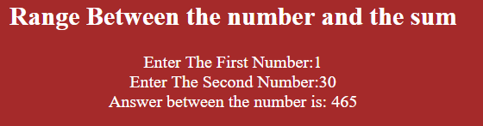

**2. Design a php script to demonstrate all php string function in it?**

Ans:- The Code For The Above Program:-

<html>

<body style="background-color:pink;">

<h2> String Function</h2>

<?php

$str = "Rakesh";

echo "<b>String Length is : </b>". strlen ("Welcome To Info-sis")."<br><br>";

echo "<b>String is : </b>". strstr ("Welcome To Info-sis","Info-sis")."<br><br>";

echo "<b>String Position is : </b>". strpos ("Welcome To Info-sis","Info-sis")."<br><br>";

echo "<b>String change is : </b>". str_replace ("World","RKU ","Hello World ")."<br><br>";

echo "<b>Return part of a string : </b>".substr ("RK University","6")."<br><br>";

echo "<b>Remove character from both side :</b>".trim ($str,"Rity")."<br><br>";

echo "<b>Remove character from right side : </b>". rtrim ($str,"University")."<br><br>";

echo "<b>Remove character from left side : </b>".ltrim ($str,"RK")."<br><br>";

echo "<b>String in Lower case : </b>". strtolower ("Welcome To RKU")."<br><br>";

echo "<b>String in Upper case : </b>". strtoupper ("RK University")."<br><br>";

echo "<b>String all word first character is in Upper case : </b>".ucwords ("rk university");

?>

</body>

</html>

**The Output:-**

