Utuhina Stream Flow
  - Multi-annual variation, high-flow events and habitat-relevant flow metrics at Utuhina at Depot St (EK378429)

Purpose
This page summarises the full continuous discharge record for the Utuhina Stream at Depot St (BOPRC site EK378429) and interrogates it to support interpretation of ~20 years of fish surveys downstream. It covers:
- Data coverage and quality (what can and cannot be trusted).
- Multi-annual variation in flow (water-year totals, seasonality, trends).
- High-flow events: how often they occur (return frequency), when they occur (timing) and how long they last (duration).
- Other flow characteristics relevant to stream-fish habitat: low flows, baseflow dominance, flashiness, rates of rise and fall, and the gaps between disturbance events.
- How flood history in the months before each annual electrofishing survey (ERI/BOPRC alum monitoring) relates to fish and koura CPUE.
- A helper that computes antecedent flow metrics for any survey date, and exported tables for joining to the fish survey data.
The flow is discharge only: habitat availability (wetted width, depth, velocity) depends on channel form and needs hydraulic data or surveyed cross-sections to convert flow into habitat. Everything here describes the flow regime that drives that habitat.

Data and quality
Table 1: Summary of the Utuhina discharge record.
Item | Value
Site | Utuhina at Depot St (EK378429), BOPRC
Records | 1,521,395
Start | 2005-09-18
End | 2026-01-14
Median flow (m³/s) | 1.60
Mean flow (m³/s) | 1.81
Max instantaneous (m³/s) | 30.8
Min instantaneous (m³/s) | 0.99

Table 2: Most common intervals between records.
Interval between records (min) | Records
5 | 1,213,215
15 | 307,988
1 | 106
30 | 37

Records are mostly 5-minute (15-minute in the early record). Short gaps are handled by working with daily means for any day with at least 20 hours of data, and with the instantaneous series for peaks and event durations.
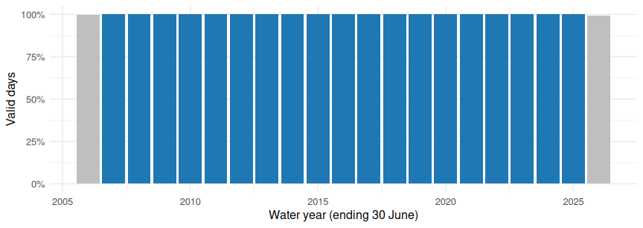
Figure 1: Fraction of days with valid daily-mean flow in each water year. Hatched/pale bars are excluded from annual statistics.
Table 3: Records by approval level.
Approval level | Records | First | Last
Approved | 1,509,023 | 2005-09-18 | 2025-12-02
Raw - yet to review | 12,372 | 2025-12-02 | 2026-01-14

Table 4: Records by grade code.
Grade code | Records | %
-1 | 1 | 0.0
0 | 12,371 | 0.8
200 | 336,253 | 22.1
300 | 365 | 0.0
400 | 139,114 | 9.1
500 | 556,877 | 36.6
600 | 476,414 | 31.3

 Caveats on the data
- The series is a derived discharge (stage-to-flow via a rating), so peak flows are the least certain values: rating extrapolation above the highest gauging inflates uncertainty in the largest events. Treat return-period estimates for the largest events as approximate.
- The final records (see approval table) are still “Raw - yet to review” and may change on approval.
- Water years 2006 and 2026 are partial or incomplete and are excluded from annual statistics. All event analyses use every available record.
- Times are NZST (UTC+12) year-round; the export has no daylight-saving shift.

Overall flow regime
Table 5: Instantaneous-flow percentiles (all records).
Percentile | Flow (m³/s)
1% | 1.09
5% | 1.17
10% | 1.23
25% | 1.39
50% | 1.60
75% | 1.94
90% | 2.43
95% | 2.95
99% | 5.60
99.9% | 14.00

The median daily flow is 1.62 m³/s and the mean is 1.81 m³/s. Mean being well above the median reflects a strongly right-skewed regime: a steady baseflow punctuated by storm peaks.
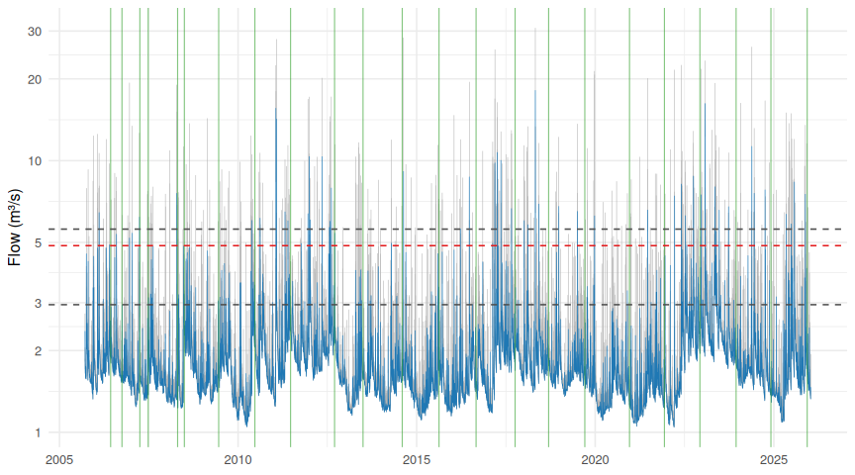
Figure 2: Daily mean flow (line) and daily maximum (grey) for the full record, log scale. Dashed lines: 3 × median, 95th and 99th percentile. Green vertical lines are electrofishing survey dates.
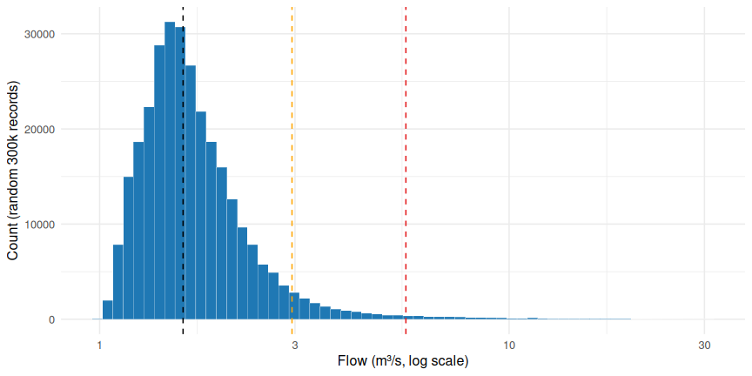
Figure 3: Distribution of instantaneous flow (log x-axis) with median, 95th and 99th percentiles.

Flow duration curve
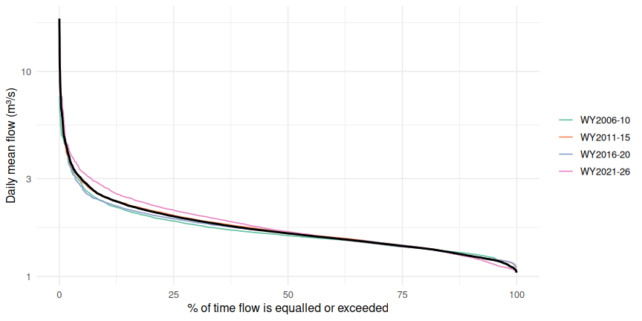
Figure 4: Flow duration curves for daily mean flow, overall and for each 5-year block.

Multi-annual variation

Annual statistics by water year
Table 6: Annual flow statistics (m³/s) for complete water years. BFI = baseflow index; R-B = Richards-Baker flashiness index.
Water year | Mean | Median | Q5 | Q95 | 7-day min | Max daily | Max inst. | CV | BFI | R-B index
2007 | 1.68 | 1.57 | 1.31 | 2.35 | 1.26 | 6.19 | 19.36 | 0.32 | 0.87 | 0.114
2008 | 1.66 | 1.50 | 1.25 | 2.67 | 1.24 | 7.58 | 19.02 | 0.36 | 0.83 | 0.123
2009 | 1.78 | 1.57 | 1.31 | 2.87 | 1.29 | 4.79 | 14.33 | 0.31 | 0.84 | 0.111
2010 | 1.69 | 1.50 | 1.11 | 3.01 | 1.07 | 6.03 | 12.37 | 0.38 | 0.82 | 0.128
2011 | 2.10 | 1.82 | 1.38 | 3.32 | 1.26 | 15.58 | 28.02 | 0.59 | 0.77 | 0.180
2012 | 2.13 | 1.92 | 1.65 | 3.19 | 1.63 | 10.35 | 20.16 | 0.40 | 0.83 | 0.125
2013 | 1.81 | 1.59 | 1.20 | 2.93 | 1.18 | 7.92 | 17.20 | 0.42 | 0.84 | 0.127
2014 | 1.58 | 1.47 | 1.21 | 2.27 | 1.20 | 4.97 | 11.95 | 0.29 | 0.86 | 0.109
2015 | 1.52 | 1.44 | 1.16 | 2.08 | 1.13 | 9.12 | 28.37 | 0.34 | 0.88 | 0.117
2016 | 1.59 | 1.42 | 1.21 | 2.40 | 1.19 | 8.70 | 19.49 | 0.40 | 0.82 | 0.158
2017 | 1.96 | 1.74 | 1.22 | 3.23 | 1.19 | 10.72 | 25.65 | 0.54 | 0.77 | 0.165
2018 | 2.10 | 1.91 | 1.48 | 3.23 | 1.42 | 18.12 | 30.82 | 0.52 | 0.79 | 0.164
2019 | 1.72 | 1.64 | 1.42 | 2.26 | 1.39 | 6.79 | 12.23 | 0.24 | 0.89 | 0.090
2020 | 1.55 | 1.45 | 1.17 | 2.21 | 1.12 | 6.50 | 21.38 | 0.35 | 0.86 | 0.117
2021 | 1.46 | 1.37 | 1.10 | 2.14 | 1.08 | 6.58 | 20.10 | 0.32 | 0.86 | 0.116
2022 | 1.60 | 1.43 | 1.11 | 2.57 | 1.06 | 8.19 | 22.50 | 0.44 | 0.81 | 0.158
2023 | 2.73 | 2.43 | 1.89 | 4.38 | 1.78 | 16.23 | 23.35 | 0.46 | 0.75 | 0.158
2024 | 1.99 | 1.84 | 1.50 | 2.77 | 1.47 | 11.28 | 26.25 | 0.38 | 0.86 | 0.127
2025 | 1.65 | 1.49 | 1.13 | 2.52 | 1.09 | 7.80 | 16.65 | 0.39 | 0.83 | 0.145

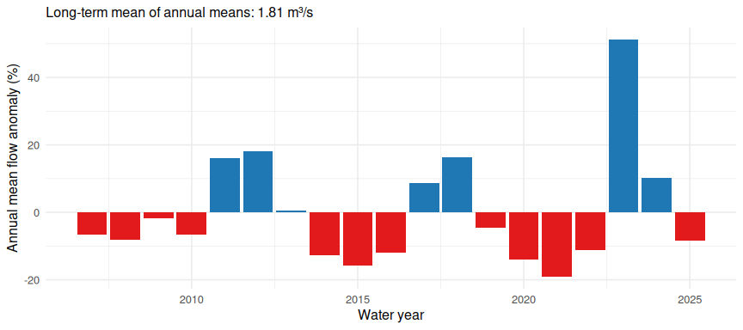
Figure 5: Annual mean flow relative to the long-term mean of complete water years. Blue = wetter than average, red = drier.
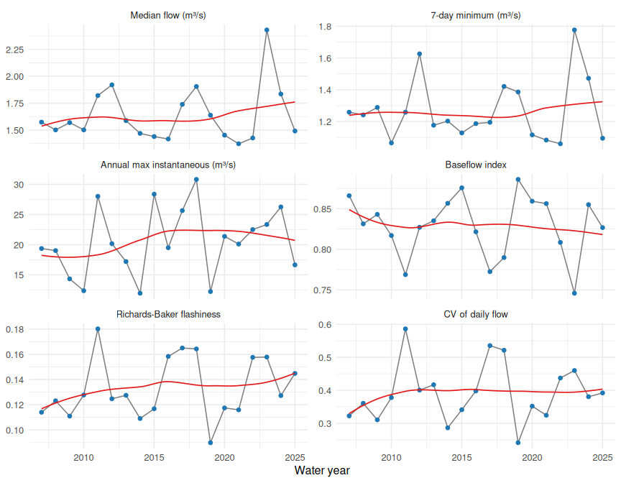
Figure 6: Annual metrics by water year with a LOESS smoother.

Trends
Non-parametric Mann-Kendall tests (via Kendall’s tau) with Theil-Sen slopes. With only ~19 annual values, power is limited and serial correlation is not accounted for; treat as indicative.
Table 7: Mann-Kendall trend tests (Kendall tau) with Theil-Sen slopes for annual flow metrics.
Metric | Sen slope (per yr) | tau | p-value
Annual mean flow (m³/s) | -0.0017 | -0.018 | 0.945
Annual median flow (m³/s) | -0.0025 | -0.053 | 0.783
Q5 (low flow, m³/s) | -0.0046 | -0.064 | 0.730
7-day minimum (m³/s) | -0.0068 | -0.111 | 0.534
Q95 (high flow, m³/s) | -0.0090 | -0.053 | 0.783
Annual max instantaneous (m³/s) | 0.2493 | 0.193 | 0.267
Baseflow index | -0.0007 | -0.088 | 0.629
Richards-Baker flashiness | 0.0009 | 0.135 | 0.447

Seasonality
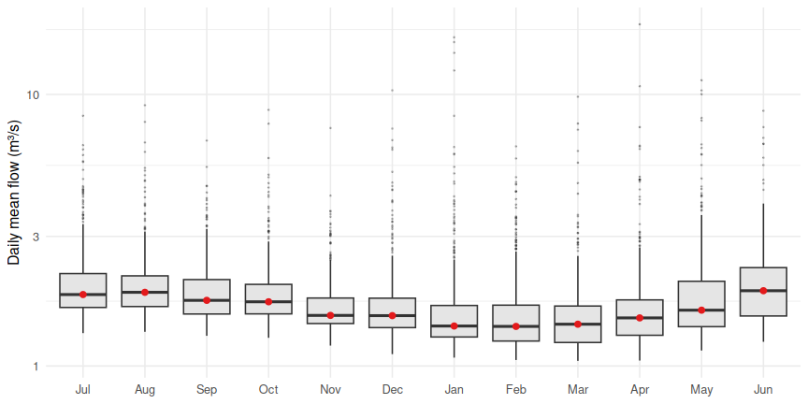
Figure 7: Distribution of daily mean flow by month (water-year order, log scale).
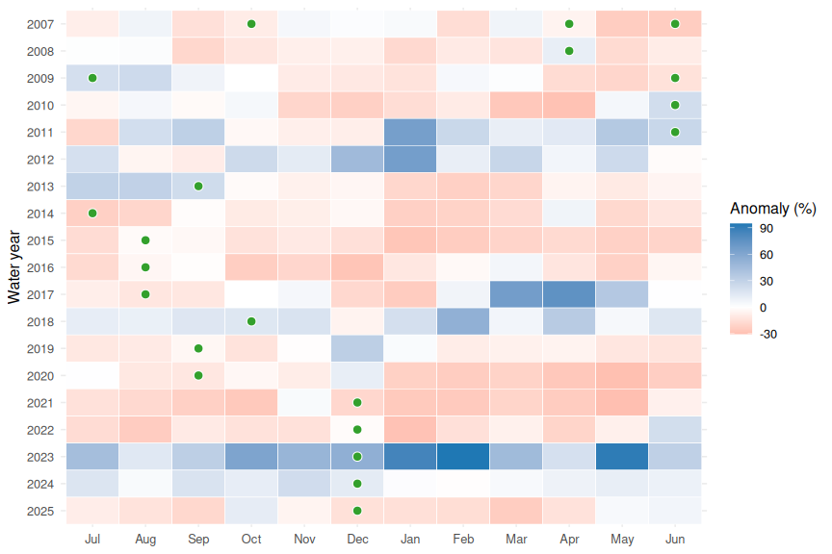
Figure 8: Monthly mean flow expressed as a percentage anomaly from that calendar month’s long-term mean. Rows are water years; green dots mark the month of each electrofishing survey.
Table 8: Water years classed as dry, average or wet by terciles of annual mean flow.
Class | Water years | Mean annual flow range (m³/s)
Dry | 2014, 2015, 2016, 2020, 2021, 2022, 2025 | 1.46-1.65
Average | 2007, 2008, 2009, 2010, 2019 | 1.66-1.78
Wet | 2011, 2012, 2013, 2017, 2018, 2023, 2024 | 1.81-2.73

High-flow events

Event definition
An event is a period when instantaneous flow exceeds a threshold. Two excursions separated by less than 48 hours below the threshold are merged into one event so that a multi-peaked storm is counted once. For each event we record the peak, its timing, the duration (first to last exceedance), the hours actually above the threshold, the volume above the threshold, the time to peak and the rate of rise.
Thresholds examined (all in m³/s):
Table 9: Flow thresholds used to define high-flow events.
Threshold | Flow (m³/s)
Q95 | 2.95
3 × median (FRE3) | 4.87
Q99 | 5.60
Mean annual flood | 20.49

Table 10: Summary of high-flow events at each threshold (all records).
Threshold | Events | Events per year | Median duration (h) | Max duration (h) | Median hrs above | Median time to peak (h) | Largest peak (m³/s) | % time exceeded
Q95 | 568 | 27.9 | 8 | 577 | 6 | 2 | 30.82 | 5.00
3 × median (FRE3) | 281 | 13.8 | 5 | 80 | 5 | 2 | 30.82 | 1.33
Q99 | 241 | 11.9 | 5 | 78 | 4 | 2 | 30.82 | 1.00
Mean annual flood | 11 | 0.5 | 4 | 13 | 4 | 1 | 30.82 | 0.03

The 3 × median threshold (4.9 m³/s) is used as the primary definition of a “high-flow event” below. It follows the common NZ ecological convention (FRE3) of a flow large enough to mobilise fine sediment and periphyton and to reset in-stream communities, and it is high enough in this stream to be a clearly storm-driven signal rather than noise on baseflow. The other thresholds are shown alongside for sensitivity.

Return frequency

Partial-duration view: how often is each threshold exceeded?
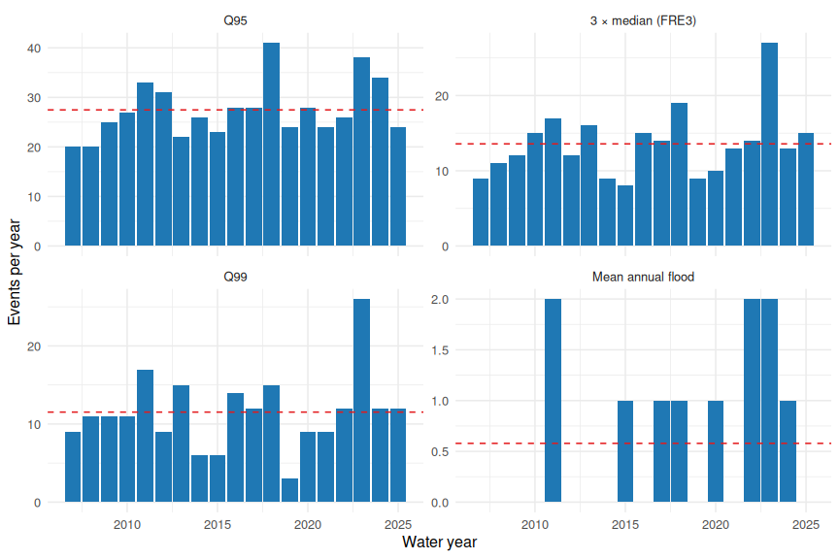
Figure 9: Number of events per water year at each threshold. Dashed line = mean of complete years.
Table 11: Time between successive event peaks (includes any data-gap periods).
Threshold | Mean interval (d) | Median interval (d) | 90th pct interval (d) | Longest interval (d)
Q95 | 13.1 | 9.6 | 26.0 | 129.2
3 × median (FRE3) | 26.4 | 18.1 | 63.5 | 129.2
Q99 | 30.8 | 19.4 | 74.4 | 191.6
Mean annual flood | 486.7 | 445.9 | 971.7 | 1299.2

Annual-maximum view: return periods of the largest floods
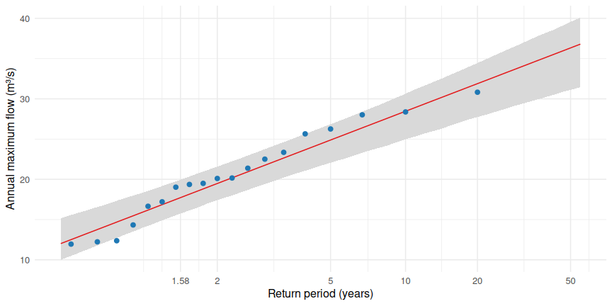
Figure 10: Annual maximum instantaneous flow plotted against Gumbel reduced variate, with the L-moment Gumbel fit and 90% bootstrap interval.
Table 12: Gumbel return-period flows from the annual maximum series of complete water years.
Return period (yr) | AEP (%) | Peak flow (m³/s) | Lower 90% CI | Upper 90% CI
1.58 | 63.3 | 17.7 | 15.8 | 20.0
2.00 | 50.0 | 19.5 | 17.4 | 21.6
5.00 | 20.0 | 24.9 | 22.1 | 26.9
10.00 | 10.0 | 28.5 | 25.0 | 30.8
20.00 | 5.0 | 31.9 | 27.7 | 34.5
50.00 | 2.0 | 36.3 | 30.9 | 39.4

The record contains 19 annual maxima, so the 2–10 year flows are reasonably constrained whereas 20 and 50 year values are extrapolations with wide intervals. The estimated mean annual flood is 20.5 m³/s.

The biggest events on record
Table 13: The twelve largest events on record (3 × median threshold).
Peak time (NZST) | Peak (m³/s) | Duration (h) | Hours above | Time to peak (h) | Volume above thr (10³ m³)
2018-04-29 11:25 | 30.8 | 30 | 30 | 3.6 | 1344
2014-08-20 10:40 | 28.4 | 13 | 13 | 5.1 | 442
2011-01-29 05:00 | 28.0 | 28 | 28 | 5.8 | 813
2024-05-21 13:50 | 26.3 | 20 | 19 | 10.1 | 580
2017-03-12 18:25 | 25.6 | 58 | 39 | 43.3 | 790
2023-01-28 11:40 | 23.4 | 64 | 63 | 14.2 | 1679
2022-05-30 17:55 | 22.5 | 40 | 21 | 3.9 | 478
2011-01-23 20:00 | 22.5 | 42 | 42 | 18.2 | 1240
2022-12-20 14:30 | 21.8 | 10 | 10 | 1.6 | 339
2022-03-23 05:30 | 21.6 | 53 | 19 | 41.2 | 306
2019-12-25 22:30 | 21.4 | 13 | 13 | 3.1 | 380
2012-05-09 09:00 | 20.2 | 24 | 23 | 8.2 | 477

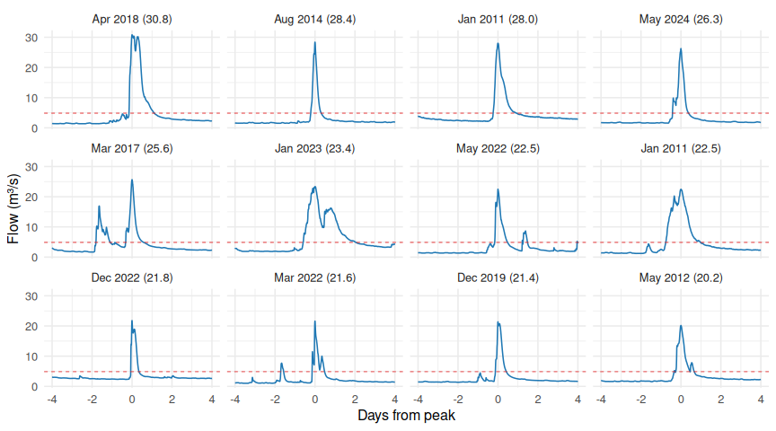
Figure 11: Hydrographs of the twelve largest events (peak-aligned, ±4 days).

Timing
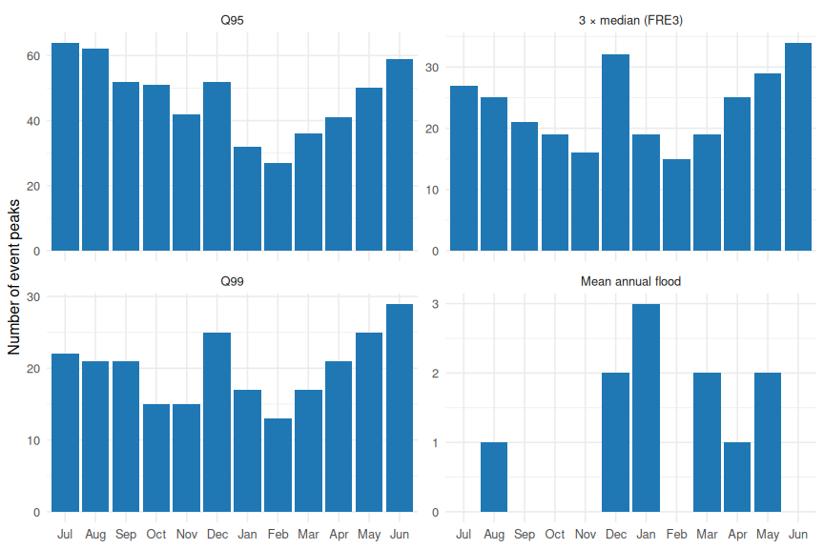
Figure 12: Number of event peaks by month (water-year order) at each threshold.
Table 14: Circular mean date of event peaks, concentration R (0 = uniform through the year, 1 = all on the same date) and counts by season.
Threshold | Mean date of peak | Concentration (R) | Spring (SON) | Summer (DJF) | Autumn (MAM) | Winter (JJA)
Q95 | 04 Aug | 0.15 | 145 | 111 | 127 | 185
3 × median (FRE3) | 17 Jun | 0.11 | 56 | 66 | 73 | 86
Q99 | 20 Jun | 0.11 | 51 | 55 | 63 | 72
Mean annual flood | 02 Mar | 0.45 | 0 | 5 | 5 | 1

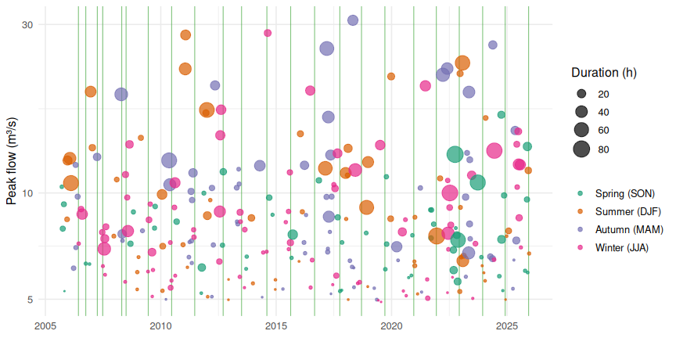
Figure 13: Timeline of 3 × median events. Point size = duration; colour = season of peak. Vertical position is the peak flow. Green vertical lines are electrofishing survey dates.

Duration and shape
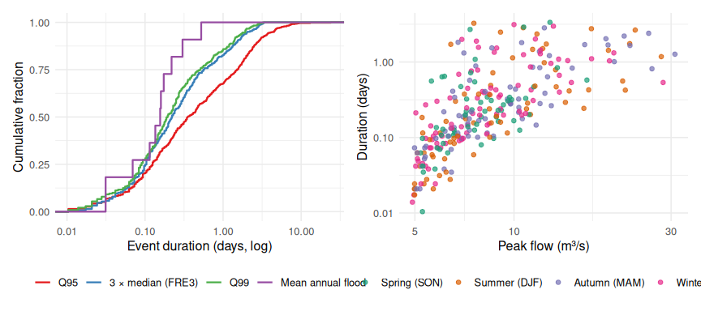
Figure 14: Event duration (left, ECDF at each threshold) and duration vs peak flow for 3 × median events (right).
Table 15: Characteristics of 3 × median events. Duration is in hours.
Statistic | Duration | Hours above threshold | Time to peak (h) | Rate of rise (m³/s/h)
10th pct | 1.17 | 0.92 | 0.25 | 0.30
Median | 5.33 | 4.75 | 1.58 | 1.37
90th pct | 36.75 | 21.25 | 13.83 | 4.95
Max | 80.33 | 63.42 | 62.42 | 15.25

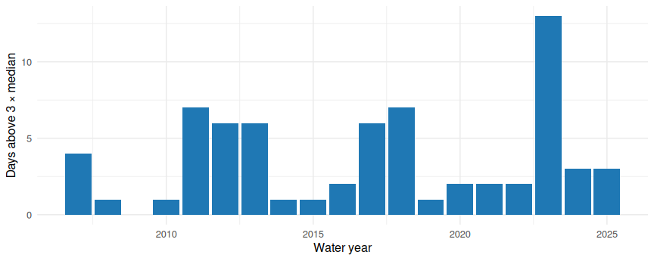
Figure 15: Days per water year with daily mean flow above 3 × median (a measure of how much of the year is spent in a disturbed state) and total event count.

Other characteristics relevant to fish habitat

Low flows and flow stability
Flows exceeded 90% and 95% of the time are 1.26 and 1.20 m³/s (daily means). The Utuhina’s low-flow range is narrow compared with its high-flow range: the 7-day minimum varies by only 1.06-1.78 m³/s across years, which is what you would expect from a groundwater-dominated stream, and is reflected in a mean baseflow index of 0.83.
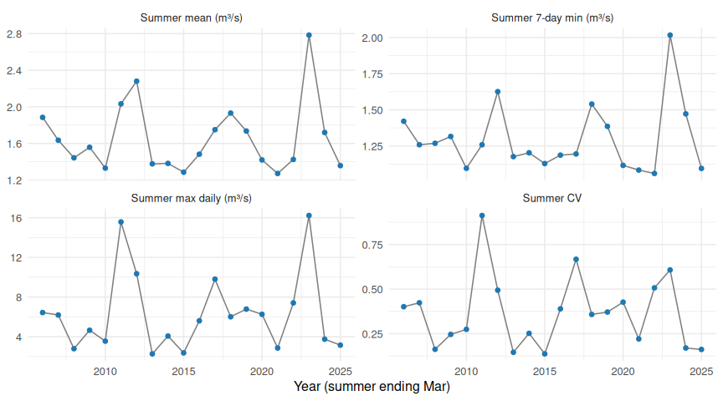
Figure 16: Summer (Dec-Mar) mean flow, 7-day minimum and variability by year (summers labelled by the year of Jan-Mar).

Gaps between disturbances
For fish, the time between flood pulses matters as much as their size: long quiet spells allow recolonisation and recruitment and favour growth of periphyton and macrophytes; frequent events reset them.
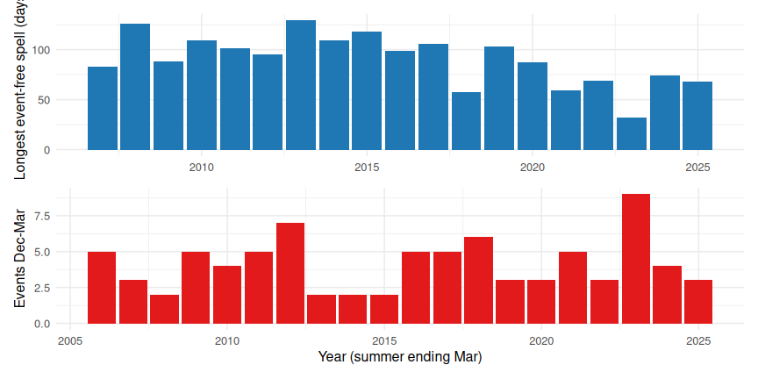
Figure 17: Per water year: longest interval without a 3 × median event (top) and number of events in Dec-Mar (bottom).

Rates of change (stranding, displacement, hydraulic stability)
Table 16: Day-over-day and sub-daily rates of change on the rising and falling limbs of events.
Metric | Value
Median day-over-day increase on the first day above 3×median (%) | 210.19
Median day-over-day decline during recession from above 3×median (%) | 45.50
Recession constant (median daily flow ratio, falling days) | 0.55
Median time-to-peak of 3×median events (h, 5-min data) | 1.58
Median rate of rise above threshold (m³/s per h, 5-min data) | 1.37

Daily means smooth over sub-daily dynamics; the 5-minute data give a faster view of how abruptly flows rise, which is the relevant timescale for displacement of small or juvenile fish. The time-to-peak and rate-of-rise values above come from the instantaneous series.

Antecedent flow for fish survey dates
Whether a survey followed a recent flood can affect abundance and size structure as much as the average flow regime. The function below returns, for any vector of survey dates, the flow on the day, maxima and means over preceding windows, the number of 3 × median events and the days since the last event and last Q99 event.
The table below applies it to the actual electrofishing survey dates.
Table 17: Antecedent flow metrics for each electrofishing survey date.
date | flow_on_day | mean_30d | max_7d | max_30d | max_90d | min7_90d | events_90d | events_365d | days_since_event | days_since_q99_event
2006-06-08 | 1.88 | 2.11 | 2.57 | 4.90 | 4.90 | 1.53 | 4 | 12 | 12 | 12
2006-10-02 | 1.85 | 1.64 | 1.69 | 1.85 | 5.36 | 1.57 | 2 | 14 | 57 | 57
2007-04-03 | 1.65 | 1.73 | 6.19 | 6.19 | 6.19 | 1.26 | 2 | 11 | 4 | 4
2007-06-27 | 1.37 | 1.48 | 2.63 | 2.63 | 6.19 | 1.33 | 2 | 8 | 6 | 6
2008-04-23 | 1.28 | 1.78 | 4.85 | 7.58 | 7.58 | 1.27 | 2 | 9 | 8 | 8
2008-07-01 | 2.27 | 1.85 | 3.23 | 4.85 | 7.58 | 1.24 | 5 | 11 | 9 | 9
2009-06-17 | 1.64 | 1.63 | 3.04 | 3.04 | 3.04 | 1.29 | 1 | 13 | 4 | 4
2010-06-22 | 2.16 | 2.77 | 3.49 | 6.03 | 6.03 | 1.07 | 6 | 16 | 2 | 2
2011-06-22 | 2.35 | 2.77 | 3.18 | 6.00 | 6.48 | 1.56 | 8 | 17 | 12 | 12
2012-09-14 | 2.13 | 2.33 | 2.45 | 3.47 | 7.92 | 1.83 | 5 | 17 | 11 | 11
2013-07-02 | 1.57 | 1.94 | 1.71 | 3.96 | 3.96 | 1.28 | 8 | 16 | 16 | 16
2014-08-07 | 1.57 | 1.69 | 2.47 | 2.52 | 3.17 | 1.41 | 3 | 10 | 4 | 4
2015-08-18 | 1.87 | 1.88 | 3.42 | 4.54 | 4.54 | 1.36 | 5 | 11 | 3 | 3
2016-08-31 | 1.47 | 1.78 | 2.43 | 2.43 | 8.70 | 1.38 | 3 | 12 | 38 | 38
2017-10-04 | 1.69 | 2.11 | 2.06 | 2.73 | 6.66 | 1.75 | 4 | 18 | 32 | 32
2018-09-12 | 1.81 | 1.91 | 2.11 | 2.89 | 2.89 | 1.61 | 2 | 16 | 29 | 99
2019-09-17 | 1.56 | 1.74 | 1.81 | 2.21 | 6.50 | 1.53 | 2 | 9 | 60 | 75
2020-12-17 | 1.26 | 1.53 | 1.75 | 3.32 | 3.32 | 1.30 | 3 | 10 | 22 | 22
2021-12-09 | 1.29 | 1.40 | 1.85 | 1.85 | 3.95 | 1.27 | 3 | 13 | 41 | 41
2022-12-07 | 1.95 | 2.50 | 2.56 | 3.73 | 8.77 | 1.92 | 6 | 19 | 19 | 19
2023-12-12 | 1.85 | 2.05 | 2.30 | 3.06 | 6.76 | 1.75 | 3 | 21 | 8 | 8
2024-12-02 | 1.42 | 1.56 | 1.45 | 3.62 | 7.80 | 1.35 | 4 | 14 | 17 | 17
2025-12-08 | 1.70 | 2.27 | 4.01 | 7.52 | 7.52 | 1.43 | 5 | 19 | 5 | 5

Flood effects on fish habitat and survey CPUE
This section uses the annual Utuhina electrofishing surveys (see the survey description below). A single large flood is unlikely to matter to the fish community for only the following week. A very large flood can displace or kill fish directly, scour the bed, and strip or undercut bank vegetation and woody cover, and recovery of that habitat (and of slow-growing or slow-recolonising species) can take months to years. So rather than looking at flow at the time of fishing, this section asks: what was the largest flood in the six months before each survey, how big was it relative to the flood record, and how long ago was the last really big one? Longer windows (12 and 24 months) are included as a proxy for habitat that takes longer to rebuild, such as bank vegetation.

Flood classes
Three event classes are used (all from the instantaneous series, with the same 48 h event-merging rule as above):
Table 18: Flood classes used in the fish survey analysis.
Class | Definition | Threshold (m³/s) | Events in record | Events per year
Moderate | Peak above 3 × median (a routine fresh) | 4.9 | 281 | 13.83
Large | Peak above the 1-in-1.6-year flood (about the median annual maximum) | 17.7 | 17 | 0.84
Major | Peak above the 1-in-5-year flood | 24.9 | 5 | 0.25

Flood history before each electrofishing survey
For each survey the table gives the number of floods of each class in the previous six months, the largest instantaneous peak in the previous 6 / 12 / 24 months (with the Gumbel return period of the six-month maximum) and the time since the last Large and Major flood at any time before the survey.
Table 19: Flood history before each electrofishing survey. Peaks in m³/s; counts are events in the six months before the survey; coverage = % of those days with valid flow data.
Survey | Coverage (%) | Moderate | Large | Major | Class (6 mo) | Max peak 6 mo | Return period (yr) | Peak date | Days peak to survey | Max peak 12 mo | Max peak 24 mo | Days since Large | Days since Major
2006-06-08 | 100 | 8 | 0 | 0 | Moderate | 12.5 | 1.1 | 2006-01-24 | 135 | 12.5 | 12.5 | NA | NA
2006-10-02 | 100 | 6 | 0 | 0 | Moderate | 12.0 | 1.0 | 2006-04-25 | 160 | 12.5 | 12.5 | NA | NA
2007-04-03 | 100 | 5 | 1 | 0 | Large | 19.4 | 2.0 | 2006-12-18 | 106 | 19.4 | 19.4 | 106 | NA
2007-06-27 | 100 | 3 | 0 | 0 | Moderate | 13.4 | 1.1 | 2007-01-14 | 164 | 19.4 | 19.4 | 191 | NA
2008-04-23 | 100 | 3 | 1 | 0 | Large | 19.0 | 1.9 | 2008-04-15 | 8 | 19.0 | 19.4 | 8 | NA
2008-07-01 | 100 | 6 | 1 | 0 | Large | 19.0 | 1.9 | 2008-04-15 | 77 | 19.0 | 19.4 | 77 | NA
2009-06-17 | 100 | 6 | 0 | 0 | Moderate | 14.3 | 1.1 | 2009-02-20 | 117 | 14.3 | 19.0 | 428 | NA
2010-06-22 | 100 | 9 | 0 | 0 | Moderate | 12.4 | 1.0 | 2010-05-13 | 40 | 12.4 | 14.3 | 798 | NA
2011-06-22 | 100 | 12 | 2 | 1 | Major | 28.0 | 9.2 | 2011-01-29 | 144 | 28.0 | 28.0 | 144 | 144
2012-09-14 | 100 | 9 | 1 | 0 | Large | 20.2 | 2.2 | 2012-05-09 | 128 | 20.2 | 28.0 | 128 | 594
2013-07-02 | 100 | 8 | 0 | 0 | Moderate | 11.7 | 1.0 | 2013-05-18 | 45 | 17.2 | 20.2 | 419 | 885
2014-08-07 | 100 | 4 | 0 | 0 | Moderate | 11.9 | 1.0 | 2014-04-17 | 112 | 11.9 | 17.2 | 820 | 1286
2015-08-18 | 100 | 6 | 0 | 0 | Moderate | 11.4 | 1.0 | 2015-08-06 | 12 | 28.4 | 28.4 | 363 | 363
2016-08-31 | 100 | 7 | 1 | 0 | Large | 19.5 | 2.0 | 2016-06-23 | 69 | 19.5 | 19.5 | 69 | 742
2017-10-04 | 100 | 12 | 0 | 0 | Moderate | 16.4 | 1.4 | 2017-04-05 | 182 | 25.6 | 25.6 | 206 | 206
2018-09-12 | 100 | 7 | 1 | 1 | Major | 30.8 | 16.1 | 2018-04-29 | 136 | 30.8 | 30.8 | 136 | 136
2019-09-17 | 100 | 5 | 0 | 0 | Moderate | 13.7 | 1.1 | 2019-07-04 | 75 | 13.7 | 30.8 | 506 | 506
2020-12-17 | 100 | 7 | 0 | 0 | Moderate | 8.4 | 1.0 | 2020-08-07 | 132 | 21.4 | 21.4 | 358 | 963
2021-12-09 | 100 | 7 | 1 | 0 | Large | 20.1 | 2.2 | 2021-06-19 | 173 | 20.1 | 21.4 | 173 | 1320
2022-12-07 | 100 | 14 | 0 | 0 | Moderate | 12.9 | 1.1 | 2022-10-02 | 66 | 22.5 | 22.5 | 191 | 1683
2023-12-12 | 100 | 6 | 0 | 0 | Moderate | 11.2 | 1.0 | 2023-06-22 | 173 | 23.4 | 23.4 | 217 | 2053
2024-12-02 | 100 | 7 | 0 | 0 | Moderate | 16.6 | 1.4 | 2024-10-03 | 60 | 26.3 | 26.3 | 195 | 195
2025-12-08 | 100 | 11 | 0 | 0 | Moderate | 14.9 | 1.2 | 2025-06-27 | 164 | 15.0 | 26.3 | 566 | 566

Table 20: Number of surveys by the largest flood class in the preceding six months.
Largest flood class in prior 6 months | N
Moderate | 15
Large | 6
Major | 2

Flood history and survey timing
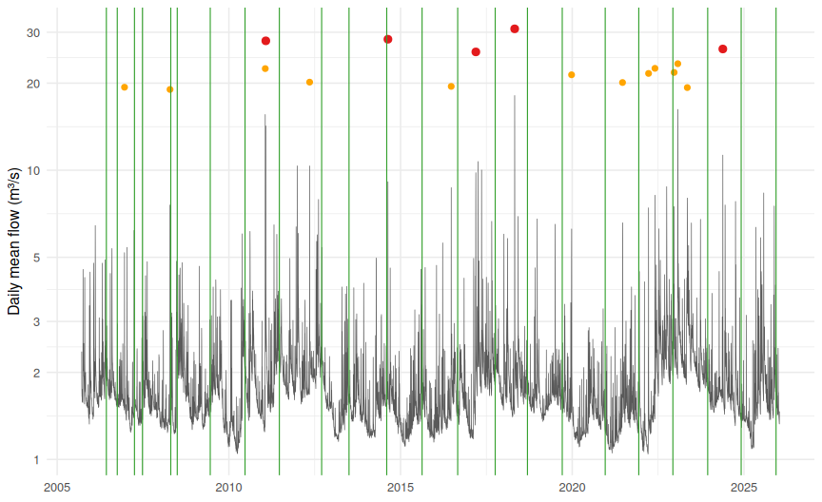
Figure 18: Daily mean flow with electrofishing surveys (green lines) and their six-month lookback windows (green bands). Points are flood peaks: Large (1-in-1.6-year or greater, orange) and Major (1-in-5-year or greater, red).
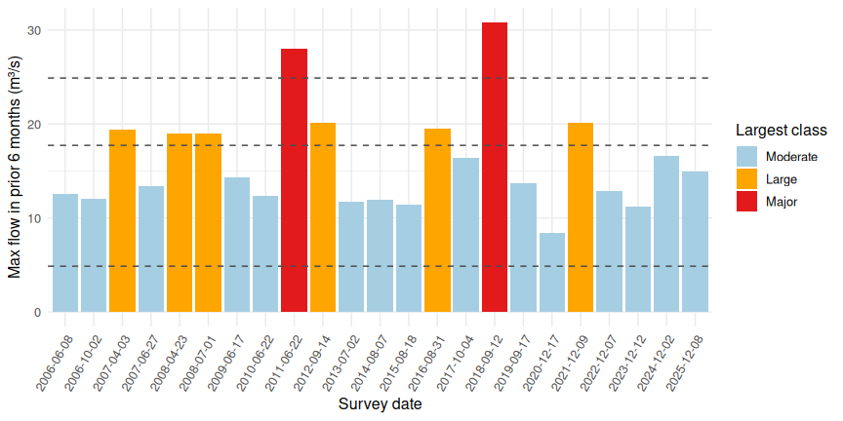
Figure 19: Largest instantaneous flow in the six months before each survey. Dashed lines are the Moderate, Large and Major thresholds.

The electrofishing surveys
The surveys are described in the University of Waikato (ERI) annual monitoring report for the 2025 survey (ERI Report No. 182, prepared for BOPRC). The points that matter for interpreting them against flow are:
- Purpose and frequency. One survey per year since June 2006, carried out as a consent requirement for in-stream alum dosing. Alum dosing began (trial) in mid-2006, was largely shut down 1 July to 10 December 2012, and was reduced in 2021; the report concludes it has no notable effect on fish or koura (kura) and attributes between-year differences mainly to hydrology and habitat.
- Sites. Three 50 m reaches: Site 1 (control, 50-100 m upstream of the alum diffuser), Site 2 (50-100 m downstream) and Site 3 (a further ~400 m downstream, near Lake Road).
- Method and metric. Bank-mounted pulsed-DC electrofishing, two passes, two teams. CPUE is fish (or koura) caught per hour of fishing. Absolute density cannot be estimated from the two passes, so CPUE and minimum numbers are used.
- Species. Common bully make up about 97% of the catch. “Trout” in the data are juvenile (young-of-the-year) trout; adult trout and eels are rare and not in the spreadsheet.
- Habitat. The stream is highly channelised through Rotorua city with little in-stream or bankside cover and eroding banks. Sites 2 and 3 are mobile pumice sand and gravel. Bully and koura prefer low velocities and stable substrate, so the report’s explanation for large year-to-year swings is that major floods disturb the bed and banks and displace animals, which is the mechanism tested here.
- Sites differ systematically. Long-term mean bully CPUE is lowest at Site 1 (102 fish per hour) and highest at Site 3 (184); koura CPUE in the spreadsheet is lowest at Site 2 (4.6 per hour) and highest at Site 3 (12.3). The report prints a Site 3 koura long-term mean CPUE of 2.30, which does not match the spreadsheet (12.3) and looks like a typo; the other site means in the report match the data. Averaging sites would mix site effects into the time series, so the analysis below works per site, then uses site-standardised anomalies to combine them.
- Timing. Surveys were done in different months (autumn to winter in most years, in December from 2020). Season matters for CPUE (and for juvenile trout in particular, which are newly recruited in spring), so survey month is shown and checked.
Table 21: CPUE (fish or koura per hour) by species and site over all surveys.
Species | Site | Long-term mean CPUE (per hour) | SD | Min | Max
Common bully | Site 1 | 101.6 | 63.9 | 23.9 | 265.8
Common bully | Site 2 | 159.8 | 102.1 | 40.0 | 443.0
Common bully | Site 3 | 184.2 | 82.0 | 60.7 | 397.0
Koura | Site 1 | 9.4 | 6.8 | 1.0 | 28.1
Koura | Site 2 | 4.6 | 3.0 | 0.6 | 11.1
Koura | Site 3 | 12.3 | 7.3 | 1.6 | 31.6
Trout | Site 1 | 10.4 | 6.3 | 1.6 | 23.2
Trout | Site 2 | 10.4 | 8.2 | 1.3 | 33.3
Trout | Site 3 | 5.6 | 3.2 | 0.4 | 11.8

Table 22: Number of surveys by calendar month.
Survey month | Surveys
Apr | 2
Jun | 5
Jul | 2
Aug | 3
Sep | 3
Oct | 2
Dec | 6

CPUE against flood history
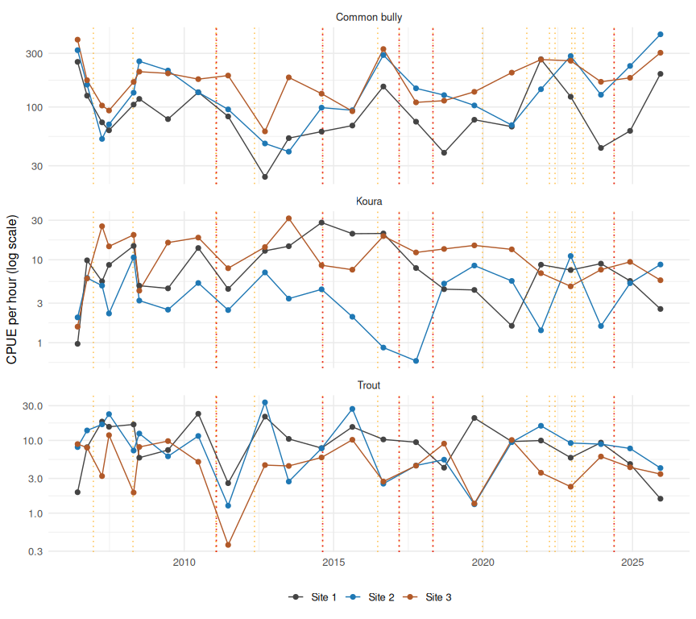
Figure 20: CPUE (fish or koura per hour, log scale) at each site through time, with Large (orange) and Major (red) flood peaks. Site 1 is the control above the alum diffuser.
To combine sites, each survey’s CPUE is expressed as a log-ratio against that site’s own long-term mean (the anomaly; 0 = typical, +0.69 = double, -0.69 = half) and then averaged across the three sites.
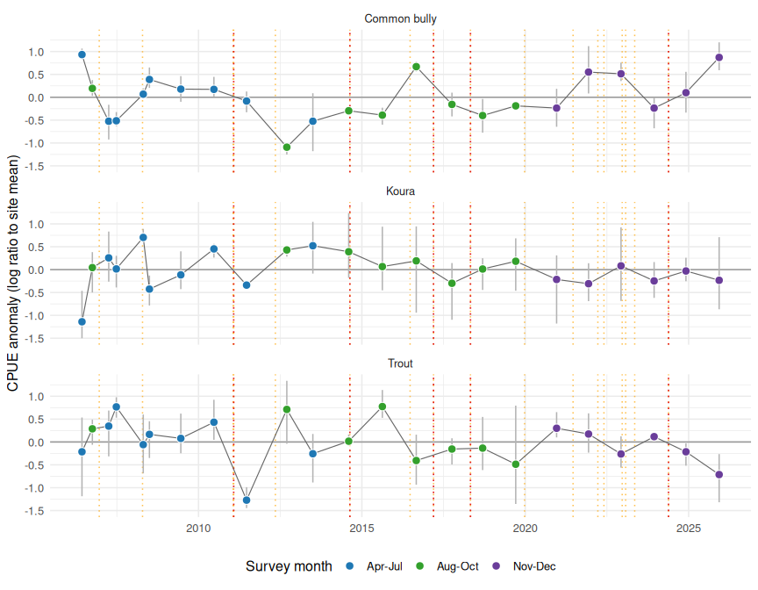
Figure 21: Site-standardised CPUE anomaly (mean of three sites, bars = site range; 0 = site long-term mean). Point colour shows survey month; dotted lines are Large (orange) and Major (red) floods.
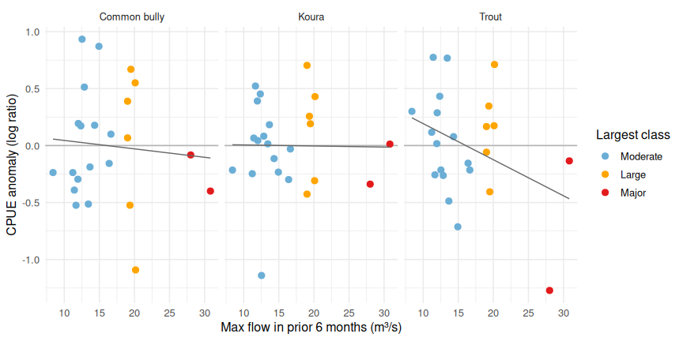
Figure 22: CPUE anomaly (mean of three sites) against the largest flow in the six months before the survey, coloured by the largest flood class in that window. Line = linear fit, for guidance only.
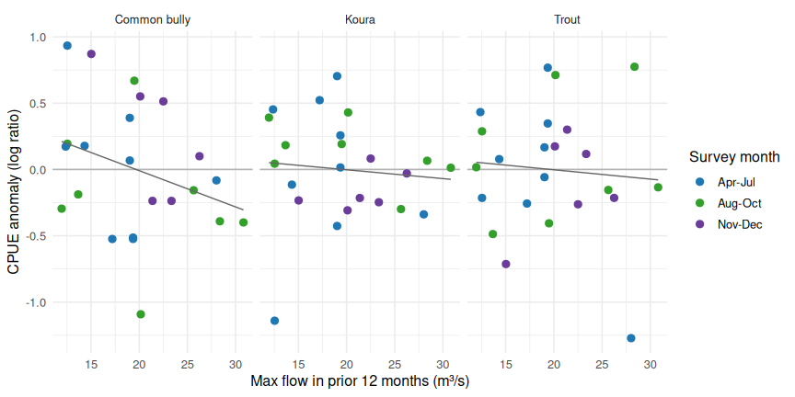
Figure 23: CPUE anomaly against the largest flow in the 12 months before the survey. A longer window allows for slower recovery of bed, cover and bank habitat.
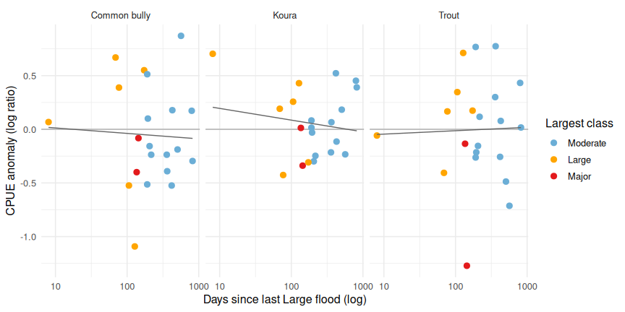
Figure 24: CPUE anomaly against the time since the last Large flood (1-in-1.6-year or greater).
Table 23: Spearman rank correlations between the site-standardised CPUE anomaly (mean of three sites) and flood-history predictors.
Species | Predictor | Spearman rho | p-value | n
Common bully | Max peak, prior 3 mo | 0.18 | 0.418 | 23
Koura | Max peak, prior 3 mo | 0.22 | 0.309 | 23
Trout | Max peak, prior 3 mo | -0.19 | 0.381 | 23
Common bully | Max peak, prior 6 mo | 0.09 | 0.678 | 23
Koura | Max peak, prior 6 mo | -0.10 | 0.636 | 23
Trout | Max peak, prior 6 mo | -0.23 | 0.299 | 23
Common bully | Max peak, prior 12 mo | -0.27 | 0.206 | 23
Koura | Max peak, prior 12 mo | -0.27 | 0.212 | 23
Trout | Max peak, prior 12 mo | 0.00 | 0.995 | 23
Common bully | Max peak, prior 24 mo | -0.31 | 0.153 | 23
Koura | Max peak, prior 24 mo | -0.10 | 0.636 | 23
Trout | Max peak, prior 24 mo | -0.26 | 0.224 | 23
Common bully | Large floods, prior 6 mo | -0.04 | 0.859 | 23
Koura | Large floods, prior 6 mo | -0.02 | 0.940 | 23
Trout | Large floods, prior 6 mo | -0.04 | 0.859 | 23
Common bully | Large floods, prior 12 mo | -0.16 | 0.470 | 23
Koura | Large floods, prior 12 mo | -0.23 | 0.285 | 23
Trout | Large floods, prior 12 mo | 0.06 | 0.800 | 23
Common bully | Large floods, prior 24 mo | -0.12 | 0.592 | 23
Koura | Large floods, prior 24 mo | -0.21 | 0.339 | 23
Trout | Large floods, prior 24 mo | -0.13 | 0.548 | 23
Common bully | Days since last Major flood | 0.08 | 0.773 | 15
Koura | Days since last Major flood | 0.17 | 0.549 | 15
Trout | Days since last Major flood | 0.26 | 0.347 | 15
Common bully | Days since last Large flood | -0.01 | 0.960 | 21
Koura | Days since last Large flood | 0.05 | 0.814 | 21
Trout | Days since last Large flood | -0.05 | 0.843 | 21
Common bully | Volume above 3×median, prior 6 mo | 0.24 | 0.273 | 23
Koura | Volume above 3×median, prior 6 mo | -0.33 | 0.129 | 23
Trout | Volume above 3×median, prior 6 mo | -0.42 | 0.045 | 23

Table 24: The same correlations for each site separately. Sites 2 and 3 have mobile pumice substrate; Site 1 is the control reach above the alum diffuser.
Species | Site | Predictor | Spearman rho | p-value | n
Common bully | Site 1 | Max peak, prior 6 mo | 0.12 | 0.585 | 23
Common bully | Site 2 | Max peak, prior 6 mo | 0.12 | 0.585 | 23
Common bully | Site 3 | Max peak, prior 6 mo | 0.00 | 0.998 | 23
Koura | Site 1 | Max peak, prior 6 mo | -0.15 | 0.482 | 23
Koura | Site 2 | Max peak, prior 6 mo | -0.03 | 0.890 | 23
Koura | Site 3 | Max peak, prior 6 mo | 0.14 | 0.536 | 23
Trout | Site 1 | Max peak, prior 6 mo | -0.10 | 0.665 | 23
Trout | Site 2 | Max peak, prior 6 mo | -0.17 | 0.435 | 23
Trout | Site 3 | Max peak, prior 6 mo | -0.44 | 0.037 | 23
Common bully | Site 1 | Max peak, prior 12 mo | -0.38 | 0.071 | 23
Common bully | Site 2 | Max peak, prior 12 mo | -0.19 | 0.397 | 23
Common bully | Site 3 | Max peak, prior 12 mo | -0.22 | 0.314 | 23
Koura | Site 1 | Max peak, prior 12 mo | -0.08 | 0.711 | 23
Koura | Site 2 | Max peak, prior 12 mo | -0.23 | 0.285 | 23
Koura | Site 3 | Max peak, prior 12 mo | -0.09 | 0.675 | 23
Trout | Site 1 | Max peak, prior 12 mo | -0.15 | 0.501 | 23
Trout | Site 2 | Max peak, prior 12 mo | 0.02 | 0.923 | 23
Trout | Site 3 | Max peak, prior 12 mo | -0.01 | 0.970 | 23
Common bully | Site 1 | Large floods, prior 12 mo | -0.23 | 0.298 | 23
Common bully | Site 2 | Large floods, prior 12 mo | -0.13 | 0.559 | 23
Common bully | Site 3 | Large floods, prior 12 mo | -0.12 | 0.595 | 23
Koura | Site 1 | Large floods, prior 12 mo | 0.03 | 0.896 | 23
Koura | Site 2 | Large floods, prior 12 mo | -0.20 | 0.371 | 23
Koura | Site 3 | Large floods, prior 12 mo | -0.15 | 0.497 | 23
Trout | Site 1 | Large floods, prior 12 mo | -0.05 | 0.818 | 23
Trout | Site 2 | Large floods, prior 12 mo | 0.16 | 0.468 | 23
Trout | Site 3 | Large floods, prior 12 mo | -0.16 | 0.462 | 23
Common bully | Site 1 | Days since last Large flood | -0.08 | 0.741 | 21
Common bully | Site 2 | Days since last Large flood | -0.04 | 0.862 | 21
Common bully | Site 3 | Days since last Large flood | 0.00 | 0.989 | 21
Koura | Site 1 | Days since last Large flood | -0.06 | 0.806 | 21
Koura | Site 2 | Days since last Large flood | 0.10 | 0.656 | 21
Koura | Site 3 | Days since last Large flood | -0.08 | 0.729 | 21
Trout | Site 1 | Days since last Large flood | -0.03 | 0.902 | 21
Trout | Site 2 | Days since last Large flood | -0.15 | 0.514 | 21
Trout | Site 3 | Days since last Large flood | 0.25 | 0.267 | 21

Table 25: CPUE anomaly grouped by the largest flood class in the six months before the survey (ratio = anomaly back-transformed; 1 = site long-term mean).
Species | Largest flood class, prior 6 mo | Mean anomaly | Ratio to site mean | Surveys
Common bully | Moderate | 0.03 | 1.03 | 15
Common bully | Large | 0.01 | 1.01 | 6
Common bully | Major | -0.24 | 0.79 | 2
Koura | Moderate | -0.03 | 0.97 | 15
Koura | Large | 0.14 | 1.15 | 6
Koura | Major | -0.16 | 0.85 | 2
Trout | Moderate | 0.03 | 1.03 | 15
Trout | Large | 0.16 | 1.17 | 6
Trout | Major | -0.70 | 0.50 | 2

Table 26: As above for the 12 months before the survey.
Species | Largest flood class, prior 12 mo | Mean anomaly | Ratio to site mean | Surveys
Common bully | No Large/Major | 0.17 | 1.18 | 8
Common bully | Large | -0.04 | 0.96 | 10
Common bully | Major | -0.19 | 0.83 | 5
Koura | No Large/Major | 0.01 | 1.01 | 8
Koura | Large | 0.05 | 1.05 | 10
Koura | Major | -0.12 | 0.89 | 5
Trout | No Large/Major | -0.11 | 0.90 | 8
Trout | Large | 0.19 | 1.20 | 10
Trout | Major | -0.20 | 0.82 | 5

Table 27: CPUE anomaly by survey month group, to check for a season effect that could be confused with flood history.
Species | Survey month | Mean anomaly | Surveys
Common bully | Apr-Jul | 0.01 | 9
Common bully | Aug-Oct | -0.21 | 8
Common bully | Nov-Dec | 0.26 | 6
Koura | Apr-Jul | -0.01 | 9
Koura | Aug-Oct | 0.13 | 8
Koura | Nov-Dec | -0.16 | 6
Trout | Apr-Jul | 0.00 | 9
Trout | Aug-Oct | 0.08 | 8
Trout | Nov-Dec | -0.10 | 6

 How far these can be pushed
- There are only 23 surveys, so correlations have little power and a handful of years dominate. Treat results as hypothesis-generating rather than confirmatory.
- Only one survey per year, with no replicate reaches, and CPUE (catch per hour of fishing, two passes) is a relative index that can be affected by water clarity, conductivity and operator effort as well as by abundance.
- About 27 correlations are tested (9 predictors by 3 species), so one or two will look “significant” by chance; none should be read in isolation.
- “Days since last Major/Large flood” is missing for early surveys because no such flood had occurred since the flow record began (September 2005); those surveys are dropped from the correlation (reduced n), which is a form of censoring.
- Floods also covary with wet years, which change other things (temperature, nutrients, turbidity) that could also influence catch.
- Combining sites uses each site’s anomaly from its own long-term mean, which assumes all three respond to floods in a similar way; the per-site table checks this.
- Alum dosing began in 2006, was interrupted in 2012 and reduced in 2021, and Site 1 is a control above the diffuser. The ERI report finds no alum effect, but dosing history is not controlled for here.
- Survey month moved to December from 2020, so the most recent surveys are seasonally different from the earlier ones (juvenile trout especially).
- Flood size here is flow at the gauge, not the energy or shear stress at the fish habitat. A flood that is “Major” at the gauge may be less damaging to a sheltered reach.
- If the aim is to model recovery, the 12 and 24 month predictors and days since the last Major flood are better matches to slow processes (vegetation regrowth, koura and trout recolonisation) than the 6 month window.

Summary
- Regime. The Utuhina is a baseflow-dominated stream (consistent with groundwater/spring supply) (median 1.62 m³/s; baseflow index ≈ 0.83) with a narrow low-flow range and brief, sharp storm peaks reaching 30.8 m³/s.
- Multi-annual variation. Annual mean flow ranges from 1.46 m³/s (WY2021) to 2.73 m³/s (WY2023), i.e. -19% to +51% of the long-term mean. Metrics with a statistically significant monotonic trend (p < 0.05): none.
- Return frequency. 3 × median (4.9 m³/s) events occur on average 13.6 times per water year (range 8-27). Estimated mean annual flood is 20.5 m³/s, the 10-year flow 28.5 m³/s. The largest event was 30.8 m³/s on 29 Apr 2018.
- Timing. Events occur in every season with only a weak winter bias (concentration R = 0.11, where 0 is uniform through the year): Spring (SON) 56, Summer (DJF) 66, Autumn (MAM) 73, Winter (JJA) 86 3 × median events respectively. There is no reliably event-free season, so any survey window can follow a recent high flow.
- Floods before fish surveys. In 23 surveys, the largest flood in the previous six months was Major (> 1-in-5-year, 24.9 m³/s) before 2, Large (> 1-in-1.6-year, 17.7 m³/s) before 6 and only Moderate before 15. Working with site-standardised CPUE (fish per hour relative to each site’s own mean), there is no consistent relationship between CPUE of common bully, koura or juvenile trout and the largest flood in the preceding 3-24 months, the number of Large floods, or time since the last Large flood (most |rho| below 0.3; none significant after allowing for the number of tests). The direction is mostly negative for the longer windows, and surveys following a Major flood in the previous 12 months had somewhat lower bully (about 17% below site mean) and trout CPUE than surveys with no Large or Major flood, but with only five such surveys this is weak evidence. The two surveys within six months of a Major flood (2011 and 2018) had much lower juvenile trout CPUE (about half the site mean). Survey month shifts bully CPUE by a similar amount (about +0.26 in Nov-Dec and -0.21 in Aug-Oct in log units) so season is a competing explanation that cannot be separated with 23 annual surveys.
- Duration. The median 3 × median event lasts 5 h from first to last exceedance (5 h actually above the threshold), peaking 2 h after the threshold is crossed; 90% last under 37 h.

Exports for joining to fish survey data
Written to data/processed/:
- utuhina_annual_flow_metrics.csv – one row per complete water year (flow statistics, low-flow, event counts, summer metrics).
- utuhina_daily_flow.csv – daily mean/max/min flow and baseflow.
- utuhina_flood_history_before_fishing.csv – flood metrics for the six (and 3/12/24) months before each electrofishing survey.
- utuhina_high_flow_events.csv – every event at each threshold, with peak, duration, volume, rise time and season.

