Fieldnotes project documentation
  - Student and administrative workspace
Project version 0.0.0 | 13 October 2026

Purpose and scope
Fieldnotes is an independent student workspace that brings academic records, course registration and account information into one web application. Students use their student number and password; administrators have a separate email-based sign-in. This document explains the current application, its implementation and the work needed before an operational release. [1]
The repository contains a live Supabase integration and administrative workflows. It remains a development application: a successful build does not establish production readiness or prove that the hosted database matches the checked-in migration.

Application appearance
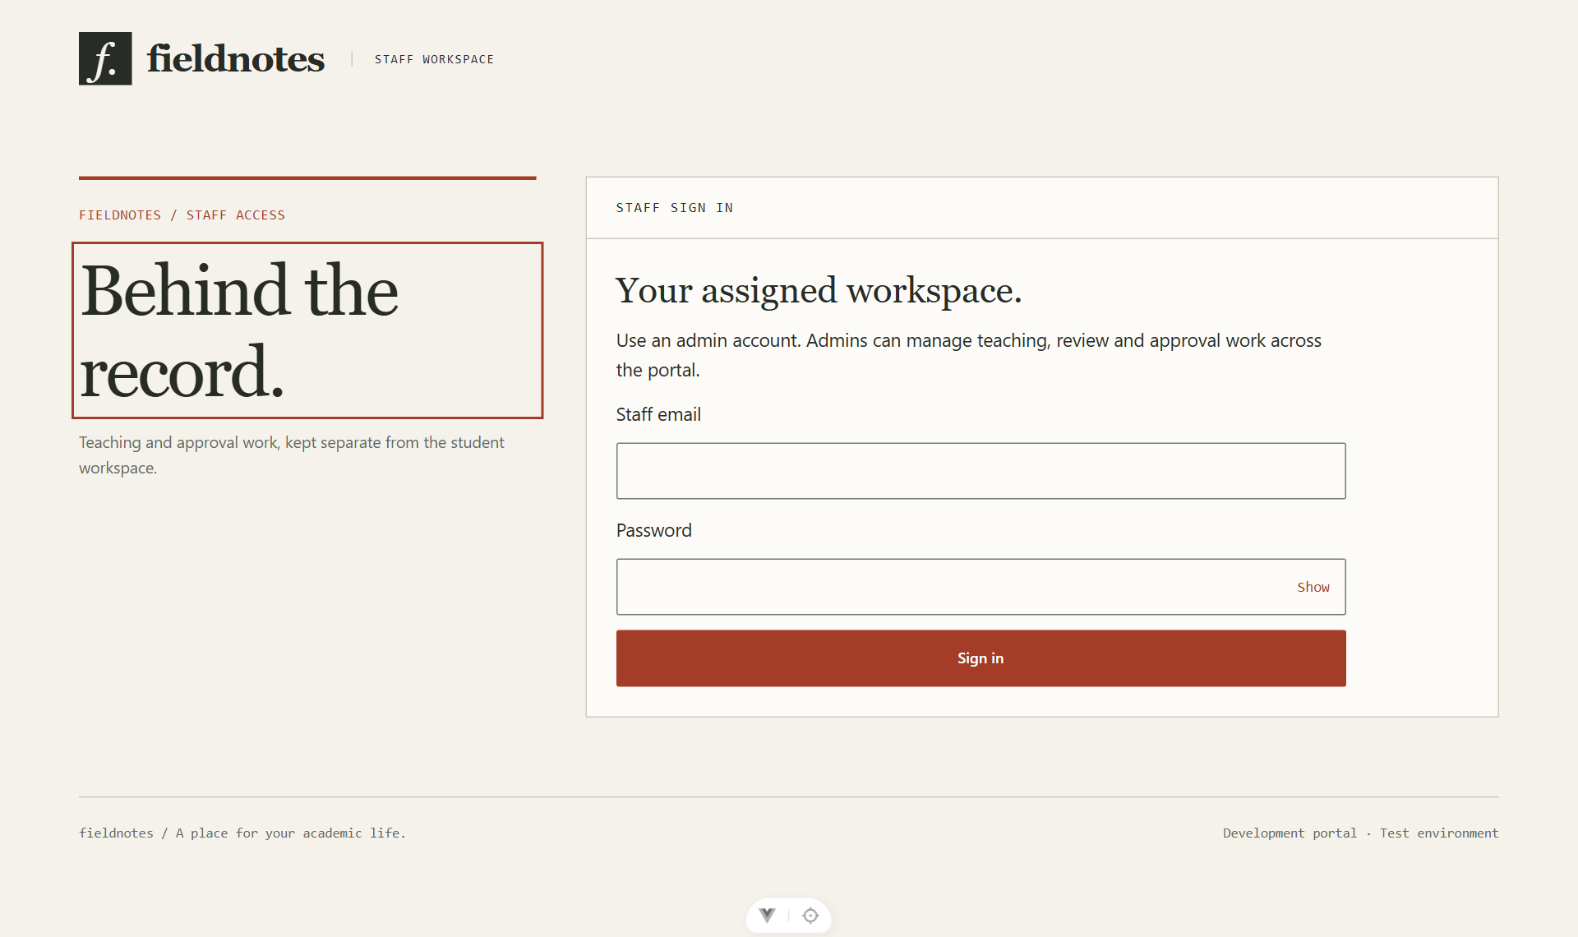
Figure 1. Current staff sign-in screen at /staff/login. Student pages do not link to this entry point. Screenshot captured from the local application on 13 October 2026.

Technology and design
Vue 3.5 and TypeScript 6 implement the interface; Vue Router 5 handles navigation and Pinia 4 shares session and record state. Vite 8 builds the frontend. Supabase provides Auth, PostgreSQL and the student-login Edge Function. The interface uses plain CSS, warm paper surfaces, dark text, rust accents and numbered student navigation. [1–6]

User features and workflows
The router defines eleven named-purpose routes and a catch-all page. Student navigation and the account header are hidden until authentication. The current student menu is a collapsible sidebar numbered 01 to 08. [1]
Page or route | Current capability
Student login /login | Student number and password; password visibility toggle; safe return to the originally requested student page.
01 Overview / | Student and programme details, registration status, course count, account balance and an expandable student record.
02 My courses /courses | Enrolled-course table and an empty state. The current version does not include course search.
03 Results /grades | Released course grades, credits and scores. No automatic GPA calculation or grade filter.
04 Coursework /assessment | Placeholder explaining that coursework publication is unavailable.
05 Exam planner /schedule | Published examination dates, course details and venues, with an empty state.
06 Account /payments | Read-only USD transaction history and a balance held on the student record; printable statement. No payment gateway.
07 Registration /register | Programme-matched course choices, saved selections and submission when registration is enabled; admin review creates enrolments.
08 Study room /resources | Published resources for enrolled courses; only valid HTTPS links without embedded credentials are opened.
Staff /staff/login and /staff | Separate email sign-in and an admin workspace with registrations, marks and resources tabs.

Administrative workflow
An admin reviews course requests and approves or rejects them. For marks, the admin selects an enrolled student and assessment, saves a raw score, submits it, approves it and enters a grade for publication. Published results are copied to the student-readable results table. The current admin model permits the same admin to submit and approve; it does not implement independent approval. [1]
Resource management supports adding published or draft course links and deleting resources. Course, term, assessment and exam setup use database tools or the sample seed rather than dedicated screens. Registration and publication depend on registry configuration flags; the seed enables registration, not result publication.

Architecture and repository structure

How a request reaches the database
The browser renders Vue views and uses the Pinia store for shared state. Student login calls services/portal.ts, which invokes the student-login Edge Function. The function resolves the student number on the server, checks the password with Supabase Auth and returns access and refresh tokens. Staff sign-in uses email and password directly. The store verifies the identity, then retrieves the permitted records. [1]
Normal reads use typed Supabase queries in pages of 500 rows. Administrative writes call PostgreSQL functions through remote procedure calls, or RPCs. Database permissions and row-level security determine access; hiding a menu or redirecting a route is not authorization. Session expiry, sign-out and account changes clear the store, and request counters prevent stale responses restoring old data. [1,6]
Location | Responsibility
src/views/ | Student pages, separate staff pages and NotFoundView.vue.
src/components/layout/ | PortalShell.vue provides the header, student sidebar, focus handling and shared loading/error presentation.
src/router/ and src/stores/ | Route definitions and asynchronous guards; studentPortalStore.ts owns authentication and displayed records.
src/services/ and src/lib/ | Typed data queries, login transport and validated Supabase client configuration.
src/types/ and src/assets/styles/ | Database types and shared design-system.css styling.
supabase/ | One consolidated baseline migration, sample seed.sql, config.toml and functions/student-login/.
scripts/ | Trusted development student provisioning and local admin connection helper.
Project root | README, package and lock files, Vite/TypeScript configuration, .env.example, index.html and public/ assets.

Data model and access boundaries
Students link to Auth identities. Courses and academic terms form offerings; enrolments connect students to offerings. Assessments and raw marks feed released result snapshots. Transactions belong to students; resources and exam sessions belong to offerings. Registration requests hold selections and review state. Private tables hold staff assignments, login-attempt counters and audit events. [1]
The current privileged role is admin, with portal-wide access. Student reads are scoped to their records and published course content. Secret/service-role keys belong only in trusted server tools; VITE_* settings are exposed in the browser. The private schema must not be exposed through the Data API. [1,6]

Setup validation and references

Run the application
Use Node ^22.18.0 or >=24.12.0, matching package.json. Copy .env.example to .env.local only when the local file does not already exist. Set VITE_SUPABASE_URL and VITE_SUPABASE_PUBLISHABLE_KEY, then run npm.cmd ci and npm.cmd run dev. Use the local address printed by Vite. npm.cmd run build performs type checking and writes the frontend to dist/. [1,5]
For a new development database, review and apply the baseline migration, expose only the fieldnotes application schema and deploy the student-login Edge Function. Create the admin Auth account and review seed.sql before using it: it grants admin access and creates sample academic data. Provision students through scripts/provision-student.mjs using a private input file outside the repository. Do not include credentials in Git. [1]

Validation and release limitations
The current checkout passed npm.cmd run build, including TypeScript checking, on 13 October 2026. Its staff login page was opened locally for Figure 1. The student login displayed a session-restoration warning in this environment; authenticated workflows and the hosted database were not revalidated for this document.
This checkout has no automated test or lint scripts, tests directory or CI workflow. Restore repeatable authentication, registration, isolation and publication tests before release. Registration currently lacks complete prerequisite, credit-limit and registration-window enforcement. Publication copies a single approved raw mark per enrolment; it does not aggregate assessment weights or calculate a validated grade/GPA. A later publication can replace the enrolment’s previous result. [1]
Production work also includes verified account activation/recovery, independent approval if required, payment ingestion, accessibility and print checks, HTTPS deployment with SPA fallbacks, security headers, backups and operational ownership. The sample seed is demonstration data, not authoritative academic policy. [1]

References
Source review and online reference access date: 13 October 2026. Bracketed numbers in the text refer to the sources below.
[1] Fieldnotes repository. README.md; package.json; src/router/index.ts; src/stores/studentPortalStore.ts; src/services/portal.ts; src/views/; supabase/migrations/20261013013100_baseline.sql; supabase/seed.sql. Local source snapshot reviewed for this document.
[2] Vue documentation. Introduction
https://vuejs.org/guide/introduction.html
[3] Vue Router documentation. Getting Started
https://router.vuejs.org/guide/
[4] Pinia documentation. Introduction
https://pinia.vuejs.org/introduction.html
[5] Vite documentation. Building for Production
https://vite.dev/guide/build
[6] Supabase documentation. Row Level Security
https://supabase.com/docs/guides/database/postgres/row-level-security

