Employee Management System
  - Current project documentation
EMS manages employees, departments, attendance, leave and payroll in one role-based workspace. This guide explains the current application, its main controls and how to run it. It is intended for project partners, lecturers and maintainers.
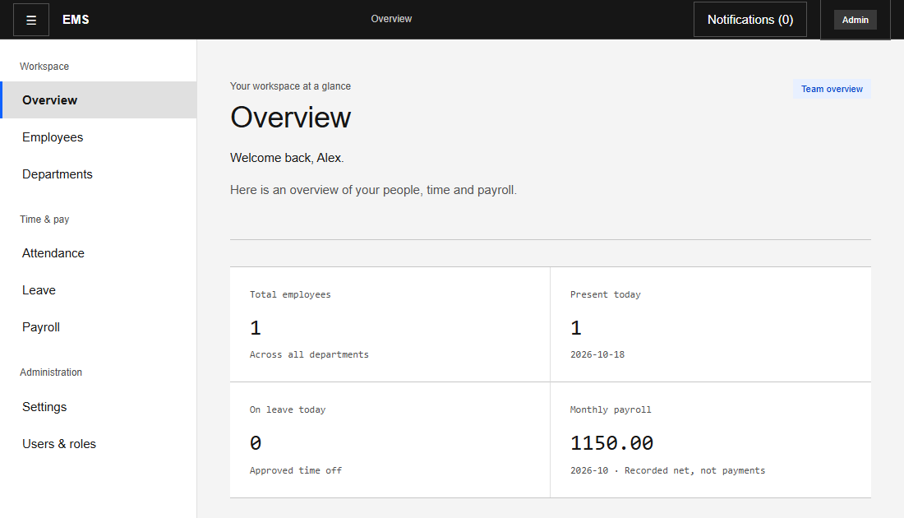
Figure 1 Admin overview with demonstration records

Who can do what
Role | Main responsibilities
Admin | Manage employees and departments; review team attendance and leave; prepare and approve payroll; manage budgets, roles and Settings; record external payments.
HR | Manage employees and departments; review team attendance and leave; prepare and approve payroll. Budget adjustments and payment recording remain Admin-only.
Employee | View directories, check in and out, request leave, and view linked personal payslips.
Admin and HR see team attendance only. Personal check-in/out and My attendance are shown to Employees. Admin/HR may still access their own leave and payslips when linked to an employee record.

Architecture and daily use
The React application uses Vite, React Router, Axios and plain CSS. Its services call an Express API; Mongoose models store records in MongoDB. Server-side validation and role checks protect operations independently of the interface.

Accounts and records
Public registration creates an Employee-role user account. Admin or HR creates the employment record and links it to that account. Departments group employees; attendance, leave and payslips reference the employee. A registered account alone does not provide personal employment records.
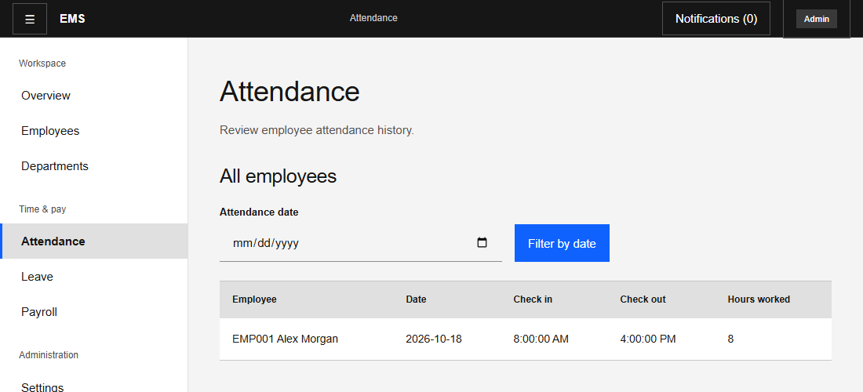
Figure 2 Admin attendance view with team records and date filtering

Attendance and leave
Employees record check-in and check-out; the system calculates working hours. Admin and HR filter team attendance by date. Leave requests move through pending, approved, rejected or cancelled states. Users cannot approve their own leave. Annual leave defaults to 21 calendar days; environment settings can change the allowance and counting policy for new requests.

Access and interface
JWT authentication identifies the user, and the API reads the current database role. Passwords are hashed with bcrypt. The shared sidebar adapts to role and screen size; expired sessions return to login. Notifications have unread indicators and a scrollable dropdown. The Audit history interface and read endpoint have been removed; stored internal records remain intact.

Department payroll and budgets
Admin or HR selects a department and month, prepares missing payroll, and enters bonuses or deductions. Either role can approve the batch, including payroll they prepared. There is no separate HR-review stage or different-person approval requirement.
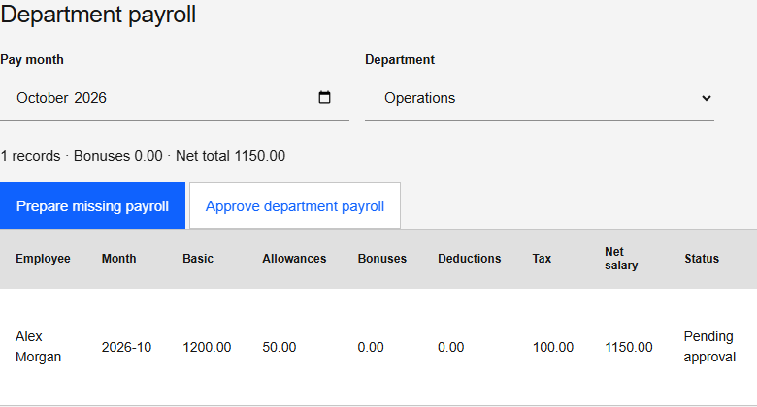
Figure 3 Department selection and approval controls

Calculation and approval
Net pay = basic salary + allowances + bonuses + overtime - PAYE/tax - NSSA/pension - loan deductions - other deductions. Deductions are entered manually. The server calculates totals and checks the combined department budget before approval. Confirmation, justification and version checks protect decisions. Approved records cannot be edited; employee/month uniqueness prevents duplicates.

Budget and payment rules
Budgets are recurring monthly limits. Salary commitments, approved gross payroll and approved expenses consume the limit. Over-budget hires, salary increases and expenses stay pending. Admin adjusts or reallocates budgets with a reason; warnings appear at 80% and 90%. Existing salary obligations remain visible when over budget.
Payroll defaults to preparation on the 25th, approval due by the 28th and planned payment on the last working day. Admin configures dates and holidays. Automatic preparation is off until enabled. Approved payroll becomes due on its scheduled date; EMS never transfers money. Admin records a reference only after all approved unpaid records in the batch have been paid externally. Employees can view, print or download approved payslips as HTML.

Setup verification and maintenance

Run locally
1. Install Node.js 20.19+ or a newer supported LTS. Use MongoDB Atlas or a replica set because financial operations require transactions.
2. In server, run npm ci. For a fresh checkout only, copy .env.example to .env. Set MONGO_URI with the intended existing database name, a random JWT_SECRET of at least 32 characters, and CLIENT_URL=http://localhost:5173.
3. If no Admin exists, set ADMIN_NAME, ADMIN_EMAIL and ADMIN_PASSWORD and run npm run create-admin. Remove ADMIN_PASSWORD afterward. Start the API with npm run dev.
4. In a separate terminal, enter client and run npm ci. Set VITE_API_URL=http://localhost:5000/api in client/.env. Run npm run dev -- --host 127.0.0.1 --port 5173 --strictPort, then open http://127.0.0.1:5173.
5. Create departments and employee links, assign budgets and configure Settings. Keep both services running. Stop each with Ctrl+C.

Project conventions
Frontend screens live in client/src/pages, reusable UI in components, API helpers in services and styles in index.css. The backend separates routes, controllers, models, middleware and utils. Keep JavaScript/JSX, plain CSS, small components and existing validation. Store credentials only in ignored environment files or hosting settings.

Verification record
Latest relevant check | Result
Backend and frontend unit tests | 30 backend and 4 frontend passed
Live API integration | 93 checks passed; disposable QA database removed
Notifications | 320, 390, 768 and 1440px checks passed
Latest attendance visibility change | Production build passed
Repeat npm test in server and client, then npm run build in client. The optional server/scripts/verifyIntegration.js uses a separate ems_qa database. Browser checks use demonstration API responses. These checks do not certify production deployment or every browser combination.

Deployment and limitations
Render runs server with npm start; Vercel builds client with npm run build and serves dist. Set the hosted frontend origin in CLIENT_URL and the hosted API address in VITE_API_URL. Check API health, login and nested-route refresh after deployment.
Scheduling requires a running backend and catches up only the current preparation month. There is no automated bank transfer, tax-rate engine, salary prorating, currency conversion or partial-payment reconciliation. Monthly budgets are recurring limits rather than immutable historical allocations. Payment recording is an Admin confirmation, not bank verification.
README.md contains setup details, progress.md preserves development history, and PRESENTER_NOTES.md provides a short demonstration outline. This edition replaces the earlier documentation snapshot.

