Pi-Games Project Report

Thomas Adkins, Gabrielle Panuelos, Micah Eye, Izaiah Rodriguez
BAT Program, Lone Star College
ITCS-3301 W005 1 Data Structures & Algorithms
Professor Lindstrom
May 6, 2026

Table of Contents
- Executive Summary 3
- Introduction and Project Selection 4
- System Architecture and Design 5
- Python Implementation Details 7
- Security Analysis 9
- Testing and Results 11
- Challenges and Lessons Learned 13
- Conclusions and Future Work 17
- References 18
- Appendix A: Full Code Listings 19

1. Executive Summary - Primary Author: Collaborative (all team members)
Pi Party Games is a multiplayer terminal-based gaming platform developed in Python for Raspberry Pi devices connected over a local area network (LAN). The system allows multiple players to connect to a host Raspberry Pi and play several multiplayer games including Heads or Tails, Rock Paper Scissors, Number Guess, Snake, and Pac-Man. The project combines networking, Python programming, and cybersecurity concepts into a single interactive system. One Raspberry Pi acts as the host server while the remaining devices connect as clients using TCP sockets. Communication between systems uses JSON-formatted messages sent over the LAN.
The project was designed to demonstrate practical cybersecurity concepts such as input validation, defensive programming, timeout handling, replay protection, and secure handling of untrusted network data. The system was tested with multiple Raspberry Pis on the same network and successfully supported multiplayer gameplay across all implemented games. Throughout development, the team focused on keeping the application easy to deploy. The entire platform runs from a single Python file using only Python standard libraries. This allowed the project to run on Raspberry Pi OS and other Linux-based systems without installing external dependencies. The project successfully met its primary goals by demonstrating reliable communication between Raspberry Pis, implementing several multiplayer games, and applying cybersecurity concepts to a practical networking application.

2. Introduction and Project Selection - Primary Author: Izaiah Rodriguez

For our semester project, our group decided to develop the Pi-Games system because it gave us the opportunity to combine cybersecurity, networking, and Python development into one interactive project. We wanted to create something that was not only educational but also enjoyable to test and demonstrate using multiple Raspberry Pis connected through a network.
The project was designed around a multiplayer client/server setup where different Raspberry Pis could communicate and exchange data during gameplay. By building this system, we were able to gain practical experience with network communication, troubleshooting, and software development while also learning how security practices are important in connected systems.
Throughout the project, we focused on several important cybersecurity concepts, including
- Verifying and validating user input
- Protecting communication between devices
- Managing connection timeouts and errors
- Reducing risks from malicious or excessive network traffic
- Handling multiple client connections using threads
In addition to cybersecurity concepts the project helped improve our understanding of TCP socket programming, JSON data handling, GitHub collaboration, and Raspberry Pi networking. Since Raspberry Pis are often used in loT and embedded environments, the project also demonstrated how security and networking principles apply to smaller-Scale systems.

3. System Architecture and Design - Primary Author: Gabrielle Panuelos
3.1 Physical and Network Layout
The layout of the system is arranged in a star topology. A designated Pi will act as the central host server, while the remaining Pi devices will connect as clients over the same local network. The host server is responsible for managing incoming client connections, coordinating game selections, serving as player 1, and tracking the scores of all the players and displaying the scoreboard across the network. The clients connect to the host using TCP sockets on Port 65432. All game communication passes through the host server to prevent synchronization issues. Delays can occur if communication passes client to client.
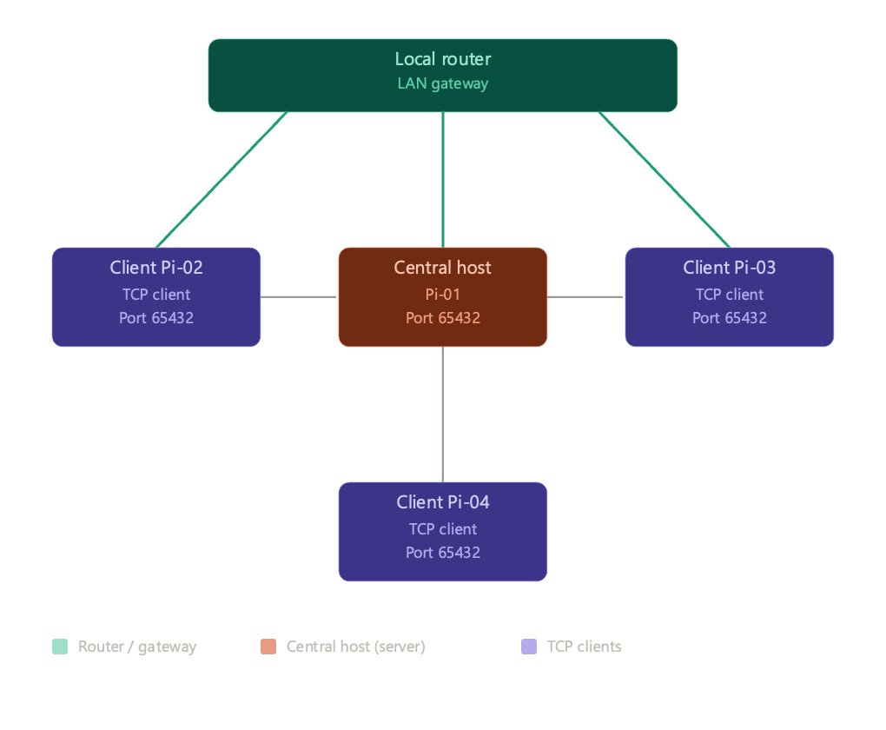

3.2 System Data Flow

In order to keep the system organized, easy to debug, and expand upon during development, the application is organized into three different layers: Game Layer, Session Layer, and Transport Layer.
- The Game Layer: Contains the rules and logic for the 5 games in PiParty, processes the live inputs of clients, tracks the game score, and determines the winner of each round.
- The Session Layer: Tracks the clients (players) who are actively participating in the session, ensures that the game is synchronized for all the clients participating, detects when clients get disconnected from the session, and updates the score board across the system.
- The Transport Layer: Establishes the communication between the clients, ensures that devices are in constant communication, and manages the transfer of data back and forth between the devices.
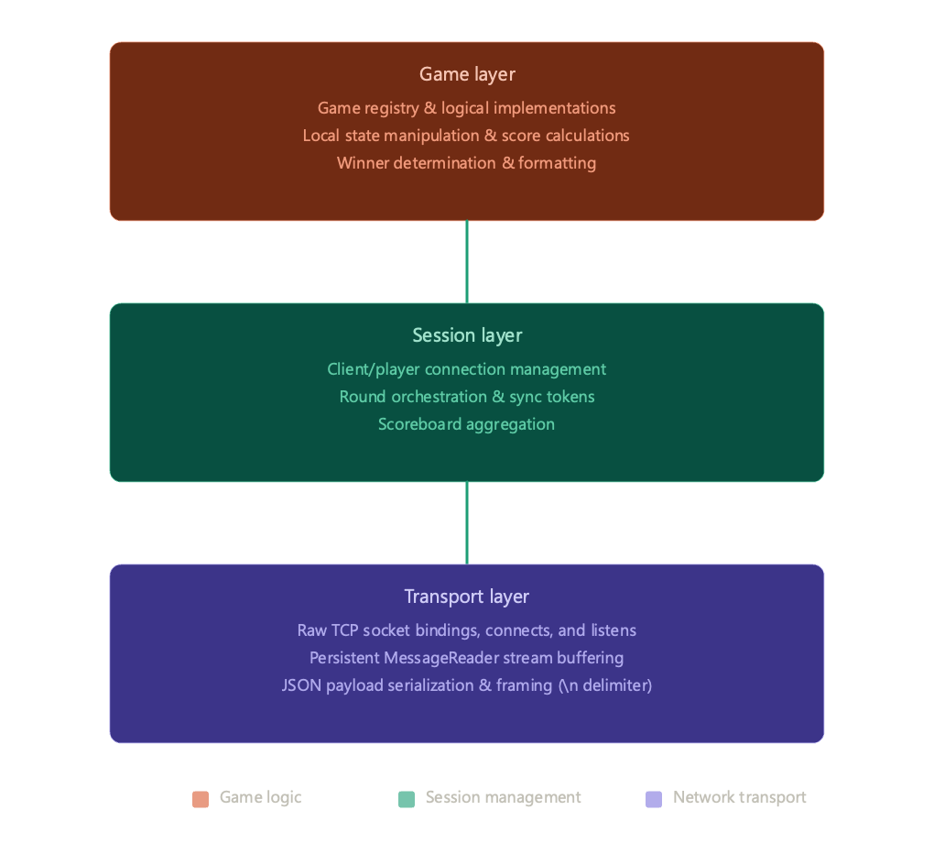
4. Python Implementation Details - Primary Author: Izaiah Rodriguez
The Pi-Games application was fully developed in Python and organized within a single main file called “ExtraSecurePiGames.py. Python was chosen because of its flexibility, simplicity, and string support for networking and multithreaded applications. Using Python also allowed the project to remain lightweight and compatible across multiple Raspberry Pi and other devices without requiring large external dependencies.
A variety of Python libraries were used during development to support both networking and gameplay features. The “socket” library was responsible for establishing TCP communication between the server and connected clients, while the threading module allowed several users to interact with the system simultaneously. JSON formatting was used to organize and transfer data between devices in a structured format. The curses module was implemented for the Snake and Pac-Man games to create interactive terminal based gameplay. Other supporting libraries included:
- “random” for game events and number generation
- “time” for delays and timing control
- “argparse” for command line setup and execution
- “Subprocess” for handling system-level operations
The networking portion of the project followed a client/server model using TCP sockets. One Raspberry Pi acted as the host server while remaining Raspberry Pis connected as clients over the network. Data exchanged between devices was converted into JSON format before being transmitted and then decoded after being received. To support multiple players at once, the server used multithreading so each client connection could operate independently without affecting the rest of the system.
The application included five different games: Heads or Tails, Rock Paper Scissors, Number Guess, Snake, and Pac-Man. The first three games used a text based interaction system, while snake and Pac-Man used “curses” library to provide real time movement and screen updates within the terminal. Despite the differences in gameplay, each game followed a similar communication structure where user input was processed by the host system and results were shared with connected players.
To improve the stability and reliability of the application, several defensive programming methods were included throughout development. Exception handling with try/except blocks helped prevent crashes caused by invalid network data or JSON formatting errors. Timeout controls were also implemented to avoid stalled connections from disconnected clients. Additional input validation checks ensured that unexpected or incorrect user entries would not interrupt the execution of the multiplayer system.
Overall, the completed implementation demonstrated successful communication between multiple Raspberry Pis while maintaining an efficient and portable Python-based design.

5. Security Analysis - Primary Author: Thomas Adkins
Initial versions of the platform required only the host’s IP address to join a session. This created a security weakness because any user on the local network who knew the IP address could connect to the host server.
The next version introduced password-based authentication. However, the password was transmitted in plaintext across the local network. This meant that a user monitoring LAN traffic could potentially intercept the password and reuse it to join the session.
The version after that implemented SHA-256 hashing for session authentication. The host enters a password which is immediately hashed and stored only as a hash value. Joining clients enter the same plaintext password locally on their system. Their client also hashes the password using SHA-256 before transmission. Only the hashed value is transmitted across the network and compared against the host’s stored hash. This design prevented plaintext passwords from being transmitted or stored directly by the application. Additionally, users running the unmodified client cannot simply paste an intercepted hash directly into the password field because the client automatically hashes all entered input before transmission, resulting in a different hash value.
Additional defensive networking protections were also implemented into the final version. The server now enforces oversized packet protection by rejecting unusually large incoming messages in order to reduce the risk of memory abuse or denial-of-service style attacks. The system also implements IP-based rate limiting. After multiple failed authentication attempts, the offending IP address is permanently blocked for the remainder of the host session. Security events including successful joins, failed login attempts, rate-limit triggers, and disconnect events are also appended to a running security log file for auditing and monitoring purposes.
Despite these improvements, the system still remains vulnerable to replay-style attacks because the transmitted hash itself effectively acts as the authentication credential. An attacker capable of modifying the Python client or crafting custom packets could potentially reuse an intercepted hash to authenticate successfully. The project therefore improves credential protection and defensive networking behavior, but does not provide full cryptographic authentication security comparable to TLS or challenge-response authentication systems.

6. Testing and Results - Primary Author: Micah Eye
Testing was performed using multiple Raspberry Pi 5 systems connected to the same local network. Additional testing was also conducted on laptops to verify compatibility across different operating systems, such as MacOS, Windows and other Linux systems such as CachyOS. The project was tested repeatedly throughout development to ensure that networking, gameplay, and security features functioned correctly.
All five games were tested with multiple players connected simultaneously to the host server. Heads or Tails, Rock Paper Scissors, and Number Guess successfully handled player input and correctly calculated winners across multiple rounds. Snake and Pac-Man successfully launched in terminal windows and returned scores to the server after gameplay ended. Multiplayer sessions with cumulative score tracking also operated correctly during extended testing sessions.
There are several defenses that were implemented into this code to make sure that the game will stay running under various network conditions.. If a client is removed mid-round, using the server-class with the snapshot clients and client_locks methods, it will iterate through the list of players to make sure that the server does not crash. Using SOCKET_POLL_TIMEOUT and CHOICE_TIMEOUT_SEC, this makes sure to timeout a player or the server if there is no response.
Along with the network defenses, there are several defense methods to keep data integrity. If a client sends invalid JSON messages, the code will continue to the next block instead of crashing because of the MessageReader.read() code. Along with that, if there are invalid scores, such as a string “high-score” instead of a number, the code will default back to 0. This is done by using try/except blocks when casting client inputs.
Overall, the project successfully demonstrated reliable LAN communication between Raspberry Pis, stable multiplayer gameplay, and practical implementation of cybersecurity concepts. The final platform met the primary goals established during project planning and functioned consistently throughout testing.

7. Challenges and Lessons Learned
Primary Author: Collaborative (all team members)

Thomas:
This project proved to be far more complex and difficult than I expected. This was my first time working on a coding project in a group environment. Even though I created personal folders for each team member along with a shared GitHub repository, the project still felt overwhelming and unorganized at times since none of us had extensive experience with large collaborative software development projects. I learned how important it is to truly understand your code, especially when integrating AI-assisted code suggestions into a shared project, so that you can properly work with teammates and integrate everyone’s contributions into the main application.
I also saw how quickly large codebases can become difficult to manage without consistent development standards and readable structure. During development, we encountered many bugs that required troubleshooting as we merged each other’s code together. This was often more difficult because our project lacked consistent organizational structure and shared coding standards across all team members.
This project made me realize how much room for improvement I still have when creating readable code, communicating technical ideas, and maintaining organized project structure. Though the creation process of my individual games was relatively simple, I played a major role in the development of the cross-device communication system and several security features and learned a lot about balancing both functionality and security within a project. Overall, this project gave me valuable experience in teamwork, debugging, and troubleshooting code, especially when working with code written by other developers or helping teammates understand my own code.
Gabrielle:
During this project, I gained a better understanding of Python and utilizing the different functions built within Python to keep multiple clients in sync when a game session is occurring. The game I decided to contribute to our gaming system was Number Guess. I utilized the help of Claude to create the first iteration of my source code. Even though the concept of my game is very simple, it was difficult to make sure that all the devices were communicating, because everyone took different times to type in the number they chose. One of the main challenges I encountered during development was making sure that players only used numbers for their answers and that when letters or characters were anything but the input that was wanted. During the next iteration of my code, I had asked Claude if input sanitation could be implemented. Claude suggested using a try-except block to catch errors in the values player input, adding this prevented the game from accepting invalid inputs. Creating a code that checked the math on how close everyone’s guess was to the target number allowed me to practice using Python dictionaries and sorting lists.
The other challenge I encountered was making sure that the Number Guess game seamlessly joined into our main multiplayer game program. During the merge, I had to make sure that the game I contributed was able to communicate and function well with the rest of the game codes my other group members created. Ensuring that the games worked smoothly together, we used Claude to find the bugs that were breaking our system and implemented suggestions that AI had recommended. Combining everyone’s code taught me how to integrate different parts of a program to work together. The application we created not only allowed us to expand and practice our knowledge of Python, but also gave us the freedom and creativity to make a fun and engaging program.

Micah:
In this process of making the snake game, I learned a lot of things regarding Python programming and multiplayer game making as well. Making the snake game taught me how to show the board in the terminal, move the player in real-time, and control user actions through the terminal. Using the curses library and the curses.wrapper() method allowed me to gain better control of the terminal screen. In addition to this, I got to practice programming in Python with the help of concepts like client-server interaction, communication between players and multiplayer gameplay on a LAN connection. In conclusion, this project helped me become a better problem solver and programmer by making me familiar with building Python-based programs. The most difficult task in the project was to merge the Snake game to the multiplayer game file that had already existed, without compromising its previous performance. In the course of performing this task, I acquired some valuable experience in working with large Python files and putting various functions and classes in their proper places. In order to achieve that, I referred to various Internet materials and documentation.
Izaiah:
One of the biggest challenges during the development of the Pac-Man project was maintaining stable communication between Raspberry Pis while the game was running. Since the project used TCP networking and multithreading, there were times when player movement or game updates would not properly synchronize between systems. Debugging these networking issues required repeated testing and adjustments to the communication logic.
Another challenge involved working with Python’s “curses” library. Because the game runs inside the terminal, different screen sizes occasionally cause display errors, misplaced characters, or gameplay interruptions. Additional testing and terminal checks were added to improve the stability and appearance of the game.
Through this project, I learned the importance of debugging, defensive programming, and testing edge cases before deployment. I also gained a better understanding of Python programming, multiplayer networking, GitHub collaboration, and how real-time game systems operate. The project helped improve both my technical skills and my ability to troubleshoot problems in a collaborative development environment.

8. Conclusion and Future Work - Primary Author: Collaborative (all team members)
Pi Party Games successfully demonstrated how Raspberry Pis can be connected over a local area network to support a multiplayer Python application. The project combined networking, cybersecurity, and software engineering concepts into a functional and interactive system that allowed multiple users to participate in shared gameplay sessions. The final platform implemented multiplayer client/server networking, JSON-based communication, score tracking, multithreading, and five fully playable games. The project also demonstrated several cybersecurity concepts including input validation, replay protection, timeout handling, and defensive handling of untrusted network data.
8.1 Future Work:
Several improvements could be added in future versions of the project.
- Persistent reconnection that allows players to reconnect using a unique ID so they can resume their score.
- Service Discovery that allows for players to find local games on their network without an IP address.
- Use SSL/TLS to encrypt the game data and hashes sent between the host and clients.
- Since IP addresses are blocked if they exceed too many failed attempts, a ban list could be implemented that stores the timestamps and how many attempts were made.
- Game customization that allows the host to use custom parameters (game duration, max score).
- Multiple password attempts without having to restart the program.
9. References - Primary Author: Gabrielle Panuelos
Dr. Lindstrom (2026). ITCS 3301 Data Structures and Algorithms course materials. BAT - Program, Lone Star College - Cyfair
Python Software Foundation. (2024). Curses - Terminal handling for character-cell displays. Retrieved from https://docs.python.org/3/library/curses.html
Python Software Foundation. (2024) Hashlib - Secure hashes and message digest. Retrieved from https://docs.python.org/3/library/hashlib.html
Python Software Foundation. (2024). Socket - Low-level network interface. Retrieved from https://docs.python.org/3/library/sockt.html
Real Python. (2023). Socket Programming in Python. Retrieved from https://realpython.com/python-sockets/
Safety. (2024). Python Security Best Practices for Developers. Retrieved from https://www.getsafety.com/blog-posts/python-security-best-practices-for-developers
W3Schools. (2024). Python Built-in Functions. Retrieved from https://www.w3schools.com/python/python_ref_functions.asp

10. Appendix A: Full Code Listings
Complete source code for PiParty is available on the team’s Github repository at https://github.com/tadkins01/PI_Project/tree/main/Everyone (access will be granted to Dr. Lindstrom)
The repository contains 2077 lines of Python code. To make editing, debugging, and deployment across all nodes, the repository is structured in a logical manner that allows the application to run smoothly. AI tools such as Claude, Gemini, and ChatGPT were utilized to help us develop our program. Selected key files are printed below:
Number Guess: Primary - Author: Gabrielle Panuelos
This section of the code ensures that the input players are entering are valid. Without utilizing the ValueError function, the code would have crashed if players entered an invalid input. This guardrail ensures that mistakes are caught and that it ignores the crash to allow the program to keep running.
raw = input(f" {C.BOLD}> {C.RESET}").strip()
try:
num = int(raw)
if NumberGuess.TARGET_MIN <= num <= NumberGuess.TARGET_MAX:
return num
except ValueError:
pass
cprint(
f" ⚠ Please enter an integer between "
f"{NumberGuess.TARGET_MIN} and {NumberGuess.TARGET_MAX}.",
C.YELLOW, )

Snake Game: Primary Author: Micah Eye
curses.wrapper(): This function puts the terminal into a cbreak mode and enables the keypad for arrow use. This simply allows python to set up the terminal and clean it up once the game returns the final score or if an error occurs.
score = curses.wrapper(SnakeGame._run)
return int(score)
except curses.error as e:
cprint(f" ⚠ Curses error: {e}. Scoring 0 for this round.", C.YELLOW)
return 0
except (RuntimeError, OSError) as e:
cprint(f" ⚠ Snake couldn't run ({e}). Scoring 0 for this round.", C.YELLOW)
return 0

Pac-Man: Primary Author - Izaiah Rodriguez
For “PacmanChase” this section of code controls the single-player version of Pac-Man. It manages player movement, ghost movement, score tracking, lives, pellets, and the game timer while the player moves through the maze collecting points.
class PacmanChase:
DIRECTION_KEYS = {
ord("w"): (0, -1), ord("W"): (0, -1), curses.KEY_UP: (0, -1),
ord("s"): (0, 1), ord("S"): (0, 1), curses.KEY_DOWN: (0, 1),
ord("a"): (-1, 0), ord("A"): (-1, 0), curses.KEY_LEFT: (-1, 0),
ord("d"): (1, 0), ord("D"): (1, 0), curses.KEY_RIGHT: (1, 0),
}
For “PacManGame” this section of code controls the multiplayer Pac-Man system. It allows multiple players to take turns playing the game, compares scores between players, manages ghost behavior, and handles the multiplayer gameplay logic between Raspberry Pis.
class PacManGame:
DIRECTION_KEYS = {
ord("w"): (0, -1), ord("W"): (0, -1), curses.KEY_UP: (0, -1),
ord("s"): (0, 1), ord("S"): (0, 1), curses.KEY_DOWN: (0, 1),
ord("a"): (-1, 0), ord("A"): (-1, 0), curses.KEY_LEFT: (-1, 0),
ord("d"): (1, 0), ord("D"): (1, 0), curses.KEY_RIGHT: (1, 0),
}
Security Implementations - Primary Author: Thomas Adkins:
SHA-256 Password Hashing:
hashlib.sha256(password.encode("utf-8")).hexdigest() was responsible for actually hashing the passwords to ensure that plain text passwords were not sent over the network.
Password Verification Logic:
if self.join_password and provided_password != self.join_password: was the code responsible for actually verifying that passwords sent in by guests matched the host password that was set to control who has access to the games.
IP-Based Rate Limiting:
self.failed_attempts[ip] += 1 and self.blocked_until[ip] = float("inf") were responsible for tracking login attempts and triggering the permanent blocking of IP addresses that could be attempting a brute force login into the session.
Oversized Packet Protection:
if len(self._buf) > MAX_MSG_SIZE:
self._closed = True
return None
This part was responsible for ensuring that incoming packets that exceed the maximum allowed message size are safely rejected to reduce denial-of-service and memory abuse risks.
Security Logging:
with open("security.log", "a") as f: and log_security_event(...) were responsible for ensuring sufficient logging of security events including joins, failed logins, disconnects, and rate-limit triggers persistently for monitoring and auditing purposes.

