Global Unified Security Command (GUSC)

Thomas Adkins
BAT Program, Lone Star College
ITCS-3330 W005 1 Applied Database Management
Dr. Watson
April 26, 2026

Phase 0: The Architecture Design
Task 0.1: Security Architecture Overview
The infrastructure for the Global Unified Security Command (GUSC) environment consists of a primary workstation running CachyOS Linux and Windows 11, along with a Raspberry Pi 5 running Ubuntu Server. The main workstation functions as the administrative client system and is responsible for remote management, database access, and development operations. Administrative access is performed through secure SSH connections using tools such as Konsole, PowerShell, PuTTY, and DBeaver. This design allows the administrator to manage both the Raspberry Pi host and the isolated cloud node environment from a centralized system while maintaining encrypted communications across the network.
The Raspberry Pi 5 acts as the secure gateway and virtualization host for the project environment. Within the Pi, the gsoc-node simulated cloud environment is deployed inside an Incus container, creating a logically isolated security boundary between the host operating system and the database services running inside the container. This layered architecture improves containment and reduces the attack surface by preventing direct exposure of the database node to the broader network. Communication between systems is controlled through UFW firewall rules and restricted ports, while database access is tunneled securely through SSH rather than exposed publicly. This infrastructure design supports both administrative flexibility and secure segmentation principles commonly used in enterprise security operations environments.
(see figure 1)

Figure 1:
Infrastructure mapping
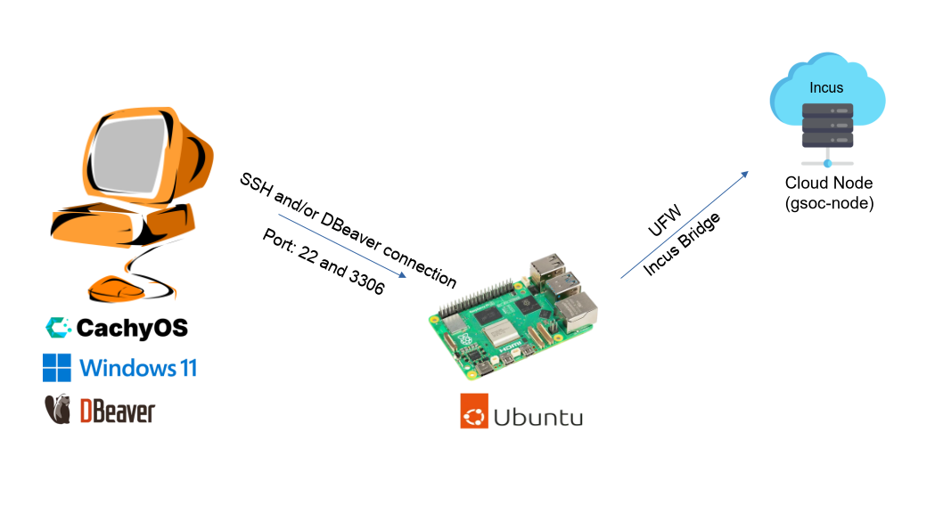
Task 0.2: Data Flow Logic
Ingestion: The actual data itself originates from the security_logs.csv file that was provided for lab 6.2 and imported into the tbl_AccessLogs table inside of the GSOC_Security database. After this import, the table went from 5 to 1005 rows. This data includes “Object-Oriented” extensions such as XML (stored in SensorXML) and JSON (stored in ThreatIntel).
Normalization: By starting with 3rd Normal Form (3NF), redundancy can be eliminated so that each transaction interacts with only one core version of the database. This makes operations such as ROLLBACK, row-level locking, and ACID compliance reliable and consistent.
Intelligence: During the transaction phase, 3NF is used to efficiently ingest and preserve live security event data with high integrity and minimal redundancy. During the reporting phase, the data is transformed into a Star Schema because analytical security queries require faster aggregation and simplified joins across large volumes of log data. The Star Schema organizes data into a central Fact Table surrounded by Dimension Tables (such as Dim_Time, Dim_Location, and Dim_Resource), which eliminates the complex multi-table joins that 3NF requires. This allows executive queries — like identifying which resource type had the highest number of denied attempts during the night shift — to aggregate millions of rows with minimal overhead, producing near-instant results where a flat or normalized table could take minutes.
Task 0.3: Security Protocol Specification
Table 1:
Port | Service | Rule | Justification
22 | SSH | Allow — restricted to administrative access only | Port 22 is the entry point for all administrative access to both the Raspberry Pi host and the gsoc-node container. It is not blocked entirely because it is required for PuTTY connections and DBeaver's SSH tunnel, but exposure is minimized by keeping the container off the public network entirely and requiring authentication through the Pi first.
3306 | MySQL | Allow within network — blocked from public internet | Port 3306 is the MySQL database port. It is allowed within the internal Incus network so that DBeaver can reach it through the SSH tunnel, but it is never exposed directly to the public internet. Exposing a database port publicly would allow anyone to attempt direct authentication against the database, bypassing all other security layers.

Task 0.4: Security Architecture Overview
Tiered Security: The project uses a tiered security model with two layers of protection. The Raspberry Pi acts as the first layer, serving as the host system that the gsoc-node container runs on top of. Rather than exposing the container directly to the local network or internet, all administrative access must first pass through the Raspberry Pi using SSH. This allows the Pi to function as a controlled gateway that filters and limits access to the internal container environment. Because the container exists inside the private Incus virtual network, external systems cannot directly communicate with it unless traffic is intentionally forwarded through the Pi. Even if the database inside the container were compromised, an attacker would theoretically be confined to the container itself rather than gaining access to the Pi's main operating system or the broader network environment. The container then adds a second layer through its own UFW firewall, which is configured to explicitly allow only port 22 for SSH and port 3306 for MySQL traffic while blocking all other unsolicited incoming connections. This minimizes the attack surface by restricting access to only two tightly controlled services while preventing unnecessary exposure of additional ports or services.
Data Gravity: Data Gravity is the concept that as data grows larger, it becomes increasingly impractical to move it. In this project, rather than exporting the entire GSOC_Security database to a local machine, DBeaver can be used to connect directly to the databases running inside the Raspberry Pi and its containers. This keeps the data where it lives while still giving the analyst a full-featured GUI to interact with it, avoiding the overhead, security risks, and potential inconsistencies that would come with constantly moving large datasets around. Keeping the database centralized also reduces the attack surface because sensitive security logs are not repeatedly copied or transmitted across the network, lowering the risk of interception, unauthorized duplication, or accidental exposure on endpoint devices.
Phase 1: The Secure Cloud Foundation
Task 1.1: Securing the Cloud Gateway
Principle of Least Privilege — Network Ports: The Principle of Least Privilege states that a system should only be granted the minimum level of access required to perform its intended function. In the context of network ports, this means that every port that is not explicitly needed should be closed by default, which is the foundation of UFW's Default Deny policy. Port 3306 is restricted because exposing MySQL directly to the public internet would allow anyone to attempt authentication against the database, bypassing every other security layer in the stack. SSH on Port 22 is the preferred method for remote administration because it encrypts all traffic in transit, meaning credentials and commands cannot be intercepted, and serves as a single controlled entry point that can be monitored and locked down. Although UFW displays both ports as ALLOW from "Anywhere", this is constrained in practice by the container's placement inside the internal Incus network. The only host that can physically reach the container is the Raspberry Pi itself, adding an additional layer of network isolation beyond what UFW alone provides. (see figures 2-3)

Figure 2:
SSH is enabled and running within the gsoc-node
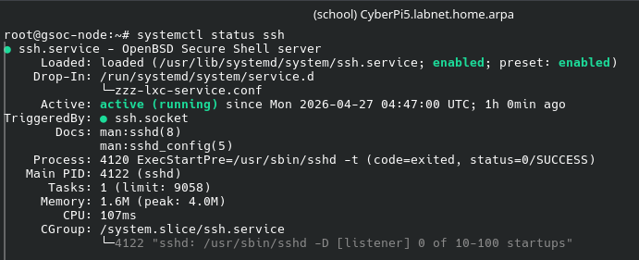
Figure 3:
UFW configuration showing port 22 and 3306 set to allow
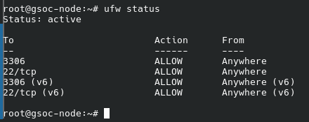
Task 1.2: Remote Administrative Handshake
Connecting to the Node via PuTTY: Rather than exposing the container directly to the network, I configured PuTTY to SSH into the Raspberry Pi host and execute incus shell gsoc-node as a remote command upon login. This keeps the container's internal Incus network address completely unreachable from outside the Pi, meaning the container has no direct attack surface on the local network. Only the Pi's SSH port is exposed, and access to the container is gated behind it. (see figure 4-6)
Figure 4:
Putty configuration: connection to host Pi5
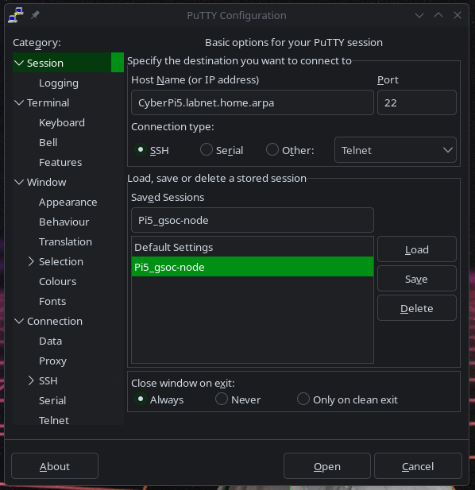
Figure 5:
Remote command to automatically access the shell after host connection
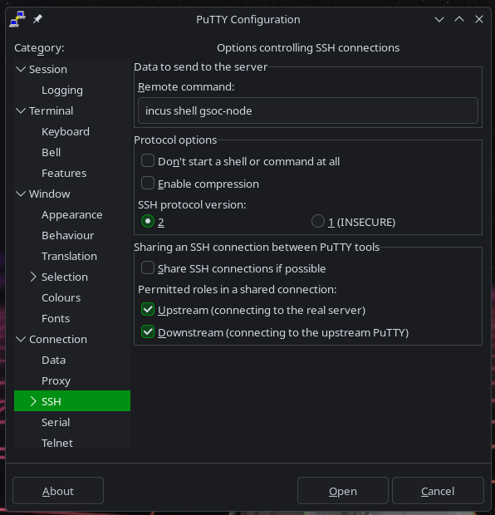
Figure 6:
Successful connection to gsoc-node
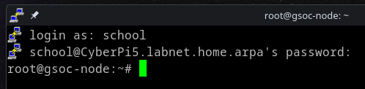
Connect via DBeaver using an SSH Tunnel: In order to use a graphical database manager such as DBeaver with an isolated container, an SSH tunnel must be implemented. DBeaver is configured to first authenticate through the Raspberry Pi via SSH, then forward the database connection through to MySQL running inside the gsoc-node container on port 3306. This allows full GUI access to the database without ever exposing MySQL directly to the network — the only publicly reachable entry point remains the Pi's SSH port. (see figures 7-9)
Figure 7:
Container connection details
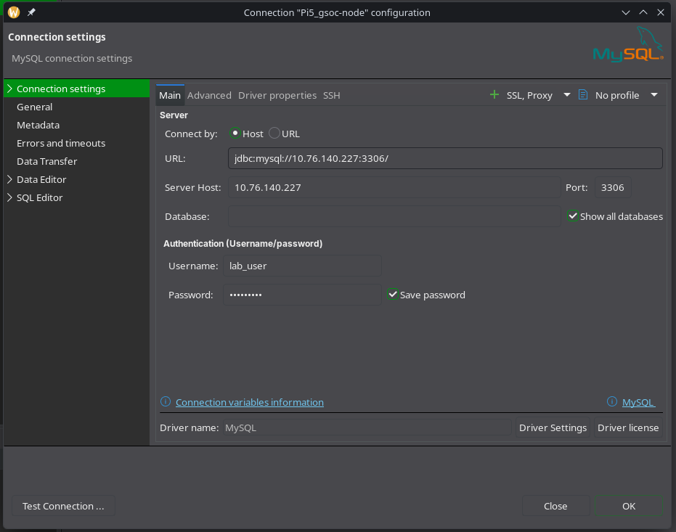
Figure 8:
SSH settings to connect to the Pi5
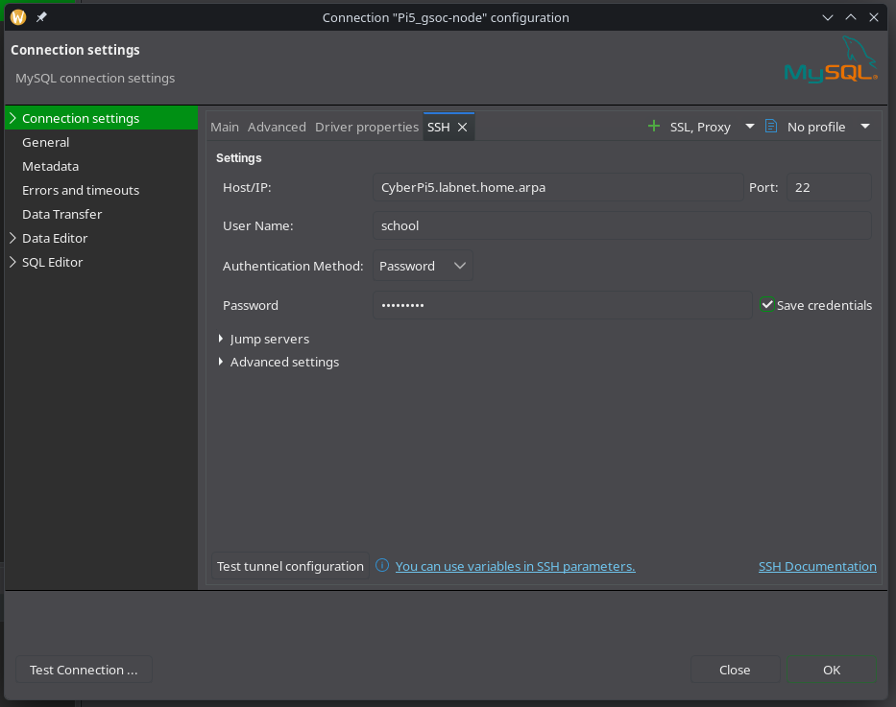
Figure 9:
Successful container database connection
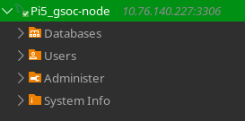
CLI vs GUI: PuTTY and DBeaver serve different administrative purposes within the project environment. PuTTY functions as a Command Line Interface (CLI) tool, allowing remote administration through direct shell access and command execution over SSH. DBeaver functions as a Graphical User Interface (GUI) database management tool, providing a more visual and user-friendly method for interacting with MySQL databases, executing queries, and reviewing schema structures. A Cloud Engineer requires both CLI and GUI tools because CLI access is essential for system-level administration and troubleshooting, while GUI tools improve efficiency for database analysis, monitoring, and management tasks.
Phase 2: Intelligence & Integration
Task 2.1: Designing the Analytical Warehouse
Figure 10:
Statements to create the Users and Locations dim tables
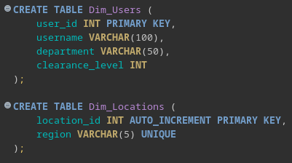
Figure 11:
Statement to create the Fact_Security_Events table
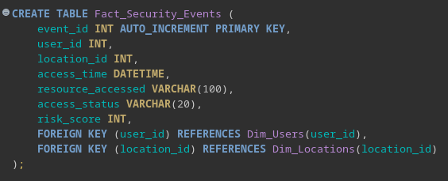
Figure 12:
Populating the Dim_Users table
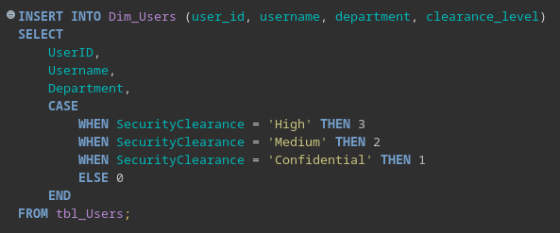
Figure 13:
Populating the Dim_Locations table
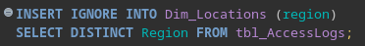
Figure 14:
Populating the Facts_Security_Events table
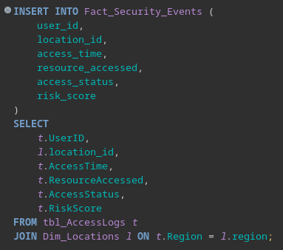
Figure 15:
ER Diagram
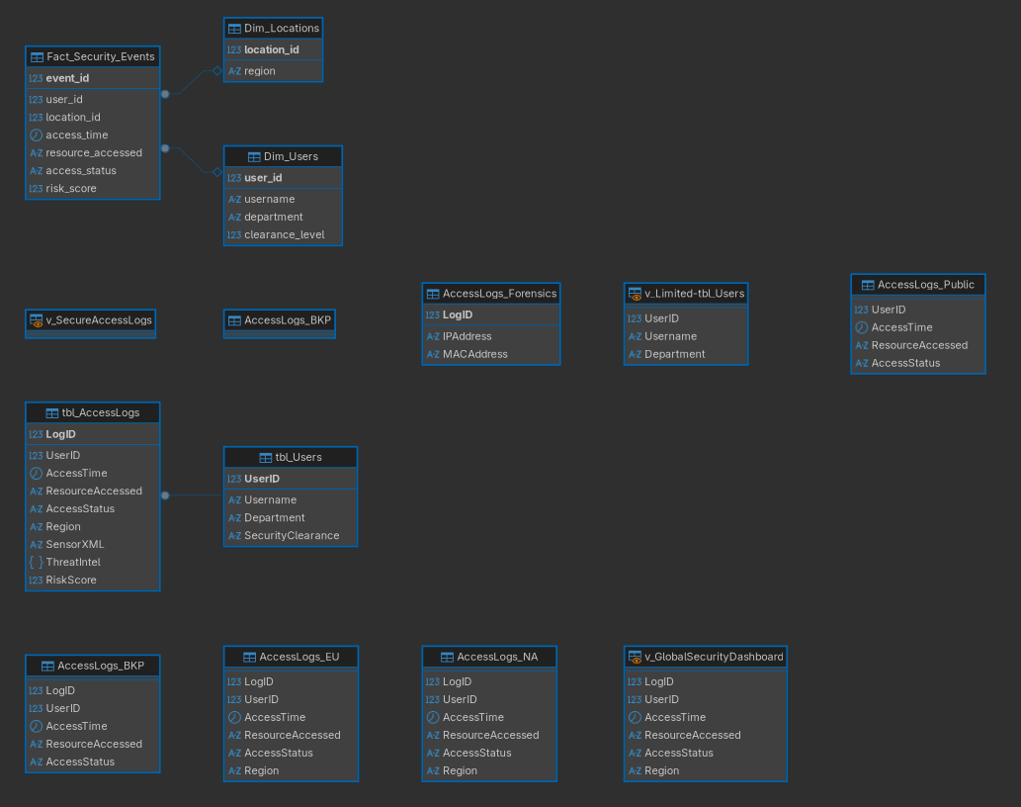
Star Schema vs. 3NF: A Star Schema is more efficient for data analysis than a 3rd Normal Form (3NF) model because it is optimized for read-heavy operations and analytical queries. In a 3NF design, data is highly normalized and spread across many related tables, which requires complex joins to retrieve data. This increases query complexity and reduces performance when analyzing large datasets. In contrast, a Star Schema organizes data into a central Fact table surrounded by Dimension tables, minimizing the number of joins required. This structure allows queries to aggregate and filter data more efficiently, making it ideal for reporting and security analytics. This is especially important for executive dashboards where security administrators require access to real-time data without delays caused by complex normalized queries.
The Role of a ‘Fact Table’: The Fact_Security_Events table serves as the central record of all security-related events within the system. Each row represents a single access attempt, including details such as the user, location, time, resource accessed, status, and associated risk score. In a security context, the Fact table enables analysts to track patterns of behavior, identify suspicious activity, and generate reports such as failed login attempts by region or high-risk access events. By linking to Dimension tables, the Fact table provides a structured and efficient way to analyze large volumes of security data.
Task 2.2: Object-Oriented Semi-Structured Data
Figure 16:
Using ExtractValue() to pull ‘status’ metadata
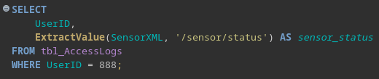
Figure 17:
Output for UserID 888
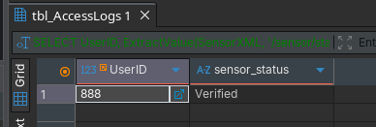
Figure 18:
Using the JSON operator to extract risk scores
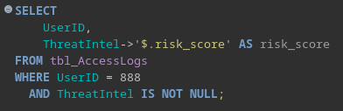
Figure 19:
Extracted risk score from UserID 888
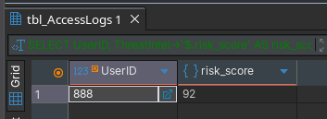
XML and JSON – Schema Flexibility: XML and JSON columns provide schema flexibility by allowing a security command center to store complex and evolving data without requiring changes to the relational database structure. For example, the ThreatIntel JSON column can store varying threat attributes such as risk scores or indicators of compromise, while the SensorXML column can store device-specific metadata like sensor type, firmware version, and verification status. As new fields or attributes are introduced, they can be added directly to the XML or JSON data without altering table schemas, making the system adaptable to changing security requirements.
Trade offs: However, there are trade-offs when using semi-structured data. While XML and JSON provide flexibility, they require additional parsing logic (such as ExtractValue() or JSON operators) to retrieve specific values, which increases query complexity. Additionally, queries on semi-structured data are generally less efficient than those on standard relational columns, especially for large datasets, and may be harder to index and optimize. In contrast, traditional columns are faster and easier to query but lack the flexibility needed for dynamic or evolving data structures.

Phase 3: Production Wrap-Up
Task 3.1: Performance Audit and Optimization
Figure 20:
EXPLAIN command to identify an unoptimized query (type: ALL)
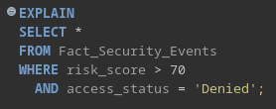
Figure 21:
Results of the command showing the unoptimized query
Figure 22:
Command to create a composite index on the risk_score and access_status
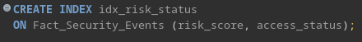
Figure 23:
Re-run of the EXPLAIN command from figure 20 showing optimization
Physical mechanism of an index: A database index works similarly to the index of a textbook. Instead of scanning every row in a table, the database engine can use index structures to quickly locate relevant records. Internally, most database indexes are implemented using B-Trees, which organize values in a sorted hierarchical structure. This allows MySQL to efficiently search, filter, and retrieve matching rows without performing a full table scan.
Why indexes speed up SELECT queries: Indexes improve SELECT query performance because the database can directly navigate to matching values rather than reading every row in the table. In this project, the composite index on risk_score and access_status allowed MySQL to reduce the number of scanned rows dramatically, changing the query execution type from ALL (full table scan) to range, which is significantly more efficient for analytical workloads.
Why indexes can slow down INSERT operations: Although indexes improve read performance, they can reduce write performance because every INSERT, UPDATE, or DELETE operation requires the index structure to also be updated. When new rows are inserted, MySQL must maintain the sorted B-Tree structure of the index, which adds additional processing overhead. As a result, heavily indexed tables may experience slower insertion speeds compared to tables without indexes.

Task 3.2: Concurrency Controls and Auditing
Figure 24:
Command to create a Concurrency_Audit table to log update attempts
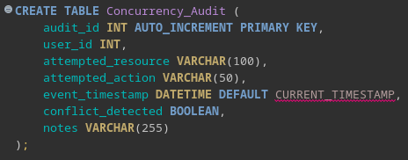
Figure 25:
ALTER TABLE statement to implement ‘Optimistic Locking’ using a version column to detect and log simultaneous update collisions.
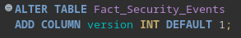
Importance of Concurrency Controls: Concurrency controls are essential in a multi-user database environment because they protect data integrity when multiple users attempt to access or modify the same records simultaneously. Without concurrency controls, conflicting updates could overwrite one another, resulting in inconsistent or inaccurate data. Optimistic locking helps prevent these collisions by using a version column to verify that a record has not been modified by another transaction before an update is committed. If the version value changes unexpectedly, the system can detect the conflict and reject or log the update attempt rather than silently overwriting data.
Importance of an Audit Trail in Security Forensics: Audit trails provide a historical record of database activity, including update attempts, detected conflicts, and suspicious actions. In a security operations environment, audit logs are critical for forensic analysis because they allow investigators to determine who performed an action, what resource was targeted, when the event occurred, and whether a concurrency conflict or insider-threat event was detected. Maintaining an audit trail improves accountability, supports incident investigations, and helps organizations identify abnormal behavior patterns or unauthorized modification attempts. A sample collision event was recorded in the Concurrency_Audit table to demonstrate how optimistic locking conflicts and suspicious update attempts could be tracked within a multi-user security environment. (see figure 26)
Figure 26:
Simulated recorded event shown in the Concurrency_Audit table

