Global Unified Security Command (GUSC)

Thomas Adkins
BAT Program, Lone Star College
ITCS-3330 W005 1 Applied Database Management
Dr. Watson
April 26, 2026

Phase 0: The Architecture Design
Task 0.1: Infrastructure Mapping
- The infrastructure will consist of a main PC running CachyOS and Windows 11 where necessary, and a Raspberry Pi 5 running Ubuntu. The Main computer will connect to the Pi 5 through either ssh via Konsole, Terminal, PowerShell, or Putty — or through Dbeaver. Then, the Pi 5 can connect to the “Cloud Node” (gsoc-node) through Incus. (see figure 1)
Figure 1:
Infrastructure mapping
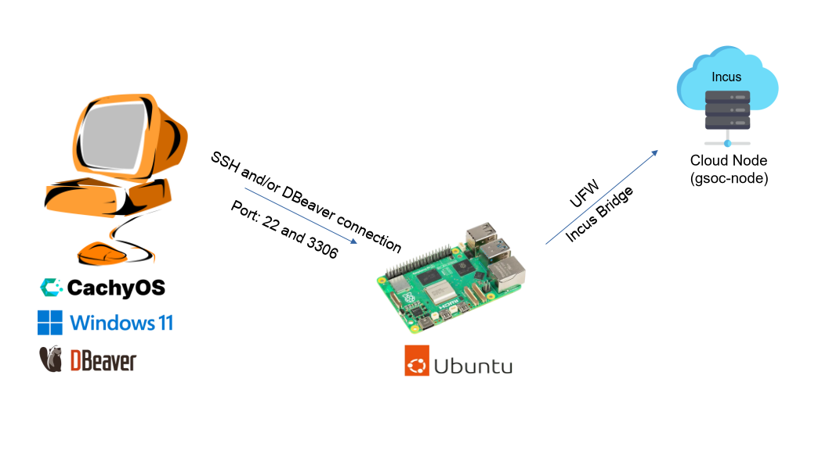

Task 0.2: Data Flow Logic
- Ingestion: The actual data itself originates from the security_logs.csv file that was provided for lab 6.2 and imported into the tbl_AccessLogs table inside of the GSOC_Security database. After this import, the table went from 5 to 1005 rows. This data includes “Object-Oriented” extensions such as XML (stored in SensorXML) and JSON (stored in ThreatIntel).
- Normalization: By starting with 3rd Normal Form (3NF), redundancy can be eliminated so that each transaction interacts with only one core version of the database. This makes operations such as ROLLBACK, row-level locking, and ACID compliance reliable and consistent.
- Intelligence: Once data has been normalized into 3NF, it must be transformed into a Star Schema for the final reporting phase because 3NF is optimized for writing transactions, not reading at scale. The Star Schema organizes data into a central Fact Table surrounded by Dimension Tables (such as Dim_Time, Dim_Location, and Dim_Resource), which eliminates the complex multi-table joins that 3NF requires. This allows executive queries — like identifying which resource type had the highest number of denied attempts during the night shift — to aggregate millions of rows with minimal overhead, producing near-instant results where a flat or normalized table could take minutes.

Task 0.3: Security Protocol Specification
Table 1:
Port | Service | Rule | Justification
22 | SSH | Allow — restricted to administrative access only | Port 22 is the entry point for all administrative access to both the Raspberry Pi host and the gsoc-node container. It is not blocked entirely because it is required for PuTTY connections and DBeaver's SSH tunnel, but exposure is minimized by keeping the container off the public network entirely and requiring authentication through the Pi first.
3306 | MySQL | Allow within network — blocked from public internet | Port 3306 is the MySQL database port. It is allowed within the internal Incus network so that DBeaver can reach it through the SSH tunnel, but it is never exposed directly to the public internet. Exposing a database port publicly would allow anyone to attempt direct authentication against the database, bypassing all other security layers.
Task 0.4: Security Architecture Overview
- Tiered Security: The project uses a tiered security model with two layers of protection. The Raspberry Pi acts as the first layer, serving as the host system that the gsoc-node container runs on top of. Even if the database inside the container were compromised, an attacker would theoretically be confined to the container itself rather than gaining access to the Pi's main operating system. The container then adds a second layer through its own UFW firewall, which is configured to explicitly allow only port 22 for SSH and port 3306 for MySQL traffic while blocking all other unsolicited incoming connections — meaning the container is only reachable through two very specific and controlled entry points.
- Data Gravity: Data Gravity is the concept that as data grows larger, it becomes increasingly impractical to move it. In this project, rather than exporting the entire GSOC_Security database to a local machine, DBeaver can be used to connect directly to the databases running inside the Raspberry Pi and its containers. This keeps the data where it lives while still giving the analyst a full-featured GUI to interact with it, avoiding the overhead, security risks, and potential inconsistencies that would come with constantly moving large datasets around.
Phase 1: The Secure Cloud Foundation
Task 1.1: Securing the Cloud Gateway
- Principle of Least Privilege — Network Ports: The Principle of Least Privilege states that a system should only be granted the minimum level of access required to perform its intended function. In the context of network ports, this means that every port that is not explicitly needed should be closed by default, which is the foundation of UFW's Default Deny policy. Port 3306 is restricted because exposing MySQL directly to the public internet would allow anyone to attempt authentication against the database, bypassing every other security layer in the stack. SSH on Port 22 is the preferred method for remote administration because it encrypts all traffic in transit, meaning credentials and commands cannot be intercepted, and serves as a single controlled entry point that can be monitored and locked down. Although UFW displays both ports as ALLOW from "Anywhere", this is constrained in practice by the container's placement inside the internal Incus network. The only host that can physically reach the container is the Raspberry Pi itself, adding an additional layer of network isolation beyond what UFW alone provides. (see figures 2-3)
Figure 2:
SSH is enabled and running within the gsoc-node
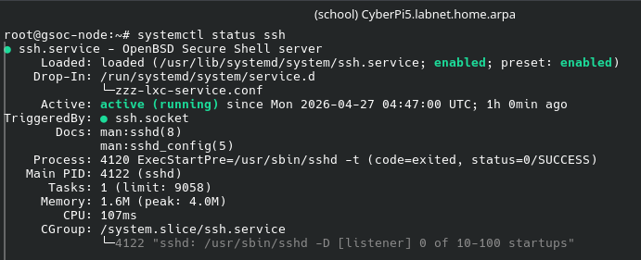
Figure 3:
UFW configuration showing port 22 and 3306 set to allow
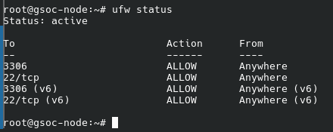

Task 1.2: Remote Administrative Handshake
- Connecting to the Node via PuTTY: Rather than exposing the container directly to the network, I configured PuTTY to SSH into the Raspberry Pi host and execute incus shell gsoc-node as a remote command upon login. This keeps the container's internal Incus network address completely unreachable from outside the Pi, meaning the container has no direct attack surface on the local network. Only the Pi's SSH port is exposed, and access to the container is gated behind it. (see figure 4-6)
Figure 4:
Putty configuration: connection to host Pi5
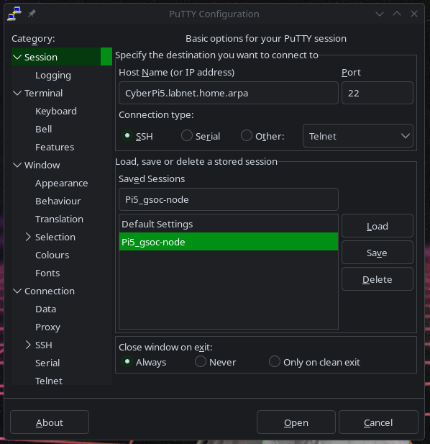
Figure 5:
Remote command to automatically access the shell after host connection
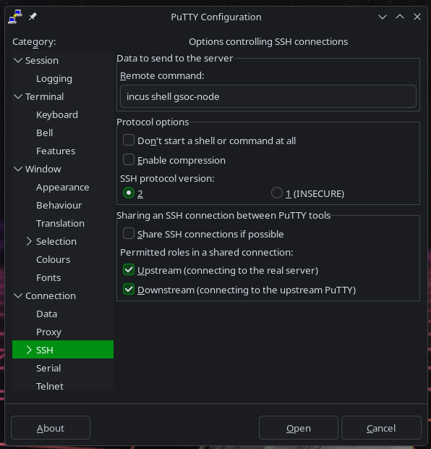
Figure 6:
Successful connection to gsoc-node
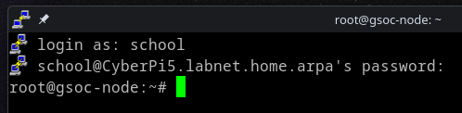
- Connect via DBeaver using an SSH Tunnel: In order to use a graphical database manager such as DBeaver with an isolated container, an SSH tunnel must be implemented. DBeaver is configured to first authenticate through the Raspberry Pi via SSH, then forward the database connection through to MySQL running inside the gsoc-node container on port 3306. This allows full GUI access to the database without ever exposing MySQL directly to the network — the only publicly reachable entry point remains the Pi's SSH port. (see figures 7-9)
Figure 7:
Container connection details
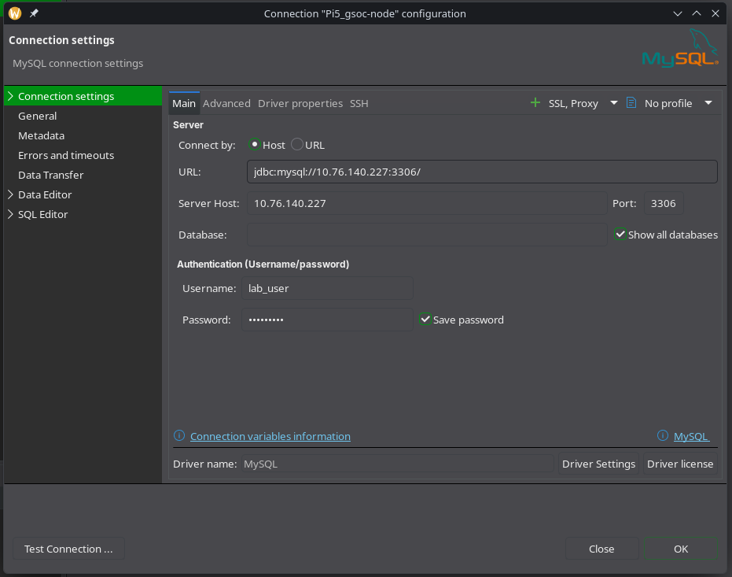
Figure 8:
SSH settings to connect to the Pi5
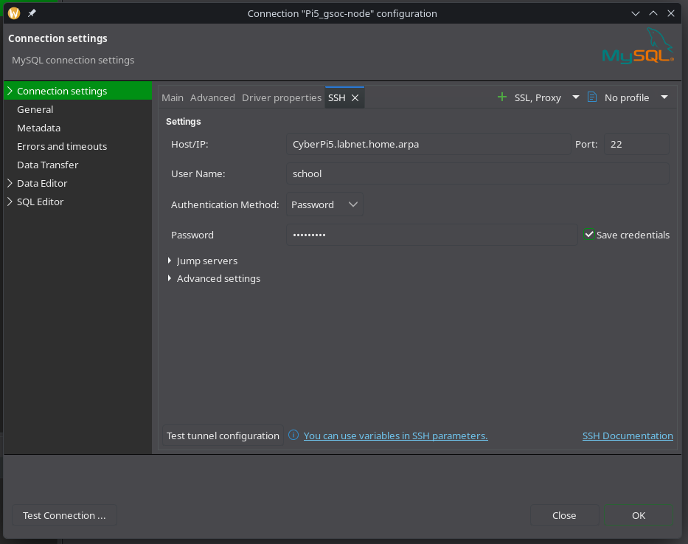
Figure 9:
Successful container database connection
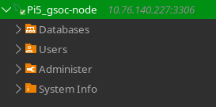
Phase 2: Intelligence & Integration
Task 2.1: Designing the Analytical Warehouse
Figure 10:
Statements to create the Users and Locations dim tables
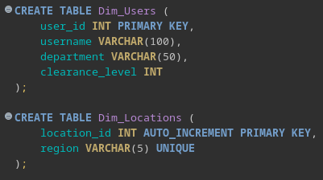
Figure 11:
Statement to create the Fact_Security_Events table
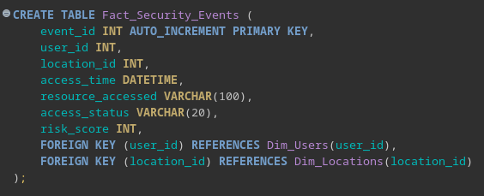
Figure 12:
Populating the Dim_Users table
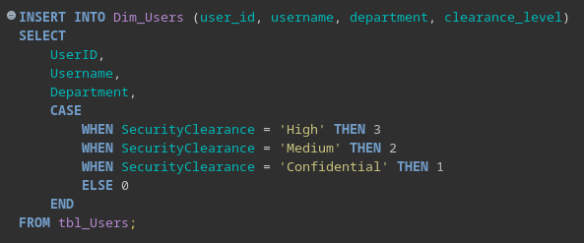
Figure 13:
Populating the Dim_Locations table
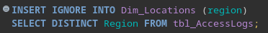
Figure 14:
Populating the Facts_Security_Events table
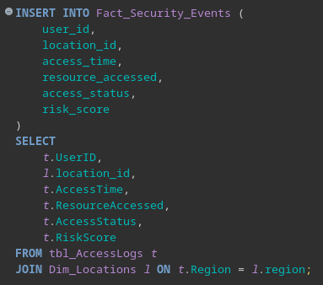
Figure 15:
ER Diagram
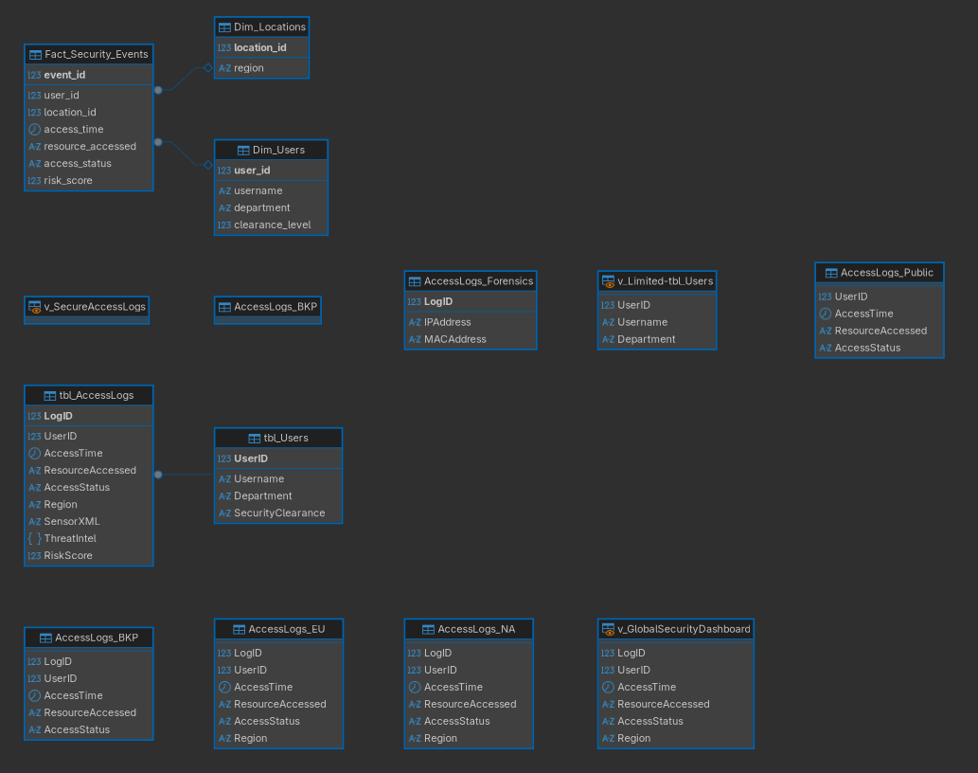
Why Star Schema Are More Efficient: A Star Schema is more efficient for data analysis than a 3rd Normal Form (3NF) model because it is optimized for read-heavy operations and analytical queries. In a 3NF design, data is highly normalized and spread across many related tables, which requires complex joins to retrieve data. This increases query complexity and reduces performance when analyzing large datasets. In contrast, a Star Schema organizes data into a central Fact table surrounded by Dimension tables, minimizing the number of joins required. This structure allows queries to aggregate and filter data more efficiently, making it ideal for reporting and security analytics.
The Role of a ‘Fact Table’: The Fact_Security_Events table serves as the central record of all security-related events within the system. Each row represents a single access attempt, including details such as the user, location, time, resource accessed, status, and associated risk score. In a security context, the Fact table enables analysts to track patterns of behavior, identify suspicious activity, and generate reports such as failed login attempts by region or high-risk access events. By linking to Dimension tables, the Fact table provides a structured and efficient way to analyze large volumes of security data.
Task 2.2: Object-Oriented Semi-Structured Data
Figure 16:
Using ExtractValue() to pull ‘status’ metadata
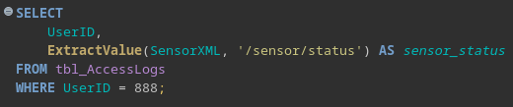
Figure 17:
Output for UserID 888
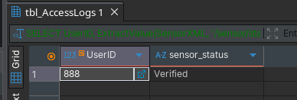
Figure 18:
Using the JSON operator to extract risk scores
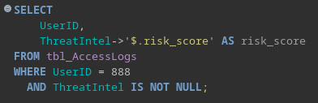
Figure 19:
Extracted risk score from UserID 888
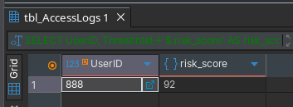
XML and JSON – Schema Flexibility: XML and JSON columns provide schema flexibility by allowing a security command center to store complex and evolving data without requiring changes to the relational database structure. For example, the ThreatIntel JSON column can store varying threat attributes such as risk scores or indicators of compromise, while the SensorXML column can store device-specific metadata like sensor type, firmware version, and verification status. As new fields or attributes are introduced, they can be added directly to the XML or JSON data without altering table schemas, making the system adaptable to changing security requirements.
Trade offs: However, there are trade-offs when using semi-structured data. While XML and JSON provide flexibility, they require additional parsing logic (such as ExtractValue() or JSON operators) to retrieve specific values, which increases query complexity. Additionally, queries on semi-structured data are generally less efficient than those on standard relational columns, especially for large datasets, and may be harder to index and optimize. In contrast, traditional columns are faster and easier to query but lack the flexibility needed for dynamic or evolving data structures.
Phase 3: Production Wrap-Up
Task 3.1: Performance Audit and Optimization
Task 3.2: Concurrency Controls and Auditing

