Assignment 7 – SOC Analyst Simulation

Thomas Adkins
BAT Program, Lone Star College
ITCS-3301 W005 1 Data Structures & Algorithms
Professor Lindstrom
March 25, 2026

Priority Queues in Cybersecurity
SOC Dashboard
Screenshot 1 SOC Dashboard
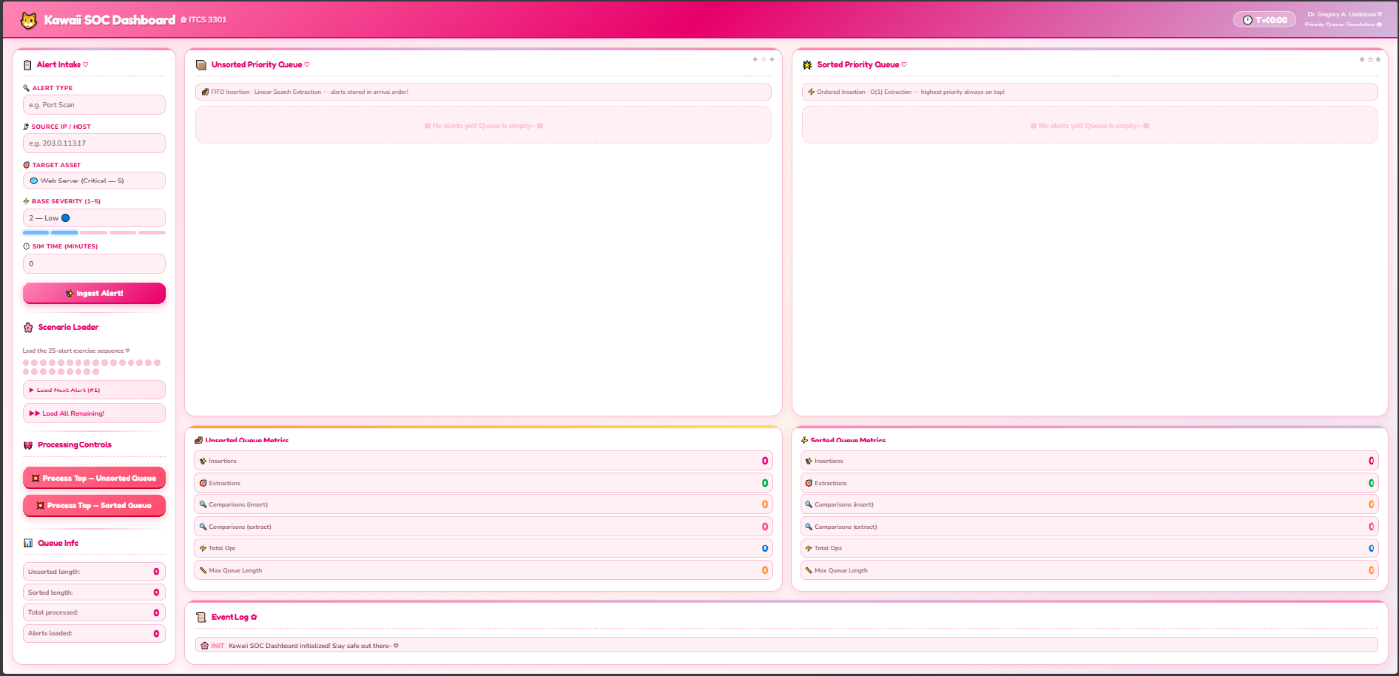
Alert Intake
Screenshot 2 Alert Intake Unsorted Queue Insertion
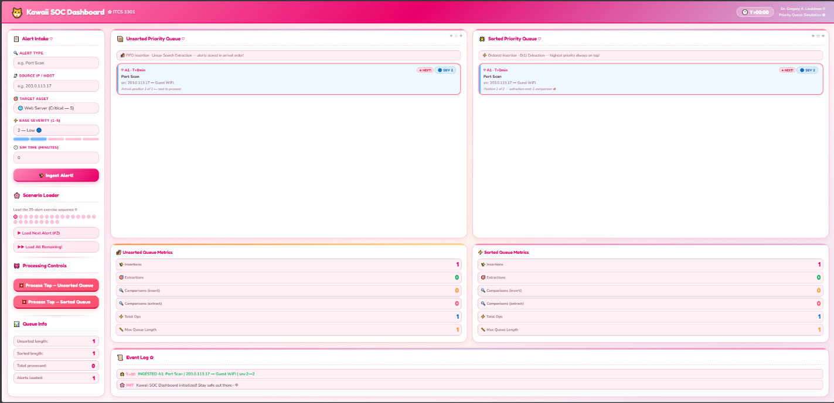
Sorted Queue State – Mid-Simulation
Screenshot 3 Sorted Queue Mid Sim
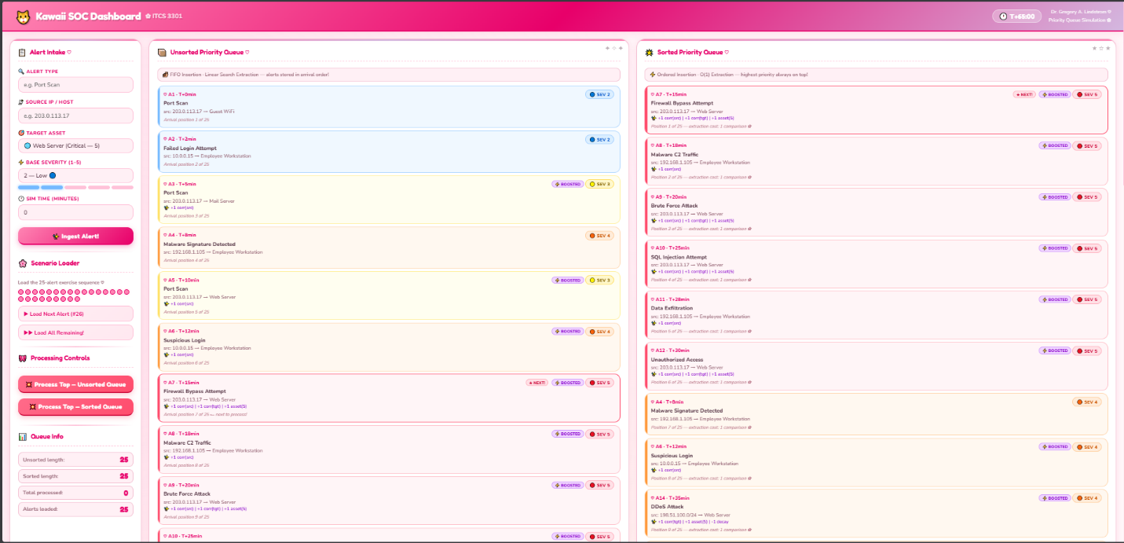
Dynamic Reprioritization in Action
Screenshot 4 Reprioritization

Queue Comparison Side by Side
Screenshot 5 Queue Comparison

Alert Processing / Extraction
Screenshot 6 Alert Processing Extraction
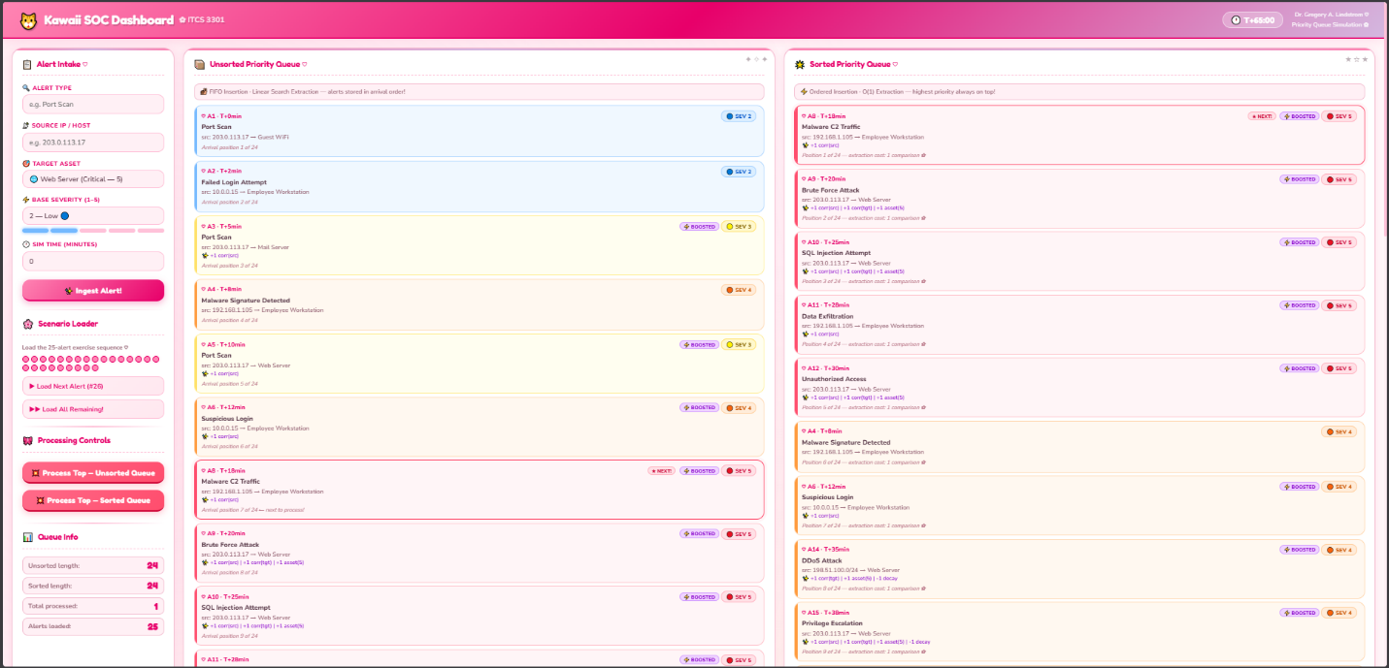
Performance Metrics Display
Screenshot 7 Performance Metrics
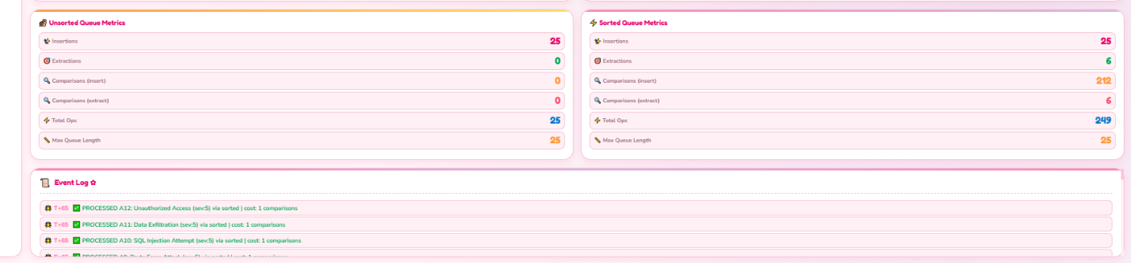
Attack Phases and Progression
The attack began at T+0 with a port scan from 203.0.113.17 targeting the Guest Wi-Fi, which was the attacker's way of quietly looking for weak points in the network before doing anything aggressive. Around the same time, a separate IP address (10.0.0.15) attempted a failed login on an Employee Workstation, suggesting a second attacker or a second method of entry was being tried at the same time. By Alert 3, the same IP from the first port scan had already scanned the Mail Server as well, which triggered a severity boost due to the repeated activity from the same source within 30 minutes. Alert 4 was where it started to get serious: malware was successfully installed on an employee workstation, meaning the attacker was no longer just looking around, they were now inside. Alerts 7 through 12 marked the most intense escalation, with the attacker attempting a Firewall Bypass, establishing Malware Command and Control traffic, launching a Brute Force Attack on the Web Server, attempting SQL Injection and gaining unauthorized access to the web server. The final stretch from Alerts 13 through 25 showed the attacker shifting focus toward the Customer Database, ending with Ransomware Activity, the creation of a new Admin Account, and finally Log Deletion at T+65, which was a clear attempt to erase any evidence of what had happened.
Threat Actor Intent and Impact Assessment
The attacker was clearly financially motivated, with their primary goal being to steal valuable customer data and then encrypt it to extort payment from the company. This double extortion approach: stealing the data first with Alert 19 (Customer Data Access) and then encrypting it with Alerts 20 and 22 (Data Encryption and Ransomware Activity), meant the company faced two simultaneous threats: being locked out of their own systems and having sensitive customer data potentially leaked publicly if the ransom was not paid. The Log Deletion in Alert 25 was particularly damaging because it likely destroyed much of the forensic trail that investigators would need to understand the full scope of the breach, making recovery and attribution significantly harder. The most operationally devastating alerts were the Ransomware Activity and Data Encryption targeting the Customer Database, as these directly disrupted business operations and put customer data at serious legal and reputational risk. While both queue types captured all 25 alerts, the sorted priority queue would have given analysts the best chance of early intervention. Critical alerts like the Firewall Bypass at Alert 7 and the SQL Injection at Alert 10 were surfaced immediately at the top of the queue, meaning a fast-responding analyst could have potentially blocked the attacker before the ransomware was ever deployed, whereas the unsorted queue would have buried those same alerts among lower priority ones, costing critical response time.

