**Flat Earth Society**

**2:45AM 19/8/2018**

**URGENT: NEW CLASSIFIED INFORMATION.**

IT HAS COME TO OUR ATTENTION THAT THERE HAS BEEN A LARGE AMOUNT OF INTERNET TRAFFIC BETWEEN BBC HQ AND AN UNKNOW ADDRESS IN LEWES, EAST SUSSEX. THE SENDER OF THIS DATA IS SUSPECTED TO BE **SCHUTZSTAFFEL** **SAMANTHA** (aka. STRAWBERRY SMELLING SAMANTHA). LAST KNOW PICTURE ATTACHED.

OUR INTEL SUGGESTS THAT THIS INDIVIDUAL IS A HYPNOTIST, CAPABLE OF DECEIVING VICTIMS INTO BELIEVING THAT THE EARTH IS COMPLETELY ROUND, NOT THE HEMISPHERE OUR EVIDENCE SUGGESTS, IN AN EXPERIMENT CONDUCTED BY THE **BBC** (BRITISH INTELLIGENCE).

SHE IS THEN FURTHER CONVINCING THEM OF A 7TH CONTINENT, A ‘PERFECT’ PLACE – **AMERICA**. AS YOU ARE AWARE, AMERICA AND THE OTHER HALF OF THE GLOBE WAS REMOVED IN **WORLD WAR IV**.

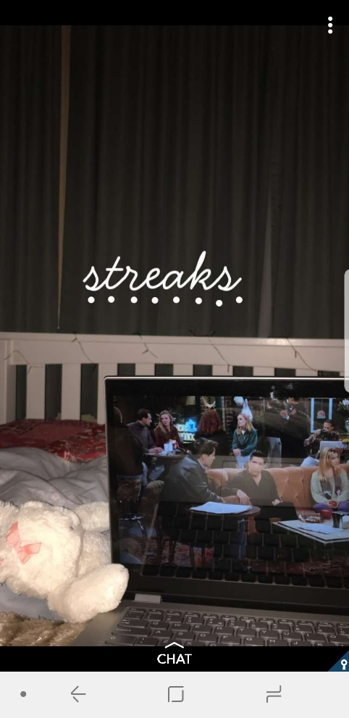PLEASE MAY ALL SOCIETY MEMBERS BE CAREFULL WHEN AROUND LEWES, AND STAY AWARE OF ANY STRANGER WHO COULD BE **SS SAMANTHA.**

MANY THANKS,

**THE FLAT EARTH SOCIETY**