**Flat Earth Society**

**7:16PM 19/8/2018**

**URGENT: NEW CHARACTER PROFILE.**

**SS SAMANTHA**

**AKA:** STRAWBERRY SMELLING SAMANTHA

Schutzstaffel SAMANTHA

**hEIGHT:** 1‘ 6“ OR 46CM

**gENDER:** fEMALE (aSSUMED)

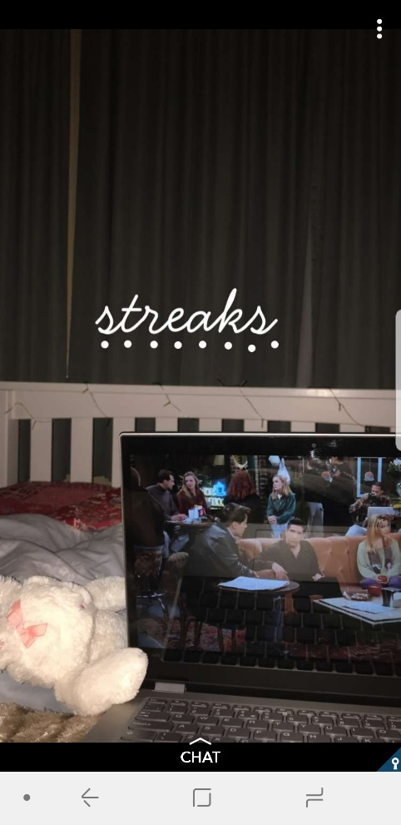**dESCRIPTION:** wHITE CAUCASIAN RABBIT, LARGE EARS AND 1 PINK BOW ON FOREHEAD – BLACK EYES.

**lIKES:** tv SHOW fRIENDS

**DISLIKES:** fLAT eARTHERS

**LAST KNOWN PHOTO IS ATTACHED**

**IF ANYONE HAS ANY MORE INFO ON SS SAMANTHA, DO NOT HESITATE TO UPDATE THIS.**