De only

parmeters

1 hidden layer with 128 nueron
np = 50
extination = 300
extanation perc = .2
genrations = 1200
F = .8
cr = .7
seed = 31

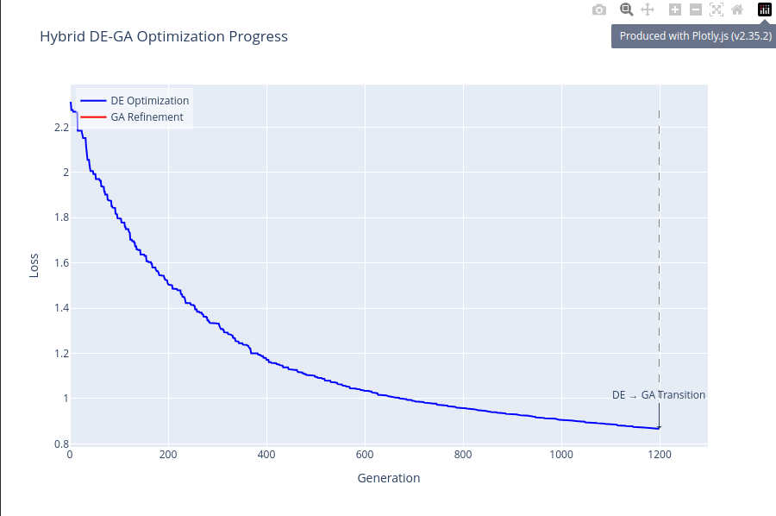
acc on test = 78.1
test loss = .85
time = 22 min

second try:

parmeters

1 hidden layer with 32 nueron
np = 100
extination = 150
extanation perc = .2
genrations = 900
F = 1.2
cr = .7
seed = 32

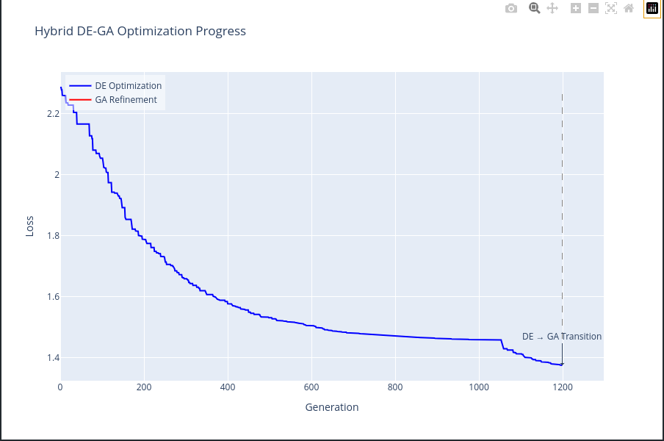
acc:64.16
loss:1.35
time:18.29 mmin

third try:
parmeters

1 hidden layer with 128 nueron
np = 100
extination = 200
extanation perc = .2
genrations = 700
F = .8
cr = .7
seed = 33

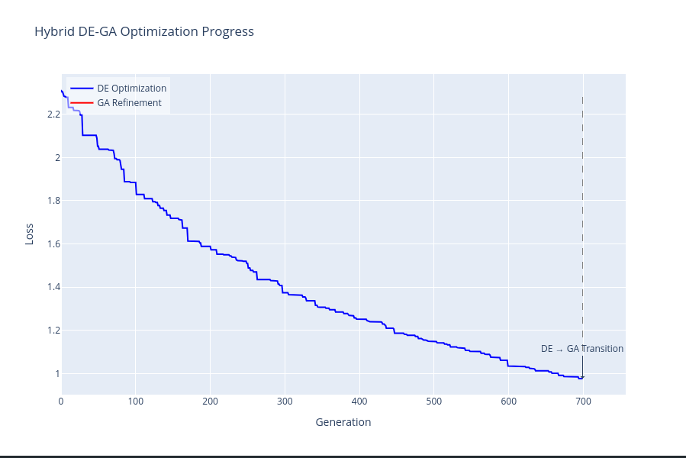
acc: 73.57
loss : 0.95
time: 24.29

fourth:
second try:

parmeters

1 hidden layer with 32 nueron
np = 50
extination = 100
extanation perc = .2
genrations =1200
F = .8
cr = .7
seed = 34

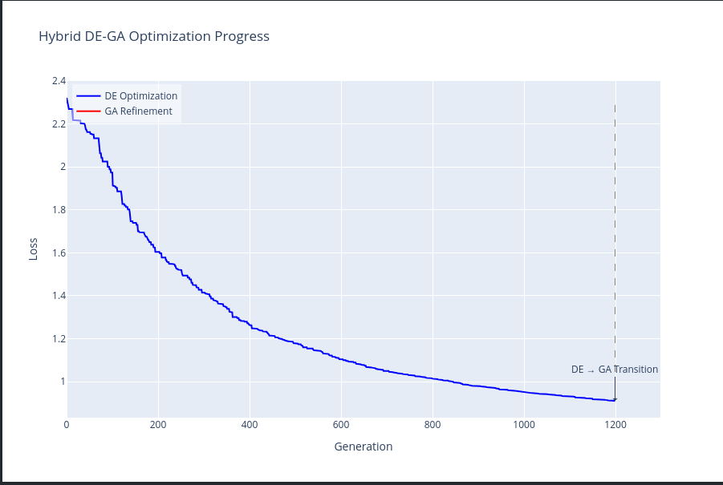
acc: 77.59
loss: .89
time: 22.5

