**GPO**

Lock user account if wrong login 5 times.

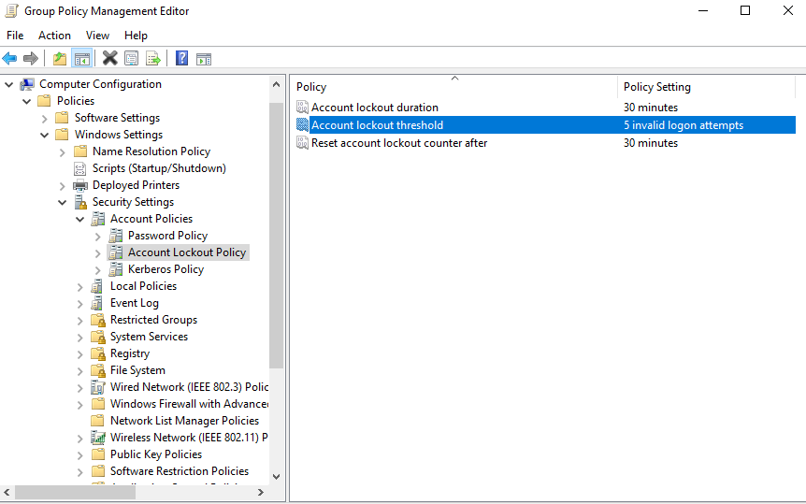

The default website when accessing is: www.vlute.edu.vn

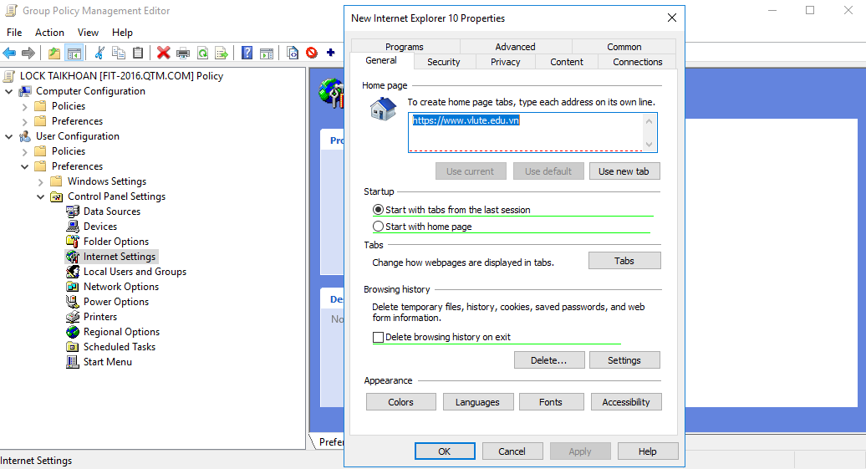

User must change password on first login.

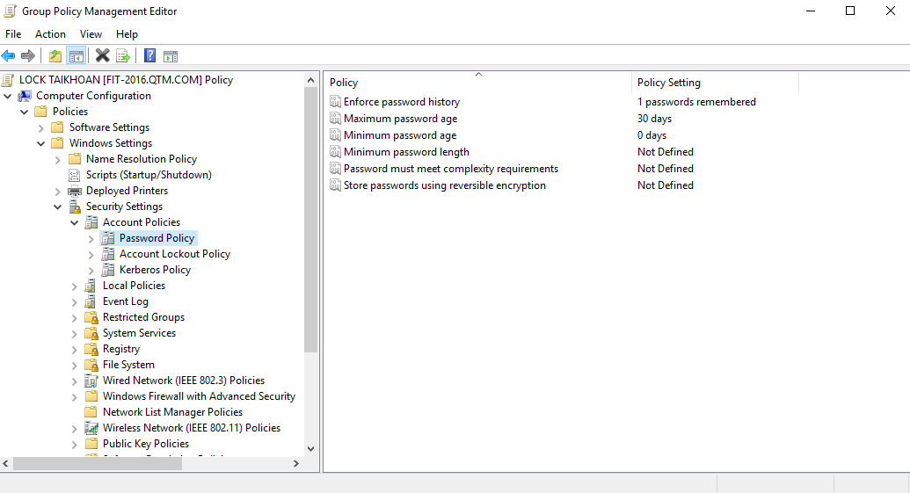

Password must be at least 3 characters long.

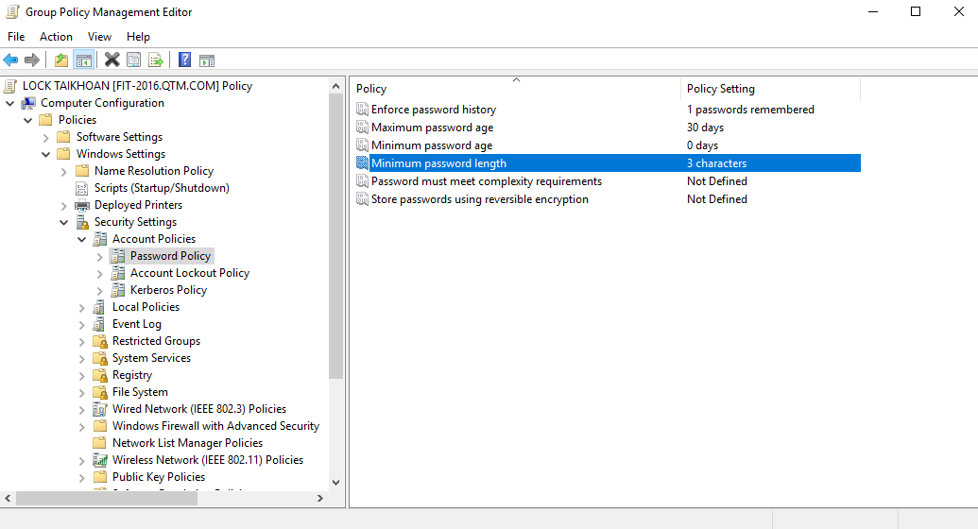

Prohibit Access to the Control Panel Function

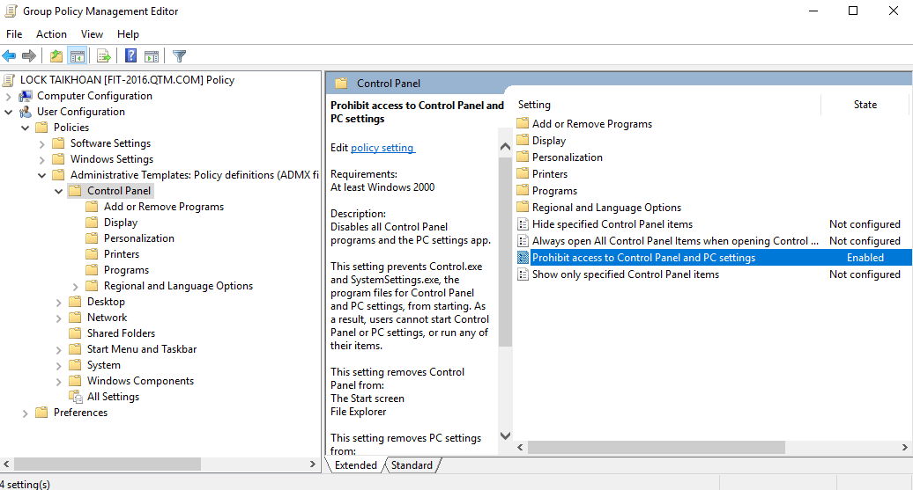

Forbid Access to the Command Prompt

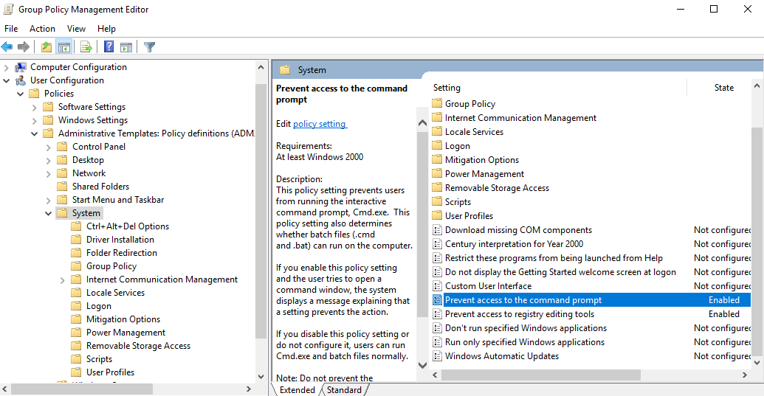

Set Default Desktop for Each User

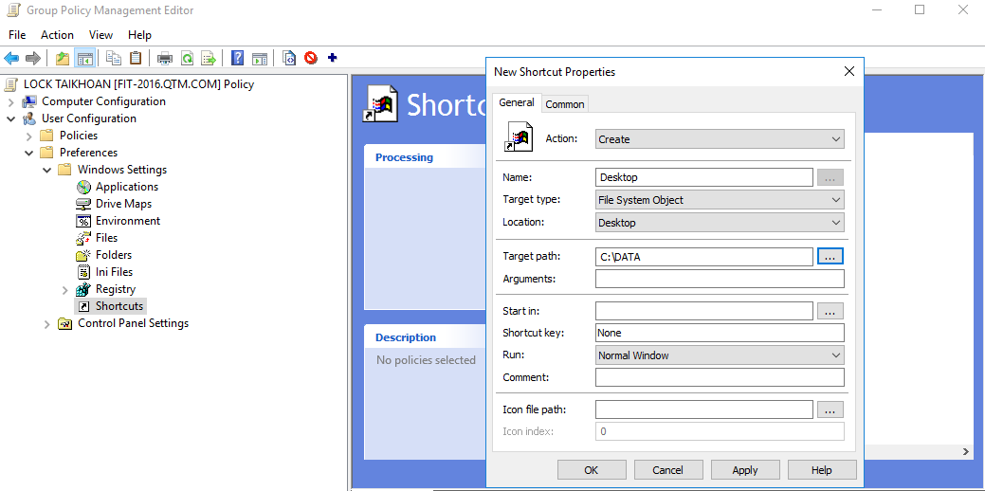

Remove Complicated Password Policy

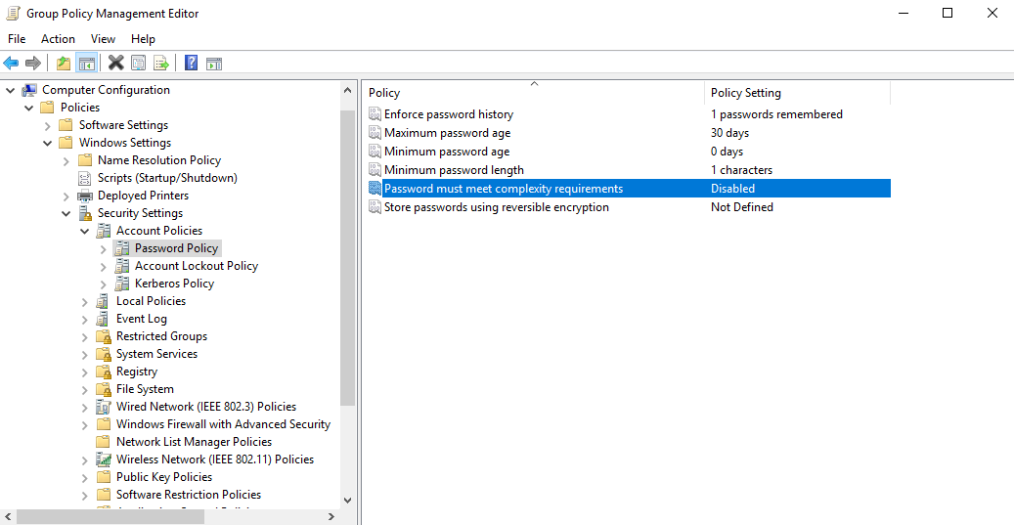

Allows nv users to logon only on MAY1

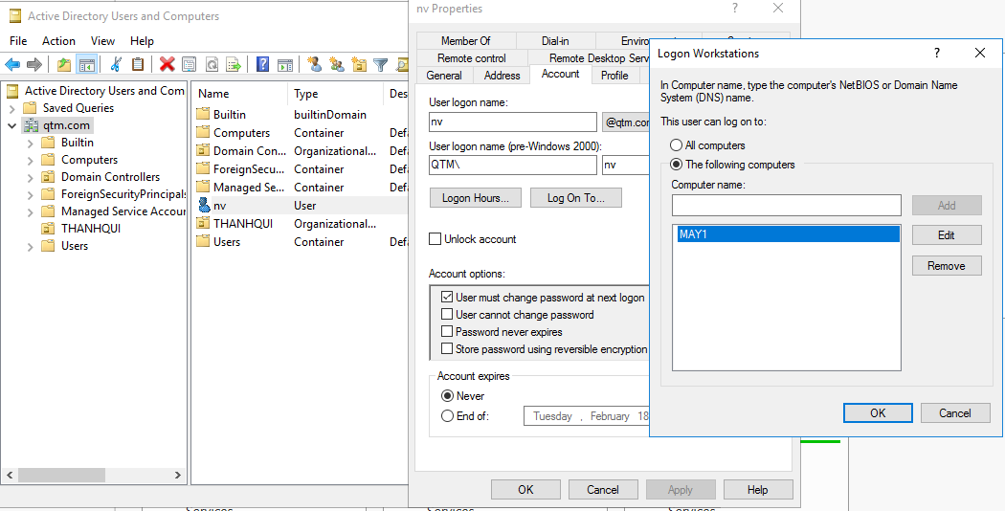

Allow users of the TOT_NGHIEP group to have local Administrators rights on the Client machine.

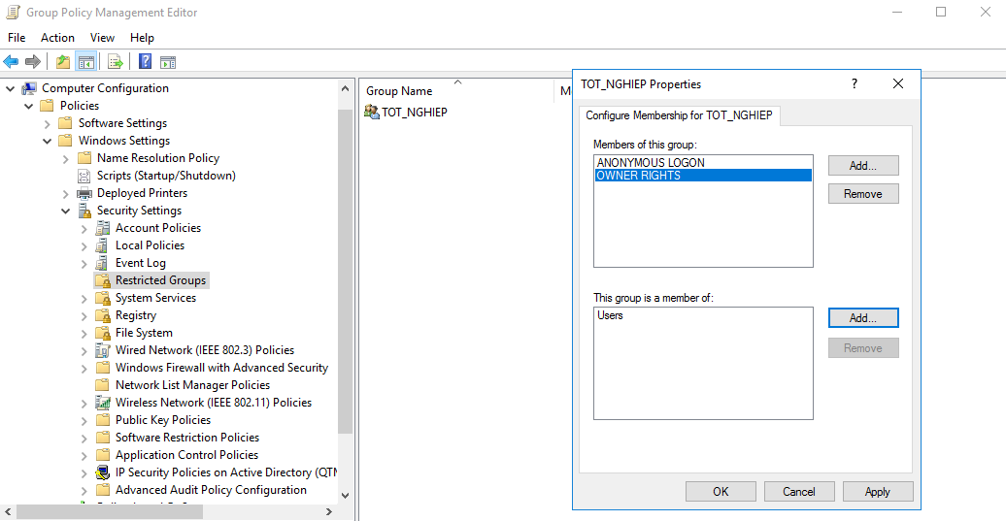

Prohibit the Kinhte OU from Installing Additional Software (Except MS Office)

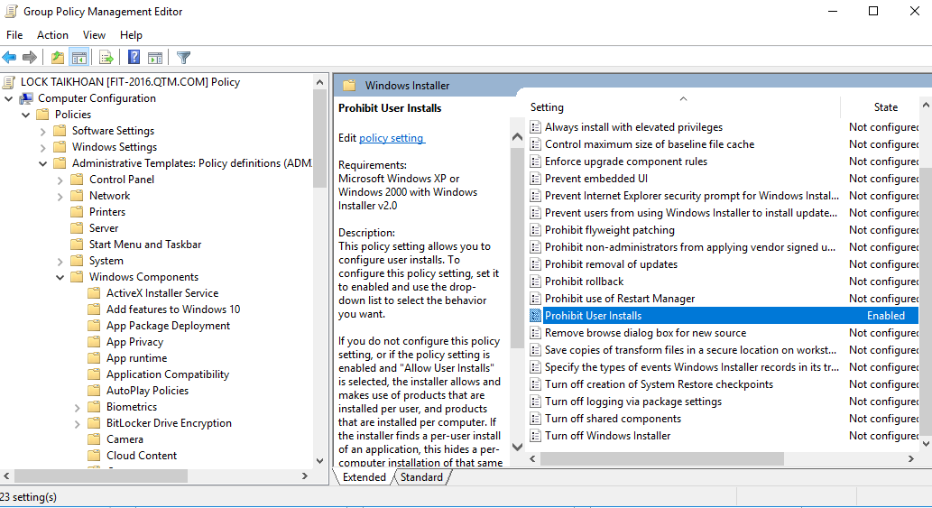

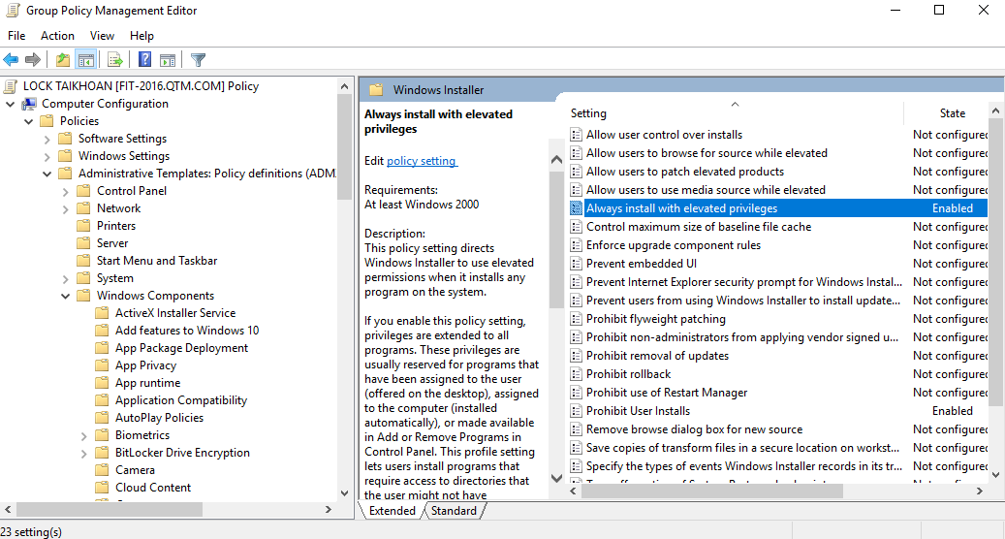

Prohibit the Kythuat OU from Using IE During Business Hours

