Chỉnh host-name

Sudo hostnamectl set-hostname …

Sudo hostnamectl

Cai font

(arial, time new roman)

sudo add-apt-repository multiverse

sudo apt update && sudo apt install ttf-mscorefonts-installer

sudo fc-cache -fv

(tahoma)

Sudo apt install git

Git clone <https://github.com/sxnd57/tahoma.git>

Cd tahoma

Sudo mkdir ~/.fonts

Ls

Sudo mv tahoma.ttf ~/.fonts

Sudo fc-cache -fv

Kiem tra timezone

Timedatectl

* de 2

2.1 Tao group

Sudo groupadd…

Tao user

Sudo adduser…

Add user vào group

Sudo usermod -aG tengroup tenuser

* kiem tra

Sudo cat /etc/group

2.2 Tao cay

2.3 Phan quyen

r: 4

w: 2

x: 1

sudo chmod -R …(r+w+x) tengroup

* kiem tra ls -l

2.4

2.5

Sudo mv …(ten file nguon) …(Duong dan file dich)



3.2 DHCP server

- Install and configure the DHCP service to allocate the range of addresses in the range: 192.168.56.150 - 192.168.56.220. Exclude the address range: 192.168.56.150 - 192.168.56.160.

- Perform configuration on the client and check the result address.

Sudo apt-get update

Sudo apt-get install isc-dhcp-server -y

Sudo gedit /etc/dhcp/dhcpd.conf

Sudo gedit /etc/default/isc-dhcp-server

Sudo systemctl restart isc-dhcp-server

Sudo systemctl status isc-dhcp-server

* Kiem tra client

3.3 SAMBA

3.4 NFS

3.4 Configuring NFS Server: Create and share a home directory for each of the office users in /data/home. The home directory should only be accessible by the respective users. You only need to create home directories to the users found in the table office users above.

- Office Users:

|  |  |  |
| --- | --- | --- |
| username | password | home directory |
| adam | Passw0rd$ | /data/home/adam |
| jane | Passw0rd$ | /data/home/jane |

- Configure NFS client:

• Creating Mount Point for Share Directory.

• Mounting the Share Directory.

Sudo useradd -md /data/home/adam adam

Sudo passwd adam

Cd /data/home

Sudo chmod 777 adam

Sudo apt install nfs-kernel-server

Sudo gedit /etc/exports

sudo exportfs -a

sudo systemctl restart nfs-kernel-server

Client

sudo apt update

sudo apt install nfs-common

sudo mkdir /mnt/nfs_client

ping 192.168.56.100

sudo mount 192.168.56.100:/data/home/adam /mnt/nfs_client

cd /mnt/nfs_client/

My SQL

Sudo apt install mysql-server

Sudo mysql

Sudo mysql -u root -p

Show my_database;

USE my_database;

CREATE TABLE accounts (

acc_id INT PRIMARY KEY,

username VARCHAR(10),

password VARCHAR(10)

);

Insert into accounts (acc_id,username,password)

VALUES

(1,’user1’,’123’),

(2,’user2’,123’),

(3,’user3’,’123);

SELECT * FROM accounts;

WEB

Sudo apt update

Sudo apt install apache2

Sudo mkdir -p /www/intranet

Ls /www

{D4566C5E-C0A3-4A15-A82F-21A0F94C8C05}

Sudo chown -R $USER:$USER /www/intranet

Sudo chmod -R 755 /www/intranet //cap quyen

Sudo gedit /www/intranet/index.html //tao file index

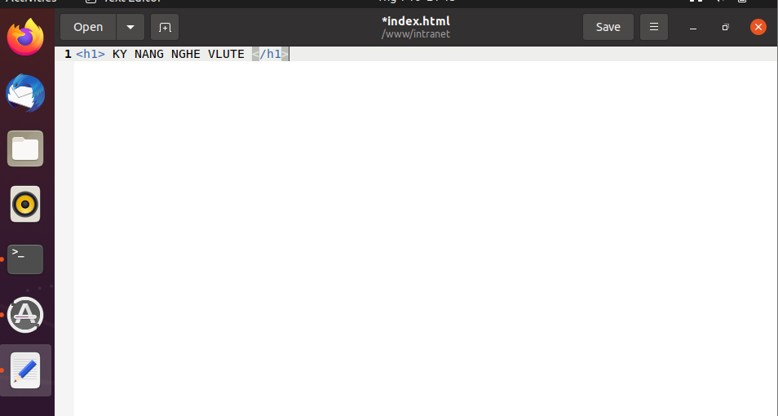

Sudo cp /etc/apache2/sites-available/000-default.conf /etc/apache2/sites-available/intranet.conf

Sudo gedit /etc/apache2/sites-available/intranet.conf

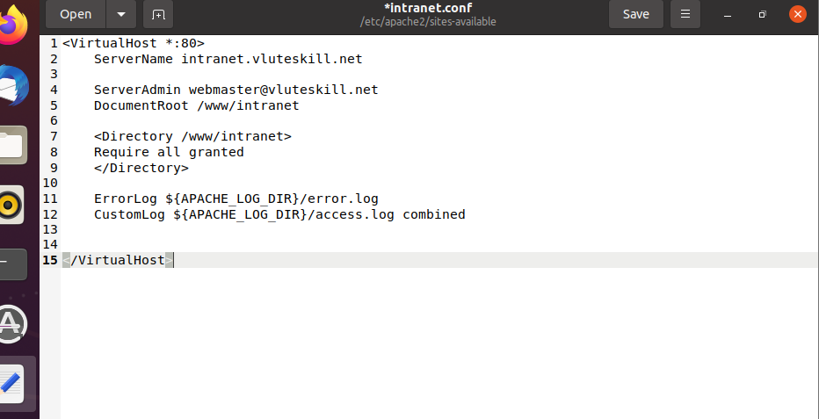

Sudo a2ensite intranet.conf

Sudo a2dissite 000-default.conf

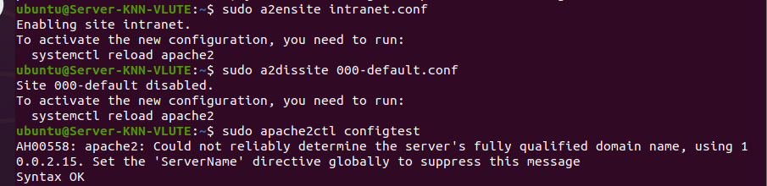

Sudo systemctl restart apache2

Sudo systemctl status apache2

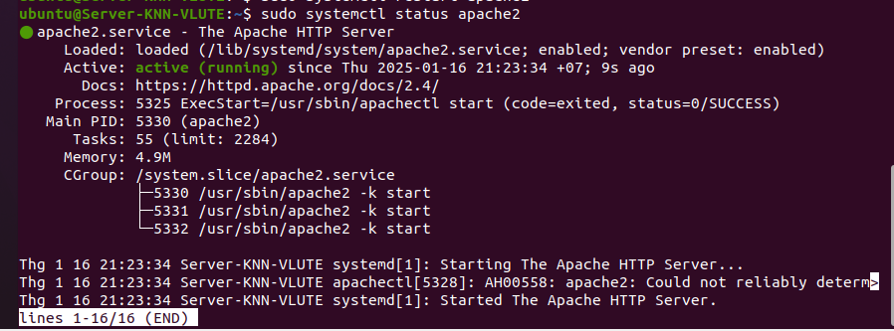

Sudo gedit /etc/hosts

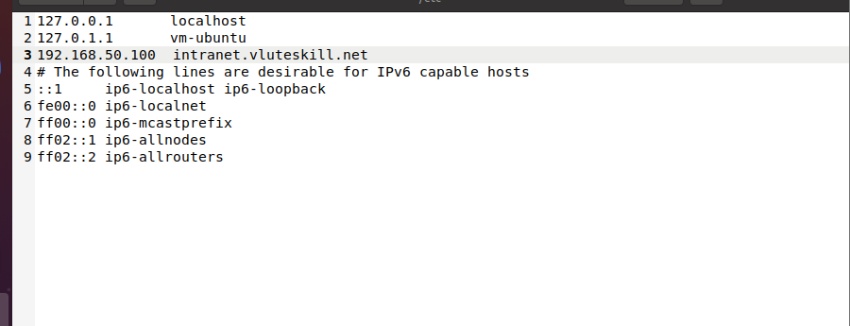

Tim kiem bang ip (IP tự tụi bây sửa đi tao làm lại nên để đại)

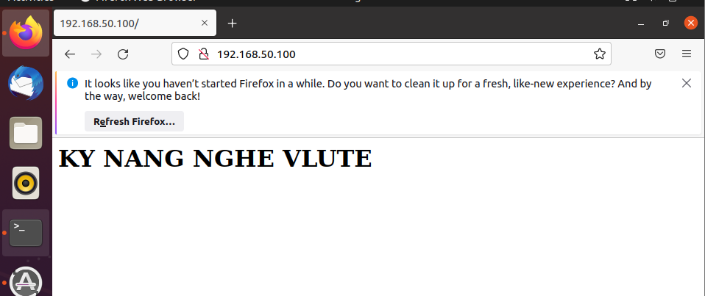

Tim kiem bang ten mien

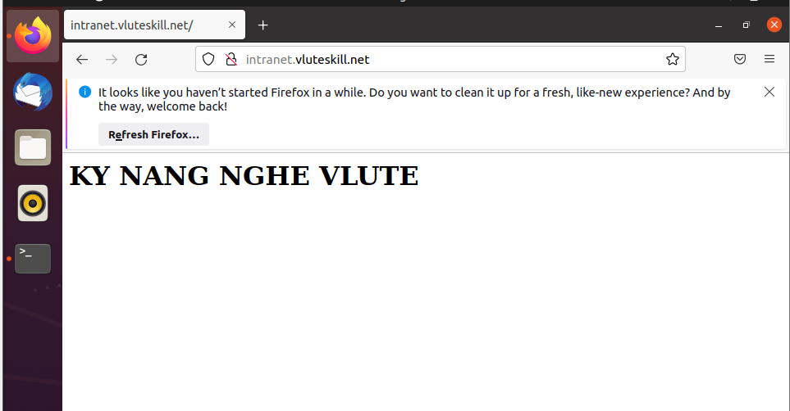

ftp

sudo apt install vsftpd

sudo systemctl start vsftpd

sudo systemctl enable vsftpd

sudo systemctl status vsftpd

sudo useradd -d /home/ftp1 -m ftp1

sudo passwd ftp1

cd /home

sudo chmod 777 ftp1

sudo ufw allow 20/tcp

sudo nano /etc/vsftpd.conf

sudo systemctl restart vsftpd

sudo systemctl status vsftpd

* Kiem tra

<ftp://diachi>

RAID

Sudo apt install mdadm

Sudo mdadm –create –verbose /dev/md0 –level=0 –raid-devices=2 /dev/sdb /dev/sdc

Sudo mkfs.ext4 -F /dev/md0

