**Exercise 1** – **Tapio Koskinen**

Screen captures of the code Exercise1.py:

part 1 code and output

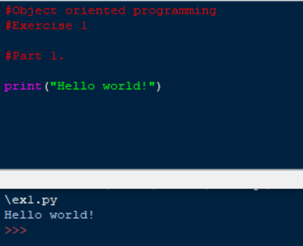

part 2

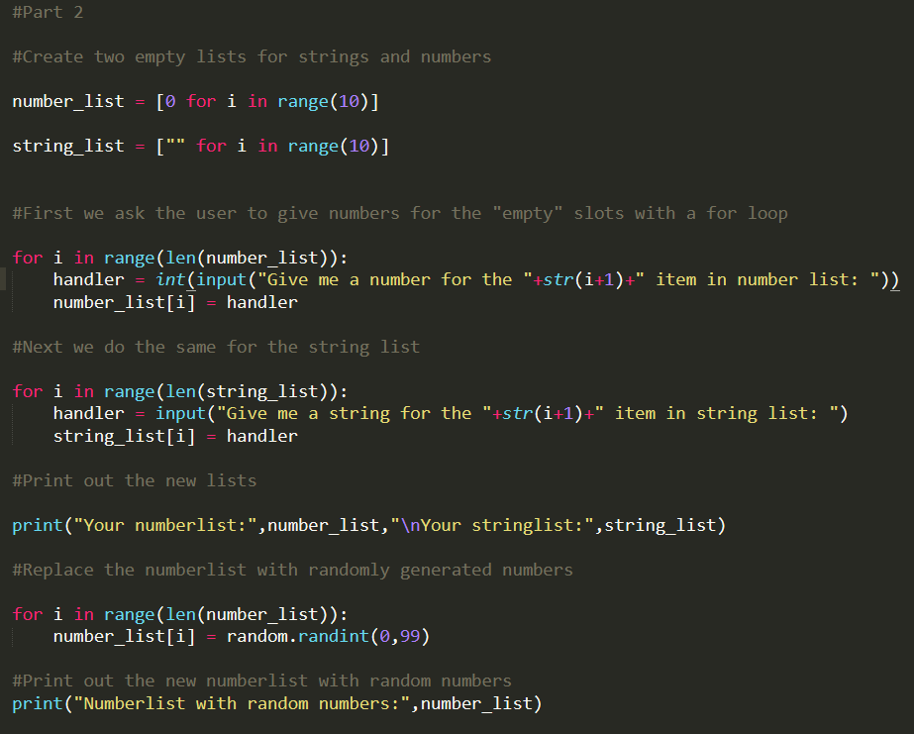

part 3 code and output  
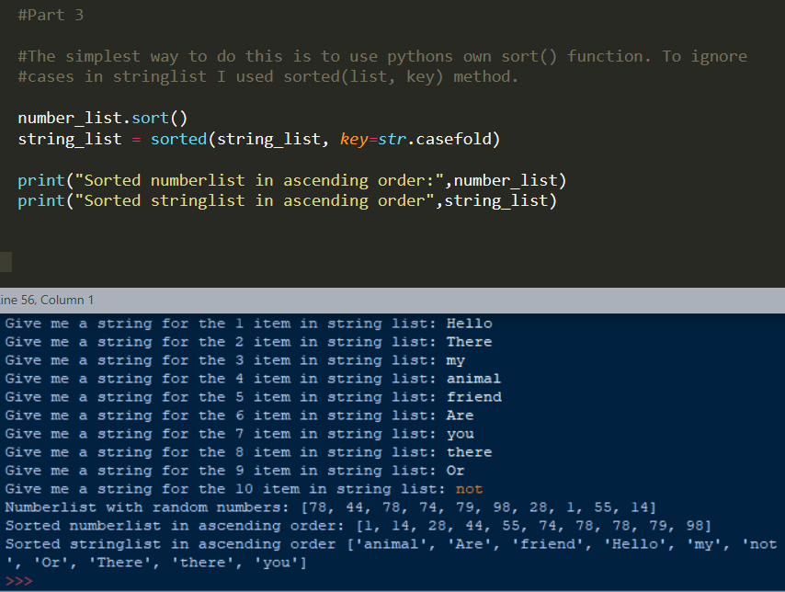

Part 4 code and output  
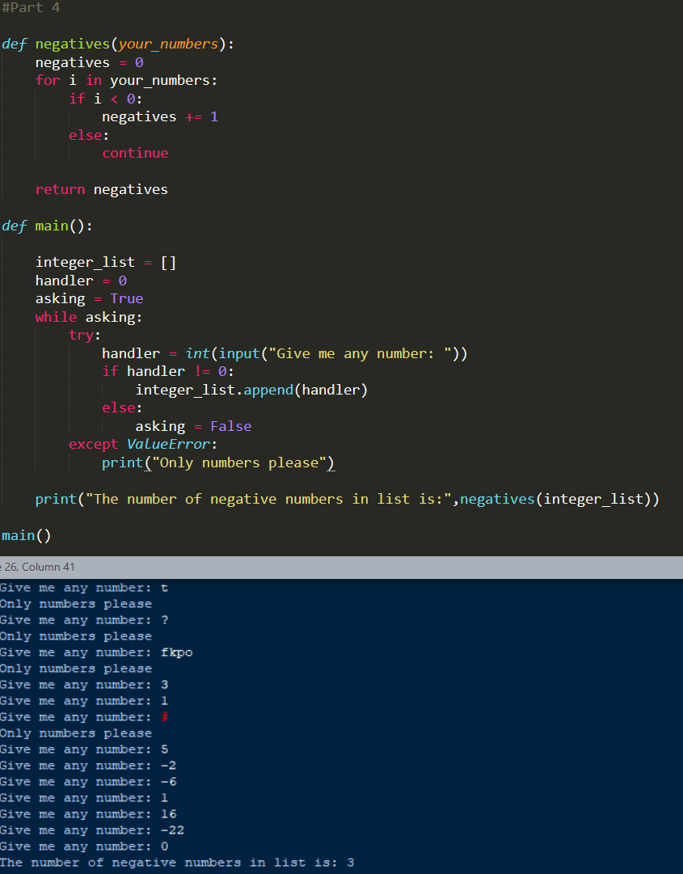

Part 5 code and output  
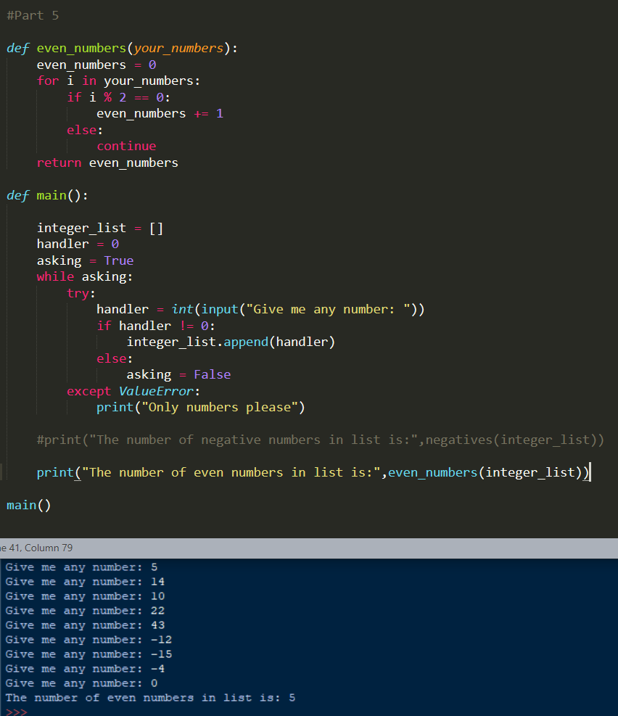

Part 6 code and output  
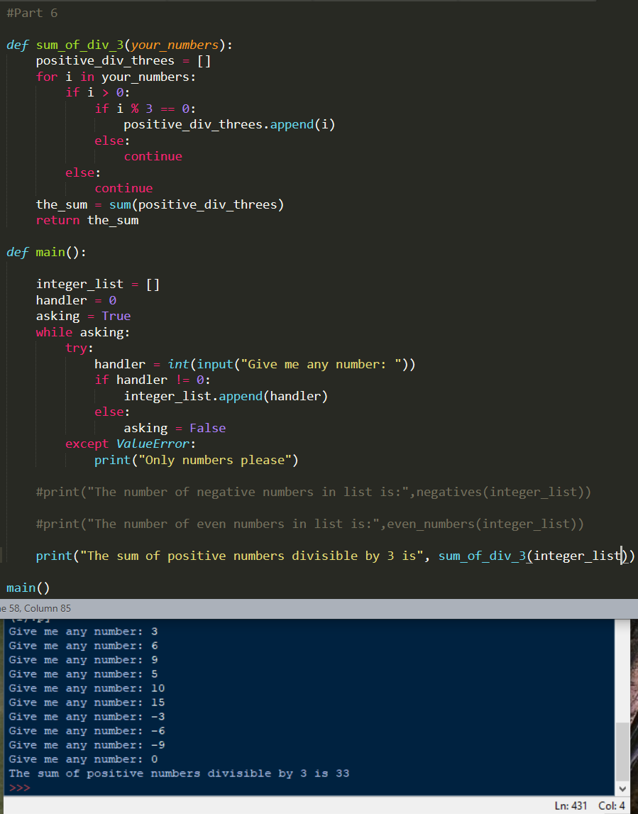

Part 7 code and output  
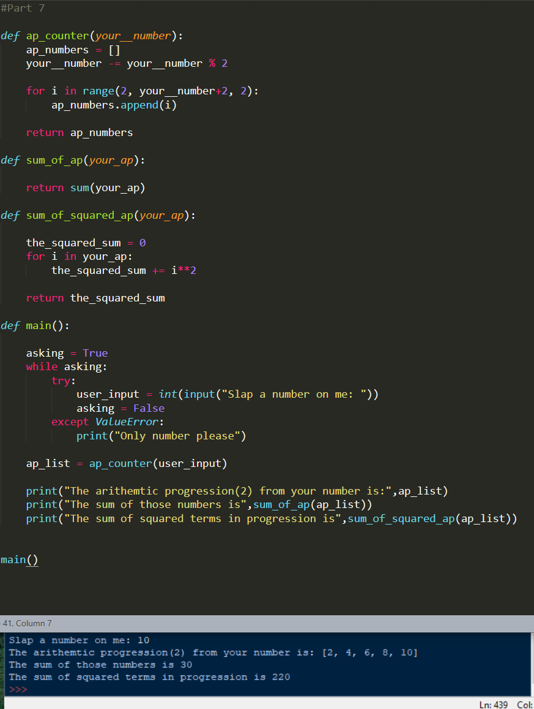

Part8  
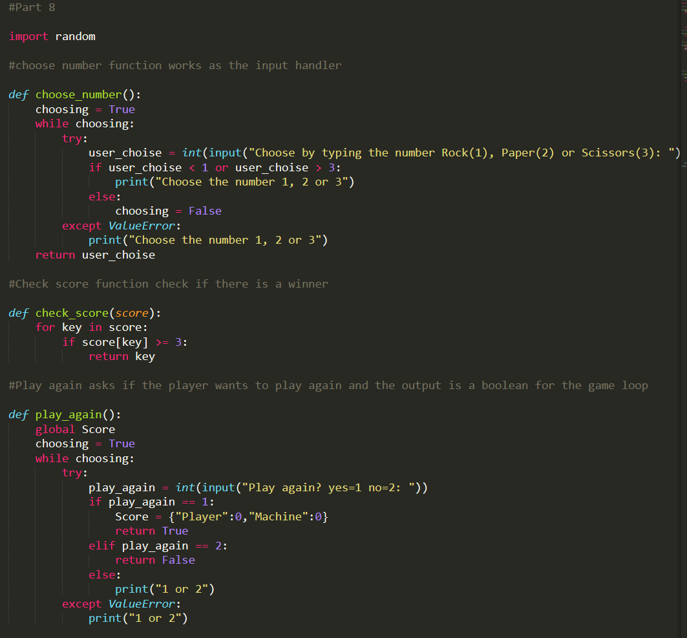  
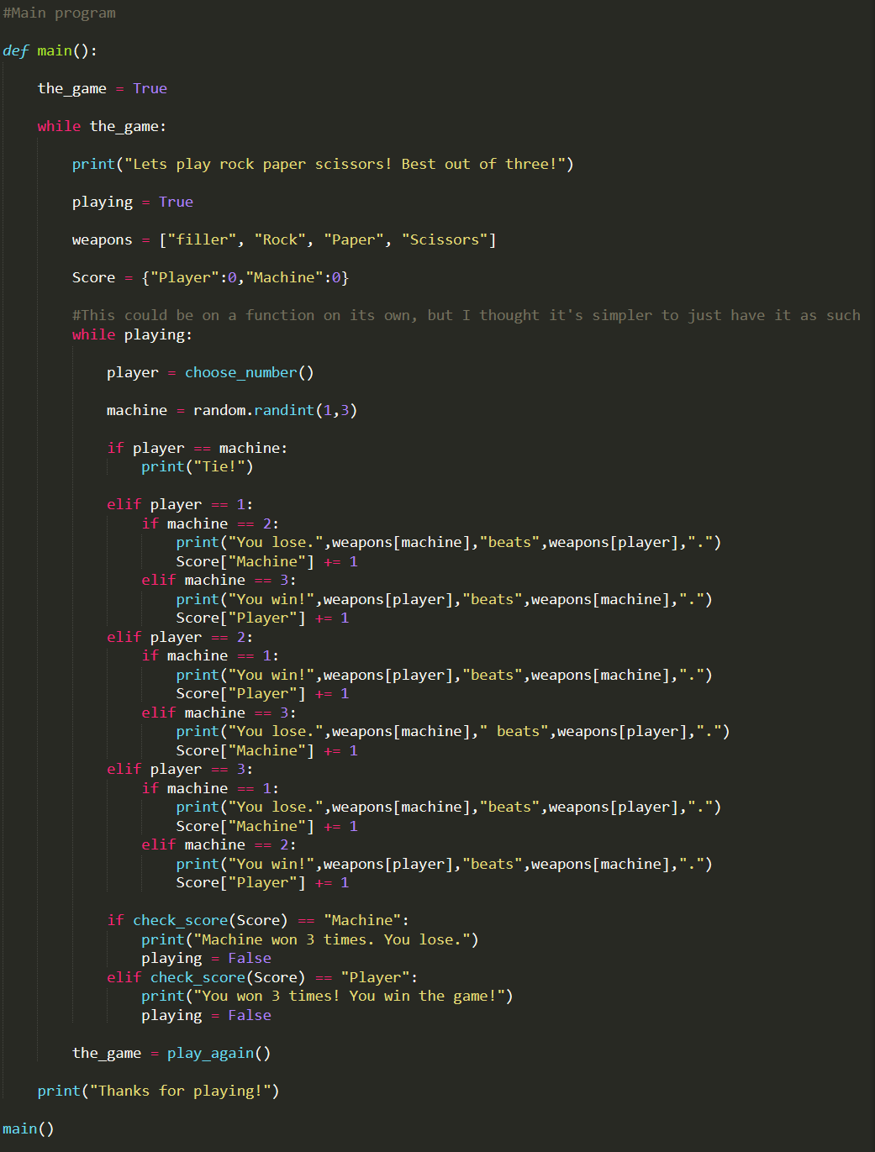

Screen capture of the output:

Part 2 output  
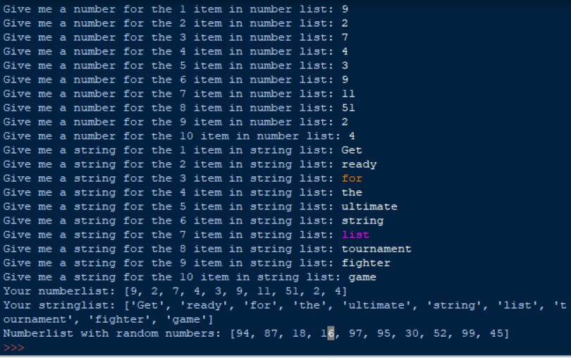

Part 8 output  
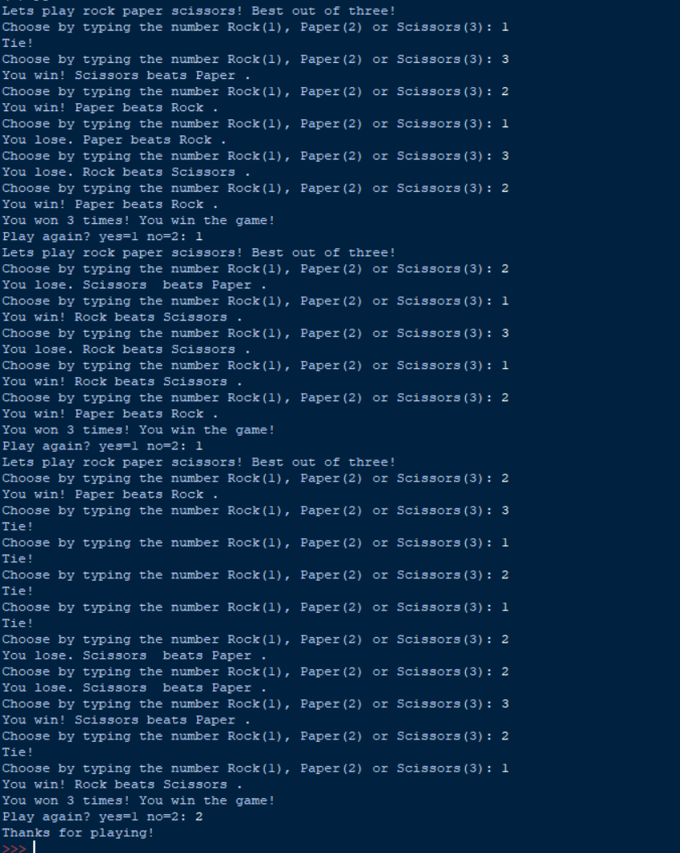

Screen capture of the Git status:

Self-assessment:

This exercise was easy/difficult/ok/etc. for me because…

Doing this exercise, I learned…

I am still wondering…

I understood/did not understand that… ; I did/did not know that… ; I did/did not manage to do…