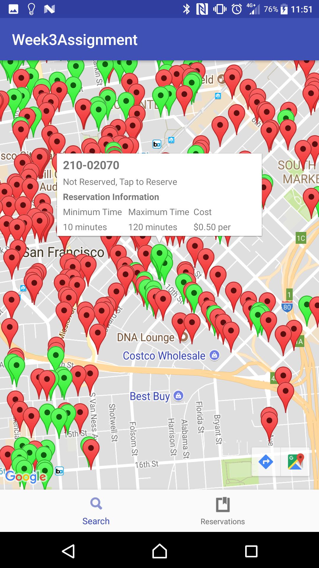
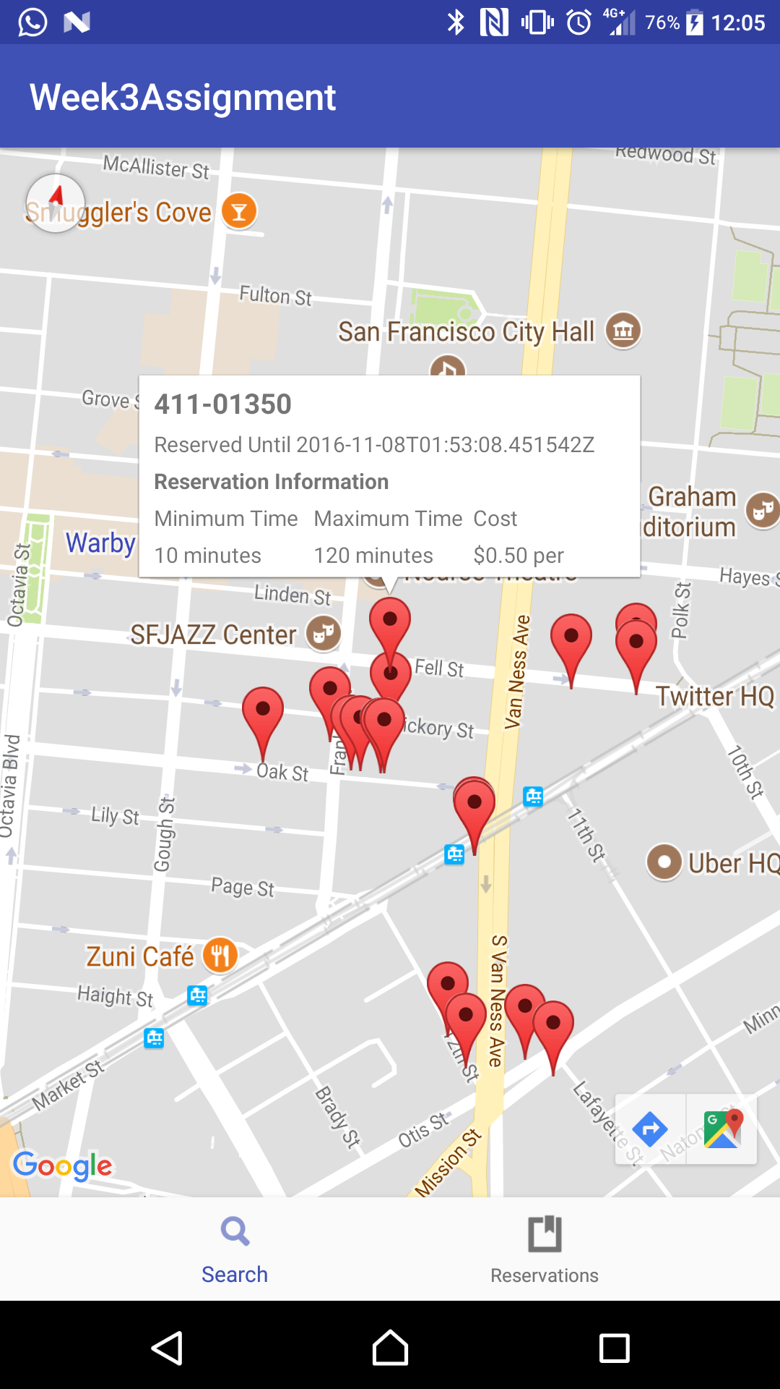
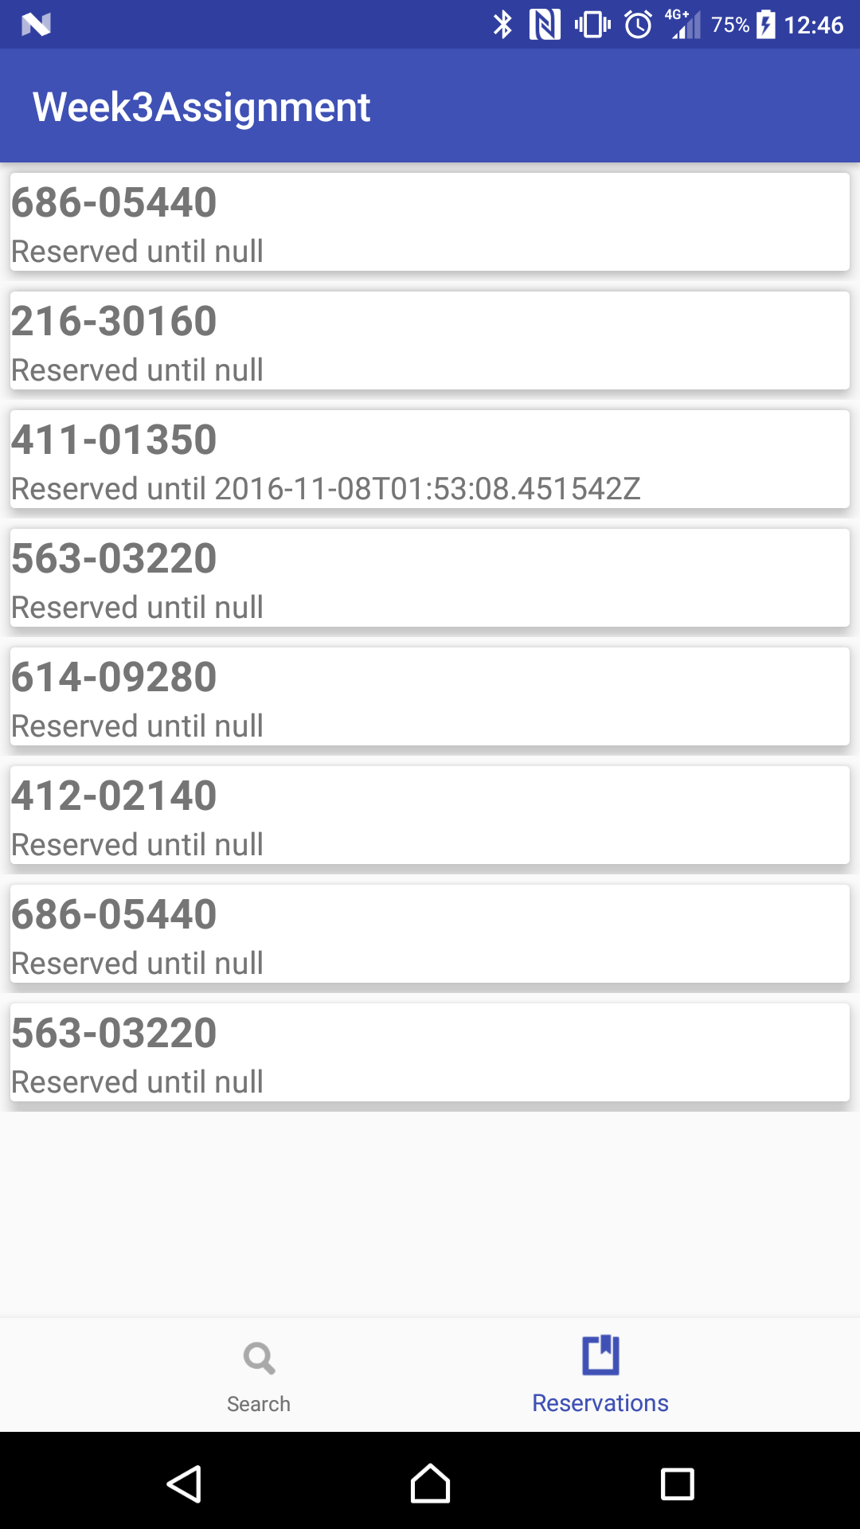
Android Assignment-3
Mobile Application Guidelines

- Guidelines
- Your weekend assignment is your chance to demonstrate to us what you’ve learnt during your week in training and what quality of work we can expect from you going forward.
- You’ll be producing an application and presenting it to us on Monday morning.
- This application should be built on the following requirements specified, we want to see you build a product that you’re interested in and enthusiastic about and build it to the best of your abilities.
- You don’t have to hand in a completely finished product, you can hand in a completed section of an on-going project, as long as what you hand in is an appropriate achievement and works properly.

- Assignment Checklist
No | Task |  | Required | Required
1 | RxJava, Retrofit |  | Yes | Get the response
2 | Custom Markers |  | Yes | Markers on maps.
3 | Location Features |  | optional | Get user current location
4 | Realm/Caching |  | optional | View offline data.
5 | Google Maps V3 |  | Yes | Display maps with custom styles
6 | Dagger 2 / Butterknife |  | Yes | Inject Presenter
7 | Use Case 1 |  | Yes | Get all Points
8 | Use Case 2 |  | Yes | Pass the ID to get the confirmation
9 | Use Case 3 |  | Yes | Reserve the location
10 | Use Case 4 |  | Yes | Send Push Notifications
13 | App Function( only on app launch…not while using) |  | Yes | Should not crash
14 | MVP Design Pattern |  | Yes | Separation of concerns
15 | X-Factor |  | Optional | More out of the box features

- Assessment
- How well you’ve grasped the technologies covered in training. This will be judged on how well you’ve molded the knowledge to fit the situation. i.e. I want to see an implementation that fits with your application, not just the code I’ve given you hammered in where it fit.
- A good understanding of touch-first thinking in the UI design of your application. I’d like to see an application that is well designed for a mobile platform, with appropriate controls and user interactions.
- Good and appropriate use of the tools available both within the default environment and online.
- Use of technologies and functionalities outside of the training syllabus.
- Good use of the time given. Depending on the scale of the application you’re designing, I don’t always expect to see a completely finished product.

Guidelines

Base Server Framework:

http://ridecellparking.herokuapp.com/api/v1/parkinglocations

User Story 1:
Search:

Gets lat and lng as input and returns free parking locations.
METHOD: GET

Input params:

lat -> Latitude of current location
lng -> Longitude of current location

As a user, I must be able to display the markers on Google Maps V2 received from the API.
(Use any latitude and longitude)
Example:

http://ridecellparking.herokuapp.com/api/v1/parkinglocations/search?lat=51.5074&lng=0.1278

User Story 2:
As I user, when I click on the marker I should get the detail information for that parking location by passing the ID of the marker location.

This is a detail view and acts on specific Parking Location. Detailed view can be activated by using the id parameter. For e.g. http://ridecellparking.herokuapp.com/api/v1/parkinglocations/1. METHOD: GET
API to ping:

http://ridecellparking.herokuapp.com/api/v1/parkinglocations/{{id}}

Example:

http://ridecellparking.herokuapp.com/api/v1/parkinglocations/1958

User Story 3:
As a user I must be able to reserve the parking location.
API to ping:
METHOD: =

http://ridecellparking.herokuapp.com/api/v1/parkinglocations/{{id}}/reserve

Example:

http://ridecellparking.herokuapp.com/api/v1/parkinglocations/2034/reserve

ScreenShots

Refer to pdf. Refined/ polished UI/UX not important.

