GhostLab: Understanding Sociocultural Patterns and Psychological Factors of Human and Ghost Co-Interactive Existence in Thailand Context through the "Man vs Ghost" (Kon Uat Phee) Program
Taechasith Kangkhuntod, University of the Thai Chamber of Commerce, Thailand
Kasidis Miankamnerd, Kasetsart University, Thailand
Chatdanai Thongchai, Harbour.Space Institute of Technology @UTCC, Thailand

Figure 1. Conceptual Framework for the Content Analysis of Televised Ghost-Encounter Narratives
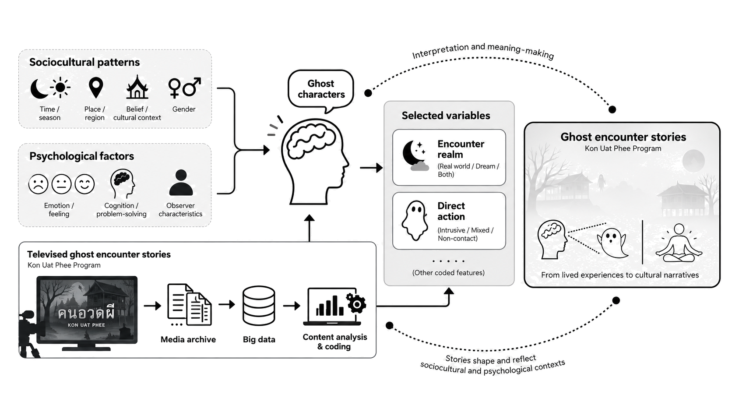
Abstract
Thai ghost narratives are often interpreted through folklore, religious practice, and psychology, but quantitative evidence about how their constituent elements co-occur is limited. This study reanalyzes 236 coded cases from the Thai television program Man vs. Ghost as a media-content corpus, not a sample of people or a record of supernatural events. Qualitative narratives were cleaned and coded into categorical variables. We tested 224 eligible pairwise associations using Pearson chi-square or fixed-margin Monte Carlo exact tests where sparse cells required it, controlled multiplicity with the Benjamini-Hochberg false discovery rate, and conducted a 2016-2018 sensitivity analysis. Rather than list every screening result, we report one non-structural association selected for novelty, interpretability, and robustness: encounter realm by reported direct action. Among 211 complete cases, dream encounters were overwhelmingly coded as non-contact/sensory (46/47, 97.9%), whereas real-world encounters more often included intrusive/contact action (50/153, 32.7%). The association remained significant after FDR correction (Monte Carlo exact chi-square(4) = 37.705, p = .00008, q = .00179, bias-corrected Cramer's V = .284) and in the early-period sensitivity analysis. This supplies a focused corpus-level estimate of a narrative-action pattern; it does not establish causal psychological processes, population prevalence, or paranormal events.
Keywords: Thai ghost narratives, content analysis, encounter realm, paranormal media, Man vs. Ghost
Introduction
Ghosts and supernatural entities are integral to Thai culture, where folklore, Buddhist and animist practices, and popular media provide ways to discuss uncertainty, moral obligation, relationships with the dead, and experiences that resist easy explanation. Ghost stories are therefore not only tales of fear. They can transmit social norms, make grief and disruption narratively visible, and offer culturally recognizable paths toward restoring equilibrium (Goldstein et al., 2007; Johnson, 2013; Sorajjakool, 2007).
The Thai television program Man vs. Ghost provides a useful but bounded archive for studying these representations. Its cases are edited, broadcast narratives rather than direct observations of experiences or a random survey of Thai people. This distinction is central: a regularity in the archive can reveal how a program frames encounters, but it cannot demonstrate the frequency, causes, or reality of supernatural events.
GhostLab connects folklore, psychology, and social context through content analysis while maintaining a narrow empirical claim. The focal result is one transparent, reproducible association from the supplied complete analysis package: whether the realm in which an encounter is narrated co-occurs with the action category attributed to the ghost.
Literature Review
Thai Ghost Media as Constructed Narrative
Existing scholarship already shows that Kon Uad Phee (also known here as Man vs. Ghost) has cultural and production significance. Jankham and Sriprapandh (2017) qualitatively compared meanings of ghosts in the program with Thai social beliefs, while Roekphuengdee and Thonglert (2019) examined how the program constructs suspense. These studies support reading the archive as a crafted media form in which testimony, entertainment, religious language, and narrative pacing are intertwined.
That literature makes an important contribution, but it does not provide a corpus-level, multiplicity-controlled estimate of the association between encounter realm and action category in Thai televised ghost stories. In targeted Thai- and English-language searches, we did not locate a prior quantitative estimate of this exact narrative association. The novelty claim in this paper is deliberately narrow: it concerns this statistical estimate in this kind of corpus, not the broad ideas of dreams, ghosts, or Thai belief.
Broader Thai scholarship shows why a media-centered analysis benefits from cultural context. Johnson (2013) interprets haunting stories in Chiang Mai as expressions of uncertainty surrounding urban development and social change. Sorajjakool (2007) documents the role of Buddhist ritual and ghost narratives in making sense of loss after the Indian Ocean tsunami, while Rittichainuwat (2011) demonstrates that ghost beliefs can shape reported travel decisions around disaster-affected places. Together, these studies show that ghost narratives can organize meanings of place, memory, danger, obligation, and recovery without implying that every narrative describes a verifiable supernatural event.
Statistical Content Analysis and Scope
Content analysis makes it possible to transform repeated narrative features into transparent categorical evidence while preserving the distinction between the text and the people or events represented in it. Rule-guided category development and explicit coding decisions are central to established content-analysis approaches (Hsieh & Shannon, 2005; Krippendorff, 2013; Mayring, 2000). In this study, tests of association are descriptive tools for determining whether coded categories co-occur more often than expected under independence; they do not identify causal mechanisms (McHugh, 2013).
Psychological accounts of anomalous experience can help generate careful hypotheses, but they do not turn a television corpus into evidence about individual cognition. Houran and Lange (1996) describe how ambiguous events can be amplified by attention and interpretation. Sleep-related studies report associations among lucid dreaming, nightmares, sleep paralysis, paranormal experience, and paranormal belief (Drinkwater et al., 2020; Rauf et al., 2023). Research on perceptual judgment likewise suggests that prior belief can relate to how ambiguous stimuli are categorized, although findings are heterogeneous and method-dependent (Dean et al., 2022; van Elk, 2015). These accounts are interpretive background only in the present study; no psychological state, perceptual process, or sleep variable was measured.
Methodology
Corpus and Preparation
The reanalysis used 236 recorded cases from Man vs. Ghost broadcasts from 2016 through 2020. Each row represents a televised case rather than an individual respondent, a verified event, or an episode-level audience measure. The supplied analysis package reports 25 raw columns. It standardized Unicode and whitespace, harmonized spelling, treated N/A-style values as missing, and collapsed rare or semantically similar categories before analysis.
Figure 2. Overview of All Variables Used in the Research Framework
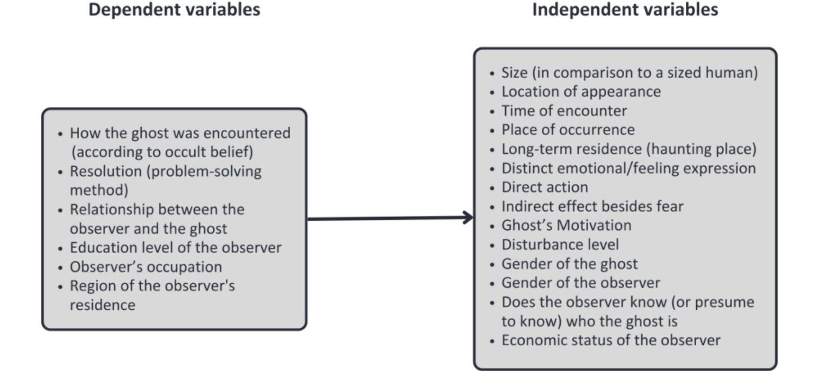
The selected variables were encounter realm (Dream; Dream and real world; Real world) and reported direct action (Intrusive/contact; Mixed intrusive/non-contact; Non-contact/sensory). The action categories are coding labels supplied in the package, not clinical, metaphysical, or behavioral diagnoses. Realm was complete for all 236 cases; direct action was missing for 25 cases, leaving 211 complete observations for this analysis.
Figure 3. Selected Variable Set for Statistical Analysis
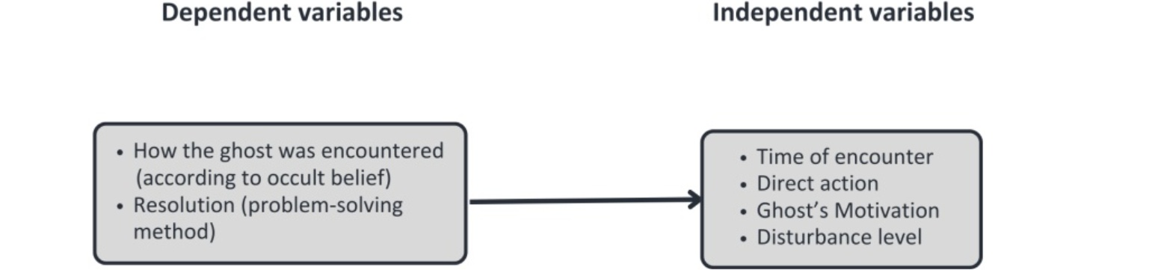
Note. The results section reports the focal encounter-realm by direct-action association selected from the complete analysis package.
The available reanalysis relied on the accessible source workbook. The package notes that an attachment named Revised-data was not mounted during the reanalysis. Accordingly, the accessible workbook is the source for the estimates reported here.
Statistical Analysis and Selection of the Result
The package screened 224 eligible pairwise associations. Eligibility required at least 30 complete cases, at least two observed categories per factor, and marginal counts of at least two. Pearson chi-square tests were used when expected-cell criteria were met. Sparse 2 x 2 tables used Fisher exact tests; sparse larger tables used fixed-margin Monte Carlo exact tests with 50,000 simulations. P values were adjusted across the screening family using the Benjamini-Hochberg false discovery rate procedure (Benjamini & Hochberg, 1995), and association magnitude was summarized with bias-corrected Cramer's V.
This manuscript intentionally reports one result rather than every significant screen. The association was selected after analysis because it is non-structural, interpretable, robust after false-discovery-rate control, and distinct from prior qualitative work on the program. This selection is not preregistered; the result should therefore be read as a focused discovery requiring confirmation, not as a confirmatory test of a prior hypothesis.
Results
Selected Discovery: Encounter Realm and Reported Action
Within the 211 complete televised narratives, encounter realm and reported direct action co-occurred non-randomly. Dream-framed cases were overwhelmingly coded as non-contact/sensory (46 of 47, 97.9%), whereas real-world-framed cases had a larger intrusive/contact share (50 of 153, 32.7%). The association was significant in the package's fixed-margin Monte Carlo exact test, chi-square(4) = 37.705, p = .00008, and remained significant after Benjamini-Hochberg adjustment across the 224 eligible tests (q = .00179). The bias-corrected Cramer's V was .284, a moderate association for this coded media corpus.
Table 1. Encounter Realm by Reported Direct Action
Encounter realm | Intrusive/  contact | Mixed intrusive/  non-contact | Non-contact/  sensory | Total
Dream | 1 (2.1) | 0 (0.0) | 46 (97.9) | 47
Dream and real world | 2 (18.2) | 3 (27.3) | 6 (54.5) | 11
Real world | 50 (32.7) | 5 (3.3) | 98 (64.1) | 153
Note. Row percentages; N = 211 complete cases. Fixed-margin Monte Carlo exact test: chi-square(4) = 37.705, p = .00008, BH-FDR q = .00179, bias-corrected Cramer's V = .284.
Adjusted residuals locate the clearest departures from independence: dream/non-contact-sensory was overrepresented (46 observed versus 33.41 expected; adjusted residual = 4.59), while dream/intrusive-contact was underrepresented (1 observed versus 11.81 expected; adjusted residual = -4.12). In contrast, real-world/intrusive-contact was overrepresented (50 observed versus 38.43 expected; adjusted residual = 4.11). Restricting the analysis to the 2016-2018 subset preserved the association after FDR adjustment (q = .00413; bias-corrected Cramer's V = .320).
Figure 4. Encounter Realm by Reported Direct Action
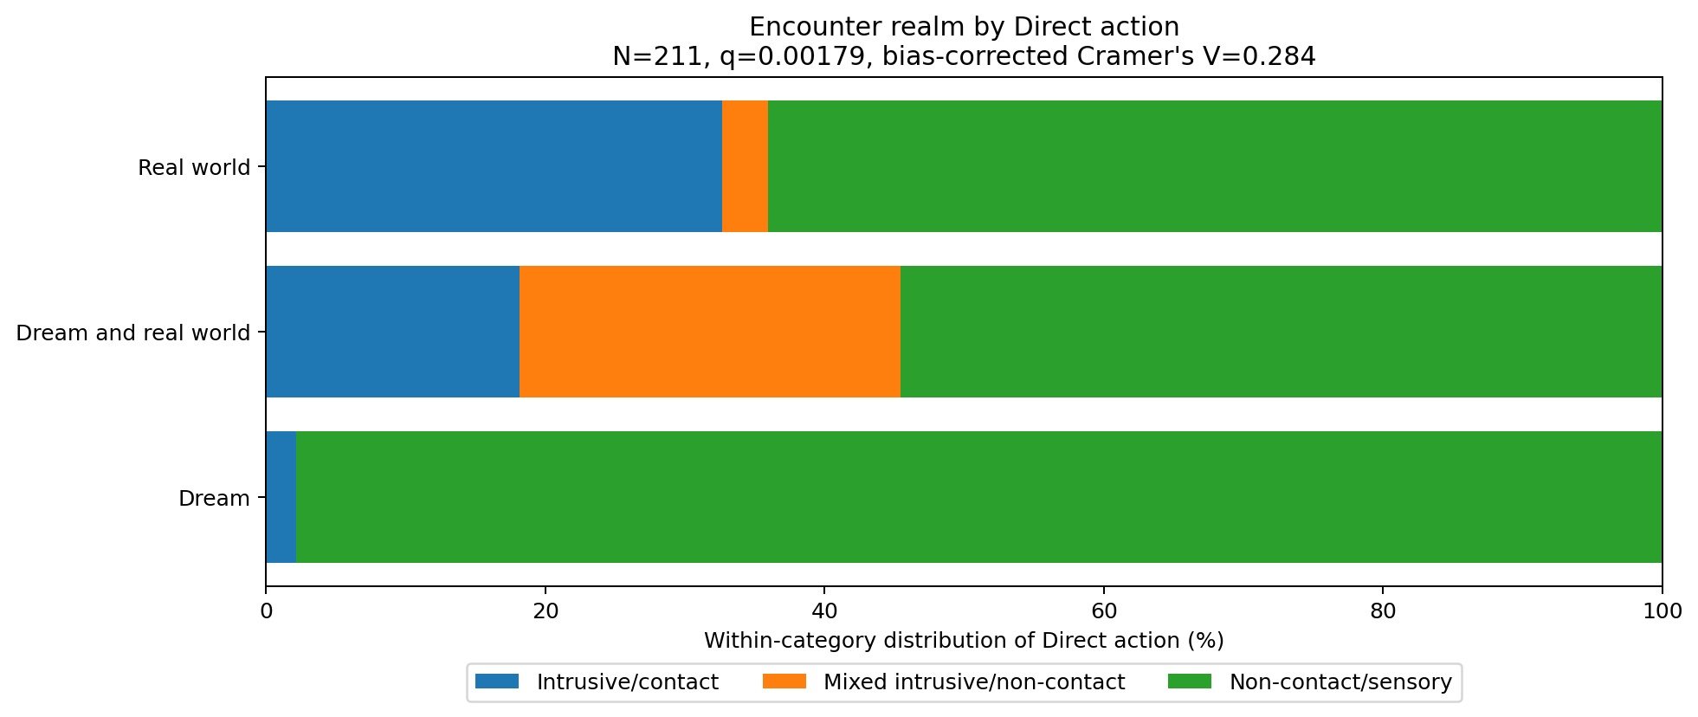
Note. Each bar gives the within-realm distribution of reported action in the 211 complete cases.
Discussion
Interpreting the Selected Pattern
The result is a pattern in story framing. When a case is narrated as a dream, the program's coded account is much more likely to present the ghost through non-contact or sensory action. When it is narrated as occurring in the real world, intrusive/contact action occupies a larger share. This does not mean that dreams prevent contact, that real-world settings cause intrusion, or that these coded categories describe actual entities. It identifies a reliable difference in how two types of televised narrative are constructed.
The original discussion treated ritual response as a culturally legible way to restore spiritual and social equilibrium. That idea remains useful as interpretive context, but it is no longer presented here as a result of an unreported resolution analysis. A narrative that makes disruption visible may also make consultation, merit-making, appeasement, or other responses intelligible to viewers. Future work can test that proposition with a preregistered design and clearly separate narrative motive, encounter type, and resolution.
Linking the Finding to Cultural and Psychological Accounts
The previous manuscript also discussed perceptual ambiguity, cultural expectation, Gestalt closure, pareidolia, confirmation bias, and social reinforcement. Those concepts should be treated as possible explanatory pathways, not findings of this dataset. The present reanalysis did not measure darkness, visual ambiguity, fear, belief, sleep state, or audience interpretation; consequently, it does not support the earlier claim that nighttime encounters were more disturbing. Instead, the dream/non-contact pattern offers a narrower hypothesis: different narrative realms may invite different culturally available ways of representing ambiguous contact.
This restraint matters because folklore and psychology can complement one another without collapsing into a single causal account. Work on ambiguous perception and prior belief provides plausible hypotheses, but individual studies do not converge on a simple deficit model (Dean et al., 2022; van Elk, 2015). Sleep and dream research also identifies associations with paranormal experiences and beliefs without establishing a mechanism in this television archive (Drinkwater et al., 2020; Rauf et al., 2023). The contribution here is the newly quantified narrative regularity that future research can try to explain.
Limitations and Reproducibility
Several limits constrain interpretation. The corpus is a selected and edited media archive, so it cannot be generalized to Thai people, viewers, dreamers, or alleged encounters. Direct-action coding was missing for 10.6% of cases (25 of 236), and missingness varied by broadcast year. Some categories, especially the combined dream-and-real-world realm, are small. The supplied package documents data cleaning and tests but does not supply operational coding rules or intercoder-reliability estimates. Finally, the accessible source workbook rather than the unmounted revised attachment was analyzed.
The early-period sensitivity result is reassuring but not a substitute for replication. A next study should publish a codebook, preserve the canonical source data and all transformations, preregister the focal association, report intercoder reliability, and distinguish editorial choices from firsthand testimony. It should then retest the result in an independently coded sample or a second Thai paranormal-media corpus.
Conclusion
This study reports one focused discovery: in 211 complete Thai televised ghost narratives, dream-framed encounters were predominantly coded as non-contact/sensory, while real-world-framed encounters contained a larger intrusive/contact share. The association survived multiplicity control and an early-period sensitivity analysis. To our knowledge, it is the first quantitative estimate of this specific association in a Thai televised ghost-story corpus. Its value lies in providing a transparent starting point for cultural and psychological inquiry, not in establishing causal processes, population patterns, or supernatural facts.
Acknowledgments
We extend our sincere gratitude to the JSTP (Junior Science Talent Project) Alumni and staff for organizing the 25th camp for middle school students, which not only inspired the inception of this project but also provided essential funding. Special thanks go to Dr. Pongdet Piromyou for identifying the central focus of this work and for introducing me to numerous experts in the field of psychology for invaluable discussions. I am also deeply grateful to Dr. Pitoon Amornwitthawat for his assistance with manuscript preparation and data representation. My heartfelt appreciation is extended to Dr. Pat Pataranutaporn, whose insights in both art and science greatly contributed to designing the methodology and guiding the data cleaning and visualization process. I would also like to thank Dr. Sukrit Sucharitakul, Dr. Opas Tantithakura, and Dr. Potiwat Ngamkajornwiwat for their constructive comments, which significantly improved this work during the JSTP Camp. I am particularly thankful to Watchara Pratan and Dr. Nawawit Navachewinmai for their valuable assistance in discussing and refining the psychological interpretations of the findings. I am thankful as well to my friend, Natch Prawatwong, for engaging in productive discussions and for consistently providing encouragement throughout the development of this project. Finally, my sincere thanks go to Paween Purijitpanya and his team for creating the film "GhostLab," whose innovative approach and insightful discussions propelled me to see this project through to its completion.

References
Benjamini, Y., & Hochberg, Y. (1995). Controlling the false discovery rate: A practical and powerful approach to multiple testing. Journal of the Royal Statistical Society: Series B (Methodological), 57(1), 289-300. https://doi.org/10.1111/j.2517-6161.1995.tb02031.x
Dean, C. E., Akhtar, S., Gale, T. M., Irvine, K., Grohmann, D., & Laws, K. R. (2022). Paranormal beliefs and cognitive function: A systematic review and assessment of study quality across four decades of research. PLOS ONE, 17(5), e0267360. https://doi.org/10.1371/journal.pone.0267360
Drinkwater, K. G., Denovan, A., & Dagnall, N. (2020). Lucid dreaming, nightmares, and sleep paralysis: Associations with reality testing deficits and paranormal experience/belief. Frontiers in Psychology, 11, Article 471. https://doi.org/10.3389/fpsyg.2020.00471
Goldstein, D. E., Grider, S. A., & Thomas, J. B. (Eds.). (2007). Haunting experiences: Ghosts in contemporary folklore. Utah State University Press.
Houran, J., & Lange, R. (1996). Hauntings and poltergeist-like episodes as a confluence of conventional phenomena: A general hypothesis. Perceptual and Motor Skills, 83(3), 1307-1316. https://doi.org/10.2466/pms.1996.83.3f.1307
Hsieh, H.-F., & Shannon, S. E. (2005). Three approaches to qualitative content analysis. Qualitative Health Research, 15(9), 1277-1288. https://doi.org/10.1177/1049732305276687
Jankham, W., & Sriprapandh, K. (2017). A comparison of the meanings of ghosts in the television program Kon Uad Phee and beliefs about ghosts in Thai society [Article in Thai]. Journal of Mass Communication, Chiang Mai University, 5(2), 46-70. https://so03.tci-thaijo.org/index.php/masscomm/article/view/107520
Johnson, A. A. (2013). Progress and its ruins: Ghosts, migrants, and the uncanny in Thailand. Cultural Anthropology, 28(2), 299-319. https://doi.org/10.1111/cuan.12005
Krippendorff, K. (2013). Content analysis: An introduction to its methodology (3rd ed.). Sage.
Mayring, P. (2000). Qualitative content analysis. Forum: Qualitative Social Research, 1(2), Article 20. https://www.qualitative-research.net/index.php/fqs/article/view/1089
McHugh, M. L. (2013). The chi-square test of independence. Biochemia Medica, 23(2), 143-149. https://doi.org/10.11613/BM.2013.018
Rauf, B., Perach, R., Madrid-Valero, J. J., Denis, D., Sharpless, B. A., Farron, H., French, C. C., & Gregory, A. M. (2023). Associations between sleep variables and ostensibly paranormal experiences and paranormal beliefs: A scoping review. British Journal of Psychology, 114(4), 797-818. https://doi.org/10.1111/bjop.12655
Rittichainuwat, B. N. (2011). Ghosts: A travel barrier to tourism recovery. Annals of Tourism Research, 38(2), 437-459. https://doi.org/10.1016/j.annals.2010.10.001
Roekphuengdee, N., & Thonglert, G. (2019). The production and construction of suspense element in Kon-Ouad-Pee show. In Proceedings of the Rangsit University National Academic Conference 2019 (pp. 1637-1645). Rangsit University. https://doi.org/10.14458/RSU.res.2019.258
Sorajjakool, S. (2007). Tsunami and ghost stories in Thailand: Exploring the psychology of ghosts and religious rituals within the context of Thai Buddhism. Journal of Pastoral Care & Counseling, 61(4), 343-349. https://doi.org/10.1177/154230500706100406
van Elk, M. (2015). Perceptual biases in relation to paranormal and conspiracy beliefs. PLOS ONE, 10(6), e0130422. https://doi.org/10.1371/journal.pone.0130422
Correspondence: tae.creativelab@gmail.com

