**Practical No:8**

**Aim: Recovering and Inspecting deleted files.**

* Check for Deleted Files
* Recover the Deleted Files
* Analyzing and Inspecting the recovered files

**Screenshot:-**

Step 1: Start Autopsy from Desktop.



Step 2: Now create on New Case.

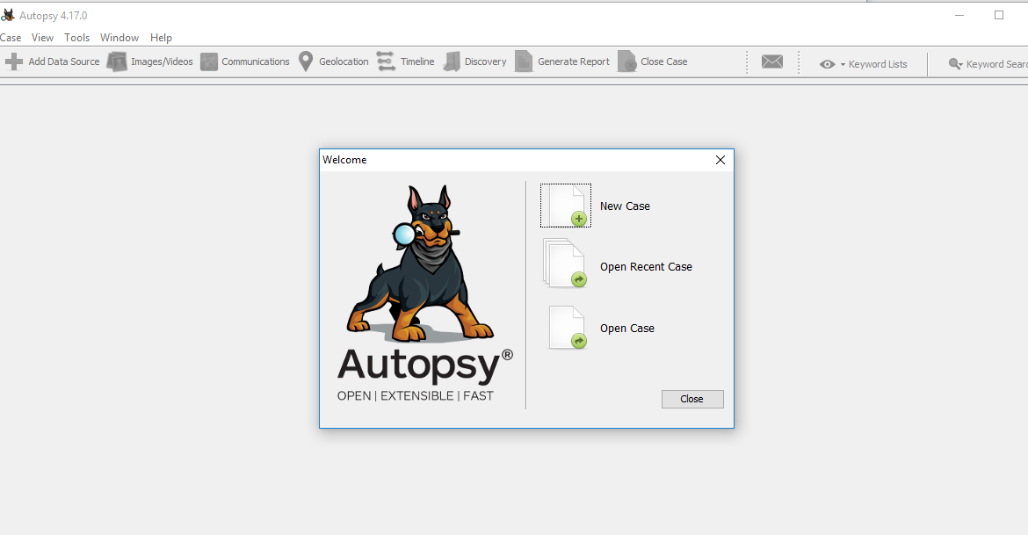

Step 3: Enter the New case Information and click on Next Button.

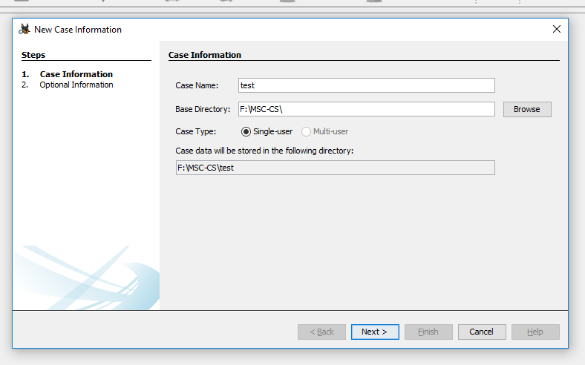

Step 4: Enter the additional Information and click on Finish.

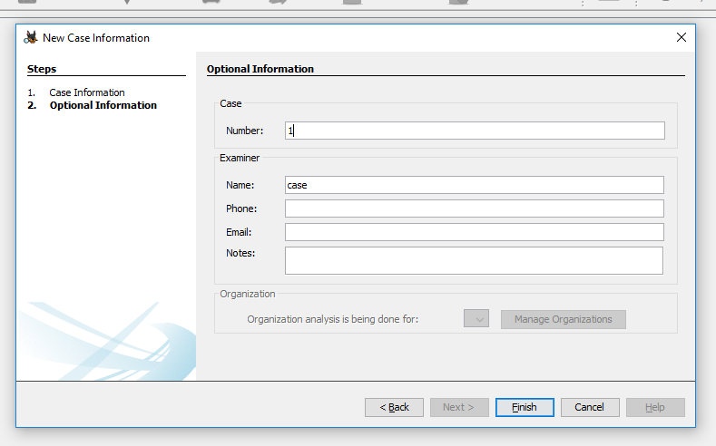

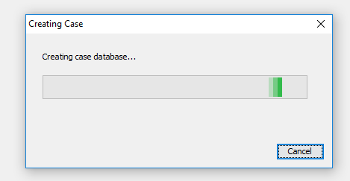

Step 5: Now Select Source Type as Local disk and Select Local disk form drop down list and click on Next.

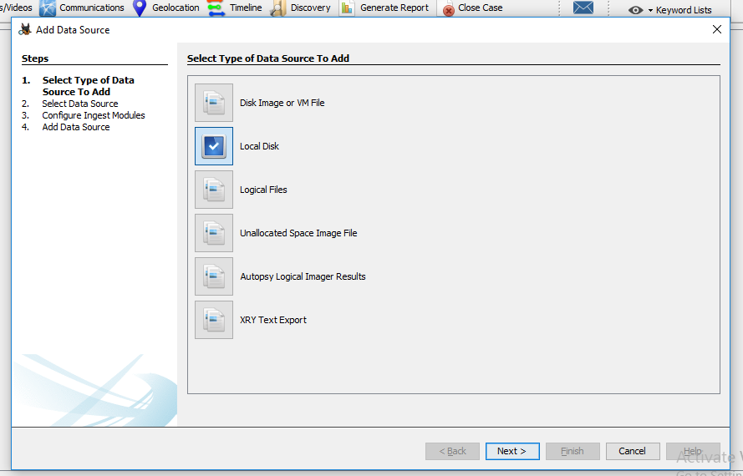

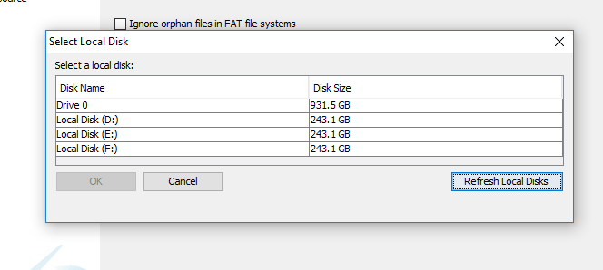

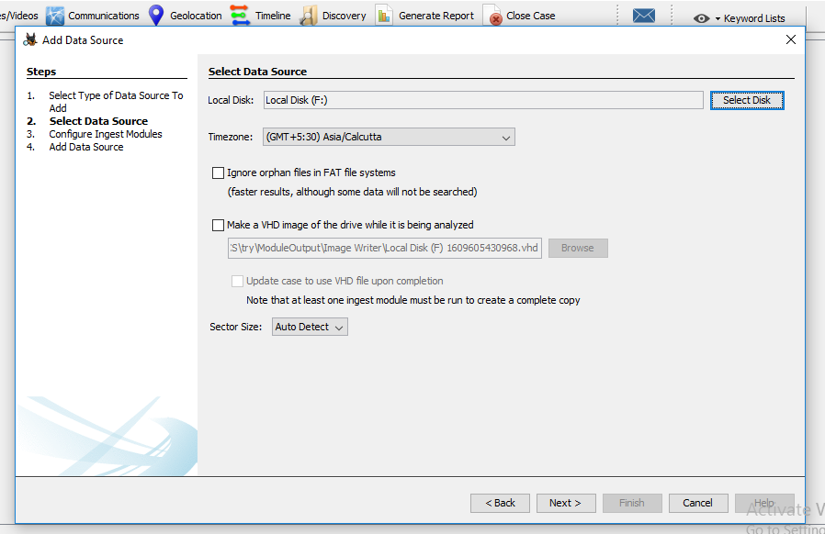

Step 6: Click on Next Button.

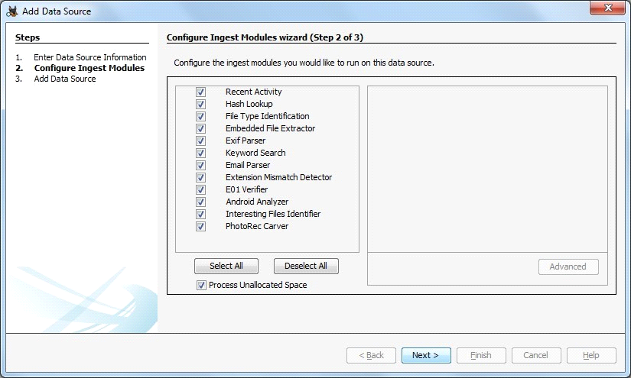

Step 7: Now click On Finish.

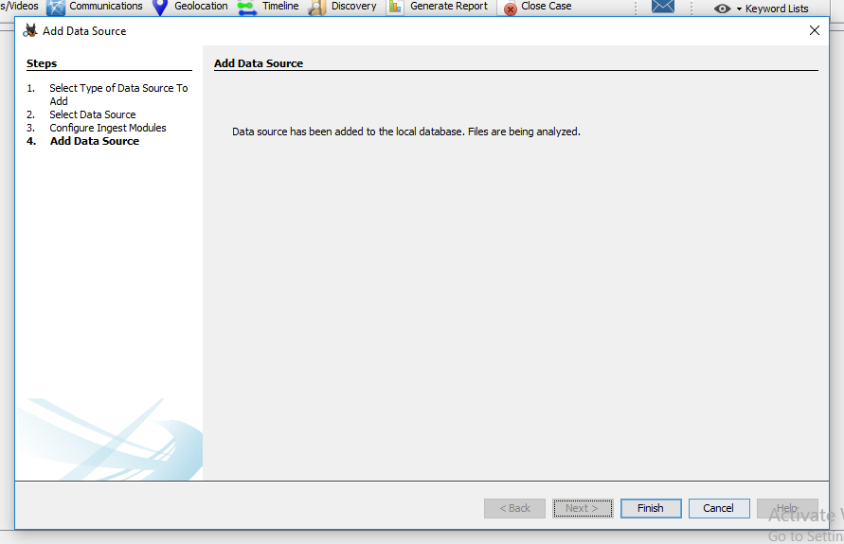

Step 8: Now Autopsy window will appear and it will analyzing the disk that we have selected.

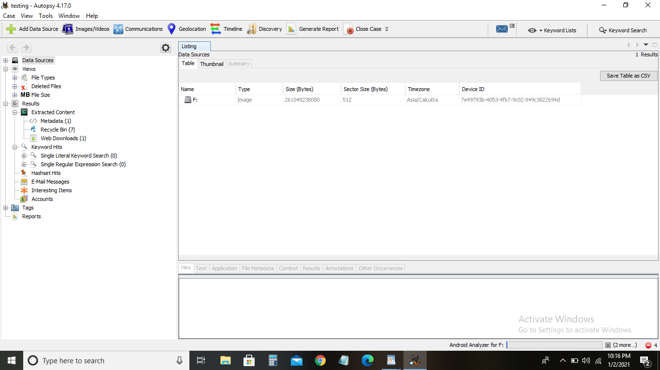

Step 9: All files will appear in table tab select any file to see the data.

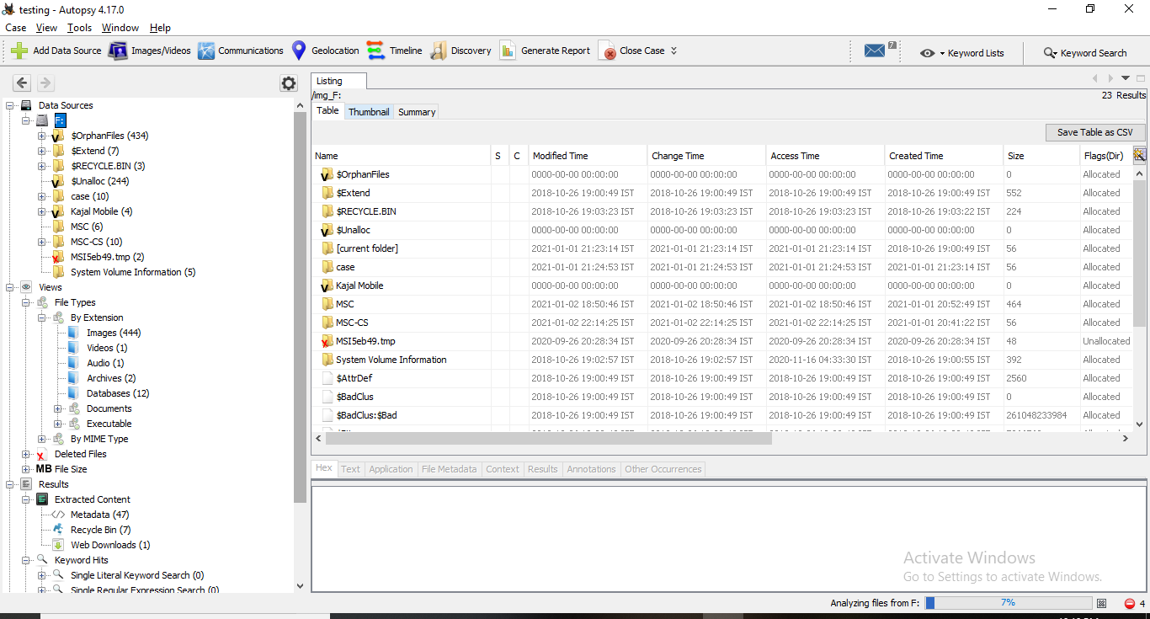

Step 10:Expand the tree from left side panel to view the document files.

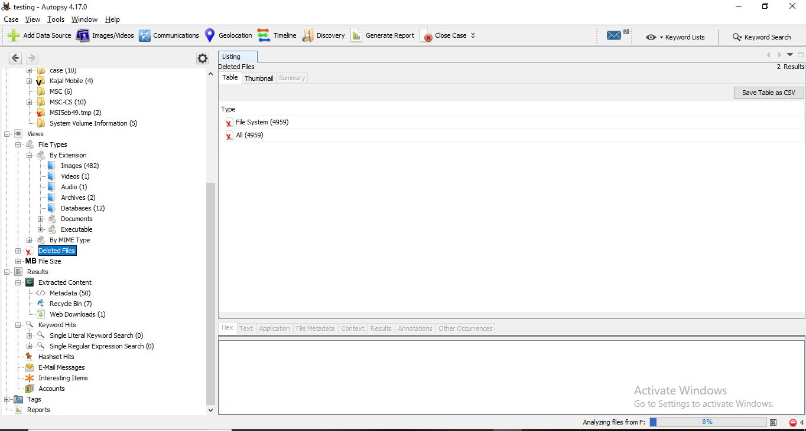

Step 11: To recover the file, go to view node-> Deleted Files node , here select any file and right click on it than select Extract Files option.

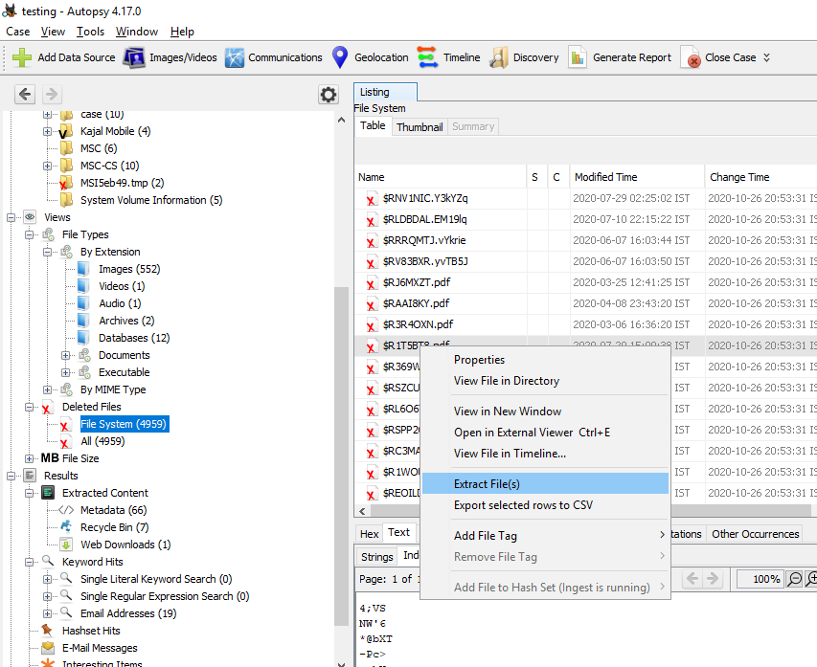

Step 12: By default Export folder is choose to save the recovered file.

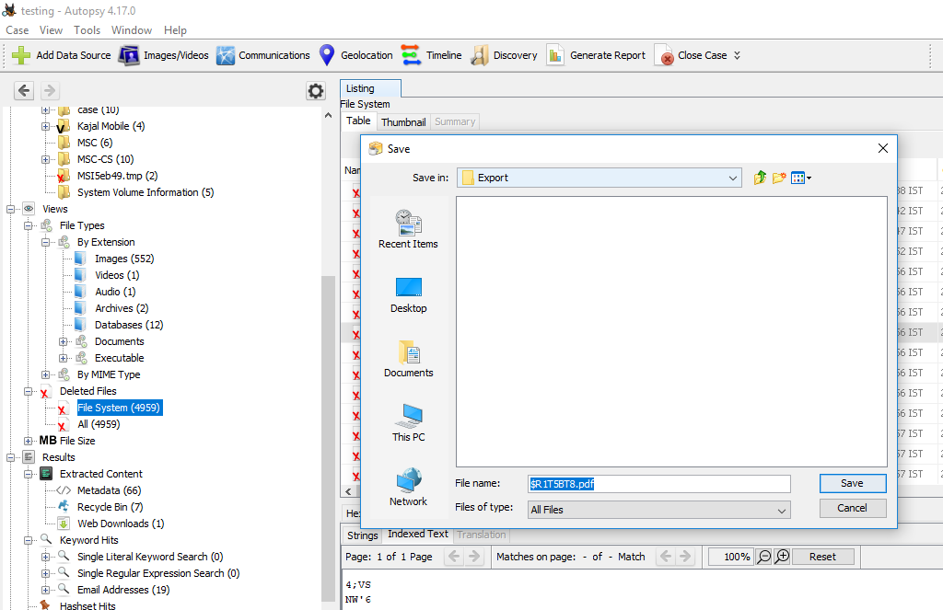

Sep 13 : Now Click on Ok.

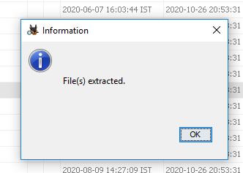

Step 14: Now go to the Export Folder to view Recover file.

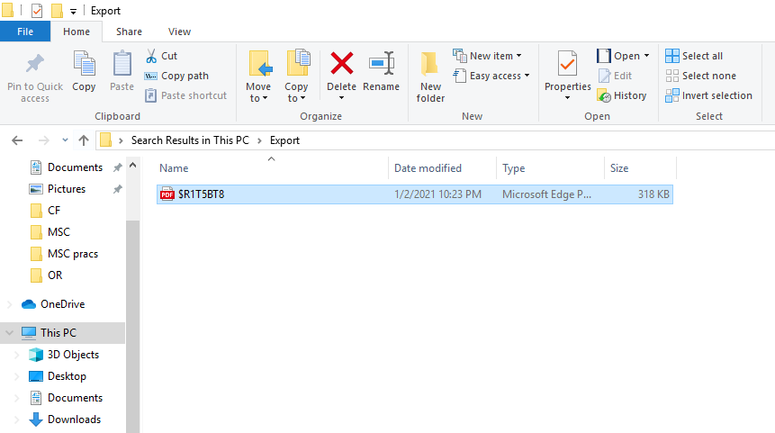

Step 15: Click on Generate Report from autopsy window and Select the Excel format and click on next.

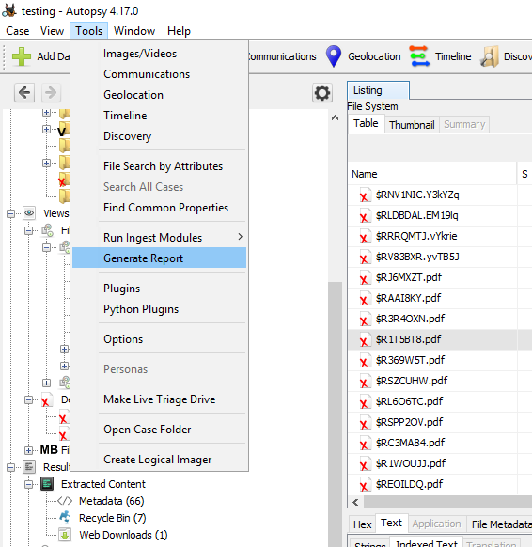

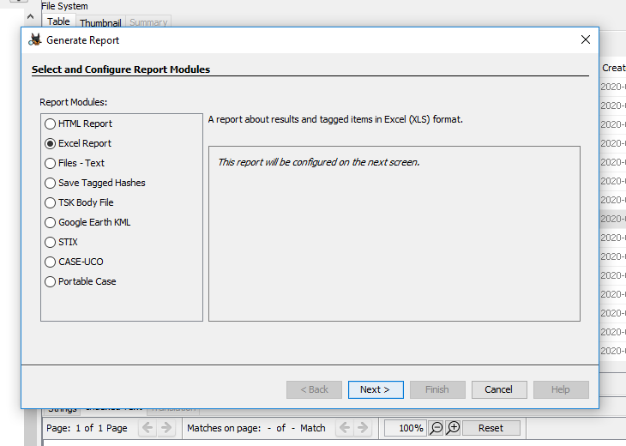

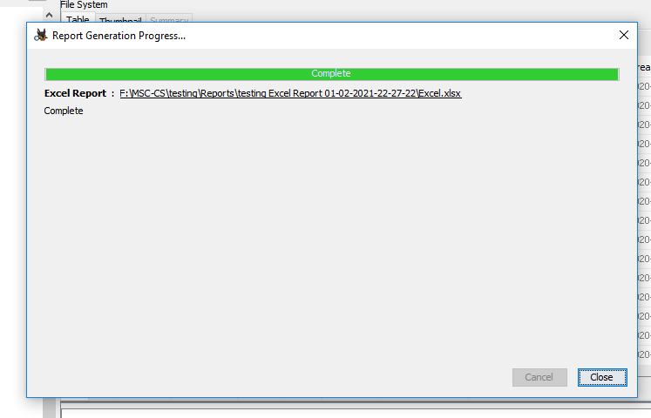

Step 16: Now Report is Generated So click on close Button .we can see the Report on Report Node.

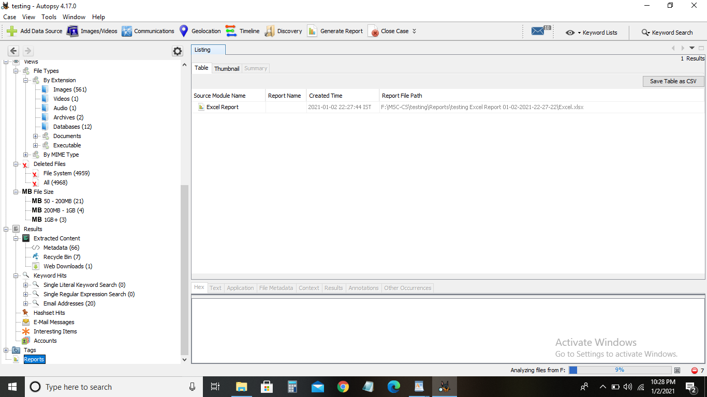

Step 17: Now open the Report folder and Open Excel File.

