Lab1: Object, Class, JUnit (Worksheet)

Section 33 Date 26/08/2560

Student ID 5931034721 Name Patipol Wuthiprasert

# Part A: Implementation

1. Summarize the step to export your project into jar file.

1. go to menu File > Export…

2. select Java > JAR file and click Next

3. choose your project and make sure you have checked “Export Java source files and resources”

4. select the export destination and name your JAR file then click Finish

Done

1. Create a UML diagram of the program using eclipse and tell us the name of software/eclipse extension you are using.

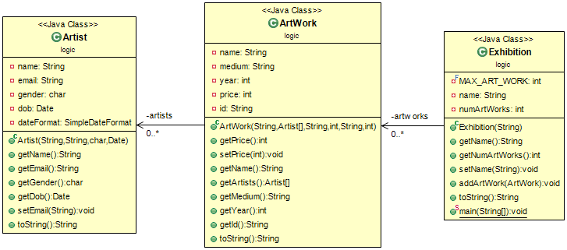

UML diagram created by ObjectAid (eclipse extension)

1. Capture the screen of JUnit Test Cases.

