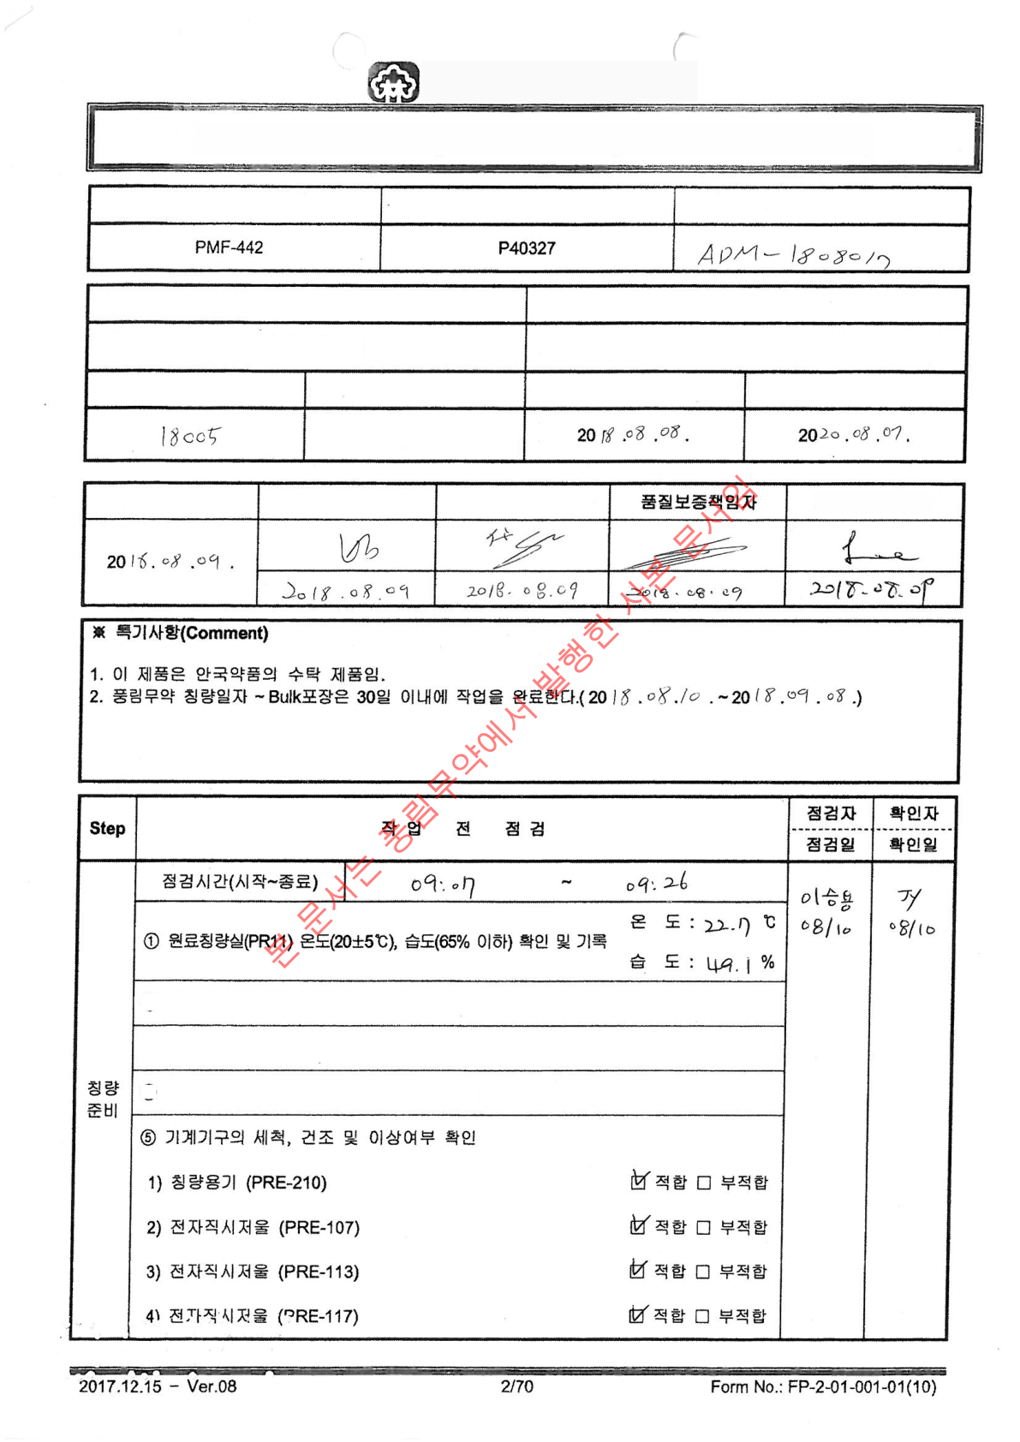
POONG LIM
PHARMACEUTICAL CO., LTD
Manufacturing Order and Record
Product Standard No.
Product Code No.
Manufacturing Instruction No.
Product Name
Appearance
Cephorin-F Tablet
Green oblong ﬁlm-coated layered tablet
Manufacturing Number
Manufacturing Unit
Manufacturing Date
Expiration Date
200,000 tablets
Manufacturing Instruction Site
Issuer
Veriﬁer
Manufacturing Manager
② Check for Raw Material Proper Label Attachment □ Attached □ Not Attached
③ Check Weighing Scale Leveling and Zero Point □ Suitable □ Unsuitable
④ Verify Cleanliness and Clean State of Operation Room □ Suitable □ Unsuitable

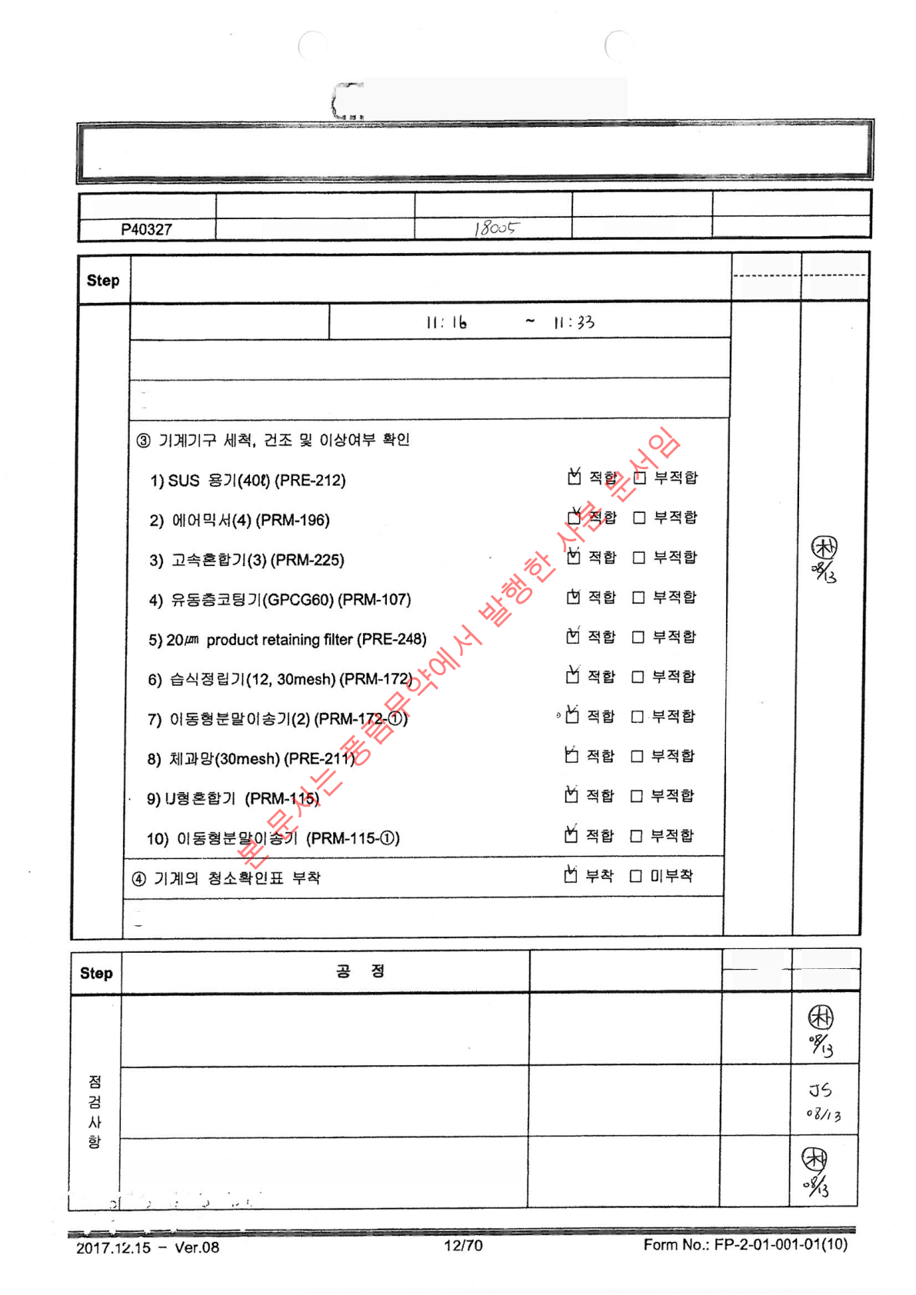
POONG LIM
PHARMACEUTICAL CO., LTD
Manufacturing Instruction and Record
Manufacturing Process Name
Manufacturing Unit
Manufacturing Number
Product Name
Product Code No.
(Middle Layer) Mixing
200,000 tablets
Cephorin-F Tablet
Veriﬁer
Veriﬁcation
Date
Inspector
Inspection
Date
Pre-Operation Check
Ahn
Joo-
Sang
08/13
Inspection Time (Start~End)
① Check Weighing Scale Leveling and Zero Point ② Re-Verify Weighed Raw
Material Weight, Input and Label Record Attachment □ Suitable □ Unsuitable
⑤ Verify Cleanliness and Clean State of Operation Room □ Suitable □ Unsuitable
Worker
Veriﬁer
Record Details
Work Process
Work Date
Veriﬁcation Date
Ahn Joo-
Sang
08/13
Temperature: 21.9 ℃
Humidity: 54.9 %
Verify and Record Temperature (20±5℃) and
Humidity (65% or less) in Mixing Room 8 (PR227)
Temperature: 21.3 ℃
Humidity: 60.7 %
Park
Cheon-
Mok
08/13
Verify and Record Temperature (20±5℃) and
Humidity (65% or less) in Granulation Room 2
(PR36)
Temperature: 21.5 ℃
Humidity: 56.2 %
Ahn Joo-
Sang
08/13
Verify and Record Temperature (20±5℃) and Humidity (65% or less) in
Mixing Room 3 (PR63)

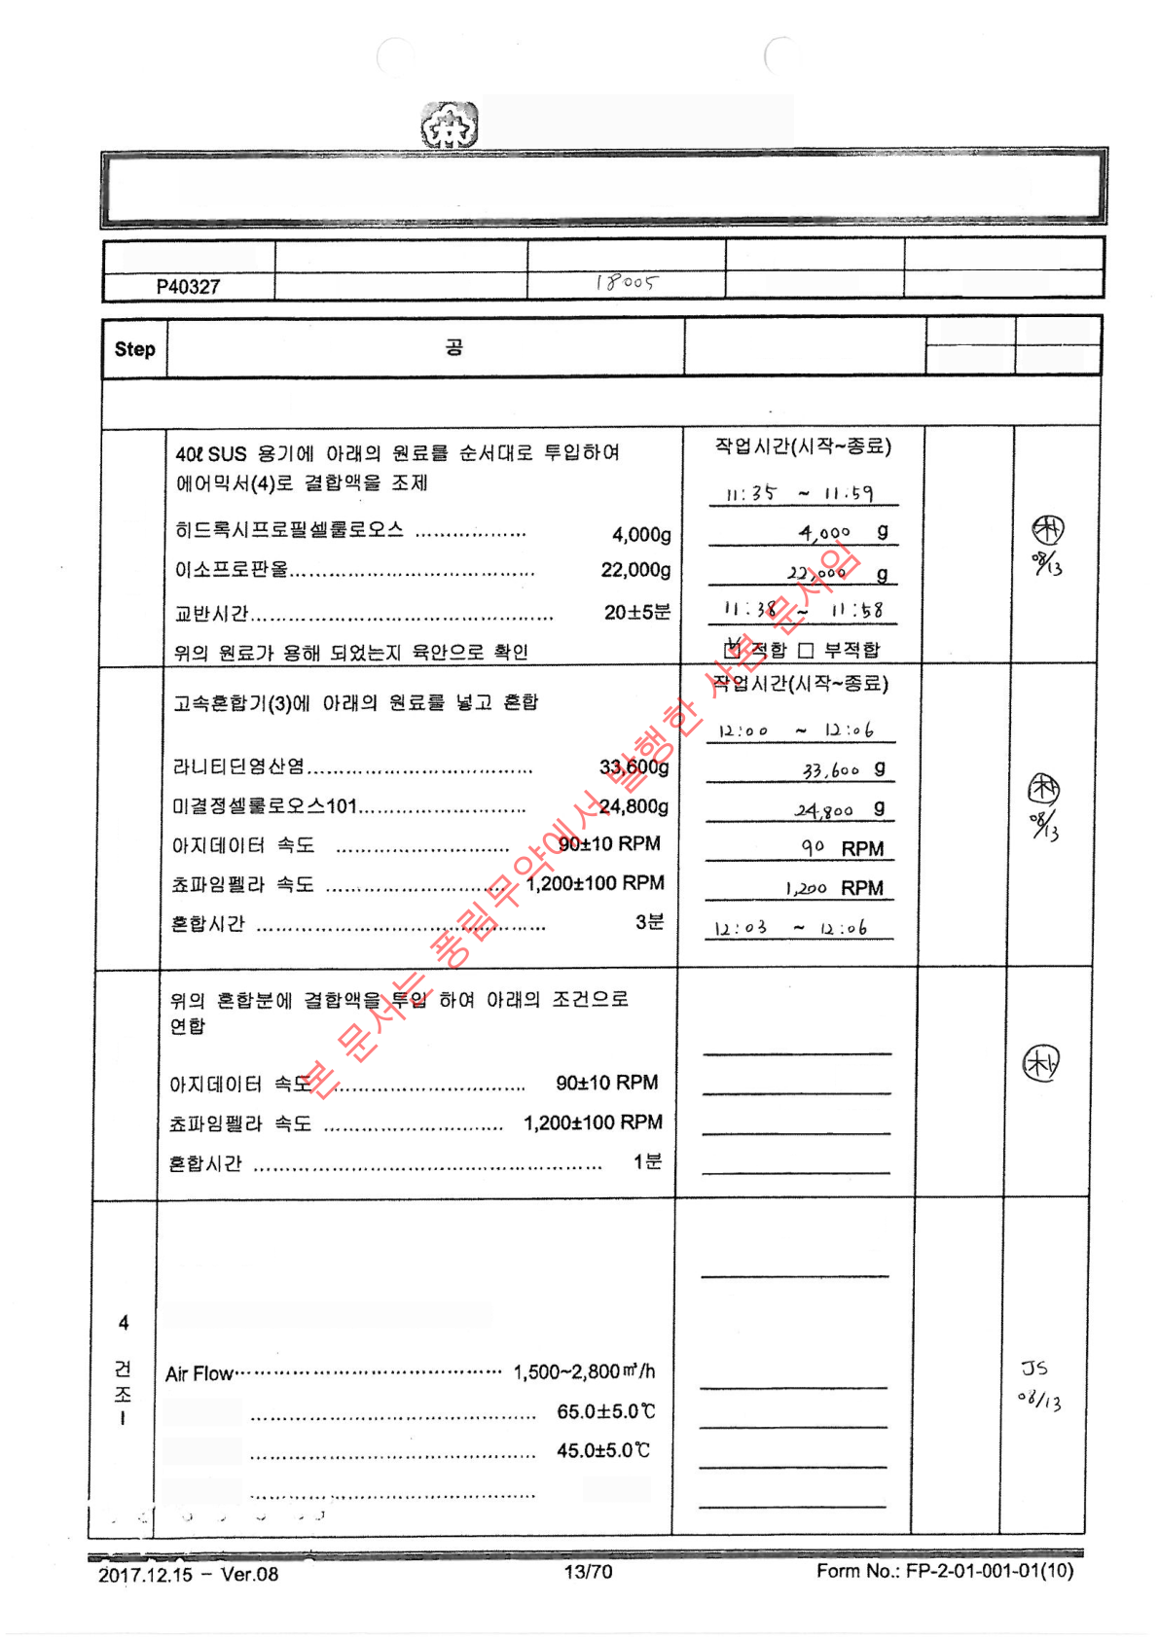
POONG LIM
PHARMACEUTICAL CO., LTD
Manufacturing Instruction and Record
Manufacturing Process Name
Manufacturing Unit
Manufacturing Number
Product Name
Product Code No.
(Middle Layer) Mixing
200,000 tablets
Cephorin-F Tablet
Veriﬁer
Worker
Record Details
Work Process
Work Date
Veriﬁcation Date
Middle Layer Mixing Manufacturing Process
Man
Joo-
Sang
Aug/13
1 Binding
Solution
Preparation
Ahn
Joo-
Sang
08/13
2
Mixing
Dan
Joo-
Sang
08/13
Work Time (Start~End) 12:06
~ 12:15 90 RPM 1,200 RPM
12:10 ~ 12:11
3
Amalgamation
Work Time (Start~End)
12:18 - 12:37 ☑
Suitable ☐ Unsuitable
1,500 ∨ 2,800 �/h 65.0
℃ 43.2 ℃ 12:20 -
12:35
Jinwook
Park
08/13
After checking the mesh screen, dry the composite
in the ﬂuid bed coater under the following conditions.
Verify mesh screen installation and check for any
abnormalities.
Inlet
Temperature
Product
Temperature
15±5 min
Drying Time

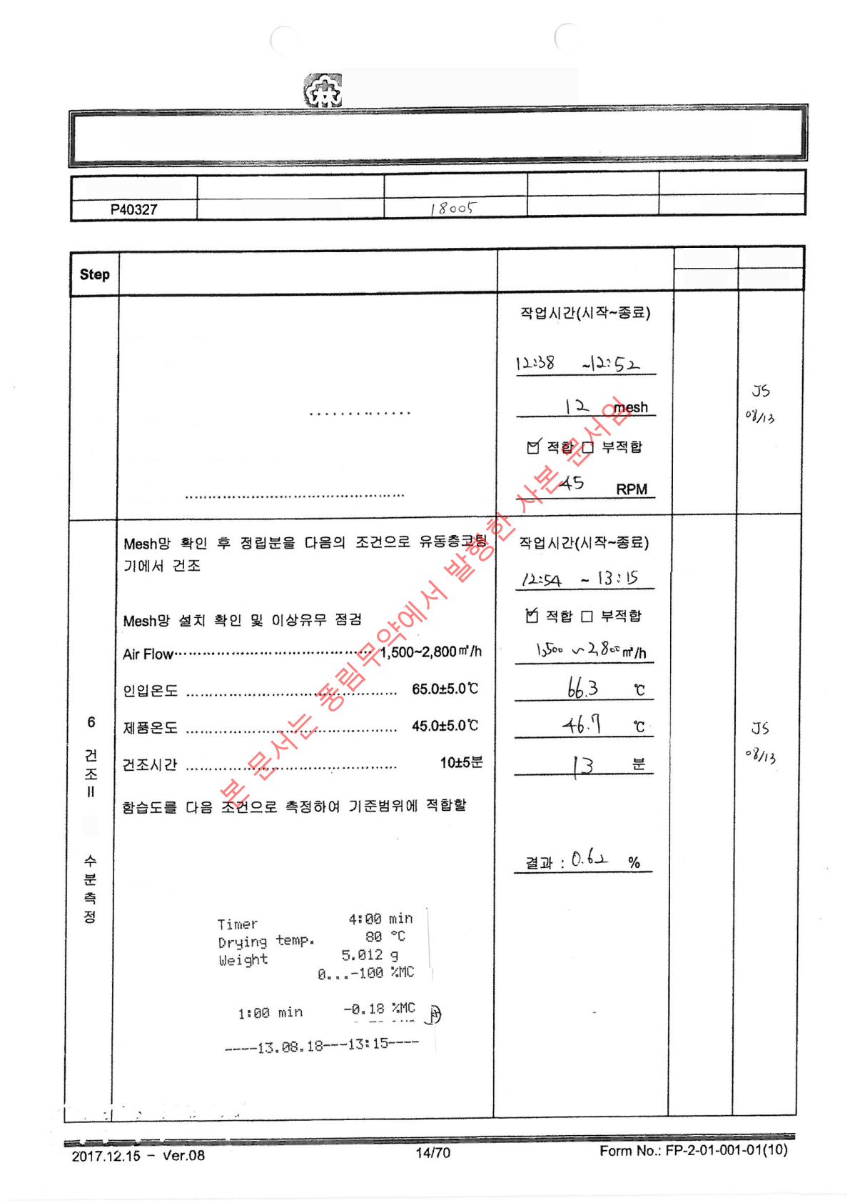
POONG LIM
PHARMACEUTICAL CO., LTD
Manufacturing Instruction and Record
Manufacturing Process Name
Manufacturing Unit
Manufacturing Number
Product Name
Product Code No.
(ChoongChoong) Mixing
200,000 tablets
Cephorin-F Tablet
Worker
Veriﬁer
Record Details
Work Process
Work Date
Veriﬁcation Date
Chanwook
Park
08/13
After verifying the granulation mesh, feed the dried
material into the wet granulator under the following
conditions. Verify granulation mesh installation and
speciﬁcations...12 mesh Check exterior and any
abnormalities of granulation mesh Rotation Speed...45±5
RPM
5
Granulator
Chanok
Park
08/13
and
In case of, end the drying process
Halogen Moisture Analyzer, 80℃, 4
min, 5g usage Moisture Content
Standard below 2.0%

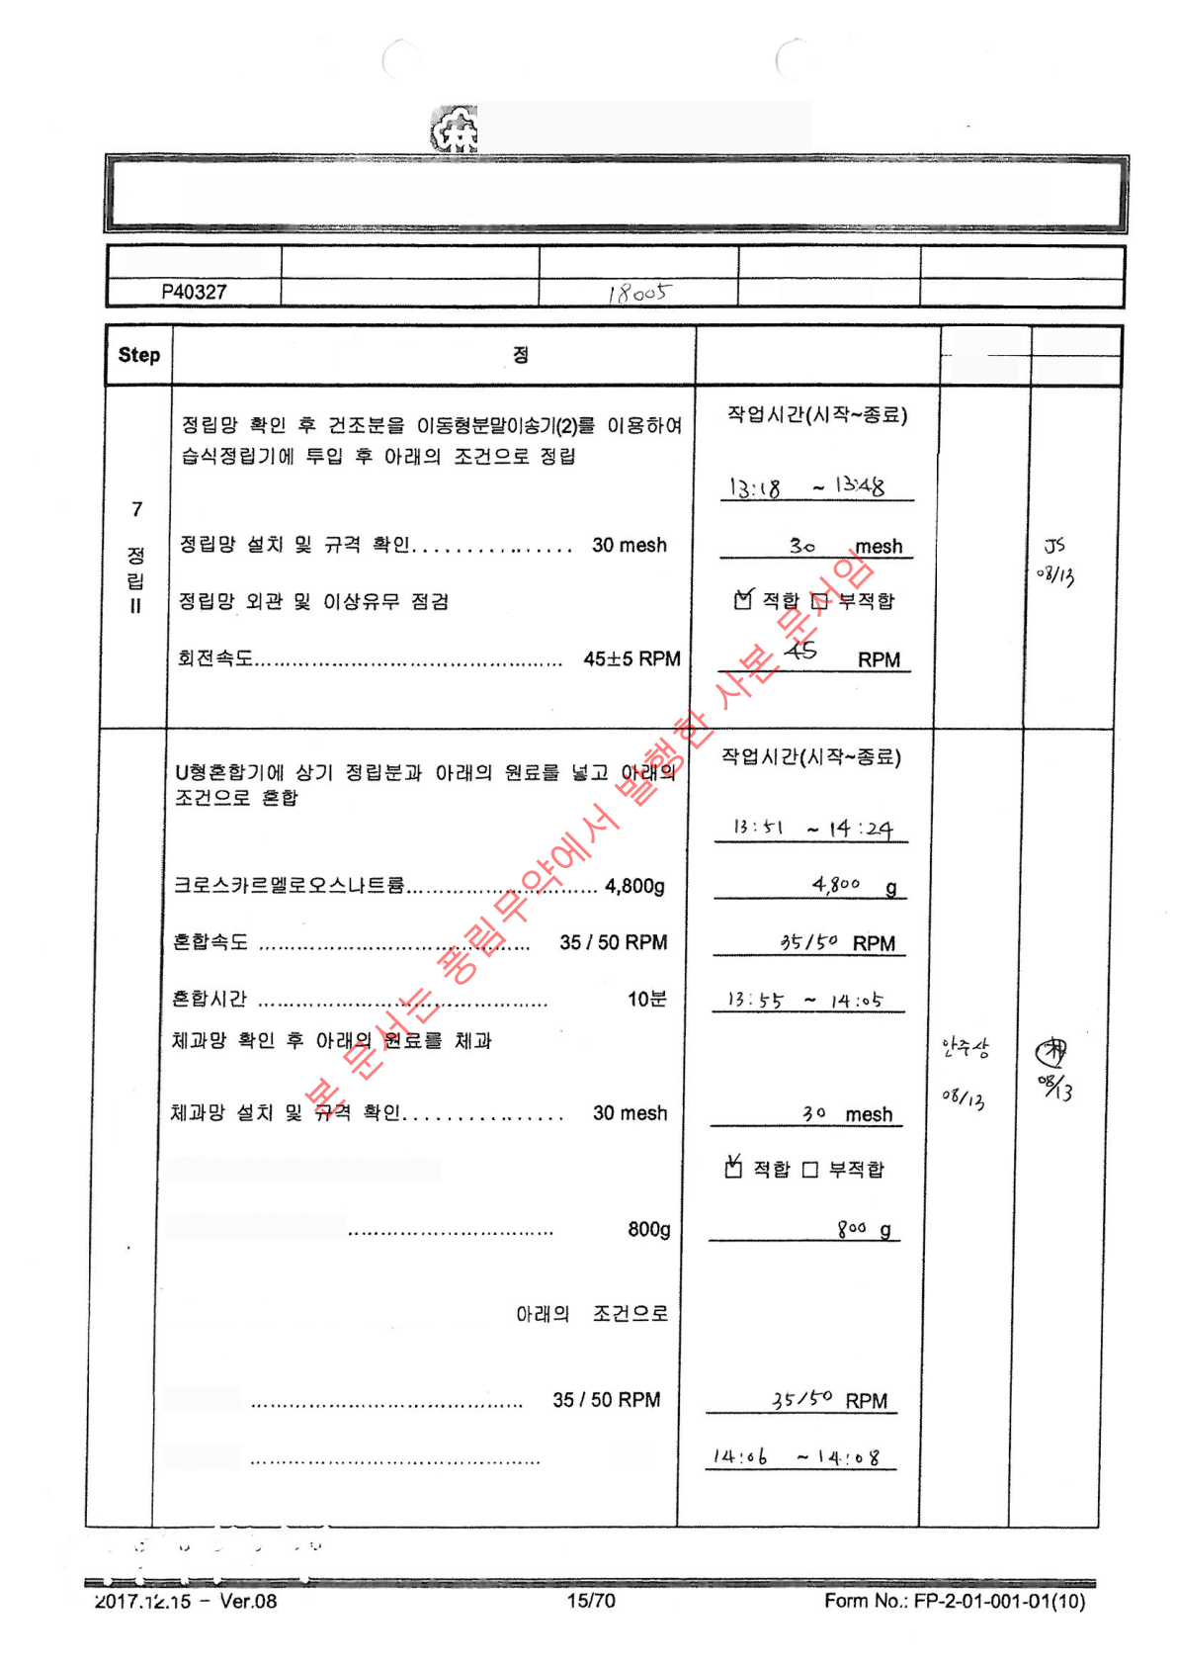
POONG LIM
PHARMACEUTICAL CO., LTD
Manufacturing Instruction and Record
Product Code No.
Manufacturing Unit
Product Name
Manufacturing Number
Manufacturing Process Name
(Middle Layer) Mixing
Cephorin-F Tablet
200,000 tablets
Worker
Veriﬁer
Work Process
Record Details
Work Date
Veriﬁcation
Date
Jinok
Park
08/13
8
Final
Mixing
Check exterior and any abnormalities of the mesh
screen.
Magnesium Stearate.
Put the above sifted material into the U-
shaped mixer Final Mixing
Mixing Speed
2
mins
Mixing Time

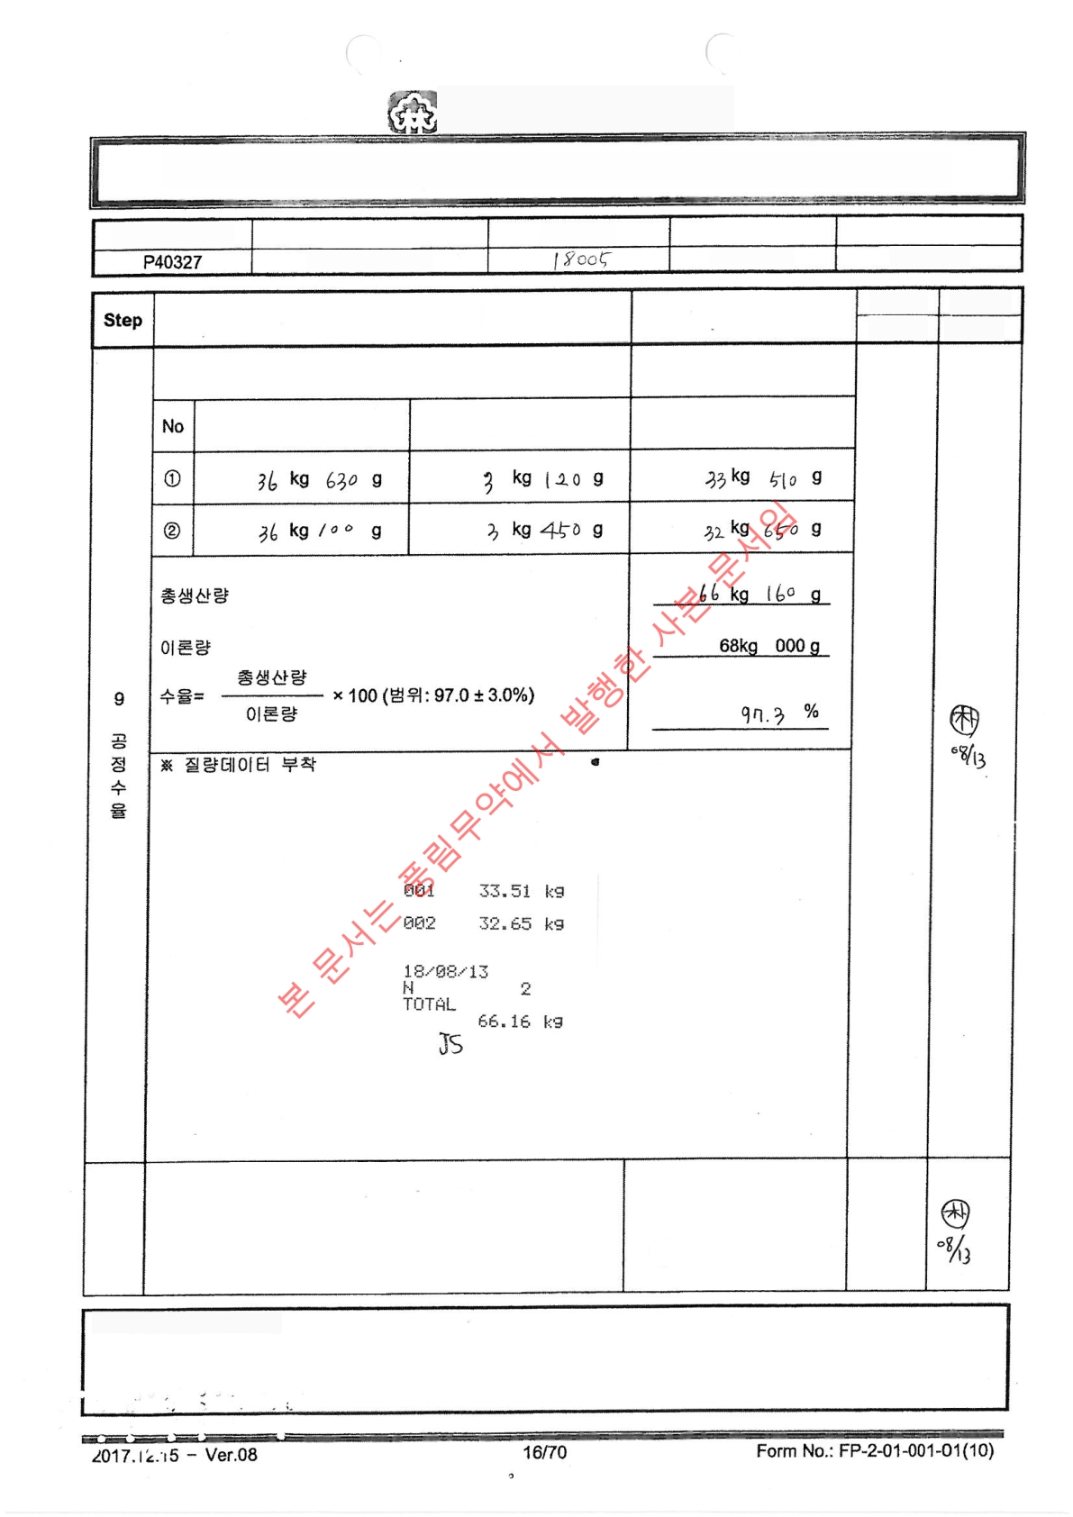
POONG LIM
PHARMACEUTICAL CO., LTD
Manufacturing Instruction and Record
Manufacturing Process Name
Manufacturing Unit
Manufacturing Number
Product Name
Product Code No.
(Middle Layer) Mixing
200,000 tablets
Cephorin-F Tablet
Worker
Veriﬁer
Veriﬁcation
Date
Record Details
Work Process
Work Date
Jusang
Ahn
98/13
Verify production amount of the mixture
Net Content
Container Weight
Gross Weight
Moosang
Ahn
08/13
1) ☑ Packaging
Veriﬁcation 2) ☑
Attachment Completed
3) ☑ Storage Completed
4) ☑ Fit Veriﬁcation
Managed according to In-process Intermediate Product
Management Regulations (PP-2-04-003). 1) Double Vinyl
Bag Packaging 2) Attach Process Veriﬁcation Label on
Intermediate Product Storage Container 3) Store in
Intermediate Product Room 1 4) Verify Temperature and
Humidity of Intermediate Product Room (20±5℃, below 65%)
10
Storage
※ Special Comments (Comment)

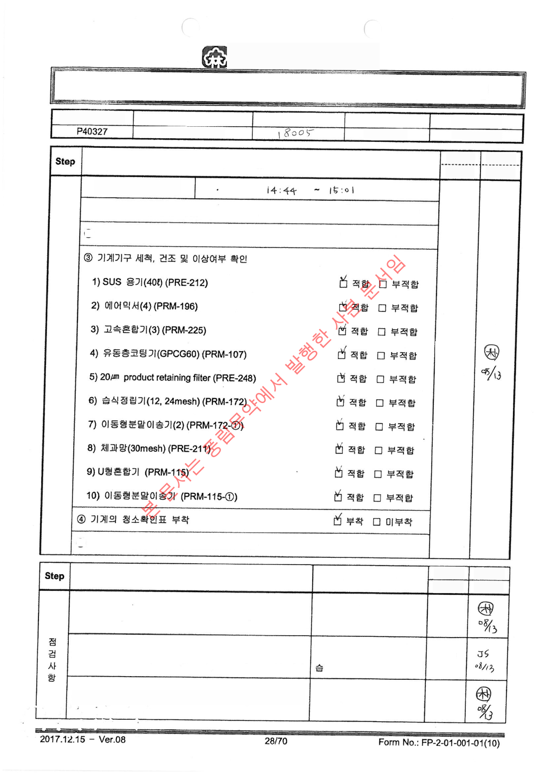
POONG LIM
PHARMACEUTICAL CO., LTD
Manufacturing Instruction and Record
Product Code No.
Product Name
Manufacturing Number
______ Manufacturing Unit
Manufacturing Process Name
Cephorin-F Tablet
200,000 tablets
(Upper, Lower Layer) Mixing
Pre-Operation Check
Inspector
Inspection
Date
Veriﬁer
Veriﬁcation
Date
Inspection Time (Start~End)
① Conﬁrm Scale Balance and Zero Point Suitable □ Unsuitable
② Reconﬁrm Weighed Raw Material, Input and Attach Cleanliness Label Record
Jusam
Ahn
08/13
⑤ Verify Cleanliness and Cleaning Status of Workroom □ Suitable □ Unsuitable
Work Process
Worker
Record Details
Veriﬁer
Work Date
Veriﬁcation
Date
Verify and Record Temperature (20±5℃) and
Humidity (65% or less) in Mixing Room 8
(PR227)
Temperature : 22 ℃
Humidity : 55.7 %
Man-gok
Sang
08/13
Verify and record temperature (20±5℃) and
humidity (below 65%) in Room 2 of Gwalim
(PR36)
Temperature : 21.5 ℃
Humidity : 59.8 %
Chanwook
Park
08/13
Temperature : 22.1 ℃
Humidity : 57.3 %
Ahn Joo-
Sang
08/13
Verify and Record Temperature (20±5℃) and Humidity (65% or less) in
Mixing Room 3 (PR63)

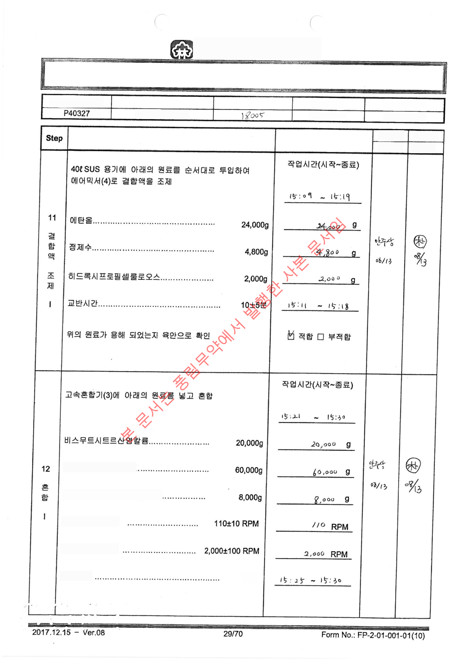
POONG LIM
PHARMACEUTICAL CO., LTD
Manufacturing Instruction and Record
Product Code No.
Product Name
Manufacturing Number
Manufacturing Unit
Manufacturing Process Name
Gaseporim F-Tablets
200,000 tablets
(Upper, Lower Layer) Mixing
Work Process
Worker
Record Details
Veriﬁer
Work Date
Veriﬁcation
Date
Sucralfate Hydrate..
Microcrystalline Cellulose vivapur12.
Agitator Speed
Super Impeller Speed
Mixing Time
5
minutes

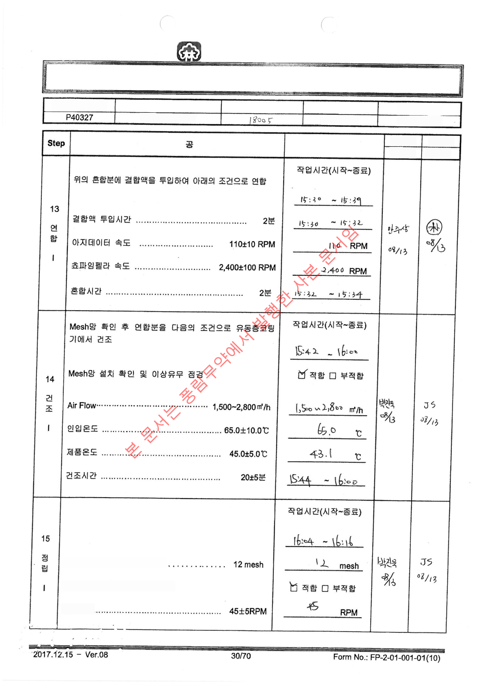
Punglim Pharm. Co., Ltd. Manufacturing
Instruction and Record
Product Code No.
Product Name
Manufacturing Number
Manufacturing Unit
Manufacturing Process Name
Cephorin-F Tablet
200,000 tablets
(Upper, Lower Layer) Mixing
Work Process
Record Details
Worker
Veriﬁer
Veriﬁcation
Date
Work Date
After checking the granulation mesh, inject the dried material
into the wet granulator under the following conditions for
granulation
Check installation and speciﬁcation of
granulation mesh..
Check appearance and inspect for
abnormalities of granulation mesh
Rotational
Speed.

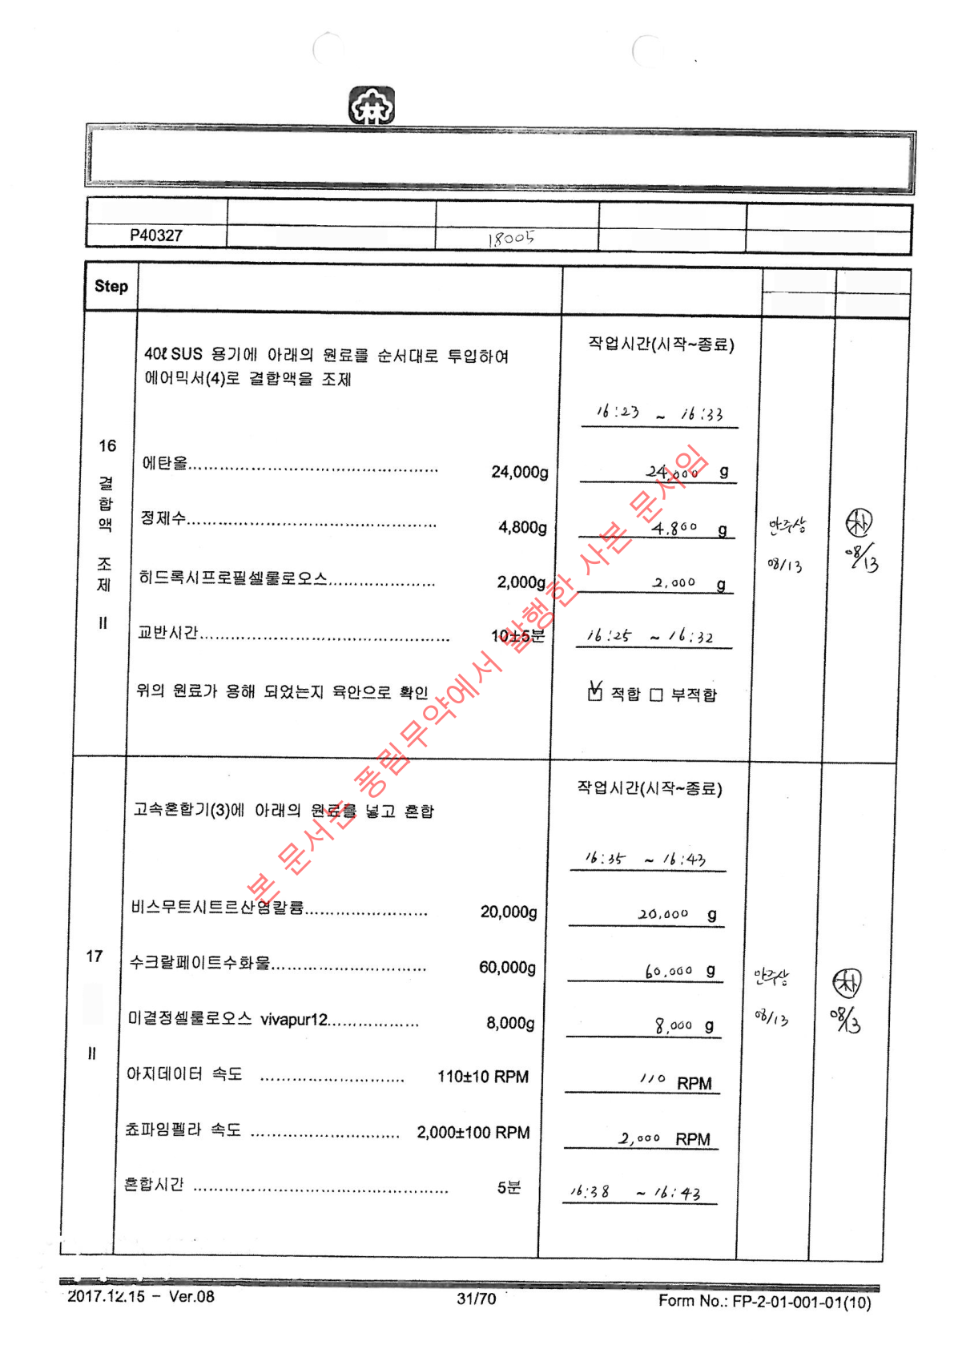
Punglim Pharm. Co., Ltd. Manufacturing
Instruction and Record
Product Code No.
Product Name
Manufacturing Number
Manufacturing Unit
Manufacturing Process Name
Gasprin F Tab
200,000 tablets
(Upper, Lower Layer) Mixing
Work Process
Record Details
Worker
Veriﬁer
Work Date
Veriﬁcation
Date
Mixing

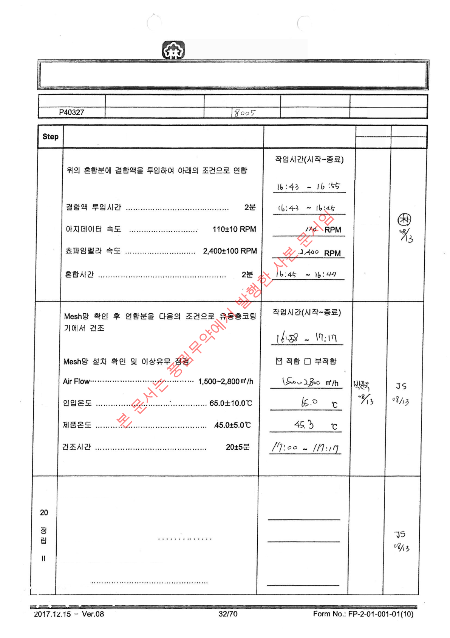
POONG LIM
PHARMACEUTICAL CO., LTD
Manufacturing Instruction and Record
Product Code No.
Product Name
Manufacturing Number
Manufacturing Unit
Manufacturing Process Name
Cephorin-F Tablet
(Upper, Lower Layer) Mixing
200,000 tablets
Worker
Veriﬁer
Work Process
Record Items
Work Date
Veriﬁcation Date
18
Amalgamation
II.
Ahn
Joo-
Sang
08/13
19
Drying
II
After checking the granulation mesh, inject the dried material
into the wet granulator under the following conditions for
granulation Check installation and speciﬁcation of granulation
mesh... 12 mesh Check appearance and inspect for
abnormalities of granulation mesh Rotational Speed...
45±5RPM
Working Time (Start-
End) 17:18 - 17:30 12
mesh ☑ Suitable ☐ Not
Suitable 45 RPM
Chanwook
Park
08/13

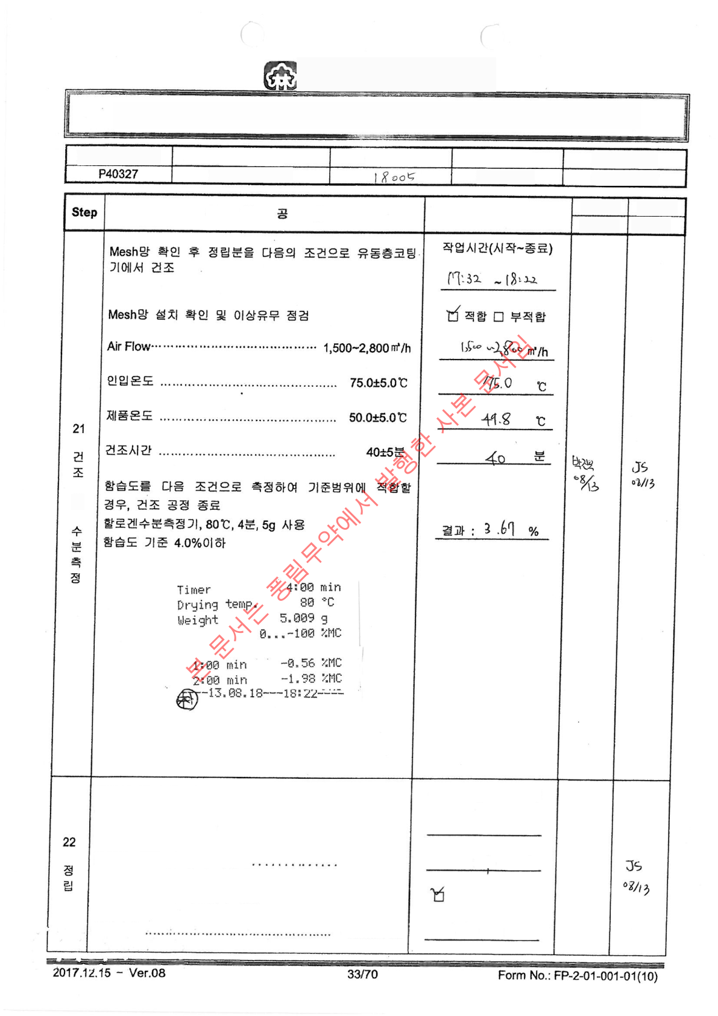
POONG LIM
PHARMACEUTICAL CO., LTD
Manufacturing Instruction and Record
Product Code No.
_________ Product Name
Manufacturing Number
________ Batch Size
Manufacturing Process Name
Cephorin-F Tablet
200,000 tablets
(Upper, Lower Layer) Mixing
Work Process
Worker
Veriﬁer
Record Details
Work Date
Veriﬁcation Date
It
After checking the granulation mesh, inject the dried
material into the mobile powder feeder (2) for granulation
under the following conditions Check installation and
speciﬁcation of granulation mesh... 24 mesh Check
appearance and inspect for abnormalities of granulation
mesh Rotational Speed... 45±5RPM
Working Time
(Start~End) 18:24 - 18:52
24 mesh ☑ Suitable ☐
Not Suitable 45 RPM
Jinok
Park
08/13

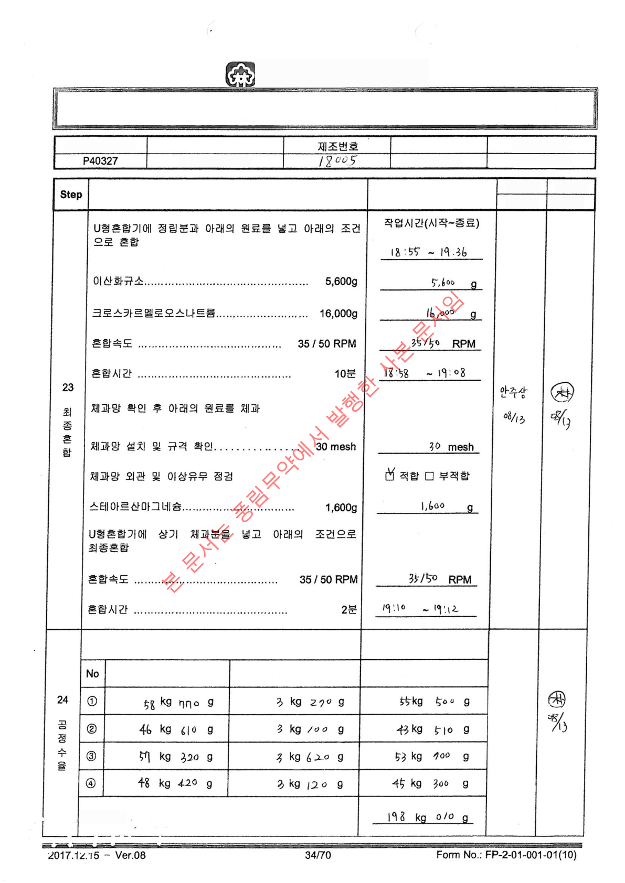
POONG LIM
PHARMACEUTICAL CO., LTD
Manufacturing Instruction and Record
Manufacturing Process Name
Product Code No.
Product Name
Manufacturing Unit
Cephorin-F Tablet
(Upper, Lower Layer) Mixing
200,000 tablets
Worker
Veriﬁer
Record Details
Work Process
Work Date
Veriﬁcation Date
Check the yield of the ﬁnal mixture
Ahn
Joo-
Sang
08/13
Net Content
Gross Weight
Container Weight
Output yield

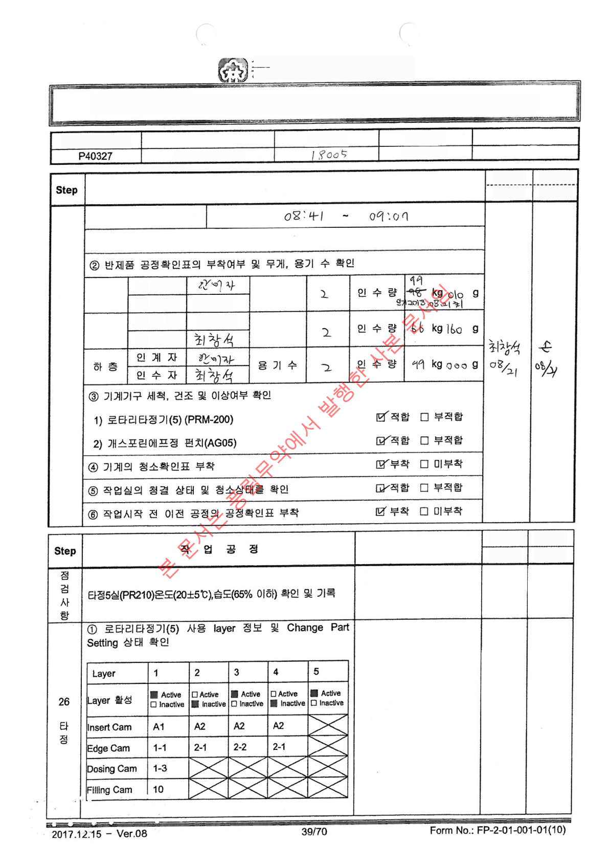
Dongrim Pharmaceutical Co.,
Ltd.
Manufacturing Instruction and Record
Manufacturing Process Name
Manufacturing Unit
Manufacturing Number
Product Name
Product Code No.
compression
200,000 tablets
Cephorin-F Tablet
Inspector
---------
Inspection
Date
Conﬁrmer
---------
Conﬁrmation
Date
Pre-Operation Check
Inspection Time (Start~End)
① Check scale balance and zero point ☑ Conform ☐ Non-conform
Number of
Containers
Transmitter
Upper
Layer
Choi Chang-seok
Recipient
Number of
Containers
Limit Excess
Transmitter
Increase
Weight
Recipient
Worker
Veriﬁer
Record Details
Work Date
Veriﬁcation Date
Son
08/21
Temperature : 21.1 ℃
Humidity : 53.5 %
Choi
Chang-
seok
08/21
Sequence
08/21
Conform Non-conform
Choi
Chang-
seok
08/21

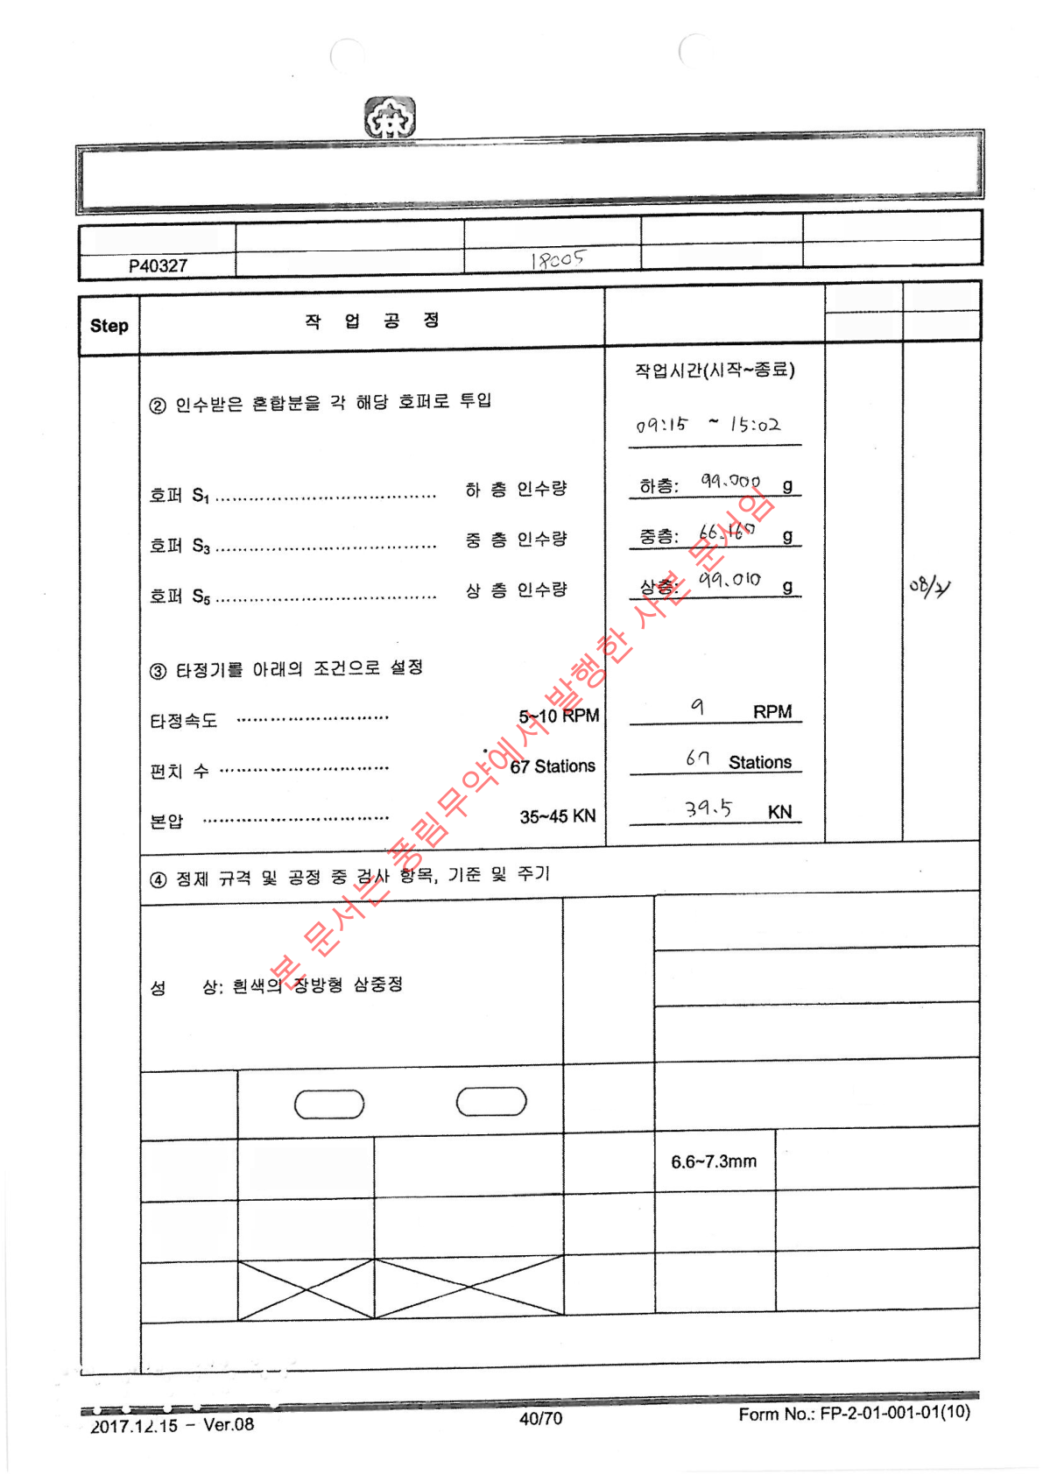
Punglim Pharm. Co., Ltd. Manufacturing Instruction and
Record
Manufacturing Process Name
Manufacturing Unit
Manufacturing Number
Product Name
Product Code No.
compression
200,000 tablets
Cephorin-F Tablet
Veriﬁer
Operator
Work
Date
Record Details
Veriﬁcation
Date
Son
08/3
Choi
Chang-
seok
08/21
508.0mg (Upper Layer Standard
Mass:508.0mg)
Compression
Instruction
Quantity
(1,356.0mg)
340.0mg (Middle Layer Standard
Mass:340.0mg)
508.0 mg (Lower Layer Standard
Mass:508.0 mg)
Length : 19.7mm Width : 8.7mm
Size
Front: Back:
Embossing
Identiﬁcation
Test Compression and
Every Hour Interval
Thickness
(5T)
Test Compression and
Every Hour Interval
Standard Mass
±5.0%
1,288.2~1423.8�
Individual
Mass ( 20T)
Test Compression and
Every Hour Interval
Above
10.0kp
Hardness
(5T)
Test Compression
and 30 Minute Interval
Standard Mass
±3.0%
1315.3~1396.6mg
Average
Mass (20T)
Test Compression and
Once Each Morning and
Afternoon
Below 1.0%
Friability
(20T)
Seal

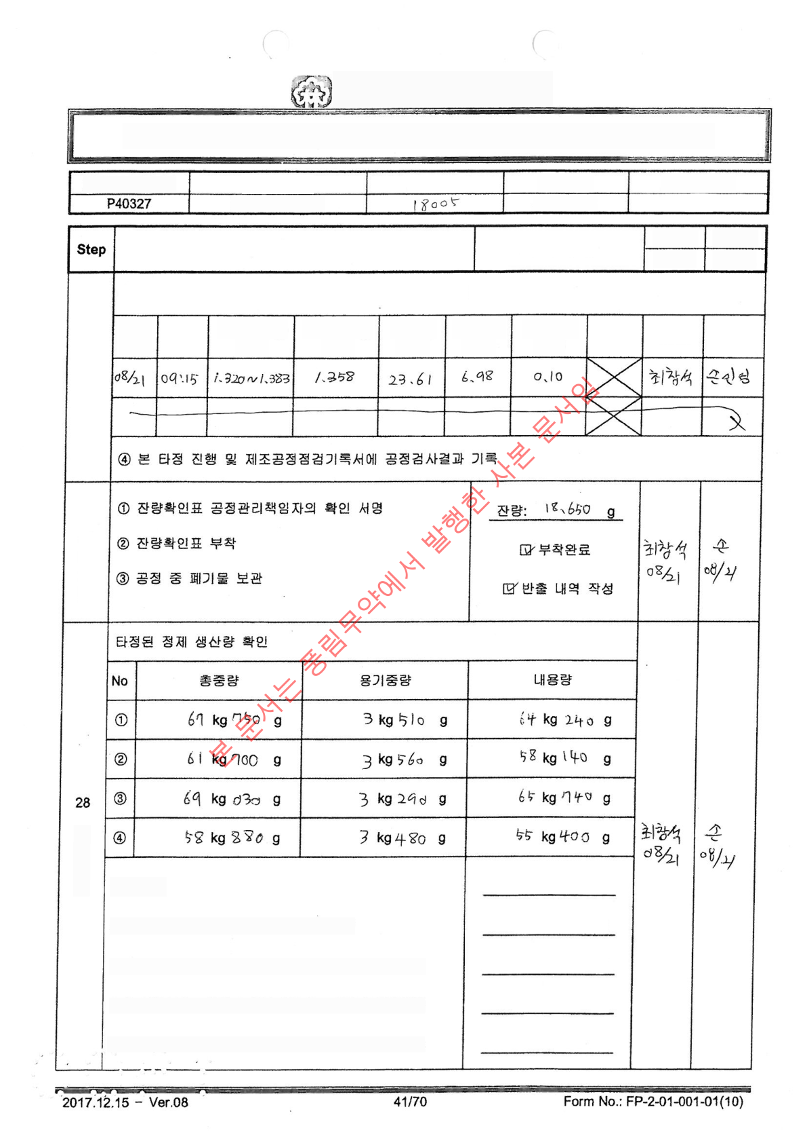
POONG LIM
PHARMACEUTICAL CO., LTD
Manufacturing Instruction and Record
Manufacturing Unit
Manufacturing Process Name
Manufacturing Number
Product Code No.
Product Name
compression
Cephorin-F Tablet
200,000 tablets
Worker
Record Details
Veriﬁer
Work Process
Work Date
Veriﬁcation Date
③ Record and conﬁrm veriﬁer's conﬁrmation after 3 rotations test compression results
Thickness
(mm) (67T)
Friability
(%) (20T)
Seal
Worker
Veriﬁer
Start
Date
Time
Hardness
(kp) (67T)
Individual Mass
(mg) (67T)
Average Mass
(mg) (67T)
27
Remaining
Processing
Pro
gress
Yield
243 kg 520 g
179,679 tablets
194,901 tablets
194,588 tablets
194,881 tablets
Total Production
Volume
Total Production Quantity = Total Production Volume + Average
Mass of Compressed Tablets
Theoretical Quantity for Upper Layer = Quantity of Mixed Material for Upper Layer ÷
Instruction Quantity for Upper Layer Compression
Theoretical Quantity for Middle Layer = Quantity of Mixed Material for Middle Layer ÷
Instruction Quantity for Middle Layer Compression
Theoretical Quantity for Lower Layer = Quantity of Mixed Material for Lower Layer +
Instruction Quantity for Lower Layer Compression

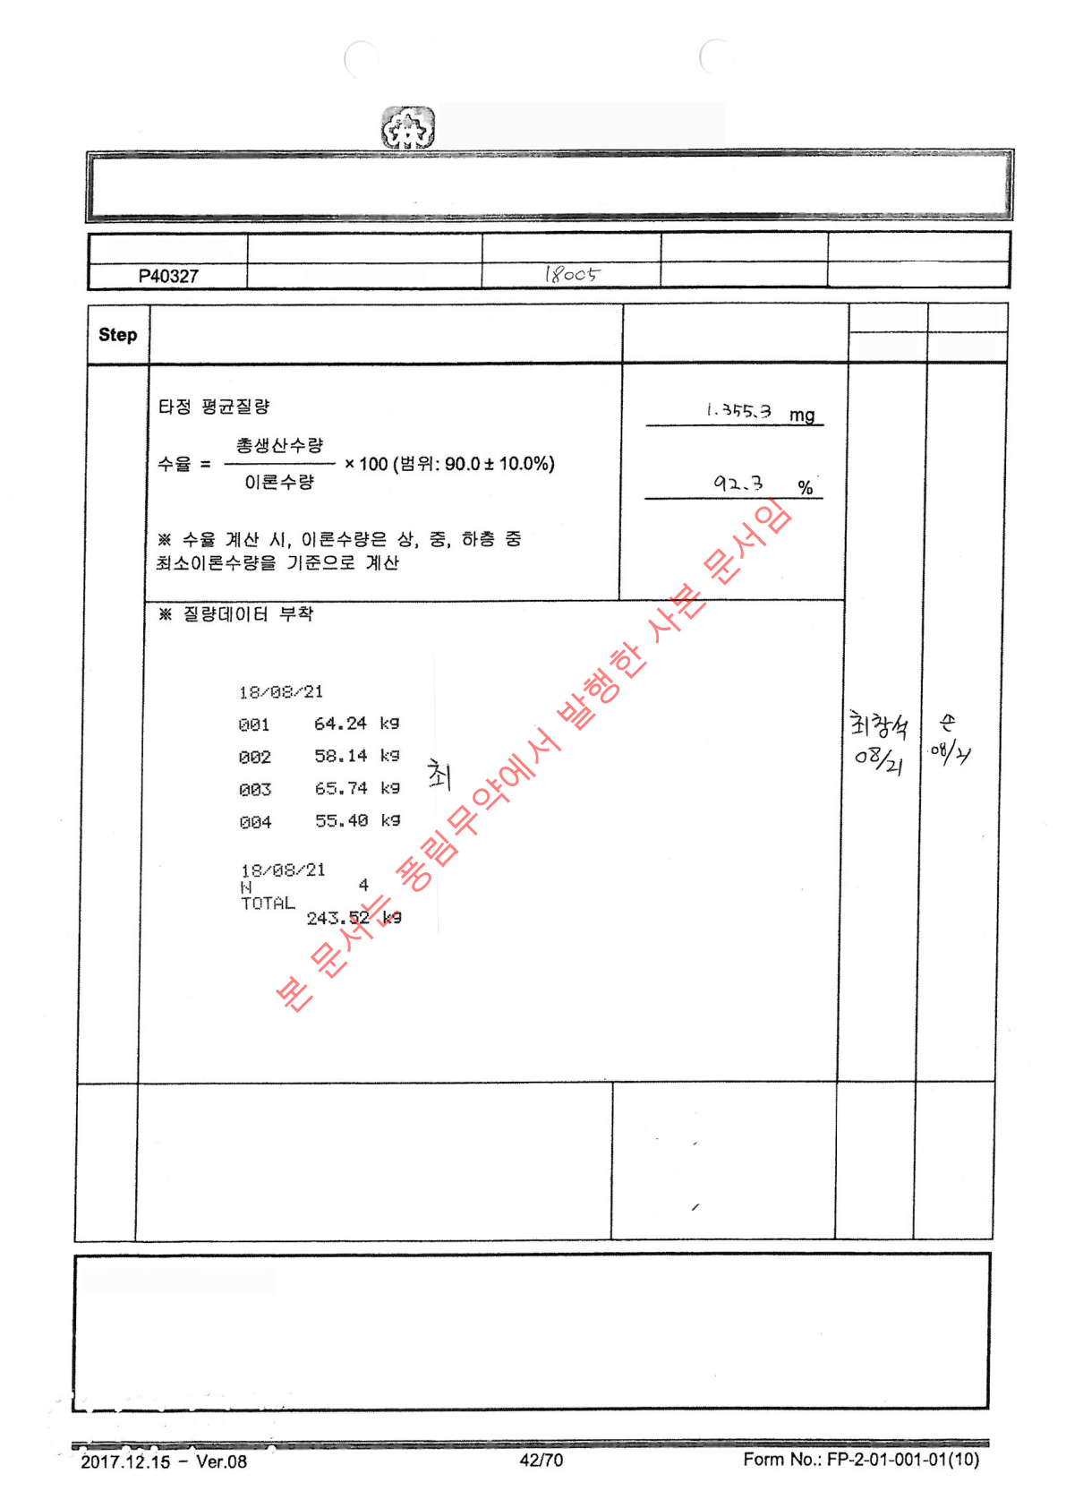
POONG LIM
PHARMACEUTICAL CO., LTD
Manufacturing Instruction and Record
Manufacturing Unit
Manufacturing Process Name
Manufacturing Number
Product Name
Product Code No.
compression
200,000 tablets
Cephorin-F Tablet
Worker
Veriﬁer
Record Details
Work Process
Work Date
Veriﬁcation Date
1) Packaging Conﬁrmation
2) Attachment Completed
3) Storage Completed 4)
Suitability Conﬁrmation
Choi
Chang-
seok
08/21
Son
08/21
Managed according to In-Process Semi-Product
Management Regulations (PP-2-04-003). 1) Double
plastic bag packaging 2) Attach Process Veriﬁcation Tag
to Semi-Product Storage Container 3) Store in Semi-
Product Room 7 4) Conﬁrm Temperature and Humidity in
Semi-Product Room (20±5℃, below 65%)
29
Stor
age
※ Special Comments (Comment)

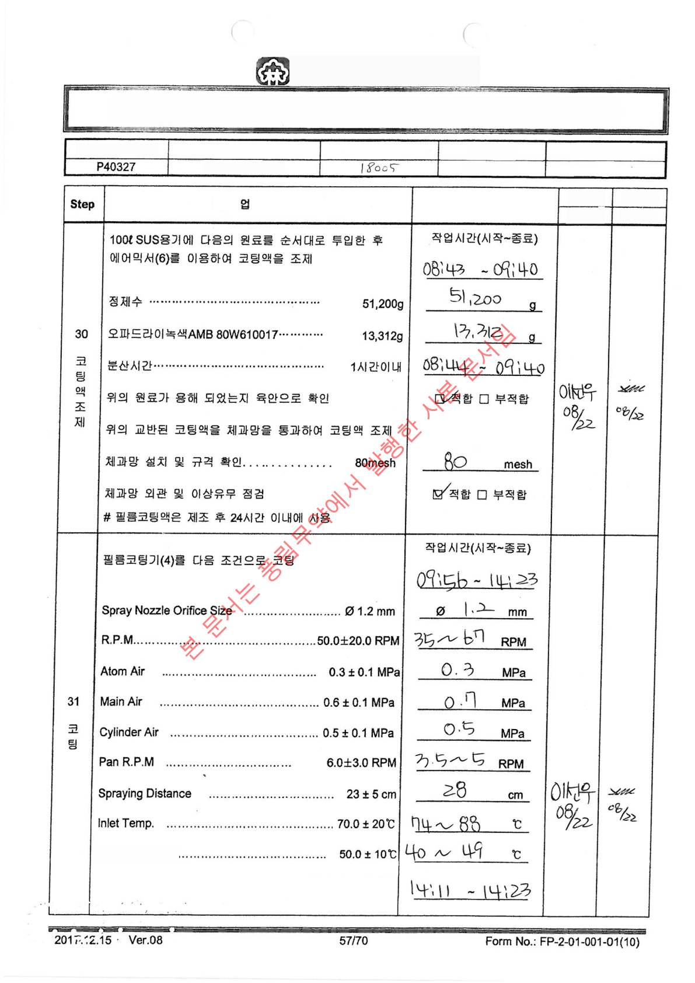
Poonglim Pharmaceutical
Co., Ltd.
Manufacturing Instruction and Record
Product Code No.
Product Name
Manufacturing Number
Manufacturing Unit
Manufacturing Process Name
Cephorin-F Tablet
Coating
200,000 tablets
Work Process
Record Details
Operator
Date of
Work
Veriﬁer
Veriﬁcation Date
Outlet Temp. ...
After completing the spray, rotate the pan for about 20 ±
10 minutes to dry the coated tablets

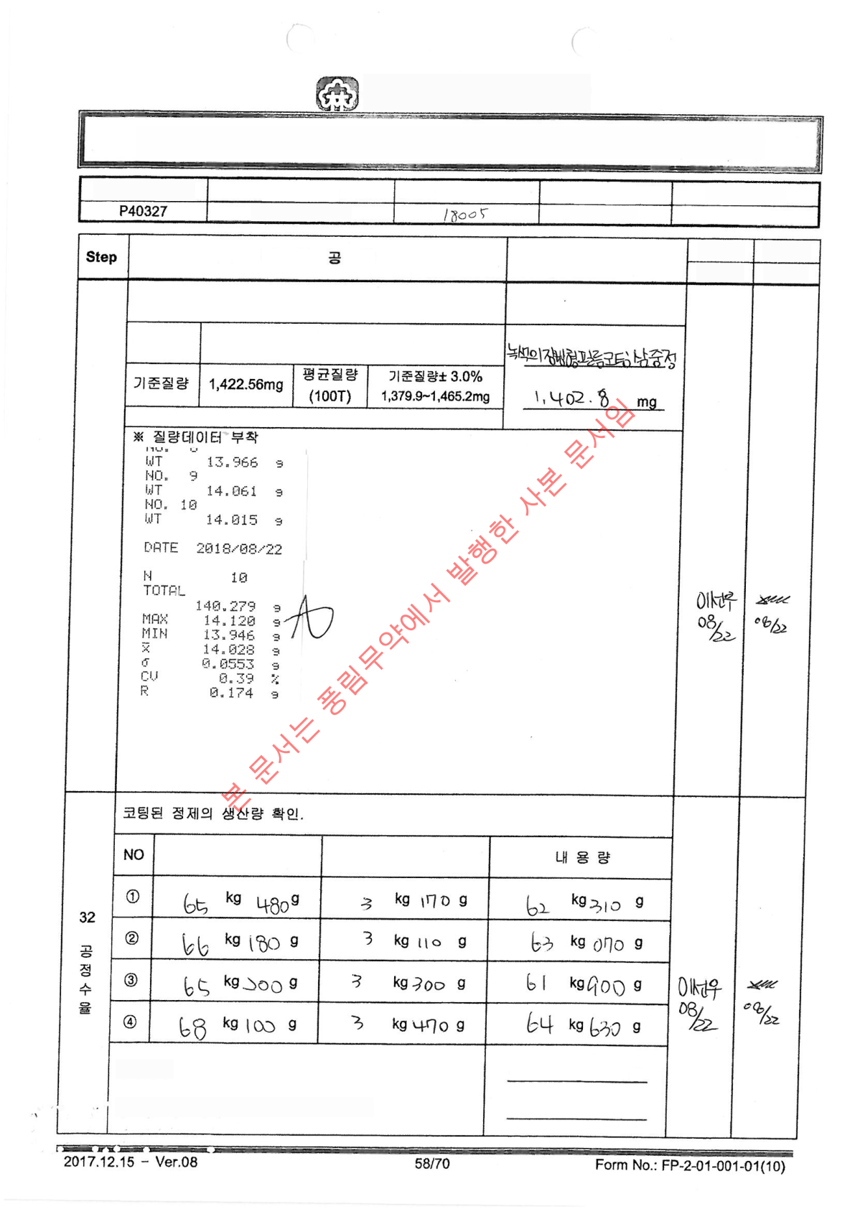
Dongrim Pharmaceutical Co.,
Ltd.
Manufacturing Instruction and Record
Product Code No.
Product Name
Manufacturing Number
Manufacturing Unit
Manufacturing Process Name
Cephorin-F Tablet
Coating
200,000 tablets
Work Process
Record Details
Worker
Veriﬁer
Work Date
Veriﬁcation Date
Verify and Record Physical Characteristics,
Average Mass after Coating Completion
Appearance
Green oblong ﬁlm-coated layered tablet
Gross Weight
Container Weight
251 kg 910 g 179,579
tablets
Total Production
Volume
Total Production Quantity = Input Quantity - Process Test
Quantity

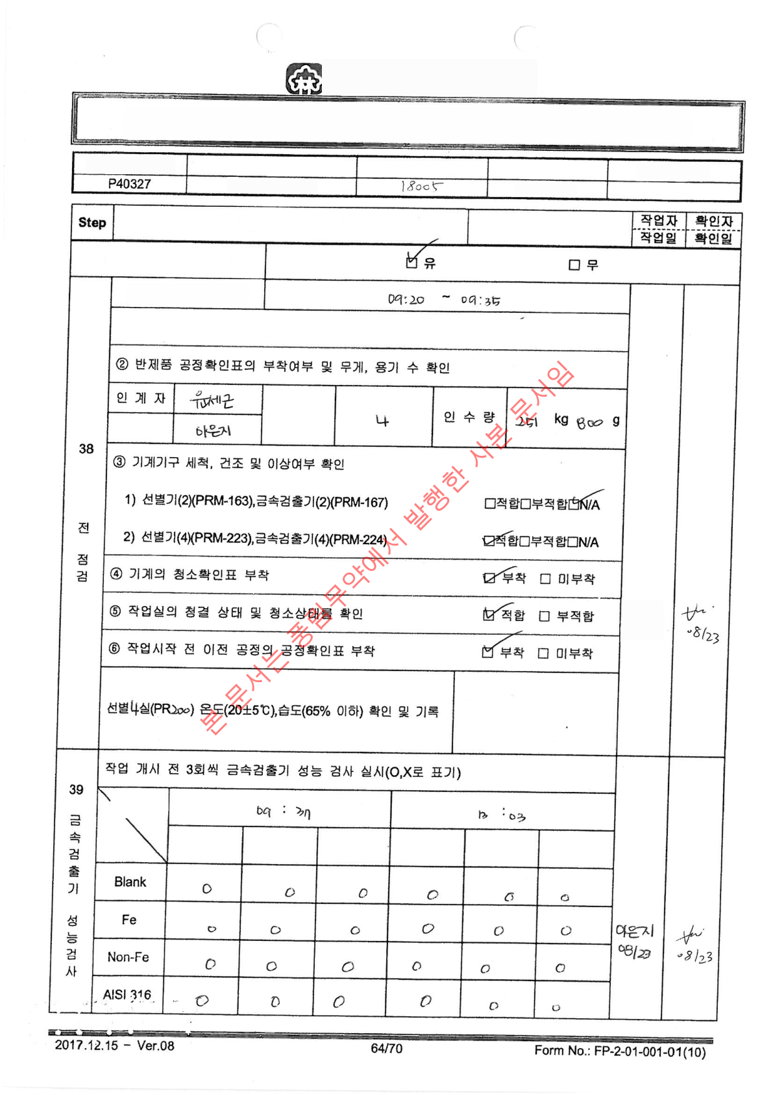
POONG LIM
PHARMACEUTICAL CO., LTD
Manufacturing Instruction and Record
Product Code No.
Product Name
Manufacturing Number
Manufacturing Unit
Manufacturing Process Name
Cephorin-F Tablet
Selection
200,000 tablets
Work Process
Record Details
Manual sorter usage
Inspection Time (Start~End)
⓵ Check scale leveling and zero setting Conform Non-conform
Number of
Containers
Recipient
Work
Ion
paper
08/23
Temperature: 20.5 ℃
Humidity: 56.1 %
Time/
Count
Sample
1st round
2nd round
3rd round
1st round
2nd round
3rd round

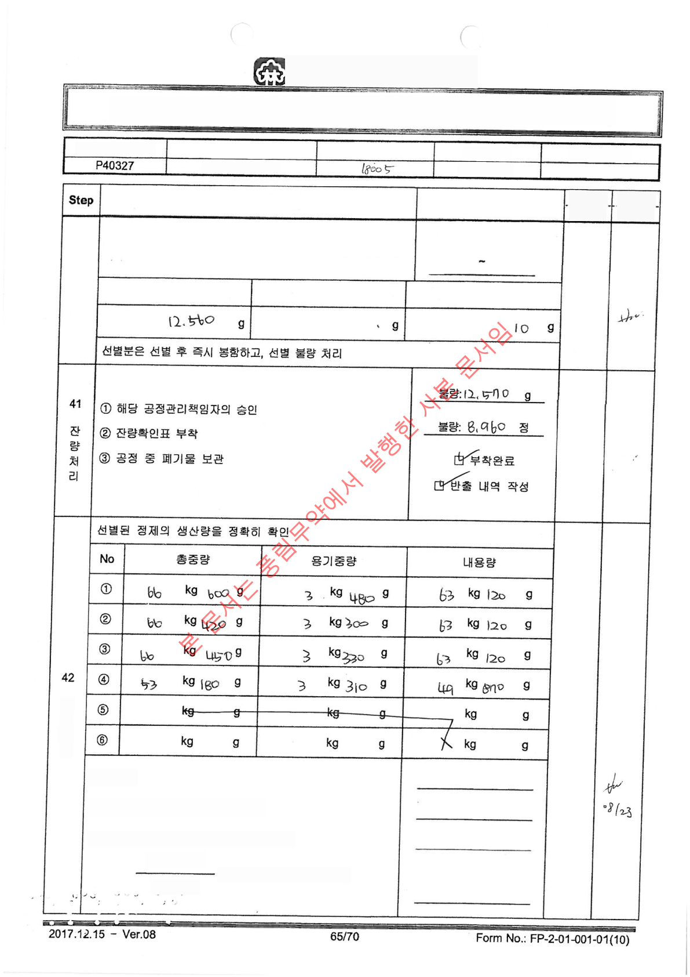
POONG LIM
PHARMACEUTICAL CO., LTD
Manufacturing Instruction and Record
Product Code No.
Product Name
Manufacturing Number
Manufacturing Unit
Manufacturing Process Name
Cephorin-F Tablet
200,000 tablets
Selection
Work Process
Operator
Date of
Work
Veriﬁer
Veriﬁcation
Date
Record Details
40
Manual
selection
Proceed with manual selection after completing the
performance check of the metal detector.
Working time
(Start~End) 09:50 -
17:30
Incomplete
08/23
Product
08123
Product
Selection defect
Metal foreign object
Others
Ha
Unji
8/23
Ha
Unji
8/23
Pro
gress
Yield
239 kg 230 g 110,539
tablets 119,499 tablets
95.0 %
Total
production
Lee
Eunji
08/23
Total production quantity = Theoretical quantity
- Defective quantity
Theoretical quantity = Coated tablet received quantity - Test
sample quantity
Total production
quantity
Yield =
× 100 (Range: 95.0 ± 5.0%)
Theoretical
quantity

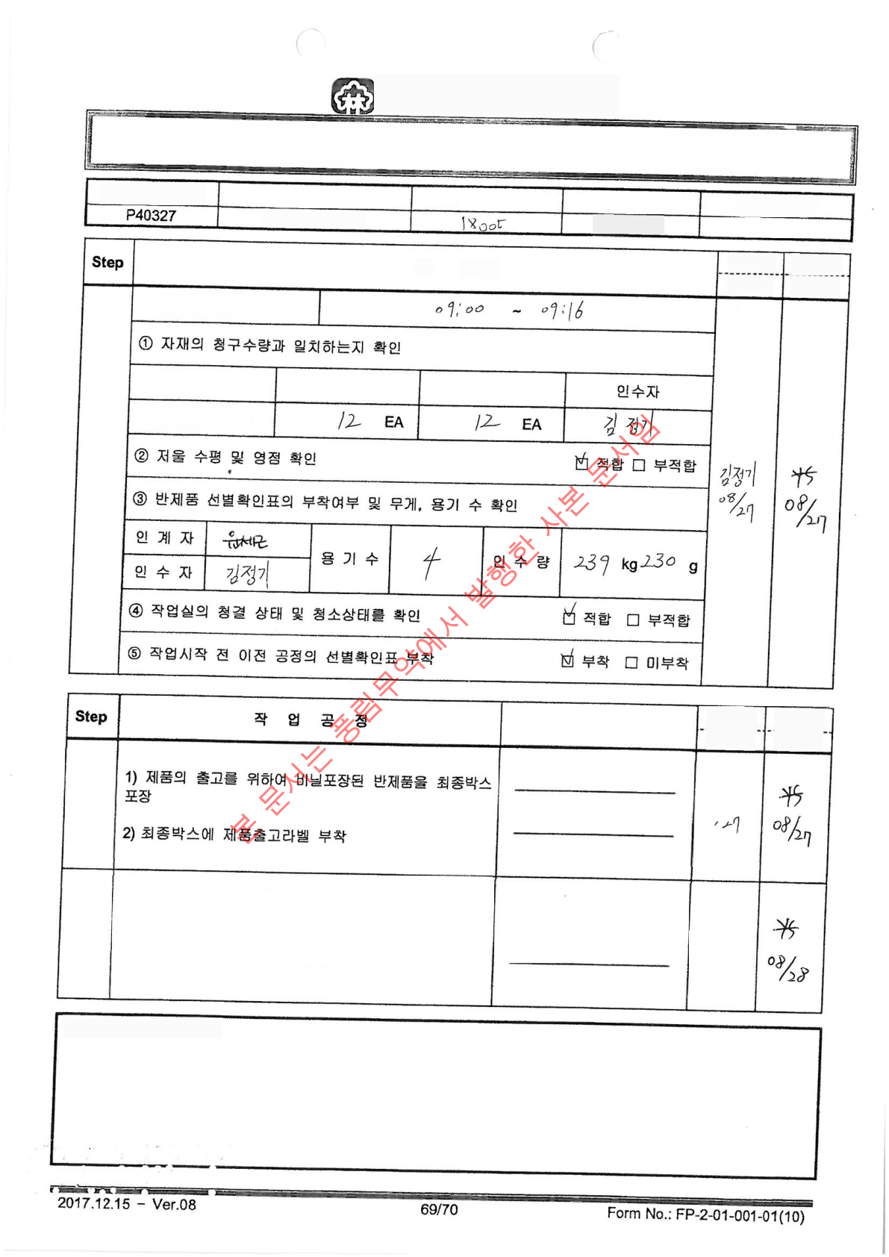
POONG LIM
PHARMACEUTICAL CO., LTD
Manufacturing Instruction and Record
Product Code No.
Product Name
Manufacturing Number
Manufacturing Unit
Manufacturing Process Name
Cephorin-F Tablet
200,000 tablets
Bulk packaging
Inspector
--------
Inspection
date
Veriﬁer -------
Veriﬁcation
date
Work
Before
Inspection
Inspection time (Start-End)
Match □
Mismatch
Material name
Requested quantity
Reception Quantity
Final box (Bulk)
Record Details
Worker Veriﬁer Work
Date Veriﬁcation Date
44
Pack
aging
15,000 pcs x 11
BOX 5,539 pcs x 1
BOX
Kim
Jung-
gi
08/27
45
Product
Dispatch
1) Issue product inbound and outbound slips 2)
Transfer products to the production support team
Handover Complete
Recipient: Tae Man-
wi
Kim
Jung-
gi
08/28
Remarks(Comment)

