**Let’s get rich in Chula Documentation**

**Created by**

Taeshin Srisomsak 6230198021

Patcharapong Khempan 6230362521

**2110215 Programming Methodology**

**Semester 2 Year 2020**

**Chulalongkorn University**

**Let’s Get Rich in Chula**

**Introduction**

Let’s Get Rich in Chula is a game based on Monopoly. Monopoly is a game where each player has to manage their money by investing in places. If a player loses all money, they will get bankrupt and lose the game.

**Gameplay and Rules**

* There are two players.

|  |  |
| --- | --- |
|  |  |
| Player 1 Character | Player 2 Character |
|  |  |
| Player 1 Color | Player 2 Color |

* Each player has given a starting money of 100,000
* Each turn a player gets to roll a dice and be moved to the corresponding position (tile). Each tile has its corresponding action listed by the following table :

|  |  |
| --- | --- |
|  | Normal location tile – White Background  A player can buy and the other can rebuy if they want. |
|  | Island location tile – Yellow Background  A player can only buy once, other player cannot rebuy. |
|  | Jail Tile – LarnGear icon  A player gets distracted in LarnGear, loses one turn for free. |
|  | Item tile  You will get one random card  1. GetMoneyCard (Money +20000)  2. LoseMoneyCard (Money -20000, if Player’s Money less than 20000, gets reset to 0)  3. ProtectionCard (Skip a turn where u don’t have enough money) |
|  | Drunk tile  You are now drunk, 50% of your current money will be gone. |
|  | “A” tile  You get an A in ProgMeth. As a bonus, Aj.Toe gives you 50% more of your current money |
|  | Start tile  If you landed or passed here, you will get 20,000 money. But by landing here you can’t do anything. |

* There are 30 turns to play, a player can win by either

1. having overall value (their assets + their current money) more than the opponent.
2. The opponent has no money and lands on your property.

**GUI of the Game**



*Main Screen*

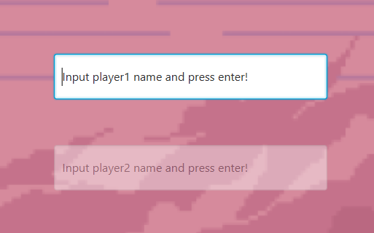Main screen – You get to type Player1 and Player2’s names in here.

You can use your mouse to click on the label to clear the text.

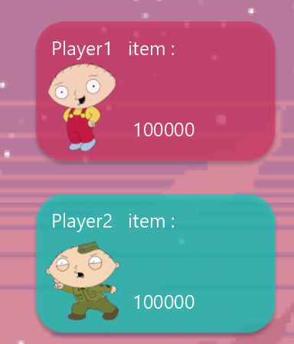

If a player hasn’t typed their name in, or decided to leave it blank, the game will automatically assign the name “Player1” and “Player2” respectively.

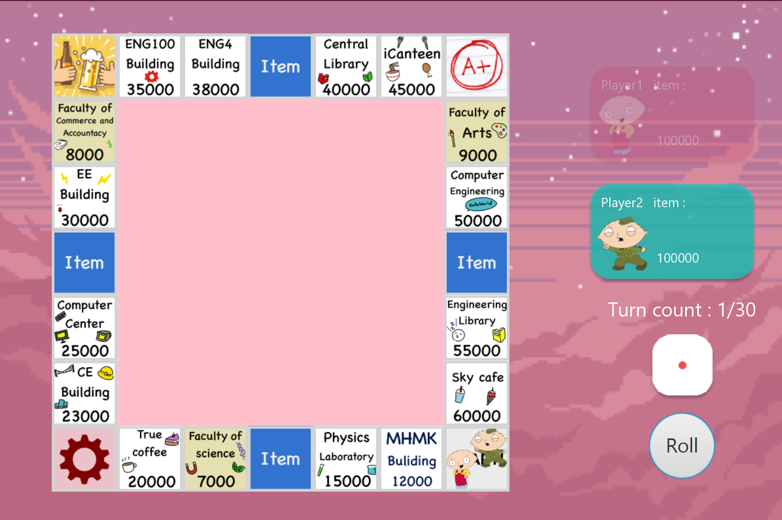

*Gameplay Scene*

**Gameplay Scene**

The blinking player menu indicates who will be playing in this current turn. A player must click “Roll” to proceed.

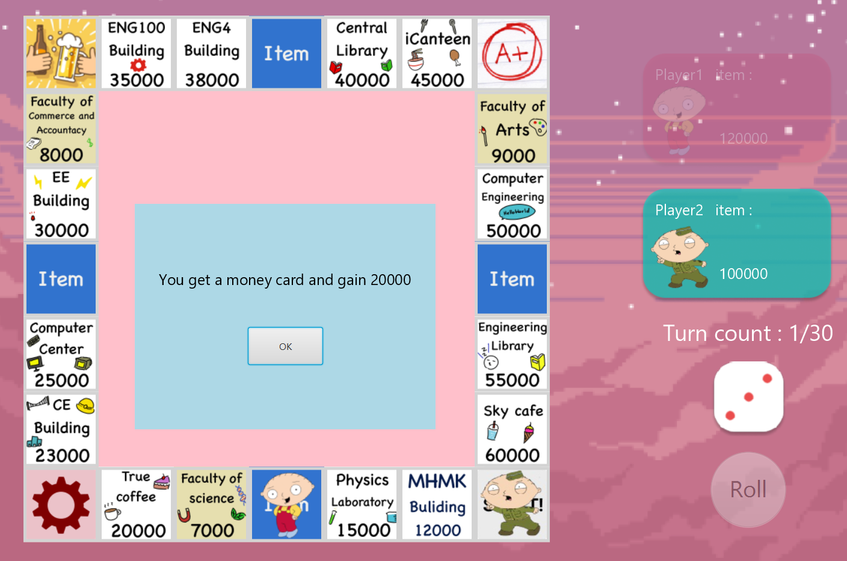

Since Player1 has rolled a 3, he moves 3 position from start, making him landed on ItemTile. On ItemTile, he is lucky to get a money card item. After he clicks OK, Player2 gets to play next and the turn count increases.

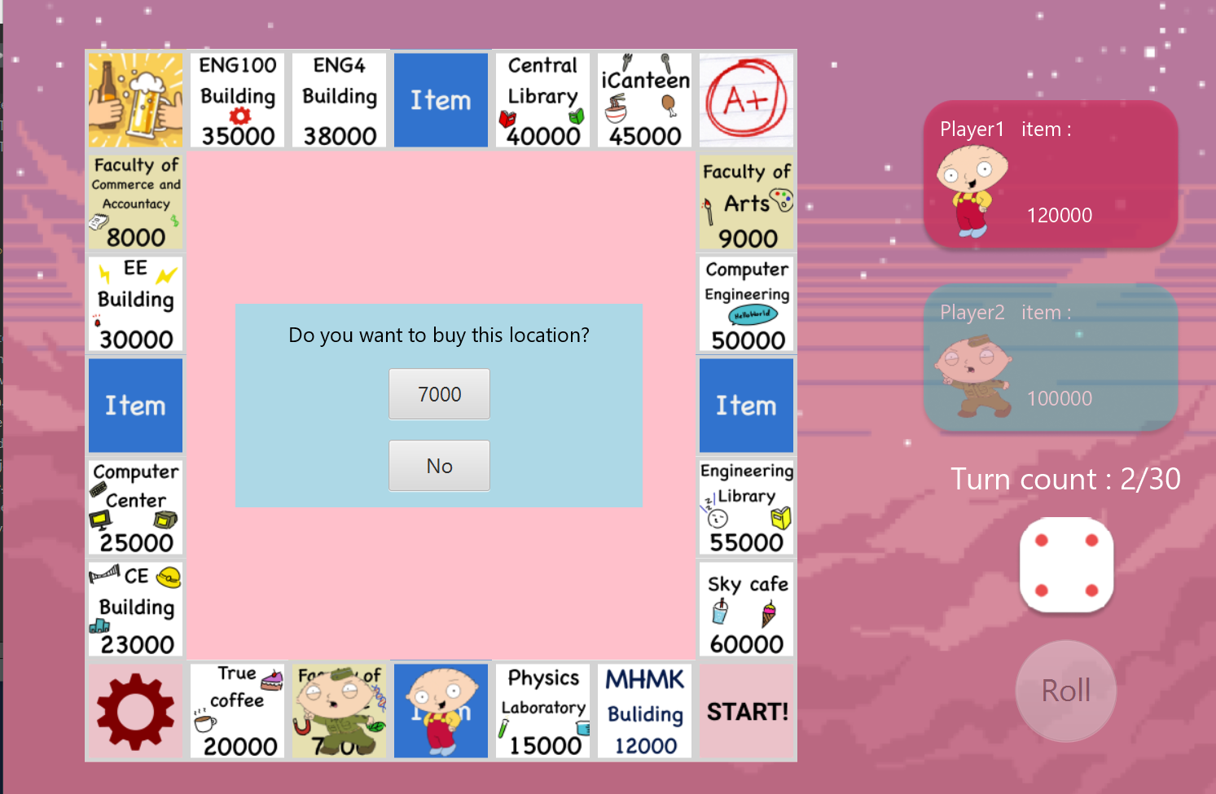

Now Player2 has rolled and got a 4, he moved 4 positions to an IslandLocation (No one else can retake this place once taken). He now has two options to choose, either buy it (spends 7000 money) or just decline it.

****This is what happens when he buys it, the location has the green border around indicating that this location belongs to Player2.



Now if Player1 lands on this, he will lose money. You can see the money stats by hovering over each location.

Now the turn gets increased, Player1 gets to play again.

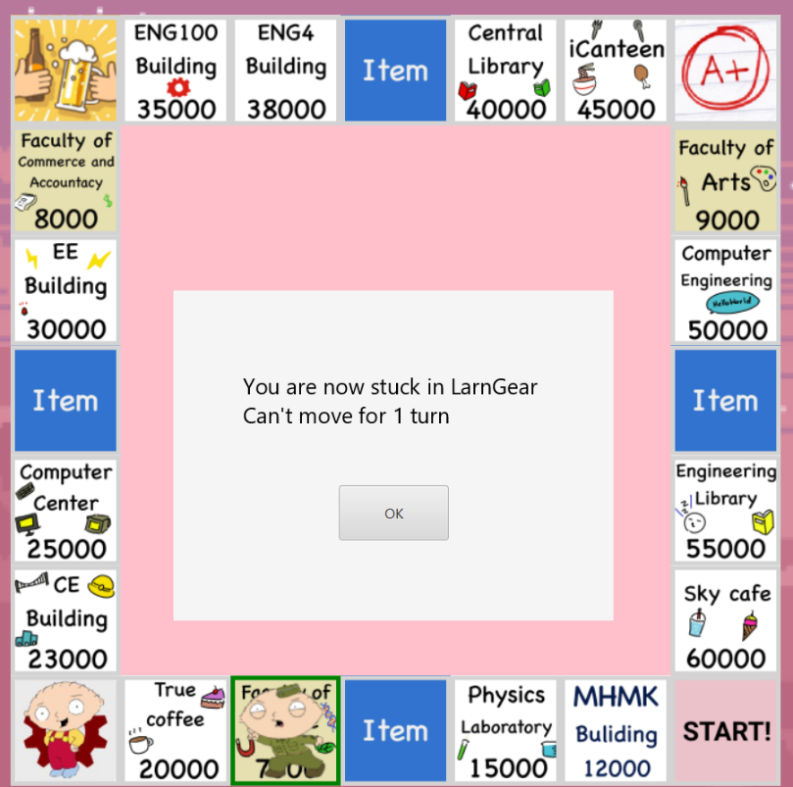

Oh no, Player1 rolled a 3 and go straight into LarnGear, he now stucks in there for one turn.

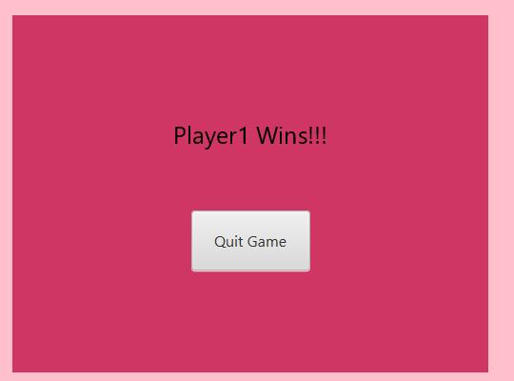

The game continues for 30 turns if no one gets bankrupt. Each player will get their money and their property value calculated. A player with more value wins.

Or if someone bankrupts, the other one automatically wins as well.

**Implementation Details**

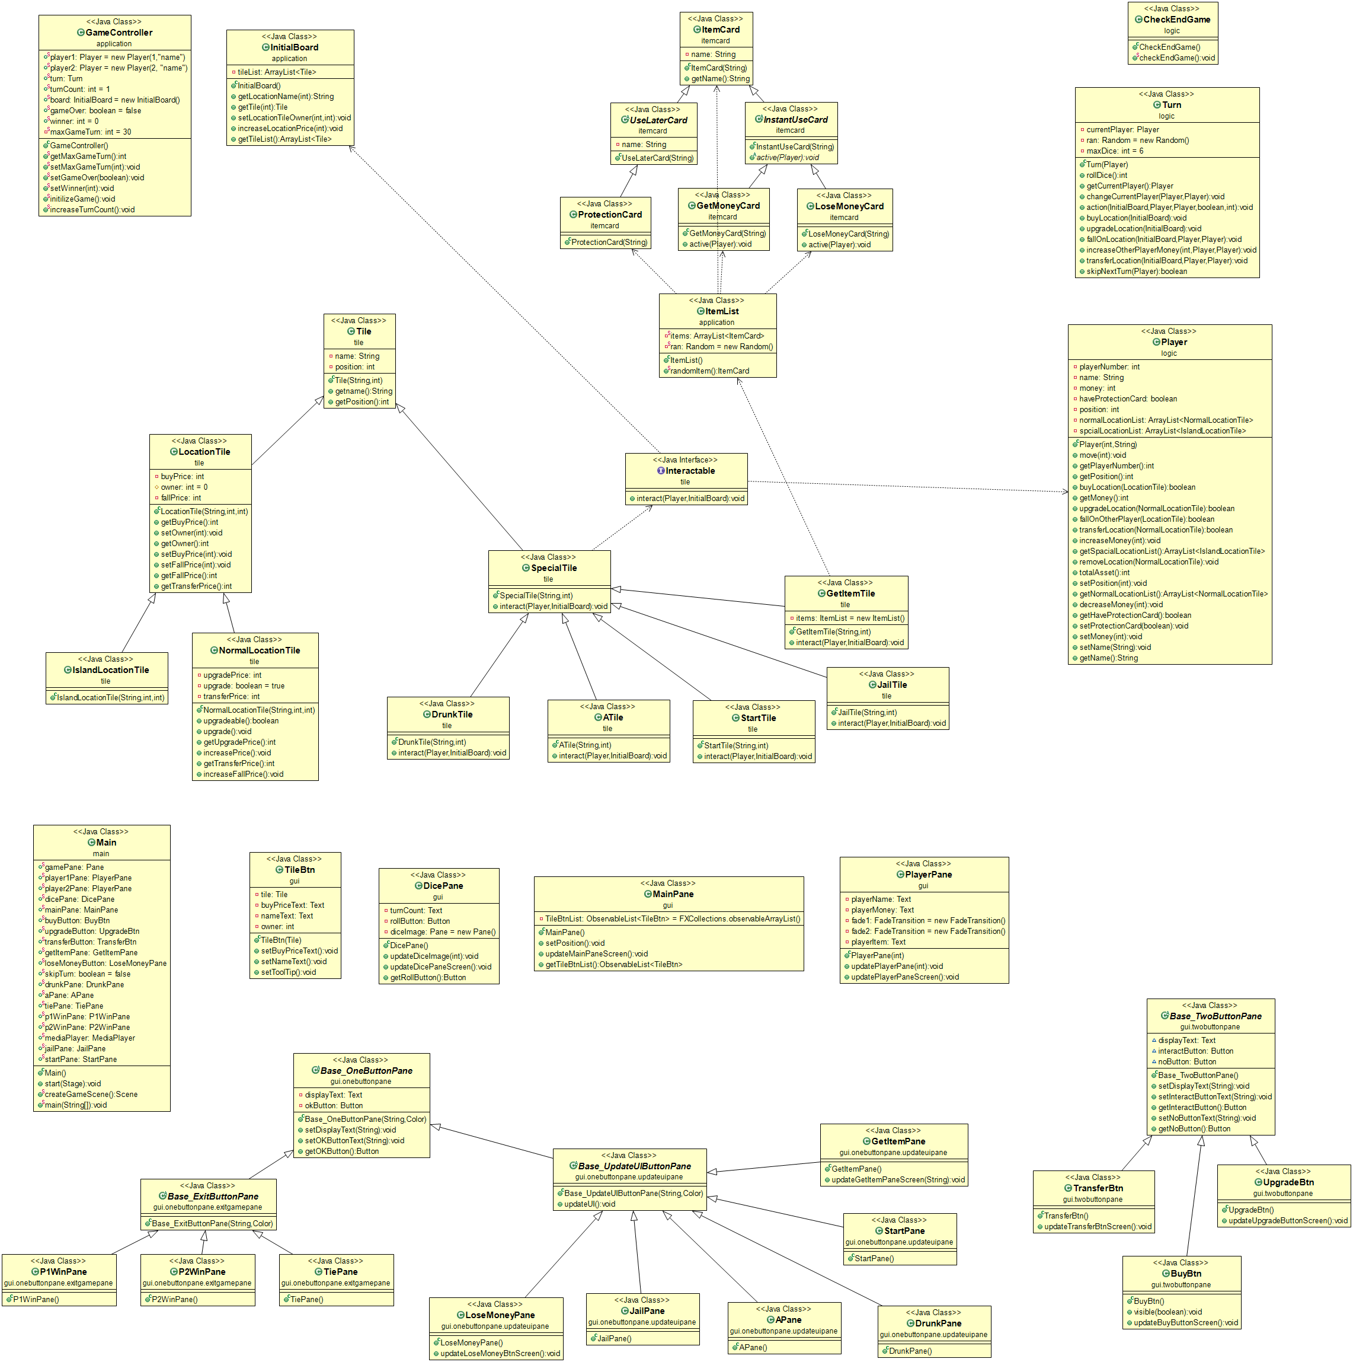

**1.Package tile**

1.1 Class Tile

Fields

|  |  |
| --- | --- |
| - String name | Name of each tile |
| - position | Position of the tile |

Constructor

|  |  |
| --- | --- |
| + Tile(String name,int Position) | - Initialize tile name  - Initialize tile position |

Methods

|  |  |
| --- | --- |
| + String getname() | Return name |
| + int getPosition() | Return position |

1.2 Class LocationTile extends Tile

Fields

|  |  |
| --- | --- |
| - int buyPrice | Price to buy this tile |
| - int owner | Owner of this tile  0 = no owner  1 = owner is player1  2 = owner is player 2 |
| - int fallPrice | Price if other player fall on this tile |

Constructor

|  |  |
| --- | --- |
| + LocationTile(String name,int buyprice,int position) | - super(name,position) form Tile class  - Initilize buyPrice  - Initialize fallPrice = 0.75*buyPrice |

Methods

|  |  |
| --- | --- |
| + int getBuyPrice() | return buyPrice |
| + void setOwner(int playerNumber) | Set owner of this tile by number  1 = player1  2= player2 |
| + int getOwner() | Return number of owner |
| + void setBuyPrice(int buyPrice) | Set buyPrice |
| + void setFallPrice(int newfallprice) | Set fallPrice |
| + int getFallPrice() | Get fallPrice |
| + int getTransferPrice() | Get transferPrice |

1.3 Class NormalLocationTile extends LocationTile

fields

|  |  |
| --- | --- |
| - int upgradePrice | Price to upgrade this location |
| - Boolean upgrade | Show that this location can be upgrade or not |
| - int transferPrice | Price to transerfer this location to other player |

Constructor

|  |  |
| --- | --- |
| + NormalLocationTile(Sting name,int buyprice,int position) | -super(name,buyprice,position)  From LocationTile  -Initialize transferPrice to 1.5*buyprice  -Initialize upgradePrice to 0.5*buyprice |

Methods

|  |  |
| --- | --- |
| + Boolean upgradeable | Return upgrade |
| + void upgrade() | Set upgrade to fasle |
| + int getUpgradePrice() | Get upgradePrice |
| + void increasePrice() | -Increase upgradePrice = 0.5*buyPrice  -Increase transferPrice = 0.5*buyPrice  -Increase fallPrice = 0.5*buyPrice |
| + int getTransferPrice() | Get transferPrice |
| + void increaseFallPrice() | Double current fallPrice |

1.4 Class IslandLocationTile extends LocationTile

Constructor

|  |  |
| --- | --- |
| + IslandLocationTile(String name,int buyprice,int position) | Super(name,buyprice,position)  From LocationTile |

1.5 Interface Interactable

Methods

|  |  |
| --- | --- |
| + void interact(Player player,InitialBoard board) | Interact when player step on tile that is interactable |

1.6 Class SpecialTile extends Tile implements Interactable

Constructor

|  |  |
| --- | --- |
| + SpecialTile(String name,int position) | Super(name,position) from Tile |

Methods

|  |  |
| --- | --- |
| + void interact(Player player,InitialBoard board) | Interact when player step on tile that is interactable |

1.7 Class StartTile extends SpecialTile

Constructor

|  |  |
| --- | --- |
| + StartTile(String name,int position) | Super(name,position) from SpacialTile |

Methods

|  |  |
| --- | --- |
| + void interact(Player player,InitialBoard board) | -Set StartPane to be visible |

1.8 Class JailTile extends SpecialTile

Constructor

|  |  |
| --- | --- |
| + JailTile(String name,int position) | Super(name,position) from SpecialTile |

Methods

|  |  |
| --- | --- |
| + void interact(Player player,InitialBoard board) | -Set jailPane to be visible |

1.9 DrunkTile extends SpecialTile

Constructor

|  |  |
| --- | --- |
| + DrunkTile(String name,int position) | Super(name,position) from SpecialTile |

Methods

|  |  |
| --- | --- |
| + void interact(Player player,InitialBoard board) | -Set drunkPane to be visible  -Decrease current player money by 50% |

1.10 ATile extends SpecialTile

Constructor

|  |  |
| --- | --- |
| + ATile(String name,int position) | Super(name,position) from SpecialTile |

Methods

|  |  |
| --- | --- |
| + void interact(Player player,InitialBoard board) | -Set aPane to be visible |

1.11 GetItemTile extend SpecialTile

Fields

|  |  |
| --- | --- |
| - ItemList items | List of item cards |

Constructor

|  |  |
| --- | --- |
| + GetitemTile(String name,int position) | Super(name,position) from SpecialTile |

Methods

|  |  |
| --- | --- |
| + void interact(Player player,InitialBoard board) | - randomly give player one of three item card  If card is getmoney and losemoney card active card ability  But if it is protection set Player Protectioncard to true |

**2. Package itemcard**

2.1 Class ItemCard

Fields

|  |  |
| --- | --- |
| - String name | Name of item card |

Constructor

|  |  |
| --- | --- |
| + ItemCard(String name) | Initialize name of item card |

Methods

|  |  |
| --- | --- |
| + String getName() | Get name of item card |

2.2 Abstract Class InstantUseCard extends ItemCard

Constructor

|  |  |
| --- | --- |
| + InstantUseCard(String name) | Super(name) from ItemCard |

Methods

|  |  |
| --- | --- |
| *+ void active(Player player)* |  |

2.3 Abstract Class UseLaterCard extends ItemCard

Constructor

|  |  |
| --- | --- |
| + UseLaterCard(String name) | Super(name) from ItemCard |

2.4 Class GetMoneyCard extends InstantUseCard

Constructor

|  |  |
| --- | --- |
| + GetMoneyCard(String name) | Super(name) from ItemCard |

Methods

|  |  |
| --- | --- |
| + void active(Player player) | -Increase player money by 20000  -Update getItemPane Screen  -Update player 1 and Player 2 Pane  -Visible getItemPane |

2.5 Class LoseMoneyCard extends InstantUseCard

Constructor

|  |  |
| --- | --- |
| + LoseMoneyCard(String name) | Super(name) from ItemCard |

Methods

|  |  |
| --- | --- |
| + void Active(Player player) | -Decrease player money by 20000  If player have less than 2000 set money to 0  - Update getItemPane Screen  -Update player 1 and Player 2 Pane  -Visible getItemPane |

2.6 Class ProtectionCard extends UseLaterCard

Constructor

|  |  |
| --- | --- |
| + ProtectionCard(String name) | Super(name) from ItemCard |

**3.Package application**

3.1 Class GameController

Fields

|  |  |
| --- | --- |
| + Player player1 | Player 1  Initialize player number to 1 and name to “name” |
| + Player player2 | Player2  Initialize player number to 2 and name to “name” |
| + Turn turn | Turn to control things to do in 1 turn |
| + int turnCount | Number of turn ,Initialize to 1 |
| + int maxGameTurn | Number of maximum turn |
| + InitialBoard board | Board of the game that contain list of location,Initial new board |
| + Boolean gameOver | Game over status,Initialize to false |
| + int winner | Number of player that win the game,Initialize to 0 |

Methods

|  |  |
| --- | --- |
| + void setGameOver(Boolean status) | Set gameOver |
| + void setWinner(int player) | Set winner |
| + void initializeGame() | Initialize turn to start with player1 |
| + void increaseTurnCount() | Increase turnCount by 1 |
| + int getMaxGameTurn() | Get number of maximum turn |
| + void setMaxGameTurn(int maxGameTurn) | Set number of maximum turn |

3.2 Class InitialBoard

Fields

|  |  |
| --- | --- |
| - ArrayList<Tile>tileList | ArrayList that contain tile in the board |

Constructor

|  |  |
| --- | --- |
| + initialBoard() | -Initialize tileList  -add every tile on the board to tileList |

Methods

|  |  |
| --- | --- |
| + String getLocationName(int index) | Get Tile name in tileList from input index |
| + Tile getTile(int index) | Get Tile in tileList from input index |
| + void setLocationTileOwner(int index,int playerNumber) | Set owner of locationTille in Tile list to match input number |
| + void increaseLocationPrice(int index) | Call method increasePrice on selected NormalLocationTile |
| + ArrayList<Tile> getTileList() | Get tileList |

3.3 Class ItemList

Fields

|  |  |
| --- | --- |
| - ArrayList<ItemCard> items | ArryList that contains ItemCard |
| - Random ran | Constant Random |

Constructor

|  |  |
| --- | --- |
| + ItemList() | - Initialize items  -add GetMoneyCard,LoseMoneyCard,ProtectionCard to items |

Methods

|  |  |
| --- | --- |
| + ItemCard randomItem() | Random item in items and return ItemCard |

**4.Package Logic**

4.1 Class CheckEndGame

Methods

|  |  |
| --- | --- |
| + void checkEndGame() | Check if the game is end of not  1.if turnCount == maxiumTurn (GameController.getMaxGameTurn())  Check totalAsset() of both player if equals set visible tiePane  ,If player1 > player2 set visible p1WinPane ,if player2 > player1 set visible p2WinPane  2.if winner != 0  If winner == 1 set visible p1WinPane, if winner == 2 set visible p2WinPane |

4.2 Class Player

Fields

|  |  |
| --- | --- |
| - int playerNumber | Number of player  1 == player1  2 == player 2 |
| - String name | Name of player |
| - int money | Money of player |
| - Boolean haveProtectionCard | Show that player have ProtectionCard or not |
| - int position | Position of player |
| - ArrayList<NormalLocationTile>  normalLocationList | List that contains  NormalLocationTile that player own |
| - ArrayList<IslandLocationTile>  spacialLocationList | List that contains  IslandLocationTile that player own |

Constructor

|  |  |
| --- | --- |
| Player(int playerNumber,String name) | - Initialize player name  - Initialize playerNumber  - Initialize money to 100000  - Initialize haveProtectionCard to fasle  - Initialize position to 0  - Initialize normalLocationList and spacialLocationList |

Methods

|  |  |
| --- | --- |
| + void move(int step) | Create int newPosition = (position + step)%24 and set position to newPosition |
| + int getPlayerNumber() | Return playerNumber |
| + int getPosition() | Return position |
| + boolean buyLocation(LocationTile location) | If player money >= location buyPrice decrease player money and add location to normalLocationList if location is NormalLocation and add to spacialLocationList if location is IslandLocation  If buy success return true else return false |
| + int getMoney | Return money |
| + boolean upgradeLocation(NormalLocationTile normalLocation) | If playermoney >=  normalLocation upgradePrice decrease player money and return true else return false |
| + boolean fallOnOtherplayer(LocationTile location) | If player money >= location fallPrice decrease player money and return true else return false |
| + boolean transferLocation(NormalLocationTile normalLocation) | If player money >= normalLocation transferPrice decrease player money,add normalLocation to normalLocationList and return true else return false |
| + void increaseMoney(int amount) | Increase player money by amount |
| + ArrayList<IsLandLocationTile> getSpacialLocationList() | Return spacialLocationList |
| + void removeLocation(NormalLocationTile normalLocationTile) | Remove normalLocationTile from normalLocationList |
| + int totalAsset() | Return total asset of player that equal player current money + fallPrice for each location that player own |
| + void setPosition(int position) | Set position of player |
| + ArrayList<NormalLOcationTile> getNormalLocationList() | Return normalLocationList |
| + void decreaseMoney(int amount) | Decrease player money by amount |
| + Boolean getHaveProtectionCard | Return haveProtectionCard |
| + void setProtectionCard(Boolean b) | Set haveProtectionCard to b |
| + void setMoney(int money) | Set player money |
| + void setName(String text) | Set player name |
| + String getName() | Return name |

4.3 Class Turn

Fields

|  |  |
| --- | --- |
| - Player currentPlayer | Current player of this turn |
| - Random ran | Use to random |
| - int maxDice | Max number on dice |

Constructor

|  |  |
| --- | --- |
| + Turn(Player player) | Set currentPlayer to player |

Methods

|  |  |
| --- | --- |
| + int rollDice() | Return Random number that not exceed maxDice and +1 |
| + Player getCurrentPlayer() | Return currentPlayer |
| + void changeCurrentPlayer(Player player1,Player player2) | If currentPlayer number is 1 change currentPlayer to player2 else change currentPlayer to player1 |
| + void action(InitialBoard board,Player player1,Player player2,Boolean gameOver,int winner) | If position of player on board is LocationTile and this tile owner == 0 call method buyLocation(board) but if location owner == currentPlayerNumber and Location is NormalLocation call method upgradeLocation(board)  If Tile owner != currentPlayerNumber call method fallOnLocation(board,player1,player2)  And if Tile is NormalLocationTile call method transferLocation(board,player1,player2)  If player don’t have enough monry call method getHaveProtectionCard to check that player have protectionCrd or not if yes setProtection to false,update playerPane,increase turn and change turn but if player don’t have protectionCard setGameOver to true and set winner to opposite player  If tile is SpacialTile call method interact(currentPlayer,board) of that Tile  Increase turnCount  UpdateDicePane and playerPane  changeTurn of player |

Methods

|  |  |
| --- | --- |
| + void buyLocation(InitialBoard board) | updateBuyButtonScreen and set visible of buyButton to true |
| + void upgradeLocation(InitialBoard board) | updateUpgradeButtonScreen and set visible of upgradeButton to true |
| + void fallOnLocation(InitialBoard,Player player1,Player player2) | updateLoseMoneyButton and setVisible to true  Increase other player money |
| + void increaaseOtherPlayerMoney(int amount,Player player1,Player player2) | If currentPlayer is player1 increase player2 money else increase player 1 money |
| + void transferLocation(InitialBoard board,Player player1,Player player2) | updateTransferbtnScreen and setVisible of transferButton to true |
| + Boolean skipNextTurn(Player player) | If player position is 6 return true else return false |

**5. Package gui**

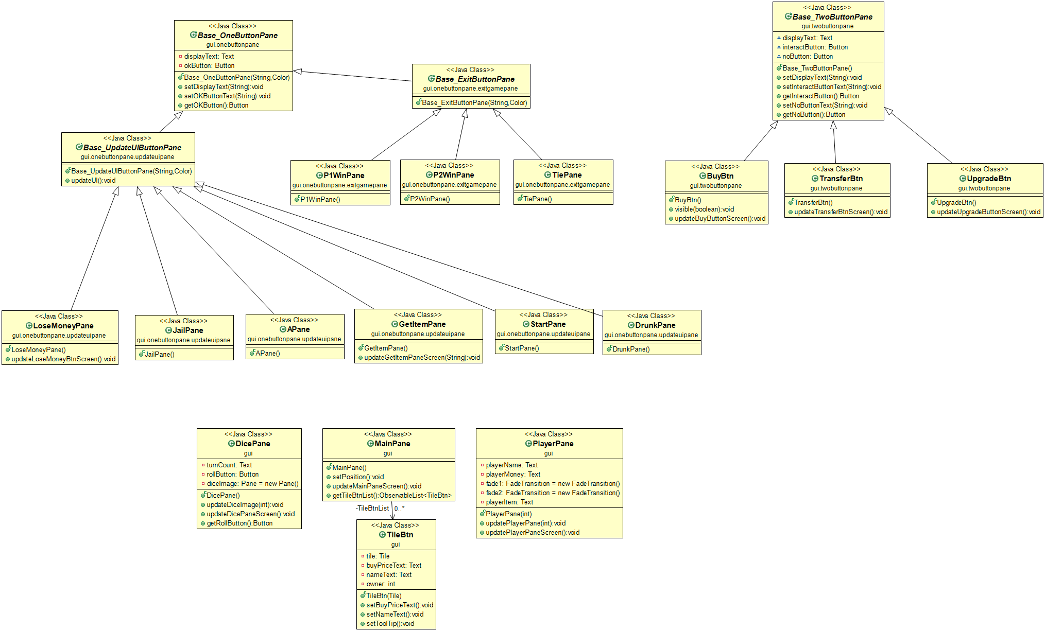

*UML For Package GUI Only*

**5.1 Package gui.onebuttonpane**

5.1.1 Abstract Class Base_OneButtonPane extends VBox

Base_OneButtonPaneis a pane that has only one button (OK). Every pane that has only one button will inherit properties.

Fields

|  |  |
| --- | --- |
| - Text displayText | JavaFX Text |
| - Button okButton | JavaFX Button |

Constructor

|  |  |
| --- | --- |
| + Base_OneButtonPane(String display, Color bgColor) | Initialize a pane that contains displayText and okButton with a background color of bgColor |

Methods

|  |  |
| --- | --- |
| + void setDisplayText(String newText) | Set displayText Text |
| + void SetOkButtonText(String newText) | Set OKButton Text |
| + Button getOKButton() | Get OKButton |

**5.1.2 Package gui.onebuttonpane.exitgamepane**

5.1.2.1 Abstract Class Base_ExitButtonPane extends Base_OneButtonPane

Constructor

|  |  |
| --- | --- |
| + Base_ExitButtonPane(String display, Color bgColor) | Create a OneButtonPane with a button with text(“Quit Game”) and set the button onAction to quit the application. |

5.1.2.2 Class P1WinPane extends Base_ExitButtonPane

Constructor

|  |  |
| --- | --- |
| + P1WinPane() | Initialize ExitButtonPane with buttonText = “Player1 Wins!!!” and bgColor = rgb(207,54,100) |

5.1.2.3 Class P2WinPane extends Base_ExitButtonPane

Constructor

|  |  |
| --- | --- |
| + P2WinPane() | Initialize ExitButtonPane with buttonText = “Player2 Wins!!!” and bgColor = rgb(10,205,193) |

5.1.2.4 Class TiePane extends Base_ExitButtonPane

Constructor

|  |  |
| --- | --- |
| + TiePane() | Initialize ExitButtonPane with displayText = “Both player have equal total asset 🡪 Tie!!” and bgColor = Color.LIGHTBLUE |

**5.1.3 Package gui.onebuttonpane.updateuipane**

5.1.3.1 Abstract Class Base_UpdateButtonPane extends Base_OneButtonPane

Constructor

|  |  |
| --- | --- |
| + Base_UpdateButtonPane (String display, Color bgColor) | Create a OneButtonPane from super class. |

Method

|  |  |
| --- | --- |
| + void updateUI() | - Disable roll button  - Update player1&2 pane  - Update dicePane  - Increase turn count |

5.1.3.2 Class APane extends Base_UpdateUIButtonPane

Constructor

|  |  |
| --- | --- |
| + APane() | Create an UpdateUIButtonPane with  displayText = "You get grade A in Progmeth so Aj.Toe"+"\n" +"give you 50% of your current money!!!”  and bgColor = Color.LIGHTYELLOW  Set OKButton onAction to set Main.aPane’s visibility to false |

5.1.3.3 Class DrunkPane extends Base_UpdateUIButtonPane

Constructor

|  |  |
| --- | --- |
| + DrunkPane () | Create an UpdateUIButtonPane with  displayText = "You are drunk and lose 50% of your money!!!" and bgColor = Color. MEDIUMPURPLE  Set OKButton onAction to set Main.drunkPane’s visibility to false |

5.1.3.4 Class GetItemPane extends Base_UpdateUIButtonPane

Constructor

|  |  |
| --- | --- |
| + GetItemPane() | Create an UpdateUIButtonPane with  displayText = "" and bgColor = Color. LIGHTBLUE  Set OKButton onAction to set Main.getItemPane’s visibility to false and then call updateUI() |

Method

|  |  |
| --- | --- |
| + void updateGetItem  PaneScreen(String text1) | Method for setting displayText to text1 |

5.1.3.5 Class JailPane extends Base_UpdateUIButtonPane

Constructor

|  |  |
| --- | --- |
| + JailPane() | Create an UpdateUIButtonPane with  displayText = "You are now stuck in LarnGear \n"+ "Can't move for 1 turn " and bgColor = Color. WHITESMOKE  Set OKButton onAction to set Main.jailPane’s visibility to false |

5.1.3.6 Class LoseMoneyPane extends Base_UpdateUIButtonPane

Constructor

|  |  |
| --- | --- |
| + LoseMoneyPane() | Create an UpdateUIButtonPane with  displayText = "You lose : " and bgColor = Color. LIGHTBLUE  Set OKButton onAction to set Main.loseMoneyButton’s visibility to false and updateUI |

Methods

|  |  |
| --- | --- |
| + updateLoseMoneyBtnScreen () | Set displayText to “You lose : “ + getFallPrice() |

5.1.3.7 Class StartPane extends Base_UpdateUIButtonPane

Constructor

|  |  |
| --- | --- |
| + StartPane() | Create an UpdateUIButtonPane with  displayText = "You got 20,000 for passing the start!" and bgColor = Color. WHITESMOKE  Set OKButton onAction to set Main. startPane’s visibility to false and updateUI |

**5.2 Package gui.twobuttonpane**

5.2.1 Abstract Class Base_TwoButtonPane extends VBox

Base_TwoButtonPane is a pane that has two buttons (Interact/NO). Every pane that has two buttons will inherit properties.

Fields

|  |  |
| --- | --- |
| - Text displayText | JavaFX Text |
| - Button interactButton | JavaFX Button |
| - Button noButton | JavaFX Button |

Constructor

|  |  |
| --- | --- |
| + Base_OneButtonPane(String display, Color bgColor) | Initialize a pane that contains displayText and okButton with a background color of Color.LIGHTBLUE |

Methods

|  |  |
| --- | --- |
| + void setDisplayText(String newText) | Set displayText Text |
| + void setInteractButtonText(String newText) | Set interactButton Text |
| + Button getInteractButton() | Get interactButton |
| + void setNoButtonText(String newText) | Set noButton Text |
| + Button getNoButton() | Get noButton |

5.2.2 Class BuyBtn extends Base_TwoButtonPane

Constructor

|  |  |
| --- | --- |
| + BuyBtn() | -Create an UpdateUIButtonPane with  displayText = "Do you want to buy this location?"  - set onAction for buy button to call method buyLocation if method return true change owner of location to current player and set style of this tile to match to color of player  -update pane  -check for skipTurn and end turn |

Methods

|  |  |
| --- | --- |
| + void visible(Boolean b) | Set visibility for BuyBtn |
| + void updateBuyButtonScreen() | Set text for interactButton |

5.2.3 Class TransferBtn extends Base_TwoButtonPane

Constructor

|  |  |
| --- | --- |
| + TransferBtn() | -Create an UpdateUIButtonPane with  displayText = "Do you want to transfer this location to you?"  - set onAction for transfer button to call method transferLocation if method return true change owner of location to current player , set style of this tile to match to color of player,remove location form other player and add to current player  -update pane  -check for skipTurn and end turn |

Methods

|  |  |
| --- | --- |
| + void visible(Boolean b) | Set visibility for TransferBtn |
| + void updateBuyButtonScreen() | Set text for interactButton |

5.2.4 Class UpgradeBtn extends Base_TwoButtonPane

Constructor

|  |  |
| --- | --- |
| + UpgradeBtn() | -Create an UpdateUIButtonPane with  displayText = "Do you want to upgrade this location?"  - set onAction for upgrade button to call method upgradeLocation  -update pane  -check for skipTurn and end turn |

Methods

|  |  |
| --- | --- |
| + void visible(Boolean b) | Set visibility for UpgradeBtn |
| + void updateBuyButtonScreen() | Set text for interactButton |

5.3 Class DicePane extends Vbox

Fields

|  |  |
| --- | --- |
| - Text turnCount | Turn count of the game |
| - Button rollButton | Button to roll the dice |
| - Pane diceImage | Image of the dice |

Constructor

|  |  |
| --- | --- |
| + DicePane() | - Initialize roll button,set text to “roll” and set font to 30  - update dice image to start with 1  - set onAction of roll button to call method rollDice,update dice image with step,update each player pane and change turn  - Initialize turnCount,set font to 30 and set fill color to white |

Methods

|  |  |
| --- | --- |
| + void updateDiceImage(int step) | Set image of dice to match step |
| + void updateDicePaneScreen() | Set text of turnCount |
| + Button getRollButton() | Return rollButton |

5.4 Class MainPane extends Pane

Fields

|  |  |
| --- | --- |
| - ObservableList<TieBtn> TileBtnList | List that contains all TileBtn in board |

Constructor

|  |  |
| --- | --- |
| + MainPane() | - setPrefSize to 700,700  - setBackground with color PINK  - initialize TileBtnList  -setPosition() |

Methods

|  |  |
| --- | --- |
| + void setPosition() | Set position of all TileBtn on the board and set Background image of each TileBtn |
| + void updateMainPaneScreen() | Update Background image of each TileBtn to match the situation |
| + ObservableList<TileBtn> getTileBtnList() | Return TileBtnList |

5.5 PlayerPane extends Pane

Fields

|  |  |
| --- | --- |
| - Text playerName | Player name |
| - Text playerMoney | Player money |
| - FadeTransition fade1 | fadeTransition for player1 |
| - FadeTransition fade2 | fadeTransition for player2 |
| - Text playerItem | Player Item |

Constructor

|  |  |
| --- | --- |
| PlayerPane(int player) | - Initialize playerMoney  - Initialize playerName  - Initialize playerItem  - set each fields by int player that input |
| + void updatePlayerpane(int player) | - update each fields of player |
| + void updatePlayerPaneScreen() | Update fade effect for PlayerPane |

5.6 TileBtn extends Pane

Fields

|  |  |
| --- | --- |
| - Tile tile | Tile for each TileBtn |
| - Text buyPriceText | Text that show buyPrice |
| - Text nameText | Text of tile name |
| - int owner | Owner of the tile |

Constructor

|  |  |
| --- | --- |
| + TileBtn(Tile tile) | - Initilize tile  - setPrefSize(100, 100)  - setBackground color to WHITE  - Initilize nameText and buyPriceText |

Methods

|  |  |
| --- | --- |
| + void setBuyPriceText() | If tile is Locationtile set buyPriceText |
| + void setNametext() | Set nameText to match Tile name |
| + void setToolTip() | Set up tooltip to show information for each tile |

6 Package main

6.1 Class Main

Fields

|  |  |
| --- | --- |
| + Pane gamePane | Pane of the game |
| + PlayerPane player1Pane | Pane for player1 |
| + PlayerPane player2Pane | Pane for player2 |
| + DicePane dicePane | Pane for dice and roll button |
| + MainPane mainPane | Pane for board |
| + BuyBtn buyButton | Buy button |
| + UpgradeBtn upgradeButton | Upgrade button |
| + TransferBtn transferButton | Transfer button |
| + GetItemPane getItemPane | Pane when player get item |
| + LoseMoneyPane loseMoneyButton | Pane when player lose money |
| + boolean skipTurn | Boolean skipTurn |
| + DrunkPane drunkPane | Pane when player land on DrunkTile |
| + APane aPane | Pane when player land on ATile |
| + TiePane tiePane | Pane for game that tie |
| + P1WinPane p1WinPane | Player1 win pane |
| + P2WinPane p2WinPane | Player2 win pane |
| + MediaPlayer mediaPlayer | Media player |
| + JailPane jailPane | Pane when player land on JailTile |
| + StartPane startPane | Pane when player land on StartTile |

Methods

|  |  |
| --- | --- |
| + void start(Stage primaryStage) | - create new pane and create scene from this pane to be 1200,800 sized ,set title to “Let’s Get Rich In Chula”,set image background,add TextField for player1 and player2 name  -set onAction when player1 press enter to disable Textfield for player1 and when player2 press enter call method initialzeGame and set primaryStage scene to method createGameScene() |
| + Scene createGameScene() | - Initialize bgm for the game  - create new gamePane  - add all gamePane in fields to new gamePane  - set layout for each pane  - create game scene form new game pane  - return new game scene |
| +void main(String[] args) | Launch the program |