**Name: Ranjana Singh Roll No:46 Section:E**

**Program 6:** Design a LEX Code to remove the extra spaces and empty line and write it into

“Store.txt” file.

**Solution:**

%{

%}

%%

[\n\t]+ {fprintf(yyout," ");}

{fprintf(yyout,"%s",yytext);}

[ ]* {fprintf(yyout," ");}

%%

yywrap(){}

main(int argc, char *argv[]){

extern FILE *yyout;

yyin = fopen("Score.txt","r");

yyout = fopen("Store.txt","w");

yylex();

return 0;}

**OUTPUT:**

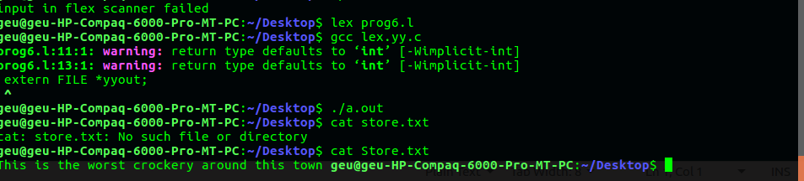

**Name: Ranjana Singh Roll No:46 Section:E**

**Program 7:**Design a LEX Code to remove the comments from any C-Program given at run-time and store into "comment.txt" file.

**Solution:**

%{

%}

%%

\/\/.* ;

\/\*(.*\n)*.*\*\/ ;

%%

yywrap(){}

main(int argc, char *argv[]){

extern FILE *yyout;

yyout= fopen("comment.txt","w");

yylex();

return 0;

}

**Output:**

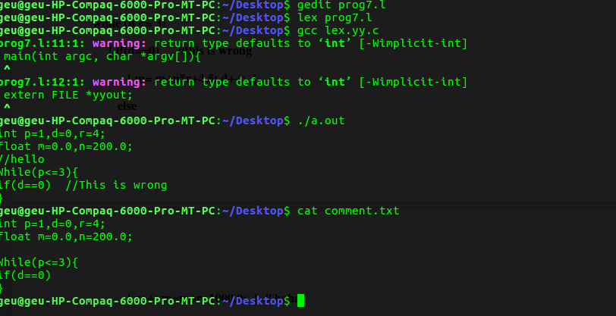

**Name: Ranjana Singh Roll No:46 Section:E**

**Program 8:**Design a LEX Code to extract all html tags in the given HTML file at run time and store

into Text file "Tags.txt" given at run time.

**Solution:**

%{

%}

%%

"<"[^>]*> {printf("%s\n",yytext);}

. ;

%%

yywrap(){

}

main(int argc, char *argv[]){

extern FILE *yyin;

yyin = fopen("Tags.txt","r");

yylex();

return 0;}

**OUTPUT:**

