UNIVERSITY OF YORK
New Security Challenges
Summative Essay

Who bears industrial adjustment? Employment security in Korean and British manufacturing
Word count: 4,000 words
Main text, including section headings and in-text citations. Abstract, tables, figure captions and references are excluded.

Abstract
This essay compares employment security through GM Korea, Hyundai Motor and Rolls-Royce. Human security and comparative institutional theory guide a structured reading of company disclosures, union accounts and public evidence. The analysis distinguishes company viability from worker protection, and signed commitments from realised outcomes. Descriptive Hyundai series illustrate the limits of treating training and membership as direct security measures. The comparison does not estimate a national effect across dissimilar firms. It argues that bargaining scope, implementation and the distribution of adjustment costs determine whether industrial recovery protects livelihoods.

Contents
1 Introduction
2 Human security and comparative institutions
3 Method and the limits of comparison
4 Korean manufacturing and the distribution of adjustment
5 Rolls Royce and the scale of negotiated protection
6 Comparative interpretation beyond national stereotypes
7 Policy implications and an evaluation framework
8 Conclusion
References
Figures and tables appear alongside the relevant numbered sections.

1 Introduction
Manufacturing employment raises a security question that corporate performance indicators cannot answer alone: who remains protected when firms adjust to economic and technological change? A company can restore profitability while particular workers lose employment, income or access to representation. This essay argues that employment security depends on how adjustment costs are negotiated and distributed. Comparing Hyundai Motor and GM Korea with Rolls-Royce shows that national institutions matter, but plant-level agreements, workforce boundaries and implementation are equally important. Corporate survival becomes a meaningful source of human security when it supports livelihoods or provides a credible route into alternative work.
The comparison concerns different industries and periods. Hyundai and GM Korea operate in automotive manufacturing, while Rolls-Royce here denotes the aerospace and power-systems group. Their experiences cannot isolate a simple Korean or British national effect. Instead, the cases illuminate mechanisms through which restructuring affects people: the concentration of losses at a particular plant, the scope for negotiating future work and the limits of corporate training disclosures. This approach avoids equating a low strike count with secure employment or treating a prominent local agreement as evidence of protection across an entire company.
The argument draws on human security, comparative institutional analysis, company disclosures, union accounts and official labour-market reports. It combines qualitative comparison with descriptive calculations of Hyundai’s reported membership and training trends. These calculations do not estimate the effect of bargaining or training on employment. Their purpose is to demonstrate why apparently straightforward indicators require interpretation. The essay first develops a framework for evaluating security, then assesses the cases and their limitations. It concludes that the quality of adjustment should be judged through enforceable commitments, meaningful worker participation and the position of those outside the most visible bargaining arrangements.

2 Human security and comparative institutions
The Human Development Report 1994 shifts the security referent towards people and their everyday conditions (UNDP, 1994). Within this framework, employment matters because it supports income, stability and the ability to plan. This does not mean every organisational change constitutes a security crisis. It means that evaluating industrial adjustment solely through output or competitiveness leaves important consequences unexplained. A human-security approach asks how change affects the material conditions of workers and households, particularly where alternative employment is difficult to obtain or where protection depends on remaining with a particular employer.
Booth’s (1991) discussion of security and emancipation supports attention to the constraints people face rather than only the resilience of large institutions. Applied here, the relevant issue is whether workers can influence changes affecting their livelihoods or have workable alternatives when jobs disappear. This is an analytical application, not a claim that his argument supplies a specific industrial-relations model. The framework makes participation and practical options relevant to security. It also explains why compensation alone may not capture the experience of displacement if workers lose access to future employment or face prolonged uncertainty.
Hall and Soskice (2001) provide a comparative perspective on coordination between firms and other institutions. Their framework helps organise questions about skills, employment relationships and negotiation. However, national categories should not predetermine the interpretation of particular cases. Firms within one economy may differ in product markets, ownership, bargaining arrangements and exposure to shocks. Korea and Britain also cannot be represented adequately by one manufacturer each. This essay therefore uses institutional comparison to identify relevant relationships, while treating the observed outcomes as contingent rather than expressions of a fixed national culture.
Collective bargaining offers one mechanism for distributing adjustment costs. The OECD (2019) and ILO (2022a) examine how bargaining institutions can organise negotiation and support responses to change. Yet the existence of bargaining is not sufficient evidence of equal protection. The scope of representation determines whose concerns enter negotiations, while the substance of an agreement determines what is protected. A commitment covering a particular workforce may leave agency workers or employees elsewhere unaffected. Evaluating security therefore requires attention both to the strength of an agreement and to the boundary around those who can benefit from it.
The framework used here distinguishes employment continuity, income protection, participation and transition capacity. Employment continuity concerns whether a job remains available; income protection concerns purchasing power and support during disruption. Participation concerns the ability to influence decisions, while transition capacity concerns realistic access to new work. These dimensions may move differently. A restructuring agreement might reduce immediate dismissals while leaving long-term work uncertain, or provide training without available vacancies. Keeping the dimensions separate prevents a favourable result on one measure from being mistaken for a complete assessment of worker security.
There is an important counterargument: a firm unable to adjust may ultimately provide less security because its operations become unsustainable. A human-security approach should take that possibility seriously. The argument here is not that preserving every job is always feasible, but that the distribution of unavoidable change remains a political and institutional question. Financial viability can constrain the available options without determining whose income is interrupted or how alternatives are developed. Security analysis consequently evaluates the way constraints are managed. It should neither deny commercial pressures nor treat their existence as sufficient justification for every proposed allocation of costs.

3 Method and the limits of comparison
This essay undertakes a structured comparison rather than a causal evaluation of national systems. Each case is examined through the same questions: what adjustment was proposed, who could negotiate, what protection was described and what outcomes remain unknown? The evidence consists principally of corporate disclosures and contemporaneous union accounts, situated within official and international reports. Company statements establish management’s announced strategy, while union statements establish the reported terms and interpretation of agreements. Neither should be treated as an independent measurement of the subsequent welfare of every affected worker.
The cases are deliberately bounded. GM Korea’s 2018 announcements concern plant closure and a wider viability strategy. Rolls-Royce’s 2020 restructuring proposal concerns global adjustment during the pandemic, while Barnoldswick provides a local bargaining episode in 2021. Hyundai’s 2021–2023 disclosures provide an additional perspective on representation and training inputs. These periods are not synchronised, and the demand shocks differ. The comparison therefore identifies mechanisms and evidential gaps rather than assigning an outcome difference to the countries in which the firms operate. OECD country surveys supply context without resolving those identification problems (OECD, 2024a; OECD, 2024b).
The quantitative component is similarly limited. Figures 1 and 2 calculate changes in Hyundai’s reported domestic union membership and training hours per employee. Percentage change is calculated by dividing the later observation by the earlier observation, subtracting one and multiplying by one hundred. Membership rates are kept separate from membership counts, and percentage-point changes are distinguished from percentage changes. No regression is presented because three annual observations, without an identification strategy or appropriate controls, would not support a credible causal inference about training, representation or job security.
Source selection also creates a visibility problem. Large company reports and successful bargaining announcements are easier to access than the experiences of workers who leave or remain outside established agreements. This essay treats that imbalance as a limitation of the evidence rather than assuming that unreported groups were unaffected. A stronger design would follow workers after restructuring, distinguish contract categories and document whether commitments were implemented. Table 1 records the boundaries of the available cases so that the comparison remains explicit about what its sources establish and what would require further investigation.
Selection of visible cases limits the conclusions further. A widely reported agreement may attract attention precisely because it is unusual, while company sustainability reporting may favour indicators that are readily standardised. The comparison cannot determine how typical these episodes are across either national economy. Its contribution is to develop questions that could guide a broader study. Such a study would sample both negotiated and unsuccessful adjustment processes, use consistent periods and compare similar industries where possible. That design would provide a stronger basis for generalisation than selecting one prominent example and allowing it to represent an entire national system.
Case | Observed evidence | Boundary
GM Korea, 2018 | Closure and viability announcements | Strategy, not displaced-worker outcomes
Rolls-Royce, 2020 | At least 9,000 proposed reductions | Global proposal, not UK-only
Barnoldswick, 2021 | Agreement covering 350 jobs | Local and time-bounded protection
Hyundai, 2021–23 | Membership and training disclosures | Inputs, not a security index
TABLE 1. Case selection and the boundaries of comparison.
Source: General Motors (2018a, 2018b); Rolls-Royce (2020); Unite Legal Services (2021); Hyundai Motor Company (2024).

4 Korean manufacturing and the distribution of adjustment
GM Korea’s restructuring announcements demonstrate why corporate viability and worker security must be examined separately. In February 2018, General Motors described a planned closure of Gunsan following prolonged low utilisation. The statement identifies management’s rationale and proposed action, but it does not establish the subsequent employment or earnings of displaced workers (General Motors, 2018a). From a human-security perspective, the analytical unit cannot remain the company alone. A strategy intended to stabilise the wider business may concentrate losses in one location, where workers’ opportunities depend on conditions that a company announcement does not measure.
The subsequent viability plan outlined investment and other measures intended to restore profitability (General Motors, 2018b). Such commitments are relevant because continuing investment can support future production. Nevertheless, it would be incorrect to infer that all workers affected by the closure benefited from the wider plan. The distributional question is whether those bearing the immediate costs gained access to employment, compensation or effective transition support. This essay does not claim that such support was absent. It identifies the evidence needed before a company-level recovery narrative can become a defensible claim about the security of the affected workforce.
This distinction also clarifies the role of time. An investment commitment concerns expected future activity, whereas a job loss can create an immediate income interruption. Even where new production eventually generates employment, the same individuals may not obtain those jobs. Skills, location and the timing of recruitment can all affect access. These are mechanisms to investigate, not outcomes established for Gunsan by the sources used here. Following individual trajectories would therefore be more informative than comparing investment announcements with an aggregate employment total that does not identify who moved into or out of work.
Hyundai’s disclosures illustrate a different evidential challenge. Reported domestic union membership falls from 47,538 in 2021 to 44,095 in 2023, a calculated decline of 7.24% (Hyundai Motor Company, 2024). The figures show a change in the number recorded as members. They do not by themselves demonstrate reduced bargaining power, declining employee support or weaker protection. Those interpretations would require additional information about the eligible workforce, workforce composition and the operation of bargaining. Figure 1 therefore presents the count without assigning an unsupported explanation to its decline.
Over the same period, reported training hours per employee rise from 27.9 to 47.5, an increase of 70.25% (Hyundai Motor Company, 2024). That is evidence of a larger reported training input, not proof that workers acquired transferable skills or became more secure. The content, participation and use of training would matter to that conclusion. Figure 2 deliberately preserves the original unit rather than combining it with membership in an index. The parallel trends are descriptively interesting, but their coexistence does not establish that one caused the other or that either measures employment security directly.
The later reporting change makes continuity especially important. Hyundai’s 2025 report changes the denominator used for the later membership rate to employees eligible under the collective agreement (Hyundai Motor Company, 2025). Appending that rate to an earlier series would risk mistaking a definitional change for a substantive organisational trend. Table 2 therefore retains the earlier period and explains the boundary. The broader lesson is that disclosure analysis requires attention to definitions as well as numbers. An apparently precise comparison can mislead when populations or reporting rules change across observations.
These two Korean cases therefore address different dimensions of the argument rather than forming a ranking of employers. GM Korea provides an adjustment episode; Hyundai provides disclosed organisational indicators. It would be misleading to infer that the company with more visible training data necessarily delivered greater protection. The comparison instead asks what additional evidence each source invites. For GM Korea, the priority is the subsequent position of affected workers. For Hyundai, it is the relationship between reported development activity and actual capability or employment outcomes. Keeping those questions distinct prevents disclosure availability from becoming a substitute for comparative judgement.
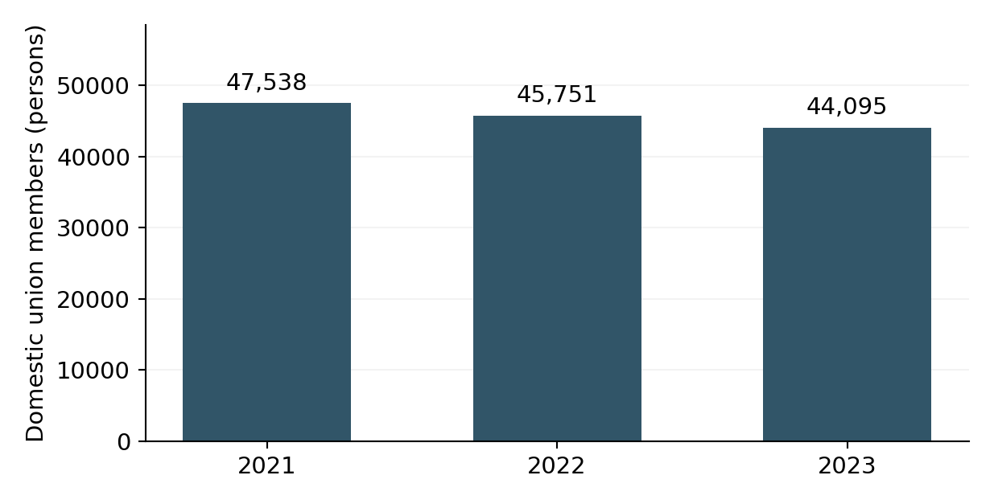
FIGURE 1. Hyundai domestic union membership, 2021–2023.
Source: Hyundai Motor Company (2024), p. 102. The disclosure uses a November reference date for 2023. Calculated change: −7.24%; workforce composition can affect the series.
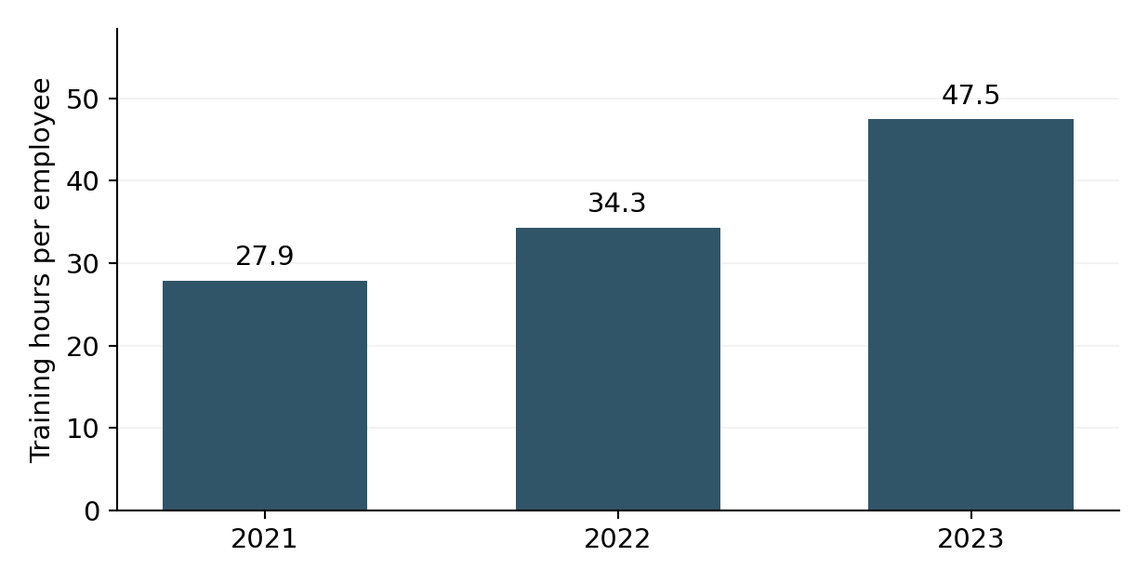
FIGURE 2. Hyundai training hours per employee, 2021–2023.
Source: Hyundai Motor Company (2024), p. 102. Calculated change: +70.25%. Hours measure training input, not acquired skill or employment security.
Year | Union members | Membership (%) | Training hours
2021 | 47,538 | 66.3 | 27.9
2022 | 45,751 | 63.1 | 34.3
2023 | 44,095 | 59.9 | 47.5
TABLE 2. Disclosed series underlying the descriptive analysis.
Source: Hyundai Motor Company (2024), p. 102. Membership rate falls 6.4 percentage points. The later denominator change in the 2025 report prevents a seamless extension.

5 Rolls Royce and the scale of negotiated protection
Rolls-Royce’s pandemic response provides evidence of adjustment at a different scale. In May 2020, the company proposed at least 9,000 reductions from a global workforce of 52,000 (Rolls-Royce, 2020). These figures describe an announced global programme, not completed redundancies confined to Britain. Preserving that distinction is essential: a local employment claim cannot be evaluated against a global proposal without considering the populations involved. The announcement establishes the anticipated scale of corporate adjustment, while the consequences for particular plants require more specific evidence.
Subsequent results reported implementation of the restructuring programme (Rolls-Royce, 2021; Rolls-Royce, 2022). Such reporting helps distinguish an initial proposal from later action. However, company results still do not directly measure workers’ post-restructuring earnings or access to comparable employment. The company’s earlier 2018 restructuring announcement also shows that organisational adjustment predated the pandemic (Rolls-Royce, 2018). This matters because the 2020 programme should not become an explanation for every employment change observed across several years. Different programmes and reporting periods need to be kept analytically distinct.
Barnoldswick offers a more focused example of negotiation. Unite reported an agreement protecting 350 jobs, securing future work and including a two-year commitment against compulsory redundancies (Unite Legal Services, 2021). IndustriALL Global Union (2021) reported the same agreement. These accounts support the claim that local bargaining produced specific commitments during a period of wider contraction. They do not establish uniform company-wide protection, and the two union reports should not be mistaken for independent long-term evaluations. The relevant evidence is the reported agreement and its scope, rather than a general verdict on British industrial relations.
The agreement is analytically important because it concerns the substance of future work as well as the immediate avoidance of redundancy. A commitment linked to production can offer a different form of reassurance from a temporary delay alone. Nevertheless, the durability of that reassurance depends on implementation and the conditions attached to it. The sources used here do not provide a complete subsequent assessment. The defensible conclusion is therefore bounded: bargaining can influence the content of adjustment, while the extent and persistence of protection must still be evaluated after an agreement is reached.
This episode should not be used to portray conflict as either wholly destructive or automatically productive. Dispute and negotiation can interact, but the existence of an agreement does not establish the counterfactual outcome without industrial action. Nor does a successful local negotiation prove that all workers could exercise equivalent influence. My interpretation is that the case reveals bargaining as a possible mechanism for converting corporate adjustment into explicit commitments. Whether that mechanism is available elsewhere depends on representation, production circumstances and the credibility of the alternatives facing both management and workers.
The time limits of a negotiated guarantee also matter. A commitment against compulsory redundancy offers a defined protection over a specified period, rather than permanent insulation from change. This does not make the commitment insignificant: a known period can support planning and create time to develop alternatives. However, its value should be assessed alongside what happens during that interval. If skills, work allocation or investment change, the guarantee may support a longer transition; if no viable arrangement follows, it may principally postpone disruption. The available reports identify the commitment but do not independently resolve these longer-term possibilities.

6 Comparative interpretation beyond national stereotypes
The cases expose a common problem at different points in the employment relationship. GM Korea’s announcements centre on the distribution of losses between a closing location and the continuing business. Barnoldswick centres on the ability to negotiate the future of a particular workforce. Hyundai’s disclosures centre on what numerical indicators reveal about representation and development. Together they show why an evaluation of security must move between company, plant and worker levels. A favourable aggregate result can coexist with concentrated insecurity, while a strong local agreement can coexist with contraction elsewhere.
National institutions remain relevant, but they should enter the explanation through identifiable mechanisms. Country reports can establish broader economic and labour-market conditions, while comparative bargaining research helps frame questions about coverage and coordination (OECD, 2019; OECD, 2024a; OECD, 2024b). They cannot replace evidence about the agreement or workforce being analysed. Attributing the observed difference to national culture would suppress industry, timing and organisational variation. A more defensible comparison asks how institutions shape the available options, then examines how actors use those options within a particular case.
UK membership statistics reinforce the need to distinguish populations. Official reporting separates sectors rather than treating union participation as identical throughout the economy (Department for Business and Trade, 2024). A national membership measure is therefore not directly comparable with the rate disclosed by one manufacturer. Similarly, ONS (2023) evidence on strikes places disputes within a wider environment of earnings pressure, but does not establish the motives of a particular workforce. These distinctions are methodological safeguards: contextual evidence can make an interpretation plausible without proving the explanation of an individual dispute.
Income security also requires an appropriate benchmark. The ILO’s Global Wage Report distinguishes nominal earnings from purchasing power under inflation (ILO, 2022b). A pay increase can therefore be insufficient to establish improved material security. For a plant-level evaluation, the relevant evidence would include real earnings, working time and the distribution of changes across worker groups. This essay does not construct those series because comparable case data are unavailable in the sources examined. It instead identifies why a headline settlement percentage would be inadequate as a complete welfare measure.
Finally, the boundary of protection is central to comparison. An agreement can be strong for those covered while leaving other workers outside its commitments. International working-conditions evidence supports examining employment arrangements and exposure to risk rather than only organisational averages (ILO and Eurofound, 2019). In these cases, the next analytical step would be to distinguish direct employees, temporary staff and subcontracted workers where relevant records permit. Their outcomes should not be assumed either favourable or adverse. What matters is that their position remains visible in the research question rather than disappearing behind the most accessible company data.
Participation itself should be evaluated substantively. Receiving information about a completed decision differs from being able to propose alternatives before implementation. Likewise, formal consultation does not demonstrate that all affected groups had equal influence. An evaluation could examine when discussions began, which options were considered and how disagreements were resolved. Such evidence would help explain why similar contractual protections may be experienced differently. The point is not to assign intentions to managers or representatives from incomplete records, but to make the process through which decisions were reached part of the explanation of their consequences.

7 Policy implications and an evaluation framework
Temporary job-retention support can change the alternatives available during a sudden contraction. The UK furlough evaluation and OECD analyses explain the relevance of preserving employment relationships during the pandemic (HM Revenue and Customs, 2023; OECD, 2020a; OECD, 2020b). Such instruments can address a temporary interruption differently from permanent redundancy. However, the number of supported employments is not equivalent to the number of jobs permanently saved. Public support must be evaluated against an appropriate counterfactual and the nature of the shock, rather than presented as a universal solution to structural change.
For longer-term adjustment, training needs to connect with opportunities that workers can actually access. A course completion or increase in hours is an intermediate output. A stronger assessment would examine whether workers gained relevant skills, obtained redeployment and maintained reasonable earnings. This does not imply that all learning should produce an immediate job move. It means that a claim about transition capacity requires evidence beyond training provision. The framework in Table 3 therefore distinguishes inputs, enforceable commitments and subsequent outcomes, instead of combining them into a single security score.
The ILO’s just-transition guidelines provide a normative basis for including participation and social protection in adjustment (ILO, 2015). Their relevance here lies in connecting change with the conditions of those expected to bear its costs. They do not prove the effectiveness of any particular corporate agreement. My policy argument is that early negotiation should clarify who is affected, which alternatives are feasible and how commitments will be reviewed. This can make adjustment more accountable without assuming that every existing job can remain unchanged indefinitely.
Implementation should then be assessed at more than one point in time. Immediate indicators might include income continuity and access to agreed support; later indicators might examine redeployment, employment stability and real earnings. Results should distinguish participants from non-participants and explain missing observations. Otherwise, workers who leave the reporting population can disappear from the evaluation precisely when their circumstances become most important. Following affected cohorts would connect the initial decision with its consequences, while making clear whether apparent improvement reflects better outcomes or simply changes in who is counted.
My central judgement is that worker security should be treated as a condition to evaluate throughout restructuring rather than an assumed consequence of corporate recovery. That requires credible commitments and a transparent account of their scope. It also requires recognising uncertainty: firms cannot guarantee every future market condition, and workers cannot evaluate promises without information about implementation. A process that records obligations, reviews delivery and includes those affected offers a more defensible basis for security than either optimistic corporate forecasts or national stereotypes about cooperation and conflict.
The proposed approach also involves trade-offs. Detailed monitoring requires resources and can become burdensome if every indicator is collected without a clear purpose. A proportionate design would begin with a small set of measures tied to the commitments made in the adjustment process. If redeployment is promised, the review should track access and placement; if income protection is central, it should track duration and coverage. This links measurement to an obligation rather than creating a reporting exercise detached from the workers affected. It also makes failures easier to identify and corrective action more specific.
A useful review would distinguish a failed commitment from a changed circumstance. An employer might deliver agreed training while the expected vacancy disappears because demand changes. That outcome still matters for the worker, but its explanation differs from training never being provided. Recording both delivery and subsequent outcomes allows the response to address the relevant problem. It could lead to revised support or a different transition route without pretending that either contractual compliance or an adverse market development settles the whole question of responsibility. Accountability requires an explanation of the connection between them.
Finally, comparison can support learning without prescribing identical arrangements. A local agreement may reveal an option worth considering elsewhere, but its effectiveness will depend on production requirements, representation and available resources. The appropriate lesson is therefore to investigate the mechanism rather than copy the visible terms mechanically. This is especially relevant when comparing different manufacturing industries. Shared concern for livelihoods can guide evaluation across cases, while the practical means of protecting those livelihoods remain sensitive to the organisation and the adjustment under consideration. An agreement’s scope should therefore be reported alongside its headline commitments, so that readers can distinguish protection for an identified group from a claim about the security of an entire workforce.
Dimension | Suggested evidence | Follow-up requirement
Employment | Realised retention and redeployment | Track affected workers
Income | Real earnings and support duration | Adjust for inflation
Voice | Timing and alternatives considered | Before decisions become final
Transition | Skills applied and placements | Beyond training attendance
Coverage | Contract and bargaining groups | Include peripheral workers
Durability | Outcomes at 12 and 24 months | Beyond agreement signature
TABLE 3. Proposed worker-security evaluation framework.
Source: Author synthesis informed by UNDP (1994), OECD (2019), ILO (2015, 2022a) and the case evidence. These are proposed indicators, not assessed outcomes.

8 Conclusion
The comparison shows that manufacturing adjustment becomes a human-security issue through its distributional consequences. GM Korea illustrates why a wider viability strategy does not establish the welfare of workers at a closing plant. Barnoldswick illustrates how negotiation can produce local commitments within global contraction. Hyundai illustrates why membership and training figures require careful interpretation before they become claims about protection. None of these cases supplies a complete national model, and their differences cannot be attributed to country alone.
The stronger evaluative question is whether affected workers retain livelihoods, influence the adjustment process or gain a credible route to alternative employment. Answering it requires distinguishing announcements from implementation, inputs from outcomes and covered workers from those outside agreements. Public support and training can contribute, but their effects must be demonstrated rather than assumed. Employment security is therefore not adequately measured by company survival, a low strike count or an isolated increase in training. It is established through the substance, reach and durability of the arrangements that connect industrial change to people’s lives.

References
Booth, K. (1991). Security and emancipation. Review of International Studies, 17(4), 313–326. https://doi.org/10.1017/S0260210500112033
Department for Business and Trade (2024). Trade union statistics 2023. https://www.gov.uk/government/statistics/trade-union-statistics-2023
General Motors (2018a). GM Korea announces first step in necessary restructuring. February. https://investor.gm.com/news-releases/news-release-details/gm-korea-announces-first-step-necessary-restructuring
General Motors (2018b). GM Korea outlines robust viability plan to return to profitability. 11 May. https://investor.gm.com/news-releases/news-release-details/gm-korea-outlines-robust-viability-plan-return-profitability/
HM Revenue and Customs (2023). The Coronavirus Job Retention Scheme final evaluation. https://www.gov.uk/government/publications/the-coronavirus-job-retention-scheme-final-evaluation/the-coronavirus-job-retention-scheme-final-evaluation
Hall, P. A. and Soskice, D., eds. (2001). Varieties of Capitalism: The Institutional Foundations of Comparative Advantage. Oxford University Press. https://academic.oup.com/book/301
Hyundai Motor Company (2024). Sustainability Report 2024. Social data, p. 102. https://org1.hyundai.com/content/hyundai/ww/data/csr/data/0000000052/attach/english/hmc-2024-sustainability-report-en-v6.pdf
Hyundai Motor Company (2025). Sustainability Report 2025. https://www.hyundai.news/newsroom/dam/eu/brand/20250704_2025_sustainability_report/hmc-2025-sustainability-report-en.pdf
IndustriALL Global Union (2021). Union deal saves Rolls-Royce Barnoldswick. 14 January. https://www.industriall-union.org/union-deal-saves-rolls-royce-barnoldswick
International Labour Organization (2015). Guidelines for a Just Transition towards Environmentally Sustainable Economies and Societies for All. https://www.ilo.org/publications/guidelines-just-transition-towards-environmentally-sustainable-economies
International Labour Organization (2022a). Social Dialogue Report 2022: Collective Bargaining for an Inclusive, Sustainable and Resilient Recovery. https://www.ilo.org/publications/flagship-reports/social-dialogue-report-2022-collective-bargaining-inclusive-sustainable-and
International Labour Organization (2022b). Global Wage Report 2022–23: The Impact of Inflation and COVID-19 on Wages and Purchasing Power. https://www.ilo.org/publications/flagship-reports/global-wage-report-2022-23-impact-inflation-and-covid-19-wages-and
International Labour Organization and Eurofound (2019). Working Conditions in a Global Perspective. https://researchrepository.ilo.org/esploro/outputs/report/Working-conditions-in-a-global-perspective/995219148502676
OECD (2019). Negotiating Our Way Up: Collective Bargaining in a Changing World of Work. https://doi.org/10.1787/1fd2da34-en
OECD (2020a). Job retention schemes during the COVID-19 lockdown and beyond. https://www.oecd.org/en/publications/2020/10/job-retention-schemes-during-the-covid-19-lockdown-and-beyond_5002bb9f.html
OECD (2020b). OECD Employment Outlook 2020: Worker Security and the COVID-19 Crisis. https://doi.org/10.1787/1686c758-en
OECD (2024a). OECD Economic Surveys: Korea 2024. https://doi.org/10.1787/c243e16a-en
OECD (2024b). OECD Economic Surveys: United Kingdom 2024. https://doi.org/10.1787/709e70b8-en
Office for National Statistics (2023). The impact of strikes in the UK: June 2022 to February 2023. https://www.ons.gov.uk/employmentandlabourmarket/peopleinwork/workplacedisputesandworkingconditions/articles/theimpactofstrikesintheuk/june2022tofebruary2023
Rolls-Royce (2018). Rolls-Royce confirms fundamental restructuring. 14 June. https://www.rolls-royce.com/media/press-releases/2018/14-06-2018-rr-confirms-fundamental-restructuring.aspx
Rolls-Royce (2020). Rolls-Royce proposes major reorganisation to address medium-term impact of COVID-19. 20 May. https://www.rolls-royce.com/media/press-releases/2020/20-05-2020-rr-proposes-major-reorganisation-to-address-medium-term-impact-of-covid-19.aspx
Rolls-Royce (2021). Rolls-Royce Holdings plc 2020 full year results. 11 March. https://www.rolls-royce.com/media/press-releases/2021/11-03-2021-rr-holdings-plc-2020-full-year-results.aspx
Rolls-Royce (2022). Rolls-Royce Holdings plc 2021 full year results. 24 February. https://www.rolls-royce.com/media/press-releases/2022/24-02-2022-rr-holdings-plc-2021-full-year-results.aspx
Unite Legal Services (2021). Ground-breaking deal by Unite saves Barnoldswick’s Rolls-Royce factory and 350 jobs. 14 January. https://www.unitelegalservices.org/news-stories/ground-breaking-deal-by-unite-saves-barnoldswick-s-rolls-royce-factory-and-350-jobs
United Nations Development Programme (1994). Human Development Report 1994. https://hdr.undp.org/content/human-development-report-1994

