UNIVERSITY OF YORK
Comparative Institutions and Public Policy
Summative Essay

Recruiting talent, building institutions: evaluating China’s Thousand Talents Plan
Word count: 4,000 words
Main text, including section headings and in-text citations. Abstract, tables, figure captions and references are excluded.

Abstract
This essay examines when international talent recruitment becomes durable research capacity. It combines institutional theory with published evaluations of China’s Thousand Talents initiatives and transparent descriptive calculations. Divergent findings are interpreted through differences in populations, outcomes and counterfactuals. The central argument is that recruitment incentives must be accompanied by workable settlement support, integration into host teams and credible evaluation of additional value. National expenditure and selection rates provide context rather than causal proof. A proposed framework separates arrival, institutional participation, persistence and distributional outcomes.

Contents
1 Introduction
2 Institutions and the meaning of research capacity
3 Policy architecture and implementation
4 Research design and descriptive evidence
5 What the evaluations establish
6 From individual rewards to collective capability
7 Evaluation and policy implications
8 Conclusion
References
Figures and tables appear alongside the relevant numbered sections.

1 Introduction
China’s Thousand Talents Plan raises a fundamental question for public policy: when does recruiting talented individuals strengthen the institutions that employ them? International recruitment can increase the number of distinguished researchers without necessarily improving collaboration, widening opportunity or producing lasting organisational capability. This essay argues that the programme should be evaluated as an institutional process connecting recruitment, integration and knowledge production. The central policy achievement is not the movement of a scientist across a border, but the creation of conditions in which that scientist and existing colleagues can conduct better research together.
This distinction matters because talent programmes operate within unequal research environments. A recruitment award can provide funding and status, but its practical value depends on laboratory access, administrative arrangements and relationships with other researchers. Conversely, an institution may attract an accomplished scholar while failing to translate that appointment into benefits beyond the individual. The relevant question therefore concerns the distribution and persistence of gains, rather than whether prestigious recruitment is inherently desirable. International talent flows provide the wider setting, but they do not determine how a particular university will use an appointment (Kerr et al., 2016).
It distinguishes the Thousand Talents initiative from its younger researcher schemes, which supply much of the available evidence. It also separates the findings of existing studies from the calculations undertaken here. Recruitment rates and national expenditure changes describe patterns; they are not new estimates of programme effectiveness. It concludes that recruitment can build collective research capacity when resource allocation, settlement support and evaluation reward integration as well as individual achievement.

2 Institutions and the meaning of research capacity
North (1990) treats institutions as rules that structure interaction and incentives. Applied to talent recruitment, this perspective directs attention towards what happens after an appointment is announced. Researchers make decisions within rules governing grants, promotion, employment and access to facilities. A generous recruitment offer may change the incentive to relocate, while leaving these other arrangements intact. It follows that the ability to purchase an initial commitment does not necessarily imply an ability to sustain productive participation. Institutional effectiveness must be assessed through the relationship between formal incentives and everyday research conditions.
Hall and Taylor (1996) distinguish approaches that emphasise strategic calculation, historical development and socially embedded practices. These approaches illuminate different aspects of the same policy. A researcher may compare salaries and funding strategically, encounter organisational routines inherited from earlier reforms, and depend on informal expectations about collaboration. This essay does not treat these perspectives as interchangeable explanations. Instead, their value lies in identifying why a formally identical award can produce different experiences across institutions. Financial incentives affect entry decisions, whereas established practices influence how an entrant can exercise expertise after arrival.
Cohen and Levinthal’s (1990) concept of absorptive capacity adds an organisational mechanism. External knowledge becomes useful through an institution’s existing ability to recognise and apply it. In research settings, that suggests examining complementary staff, relevant facilities and opportunities for intellectual exchange. This is an application of the concept, rather than a finding that every Chinese university lacks such capacity. Its implication is conditional: recruitment into a well-connected team may generate benefits that an isolated appointment cannot. Resources provided to one individual are consequently an incomplete measure of the institution’s capacity to learn.
The migration literature further complicates the assumption that countries simply gain or lose a fixed stock of talent. Docquier and Rapoport (2012) examine mechanisms through which skilled migration can affect development beyond immediate departures. Franzoni, Scellato and Stephan (2012) document varied international mobility patterns among scientists. These contributions justify distinguishing relocation from the circulation of knowledge. A returnee may continue collaborating abroad, while a scientist who remains overseas may contribute through professional networks. A domestic appointment and an international connection can therefore be complementary assets rather than competing indicators of national success.
I define collective research capacity as an institution’s sustained ability to produce, evaluate and share knowledge through people and organisational arrangements. This definition separates individual productivity, team spillovers and institutional durability. An increase in a recruit’s publications addresses the first dimension, but does not settle the other two. Equally, benefits to colleagues could matter even where the recruit’s own output changes little. This broader definition does not dismiss publications. It locates them within an evaluation that asks whose output improves, through which mechanism, and whether the improvement survives the initial recruitment package.
A further distinction separates an organisation from the rules through which it operates. A university is a host organisation; its promotion criteria and funding procedures are institutional arrangements. Moving a researcher into the organisation does not necessarily change those arrangements. This distinction prevents a common analytical shortcut in which a successful appointment is assumed to represent institutional reform. I instead interpret recruitment as a potential trigger for change. Whether that potential is realised depends on how the appointment affects incentives, opportunities and relationships beyond the employment contract itself. The argument consequently concerns the organisation’s response to recruitment as much as the recruitment decision.

3 Policy architecture and implementation
The policy setting is layered rather than uniform. Zhu (2019) describes talent programmes operating at national, provincial, municipal and institutional levels, alongside changes in their funding and administration. Consequently, a university appointment may combine several sources of support. Treating the resulting package as a single national intervention obscures how benefits are assembled and who is responsible for delivering them. It also makes comparison difficult: two researchers carrying a similar programme label may receive different practical support from their host institutions and local governments.
Historical accounts place the original Thousand Talents initiative within a wider effort to encourage return migration and attract expertise (Wang, 2013). However, the young researcher schemes examined in several evaluations should not be treated as representative of all recruitment categories. Senior scientists, early-career returnees and non-Chinese scholars face different career constraints and eligibility conditions. The distinction is substantive, not merely terminological. Evidence concerning young academics cannot directly establish the success of programmes targeting established foreign specialists or entrepreneurship. The unit of analysis must therefore remain explicit throughout the argument.
USTC’s historical recruitment notices illustrate how national objectives become an employment offer. Its young-scholar notice combines research start-up funding with salary and assistance concerning housing and family circumstances. Its non-Chinese-scholar notice presents a different appointment package and engagement requirement (USTC, n.d.a; USTC, n.d.b). These are first-party descriptions of advertised support, not evidence that every commitment was delivered. Nevertheless, they reveal a policy logic extending beyond salary: recruitment addresses the conditions of relocation as well as the conditions of research. They cannot establish uniform entitlements across China or current eligibility rules.
Entry arrangements form another part of this infrastructure. A consulate-hosted report describes an expansion of talent-visa eligibility in 2014, while an official-hosted account of 2018 guidelines discusses involving international scientists in research and assessment (Xinhua, 2014; Xinhua, 2018). These communications establish stated policy intentions, not independently measured outcomes. Xu’s (2023) study of Beijing provides a complementary account of local policy development. Taken together, the sources suggest that recruitment depends on coordination across organisations. A university may make an attractive offer, but the experience of joining also depends on administrative processes beyond its immediate control.
This layered structure also creates an accountability problem. When several authorities contribute to a package, responsibility for a delay or unfulfilled commitment may become difficult to identify. An attractive national programme can therefore depend on local delivery capacities that are uneven or poorly documented. The policy implication is to identify the responsible organisation for each commitment before evaluating overall performance. Otherwise, an evaluation may attribute an implementation failure to the researcher, or attribute a university’s additional support entirely to national policy. These are analytically different explanations and would require different corrective actions.

4 Research design and descriptive evidence
The empirical strategy is a critical synthesis supported by transparent descriptive analysis. Published studies provide evidence about research outcomes, while recruitment notices clarify institutional arrangements. Official expenditure statistics establish a broader funding context. These source types answer different questions and should not be combined as if they offered equivalent causal evidence. University notices show promises; evaluation studies test selected outcomes; national statistics measure aggregate expenditure. The analysis therefore uses each source within its proper scope rather than interpreting every positive number as evidence that the programme worked.
Figure 1 and Table 1 recalculate selection rates from the reported cohort groups in Ash et al.’s (2022) preliminary working paper. Dividing selected candidates by applicants produces rates between 14.69% and 29.63%. The 2017 group contains substantially more applicants than the preceding reported group, while its selection rate is lower. These observations show that expansion in recruitment can coexist with greater competition. They do not demonstrate that applicants became better qualified, that selection improved, or that the scheme retained more scientists. The absence of a 2014 category is preserved rather than converted into a zero or interpolated observation.
A source discrepancy reinforces the need for restraint. The working paper’s reported joined counts sum to 3,084, whereas its total states 3,083. Neither aggregate is used to calculate a retention rate here. More fundamentally, the source’s participation classification does not provide a standard longitudinal measure of continued employment. A numerical total can appear precise while answering a different question from the one an evaluator wishes to ask. The appropriate response is to preserve the documented selection data and avoid manufacturing a second indicator from an unsuitable variable.
Figure 2 places recruitment within China’s expanding research expenditure. The official communiqué reports 2023 expenditure of RMB 3,335.71 billion and an increase of RMB 257.42 billion. Subtraction yields RMB 3,078.29 billion for 2022, and the resulting growth calculation is 8.36%, consistent with the published rounded figure (NBS et al., 2024). These are nominal national amounts. They neither measure Thousand Talents funding nor adjust for inflation. Their analytical role is to identify a competing explanation for rising output: a more favourable funding environment may benefit researchers independently of their recruitment status.
The cohort calculations also illustrate the importance of denominators. The number selected rises from 152 in the first reported group to 1,228 in the final group, but comparing those totals alone suppresses changes in the applicant pool. Reporting both counts and rates makes the distinction visible. Nevertheless, the reported groups are not a balanced annual panel, so these endpoints should not become an annual growth estimate. More applications could reflect eligibility, awareness or programme organisation, none of which is identified by the table. Descriptive transparency therefore improves the question being asked without supplying an explanation that the underlying data cannot support.
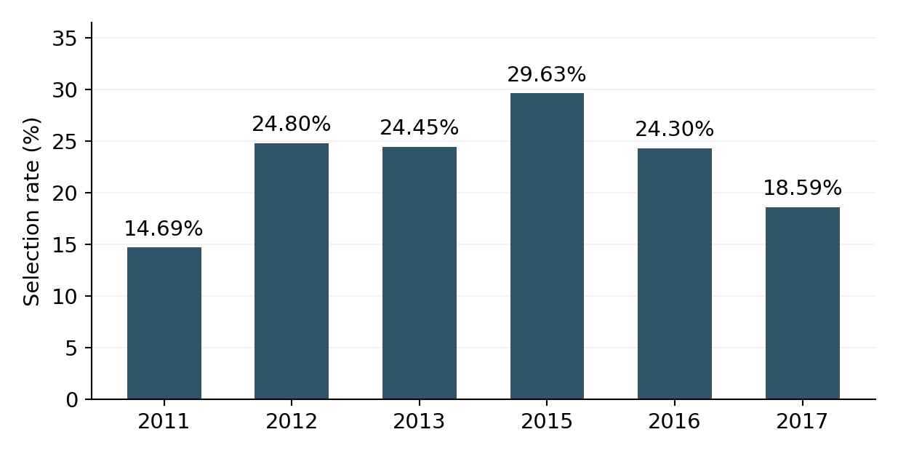
FIGURE 1. Selection rates across reported programme cohorts.
Source: Author calculations from Ash et al. (2022), Table 1, p. 6. Reported categories are not a complete annual series; 2014 is not reported and is not treated as zero.
Cohort | Applicants | Selected | Rate (%)
2011 | 1035 | 152 | 14.69
2012 | 1609 | 399 | 24.80
2013 | 2376 | 581 | 24.45
2015 | 2241 | 664 | 29.63
2016 | 2325 | 565 | 24.30
2017 | 6604 | 1228 | 18.59
TABLE 1. Underlying cohort counts and calculated selection rates.
Source: Ash et al. (2022), Table 1, p. 6. Rate = selected/applicants × 100. These are selection measures, not retention measures.
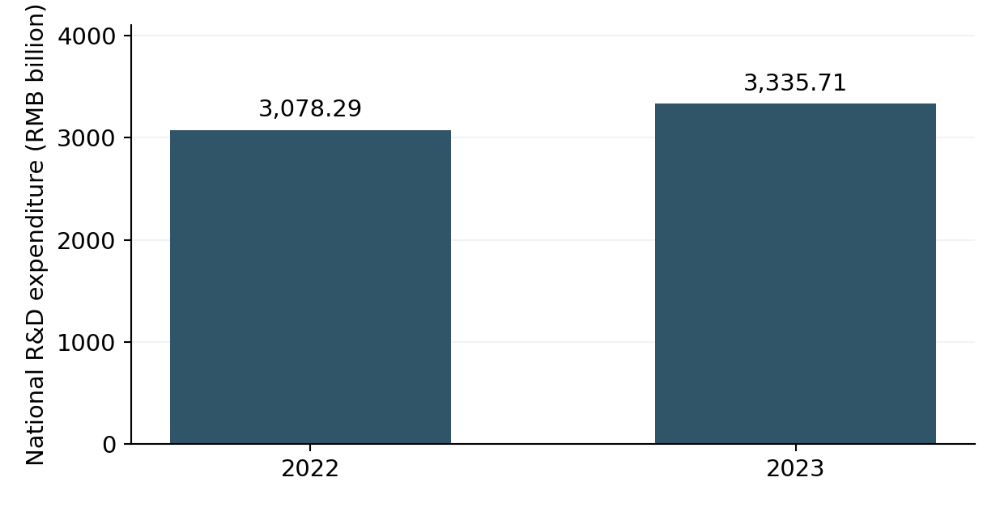
FIGURE 2. National research expenditure: contextual expansion.
Source: National Bureau of Statistics et al. (2024). 2022 is reconstructed as 3,335.71 − 257.42 = 3,078.29 billion RMB. Calculated nominal growth is 8.36%. Not a programme budget or causal estimate.

5 What the evaluations establish
Shi, Liu and Wang (2023) provide evidence of productivity gains among young returnees. The Stanford Center on China’s Economy and Institutions (2023) summarises the study as finding 27% more publications relative to overseas comparators and highlights research resources as an important mechanism. This finding supports the proposition that relocation with substantial institutional support can improve performance. It does not establish that location alone caused the gain or that all programme categories benefited equally. The Stanford account is a summary of the same study, not a second independent observation confirming its results.
Ash et al. (2022) offer a different pattern. Their preliminary matched difference-in-differences analysis reports neutral direct productivity effects over the longer observation period, alongside positive effects on local peers. This matters because a recruitment policy may influence more than the recruited scientist. If collaboration helps colleagues produce additional research, evaluation restricted to individual output would miss an organisational benefit. However, the working paper’s preliminary status and particular sample prevent its findings from settling the debate. It is evidence for considering spillovers, not a basis for asserting that every host department experiences them.
Jia and Fleisher (2024) examine recruitment and scientific production in leading mathematics departments. Their results indicate improvements in the overseas background and productivity of new hires, concentrated in stronger universities and economically developed coastal regions. They also identify a decline in incumbent output, with limited collaboration suggested as an explanation. The disciplinary and institutional boundaries are important. This evidence cannot be generalised directly to every laboratory or field. It nevertheless challenges an uncomplicated narrative in which attracting stronger candidates necessarily improves conditions for everyone already employed at the receiving institution.
Marini and Yang (2021) complicate the quantity-based interpretation by examining the distribution of publication performance among young returnees. Their findings raise concerns about how evaluation incentives may encourage output volume without equivalent improvement in quality. Huang et al. (2024), in a separate mobility analysis, identify the relevance of rebuilding collaboration networks and differences between research fields. Together these studies suggest that career trajectories depend on both incentives and research environments. Neither result warrants a universal prediction about an individual recruit; both support analysing mechanisms instead of assuming that an award has a fixed effect.
The apparent disagreement among studies is therefore informative. Different comparison groups, research fields, observation periods and outcomes can produce different answers without making one result automatically invalid. A comparison with researchers who remain abroad addresses a different counterfactual from a comparison involving other mobile researchers. Likewise, individual publications, incumbent output and peer effects are distinct dependent variables. Table 2 preserves these differences. A defensible synthesis asks which mechanisms each design can illuminate, while resisting the temptation to average incompatible estimates into a single numerical verdict on national policy.
There is also a difference between estimating benefits to participants and evaluating public value. Even a credible increase in a recruit’s output does not reveal what the same resources would have achieved through another allocation. An alternative might support existing researchers, shared equipment or a larger number of smaller awards. This essay does not rank those options because it lacks comparable cost and outcome data. It does argue that additionality requires such a comparison. A positive participant effect is an important finding, but the broader judgement about efficient public spending remains a separate question.
Study | Evidence focus | Interpretive boundary
Shi et al. (2023) | Young recruits; productivity and resources | Programme-specific comparison
Ash et al. (2022) | Direct effects and peer spillovers | Preliminary working paper
Jia and Fleisher (2024) | Mathematics hiring and incumbents | Discipline and location matter
Marini and Yang (2021) | Returnee research output | Quantity differs from quality
Huang et al. (2024) | Mobility and career trajectories | Preprint; selection remains relevant
TABLE 2. Why the evaluations need not produce identical conclusions.
Source: Author synthesis of the five studies listed. Rows compare scope rather than pool effect sizes.

6 From individual rewards to collective capability
The first mechanism concerns complementary resources. A talented researcher may require equipment, technical staff, research students and time before producing work at the level expected by a recruitment scheme. Funding can remove some constraints, but the allocation process determines whether resources arrive when needed and can be used effectively. The interpretation developed here is that recruitment offers should be assessed as operational commitments. A large advertised grant has limited explanatory value unless the evaluator also knows when it became available, what it could purchase and how it interacted with existing departmental resources.
The second mechanism concerns legitimacy inside the receiving organisation. Chen’s (2022) qualitative study of preferential recruitment practices draws attention to perceptions of unequal treatment. Such evidence does not establish the prevalence of resentment across universities, but it identifies a plausible barrier to integration. When institutions reward newcomers differently, they need to explain the purpose and criteria of those differences. Transparent allocation and opportunities for joint work may help connect recruitment to shared objectives. This is a policy inference: it should be tested rather than presented as an established remedy for every organisational dispute.
Research on domestic resistance further cautions against assuming that formal programmes eliminate organisational obstacles (Zweig, Kang and Wang, 2020). Recruitment may alter who joins a department without immediately changing how authority, recognition and access are distributed. A newcomer’s expertise will not necessarily influence practice if existing routines leave little scope for participation. The central issue is not whether institutions should abandon standards for recruits, but whether their procedures enable those recruits to contribute. Successful integration requires a workable relationship between accountability and the discretion needed to conduct research.
Settlement support is also relevant to institutional capacity, although its effects should not be assumed. Housing, family arrangements and administrative clarity can influence whether an appointment remains feasible over time. The USTC notices make these considerations visible, but do not measure their consequences. An evaluation could compare promised and delivered support, then examine whether delays predict early departure after accounting for other factors. Such a design would move beyond listing benefits towards understanding implementation. It would also avoid treating departure as proof of personal failure when organisational commitments may not have been fulfilled.
Finally, recruitment can interact with cumulative advantage. Bol, de Vaan and van de Rijt (2018) show how funding success can produce further advantage in another research setting. Applying this insight to China requires caution, but it raises a useful question: are awards adding capacity or mainly reinforcing prior status? If stronger institutions are better positioned to assemble attractive packages, a programme may widen existing differences. That possibility does not mean elite recruitment has no public value. It means that evaluators must distinguish excellence at selected institutions from gains distributed across the research system.
These concerns should not lead to the opposite simplification that differentiated rewards are necessarily unfair. Scarce expertise can justify targeted support, especially where an institution seeks to establish a capability it does not already possess. The problem arises when the criteria and intended organisational benefits are unclear. My argument is therefore for accountable differentiation rather than identical treatment. Institutions should explain what an appointment is expected to contribute, how complementary opportunities will be organised and when the arrangement will be reviewed. This would allow scrutiny of the recruitment strategy without assuming that either equal spending or prestigious selection automatically produces fairness.

7 Evaluation and policy implications
An improved evaluation should begin with explicit objectives. If the purpose is to recruit researchers who otherwise would not relocate, additional arrivals are relevant. If the purpose is stronger research, productivity and quality matter. If the purpose is wider institutional capability, collaboration and effects on colleagues become essential. These objectives can overlap, but they should not be substituted for one another after results are observed. A programme should not be declared successful on recruitment numbers alone when its stated justification concerns research performance. Table 3 translates these distinctions into separate indicators.
Longitudinal records would help connect stages of implementation. They should distinguish offers, acceptance, arrival, resource delivery and continued employment, with a consistent observation date and clear treatment of missing cases. Following cohorts at three and five years could reveal whether early gains persist. However, tracking alone cannot establish causation. Researchers who accept an award may differ from those who decline it in motivation, family circumstances or expected opportunities. Any comparison must therefore examine pre-existing differences and explain the assumptions under which subsequent divergence can be attributed to the programme.
Matched comparisons and difference-in-differences designs offer useful tools, but their credibility depends on the underlying counterfactual. Similar publication histories do not guarantee similar future trajectories without treatment. Researchers may anticipate relocation, change projects beforehand or select institutions already expanding investment. Evaluators should therefore examine pre-treatment trends, alternative comparison groups and sensitivity to sample definitions. These are proposed standards for interpreting the existing evidence, not additional tests performed in this essay. A transparent statement of uncertainty is more informative than reporting a precise effect whose identifying assumptions remain unexplained.
Institutional outcomes also require careful measurement. Co-authorship can indicate collaboration, but a rising number of joint papers does not by itself show meaningful knowledge transfer. Publication counts differ across disciplines, and team size can change without improving research quality. Evaluation should combine field-sensitive quantitative measures with evidence about working arrangements and resource use. The relevant questions include whether recruits contribute to existing teams, whether colleagues gain access to opportunities and whether new practices remain after personnel changes. This would make the concept of shared capability observable without reducing it to an arbitrary score.
International ties must remain part of the assessment. Xie and Freeman (2023) examine connections involving diaspora and returnee researchers, while Flynn et al. (2024) investigate the effects of tensions on international scientific research. These studies caution against interpreting a domestic headcount independently of cross-border relationships. A recruitment policy may gain staff while losing access to some networks, or strengthen domestic work through continued external cooperation. This essay therefore treats international connection as a potential input to national capability. It does not assume that every collaboration is beneficial or that geopolitical constraints can simply be removed by universities.
My policy judgement is that integration deserves an explicit place in funding and accountability. Institutions should be assessed on delivering recruitment commitments, supporting collaboration and explaining differences in resource allocation. Evaluation should also report who does not benefit, including incumbent staff and less advantaged host institutions. This approach would preserve the rationale for attracting exceptional people while making the public purpose of recruitment clearer. It replaces a narrow contest over visible appointments with a more demanding question: whether those appointments expand the institution’s durable ability to produce and share knowledge.
A practical evaluation would also distinguish uncertainty from failure. Some research projects require long preparation periods, so short-term publication targets may encourage activity that is easier to count rather than work with greater intellectual value. Conversely, allowing unlimited time without review could protect ineffective arrangements. The appropriate response is a staged assessment that checks implementation early and research outcomes later. Initial review could examine whether facilities and support were delivered; subsequent review could consider field-appropriate output and collaboration. This sequencing connects accountability to the stage at which an outcome can reasonably be expected, rather than imposing one timetable on every discipline.
There are limits to what an indicator system can resolve. Researchers and institutions may respond strategically to published measures, including measures of collaboration. A requirement for joint output could generate nominal partnerships without substantial exchange. For that reason, the proposed indicators should inform investigation rather than become automatic funding rules. Evaluators could use unusual patterns to identify cases for closer review, combining records with explanations from participants and colleagues. Such review must itself be transparent and proportionate. The purpose is to understand mechanisms and correct implementation, not to replace scientific judgement with another set of administrative targets.
This approach also creates a basis for learning across institutions. Comparing similar departments with different delivery arrangements could reveal which forms of support appear most useful, even before a definitive causal estimate is available. Findings should be reported with their uncertainty and institutional context, allowing other hosts to assess relevance rather than copy a package mechanically. In this sense, policy learning becomes a collective activity. The programme can improve not only by selecting different people, but by using evidence about their experience to revise the conditions under which future appointments are made.
Evaluation also has a distributional choice that cannot be settled statistically. A government may prioritise internationally competitive centres, while a different objective would favour spreading capability across institutions. The same concentration of awards could look desirable under the first objective and problematic under the second. I therefore argue that the intended balance should be stated before outcomes are assessed. Evidence can reveal where gains occur and which groups bear costs, but it cannot choose the public objective on its own. Making that objective explicit would improve accountability and prevent regional inequality from being dismissed as irrelevant simply because selected universities perform well. It would also allow disagreement about priorities to be separated from disagreement about whether the programme achieved them in practice.
Stage | Suggested measure | Required distinction
Recruitment | Accepted offers / eligible offers | Offer versus arrival
Settlement | Promised support delivered on time | Advertisement versus delivery
Integration | Sustained host-team collaboration | Affiliation versus participation
Persistence | Employment at three and five years | Arrival versus retention
Additional value | Outcomes relative to credible controls | Selection versus policy effect
Distribution | Outcomes by institution and staff group | Individual versus collective gain
TABLE 3. Proposed institutional-capacity evaluation framework.
Source: Author proposal informed by the institutional and evaluation literature; no measured scores are claimed.

8 Conclusion
Thousand Talents should be understood as an institutional intervention whose results depend on more than the qualities of those recruited. Existing evaluations indicate benefits in some settings, but also divergent individual outcomes, uneven distribution and uncertain effects on colleagues. These findings cannot be reduced to a single national success rate. Their value lies in identifying the conditions under which recruitment becomes productive: usable resources, legitimate arrangements inside host organisations and relationships that allow expertise to circulate.
The descriptive analysis supports this interpretation without claiming to prove it. Changing selection rates describe recruitment competition, while national expenditure growth identifies a broader context. Neither establishes additional research capacity by itself. The proposed evaluation framework therefore separates arrival, implementation, integration and persistence, and requires credible comparisons before attributing outcomes to policy. The strongest public-policy objective is not simply to bring talented people home. It is to create institutions in which their expertise, together with that of existing colleagues, produces lasting and shared research capability.

References
Ash, E., Cai, D., Draca, M. and Liu, S. (2022). Bootstrapping science? The impact of a “return human capital” programme on Chinese research productivity. CAGE Working Paper 628. Preliminary draft, 15 July. https://warwick.ac.uk/fac/soc/economics/research/centres/cage/manage/publications/wp628.2022.pdf
Bol, T., de Vaan, M. and van de Rijt, A. (2018). The Matthew effect in science funding. Proceedings of the National Academy of Sciences, 115(19), 4887–4890. https://doi.org/10.1073/pnas.1719557115
Chen, N. (2022). “Why should a ‘foreigner’ be better than me?”: Preferential practices in junior academic faculty recruitment among mainland Chinese universities. Tertiary Education and Management, 28, 17–41. https://doi.org/10.1007/s11233-021-09083-3
Cohen, W. M. and Levinthal, D. A. (1990). Absorptive capacity: A new perspective on learning and innovation. Administrative Science Quarterly, 35(1), 128–152. https://doi.org/10.2307/2393553
Docquier, F. and Rapoport, H. (2012). Globalization, brain drain, and development. Journal of Economic Literature, 50(3), 681–730. https://doi.org/10.1257/jel.50.3.681
Flynn, R., Glennon, B., Murciano-Goroff, R. and Xiao, J. (2024). Building a wall around science: The effect of U.S.–China tensions on international scientific research. NBER Working Paper 32622. https://www.nber.org/papers/w32622
Franzoni, C., Scellato, G. and Stephan, P. (2012). Foreign-born scientists: Mobility patterns for 16 countries. Nature Biotechnology, 30, 1250–1253. https://doi.org/10.1038/nbt.2449
Hall, P. A. and Taylor, R. C. R. (1996). Political science and the three new institutionalisms. Political Studies, 44(5), 936–957. https://doi.org/10.1111/j.1467-9248.1996.tb00343.x
Huang, Y., Cheng, X., Tian, C., Jiang, X., Ma, L. and Ma, Y. (2024). Talent hat, cross-border mobility and career development in China. arXiv:2403.00107. https://arxiv.org/abs/2403.00107
Jia, N. and Fleisher, B. M. (2024). Economic incentives and return migrant scholars: Evidence from a talent recruitment program in China. World Development, 184, 106763. https://doi.org/10.1016/j.worlddev.2024.106763
Kerr, S. P., Kerr, W., Özden, Ç. and Parsons, C. (2016). Global talent flows. Journal of Economic Perspectives, 30(4), 83–106. https://doi.org/10.1257/jep.30.4.83
Marini, G. and Yang, L. (2021). Globally bred Chinese talents returning home: An analysis of a reverse brain-drain flagship policy. Science and Public Policy, 48(4), 541–552. https://doi.org/10.1093/scipol/scab021
National Bureau of Statistics of China, Ministry of Science and Technology and Ministry of Finance (2024). Statistical communiqué on national expenditures on science and technology in 2023. https://www.stats.gov.cn/english/PressRelease/202410/t20241014_1956904.html
North, D. C. (1990). Institutions, Institutional Change and Economic Performance. Cambridge University Press. https://doi.org/10.1017/CBO9780511808678
Shi, D., Liu, W. and Wang, Y. (2023). Has China’s Young Thousand Talents program been successful in recruiting and nurturing top-caliber scientists? Science, 379(6627), 62–65. https://doi.org/10.1126/science.abq1218
Stanford Center on China’s Economy and Institutions (2023). Evaluating the success of China’s Young Thousand Talents STEM recruitment program. China Brief, 15 August. https://sccei.fsi.stanford.edu/china-briefs/evaluating-success-chinas-young-thousand-talents-stem-recruitment-program
University of Science and Technology of China (n.d.a). Thousand Talents Plan Professorship for Young Scholars. Historical eligibility notice referring to 2019. https://employment.ustc.edu.cn/cn/enindexnews.aspx?infoID=665597358281250024
University of Science and Technology of China (n.d.b). Thousand Talents Plan Professorship for Non-Chinese Scholars. https://employment.ustc.edu.cn/cn/enindexnews.aspx?infoID=665597743593750031
Wang, H. (2013). China’s return migration and its impact on home development. UN Chronicle. https://www.un.org/en/chronicle/article/chinas-return-migration-and-its-impact-home-development
Xie, Q. and Freeman, R. B. (2023). Creating and connecting US and China science: Chinese diaspora and returnee researchers. NBER Working Paper 31306. https://www.nber.org/papers/w31306
Xinhua (2014). China expands high-caliber work visa scheme. 7 June. https://newyork.china-consulate.gov.cn/eng/xw/201406/t20140607_4706361.htm
Xinhua (2018). China plans to attract more international scientists. 24 May. https://english.www.gov.cn/state_council/ministries/2018/05/24/content_281476158690404.htm
Xu, L. (2023). The evolution of China’s foreign talent policy: The case study of Beijing. Chinese Political Science Review. Published online 28 March. https://doi.org/10.1007/s41111-023-00239-7
Zhu, J. (2019). The composition and evolution of China’s high-level talent programs in higher education. ECNU Review of Education, 2(1), 104–110. https://doi.org/10.1177/2096531119840869
Zweig, D., Kang Siqin and Wang Huiyao (2020). ‘The best are yet to come:’ State programs, domestic resistance and reverse migration of high-level talent to China. Journal of Contemporary China, 29(125), 776–791. https://doi.org/10.1080/10670564.2019.1705003

