Few-Step Distillation of Multi-View RGB-D World Models: Does Geometry Survive?
Tae Yang Hong
NAIS Lab
hongtaeyang1231@gmail.com

Abstract
Multi-view RGB-D world models such as Geo4D (Liu et al., 2025) let a robot plan in 3D, but their iterative samplers are too slow for closed-loop control: the released Geo4D checkpoint needs 25 UNet evaluations and 21.8 s per prediction on an RTX 5090. Few-step distillation is the standard remedy for single-view video diffusion, yet it has not been evaluated on a multi-view RGB-D model, and pixel metrics alone cannot tell whether geometry survives. We first show that cutting the Geo4D sampler to one to four steps without training raises PSNR while seed diversity, LPIPS and sharpness degrade, so pixel metrics hide the collapse. We then distill the teacher into a three-step generator with distribution matching distillation in EDM sigma space, sample by re-noising x₀ predictions, and correct a global depth scale shift with a per-view scale anchored to the conditioning pointmap, which needs no ground truth. Two negative results, ODE-regression initialization and a ground-truth-supervised cross-view depth loss, are reported as such. With bf16 inference and the per-view input anchor, the student runs in 1.64 s on one RTX 5090 (13.3x faster than the 21.8 s teacher), its sharpness and seed diversity are statistically indistinguishable from the teacher's, and it loses a small but significant amount of depth accuracy (AbsRel +0.015) and perceptual quality (LPIPS +0.018).

1 Introduction
A robot that can predict how a scene will look a few seconds ahead, in 3D and from every camera it has, can plan and verify actions before executing them. Geo4D (Liu et al., 2025) is a recent world model of this kind. Built on Stable Video Diffusion (Blattmann et al., 2023), it takes one RGB-D frame (a color image and a pointmap) per camera view for two views and generates 10 future RGB-D frames for both views, with the pointmaps of both views expressed in the left camera frame and no camera poses required at inference. Trained with a cross-view pointmap alignment loss, it reaches a success rate of 0.53 on the bimanual PlaceAppleFromBowlIntoBin task in the LBM simulator (Toyota Research Institute, 2025), where Dreamitate (Liang et al., 2024), Diffusion Policy (Chi et al., 2023) and DP3 (Ze et al., 2024) reach 0.10, 0.00 and 0.00 respectively, as reported by Liu et al. (2025).
The cost of this capability is the sampler. Geo4D generates a latent video with a 25-step EulerEDM sampler (Karras et al., 2022) under classifier-free guidance (Ho & Salimans, 2022), and the authors themselves list the resulting inference time, about 30 s for 10 frames on an RTX 4090, as a limitation that rules out closed-loop planning. We measured 21.8 s of pure inference on an RTX 5090, of which the UNet accounts for 20.1 s; the bottleneck is running the same network 25 times, not memory. We set three target budgets: about 2 s for quasi-static pick-and-place, 0.3 to 0.5 s for humanoid control, and 0.1 s for dynamic manipulation. Closing this gap means removing most of the sampling steps.
Few-step sampling is a well-studied problem for image and video diffusion. Progressive distillation (Salimans & Ho, 2022), consistency models (Song et al., 2023) and distribution matching distillation (DMD; Yin et al., 2024a; Yin et al., 2024b) reduce image generation to one to four network evaluations, and CausVid (Yin et al., 2025), Self-Forcing (Huang et al., 2025) and Causal Forcing (Zhu et al., 2026) extend DMD-style distillation to autoregressive video models. Recent robot world models report 10.8 and 15.3 FPS without evaluating multi-view geometry (DreamDojo, Gao et al., 2026; RoboWorld, Jeon et al., 2026). None of this work asks what happens to a model whose output is not a single video but a pair of pointmap-and-color videos that must agree with each other in 3D. Geo4D has eight latent channels per frame, two views that share all UNet weights and communicate only through the left view's hidden states passed to the right view as spatial context, and a quality criterion, cross-view geometric consistency, that no existing distillation benchmark measures. Whether that criterion survives distillation is the question this paper addresses.
The question cannot be answered with pixel metrics. When we reduced the Geo4D sampler from 25 to 1 Euler step without training (Figure 2), PSNR rose from 19.75 to 20.64 dB while LPIPS (Zhang et al., 2018) worsened by 20.7%, Laplacian sharpness fell by 12.5% and the per-pixel standard deviation across four seeds fell by 77%; at one step the moving arm becomes a translucent smear and all four seeds give the same image. This is the perception-distortion tradeoff (Blau & Michaeli, 2018): few-step output approaches the conditional mean, which is blurry but scores well on a pixel average dominated by static background. The metrics also collapse in a fixed order, seed diversity first (from 8 steps), then LPIPS (4 steps), then cross-view geometry (2 steps), and PSNR never. A cross-view chamfer distance is not a substitute either, since it rewards two views that are wrong in the same way. We therefore evaluate every method on per-view depth AbsRel, LPIPS, sharpness, seed diversity and cross-view chamfer jointly, with paired Wilcoxon signed-rank tests (Wilcoxon, 1945) over 40 view-samples, and we report a training-free few-step teacher as a control row in the main comparison.
Our approach is summarized in Figure 1. We distill the frozen Geo4D teacher into a three-step student with DMD (Yin et al., 2024a) rewritten in EDM sigma space, with the backward simulation of DMD2 (Yin et al., 2024b). The student is sampled by predicting x₀ and re-noising to the next sigma rather than by Euler integration, and it uses no classifier-free guidance, so each UNet call processes half the batch of the teacher. A training diagnostic, the ratio of the student's latent standard deviation to the teacher's, tracks the recovery from a foggy initialization to teacher-level sharpness and selects the checkpoint. The student's remaining error is a global depth scale shift, a median of about 9% too far; because Geo4D receives the conditioning pointmap as input, we compute a per-view scale that aligns the predicted first frame to that pointmap at inference time, without ground-truth depth (the right view uses the known camera extrinsics to bring its conditioning pointmap into the reference frame). Finally, we run the UNet, conditioner and VAE decoder in bf16, which the released inference path did not do. Along the way we obtained two negative results that we report as such: initializing the student by regressing teacher ODE trajectories converges to the mean even with true intermediate states, and adding a cross-view depth-ratio loss to DMD (targeting the teacher's ratio in one run and the ground-truth ratio in two) reduced sharpness in all three configurations we tried, and the last one collapsed.
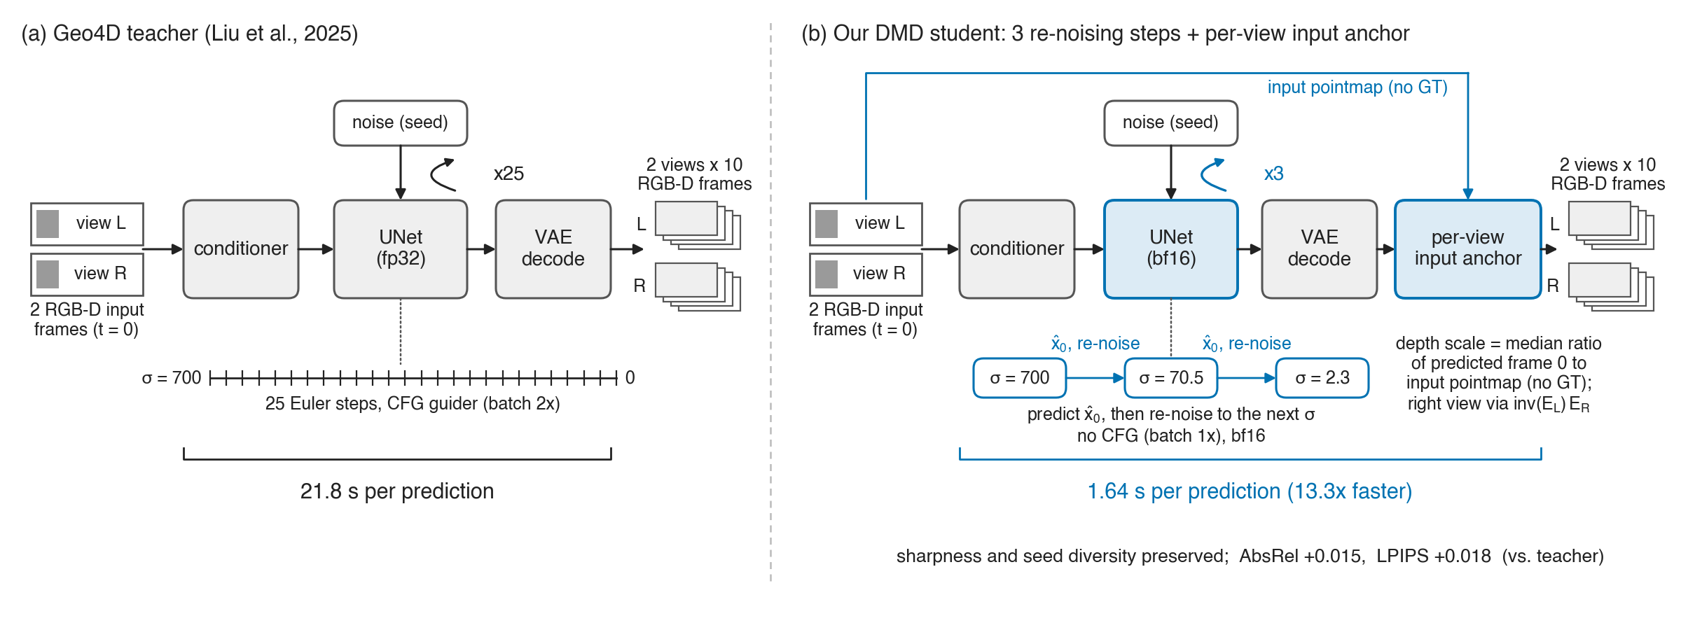
Figure 1: Overview of few-step distillation of Geo4D. The frozen 25-step Geo4D teacher is distilled into a three-step student with distribution matching distillation in EDM sigma space; the student is sampled by predicting x₀ and re-noising to the next sigma, and a per-view scale anchored to the conditioning pointmap corrects the remaining global depth scale shift at inference time.
On 20 samples (40 view-samples) of the PlaceAppleFromBowlIntoBin task, the three-step student runs in 1.64 s on one RTX 5090, 13.3x faster than the 21.8 s teacher, and meets the 2 s quasi-static budget (1.18 s with torch.compile, timed on 5 samples). Its sharpness (p=0.95) and seed diversity (p=0.84) are statistically indistinguishable from the teacher's, while AbsRel is higher by 0.015 (p<0.001) and LPIPS by 0.018 (p<0.001). The training-free three-step teacher is also fast (2.81 s in fp32) and keeps the teacher's AbsRel, but loses 47% of its seed diversity, and the one-step student halves diversity and raises LPIPS to 0.177; neither meets the quality bar. The humanoid and dynamic budgets remain open, because even with the compiled decoder 0.63 s of conditioner and decoder cost (0.98 s in the bf16 headline configuration) is independent of the number of steps.
In summary, our contributions are: (1) the first geometry-aware evaluation of few-step distillation for a multi-view RGB-D world model, with a protocol that measures per-view depth accuracy, perceptual quality, sharpness, seed diversity and cross-view consistency jointly and tests each difference against the teacher with paired statistics; (2) a set of evaluation findings and pitfalls: pixel metrics hide few-step collapse, the metrics collapse in a fixed order, a cross-view chamfer distance rewards consistent errors, and on average 53% (35-55% per sample) of the right-view ground-truth pixels produced by the released dataset transform are transformed invalid pixels that distort depth metrics unless masked; (3) an input-anchored per-view depth calibration that requires no ground truth, reduces the student's AbsRel from 0.175 to 0.082 against a teacher value of 0.066, and also improves the teacher; (4) two negative results, ODE-regression initialization and ground-truth-supervised cross-view geometry loss under DMD, together with a three-step student that is 13.3x faster than Geo4D with teacher-level sharpness and diversity.

2 Related Work
Video generation for robot world models. Video diffusion models have been used as visual world models for manipulation: the model predicts future frames from the current observation, and actions are read off the predicted frames. Dreamitate (Liang et al., 2024) uses a fine-tuned video generation model as a visuomotor policy, whereas Diffusion Policy (Chi et al., 2023) and DP3 (Ze et al., 2024) predict actions directly from images or point clouds. Geo4D (Liu et al., 2025) extends Stable Video Diffusion (Blattmann et al., 2023) to generate RGB and pointmaps jointly for two views, with a cross-view alignment loss that places both pointmaps in the reference camera frame; it samples with the EDM scheme (Karras et al., 2022) and classifier-free guidance (Ho & Salimans, 2022). On the PlaceAppleFromBowlIntoBin task in the LBM simulator (Toyota Research Institute, 2025) it reaches a success rate of 0.53 against 0.10 for Dreamitate and 0.00 for DP and DP3; its stated limitation is inference time, about 30 s per 10 frames on an RTX 4090. DreamDojo (Gao et al., 2026) and RoboWorld (Jeon et al., 2026) accelerate robot world models to 10.8 and 15.3 FPS, but neither evaluates multi-view geometry.
Few-step diffusion and distillation. Progressive distillation (Salimans & Ho, 2022) halves the number of sampling steps repeatedly, and consistency models (Song et al., 2023) map any point on the probability-flow ODE to its endpoint. Distribution matching distillation (DMD; Yin et al., 2024a) trains a one-step generator by matching the score of its output distribution to the teacher's; DMD2 (Yin et al., 2024b) removes the regression term and adds multi-step backward simulation. For video, CausVid (Yin et al., 2025), Self-Forcing (Huang et al., 2025) and Causal Forcing (Zhu et al., 2026) distill bidirectional teachers into few-step autoregressive students; Seaweed-APT (Lin et al., 2025) adds adversarial post-training toward one step; MAGI-1 (Sand.ai, 2025) and StreamDiT (Kodaira et al., 2025) target streaming generation. These works target RGB video quality and speed; none of them evaluates depth or cross-view consistency, the quantity a geometry-aware world model exists to provide. We apply DMD with DMD2-style backward simulation to Geo4D and evaluate depth error, cross-view consistency, LPIPS, sharpness and seed diversity with paired tests (Wilcoxon, 1945).
Training-free acceleration and evaluation of geometry. Orthogonal to distillation, TeaCache (F. Liu et al., 2025) and MagCache (Ma et al., 2025) reuse features across adjacent denoising steps, and SVDQuant (Li et al., 2025) quantizes the diffusion model. Caching gains shrink once few steps remain to share; quantization still applies after distillation and is left as future work. Evaluating few-step samplers is itself delicate. Blau & Michaeli (2018) show that distortion metrics such as PSNR favor the conditional mean, so a blurred sample can score higher than a sharp one, while LPIPS (Zhang et al., 2018) penalizes the blur. We observe the same effect in RGB-D: PSNR rises as the step count falls while diversity, LPIPS and cross-view geometry degrade, which motivates the metric set in Section 4.

3 Method
We take the released Geo4D model as a fixed teacher and ask how few denoising steps it can run in while keeping its multi-view geometry usable. Figure 1 gives an overview: a few-step sampler (Section 3.2), distillation (Section 3.3), a training-free depth calibration (Section 3.4), and the inference-path changes (Section 3.5).

3.1 Preliminaries: Geometry-Aware 4D Video Diffusion
Geo4D (Liu et al., 2025) is a latent video diffusion model built on Stable Video Diffusion (Blattmann et al., 2023). Given one RGB-D frame per view for two camera views, it generates 10 future RGB-D frames for both views. Each frame is a color image and a pointmap, and the pointmaps of both views are expressed in the frame of the left (reference) camera; no camera poses are given at inference. The latent of one sample has shape (2 views × 10 frames, 8 channels, 32 × 40) for 256 × 320 images, with 4 channels for the pointmap and 4 for color. We write x for this latent and c for the conditioning.
The denoiser follows the EDM parameterization (Karras et al., 2022). For a noisy latent x_σ = x₀ + σ ε, ε ~ N(0, I), the network F_θ is wrapped as
(1)
an estimate of the clean latent x₀. The released sampler is a 25-step Euler integration of the probability-flow ODE from σₘₐₓ = 700 with classifier-free guidance (Ho & Salimans, 2022) whose scale rises linearly from 1.0 to 2.5, so each step evaluates the UNet on a conditional and an unconditional batch (40 view-frames per sample).
One factual note on the released architecture: Geo4D builds the right-view UNet by shallow-copying the left one and deep-copying only its output blocks, but the shallow copy shares the module dictionary, so the new output blocks are written back into the original and the two views share all weights (all 795 output-block keys in the checkpoint are identical). The right view differs only through the spatial context it receives from the left view's hidden states and its own conditioning latent. Distilling the model therefore means distilling one UNet.

3.2 Few-Step Sampling by Re-noising
We use three noise levels, σ ∈ 700, 70.5, 2.3, the teacher's four-step EDM schedule without the slot near σ = 0. At each level the network predicts x₀, and the sample is moved to the next level by adding fresh noise rather than by integrating the ODE:
(2)
with output x̂₀⁽³⁾. This is the multi-step rule of consistency models (Song et al., 2023) and DMD2 (Yin et al., 2024b). A few-step Euler integration accumulates discretization error along the trajectory, whereas Equation (2) only asks the network for the quantity it was trained to predict. Equation (2) alone, however, does not make a few-step sampler: a denoiser trained with the standard objective returns the conditional mean of x₀ given x_σ, and with few steps the output is this blurred, seed-independent mean (Blau & Michaeli, 2018). Section 4.2 confirms this on the teacher with either sampler. The student therefore has to be trained so that its x₀ prediction at high σ is a sample rather than a mean.

3.3 Distribution Matching Distillation for Multi-View RGB-D
We distill with distribution matching distillation (DMD; Yin et al., 2024a) in EDM sigma space. Three copies of the Geo4D UNet are involved: the student G_θ, the real score, which is the frozen teacher evaluated with its classifier-free guidance, and the fake score D_φ, a trainable copy of the teacher that is continually fit to the student's outputs with the denoising loss. For a student sample x̂₀ re-noised to x_σ = x̂₀ + σε at a random σ, the generator gradient is
(3)
where w(σ) is the per-sample normalization of Yin et al. (2024a) and the difference of the two x₀ estimates equals the fake-minus-real score difference up to σ². No ground-truth video enters the objective. Following DMD2 we train on the student's own trajectory: each update draws k ∈ 0, 1, 2, runs Equation (2) for k steps without gradient, and applies Equation (3) to the x₀ prediction at step k only, as in CausVid (Yin et al., 2025) and Self-Forcing (Huang et al., 2025).
Before DMD we tried to initialize the student by regressing it onto 284 (noise, final latent) pairs from the 25-step teacher, first with pseudo-trajectories x_σ = x₀ + σε (the loss fell from 0.45 to 0.22, but AbsRel became 3x worse and PSNR dropped 4.2 dB while CV-Chamfer improved by 31%, i.e. the two views agreed with each other and both were wrong), and then with the teacher's true intermediate states at σ = 700, 70.5, 2.3, where the loss terms at σ = 700 and 70.5 plateaued at 0.40 and the student produced a uniform fog, identical across seeds. Mean-squared regression from noise to sample converges to the conditional mean even with the true trajectory (Finding 4; cf. Causal Forcing, Zhu et al., 2026, App. C.2), so we keep the second variant only as the DMD initialization.
DMD has no validation loss, so every 100 updates we generate two fixed conditioning pairs and compute
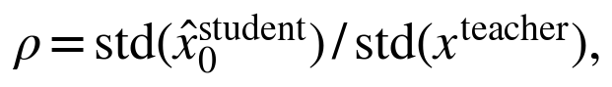 | (4)
the ratio of latent standard deviations; ρ < 1 indicates residual fog and ρ > 1 over-sharpening. In our run ρ rose from 0.79 at initialization to 0.99 (update 1000), 1.06 (1600) and 1.11 (2000); we take the checkpoint with ρ closest to 1, update 1600; update 2000, where ρ overshoots, evaluates worse (Finding 5).
To fit one 32 GB GPU, all three UNets are kept in bf16 (9.2 GB), the optimizer is 8-bit AdamW, the conditioning tensors are precomputed and held on the CPU, and the conditioner and VAEs are moved off the GPU. At batch size 1 the peak is 24.4 GB and 2000 updates take 1 h.

3.4 Input-Anchored Depth Calibration
After DMD the student matches the teacher in sharpness and seed diversity, but its depth is globally too far by about 9% (median scale to ground truth 0.909 versus 0.979 for the teacher), and fitting one scale and offset per sample removes 97% of its AbsRel gap. The error is a global shift, not broken structure (Figure 5), so we correct it with one scalar per view. Geo4D receives the conditioning frame's pointmap as input, and the first predicted frame should coincide with it, so we set
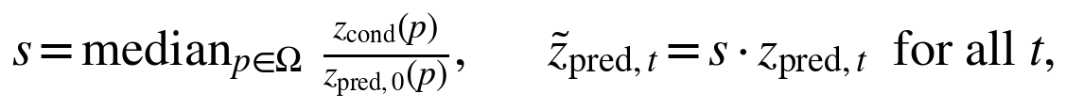 | (5)
where Ω is the set of conditioning-frame pixels with valid depth. No ground-truth future frame is used; on the left view s agrees with the oracle scale fitted to ground truth to three decimals.
The right view needs its own anchor. Its conditioning pointmap is in the right camera frame while the prediction is in the reference frame, so we transform it with T = E_L⁻¹ E_R from the dataset extrinsics before computing s for that view (the transformed frame matches ground-truth frame 0 to AbsRel 0.001 and 0.006 on two checked samples). A scale-plus-offset variant fitted per view gave no further gain (Section 4.5). The same anchor also reduces the teacher's AbsRel (Finding 12), so it is a property of the input rather than a repair specific to the student.

3.5 Inference Path
The student is sampled with Equation (2) without classifier-free guidance, so the unconditional branch is dropped from the conditioner and the UNet batch; each UNet call processes 20 view-frames instead of 40. The released inference code ran the UNet in fp32 although training was in bf16; we run the UNet, conditioner, and VAE decoders under bf16 autocast, which changed AbsRel and LPIPS by less than 0.001 on 20 samples (Section 4.4). Optionally the UNet and decoders are compiled with torch.compile, and when only depth is needed for planning the color decoder is skipped. Table 3 reports the time of each variant.

4 Experiments

4.1 Setup
Task and data. We evaluate on Task 3 of Geo4D (Liu et al., 2025), PlaceAppleFromBowlIntoBin, a bimanual task in which the left arm lifts an apple out of a bowl and hands it to the right arm, which places it in a bin. We use the simulation data released with Geo4D, recorded in the Drake-based LBM environment (Toyota Research Institute, 2025): 4 inference episodes (218 frames) from 4 cameras (scene_13 to scene_16), stride 5, one conditioning frame and 10 predicted frames at 256 × 320, two cameras drawn at random per sample. The teacher is the public Geo4D checkpoint throughout.
Protocol. Final numbers use 20 samples, i.e. 40 view-samples, with fixed data seed 1234 and generation seed 0. Differences are tested with a paired Wilcoxon signed-rank test (Wilcoxon, 1945) over the 40 view-samples. Seed diversity is measured on the first 3 samples, each generated with seeds 0 to 3. Early sweeps used 10 samples and are marked as such.
Metrics. PSNR is computed on RGB in [0, 1]. AbsRel is the absolute relative error of predicted depth z in meters under a valid-pixel mask. LPIPS uses the AlexNet backbone (Zhang et al., 2018). Sharpness is the variance of the Laplacian of the gray image, read relative to the teacher. Diversity is the per-pixel standard deviation across the 4 seeds, averaged over pixels. CV-Chamfer is the symmetric Chamfer distance between the point clouds predicted for the two views, both in the reference camera frame. Lower is better, but the metric is scale dependent and rewards two views that are wrong in the same way, so we never read it alone (Section 4.5).
Fake-pixel mask. The Geo4D data pipeline transforms the right-view pointmap into the reference frame including invalid pixels with xyz = 0. After the transform these pixels equal the camera-to-camera translation t (z between 0.18 and 0.65 m), so they pass a z > 0 mask although they carry no geometry; 35% to 55% of right-view ground-truth pixels (53% on average) are of this kind. Excluding pixels with |xyz_gt - t| < 2 · 10⁻³ changes the teacher's right-view AbsRel from 0.418 to 0.064. All final numbers exclude these pixels; the left view is not transformed and needs no correction.
Timing and hardware. Pure inference time covers the conditioner, the sampler, and the decoding of the generated latents only. Our earlier measurements (25.4 s teacher, 5.8 s student) included 2.9 s of evaluation-only work (an extra UNet call for the evaluation loss, ground-truth decoding and encoding, and a duplicated conditioner call). All times below are pure inference times unless stated otherwise, measured on a single RTX 5090 (32 GB), the only GPU used in this work.

4.2 Few-Step Sampling Without Training
Reducing the number of Euler steps is the simplest way to make the teacher faster. Table 2 reports the sweep from 25 to 1 step on 10 samples, and Figure 2 plots each metric against the step count. It was run before the fake-pixel mask existed, so the right-view part of CV-Chamfer is contaminated and we use the table for trends only; the times include evaluation overhead. PSNR rises from 19.75 dB at 25 steps to 20.64 dB at 1 step (peaking at 20.66 dB at 2 steps), while CV-Chamfer worsens from 0.176 to 0.194. Between the endpoints, LPIPS increases by 20.7% (0.1222 to 0.1474), sharpness decreases by 12.5%, and seed diversity decreases by 77% (0.0188 to 0.0043).
Table 2: Training-free step reduction of the Geo4D teacher (Euler, 10 samples, pre-maskfix). Fewer steps raise PSNR while LPIPS and diversity degrade; CV-Chamfer degrades below 4 steps. LPIPS and diversity were measured at the two endpoints only.

steps | s/sample | PSNR ↑ | CV-Chamfer ↓ | LPIPS ↓ | diversity
25 | 25.8 | 19.75 | 0.1758 | 0.1222 | 0.0188
8 | 11.4 | 20.06 | 0.1692 | — | —
4 | 7.9 | 20.35 | 0.1796 | — | —
2 | 6.4 | 20.66 | 0.1919 | — | —
1 | 5.4 | 20.64 | 0.1943 | 0.1474 | 0.0043

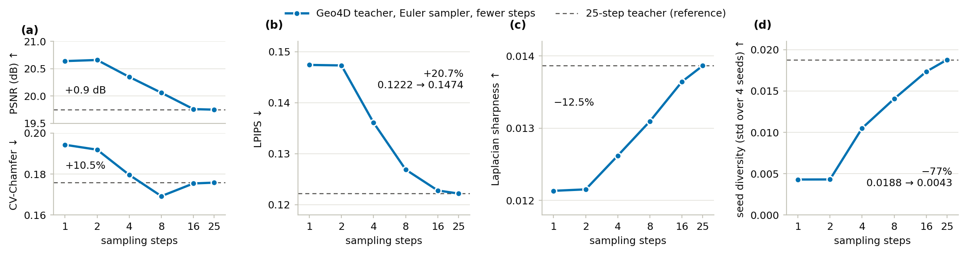
Figure 2: Metrics against step count for the training-free teacher. PSNR improves as steps are removed while diversity, LPIPS, sharpness, and CV-Chamfer degrade, each starting at a different step count; the dashed line marks the 25-step value.
The metrics do not collapse together. Diversity degrades first, from 8 steps; LPIPS from 4 steps; geometry from 2 steps; PSNR never. The rise in PSNR is the perception-distortion trade-off of Blau & Michaeli (2018): with few steps the sampler returns something close to the conditional mean, a blurred average that a pixel-wise metric prefers, and the static background dominates the image. At 1 step the background stays sharp, only the moving arm becomes a translucent smear, and the 4 seeds produce the same image. The ratio of CV-Chamfer to the Chamfer distance between the two ground-truth views is about 2.0 at every step count, consistent with the mIoU of 0.56 to 0.70 that Liu et al. (2025) report; it is a property of the released model, not of the step reduction.

4.3 Distillation Results
Table 1 compares the teacher, its training-free few-step variants, the ODE-regression initialization, and the DMD student on the 20-sample protocol. Figure 4 shows qualitative results and Figure 5 the relative depth error maps.
Table 1: Multi-view 4D video generation results. 20 samples (40 view-samples), data seed 1234, fake pixels excluded, diversity measured on 3 samples × 4 seeds. AbsRel is averaged over both views, with left/right in parentheses where measured separately.

method | training | steps | pure inference | PSNR ↑ | AbsRel ↓ (L/R) | LPIPS ↓ | sharpness | diversity | CV-Chamfer ↓
Geo4D teacher (Euler) | none | 25 | 21.80 s | 20.62 | 0.066 (0.067/0.066) | 0.118 | 0.0134 | 0.0227 | 0.169
teacher, fewer steps (Euler) | none | 4 | 4.84 s | 21.22 | 0.064 | 0.132 | 0.0121 | 0.0131 | 0.165
teacher, fewer steps (re-noising) | none | 3 | 2.81 s | 21.30 | 0.066 | 0.132 | 0.0119 | 0.0120 | 0.167
ODE regression init (v2) | regression | 4 | 7.9 s* | 14.42 | 0.547 | — | fog | seeds identical | 0.137
DMD student + per-view anchor (bf16) | DMD | 3 | 1.64 s | 20.43 | 0.082 (0.076/0.088) | 0.136 | 0.0136 | 0.0224 | 0.137
DMD student + per-view anchor | DMD | 1 | 1.65 s* | 20.56 | 0.116 | 0.177 | 0.0107 | 0.0117 | 0.165

\* v2 time includes evaluation overhead; the 1-step time is fp32. Sharpness is reported relative to the teacher.
DMD training. The student is initialized from the ODE-regression model v2 (Section 4.5) and trained with DMD (Yin et al., 2024a) for 2000 steps in 1 h at a peak of 24.4 GB. Figure 3 plots the training diagnostic: every 100 steps we generate 2 fixed pairs and compute the ratio of the standard deviation of the student's x₀ prediction to that of the teacher latent (1.0 is teacher level, lower is fog). The ratio rises from 0.79 at step 0 to 0.87 (400), 0.99 (1000), 1.06 (1600), and 1.11 (2000). We select the checkpoint closest to 1.0, step 1600; step 2000 overshoots and evaluates worse. At step 1600 the fog of v2 is gone (10-sample pre-maskfix protocol: PSNR 19.63 dB and AbsRel 0.201 against 14.42 dB and 0.547 for v2).
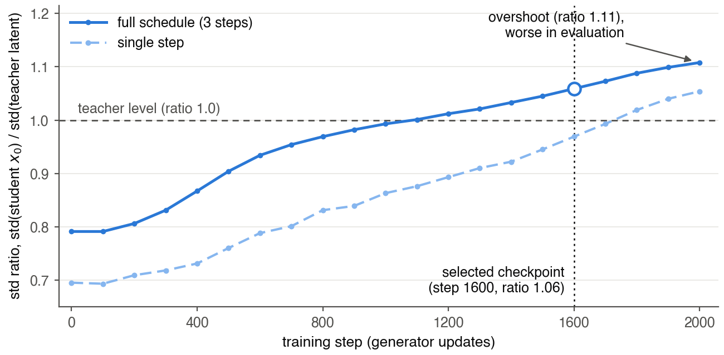
Figure 3: DMD training diagnostic. The ratio of student to teacher latent standard deviation rises from 0.79 to 1.11 over 2000 steps; the checkpoint closest to 1.0 (step 1600) is selected.
Raw student. Before calibration, the paired 20-sample comparison shows the student is 3% sharper than the teacher (p=0.024) with equal diversity (p=0.06), but its AbsRel is about twice the teacher's on every sample. An affine scale-and-offset fit to ground-truth depth removes 97% of the gap: the error is a global scale shift, not broken structure. The student predicts depth about 9% too far (median scale 0.909 versus 0.979 for the teacher) and its error maps in Figure 5 are spatially uniform. The input anchor of Section 3.4 reduces the raw 3-step AbsRel of 0.175 to 0.082 without ground truth (Section 4.5).
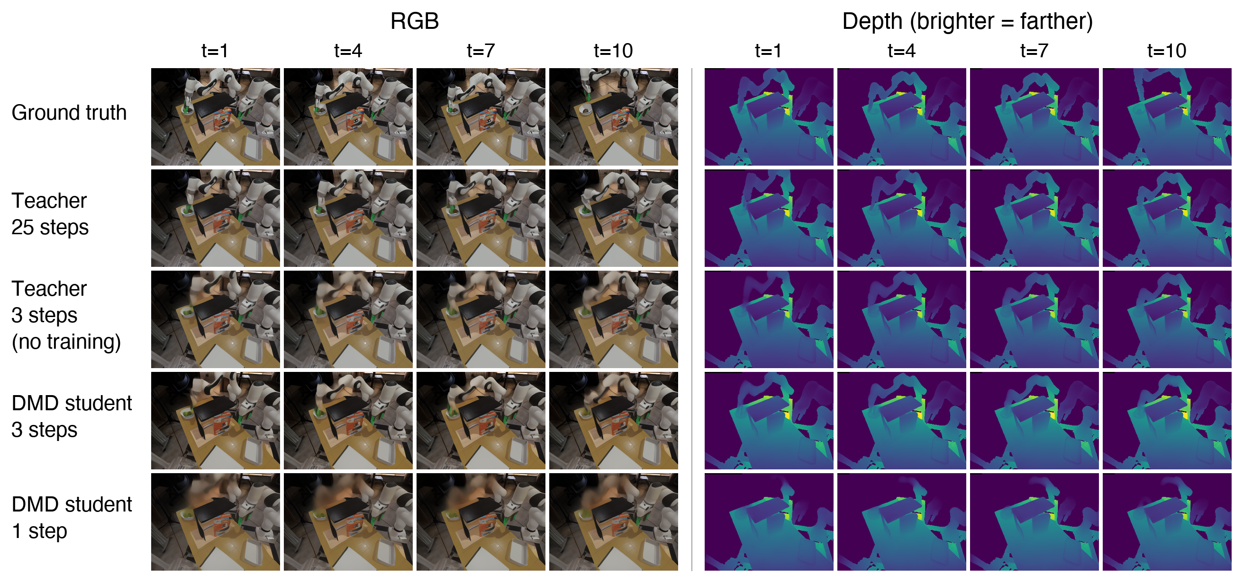
Figure 4: Qualitative results, left view. Rows: ground truth, 25-step teacher, training-free 3-step re-noising teacher, 3-step DMD student, 1-step DMD student, at predicted frames 1, 4, 7, and 10; RGB on the left, depth on the right. The 25-step teacher and the 3-step DMD student keep a sharp moving arm, whereas the training-free 3-step teacher and the 1-step student render it as a translucent smear while the static background stays sharp.
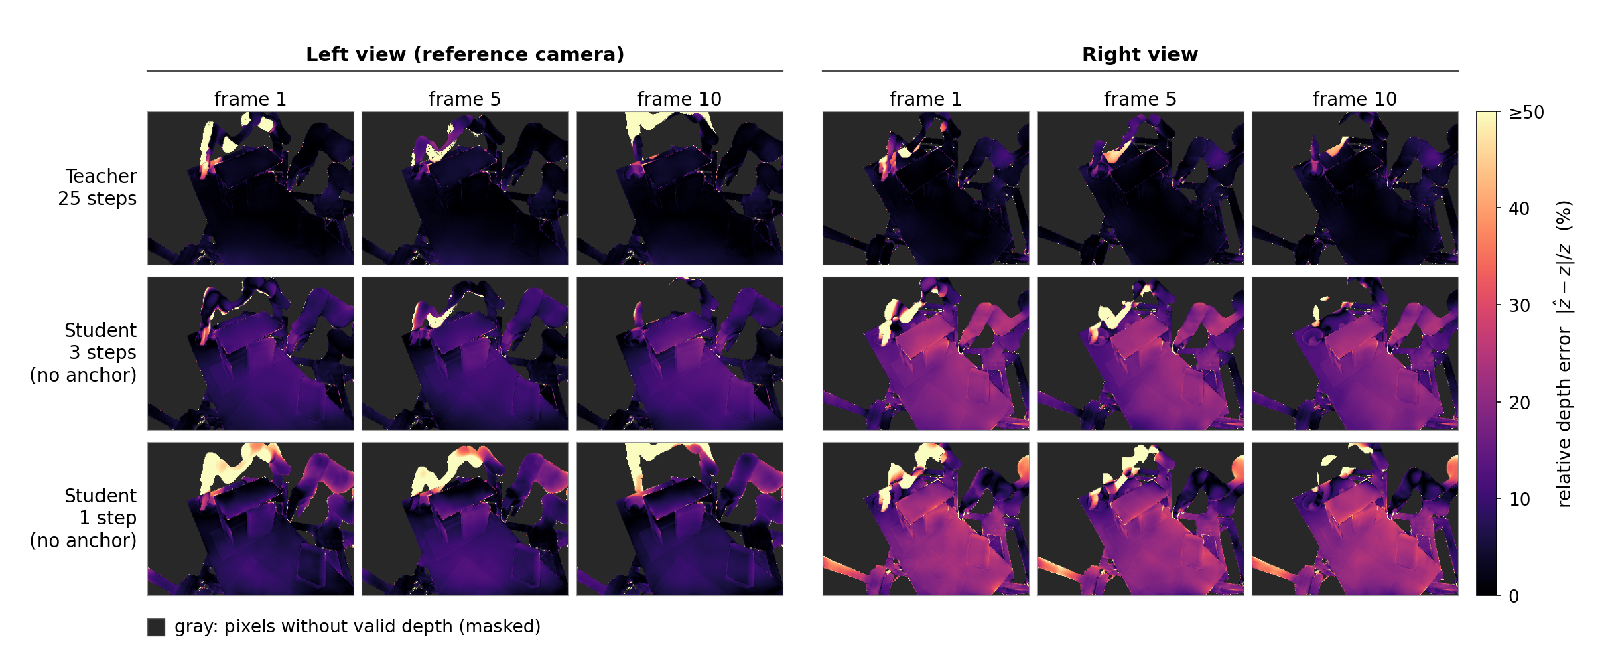
Figure 5: Relative depth error maps for both views. Rows: 25-step teacher, 3-step student, 1-step student, all without the anchor, at predicted frames 1, 5, and 10; brighter is larger error, gray marks pixels without valid depth. The student's error is a spatially uniform tint over the whole scene, stronger in the right view and at 1 step, which is what a global depth scale shift looks like and what the anchor removes; the arm and edge errors are shared with the teacher.
Anchored student versus teacher. Paired over the 40 view-samples, the 3-step student differs from the 25-step teacher by −0.19 dB PSNR (p=0.026), +0.015 AbsRel (p<0.001; left +0.008, right +0.022), and +0.018 LPIPS (p<0.001). Sharpness (+0.0001, p=0.95) and diversity (−0.0004, p=0.84) are indistinguishable from the teacher, and CV-Chamfer is lower by 0.034 (p=0.006).
Training-free versus distilled. The essential control is the 3-step re-noising teacher in Table 1. It keeps AbsRel at 0.066 and has a higher PSNR (21.30 dB), but its diversity drops by 47% (0.0227 to 0.0120) and its sharpness falls below the teacher's; its 4 seeds produce the same image and the arm is smeared (Figure 4), as in Section 4.2. The 4-step Euler teacher behaves the same way. The DMD student restores diversity (0.0224) and sharpness (0.0136) to the teacher's level at the cost of +0.015 AbsRel and +0.018 LPIPS. This is a trade-off, not a free improvement: if only a point estimate of depth is needed, the training-free few-step teacher is adequate. A world model used for planning must sample several futures and rank them, which a sampler whose seeds all return the same blurred average cannot do; for that use the distilled student is the only few-step option that keeps what the teacher offers.

4.4 Inference Time
Table 3 breaks pure inference time into UNet, conditioner, and VAE decoding; Figure 6 plots each configuration against its inference time, and Figure 7 shows the breakdown. In fp32 the 25-step teacher takes 21.75 s, of which 20.13 s is the UNet; the 3-step student takes 2.81 s. The student's UNet costs 0.40 s per call against 0.81 s for the teacher because it runs without classifier-free guidance (Ho & Salimans, 2022), a batch of 20 rather than 40. The remaining 1.6 s (conditioner 0.73 s, decoding 0.88 s) are fixed costs that the step count does not touch.
Table 3: Pure inference time (s) and acceleration variants. Upper block: fp32 breakdown on the eval-free path. Lower block: variants applied cumulatively to the 3-step student, 5 samples with the same seed; AbsRel (L/R) checks for quality drift.

configuration | UNet | conditioner | VAE decode | total | AbsRel L/R
teacher, Euler 25 steps (CFG, batch 40), fp32 | 20.13 | 0.73 | 0.89 | 21.75 | —
teacher, Euler 4 steps, fp32 | 3.22 | 0.73 | 0.89 | 4.83 | —
student, re-noising 3 steps, fp32 | 1.19 | 0.73 | 0.88 | 2.81 | —
student, re-noising 1 step, fp32 | 0.40 | 0.73 | 0.88 | 2.01 | —
student 3 steps, fp32, unconditional branch omitted | 1.18 | 0.30 | 0.90 | 2.38 | 0.107 / 0.099
+ VAE decoder bf16 | 1.18 | 0.30 | 0.68 | 2.16 | 0.108 / 0.099
+ UNet and conditioner bf16 | 0.66 | 0.30 | 0.68 | 1.64 | 0.106 / 0.099
+ torch.compile (decoder) | 0.66 | 0.30 | 0.33 | 1.29 | 0.105 / 0.098
+ torch.compile (UNet) | 0.55 | 0.30 | 0.33 | 1.18 | 0.112 / 0.094
+ skip color decoder (depth-only use) | 0.55 | 0.30 | 0.16 | 1.02 | —

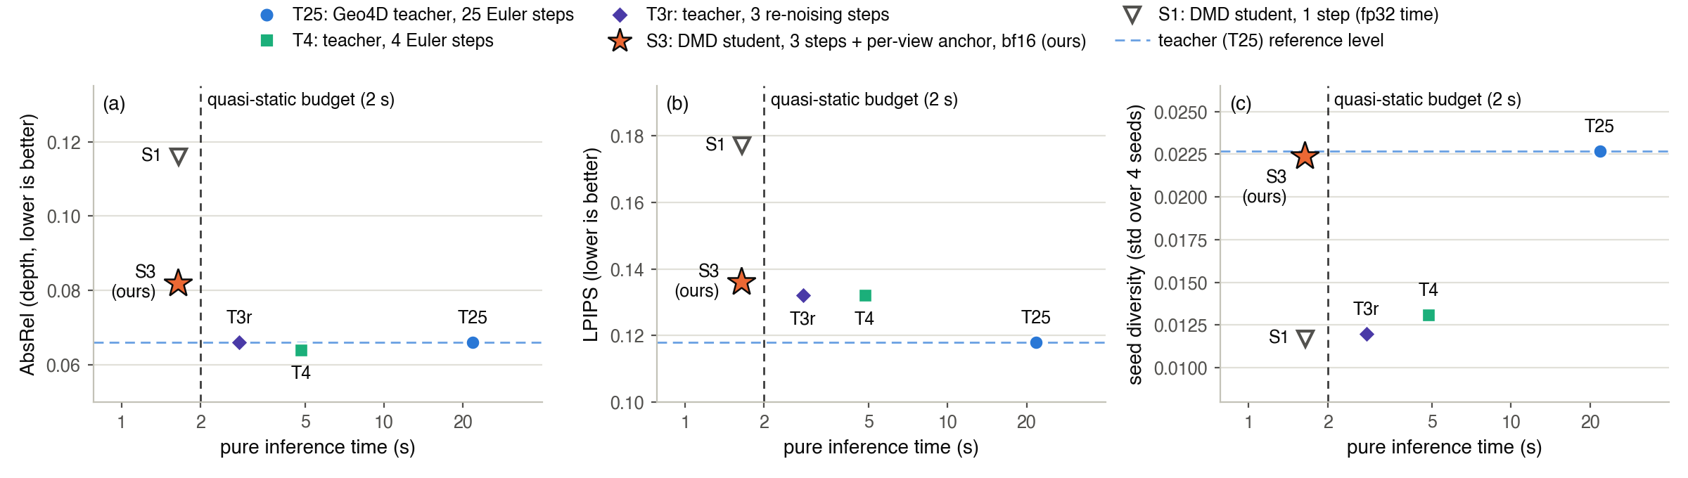
Figure 6: Speed against quality. AbsRel, LPIPS, and diversity of each configuration against pure inference time; the DMD student is the only few-step point that keeps the teacher's diversity.
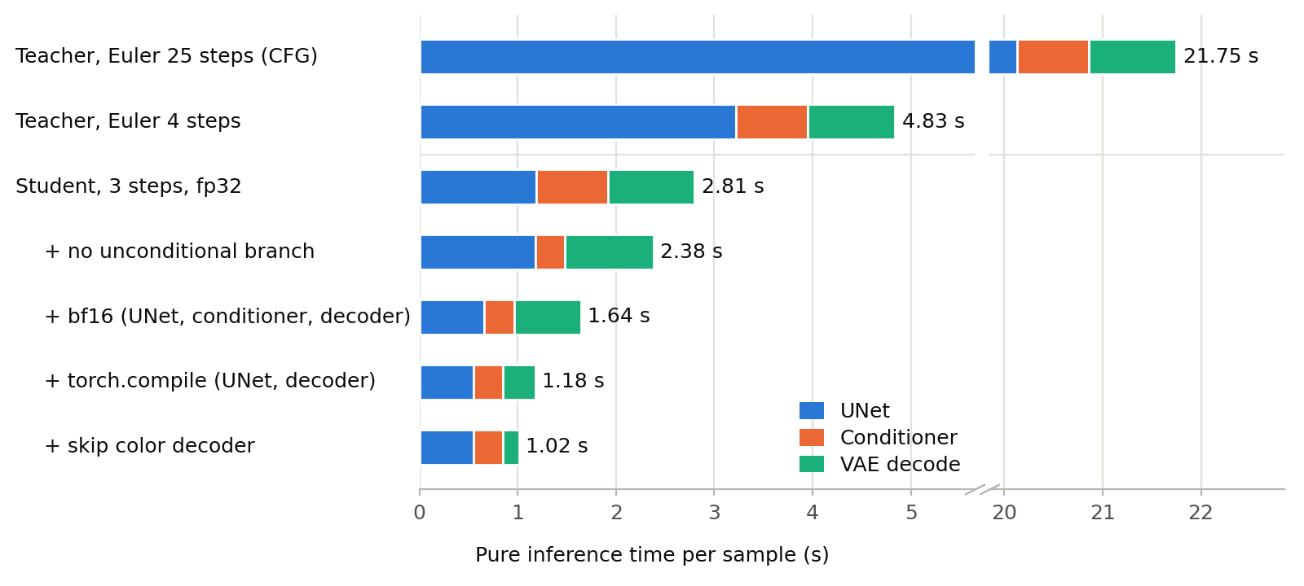
Figure 7: Pure inference time breakdown. UNet, conditioner, and decoder time for the teacher and each student variant; once the UNet is fast, the fixed cost of conditioner and decoder becomes the bottleneck.
The largest single saving comes from precision. The released inference path runs the UNet in fp32 although the model was trained in bf16; casting the UNet and conditioner to bf16 takes the student from 2.16 s to 1.64 s. On the 20-sample protocol bf16 is lossless (AbsRel 0.0813 to 0.0819, LPIPS 0.1360 to 0.1357, diversity identical), so 1.64 s is the student time in Table 1, a 13.3x reduction from the teacher's 21.80 s. torch.compile on the decoder and then the UNet reaches 1.18 s on 5 samples. The compiled UNet was verified on all 20 samples: relative to the teacher, AbsRel +0.016 (p<0.001), LPIPS +0.018 (p<0.001), sharpness +0.0002 (p=0.69), diversity −0.0003 (p=1.00), at about 1.5 s in the evaluation harness. The compiled decoder could not be run in the evaluation path (the sgm VideoDecoder sets a timesteps attribute on the module at call time, which conflicts with the compile wrapper), so 1.18 s is verified on 5 samples only. Compiling the conditioner gives no gain; skipping the color decoder when only depth is needed gives 1.02 s.
Against the budgets of Section 1, the quasi-static target of 2 s is met (1.64 s, or 1.18 s with compilation). The humanoid target of 0.3 to 0.5 s and the dynamic target of 0.1 s are not met. The fixed cost of 0.63 s (conditioner 0.30 s, decoder 0.33 s) alone exceeds the humanoid budget, and the UNet (0.55 s for 3 calls) would have to shrink through quantization or lower resolution, which we leave to future work. DreamDojo (Gao et al., 2026) and RoboWorld (Jeon et al., 2026) report 10.8 and 15.3 FPS for robot world models without multi-view geometry evaluation, so their numbers are not comparable to ours.

4.5 Ablations and Negative Results
Input-anchored depth calibration. Table 4 and Figure 8 isolate the anchor on the 10-sample protocol with the fake-pixel mask. For the left view the anchor scale computed from the conditioning pointmap equals the ground-truth oracle scale to three decimals, and the left AbsRel moves from 0.146 to 0.086 against 0.080 for the teacher (p=0.43). The right view needs its own anchor, because its conditioning pointmap is in the right camera frame while predictions are in the reference frame; transformed with the dataset extrinsics, it matches ground-truth frame 0 to an AbsRel of 0.001 and 0.006 on the first two samples. With a per-view anchor the student reaches 0.086 on both views from a raw 0.146 / 0.205; an affine variant with scale and offset gave no further gain. The anchor also improves the teacher, from 0.072 to 0.060, so part of the teacher's own error is a global scale shift. On 20 samples the student's AbsRel goes from 0.175 to 0.082 (Table 1).
Table 4: Anchor ablation (AbsRel, 10 samples, fake pixels excluded; mean over both views). The per-view anchor closes most of the gap between the raw student and the teacher, and also improves the teacher; adding an offset to the scale gives no further gain.

configuration | left | right | mean
teacher, 25 steps | 0.080 | 0.064 | 0.072
teacher, 25 steps + per-view anchor | 0.068 | 0.052 | 0.060
student, 3 steps, raw | 0.146 | 0.205 | 0.175
student, 3 steps + per-view anchor (scale) | 0.086 | 0.086 | 0.086
student, 3 steps + per-view anchor (scale and offset) | 0.089 | 0.081 | 0.085

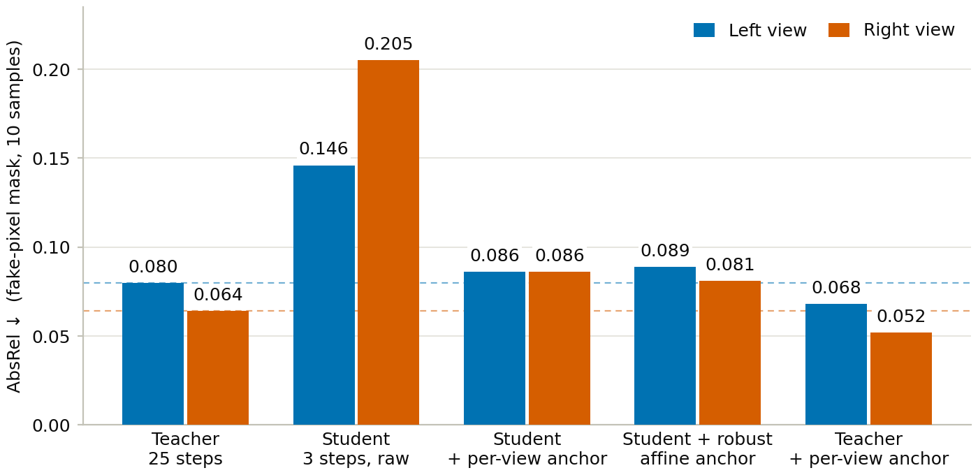
Figure 8: Input-anchored calibration. Per-view AbsRel (10 samples, fake pixels excluded) of the 25-step teacher, the raw 3-step student, the student with the per-view anchor, the student with the scale-plus-offset anchor, and the teacher with the per-view anchor; dashed lines mark the unanchored teacher. The anchor needs only the conditioning pointmap.
ODE regression initialization. Regressing the student from noise to the teacher's 25-step output, using 284 (noise, final latent) pairs (142 samples × 2 seeds), failed in two forms. Version v1 regressed on pseudo-trajectories x_σ = z + σ ε for 300 steps; the loss fell from 0.45 to 0.22 and CV-Chamfer improved by 31%, but AbsRel became three times worse and PSNR fell by 4.2 dB: the two views agreed with each other and were both wrong, the cross-view metric trap of Section 4.1. Version v2 regressed on real intermediate states captured at σ = 700, 70.5, and 2.3 for 1200 steps; the σ = 2.3 term fit, the two high-noise terms plateaued at 0.40, and the output was global fog with 4 identical seeds (PSNR 14.42 dB, AbsRel 0.547, CV-Chamfer 0.137 on 10 samples). Mean-squared regression from noise to sample converges to the mean even with true trajectories, as also observed in Appendix C.2 of Causal Forcing (Zhu et al., 2026); v2 served only as the DMD initialization.
GT-supervised cross-view depth-ratio loss. We added to DMD a log error between the ratio of mean view depths r = z̄_R / z̄_L and a target ratio, decoding one frame through the pointmap VAE in bf16 with gradient checkpointing (four frames in fp32 ran out of memory). The weight was balanced at the x₀-gradient level, λ = β |g_DMD| / |g_cv|; a fixed λ = 1 made the cross-view gradient 500 times the DMD gradient and erased distillation. Table 5 summarizes the three runs; all lost sharpness. A supervision signal that contradicts the teacher distribution fights the distillation objective, whereas the input-only anchor, which never enters training, does not. The target in 6b2 and 6b3 was the contaminated right-view ground truth of Section 4.1, so whether a clean target also conflicts is unverified. A self-anchor loss that matches predicted frame-0 depth to the conditioning depth without ground truth is implemented and training is in progress at the time of writing; we report no result for it.
Table 5: GT-supervised cross-view depth-ratio loss added to DMD. None of the three runs improved the depth ratio without losing sharpness.

run | target | β | outcome
6b | teacher r | 1 | r unchanged through 1000 steps, sharpness recovery slowed
6b2 | GT r | 10 | r overshoots target, sharpness stalls
6b3 | GT r | 3 | r regresses to dataset mean; finished 2000 steps; eval PSNR −3.5 dB, LPIPS 0.36 (collapse)

One-step student. With a single re-noising step (Table 1) the same student reaches AbsRel 0.116 and LPIPS 0.177, and its diversity halves to 0.0117, the level of the training-free few-step teacher. It saves 0.79 s of UNet time in fp32 (Table 3) but does not meet the quality bar, so we do not use it.

5 Limitation
All measurements come from one task (PlaceAppleFromBowlIntoBin), four inference episodes, 20 samples (40 view-samples), and one RTX 5090; the absolute numbers may not transfer to other tasks or to real robot data. The 3-step student is not equal to the teacher: AbsRel is 0.015 higher (p<0.001; 0.022 on the right view) and LPIPS 0.018 higher (p<0.001), and the per-view anchor reduces but does not remove the right-view gap. The 1-step student halves diversity (0.0117) and raises LPIPS to 0.177, so it does not meet our quality bar. Only the quasi-static budget of 2 s is met. The humanoid (0.3-0.5 s) and dynamic (0.1 s) budgets are not, because the conditioner (0.30 s) and VAE decoders (0.33 s) form a fixed cost of 0.63 s that step reduction cannot touch, and the three UNet calls still take 0.55 s; reducing these requires quantization such as SVDQuant (Li et al., 2025) or a lower resolution, which we did not try. We have no policy-level evaluation: Geo4D's closed-loop success rates (Liu et al., 2025, Table 2) require the LBM simulator, a pose tracker, and a policy interface that are not in the released code, so the claim that a faster model enables closed-loop planning remains untested (Appendix A.6). The components we use, DMD (Yin et al., 2024a; 2024b), re-noising few-step sampling, bf16, and torch.compile, are existing techniques; what is new is the geometry-aware measurement and the anchor. Finally, a self-anchor loss that applies the calibration during training is implemented but still training, and we report no results for it.

6 Conclusion
We asked whether the geometric consistency of a multi-view RGB-D world model survives few-step distillation. For Geo4D it does, with qualifications. Training-free step reduction keeps PSNR but loses diversity, perceptual quality, and geometry in a fixed order that pixel metrics do not show. Distribution matching distillation restores sharpness and diversity at three steps but shifts the predicted depth by a global scale, which a training-free, input-anchored calibration removes without ground truth. The resulting student produces a two-view, 10-frame RGB-D prediction in 1.64 s, 13.3x faster than the 21.80 s teacher, with AbsRel 0.082 against 0.066 and sharpness and diversity indistinguishable from the teacher. We also report that ODE regression initialization and GT-supervised geometry losses fail, that 53% of right-view ground-truth pixels in the released data are invalid, and that the two views of Geo4D share all UNet weights. We hope these measurements and pitfalls help in building world models that are both fast and geometrically reliable.

7 Ethics Statement
This work uses only the simulation data released with Geo4D (LBM, Drake-based); no human subjects, personal data, or real robot trials are involved. Faster video world models could in principle be misused to generate misleading video, but the model studied here produces 10 frames of a 256 × 320 robot manipulation scene from RGB-D input, and the work targets manipulation in simulation. We see no path to harmful use beyond that of the base model.

8 Reproducibility Statement
Code, training and evaluation scripts, configuration files, and the qualitative grids are released at https://github.com/taeyang0505/Few-Step-Distillation-of-Multi-View-RGB-D-World-Models. All experiments ran on a single RTX 5090 (32 GB). The teacher checkpoint is the public one released by the Geo4D authors; the student checkpoint corresponds to DMD step 1600. Evaluation uses data seed 1234 and generation seed 0, with seeds 0-3 for diversity. Runtimes: ODE pair generation about 2 h for 284 pairs; ODE regression v2 1200 steps; DMD 2000 steps in 1 h at a peak of 24.4 GB; inference 21.8 s per sample for the teacher and 1.64 s for the student.

References
Andreas Blattmann, Tim Dockhorn, Sumith Kulal, Daniel Mendelevitch, Maciej Kilian, Dominik Lorenz, Yam Levi, Zion English, Vikram Voleti, Adam Letts, Varun Jampani, and Robin Rombach. Stable video diffusion: Scaling latent video diffusion models to large datasets. arXiv preprint, 2023. arXiv:2311.15127.
Yochai Blau and Tomer Michaeli. The perception-distortion tradeoff. In Proceedings of the IEEE/CVF Conference on Computer Vision and Pattern Recognition (CVPR), 2018. arXiv:1711.06077.
Cheng Chi, Zhenjia Xu, Siyuan Feng, Eric Cousineau, Yilun Du, Benjamin Burchfiel, Russ Tedrake, and Shuran Song. Diffusion policy: Visuomotor policy learning via action diffusion. In Robotics: Science and Systems (RSS), 2023. arXiv:2303.04137.
Shenyuan Gao, William Liang, Kaiyuan Zheng, Ayaan Malik, Seonghyeon Ye, Sihyun Yu, Wei-Cheng Tseng, Yuzhu Dong, Kaichun Mo, Chen-Hsuan Lin, Qianli Ma, Seungjun Nah, Loic Magne, Jiannan Xiang, Yuqi Xie, Ruijie Zheng, Dantong Niu, You Liang Tan, K. R. Zentner, George Kurian, Suneel Indupuru, Pooya Jannaty, Jinwei Gu, Jun Zhang, Jitendra Malik, Pieter Abbeel, Ming-Yu Liu, Yuke Zhu, Joel Jang, and Linxi Fan. DreamDojo: A generalist robot world model from large-scale human videos. arXiv preprint, 2026. arXiv:2602.06949.
Jonathan Ho and Tim Salimans. Classifier-free diffusion guidance. arXiv preprint, 2022. arXiv:2207.12598.
Xun Huang, Zhengqi Li, Guande He, Mingyuan Zhou, and Eli Shechtman. Self Forcing: Bridging the train-test gap in autoregressive video diffusion. In Advances in Neural Information Processing Systems (NeurIPS), 2025. arXiv:2506.08009.
Byeongguk Jeon, Seonghyeon Ye, JaeHyeok Doo, Sungdong Kim, Minjoon Seo, Hyungmok Son, and Kimin Lee. RoboWorld: Fast and reliable neural simulators for generalist robot policy evaluation. arXiv preprint, 2026. arXiv:2607.01060.
Tero Karras, Miika Aittala, Timo Aila, and Samuli Laine. Elucidating the design space of diffusion-based generative models. In Advances in Neural Information Processing Systems (NeurIPS), 2022. arXiv:2206.00364.
Akio Kodaira, Tingbo Hou, Ji Hou, Markos Georgopoulos, Felix Juefei-Xu, Masayoshi Tomizuka, and Yue Zhao. StreamDiT: Real-time streaming text-to-video generation. arXiv preprint, 2025. arXiv:2507.03745.
Muyang Li, Yujun Lin, Zhekai Zhang, Tianle Cai, Xiuyu Li, Junxian Guo, Enze Xie, Chenlin Meng, Jun-Yan Zhu, and Song Han. SVDQuant: Absorbing outliers by low-rank components for 4-bit diffusion models. In International Conference on Learning Representations (ICLR), 2025. arXiv:2411.05007.
Junbang Liang, Ruoshi Liu, Ege Ozguroglu, Sruthi Sudhakar, Achal Dave, Pavel Tokmakov, Shuran Song, and Carl Vondrick. Dreamitate: Real-world visuomotor policy learning via video generation. arXiv preprint, 2024. arXiv:2406.16862.
Shanchuan Lin, Xin Xia, Yuxi Ren, Ceyuan Yang, Xuefeng Xiao, and Lu Jiang. Diffusion adversarial post-training for one-step video generation. In International Conference on Machine Learning (ICML), 2025. arXiv:2501.08316.
Feng Liu, Shiwei Zhang, Xiaofeng Wang, Yujie Wei, Haonan Qiu, Yuzhong Zhao, Yingya Zhang, Qixiang Ye, and Fang Wan. Timestep embedding tells: It's time to cache for video diffusion model. In Proceedings of the IEEE/CVF Conference on Computer Vision and Pattern Recognition (CVPR), 2025. arXiv:2411.19108.
Zeyi Liu, Shuang Li, Eric Cousineau, Siyuan Feng, Benjamin Burchfiel, and Shuran Song. Geometry-aware 4D video generation for robot manipulation. arXiv preprint, 2025. arXiv:2507.01099.
Zehong Ma, Longhui Wei, Feng Wang, Shiliang Zhang, and Qi Tian. MagCache: Fast video generation with magnitude-aware cache. In Advances in Neural Information Processing Systems (NeurIPS), 2025. arXiv:2506.09045.
Tim Salimans and Jonathan Ho. Progressive distillation for fast sampling of diffusion models. In International Conference on Learning Representations (ICLR), 2022. arXiv:2202.00512.
Sand.ai. MAGI-1: Autoregressive video generation at scale. arXiv preprint, 2025. arXiv:2505.13211.
Yang Song, Prafulla Dhariwal, Mark Chen, and Ilya Sutskever. Consistency models. In International Conference on Machine Learning (ICML), 2023. arXiv:2303.01469.
Toyota Research Institute (TRI LBM Team). A careful examination of large behavior models for multitask dexterous manipulation. arXiv preprint, 2025. arXiv:2507.05331.
Frank Wilcoxon. Individual comparisons by ranking methods. Biometrics Bulletin, 1(6):80-83, 1945.
Tianwei Yin, Michaël Gharbi, Richard Zhang, Eli Shechtman, Fredo Durand, William T. Freeman, and Taesung Park. One-step diffusion with distribution matching distillation. In Proceedings of the IEEE/CVF Conference on Computer Vision and Pattern Recognition (CVPR), 2024a. arXiv:2311.18828.
Tianwei Yin, Michaël Gharbi, Taesung Park, Richard Zhang, Eli Shechtman, Fredo Durand, and William T. Freeman. Improved distribution matching distillation for fast image synthesis. In Advances in Neural Information Processing Systems (NeurIPS), 2024b. arXiv:2405.14867.
Tianwei Yin, Qiang Zhang, Richard Zhang, William T. Freeman, Fredo Durand, Eli Shechtman, and Xun Huang. From slow bidirectional to fast autoregressive video diffusion models. In Proceedings of the IEEE/CVF Conference on Computer Vision and Pattern Recognition (CVPR), 2025. arXiv:2412.07772.
Yanjie Ze, Gu Zhang, Kangning Zhang, Chenyuan Hu, Muhan Wang, and Huazhe Xu. 3D diffusion policy: Generalizable visuomotor policy learning via simple 3D representations. In Robotics: Science and Systems (RSS), 2024. arXiv:2403.03954.
Richard Zhang, Phillip Isola, Alexei A. Efros, Eli Shechtman, and Oliver Wang. The unreasonable effectiveness of deep features as a perceptual metric. In Proceedings of the IEEE/CVF Conference on Computer Vision and Pattern Recognition (CVPR), 2018. arXiv:1801.03924.
Hongzhou Zhu, Min Zhao, Guande He, Hang Su, Chongxuan Li, and Jun Zhu. Causal Forcing: Autoregressive diffusion distillation done right for high-quality real-time interactive video generation. In International Conference on Machine Learning (ICML), 2026. arXiv:2602.02214.

A Appendix

A.1 Model and Sampler Details
Geo4D (Liu et al., 2025) is built on SVD (Blattmann et al., 2023) with the EDM parameterization (Karras et al., 2022). One sample is a latent of shape (2 views × 10 frames, 8 channels, 32 × 40) for 256 × 320 images, 4 latent channels for the pointmap and 4 for color. The teacher sampler is EulerEDM with 25 steps, σ_max = 700, and a linear classifier-free guidance guider from 1.0 to 2.5 (Ho & Salimans, 2022), so every step runs the UNet on a batch of 40 (20 conditional plus 20 unconditional).
Sigma schedule. The four-step EDM schedule with σ_max = 700 produced by the Geo4D sampler has sigmas 700, 70.5, 2.3, and a final slot near zero. The student uses the first three; the final slot corresponds to its x₀ output. The same sigmas are the intermediate states captured for the ODE regression v2 initialization.
Re-noising sampler. The student predicts x₀ at each sigma and is re-noised to the next sigma with fresh Gaussian noise; there is no Euler integration and no guidance.
sigmas = [700, 70.5, 2.3]
x = sigmas[0] * randn_like(z) # pure noise
for i, s in enumerate(sigmas):
x0 = D_student(x, s, c) # x0 prediction, no CFG
if i + 1 < len(sigmas):
x = x0 + sigmas[i + 1] * randn_like(x0) # re-noise to next sigma
return x0
Guidance. The CFG guider (1.0 to 2.5) is used only inside the teacher, at teacher inference and as the real-score network in DMD. The student runs without guidance, which is why a student UNet call costs 0.40 s in fp32 against 0.81 s for the teacher.

A.2 Dataset and Evaluation Details
Data. We use the four inference episodes (218 frames) of PlaceAppleFromBowlIntoBin from the LBM environment released by Geo4D, with four cameras (scene_13 to scene_16), stride 5, one conditioning frame followed by 10 predicted frames, and 256 × 320 images. Two cameras are sampled at random per sample with data seed 1234; the left camera is the reference frame.
Fake-pixel mask. The dataset transforms the right-view pointmap into the reference frame including invalid pixels with xyz = 0. After the transform these pixels equal the camera-to-camera translation t, with z between 0.18 m and 0.65 m, so they pass a z > 0 mask. Between 35% and 55% of right-view ground-truth pixels (53% on average) are of this kind. We exclude pixels with |gt_xyz - t| < 2e-3, which changes the teacher's right-view AbsRel from 0.418 to 0.064. The left view is not transformed, so its invalid pixels remain zero. All final numbers use this mask.
CV-Chamfer. The symmetric chamfer distance between the two views' predicted point clouds, both in the reference frame. It is scale dependent and rewards two views that are wrong in the same way (Finding 3). Its ratio to the chamfer distance between the two ground-truth clouds is about 2.0 regardless of the number of steps, consistent with the cross-view mIoU of 0.56-0.70 in Geo4D Table 1; this is a property of the released model, not of our samplers.
Seed diversity. For the first 3 samples we generate with seeds 0-3, compute the per-pixel standard deviation across seeds, and average it.
Statistics. All comparisons against the teacher are paired Wilcoxon signed-rank tests (Wilcoxon, 1945) over n = 40 view-samples with the same data and generation seeds.

A.3 Training Details
ODE pairs. 284 (noise, final latent) pairs were generated from the 25-step teacher (142 dataset samples × 2 seeds) in about 2 h. The v2 regression initialization was trained for 1200 steps on intermediate states at σ = 700, 70.5, and 2.3; the σ = 2.3 term fits while the other two plateau at 0.40.
DMD. The generator is the v2-initialized student, the real score is the frozen teacher with its CFG guider, and the fake score is a trainable copy of the teacher. The DMD loss (Yin et al., 2024a) is expressed in EDM sigma space with DMD2-style backward simulation (Yin et al., 2024b): a random k in {0, 1, 2} student steps are run and only the last x₀ prediction receives gradient. Training runs 2000 steps at batch 1 in 1 h. To fit 32 GB, all three UNets are in bf16 (9.2 GB), the optimizer is AdamW8bit, the conditions (c, uc) are precomputed on CPU, and the conditioner and VAEs are moved off the GPU; peak memory is 24.4 GB. Every 100 steps we generate two fixed pairs and record std(student x₀) / std(teacher latent), which selects step 1600.
Cross-view loss. The GT-supervised depth-ratio loss is the log error of r = mean(z_R) / mean(z_L) against the teacher's or the ground-truth ratio. It decodes one frame through the pointmap VAE in bf16 with gradient checkpointing (four frames in fp32 ran out of memory). Its weight is set at the x₀-gradient level as λ = β |g_DMD| / |g_cv|; a fixed λ = 1 made the cross-view gradient 500x the DMD gradient and erased the DMD signal.

A.4 Additional Results and Findings
The numbered findings from the experiment log are: (1) fewer steps raise PSNR but worsen LPIPS, diversity, and geometry; (2) collapse order is diversity, LPIPS, geometry, then PSNR; (3) CV-Chamfer rewards two views wrong in the same way and must not be used alone; (4) MSE regression initialization converges to the mean even with true trajectories, consistent with Causal Forcing (Zhu et al., 2026, App. C.2); (5) DMD restores sharpness and diversity within about 400 updates and the std ratio selects the checkpoint; (6) "the teacher right view collapses", retracted once the fake-pixel contamination was found; (7) GT-supervised geometry loss conflicts with DMD in three runs, the input-only anchor does not; (8) the two Geo4D views share all UNet weights; (9) a training-free few-step teacher loses 47% of diversity regardless of sampler; (10) 53% of right-view GT pixels are transformed invalid pixels; (11) earlier times included evaluation scaffolding; (12) the input anchor also improves the teacher (0.072 to 0.060).
Weight sharing. In Geo4D's wrappers.py the second-view UNet is a shallow copy of the first, followed by a deep copy of output_blocks only. The shallow copy shares the _modules dictionary, so the new output_blocks are written into the original module as well. We verified this with a toy test and by checkpoint comparison (all 795 output_blocks keys identical). The right view differs only through the spatial context (left-view hidden states) and its own conditioning latent.
Timing correction. The earlier figures of 25.4 s (teacher) and 5.8 s (student) came from the log_images path and included 2.9 s of evaluation-only work: an extra UNet call for the evaluation loss (0.40 s), ground-truth reconstruction decoding (0.88 s), ground-truth encoding (0.49 s), and a duplicated conditioner call (1.09 s). Pure inference, defined as conditioner, sampler, and decoding of the generated latents, is 21.8 s and 2.81 s in fp32 (Table 3).

A.5 The Use of Large Language Models
An LLM assistant (Claude) was used to write and debug experiment scripts, to draft text, and to organize the experiment notes. All numbers were measured by the author, and the author verified every figure and claim in the paper.

A.6 Toward Policy-Level Evaluation
For context, Geo4D Table 2 reports success rates over 30 rollouts of 0.53 on PlaceAppleFromBowlIntoBin (Dreamitate 0.10, DP 0.00, DP3 0.00; Liang et al., 2024; Chi et al., 2023; Ze et al., 2024), 0.73 on StoreCerealBoxUnderShelf, and 0.67 on PutSpatulaOnTableFromUtensilCrock, at about 30 s per 10 frames on an RTX 4090. Reproducing this requires the LBM simulator, now open-sourced as lbm_eval (Toyota Research Institute, 2025), the 6-DoF pose tracker of Geo4D Section 3.4 (not released), gripper-openness inference, and the policy interface; none of these are in the released Geo4D code, and we did not run it.
As a simulator-free proxy we implemented bench_policy_proxy.py, which computes region metrics on the gripper (label ids 29-35) and the apple (label id 44): AbsRel, PSNR, and the 3D centroid error in cm between predicted and ground-truth pointmaps inside the same mask, per predicted frame 1 to 10. This proxy has not been run and we report no numbers for it.

