**Database Documentation**

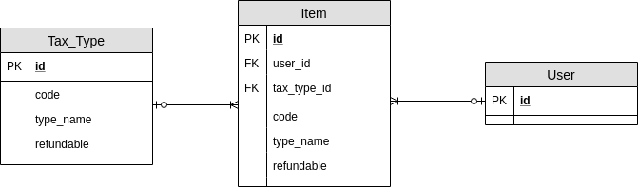

**User Table**

|  |  |  |
| --- | --- | --- |
| **Attributes Name** | **Data Type** | **Information** |
| **id** | integer | User ID |

**Tax Type Table**

|  |  |  |
| --- | --- | --- |
| **Attributes Name** | **Data Type** | **Information** |
| **id** | integer | Tax Type ID |
| code | integer | Tax Code |
| type_name | string | Tax Type |
| refundable | boolean | Refundable status |

**Item Table**

|  |  |  |
| --- | --- | --- |
| **Attributes Name** | **Data Type** | **Information** |
| **id** | integer | Item ID |
| name | string | Name of the item |
| tax_code | integer | Tax Code of the item |
| price | integer | Price of the item |
| user_id | integer | User ID who has the item |
| tax_type_id | integer | Tax Type ID of the item |