Kafka

docker compose configuration
https://github.com/conduktor/kafka-stack-docker-compose

Other cookbooks
https://github.com/robcowart/docker_compose_cookbook

Note: the UI may be outdated or not maintained. See above for Full Stack No UI in combination with Conduktor
- Single Zookeeper: $DOCKER_HOST_IP:2181
- Single Kafka: $DOCKER_HOST_IP:9092
- Kafka Schema Registry: $DOCKER_HOST_IP:8081
- Kafka Schema Registry UI: $DOCKER_HOST_IP:8001
- Kafka Rest Proxy: $DOCKER_HOST_IP:8082
- Kafka Topics UI: $DOCKER_HOST_IP:8000
- Kafka Connect: $DOCKER_HOST_IP:8083
- Kafka Connect UI: $DOCKER_HOST_IP:8003
- KSQL Server: $DOCKER_HOST_IP:8088
- Zoonavigator Web: $DOCKER_HOST_IP:8004
- (experimental) JMX port at $DOCKER_HOST_IP:9999

Run with:
docker-compose -f full-stack.yml up
docker-compose -f full-stack.yml down

# Create topic
docker exec -it kafka_kafka_1 kafka-topics.sh --create --bootstrap-server kafka:9092 --topic my-topic
# Create events
docker exec -it kafka_kafka_1 kafka-console-producer.sh --bootstrap-server kafka:9092 --topic my-topic
# Read events
docker exec -it kafka_kafka_1 kafka-console-consumer.sh --bootstrap-server kafka:9092 --topic my-topic --from-beginning

Install docker-compose
sudo curl -L "https://github.com/docker/compose/releases/download/1.29.0/docker-compose-$(uname -s)-$(uname -m)" -o /usr/local/bin/docker-compose

sudo chmod +x /usr/local/bin/docker-compose

Common commands:
docker-compose ps
docker-compose pause
docker-compose unpause
docker-compose stop
docker-compose start
docker-compose logs

Describe the topics
docker-compose exec broker kafka-topics --bootstrap-server localhost:9092 --describe

Describe a specific topic
docker-compose exec broker kafka-topics --bootstrap-server localhost:9092 --describe --topic users

Describe all groups
docker-compose exec broker kafka-consumer-groups --bootstrap-server localhost:9092 --describe --all-groups

Instantiate a Console Producer without a key
docker-compose exec broker kafka-console-producer --bootstrap-server localhost:9092 --topic users

Instantiate a Console Producer with a key
docker-compose exec broker kafka-console-producer --bootstrap-server localhost:9092 --topic users --property "key.separator=-" --property "parse.key=true"

Instantiate a Console Consumer without a key
docker-compose exec broker kafka-console-consumer --bootstrap-server localhost:9092 --topic users --from-beginning

Instantiate a Console Producer with a key
docker-compose exec broker kafka-console-consumer --bootstrap-server localhost:9092 --topic users --property "key.separator=-" --property="print.key=true"

Library App

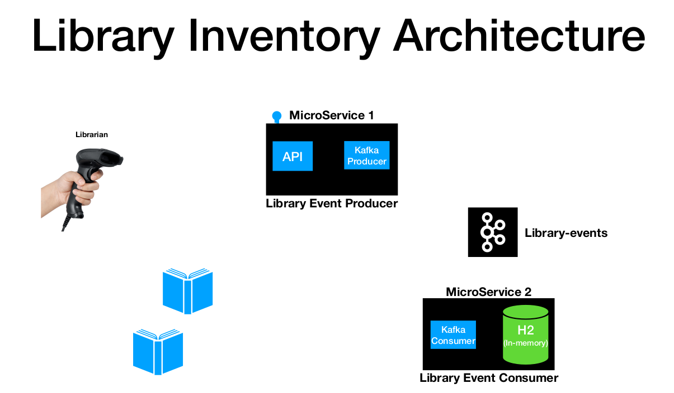

Create the project using the spring initializer

https://start.spring.io/

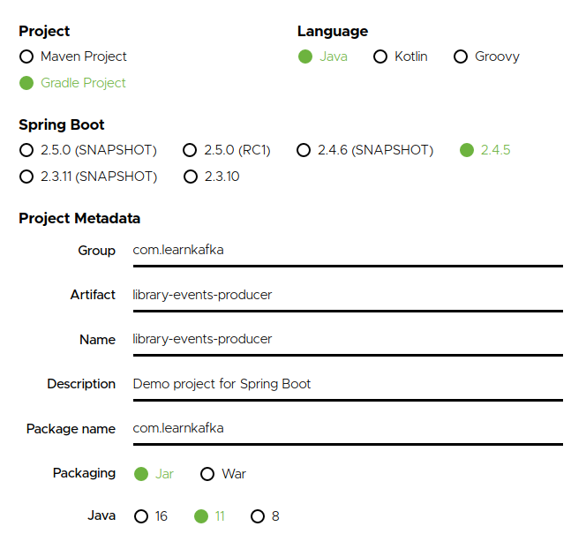

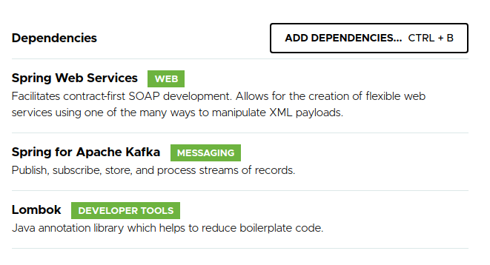

Click in the Generate button

Extracted the Zip file and import into the Intellij
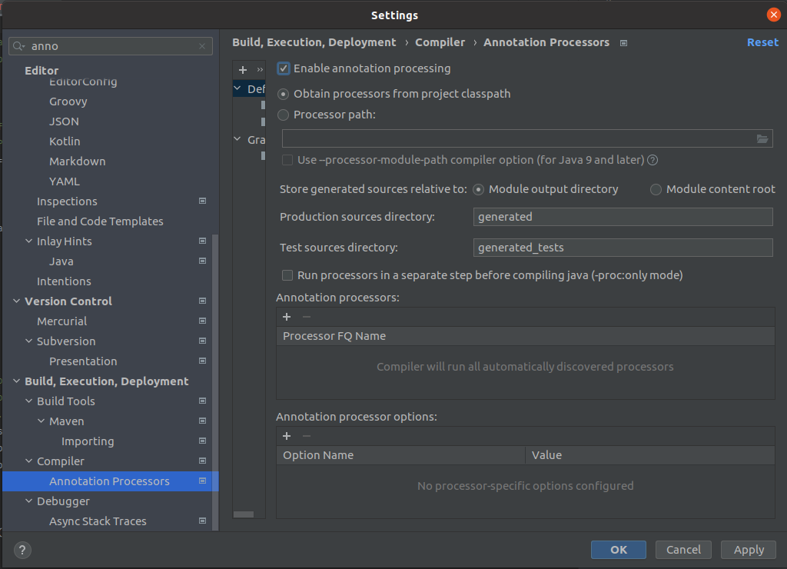

Create the LibraryEvent and Book classes
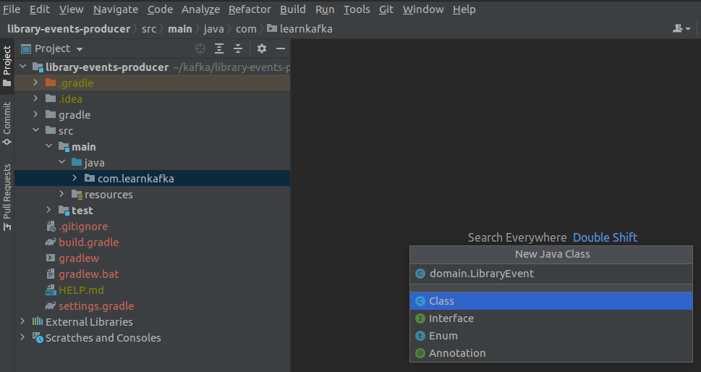

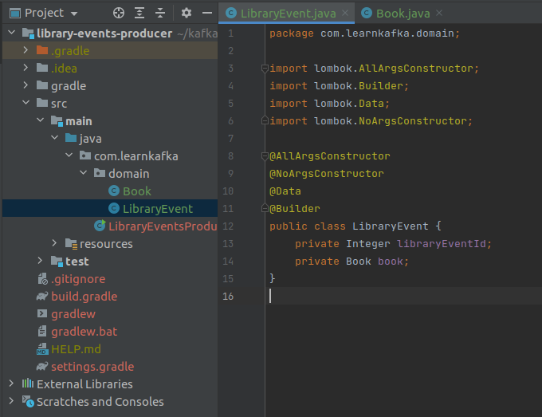

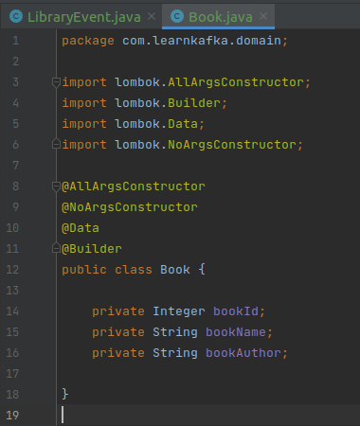

LibraryEvent.java
package com.learnkafka.domain;
import lombok.AllArgsConstructor;
import lombok.Builder;
import lombok.Data;
import lombok.NoArgsConstructor;
@AllArgsConstructor
@NoArgsConstructor
@Data
@Builder
public class LibraryEvent {
private Integer libraryEventId;
private Book book;
}

Book.Java
package com.learnkafka.domain;
import lombok.AllArgsConstructor;
import lombok.Builder;
import lombok.Data;
import lombok.NoArgsConstructor;
@AllArgsConstructor
@NoArgsConstructor
@Data
@Builder
public class Book {
private Integer bookId;
private String bookName;
private String bookAuthor;
}

Create the Producer API
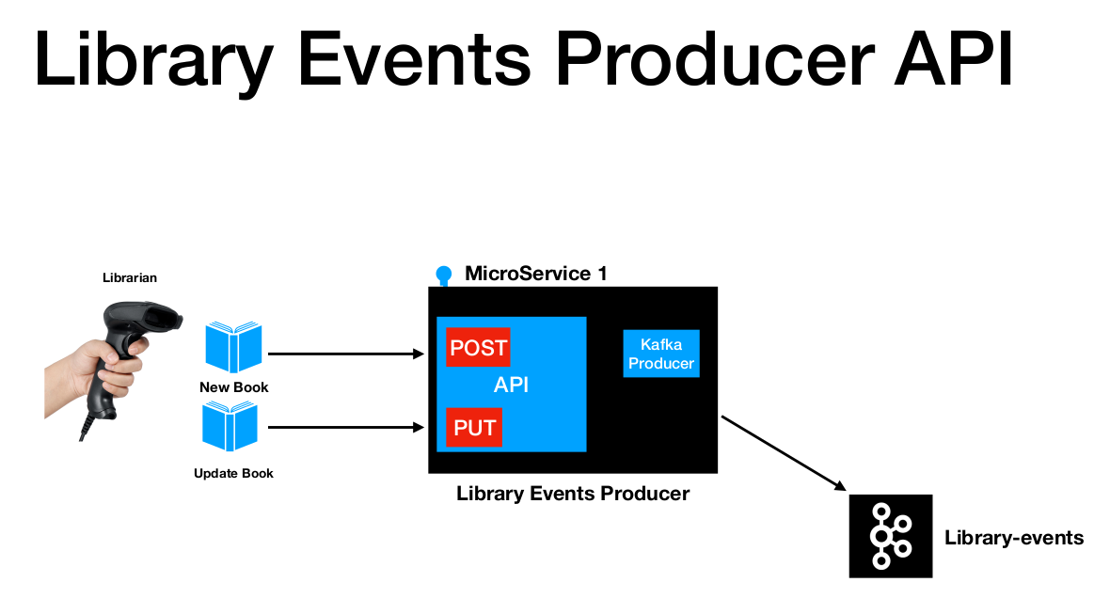

Create the LibraryEventsController

package com.learnkafka.controller;
import com.learnkafka.domain.LibraryEvent;
import org.springframework.http.HttpStatus;
import org.springframework.http.ResponseEntity;
import org.springframework.web.bind.annotation.PostMapping;
import org.springframework.web.bind.annotation.RequestBody;
import org.springframework.web.bind.annotation.RestController;
@RestController
public class LibraryEventsController {
@PostMapping("/v1/libraryevent")
public ResponseEntity<LibraryEvent> postLibraryEvent(@RequestBody LibraryEvent libraryEvent) {
//Invoke Kafka Producer
return ResponseEntity.status(HttpStatus.CREATED).body(libraryEvent);
}
}

Setup Postman
Create a new collection LibraryMicroservice App
Create a new folder Fase 1
Create a new folder inside of Fase 1 called Library Events
Create a new environment file library-env
Create a new Request librarryEventAPI
Change the service to POST
this is the url http://localhost:8080/v1/libraryevent

Paste the json file in the body section
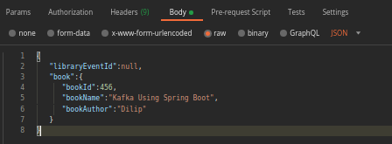

{
"libraryEventId":null,
"book":{
"bookId":456,
"bookName":"Kafka Using Spring Boot",
"bookAuthor":"Dilip"
}
}

Add in the headers
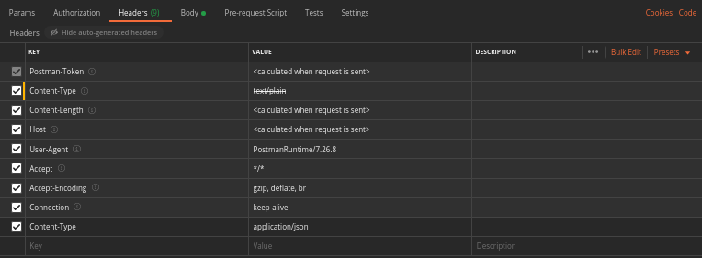
Content-Type application/json

Click in the send button to see results and it should be 201
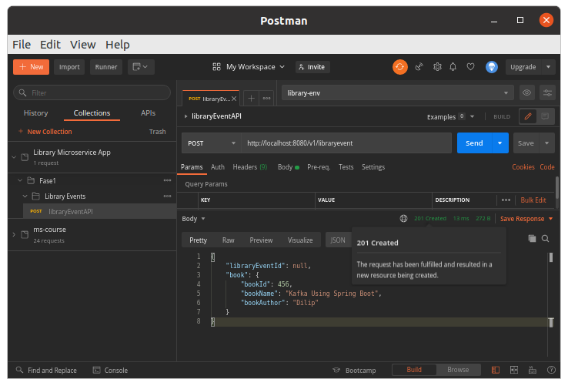

Click in the save button to record the endpoint in postman

Spring for Kafka Reference Producer
https://docs.spring.io/spring-kafka/reference/html/#reference

Concluence example
https://www.confluent.io/blog/apache-kafka-spring-boot-application/?utm_medium=sem&utm_source=google&utm_campaign=ch.sem_br.nonbrand_tp.prs_tgt.kafka_mt.mbm_rgn.latam_lng.eng_dv.all&utm_term=%2Bkafka%20%2Bspring&creative=&device=c&placement=&gclid=CjwKCAjwg4-EBhBwEiwAzYAlsoJBKo3s5Oib81ZTVE0Sgf2dAuX4Vs-D_AeFzcFLm0ihv_nJiHIb-hoC-wMQAvD_BwE

Install Spring Assistant
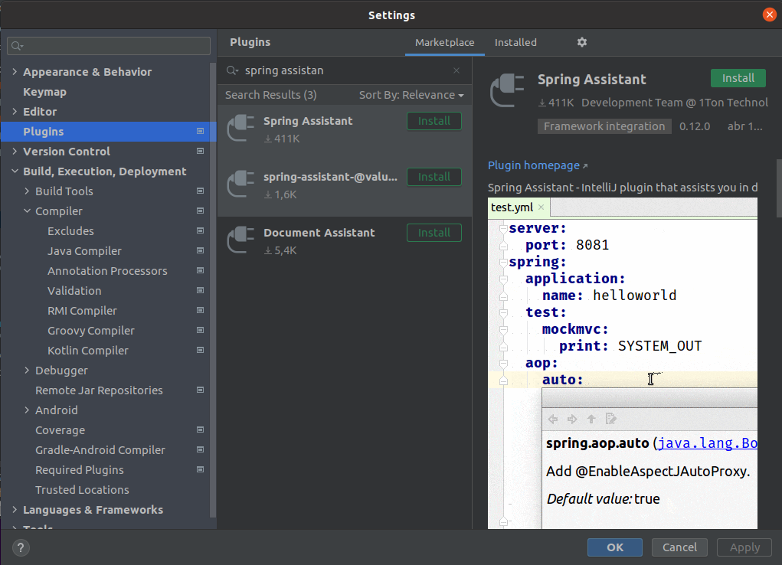

Create application.yml file for kafka local setup in the resource folder
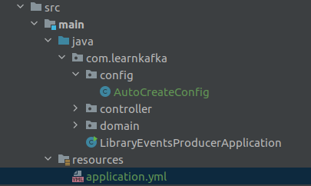

spring:
profiles:
active: local
---
spring:
profiles: local
kafka:
template:
default-topic: library-events
producer:
bootstrap-servers: localhost:29092
key-serializer: org.apache.kakfa.common.serialization.IntegerSerializer
value-serializer: org.apache.kakfa.common.serialization.StringSerializer
admin:
properties:
bootstrap.servers: localhost:29092
---
spring:
profiles: dev
kafka:
producer:
bootstrap-servers: localhost:29092
key-serializer: org.apache.kakfa.common.serialization.IntegerSerializer
value-serializer: org.apache.kakfa.common.serialization.StringSerializer
---
spring:
profiles: prod
kafka:
producer:
bootstrap-servers: localhost:29092
key-serializer: org.apache.kakfa.common.serialization.IntegerSerializer
value-serializer: org.apache.kakfa.common.serialization.StringSerializer

application.yml for confuence setup

spring:
profiles:
active: local
---
server:
port: 8080
spring:
profiles: local
kafka:
template:
default-topic: library-events
consumer:
bootstrap-servers: localhost:9092
group-id: group_id
auto-offset-reset: earliest
key-deserializer: org.apache.kafka.common.serialization.StringDeserializer
value-deserializer: org.apache.kafka.common.serialization.StringDeserializer
producer:
bootstrap-servers: localhost:9092
key-serializer: org.apache.kafka.common.serialization.StringSerializer
value-serializer: org.apache.kafka.common.serialization.StringSerializer

Create a new class config.AutoCreateConfig
This file will create the topoic library-events

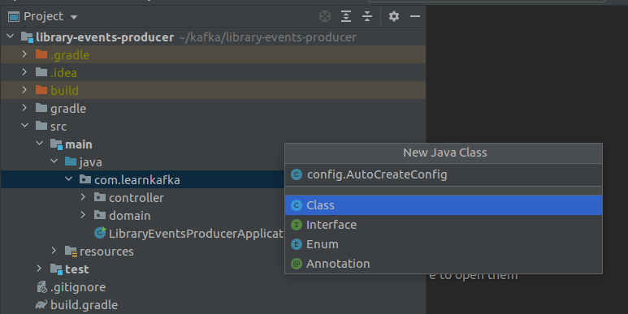

package com.learnkafka.config;
import org.apache.kafka.clients.admin.NewTopic;
import org.springframework.context.annotation.Bean;
import org.springframework.context.annotation.Configuration;
import org.springframework.kafka.config.TopicBuilder;
@Configuration
public class AutoCreateConfig {
@Bean
public NewTopic LibraryEvents() {
return TopicBuilder.name("library-events")
.partitions(1) //depends on the number of browkers
.replicas(1) //depends on the number of browkers
.build();
}
}

Run the application
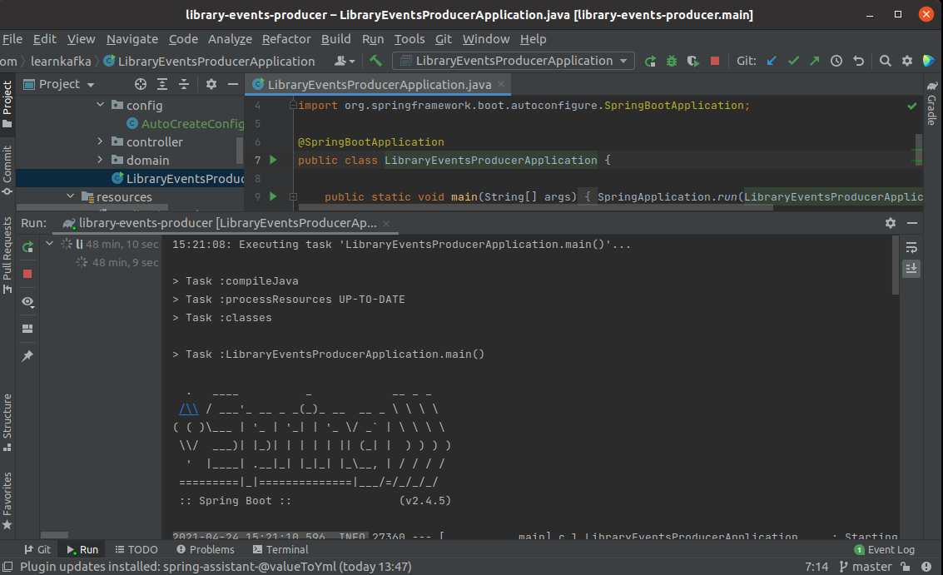

Test listing the topics
$docker-compose exec broker kafka-topics --bootstrap-server localhost:9092 --list

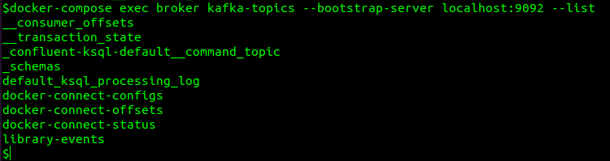

Create the Producer
package com.learnkafka.producer;
import com.fasterxml.jackson.core.JsonProcessingException;
import com.fasterxml.jackson.databind.ObjectMapper;
import com.learnkafka.domain.LibraryEvent;
import lombok.extern.slf4j.Slf4j;
import org.springframework.beans.factory.annotation.Autowired;
import org.springframework.kafka.core.KafkaTemplate;
import org.springframework.kafka.support.SendResult;
import org.springframework.stereotype.Component;
import org.springframework.util.concurrent.ListenableFuture;
import org.springframework.util.concurrent.ListenableFutureCallback;
@Component
@Slf4j
public class LibraryEventProducer {
@Autowired
KafkaTemplate<Integer, String> kafkaTemplate;
@Autowired
ObjectMapper objectMapper;
public void sendLibraryEvent(LibraryEvent libraryEvent) throws JsonProcessingException {
Integer key = libraryEvent.getLibraryEventId();
String value = objectMapper.writeValueAsString(libraryEvent);
ListenableFuture<SendResult<Integer,String>> listenableFuture = kafkaTemplate.sendDefault(key,value);
listenableFuture.addCallback(new ListenableFutureCallback<SendResult<Integer, String>>() {
@Override
public void onFailure(Throwable ex) {
handleFailure(key,value,ex);
}
@Override
public void onSuccess(SendResult<Integer, String> result) {
handleSuccess(key, value, result);
}
private void handleFailure(Integer key, String value, Throwable ex) {
log.error("Error Sending the message and the exception is {}", ex.getMessage());
try {
throw ex;
} catch (Throwable throwable) {
log.error("Error in OnFailure: {}", throwable.getMessage());
}
}
private void handleSuccess(Integer key, String value, SendResult<Integer,String> result) {
log.info("Message sent successfully for the key :{} and the value is {} , partition is {}",key, value, result.getRecordMetadata().partition());
}
});
}
}

Change LibraryEventsController.java adding the producer
package com.learnkafka.controller;
import com.fasterxml.jackson.core.JsonProcessingException;
import com.learnkafka.domain.LibraryEvent;
import com.learnkafka.producer.LibraryEventProducer;
import org.springframework.beans.factory.annotation.Autowired;
import org.springframework.http.HttpStatus;
import org.springframework.http.ResponseEntity;
import org.springframework.web.bind.annotation.PostMapping;
import org.springframework.web.bind.annotation.RequestBody;
import org.springframework.web.bind.annotation.RestController;
@RestController
public class LibraryEventsController {
@Autowired
LibraryEventProducer libraryEventProducer;
@PostMapping("/v1/libraryevent")
public ResponseEntity<LibraryEvent> postLibraryEvent(@RequestBody LibraryEvent libraryEvent) throws JsonProcessingException {
//Invoke Kafka Producer
libraryEventProducer.sendLibraryEvent(libraryEvent);
return ResponseEntity.status(HttpStatus.CREATED).body(libraryEvent);
}
}

Run the application and open the consumer to show the results and open postmand to make the call

Launch the consumer
docker-compose exec broker kafka-console-consumer --bootstrap-server localhost:9092 --topic library-events --from-beginning

Make a call using postman
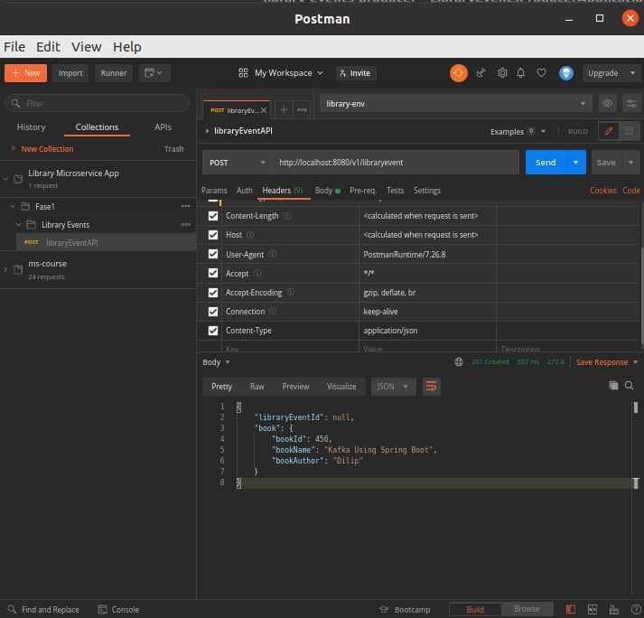

Change LibraryEventProducer
Create a Synchronous call method

package com.learnkafka.producer;
import com.fasterxml.jackson.core.JsonProcessingException;
import com.fasterxml.jackson.databind.ObjectMapper;
import com.learnkafka.domain.LibraryEvent;
import lombok.extern.slf4j.Slf4j;
import org.springframework.beans.factory.annotation.Autowired;
import org.springframework.kafka.core.KafkaTemplate;
import org.springframework.kafka.support.SendResult;
import org.springframework.stereotype.Component;
import org.springframework.util.concurrent.ListenableFuture;
import org.springframework.util.concurrent.ListenableFutureCallback;
import java.util.concurrent.ExecutionException;
import java.util.concurrent.TimeUnit;
import java.util.concurrent.TimeoutException;
@Component
@Slf4j
public class LibraryEventProducer {
@Autowired
KafkaTemplate<Integer, String> kafkaTemplate;
@Autowired
ObjectMapper objectMapper;
//Asynchronous Call
public void sendLibraryEvent(LibraryEvent libraryEvent) throws JsonProcessingException {
Integer key = libraryEvent.getLibraryEventId();
String value = objectMapper.writeValueAsString(libraryEvent);
ListenableFuture<SendResult<Integer, String>> listenableFuture = kafkaTemplate.sendDefault(key, value);
listenableFuture.addCallback(new ListenableFutureCallback<SendResult<Integer, String>>() {
@Override
public void onFailure(Throwable ex) {
handleFailure(key, value, ex);
}
@Override
public void onSuccess(SendResult<Integer, String> result) {
handleSuccess(key, value, result);
}
});
}
//Synchronous Call
public SendResult<Integer, String> sendLibraryEventSynchronous(LibraryEvent libraryEvent) throws
JsonProcessingException, ExecutionException, InterruptedException, TimeoutException, Exception {
Integer key = libraryEvent.getLibraryEventId();
String value = objectMapper.writeValueAsString(libraryEvent);
SendResult<Integer, String> sendResult = null;
try {
sendResult = kafkaTemplate.sendDefault(key, value).get(1, TimeUnit.SECONDS);
} catch (ExecutionException | InterruptedException ex) {
log.error("ExecutionException/InterruptedException Sending the message and the exception is {}", ex.getMessage());
} catch (TimeoutException ex) {
log.error("TimeoutException Sending the message and the exception is {}", ex.getMessage());
} catch (Exception ex) {
log.error("Exception Sending the message and the exception is {}", ex.getMessage());
}
return sendResult;
}
private void handleFailure(Integer key, String value, Throwable ex) {
log.error("Error Sending the message and the exception is {}", ex.getMessage());
try {
throw ex;
} catch (Throwable throwable) {
log.error("Error in OnFailure: {}", throwable.getMessage());
}
}
private void handleSuccess(Integer key, String value, SendResult<Integer, String> result) {
log.info("Message sent successfully for the key :{} and the value is {} , partition is {}", key, value, result.getRecordMetadata().partition());
}
}
Change LibraryEventProducer
package com.learnkafka.controller;
import com.fasterxml.jackson.core.JsonProcessingException;
import com.learnkafka.domain.LibraryEvent;
import com.learnkafka.producer.LibraryEventProducer;
import lombok.extern.slf4j.Slf4j;
import org.springframework.beans.factory.annotation.Autowired;
import org.springframework.http.HttpStatus;
import org.springframework.http.ResponseEntity;
import org.springframework.kafka.support.SendResult;
import org.springframework.web.bind.annotation.PostMapping;
import org.springframework.web.bind.annotation.RequestBody;
import org.springframework.web.bind.annotation.RestController;
@RestController
@Slf4j
public class LibraryEventsController {
@Autowired
LibraryEventProducer libraryEventProducer;
@PostMapping("/v1/libraryevent")
public ResponseEntity<LibraryEvent> postLibraryEvent(@RequestBody LibraryEvent libraryEvent) throws Exception {
//Invoke Kafka Producer
log.info("Before sendLibraryEvent");
//Asynchronous call
//libraryEventProducer.sendLibraryEvent(libraryEvent);
//Synchronous call
SendResult<Integer, String> sendResult = libraryEventProducer.sendLibraryEventSynchronous(libraryEvent);
log.info("SendResult is{}",sendResult.toString());
log.info("after sendLibraryEvent");
return ResponseEntity.status(HttpStatus.CREATED).body(libraryEvent);
}
}

