COMP8006 Final Project Test Document

COMP8006

Jake Miner

Albert Liao

March 29th, 2014

Table of Contents

Test Bench Setup 2

Test Cases 3

Verification Screenshots 8

SSH port 22 to 192.168.0.19:1337 test 8

SSH port 9999 to 192.168.0.19:1337 test 10

Apache port 4321 to 192.168.0.19:80 test 12

Apache port 4321 to 192.168.0.19:8080 test 14

httperf test port 4321 to 192.168.0.19:8080 test 15

Assignment 2 test port 7777 to 192.168.0.19:7777 16

Assignment 2 test port 7777 to 192.168.0.19:7777 with SSH port 9999 to 192.168.0.19:1337 latency test. 16

# Test Bench Setup

For our testing, we will be using the computers available in the Data Communications lab at BCIT. The workstations are equipped with the following:

* 8GB of RAM
* Intel Core i5-2400 @ 3.10GHz x 4
* Fedora 19 3.1.1 64 bit.

We will be using four workstations for this set of tests, each workstation will be designated as follows:

1. 192.168.0.18 will be the machine running the port forwarder
2. 192.168.0.19 will be the machine running the services (SSHD, HTTPD, Assign 2 server)
3. 192.168.0.20 will be the test client.
4. 192.168.0.22 will be the additional test client when we test SSH latency with traffic from 192.168.0.20 going through the port forwarder simultaneously.

# Test Cases

|  |  |  |  |  |
| --- | --- | --- | --- | --- |
| **Test Description** | **Setup** | **Testing Process** | **Validation** | **Pass?** |
| SSH port 22 to 192.168.0.19:1337 test | 1. Have 192.168.0.19 be the server running SSHD listening on port 1337 and start the SSHD service 2. Setup the machine 192.168.0.18 to be the Port Forwarder and forward incoming TCP connections on port 22 to 192.168.0.19:1337 | 1. Log into another lab computer that isn’t the port forwarder or SSHD server. 2. Attempt to SSH into the SSHD server through the Port Forwarder by using the command: “ssh 192.168.0.18”. Follow the prompts to login. 3. Run the “ifconfig” command to verify we are logged into the SSHD Server and not the Port Forwarder. | See validation section below for screenshots. | PASS |
| SSH port 9999 to 192.168.0.19:1337 test | 1. Have 192.168.0.19 be the server running SSHD listening on port 1337 and start the SSHD service 2. Setup the machine 192.168.0.18 to be the Port Forwarder and forward incoming TCP connections on port 9999 to 192.168.0.19:1337 | 1. Log into another lab computer that isn’t the port forwarder or SSHD server. 2. Attempt to SSH into the SSHD server through the Port Forwarder by using the command: “ssh –p 9999 192.168.0.18”. Follow the prompts to login. 3. Run the “ifconfig” command to verify we are logged into the SSHD Server and not the Port Forwarder. | See validation section below for screenshots. | PASS |
| Apache port 4321 to 192.168.0.19:80 test | 1. Have 192.168.0.19 be the Apache server running on port 80. Ensure that the service is running. 2. Set the homepage to display the text “You are on machine 192.168.0.19”. 3. Setup the machine 192.168.0.18 to be the Port Forwarder and forward incoming TCP connections on port 4321 to 192.168.0.19:80. | 1. Log into another lab computer that isn’t the port forwarder or the Apache server. 2. Open a web browser and navigate to the URL “192.168.0.18:4321” 3. Verify that the homepage is the one you set for the Apache machine. | See validation section below for screenshots. | PASS |
| Apache port 4321 to 192.168.0.19:8080 test | 1. Have 192.168.0.19 be the Apache server running on port 8080. Ensure that the service is running. 2. Set the homepage to display the text “You are on machine 192.168.0.19”. 3. Setup the machine 192.168.0.18 to be the Port Forwarder and forward incoming TCP connections on port 4321 to 192.168.0.19:8080. | 1. Log into another lab computer that isn’t the port forwarder or the Apache server. 2. Open a web browser and navigate to the URL “192.168.0.18:4321” 3. Verify that the homepage is the one you set for the Apache machine. | See validation section below for screenshots. | PASS |
| httperf test port 4321 to 192.168.0.19:8080  test | 1. Have 192.168.0.19 be the Apache server running on port 8080. Ensure that the service is running. 2. Set the homepage to display the text “You are on machine 192.168.0.19”. 3. Setup the machine 192.168.0.18 to be the Port Forwarder and forward incoming TCP connections on port 4321 to 192.168.0.19:8080. | 1. Log into another lab computer that isn’t the port forwarder or the Apache server. 2. Open a console and run httperf with the following command: “httperf –-server 192.168.0.18 –-port 4321 –-rate 30 –-num-conn 3000 -–timeout 5 3. Verify that all of the connections are successful and there are no timeouts. | See validation section below for screenshots. | PASS |
| Assignment 2 test port 7777 to 192.168.0.19:7777 | 1. Have 192.168.0.19 be the assignment 2 server running on port 7777. Ensure that the service is running. 2. Setup the machine 192.168.0.18 to be the Port Forwarder and forward incoming TCP connections on port 7777 to 192.168.0.19:7777. | 1. Log into another lab computer that isn’t the port forwarder or the assignment 2 server. 2. Open a console and run assignment 2’s client executable by using the command:”./test.sh 192.168.0.18 100 1000 135”. This will cause the client machine to attempt to run 135 clients. 3. Verify on the server side that there was no data lost (data sent received should be 200000. | See validation section below for screenshots. | PASS |
| Assignment 2 test port 7777 to 192.168.0.19:7777  with SSH port 9999 to 192.168.0.19:1337 latency test. | 1. Have 192.168.0.19 be the assignment 2 server running on port 7777 and the SSHD server listening on port 1337. Ensure that both services are running. 2. Setup the machine 192.168.0.18 to be the Port Forwarder and forward incoming TCP connections on port 7777 to 192.168.0.19:7777 and also port 9999 to 192.168.0.19:1337. | 1. Log into another lab computer that isn’t the port forwarder or the assignment 2 server. 2. Open a console and run assignment 2’s client executable by using the command:”./test.sh 192.168.0.18 100 1000 135”. This will cause the client machine to attempt to run 135 clients. 3. Open another console window and run the command “ssh 192.168.0.18 –p 9999” 4. Verify that there is no visible latency to the user by running the command “date && ls && date” and verifying that the timestamps are within 1 second of eachother. | See validation section below for screenshots. | PASS |

# Verification Screenshots

## SSH port 22 to 192.168.0.19:1337 test

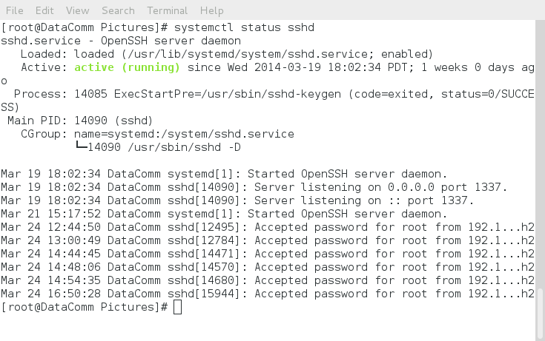

Figure Verification Server is listening on port 1337

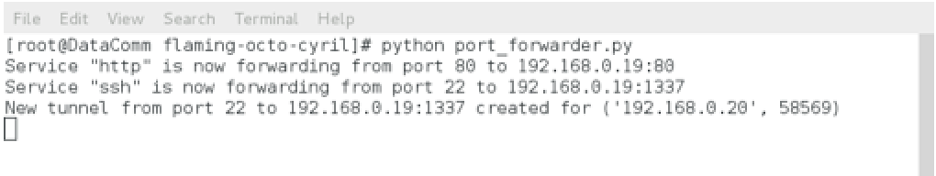

Figure Verification of Port Forwarder settings

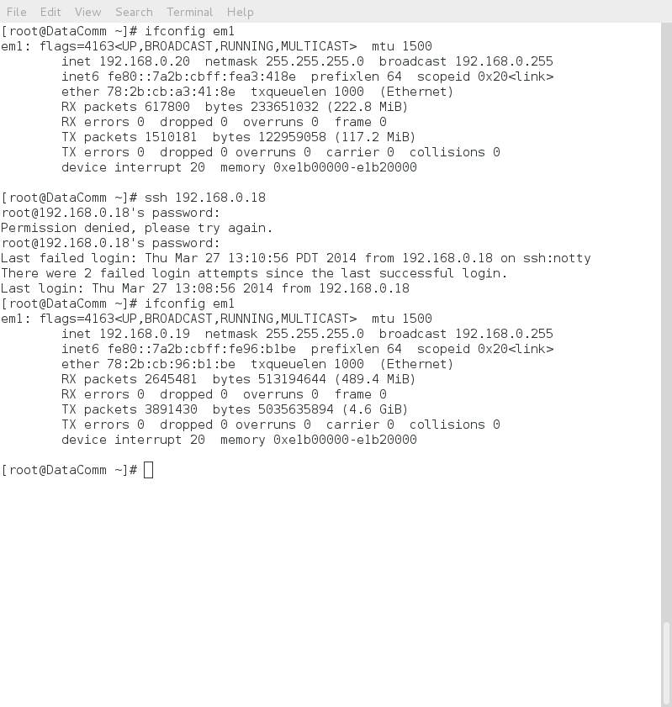

Figure Verification of Client Connecting Through Port Forwarder

## SSH port 9999 to 192.168.0.19:1337 test



Figure Verification of Server Listening on Port 1337

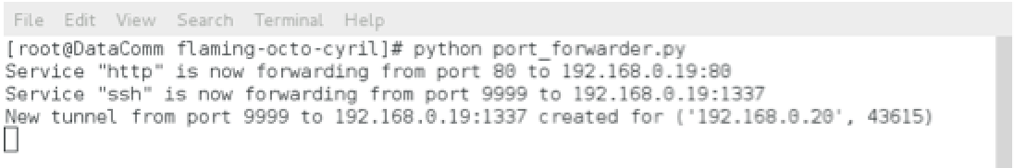

Figure Verification of Port Forwarder Settings

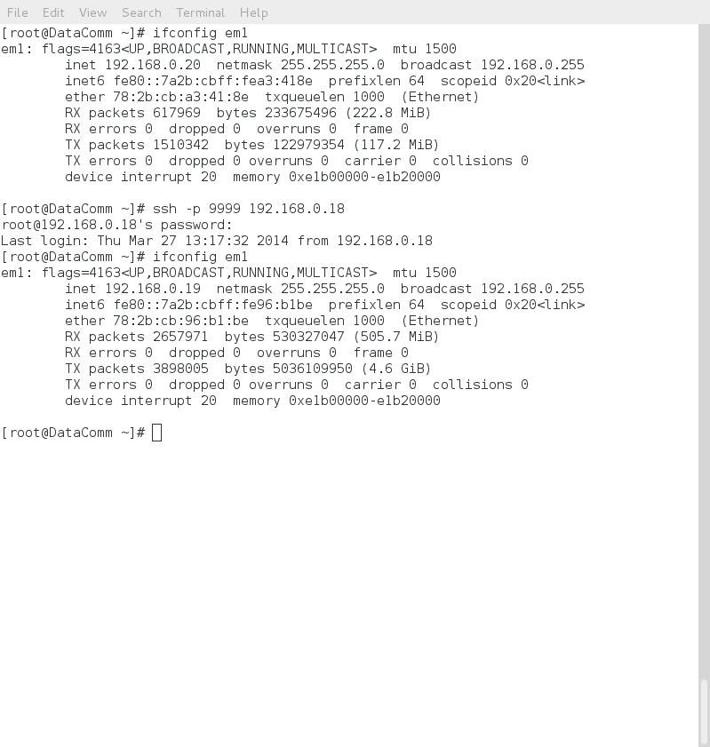

Figure Verification of Client connecting through Port Forwarder

## Apache port 4321 to 192.168.0.19:80 test

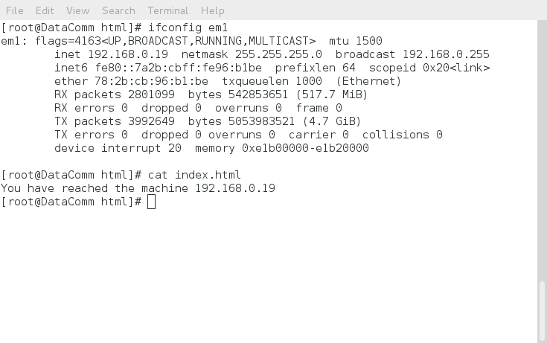

Figure Verification of Web Server Files

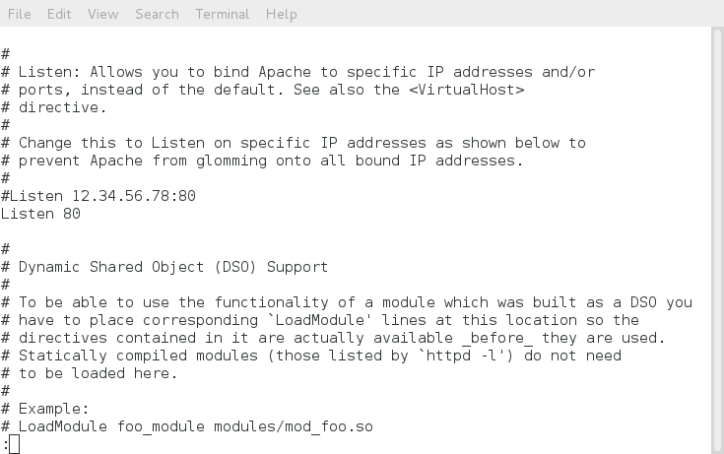

Figure Verification of Web Server Port Settings

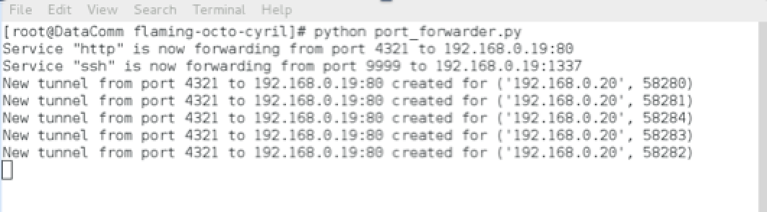

Figure Verification of Port Forwarder Logs and Settings

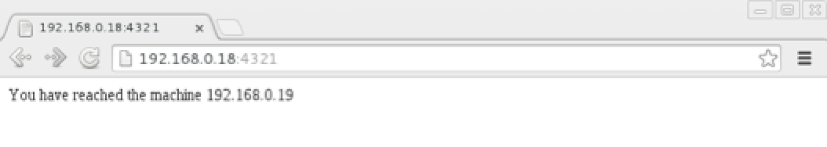

Figure Verification of Client Connection

## Apache port 4321 to 192.168.0.19:8080 test



Figure Verification of Web Server Files

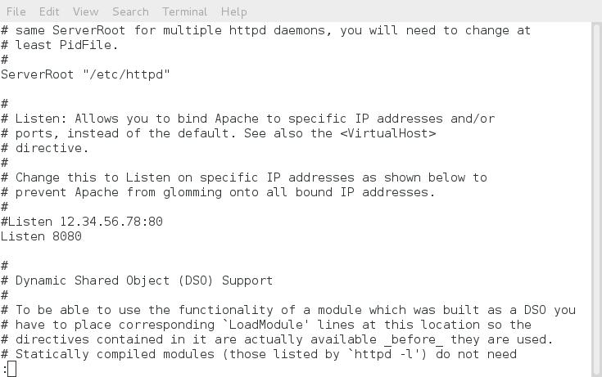

Figure Verification of Web Server Port Settings

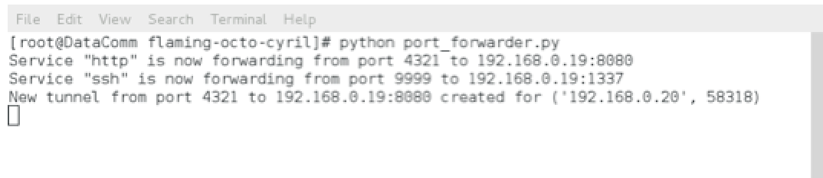

Figure Verification of Port Forwarder Logs

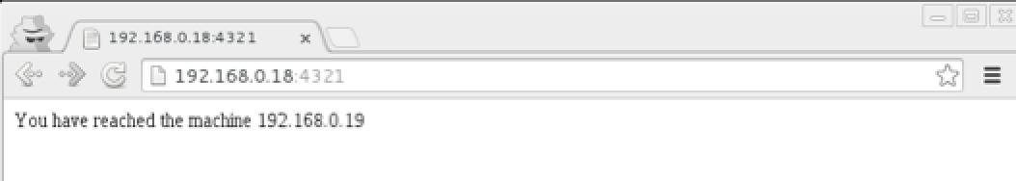

Figure Verification of Client Connection

## httperf test port 4321 to 192.168.0.19:8080 test

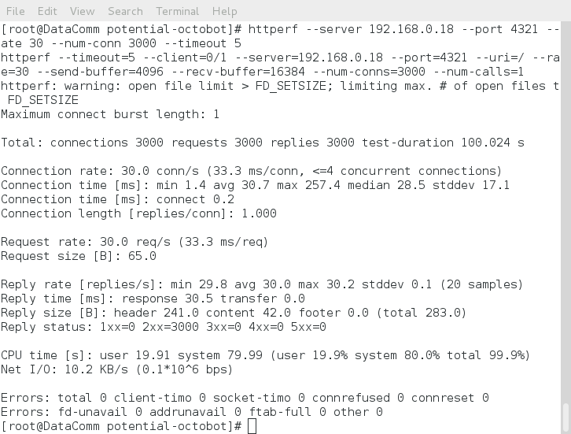

Figure Httperf results. Server in identical state as above test case.

## Assignment 2 test port 7777 to 192.168.0.19:7777

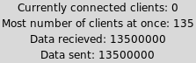

Figure Verification of client connections through port forwarder.

## Assignment 2 test port 7777 to 192.168.0.19:7777 with SSH port 9999 to 192.168.0.19:1337 latency test.

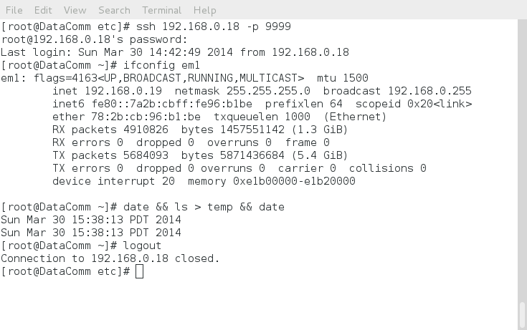

Figure Verification of SSH latency test. Ran concurrently to the above test case.