CHAPTER FOUR: RESULTS
  - Assessment of Knowledge and Socio-Cultural Factors Affecting Modern Contraceptive Use among Women of Reproductive Age at Mkuranga District, Pwani Region

4.1 Introduction
This chapter presents the findings of the study on knowledge and socio-cultural factors affecting modern contraceptive use among women of reproductive age (15–49 years) in Mkuranga District, Pwani Region. The results are organised according to the specific objectives of the study. Participant flow and the analytical sample are described first (Section 4.2), followed by the sociodemographic and other characteristics of the participants (Section 4.3). The prevalence of current modern contraceptive use is then presented (Section 4.4), followed by women’s knowledge of modern contraceptive methods, their advantages and side effects (Section 4.5). Bivariate associations between selected factors and current modern contraceptive use are presented in Section 4.6, and modified Poisson regression estimating crude and adjusted prevalence ratios is presented in Section 4.7. The chapter closes with a summary of the principal findings by objective (Section 4.8).
Categorical variables are summarised using frequencies and percentages calculated on the valid denominator of each variable. Continuous variables are summarised using the mean and standard deviation or the median and interquartile range, according to their distribution. Inferential results are reported with effect estimates, 95% confidence intervals and P-values. All analyses were conducted in R using the reproducible script-to-checkpoint pipeline of the project.

4.2 Participant Flow and Analytical Sample
Figure 4.1 shows the flow of records through the study. The KoboToolbox export contained 421 questionnaire records. Exact duplicate submissions (identical in every questionnaire field) accounted for 2 records; these were removed, leaving 419 records. All of these satisfied the age eligibility criterion (15–49 years), so no record was excluded on eligibility grounds. Four records shared an identification number with a different respondent (IDs 106, 170, 229 and 424); these were verified as different women, re-labelled and retained. The final analytical sample therefore comprised 419 women, which is 98.1% of the planned sample of 427. Of these, 299 were currently married or cohabiting and form the population for the partner-related analyses (Panel B). The study did not record the number of women approached or the number who declined, so a response rate could not be calculated.
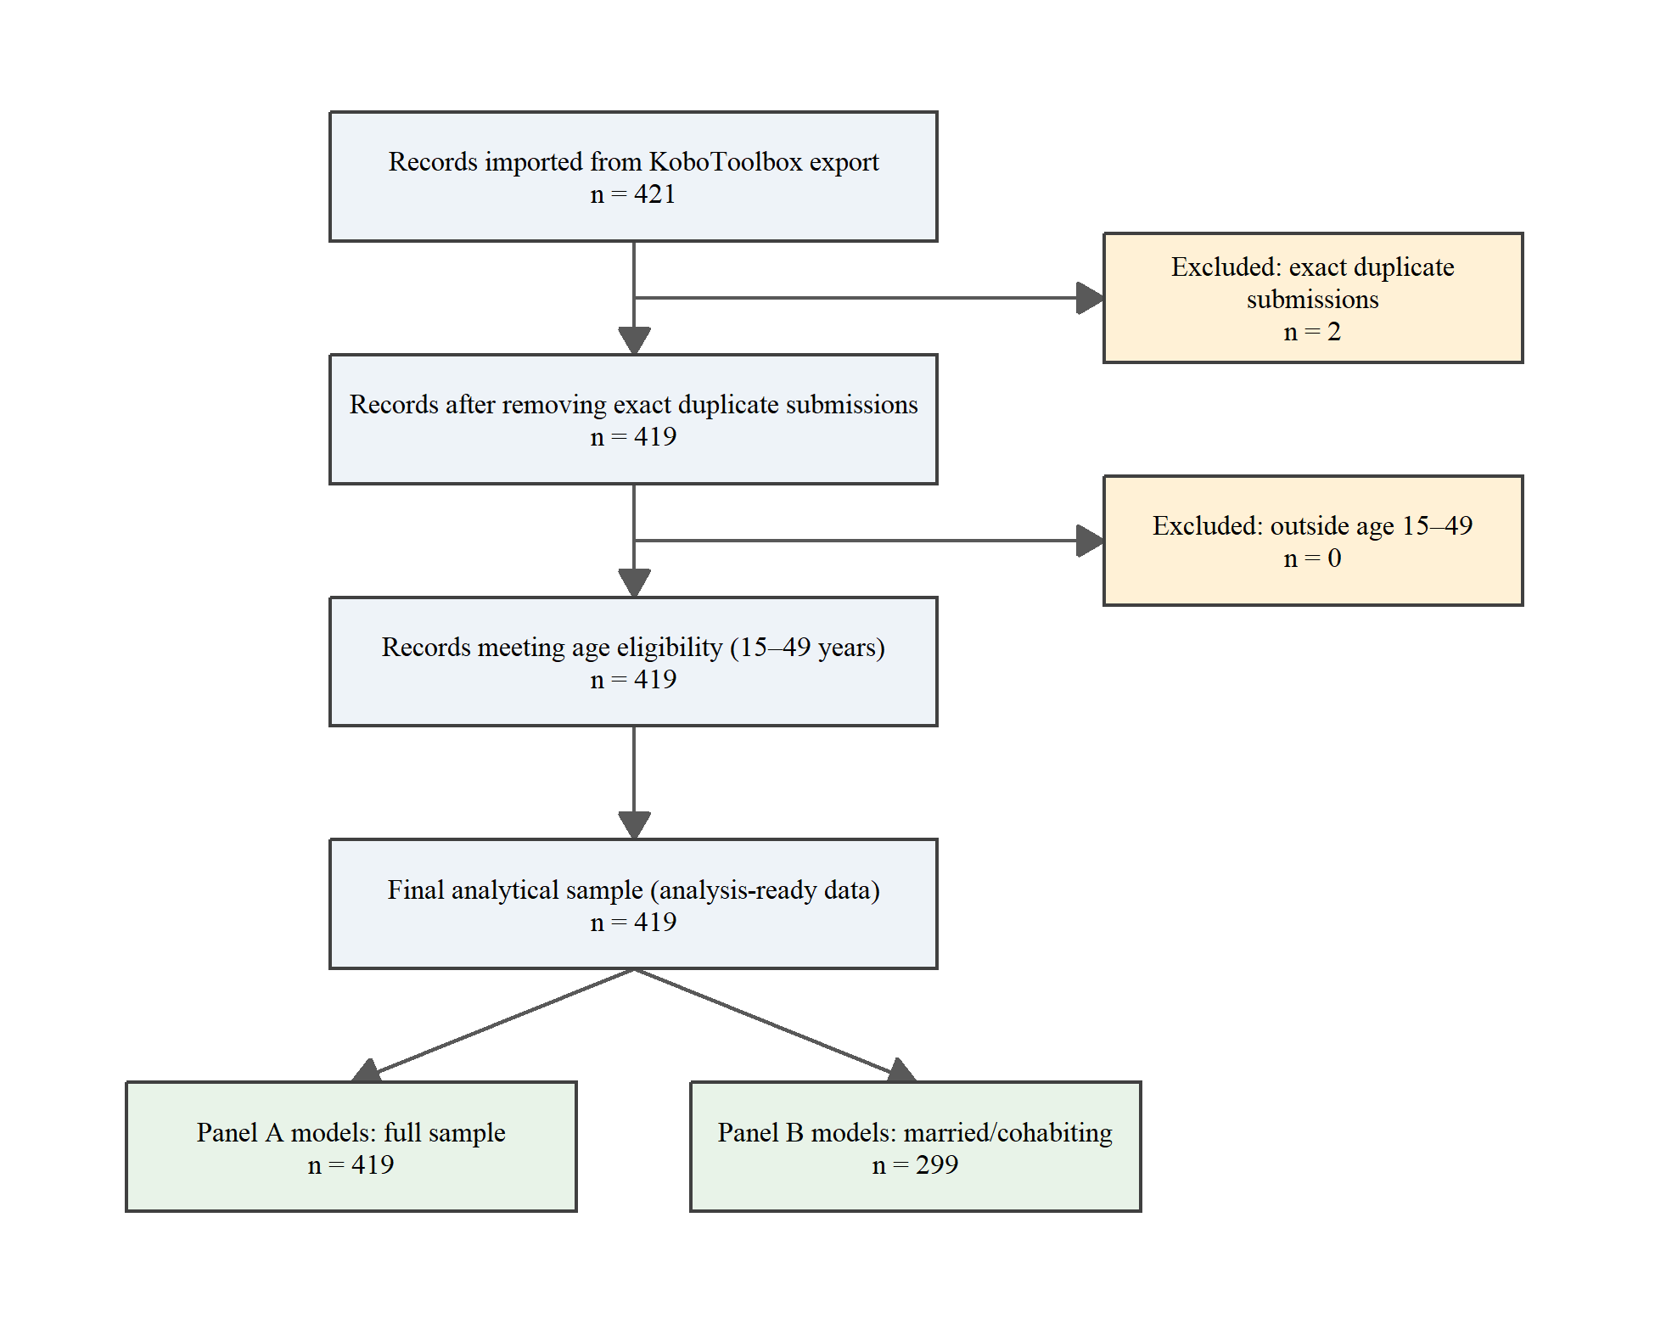
Figure 4.1. Participant flow through the study, from imported records to the final analytical sample

4.3 Sociodemographic and Other Characteristics of Participants
Table 4.1 describes the 419 women in the analytical sample. Their mean age was 30.0 years (SD 8.8) and the largest age group was 20–24 years (88, 21.0%). Most women had primary (n = 221, 52.7%) or secondary (n = 144, 34.4%) education, and Muslims accounted for n = 316, 75.4%. Women currently married or cohabiting accounted for n = 299, 71.4%, and the most common occupational status was self-employment (n = 238, 56.8%). The median number of living children was 2 (Q1–Q3: 1–3).
Table 4.1. Sociodemographic and other characteristics of study participants
Characteristic | Overall, N = 419
Age, years, mean (SD) | 30.0 (8.8)
Age group, n (%)
15–19 years | 45 (10.7%)
20–24 years | 88 (21.0%)
25–29 years | 84 (20.0%)
30–34 years | 66 (15.8%)
35–39 years | 57 (13.6%)
40–44 years | 50 (11.9%)
45–49 years | 29 (6.9%)
Educational attainment, n (%)
No education | 37 (8.8%)
Primary | 221 (52.7%)
Secondary | 144 (34.4%)
Higher / Tertiary | 17 (4.1%)
Religion, n (%)
Christian | 100 (23.9%)
Muslim | 316 (75.4%)
No religion | 2 (0.5%)
Other | 1 (0.2%)
Marital/cohabitation status, n (%)
Currently married / Cohabiting | 299 (71.4%)
Not in union (Single / Divorced / Widowed) | 120 (28.6%)
Occupation, n (%)
Unemployed | 156 (37.2%)
Self-employed | 238 (56.8%)
Employed (Private / Government) | 25 (6.0%)
Living children, number, median (Q1–Q3) | 2 (1–3)
Parity group, n (%)
0 children | 81 (19.3%)
1–2 children | 173 (41.3%)
3–4 children | 126 (30.1%)
5 or more children | 39 (9.3%)
Child spacing*, n (%) [valid n = 252; not applicable = 167]
Yes (children < 2 years apart) | 55 (21.8%)
No | 197 (78.2%)
Polygamy**, n (%) [valid n = 299; not applicable = 120]
Yes | 62 (20.7%)
No | 227 (75.9%)
Don't Know | 10 (3.3%)
Note. Values are n (%) for categorical variables, using the valid (non-missing, applicable) denominator for each variable, and mean (SD) or median (Q1–Q3) for continuous variables.
The summary statistic for each continuous variable was selected after distributional assessment (mean (SD) if |skewness| < 0.5; otherwise median (Q1–Q3)); age skewness = 0.31, living-children skewness = 0.82.
* Child spacing was asked only of respondents with at least two living children (eligible n = 252; not applicable n = 167; missing among eligible = 0).
** Polygamy was asked only of currently married/cohabiting respondents (eligible n = 299; not applicable n = 120; missing among eligible = 0).

4.4 Prevalence of Current Modern Contraceptive Use
Table 4.2 presents the primary outcome. Of the 419 women with available outcome data, 105 were currently using a modern contraceptive method, giving a prevalence of 25.1% (95% CI 21.1–29.4). Among currently married or cohabiting women the prevalence was 28.1% (95% CI 23.3–33.4). Among the 105 users, the most commonly used method was injections (48, 45.7%).
Table 4.2. Distribution and prevalence of current modern contraceptive use
Primary outcome | Number, n (%) / estimate
Currently using a modern contraceptive method (outcome present) | 105 (25.1%)
Not currently using a modern contraceptive method (outcome absent) | 314 (74.9%)
Total with available outcome data | 419 (100.0%)
Prevalence of current modern contraceptive use (95% CI) | 25.1% (21.1–29.4)
Note. Outcome: V031 current use of any modern contraceptive method. Prevalence = number currently using / number with available outcome data × 100.
The 95% confidence interval was calculated with the Wilson score interval (exact Clopper–Pearson interval: 21.0–29.5%).
Records with missing outcome data excluded from the denominator: 0 of 419.

4.5 Knowledge of Modern Contraceptive Methods, Advantages and Side Effects
Table 4.3 presents item-level responses; no item had missing data. Among the six methods, awareness was highest for injection (90.7%) and lowest for sterilization (24.8%). The most widely known advantage was “aid child spacing” (77.3%), whereas the least known was “more effective than traditional methods” (28.9%). Of the four listed side effects, “irregular bleeding” was the most frequently recognised (79.2%). Across all 18 items, the composite knowledge score (V041; range 0–18) had a mean of 9.60 (SD 4.28) and a median of 9 (Q1–Q3: 6–13; skewness = 0.15). Using the sample mean (9.60) as the cut-off, 192 women (45.8%) had high knowledge (≥ mean) and 227 (54.2%) had low knowledge (< mean).
Table 4.3. Knowledge of modern contraceptive methods, advantages and side effects
Knowledge domain | Knowledge item / summary | Yes, n (%) / summary | No, n (%) | Variable | Valid n; missing n
Knowledge of modern contraceptive methods | Pills | 368 (87.8%) | 51 (12.2%) | V010 | 419; 0
Knowledge of modern contraceptive methods | Injection | 380 (90.7%) | 39 (9.3%) | V011 | 419; 0
Knowledge of modern contraceptive methods | Condom | 275 (65.6%) | 144 (34.4%) | V012 | 419; 0
Knowledge of modern contraceptive methods | Implants (Norplant) | 356 (85.0%) | 63 (15.0%) | V013 | 419; 0
Knowledge of modern contraceptive methods | IUD | 280 (66.8%) | 139 (33.2%) | V014 | 419; 0
Knowledge of modern contraceptive methods | Sterilization | 104 (24.8%) | 315 (75.2%) | V015 | 419; 0
Knowledge of advantages | Prevent unwanted pregnancy | 307 (73.3%) | 112 (26.7%) | V016 | 419; 0
Knowledge of advantages | Aid child spacing | 324 (77.3%) | 95 (22.7%) | V017 | 419; 0
Knowledge of advantages | Allow freedom to enjoy sex | 141 (33.7%) | 278 (66.3%) | V018 | 419; 0
Knowledge of advantages | Help prevent diseases | 131 (31.3%) | 288 (68.7%) | V019 | 419; 0
Knowledge of advantages | Easy to use | 134 (32.0%) | 285 (68.0%) | V020 | 419; 0
Knowledge of advantages | Create confidence | 153 (36.5%) | 266 (63.5%) | V021 | 419; 0
Knowledge of advantages | Reduce birth rate | 163 (38.9%) | 256 (61.1%) | V022 | 419; 0
Knowledge of advantages | More effective than traditional methods | 121 (28.9%) | 298 (71.1%) | V023 | 419; 0
Knowledge of side effects | Method failure (unwanted pregnancy) | 147 (35.1%) | 272 (64.9%) | V025 | 419; 0
Knowledge of side effects | Irregular bleeding | 332 (79.2%) | 87 (20.8%) | V026 | 419; 0
Knowledge of side effects | Stress and fear | 122 (29.1%) | 297 (70.9%) | V027 | 419; 0
Knowledge of side effects | Weight gain | 185 (44.2%) | 234 (55.8%) | V028 | 419; 0
Composite knowledge score | Knowledge score (0–18), mean (SD) | 9.60 (4.28) [median 9, Q1–Q3 6–13; range 0–18] | — | V041 | 419; 0
Knowledge level | Low knowledge (< mean) | 227 (54.2%) | — | V042 | 419; 0
Knowledge level | High knowledge (≥ mean) | 192 (45.8%) | — | V042 | 419; 0
Note. Each item uses its own available-response denominator. The 18 items are V010–V015, V016–V023 and V025–V028; free-text and ‘other’ responses (V024, V029, V030) are not part of the specified score.
Yes/No are the questionnaire response categories (Yes = aware / knows the advantage / knows the side effect); they are not labelled correct/incorrect here.
Knowledge score (V041) = sum of ‘Yes’ (code 1) responses across the 18 items (range 0–18; 0 missing items). Knowledge level (V042) dichotomises participants at the sample mean (9.60): Low knowledge (< 9.60) and High knowledge (≥ 9.60), matching Scripts/Group E.R.

4.6 Bivariate Associations with Current Modern Contraceptive Use
Table 4.4 presents the bivariate associations in three sections: sociodemographic and knowledge factors in the full sample (Section A), partner-related factors among women currently married or cohabiting (Section B), and socio-cultural factors in the full sample (Section C). Of the 12 tested factors, 3 were significantly associated with current use at the 5% level: knowledge level (χ²(1) = 12.92, φ = 0.18, P < 0.001); partner support (χ²(1) = 30.78, φ = 0.32, P < 0.001); partner communication (χ²(2) = 42.88, Cramér’s V = 0.38, P < 0.001). No significant association was observed for age group, education level, parity, decision making, infertility myth, cancer myth, infidelity myth, cultural value of children and religious acceptance. In the partner-related section, women who reported that their partner supported contraceptive use had a higher proportion of current use (43.1%) than women whose partner did not support or whose partner’s view was unknown (14.2%).
Table 4.4. Bivariate associations between selected factors and current modern contraceptive use
Characteristic / category | No (not using), n (%) | Yes (currently using), n (%) | Total, n | Test statistic (df) | Effect size | P-value
SECTION A — FULL SAMPLE: sociodemographic and knowledge factors; eligible N = 419
Age group (V044)
15–24 years | 105 (78.9%) | 28 (21.1%) | 133 | χ²(2) = 4.02 | Cramér's V = 0.10 | 0.134
25–34 years | 104 (69.3%) | 46 (30.7%) | 150 | — | — | —
35–49 years | 105 (77.2%) | 31 (22.8%) | 136 | — | — | —
Education level (V047)
Primary or less | 197 (76.4%) | 61 (23.6%) | 258 | χ²(1) = 0.72 | φ = 0.04 | 0.397
Secondary or higher | 117 (72.7%) | 44 (27.3%) | 161 | — | — | —
Parity (V046)
0–2 children | 187 (73.6%) | 67 (26.4%) | 254 | χ²(1) = 0.60 | φ = 0.04 | 0.440
3 or more children | 127 (77.0%) | 38 (23.0%) | 165 | — | — | —
Knowledge level (V042)
Low Knowledge (< mean) | 186 (81.9%) | 41 (18.1%) | 227 | χ²(1) = 12.92 | φ = 0.18 | <0.001
High Knowledge (≥ mean) | 128 (66.7%) | 64 (33.3%) | 192 | — | — | —
SECTION B — WOMEN CURRENTLY MARRIED/COHABITING ONLY (V005 = 1): partner-related factors; eligible N = 299
Partner support (V048)
Supportive | 82 (56.9%) | 62 (43.1%) | 144 | χ²(1) = 30.78 | φ = 0.32 | <0.001
Not supportive / Don't Know | 133 (85.8%) | 22 (14.2%) | 155 | — | — | —
Decision making (V049)
Woman alone / Joint | 192 (71.1%) | 78 (28.9%) | 270 | χ²(1) = 0.87 | φ = 0.05 | 0.351
Husband / Other | 23 (79.3%) | 6 (20.7%) | 29 | — | — | —
Partner communication (V035)
Never | 144 (86.7%) | 22 (13.3%) | 166 | χ²(2) = 42.88 | Cramér's V = 0.38 | <0.001
Once or twice | 38 (59.4%) | 26 (40.6%) | 64 | — | — | —
More often | 33 (47.8%) | 36 (52.2%) | 69 | — | — | —
SECTION C — FULL SAMPLE: socio-cultural factors; eligible N = 419
Infertility myth (V050)
Agree (myth endorsed) | 153 (78.9%) | 41 (21.1%) | 194 | χ²(1) = 2.96 | φ = 0.08 | 0.085
Disagree or Don't Know | 161 (71.6%) | 64 (28.4%) | 225 | — | — | —
Cancer myth (V051)
Agree (myth endorsed) | 161 (78.2%) | 45 (21.8%) | 206 | χ²(1) = 2.23 | φ = 0.07 | 0.135
Disagree or Don't Know | 153 (71.8%) | 60 (28.2%) | 213 | — | — | —
Infidelity myth (V052)
Agree (myth endorsed) | 145 (78.4%) | 40 (21.6%) | 185 | χ²(1) = 2.08 | φ = 0.07 | 0.149
Disagree or Don't Know | 169 (72.2%) | 65 (27.8%) | 234 | — | — | —
Cultural value of children (V053)
Agree (children = wealth/prestige) | 99 (77.3%) | 29 (22.7%) | 128 | χ²(1) = 0.57 | φ = 0.04 | 0.451
Disagree or Don't Know | 215 (73.9%) | 76 (26.1%) | 291 | — | — | —
Religious acceptance (V054)
Religion allows contraceptive use | 82 (76.6%) | 25 (23.4%) | 107 | χ²(1) = 0.22 | φ = 0.02 | 0.639
Not allowed or Don't Know | 232 (74.4%) | 80 (25.6%) | 312 | — | — | —
Note. Outcome: V031 current use of a modern contraceptive method. Percentages are row percentages, calculated within each explanatory-variable category.
Total is the number analysed in each category (non-missing outcome and predictor); the section eligible N is not a substitute for the variable-specific denominator. One overall result is reported per predictor, on its first category row.
Pearson chi-square without continuity correction was used when assumptions were adequate (no expected count < 1 and no more than 20% of cells with expected count < 5); otherwise Fisher’s exact test. Fisher’s exact test was not required for any predictor.
Effect size: φ for 2 × 2 tables and Cramér’s V for larger tables (association strength, not a prevalence ratio).
Section B is restricted to currently married/cohabiting women (V005 = 1) because of the questionnaire skip pattern; Sections A and C use the full sample.

4.7 Factors Associated with Current Modern Contraceptive Use: Modified Poisson Regression
Table 4.5 presents crude prevalence ratios (cPR) from separate univariable modified Poisson models and adjusted prevalence ratios (aPR) from the prespecified multivariable models, using robust (sandwich) standard errors. Panel A uses the full sample (adjusted model n = 419, 105 events) and Panel B is restricted to currently married or cohabiting women (adjusted model n = 299, 84 events). Marital status is therefore not a predictor in Panel B. All models converged.
In the full sample (Panel A), the unadjusted analysis showed that knowledge level: High Knowledge (≥ mean) versus Low Knowledge (< mean) (cPR = 1.85, 95% CI 1.31–2.60, P < 0.001); marital/cohabitation status: Currently married / Cohabiting versus Not in union (Single / Divorced / Widowed) (cPR = 1.61, 95% CI 1.05–2.46, P = 0.030). After adjustment, knowledge level: High Knowledge (≥ mean) versus Low Knowledge (< mean) (aPR = 1.89, 95% CI 1.35–2.65, P < 0.001); marital/cohabitation status: Currently married / Cohabiting versus Not in union (Single / Divorced / Widowed) (aPR = 1.62, 95% CI 1.02–2.59, P = 0.043). Among currently married or cohabiting women (Panel B), the unadjusted analysis showed that education level: Secondary or higher versus Primary or less (cPR = 1.55, 95% CI 1.08–2.22, P = 0.017); parity: 3 or more children versus 0–2 children (cPR = 0.67, 95% CI 0.46–0.98, P = 0.042); knowledge level: High Knowledge (≥ mean) versus Low Knowledge (< mean) (cPR = 1.69, 95% CI 1.17–2.45, P = 0.006); partner support: Supportive versus Not supportive / Don’t Know (cPR = 3.03, 95% CI 1.97–4.66, P < 0.001); partner communication: Once or twice versus Never (cPR = 3.07, 95% CI 1.88–5.00, P < 0.001); partner communication: More often versus Never (cPR = 3.94, 95% CI 2.51–6.17, P < 0.001); cancer myth: Agree (myth endorsed) versus Disagree or Don’t Know (cPR = 0.59, 95% CI 0.40–0.86, P = 0.006); cultural value of children: Agree (children = wealth/prestige) versus Disagree or Don’t Know (cPR = 0.61, 95% CI 0.39–0.97, P = 0.037). After adjustment, parity: 3 or more children versus 0–2 children (aPR = 0.68, 95% CI 0.47–0.98, P = 0.040); partner support: Supportive versus Not supportive / Don’t Know (aPR = 1.85, 95% CI 1.14–3.01, P = 0.013); partner communication: Once or twice versus Never (aPR = 2.39, 95% CI 1.44–3.99, P < 0.001); partner communication: More often versus Never (aPR = 2.67, 95% CI 1.57–4.52, P < 0.001). Because the number of events per estimated parameter was limited (Panel A: 7.0; Panel B: 4.7), and the merged category of no religion or other religion contained very few women, the corresponding estimates have wide confidence intervals and should be interpreted cautiously.
Table 4.5. Crude and adjusted prevalence ratios for factors associated with current modern contraceptive use
Predictor | Category / contrast | cPR (95% CI) | P-value | aPR (95% CI) | P-value
PANEL A — FULL SAMPLE; unadjusted models n = 419; adjusted model n = 419 (events = 105)
Age group | 15–24 years (Ref.) | 1.00 (Ref.) | — | 1.00 (Ref.) | —
 | 25–34 years | 1.46 (0.97–2.19) | 0.071 | 1.35 (0.88–2.09) | 0.171
 | 35–49 years | 1.08 (0.69–1.70) | 0.730 | 1.16 (0.68–1.98) | 0.591
Education level | Primary or less (Ref.) | 1.00 (Ref.) | — | 1.00 (Ref.) | —
 | Secondary or higher | 1.16 (0.83–1.61) | 0.395 | 1.16 (0.80–1.70) | 0.426
Parity | 0–2 children (Ref.) | 1.00 (Ref.) | — | 1.00 (Ref.) | —
 | 3 or more children | 0.87 (0.62–1.23) | 0.443 | 0.74 (0.50–1.11) | 0.146
Knowledge level | Low Knowledge (< mean) (Ref.) | 1.00 (Ref.) | — | 1.00 (Ref.) | —
 | High Knowledge (≥ mean) | 1.85 (1.31–2.60) | <0.001 | 1.89 (1.35–2.65) | <0.001
Religion ‡ | Christian | 1.00 (0.68–1.48) | 1.000 | 0.97 (0.66–1.42) | 0.874
 | Muslim (Ref.) | 1.00 (Ref.) | — | 1.00 (Ref.) | —
 | No religion / Other | 1.33 (0.27–6.68) | 0.726 | 1.33 (0.34–5.26) | 0.685
Marital/cohabitation status | Currently married / Cohabiting | 1.61 (1.05–2.46) | 0.030 | 1.62 (1.02–2.59) | 0.043
 | Not in union (Single / Divorced / Widowed) (Ref.) | 1.00 (Ref.) | — | 1.00 (Ref.) | —
Occupation | Unemployed | 0.95 (0.67–1.35) | 0.776 | 0.94 (0.67–1.32) | 0.721
 | Self-employed (Ref.) | 1.00 (Ref.) | — | 1.00 (Ref.) | —
 | Employed (Private / Government) | 0.94 (0.45–1.94) | 0.860 | 0.91 (0.43–1.95) | 0.810
Infertility myth | Agree (myth endorsed) | 0.74 (0.53–1.05) | 0.089 | 0.74 (0.49–1.12) | 0.156
 | Disagree or Don't Know (Ref.) | 1.00 (Ref.) | — | 1.00 (Ref.) | —
Cancer myth | Agree (myth endorsed) | 0.78 (0.55–1.08) | 0.138 | 0.88 (0.61–1.28) | 0.513
 | Disagree or Don't Know (Ref.) | 1.00 (Ref.) | — | 1.00 (Ref.) | —
Infidelity myth | Agree (myth endorsed) | 0.78 (0.55–1.10) | 0.153 | 0.89 (0.61–1.30) | 0.543
 | Disagree or Don't Know (Ref.) | 1.00 (Ref.) | — | 1.00 (Ref.) | —
Cultural value of children | Agree (children = wealth/prestige) | 0.87 (0.60–1.26) | 0.456 | 1.02 (0.69–1.51) | 0.911
 | Disagree or Don't Know (Ref.) | 1.00 (Ref.) | — | 1.00 (Ref.) | —
Religious acceptance | Religion allows contraceptive use | 0.91 (0.62–1.35) | 0.642 | 0.83 (0.56–1.23) | 0.354
 | Not allowed or Don't Know (Ref.) | 1.00 (Ref.) | — | 1.00 (Ref.) | —
PANEL B — WOMEN CURRENTLY MARRIED/COHABITING ONLY (V005 = 1); unadjusted models n = 299; adjusted model n = 299 (events = 84)
Age group | 15–24 years (Ref.) | 1.00 (Ref.) | — | 1.00 (Ref.) | —
 | 25–34 years | 1.04 (0.66–1.63) | 0.878 | 1.08 (0.70–1.67) | 0.717
 | 35–49 years | 0.77 (0.46–1.28) | 0.309 | 1.09 (0.66–1.78) | 0.739
Education level | Primary or less (Ref.) | 1.00 (Ref.) | — | 1.00 (Ref.) | —
 | Secondary or higher | 1.55 (1.08–2.22) | 0.017 | 1.34 (0.94–1.91) | 0.101
Parity | 0–2 children (Ref.) | 1.00 (Ref.) | — | 1.00 (Ref.) | —
 | 3 or more children | 0.67 (0.46–0.98) | 0.042 | 0.68 (0.47–0.98) | 0.040
Knowledge level | Low Knowledge (< mean) (Ref.) | 1.00 (Ref.) | — | 1.00 (Ref.) | —
 | High Knowledge (≥ mean) | 1.69 (1.17–2.45) | 0.006 | 1.40 (1.00–1.98) | 0.053
Religion ‡ | Christian | 1.01 (0.66–1.55) | 0.962 | 0.99 (0.66–1.47) | 0.945
 | Muslim (Ref.) | 1.00 (Ref.) | — | 1.00 (Ref.) | —
 | No religion / Other | 1.79 (0.44–7.29) | 0.414 | 3.99 (1.11–14.33) | 0.034
Occupation | Unemployed | 1.26 (0.87–1.82) | 0.218 | 1.22 (0.87–1.69) | 0.245
 | Self-employed (Ref.) | 1.00 (Ref.) | — | 1.00 (Ref.) | —
 | Employed (Private / Government) | 0.97 (0.35–2.67) | 0.957 | 0.93 (0.37–2.35) | 0.875
Partner support | Supportive | 3.03 (1.97–4.66) | <0.001 | 1.85 (1.14–3.01) | 0.013
 | Not supportive / Don't Know (Ref.) | 1.00 (Ref.) | — | 1.00 (Ref.) | —
Decision making | Woman alone / Joint | 1.40 (0.67–2.92) | 0.375 | 1.38 (0.66–2.89) | 0.392
 | Husband / Other (Ref.) | 1.00 (Ref.) | — | 1.00 (Ref.) | —
Partner communication | Never (Ref.) | 1.00 (Ref.) | — | 1.00 (Ref.) | —
 | Once or twice | 3.07 (1.88–5.00) | <0.001 | 2.39 (1.44–3.99) | <0.001
 | More often | 3.94 (2.51–6.17) | <0.001 | 2.67 (1.57–4.52) | <0.001
Infertility myth | Agree (myth endorsed) | 0.69 (0.48–1.01) | 0.054 | 0.91 (0.60–1.39) | 0.662
 | Disagree or Don't Know (Ref.) | 1.00 (Ref.) | — | 1.00 (Ref.) | —
Cancer myth | Agree (myth endorsed) | 0.59 (0.40–0.86) | 0.006 | 0.84 (0.56–1.25) | 0.385
 | Disagree or Don't Know (Ref.) | 1.00 (Ref.) | — | 1.00 (Ref.) | —
Infidelity myth | Agree (myth endorsed) | 0.79 (0.54–1.17) | 0.239 | 0.98 (0.68–1.41) | 0.896
 | Disagree or Don't Know (Ref.) | 1.00 (Ref.) | — | 1.00 (Ref.) | —
Cultural value of children | Agree (children = wealth/prestige) | 0.61 (0.39–0.97) | 0.037 | 0.89 (0.57–1.39) | 0.596
 | Disagree or Don't Know (Ref.) | 1.00 (Ref.) | — | 1.00 (Ref.) | —
Religious acceptance | Religion allows contraceptive use | 0.96 (0.63–1.46) | 0.853 | 0.71 (0.48–1.07) | 0.104
 | Not allowed or Don't Know (Ref.) | 1.00 (Ref.) | — | 1.00 (Ref.) | —
Note. Outcome: V031 current use of a modern contraceptive method. Modified Poisson regression (log link) with robust (HC0 sandwich) standard errors. cPR = crude prevalence ratio from separate univariable models; aPR = adjusted prevalence ratio from the prespecified multivariable model; CI = confidence interval; Ref. = reference category (PR = 1.00).
Candidate selection followed Master Metadata: bivariate P < 0.25 OR a priori/literature-supported predictor retained irrespective of P. All listed predictors are a priori and were retained; alternative representations of the same construct were not entered together.
Panel A adjusted for: Age group, Education level, Parity, Knowledge level, Religion, Marital/cohabitation status, Occupation, Infertility myth, Cancer myth, Infidelity myth, Cultural value of children, Religious acceptance. Panel B adjusted for: Age group, Education level, Parity, Knowledge level, Religion, Occupation, Partner support, Decision making, Partner communication, Infertility myth, Cancer myth, Infidelity myth, Cultural value of children, Religious acceptance. Marital status is not estimable in Panel B (constant after restriction).
Reference categories are not specified in Master Metadata; they were fixed a priori (ordinal: lowest category; binary: unexposed state; multi-category nominal: most prevalent category) and are marked (Ref.).
‡ ‘No religion’ (n = 2) and ‘Other’ (n = 1) were merged for the regression only because each is too sparse for a stable estimate (‘Other’ has no current user). Estimates for this merged category are very imprecise.
Events per estimated parameter: Panel A = 7.0; Panel B = 4.7. Estimates should be interpreted with caution. All models converged; largest degrees-of-freedom-adjusted generalised VIF (GVIF^(1/df)) = 1.67.
Figure 4.2 displays the adjusted prevalence ratios and their 95% confidence intervals from Table 4.5 for each panel, on a logarithmic scale with the reference line at PR = 1. The figure supplements, and does not replace, the numerical results in Table 4.5.
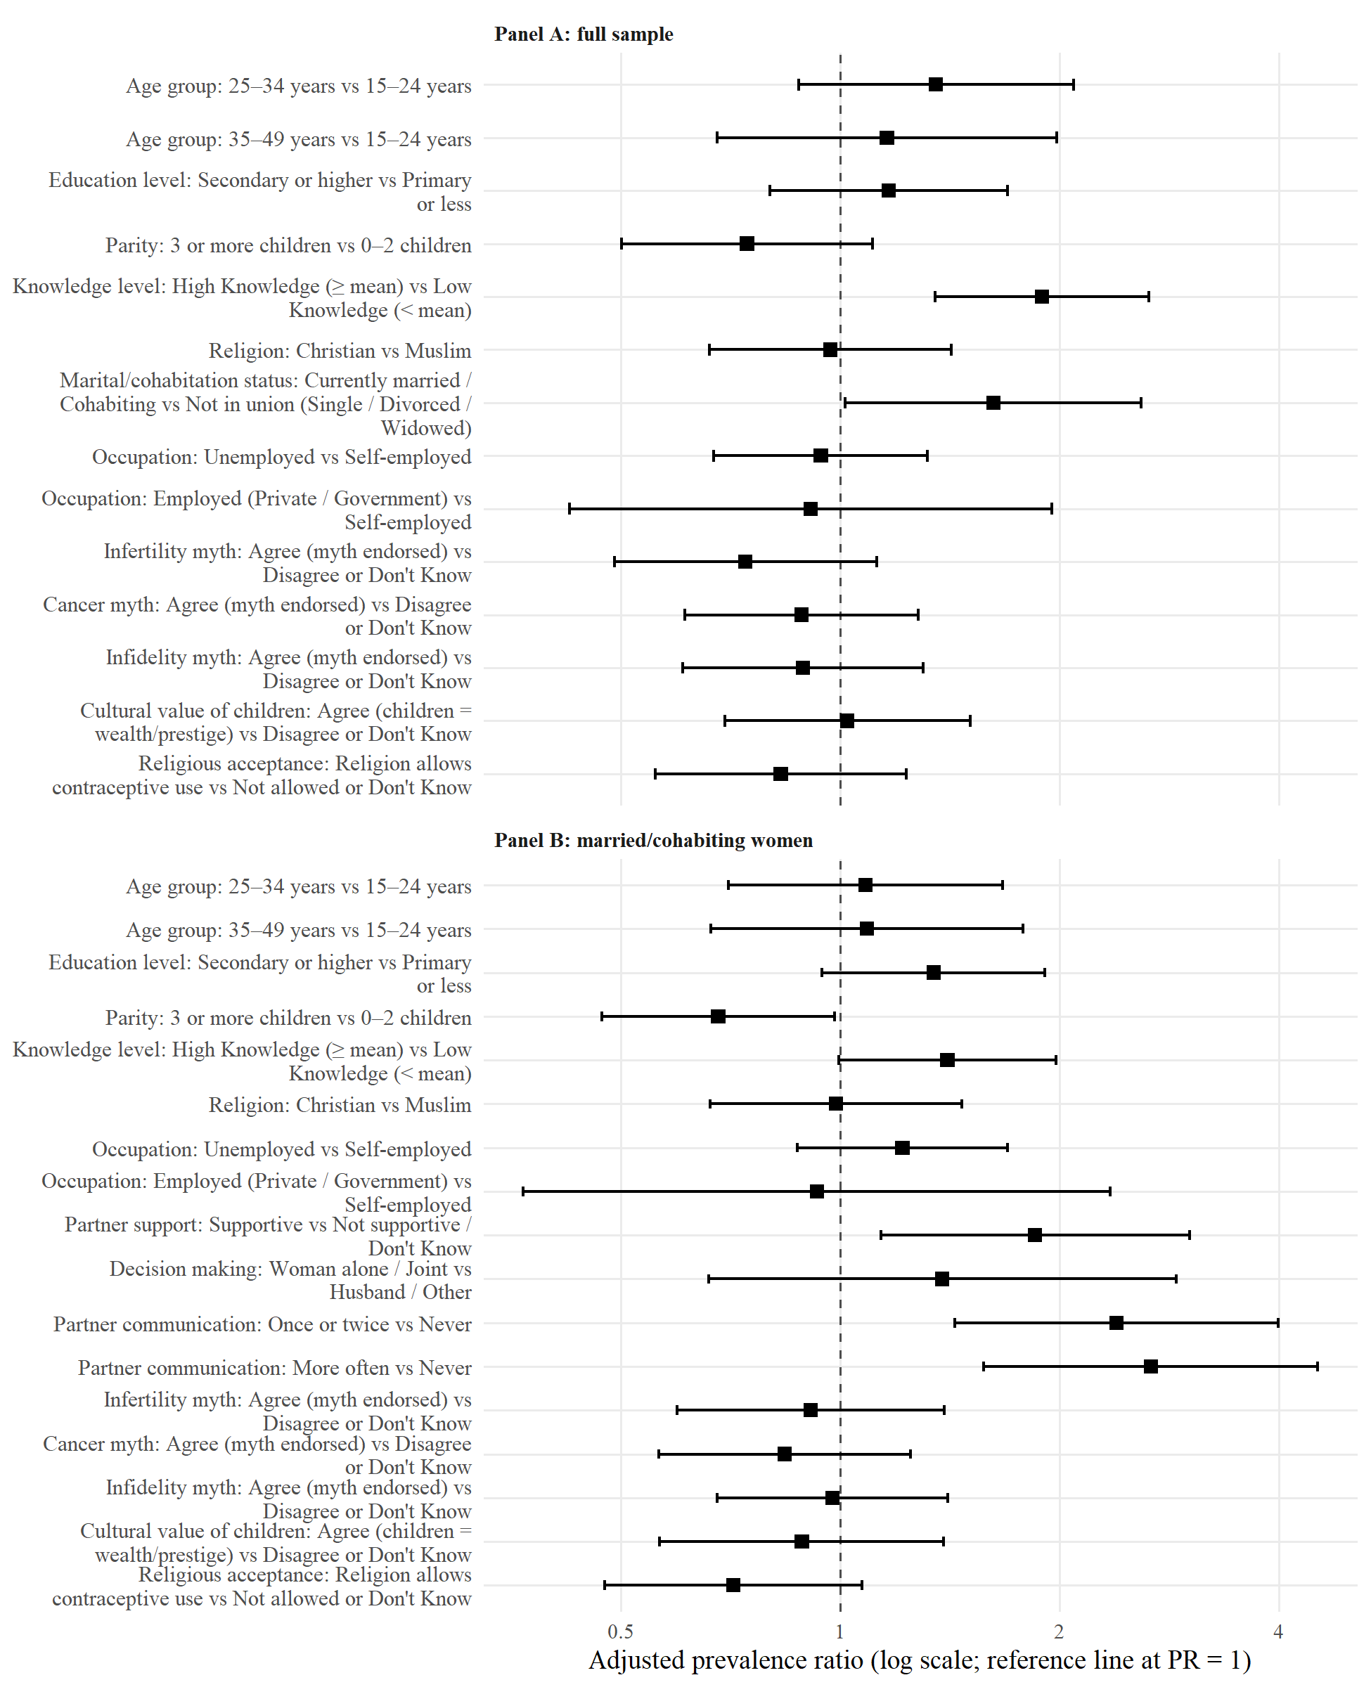
Figure 4.2. Adjusted prevalence ratios and 95% confidence intervals for factors associated with current modern contraceptive use (reference categories as in Table 4.5; the merged no religion/other category is not plotted)

4.8 Summary of Principal Findings
Objective 1: To determine the prevalence of modern contraceptive use. The prevalence of current modern contraceptive use was 25.1% (95% CI 21.1–29.4; n = 105 of 419).
Objective 2: To assess the level of knowledge of modern contraceptive methods. Awareness of individual methods ranged from 25% to 91%, whereas knowledge of individual advantages and side effects was more variable (29% to 79%). The mean composite knowledge score across the 18 items was 9.60 (SD 4.28), with 192 (45.8%) classified as having high knowledge (≥ mean) and 227 (54.2%) as having low knowledge (< mean).
Objective 3: To determine the association between socio-cultural factors and modern contraceptive use. In bivariate analysis, knowledge level, partner support and partner communication were significantly associated with current use. None of the socio-cultural belief factors (myths, cultural value of children, religious acceptance) was significantly associated with current use in bivariate analysis. In the multivariable models, in the full sample, knowledge level: High Knowledge (≥ mean) versus Low Knowledge (< mean) (aPR = 1.89, 95% CI 1.35–2.65, P < 0.001); marital/cohabitation status: Currently married / Cohabiting versus Not in union (Single / Divorced / Widowed) (aPR = 1.62, 95% CI 1.02–2.59, P = 0.043); among currently married or cohabiting women, parity: 3 or more children versus 0–2 children (aPR = 0.68, 95% CI 0.47–0.98, P = 0.040); partner support: Supportive versus Not supportive / Don’t Know (aPR = 1.85, 95% CI 1.14–3.01, P = 0.013); partner communication: Once or twice versus Never (aPR = 2.39, 95% CI 1.44–3.99, P < 0.001); partner communication: More often versus Never (aPR = 2.67, 95% CI 1.57–4.52, P < 0.001).

