International Islamic University Chittagong
Department of Computer Science and Engineering
Mid Project Report
CSE-3532: Tools and Technologies for Internet Programming
SmartShop
Online Product Store
Submitted By
Name | ID
Tafsirul Islam | C243025
Rafi Alam | C243015

Submitted To: ______________________________
GitHub Link: ______________________________
Date of Submission: ______________________

1. Introduction
SmartShop is a simple online shopping website. Users can see products, add them to a cart, use a coupon and buy them with their balance. All product data comes from a public API (FakeStore API). Customer reviews come from a local JSON file.
We built the website with only HTML, Tailwind CSS and plain JavaScript. We did not use any framework like React or Angular, and we did not write any raw CSS. All design is done with Tailwind classes.

2. Objectives
- Build a web page with HTML5 structure.
- Make the design responsive with Tailwind CSS.
- Get data from a REST API with the Fetch API and show it with the DOM.
- Make a cart that updates totals in real time without reloading the page.
- Save user data (balance) in the browser with localStorage.
- Add an extra feature (product sorting) and bonus sections (Contact and About Us).

3. Tools and Technologies
Tool | What We Used It For
HTML5 | Page structure with semantic tags: header, nav, section, aside, footer.
Tailwind CSS (CDN) | All styling and responsive layout. No raw CSS file.
JavaScript (DOM) | All interactive features: slider, cart, balance, sorting, form.
Fetch API | To get products from the API and reviews from the JSON file.
FakeStore API | Public REST API for product data: https://fakestoreapi.com/products
JSON | Reviews are stored in reviews.json.
localStorage | To save the user balance after page reload.
Google Fonts | Inter font for a clean and professional look.
VS Code + Live Server | To write and run the project.
Git and GitHub | To store and share the project.

4. Project Files
We kept the project very small. It has only three main files:
File | Purpose
index.html | The full page layout. Every section of the site is here.
script.js | All JavaScript code. It is split into parts with comments for each feature.
reviews.json | A list of 6 customer reviews (name, comment, rating, date).
README.md | Short guide for the GitHub page.

In script.js we find elements with document.getElementById() and change them with textContent, innerHTML and classList. Each part of the code has a comment with the feature name.

5. Features and How They Work

5.1 Navbar
- The navbar has 5 links: Home, Products, Reviews, About, Contact. There is also a Cart button that shows the number of items.
- It uses the Tailwind classes sticky top-0, so it stays at the top when we scroll.
- Active link: on every scroll, JavaScript checks which section is on the screen and adds a yellow background (bg-yellow-400) to that link.
- On mobile, the links are hidden. A Menu button shows or hides them with classList.toggle("hidden").
document.querySelectorAll("section").forEach((section) => {
if (window.scrollY >= section.offsetTop - 100) currentSection = section.id;
});
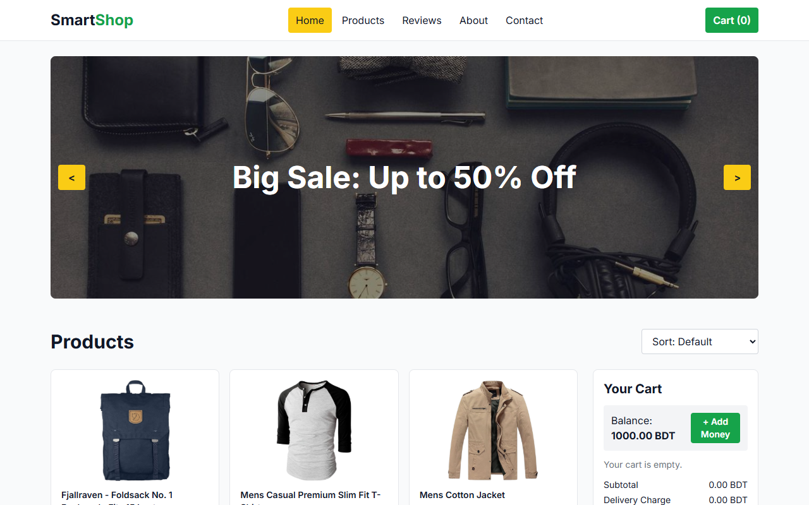
Figure 1: Home page with sticky navbar and banner

5.2 Sliding Banner
- We keep 4 banners in an array. Each banner has an image and a text.
- setInterval() moves to the next banner every 3 seconds (auto slide).
- The < and > buttons call moveBanner(-1) and moveBanner(1) (manual slide).
- After the last banner it goes back to the first one, and before the first one it goes to the last one.
function moveBanner(step) {
bannerIndex = bannerIndex + step;
if (bannerIndex >= banners.length) bannerIndex = 0;
if (bannerIndex < 0) bannerIndex = banners.length - 1;
document.getElementById("bannerImage").src = banners[bannerIndex].image;
document.getElementById("bannerText").textContent = banners[bannerIndex].text;
}
setInterval(() => moveBanner(1), 3000);
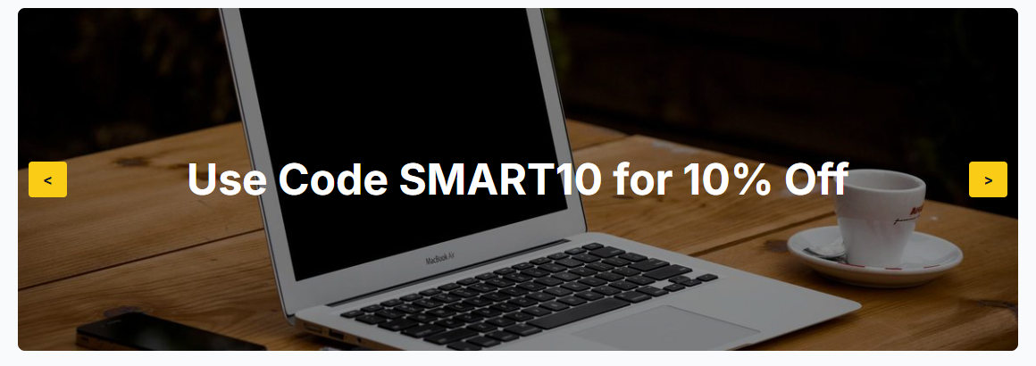
Figure 2: One of the 4 banner slides

5.3 Product Section
- We use fetch() to get 20 products from https://fakestoreapi.com/products.
- response.json() turns the response into a JavaScript array.
- showProducts() uses forEach() to make an HTML card for each product and puts all cards into the page with innerHTML.
- Each card shows the image, title, price, rating and an Add to Cart button.
- We show prices as BDT so they work with the balance system.
fetch("https://fakestoreapi.com/products")
.then((response) => response.json())
.then((data) => {
products = data;
showProducts(products);
});

5.4 Shopping Cart
- The cart is an array. Each item has the product id, title, price and quantity.
- Add to Cart: if the item is already in the cart, quantity goes up by 1. If not, the item is added with quantity 1.
- Remove: filter() makes a new cart without that item.
- After every change, updateCart() draws the cart again and updates all totals. The page never reloads.
- Coupon: if the user types SMART10 and clicks Apply, a 10% discount is added.
How the totals are calculated:
Item | Rule
Subtotal | Sum of (price x quantity) for every item
Delivery Charge | 50 BDT (only when the cart is not empty)
Shipping Cost | 30 BDT (only when the cart is not empty)
Discount | 10% of subtotal when coupon SMART10 is applied
Total | Subtotal + Delivery + Shipping - Discount

let subtotal = 0, delivery = 0, shipping = 0, discount = 0;
cart.forEach((item) => {
subtotal = subtotal + item.price * item.quantity;
});
if (cart.length > 0) {
delivery = 50;
shipping = 30;
}
if (couponApplied) discount = subtotal * 0.1;
const total = subtotal + delivery + shipping - discount;
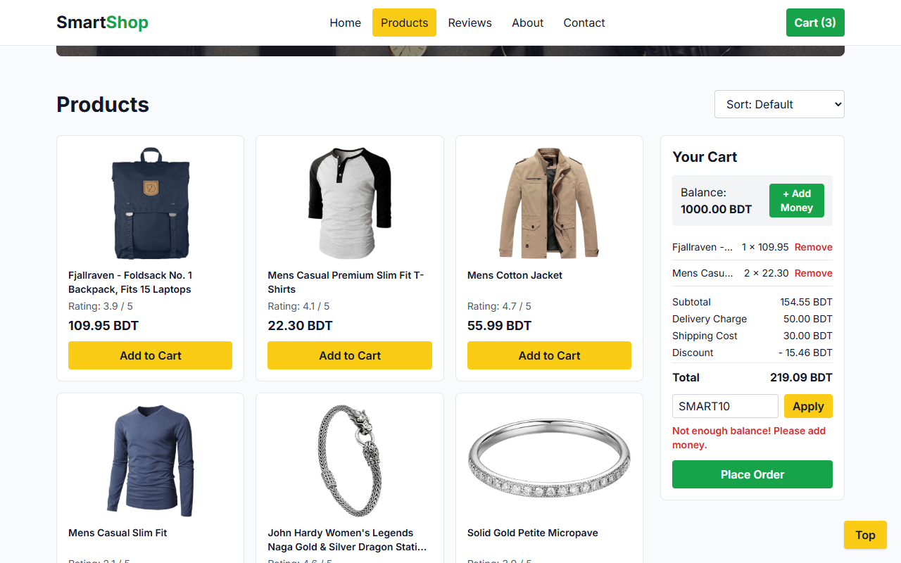
Figure 3: Cart with coupon applied and a low balance warning

5.5 Review Section
- Reviews are stored in a local file named reviews.json.
- We load it with fetch("reviews.json"), the same way as the products.
- Each review shows the name, comment, rating (as stars) and date.
- It works like the banner: it changes every 4 seconds and also has Prev and Next buttons.
- Stars are made with "★".repeat(rating) + "☆".repeat(5 - rating).
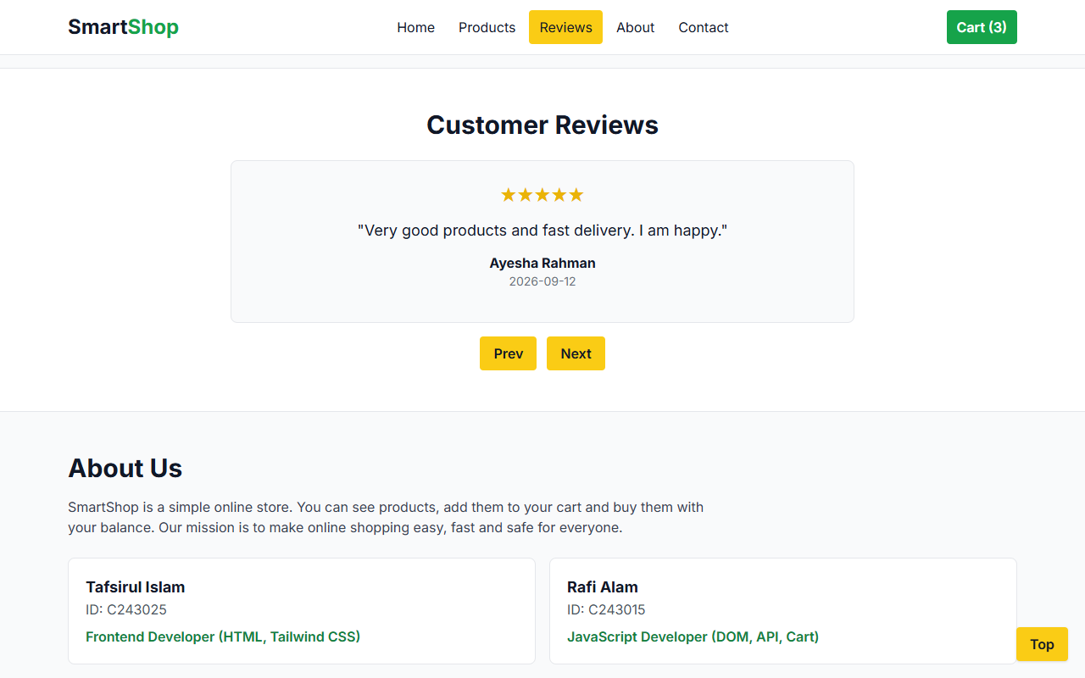
Figure 4: Review carousel and About Us section

5.6 User Balance System
- The user starts with 1000 BDT.
- When the user clicks Add to Cart, we add the item and check the new total. If the total is more than the balance, we take the item back out and show a red warning: "Not enough balance! Please add money."
- The Add Money button adds 1000 BDT to the balance.
- Place Order takes the total from the balance and empties the cart.
- The balance is saved in localStorage, so it stays the same after a page reload.
// Use the saved balance, or 1000 the first time
let balance = Number(localStorage.getItem("balance")) || 1000;

function addMoney() {
balance += 1000;
showBalance(); // shows it and saves it in localStorage
}

5.7 Additional Feature: Product Sorting
- A dropdown lets the user sort products: Default, Price Low to High, Price High to Low.
- We first copy the products array with products.slice() so the original order is not lost.
- Then we use sort(). (a, b) => a.price - b.price puts the cheap items first. (a, b) => b.price - a.price puts the expensive items first.
function sortProducts() {
const sortType = document.getElementById("sortSelect").value;
const sortedProducts = products.slice();
if (sortType === "low") sortedProducts.sort((a, b) => a.price - b.price);
if (sortType === "high") sortedProducts.sort((a, b) => b.price - a.price);
showProducts(sortedProducts);
}
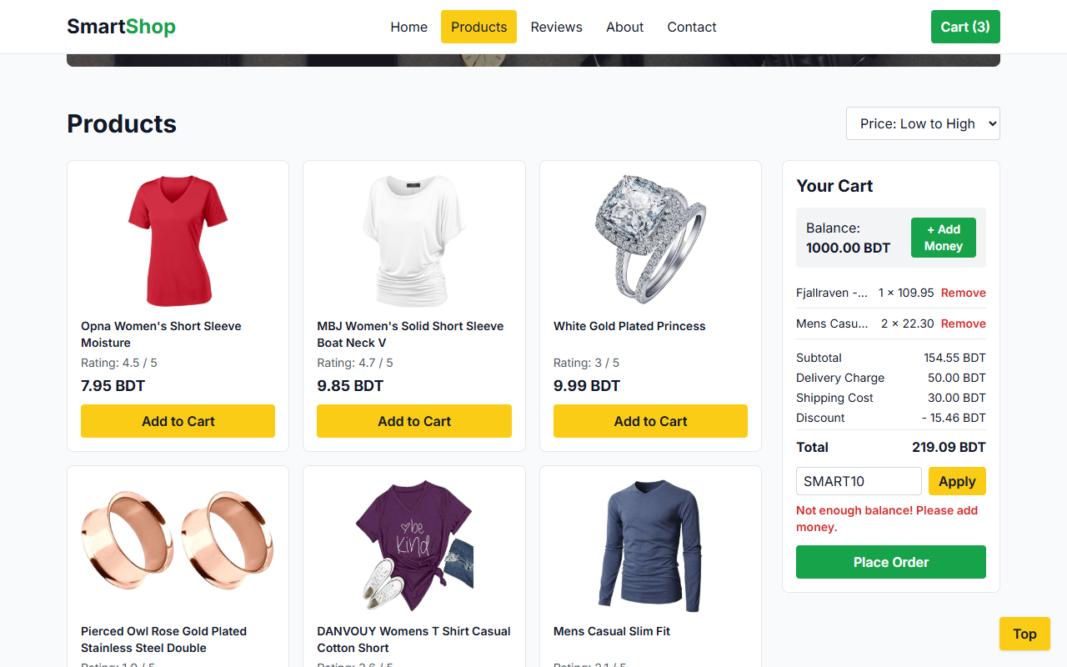
Figure 5: Products sorted by price, low to high

5.8 Bonus 1: Contact Section
- A form with Name, Email and Message fields.
- event.preventDefault() stops the page from reloading when the form is sent.
- Validation: all fields must be filled, and the email must have "@" and ".".
- If something is wrong, a red message is shown. If everything is fine, a green thank-you message with the user's name is shown and the form is cleared.
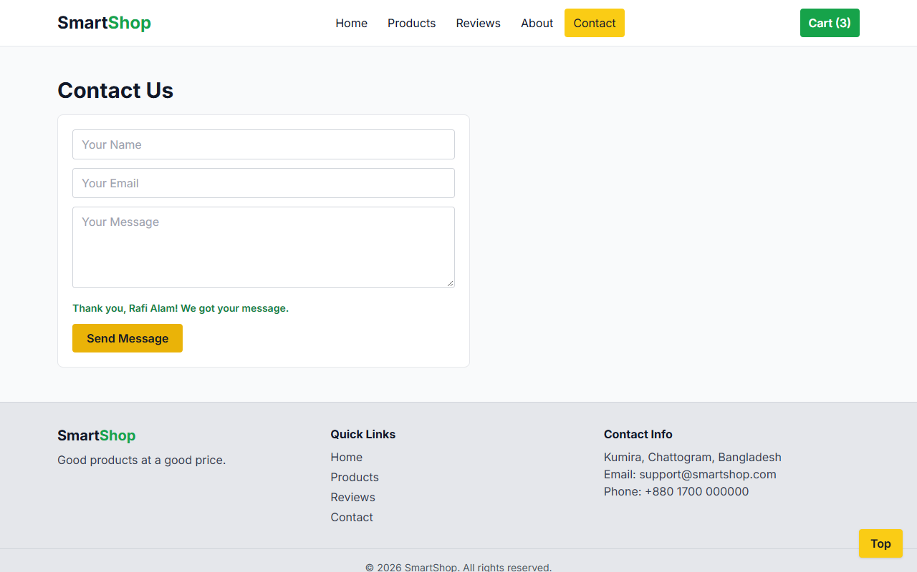
Figure 6: Contact form with thank-you message and footer

5.9 Bonus 2: About Us Section
This section has a short text about SmartShop, our mission, and a card for each team member with name, ID and role (see Figure 4).

5.10 Footer and Back to Top
- The footer has the shop name, quick links, contact info and copyright text.
- A Top button appears after the user scrolls down 300px. Clicking it runs window.scrollTo(0, 0) to go back to the top.

5.11 Responsive Design
We used Tailwind responsive prefixes like sm:, md: and lg:. For example, products show in 1 column on mobile, 2 on small screens and 3 on large screens. On mobile, the menu is hidden behind a Menu button.
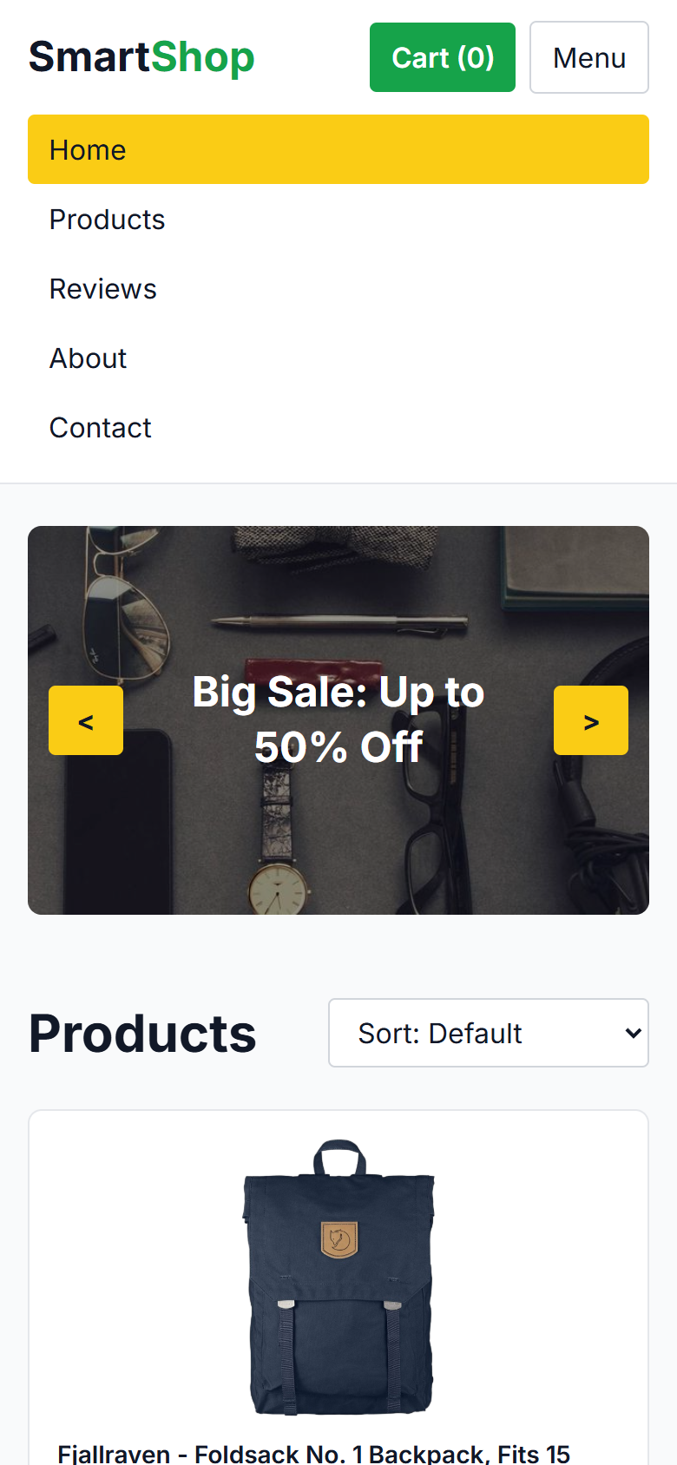
Figure 7: Mobile view with the menu open

6. How to Run the Project
- Download or clone the project from GitHub.
- Open the folder in VS Code.
- Right click index.html and choose "Open with Live Server".
- An internet connection is needed for Tailwind CSS, Google Fonts and the product API.
Note: we use Live Server because the browser does not allow fetch() to read a local JSON file when the page is opened by double click.

7. Testing
We tested every feature in the Chrome browser. All tests passed.
Test | Expected Result | Result
Open the page | 20 products load from the API | Pass
Add 1 bag and 2 T-shirts | Subtotal 154.55, Total 234.55 | Pass
Apply coupon SMART10 | Discount 15.46, Total 219.09 | Pass
Apply a wrong coupon | "Invalid coupon code." message | Pass
Add a 999.99 BDT item with 1000 BDT balance | Warning shown, item not added | Pass
Click Add Money | Balance goes from 1000 to 2000 | Pass
Reload the page | Balance stays the same | Pass
Remove an item | Item removed, totals updated | Pass
Sort Low to High / High to Low | First item is 7.95 / 999.99 BDT | Pass
Click Place Order | Total taken from balance, cart empty | Pass
Click Next on reviews | Next review is shown | Pass
Send empty contact form | "Please fill in all fields." | Pass
Send form with email "rafi" | "Please enter a valid email." | Pass
Send a correct form | Thank-you message is shown | Pass
Scroll down and click Top | Page goes back to the top | Pass
Open on a 390px wide phone screen | No side scroll, Menu button works | Pass

8. CO2 Mapping
Project Feature | Technology | How We Did It
Website Structure | HTML5 | Semantic tags: header, nav, section, aside, footer
Responsive Design | Tailwind CSS | Responsive classes like sm:, md:, lg:
Dynamic Interaction | JavaScript, DOM | innerHTML, textContent and classList change the page
Product Data Fetching | HTTP, Fetch API, REST, JSON | fetch() from FakeStore API
Shopping Cart | JavaScript Events, DOM | onclick events and real-time totals
Reviews Section | JSON, Local Data | fetch() from reviews.json
User Balance System | localStorage, JavaScript | Balance saved with localStorage.setItem()
Contact Form | HTML Forms, Validation | Form checked with JavaScript before the message
Navigation and Scrolling | Hyperlinks, DOM Events | Section links, scroll event, Back to Top

9. Problems We Faced
- Problem: reviews.json did not load when we opened index.html by double click. Solution: we used Live Server.
- Problem: the sticky navbar covered section titles after clicking a link. Solution: we added the Tailwind class scroll-mt-20 to each section.
- Problem: sorting changed the original product list. Solution: we copy the array with products.slice() before sorting.
- Problem: on mobile, the banner text went under the arrow buttons. Solution: we added side padding (px-16) to the text box.

10. Conclusion
In this project we made a working online store with only HTML, Tailwind CSS and JavaScript. We learned how to get data from an API with fetch(), how to change the page with the DOM, how to save data with localStorage and how to make a responsive design with Tailwind CSS. The project covers all the required features, the sorting feature and two bonus sections. So it fulfills CO2 of CSE-3532.

11. Team Members and Work
Name | ID | Work
Tafsirul Islam | C243025 | Page layout with HTML and Tailwind CSS, navbar, banner, reviews, About Us, footer, report
Rafi Alam | C243015 | JavaScript: API fetch, product cards, cart, coupon, balance, sorting, contact form, testing

