Mini-workshop on the Management of Electronic Tagging Data

62nd Tuna Conference

When: 19:30-21:00 on May 17, 2011 (tentative)

Where: Pineview at UCLA Conference Center

Who: Chi Hin Lam (Tim) of USC and Vardis Tsontos of SWFSC

Why:
- We love using electronic tags
- We are very good at deploying and getting tag reporting/ recovery
- We end up with a lot, yes a LOT of data files

What:
- There is no easy way to work with our data, apart from using manufacturer provided software or spreadsheets
- It is frustrating to keep opening many separate files
- I use tags from different manufacturers, and I understand the files won’t talk to each other, but I need to them to!
- It is hard to keep track and manage my datasets for long-term archiving.
- Resources are there (http://www-wram.slu.se/biologging-db-workshop/), but they are not readily available or obvious to me how I can implement it
- I just don’t have the time, ok?

How:
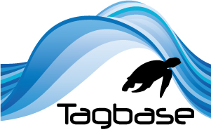

Tagbase is a free, accessible data management solution for your data

Come see an extended overview of the software

Even bring your own datasets and give it a try

Join our discussion to brainstorm and come up with best practices for our data management needs

Follow us at www.tagbase.org

