
Getting Started Guide

Chapter 6
Getting Started with Impress
Presentations in LibreOffice

Copyright
This document is Copyright © 2018 by the LibreOffice Documentation Team. Contributors are listed below. You may distribute it and/or modify it under the terms of either the GNU General Public License (http://www.gnu.org/licenses/gpl.html), version 3 or later, or the Creative Commons Attribution License (http://creativecommons.org/licenses/by/4.0/), version 4.0 or later.
All trademarks within this guide belong to their legitimate owners.

Contributors
Dave Barton | Amanda M Labby | Jorge Rodríguez

Feedback
Please direct any comments or suggestions about this document to the Documentation Team’s mailing list: documentation@global.libreoffice.org
Note: Everything you send to a mailing list, including your email address and any other personal information that is written in the message, is publicly archived and cannot be deleted.

Acknowledgments
This chapter is adapted and updated from Chapter 6 of Getting Started with OpenOffice.org 3.3. The contributors to that chapter and subsequent revisions are:
Agnes Belzunce | Barbara M. Tobias | Dan Lewis
Jean Hollis Weber | Peter Hillier-Brook | Claire Wood
Stefan A. Keel | Linda Worthington | Gary Schnabl
Michele Zarri | Peter Schofield | Hazel Russman
Kevin O’Brien | Ron Faile Jr. | Olivier Hallot

Publication date and software version
Published February 2018. Based on LibreOffice 6.0.

Note for Mac users
Some keystrokes and menu items are different on a Mac from those used in Windows and Linux. The table below gives some common substitutions for the instructions in this chapter. For a more detailed list, see the application Help.
Windows or Linux | Mac equivalent | Effect
Tools > Options menu selection | LibreOffice > Preferences | Access setup options
Right-click | Control+click or right-click depending on computer setup | Opens a context menu
Ctrl (Control) | ⌘ (Command) | Used with other keys
F5 | Shift+⌘+F5 | Open the Navigator
F11 | ⌘+T | Open the Styles and Formatting window

Contents
Copyright 2
Contributors 2
Feedback 2
Acknowledgments 2
Publication date and software version 2
Note for Mac users 2
What is Impress? 5
Starting Impress 6
Main Impress window 6
Workspace 7
Slides pane 7
Sidebar 8
Toolbars 9
Status bar 9
Workspace views 10
Normal view 10
Outline view 10
Notes view 11
Handout view 12
Slide Sorter view 13
Customizing Slide Sorter view 13
Moving a slide using Slide Sorter 14
Selecting and moving groups of slides 14
Working in Slide Sorter view 14
Creating a new presentation using the Presentation Wizard 14
Formatting a presentation 18
Inserting slides 18
New slide 18
Duplicate slide 19
Selecting slide layout 19
Modifying slide elements 21
Adding text 21
Adding objects 22
Modifying the appearance of all slides 22
Modifying the slide show 22
Adding and formatting text 22
Using AutoLayout text boxes 23
Using text boxes 23
Vertical text 23
Quick font resizing 24
Pasting text 24
Pasting unformatted text 24
Formatting pasted text 25
Creating bulleted and numbered lists 26
AutoLayout text boxes 26
Text boxes 26
Creating a new outline level 26
Changing list appearance 27
Adding pictures, tables, charts, and media 28
Adding pictures 28
Adding tables 28
Adding charts 30
Adding media files 30
Adding graphics, spreadsheets, and other objects 30
Working with slide masters and styles 30
Styles 31
Slide masters 31
Creating a slide master 31
Applying a slide master 32
Loading additional slide masters 33
Modifying a slide master 34
Adding text, footers, and fields to all slides 35
Text 35
Footers 35
Fields 36
Adding comments to a presentation 37
Creating a photo album 38
Setting up a slide show 39
One slide set – multiple presentations 39
Hiding slides 39
Custom slide shows 39
Slide transitions 39
Slide advance 40
Running a slide show 40
Presenter Console 40
Using Impress Remote control 41
Getting Impress Remote 41
Connecting the mobile device to the computer 41
Enabling remote control in Impress 41
Running a slide show with Impress Remote 42

What is Impress?
Impress is the presentation (slide show) program included in LibreOffice. You can create slides that contain many different elements, including text, bulleted and numbered lists, tables, charts, and a wide range of graphic objects such as clipart, drawings, and photographs. Impress also includes a spelling checker, a thesaurus, text styles, and background styles.
This chapter includes instructions, screenshots, and hints to guide you through the Impress environment while designing your presentations. Although more difficult designs are mentioned in this chapter, explanations for creating them are in the Impress Guide. If you have a working knowledge of how to create slide shows, we recommend you use the Impress Guide for your source of information.
To use Impress for more than very simple slide shows requires some knowledge of the elements which the slides contain. Slides that contain text use styles to determine the appearance of that text. Creating drawings in Impress is similar to the Draw program included in LibreOffice. For this reason, we recommend that you also see Chapter 3 Using Styles and Templates and Chapter 7 Getting Started with Draw in this guide. You may also wish to consult the Draw Guide for more details on how to use the drawing tools.

Starting Impress
When you start Impress for the first time, Impress window opens with the Presentation Template dialog displayed. (Figure 1)
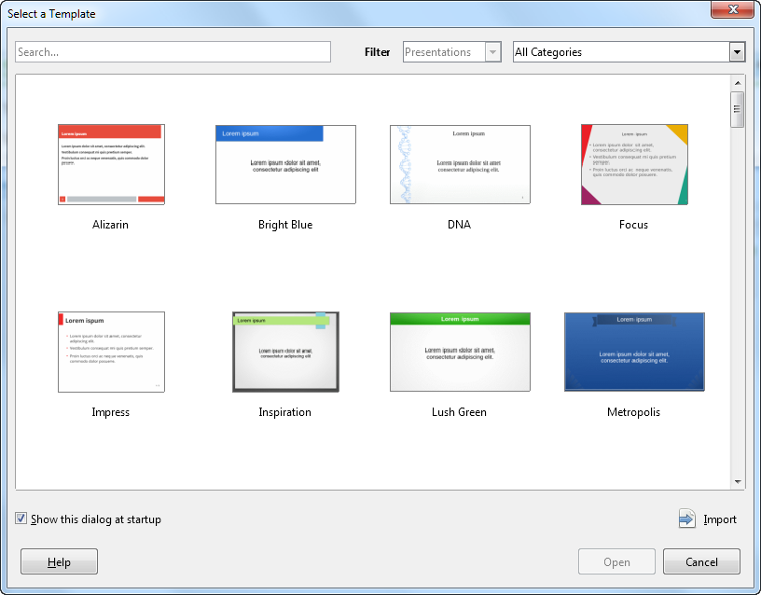Figure 1: Template Selection Dialog
You can turn off the option to start Impress with a choice of available templates by unchecking the “Show this dialog at startup” box in the dialog, or through the Tools > Options > LibreOffice Impress > General option and deselecting Start with Template Selection.
For more detailed information about Templates, please read Chapter 3 of this guide.

Main Impress window
The main Impress window (Figure 2) has three parts: the Slides pane, Workspace, and Sidebar. Additionally, several toolbars can be displayed or hidden during the creation of a presentation.
- Tip
You can close the Slides pane or the Sidebar by clicking the X in the upper right corner of each pane or go to View > Slide Pane or View > Sidebar on the Menu bar to deselect the pane. To reopen a pane, go to View on the Menu bar and select Slide Pane or Sidebar again.
You can also maximize the Workspace area by clicking on the Hide/Show marker in the middle of the vertical separator line (highlighted in Figure 2). Using the Hide/Show marker hides, but does not close, the Slide pane or Sidebar. To restore a pane, click again on its Hide/Show marker.

Workspace
The Workspace (normally in the center of the main window) opens in the Normal view. It has five tabs: Normal, Outline, Notes, Handout, and Slide Sorter. These five tabs are called View buttons. Since LibreOffice 5.1, the View buttons are not shown by default; but they can be activated by choosing View > Modes Tab Bar from the menu bar.
The Workspace below the View buttons changes with the chosen view. The workspace views are described in “Workspace views” on page 10.
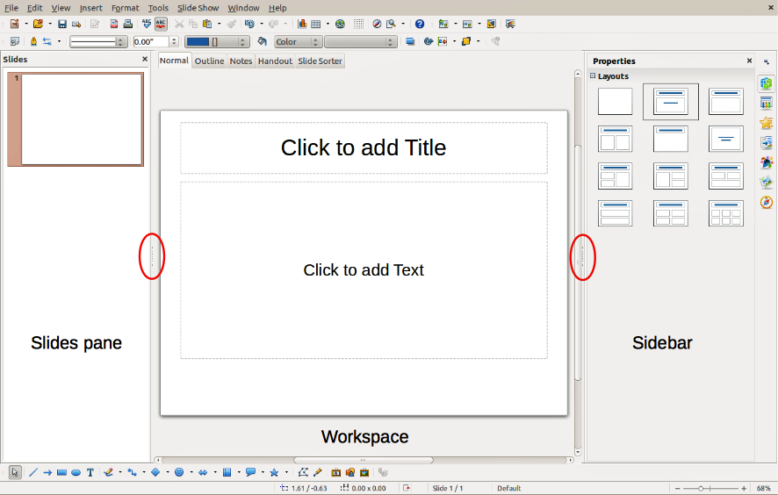
Figure 2: Main window of Impress; ovals indicate the Hide/Show markers. The View Tab Bar is visible in this image.

Slides pane
The Slides pane contains thumbnail pictures of the slides in your presentation in the order in which they will be shown, unless you change the slide show order. Clicking a slide in this pane selects it and places it in the Workspace. When a slide is in the Workspace, you can make changes to it.
Several additional operations can be performed on one or more slides simultaneously in the Slides pane:
- Add new slides to the presentation.
- Mark a slide as hidden so that it will not be shown as part of the presentation.
- Delete a slide from the presentation if it is no longer needed.
- Rename a slide.
- Duplicate a slide (copy and paste).
- Move a slide to another place in the slide stack by dragging and dropping it to the desired position. If the position is not visible in the slide pane, the slide stack will scroll up or down accordingly.
It is also possible to perform the following operations, although there are more efficient methods than using the Slides pane:
- Change the slide transition following the selected slide or after each slide in a group.
- Change the slide design.
- Change slide layout for a group of slides simultaneously.

Sidebar
The Sidebar has seven sections. To expand a section you want to use, click on its icon or click on the small triangle at the top of the icons and select a section from the drop down list. Only one section at a time can be open.
Properties
Shows the layouts included within Impress. You can choose the one you want and use it as it is, or modify it to meet your own requirements. However, it is not possible to save customized layouts.
Master Pages
Here you define the page (slide) style for your presentation. Impress includes several designs for Master Pages (slide masters). One of them – Default – is blank, and the rest have background and styled text.
- Tip
Go to Format > Styles > Styles and Formatting on the Menu bar or press the F11 key to open the Styles and Formatting dialog, where you can modify the styles used in any master page to suit your purpose. This can be done at any time.
Custom Animation
A variety of animations can be used to emphasize or enhance different elements of each slide. The Custom Animation section provides an easy way to add, change, or remove animations.
Slide Transition
Provides a number of slide transition options. The default is set to No Transition, in which the following slide simply replaces the existing one. However, many additional transitions are available. You can also specify the transition speed (slow, medium, fast), choose between an automatic or manual transition, and choose how long the selected slide should be shown (automatic transition only).
Styles and Formatting
Here you can edit and apply graphics styles and create new ones, but you can only edit existing presentation styles. When you edit a style, the changes are automatically applied to all of the elements formatted with this style in your presentation. If you want to ensure that the styles on a specific slide are not updated, create a new master page for the slide.
Gallery
Opens the Impress gallery from which you can insert an object into your presentation either as a copy or as a link. A copy of an object is independent of the original object, so changes to the object have no effect on the copy. A link remains dependent on the original object and changes to the object are reflected in the link.
Navigator
Opens the Impress navigator, in which you can quickly move to another slide or select an object on a slide. It is recommended to give slides and objects in your presentation meaningful names so that you can easily identify them when using the navigator.

Toolbars
Many toolbars can be used during slide creation. They can be displayed or hidden by going to View > Toolbars on the Menu bar and selecting from the context menu.
You can also select the icons that you wish to appear on each toolbar. For more information, refer to Chapter 1, Introducing LibreOffice.
Many of the toolbars in Impress are similar to the toolbars in Draw. Refer to the Draw Guide for details on the functions available and how to use them.

Status bar
The Status bar (Figure 3), located at the bottom of the Impress window, contains information that you may find useful when working on a presentation. For details on the contents and use of these fields, see Chapter 1 Introducing LibreOffice in this guide and the Impress Guide Chapter 1 Introducing Impress.
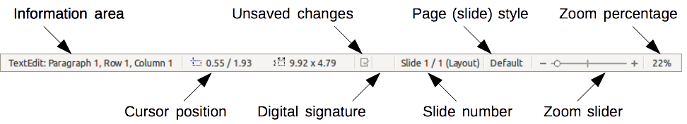
Figure 3: Status bar
Note
The sizes are given in the current measurement unit (not to be confused with the ruler units). This measurement unit is defined in Tools > Options > LibreOffice Impress > General.
From left to right, you will find:
- Information area – changes depending on the selection. For example:
Example selection | Examples of information shown
Text area | Text Edit: Paragraph x, Row y, Column z
Charts, spreadsheets | Embedded object (OLE) “ObjectName” selected
Graphics | Bitmap with transparency selected
- Cursor position – the position of the cursor or of the top left corner of the selection measured from the top left corner of the slide, followed by the width and height of the selection or text box where the cursor is located.
- Unsaved changes – a flag indicating that the file needs saving. Double-clicking on this flag opens the file save dialog.
- Digital signature – a flag indicating whether the document is digitally signed. After the file has been saved, double-clicking on this flag opens the digital signatures dialog.
- Slide number – the slide number currently displayed in the Workspace and the total number of slides in the presentation.
- Page (slide) style – the style associated with the slide, handout, or notes page currently in the Workspace. Double-clicking on the style name opens the slide design dialog.
- Zoom slider – adjusts the zoom percentage of the Workspace displayed.
- Zoom percentage – indicates the zoom percentage of the Workspace displayed. Double-clicking on zoom percentage opens the zoom and layout dialog.
You can hide the Status Bar and its information by going to View on the Menu bar and deselecting Status Bar.

Workspace views
Each of the Workspace views is designed to ease the completion of certain tasks. It is therefore useful to familiarize yourself with them in order to accomplish those tasks quickly.
Note
Beginning with LibreOffice 5.1, the Workspace View tab bar is hidden by default. Turn it visible by choosing View > Modes Tab Bar.
Note
Each Workspace view displays a different set of toolbars when selected. These toolbar sets can be customized by going to View > Toolbars on the Menu bar, then check or uncheck the toolbar you want to add or remove.

Normal view
Normal view is the main view for working with individual slides. Use this view to format and design and to add text, graphics, and animation effects.
To place a slide in the slide design area (Normal view) (Figure 2 on page 7), click the slide thumbnail in the Slides pane or double-click it in the Navigator (see Chapter 1 Introducing LibreOffice and the Impress Guide for more information on the Navigator).

Outline view
Outline view (Figure 4) contains all the slides of the presentation in their numbered sequence. It shows topic titles, bulleted lists, and numbered lists for each slide in outline format. Only the text contained in the default text boxes in each slide is shown, so if your slide includes other text boxes or drawing objects, the text in these objects is not displayed. Slide names are not included either.
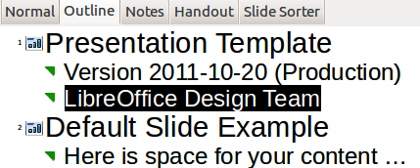
Figure 4: Outline view
Figure 5: Outline level and movement arrows in Text Formatting toolbar
Use Outline view for the following purposes:
- Quickly inserting text for fast content creation or editing, when formatting and adding graphic objects is postponed until the final stages of creating the presentation.
- Making changes in the text of a slide:
- Adding and deleting the text in a slide as in the Normal view.
- Moving the paragraphs of text in the selected slide up or down by using the up and down arrow buttons (Move Up or Move Down) on the Text Formatting toolbar (highlighted in Figure 5).
- Changing the outline level for any of the paragraphs in a slide using the left and right arrow buttons (Promote or Demote) on the Text Formatting toolbar.
- Moving a paragraph and changing its outline level at the same time using a combination of these four arrow buttons.
- Comparing slides with your outline (if you have prepared one in advance). If you notice from your outline that another slide is needed, you can create it directly in the Outline view or you can return to the Normal view to create it.

Notes view
Use the Notes view (Figure 6) to add notes to a slide. These notes are for your information and are not seen by the audience when the presentation is shown.
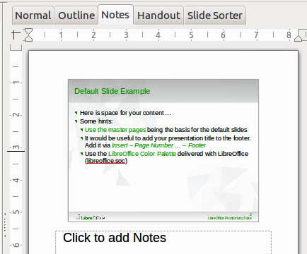
Figure 6: Notes view
- Click the Notes tab in the Workspace.
- Select the slide to which you want to add notes: click the slide in the Slides pane, or double-click the slide name in the Navigator.
- In the text box below the slide, click on the words Click to add notes and begin typing.
You can resize the Notes text box using the colored resizing handles which appear when you click on the edge of the box. You can also move the box by placing the pointer on the border, then clicking and dragging. To make changes in the text style, click on the Styles and Formatting icon on the Sidebar.

Handout view
Handout view is for setting up the layout of your slide for a printed handout. Click the Handout tab in the workspace and the Layouts section opens on the Sidebar (Figure 7). Here you can choose to print 1, 2, 3, 4, 6, or 9 slides per page. If the Layouts section does not open, then click on the Properties icon at the side of the Sidebar.
Use this view also to customize the information printed on the handout. Refer to Chapter 10, Printing, E-mailing, Exporting, and Saving Slide Shows, in the Impress Guide for instructions on printing slides, handouts, and notes.
Go to Insert > Page Number, Insert > Fields, or Insert > Header and Footer on the Menu bar and the Header and Footer dialog opens. Click on the Notes and Handouts tab (Figure 8) and select the elements you want to appear on each handout page and their contents. More details on how to use this dialog are provided in the Impress Guide.
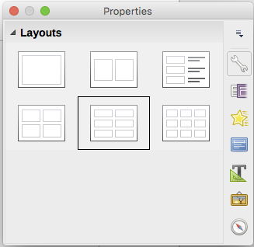
Figure 7: Handout layouts
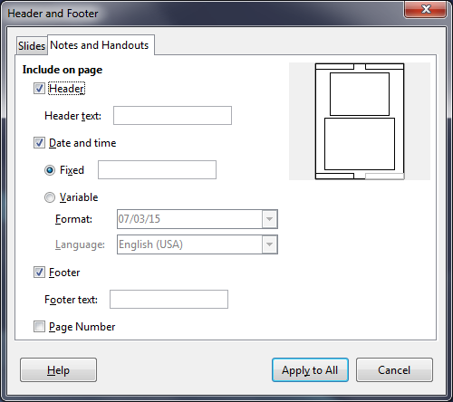
Figure 8: Header and Footer dialog – Notes and Handouts page

Slide Sorter view
Slide Sorter view (Figure 9) contains all of the slide thumbnails. Use this view to work with a group of slides or with only one slide.
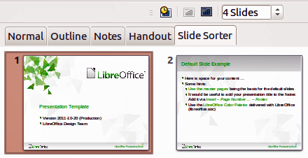
Figure 9: Slide Sorter view

Customizing Slide Sorter view
To change the number of slides per row:
- Go to View > Toolbars and select Slide Sorter and Slide View to show or hide the Slide Sorter and Slide View toolbars (Figure 10).
- Adjust the number of slides (up to a maximum of 15).

Figure 10: Slide Sorter and Slide View toolbars

Moving a slide using Slide Sorter
To move a slide in a presentation in the Slide Sorter:
- Click the slide and the slide is highlighted (Figure 9).
- Drag and drop the slide to the location you want.

Selecting and moving groups of slides
To select a group of slides, use one of these methods:
- Using the Ctrl key – click on the first slide and, while pressing the Ctrl key, select the other desired slides.
- Using the Shift key – click on the first slide, and while pressing the Shift key, select the final slide in the group. This selects all of the other slides between the first and the last slide selected.
- Using the mouse – click slightly to one side (left or right) of the first slide to be selected. Hold down the left mouse button and drag the cursor until all of the slides you want selected are highlighted.
To move a group of slides, select them and then drag and drop the group to their new location.

Working in Slide Sorter view
You can work with slides in the Slide Sorter view just as you can in the Slide pane. To make changes, right-click a slide and choose any of the following from the context menu:
- New Slide – adds a new slide after the selected slide (see “New slide” on page 14).
- Duplicate Slide – creates a duplicate of the selected slide and places the new slide immediately after the selected slide (see “Duplicate slide” on page 15).
- Delete Slide – deletes the selected slide.
- Rename Slide – allows you to rename the selected slide.
- Slide Layout – allows you to change the layout of the selected slide.
- Slide Transition – allows you to change the transition of one or a group of selected slides.
- Hide Slide – any slides that are hidden are not shown in the slide show.
- Cut – removes the selected slide and saves it to the clipboard.
- Copy – copies the selected slide to the clipboard without removing it.
- Paste – inserts a slide from the clipboard after the selected slide.

Formatting a presentation
A new presentation contains only one empty slide. In this section we will start adding new slides and preparing them for the intended contents.

Inserting slides

New slide
A new slide can be inserted into a presentation after the selected slide as follows:
- Go to Slide on the Menu bar and select New Page/Slide.Or, right-click on a slide in the Slides Pane or Slide Sorter view and select New Slide from the context menu.
- Or, right-click in an empty space in the Workspace and select Slide > New Slide from the context menu.
- Or click the NewPage/Slide icon in the Presentation toolbar. You can also select the desired layout of the new slide if you click on the small downward arrow of the icon. If the Presentation toolbar is not visible, go to View > Toolbars on the Menu bar and select Presentation from the list.
- Or use keyboard : CTRL- M to insert new one.

Duplicate slide
Sometimes, rather than starting from a new slide you may want to duplicate a slide already included in your presentation. To duplicate a slide:
- Select the slide you want to duplicate from the Slides Pane.
- Go to Slide on the Menu bar and select Duplicate Page/Slide.
- Or, right-click on the slide in the Slides Pane or Slide Sorter view and select Duplicate Slide from the context menu.
- Or, right-click on a slide in the Workspace and select Slide > Duplicate Slide from the context menu.
- Or, click on the triangle to the right of the Slide icon in the Presentation toolbar and select Duplicate Page/Slide from the context menu. If the Presentation toolbar is not visible, go to View > Toolbars on the Menu bar and select Presentation from the list.
- A duplicate slide is inserted after the selected slide in the presentation.

Selecting slide layout
When creating a presentation, the first slide is normally a title slide. You can use either a blank layout or one of the title layouts as your title slide.
Click on the Slide Layout icon on the Presentation Toolbar to open Layouts section and display the available layouts
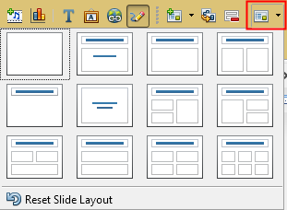Figure 11: Available slide layouts
Or
Click on the Properties icon  at the side of the Sidebar to open Layouts section and display the available layouts (Figure 12). The layouts included in LibreOffice range from a blank slide to a slide with six contents boxes and a title.
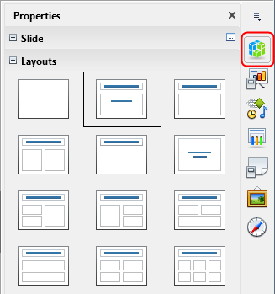
Figure 12: Available slide layouts
To create a title, if one of the title layouts has been selected, click on Click to add title and then type the title text. To add text content, depending on the slide layout selected, click on Click to add text. To adjust the formatting of the title, subtitle or content modify the presentation style; see the Impress Guide Chapter 2 Using Slide Masters, Styles, and Templates.
Note
Text and graphical elements can be readjusted at any time during the preparation of the presentation, but changing the layout of a slide that already contains some content can have an effect on the content format. Therefore, it is recommended that you pay particular attention to the layout you select to prevent any loss of content.
- Tip
To view the names for the included layouts, use the Tooltip feature: position the cursor on an icon in the Layout section (or on any toolbar icon) and its name will be displayed in a small rectangle.
In Tools > Options > LibreOffice > General > Help, select the Extended tips option to get more detailed tooltip information.
To select or change the layout of a slide, select the slide in the Slides Pane so that it appears in the Workspace and select the desired layout from the Layouts section in the Sidebar. Several layouts contain one or more content boxes. Each of these content boxes can be configured to contain text, movies, images, charts or tables.
You can choose the type of content by clicking on the corresponding icon that is displayed in the middle of the content box as shown in Figure 13. If you intend to use the content box for text, click on Click to add text.
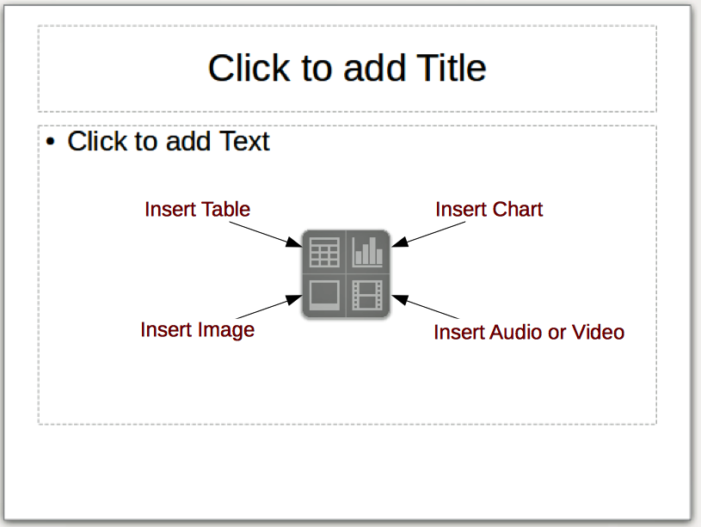
Figure 13: Selecting content type

Modifying slide elements
A slide contains elements that were included in the slide master, as well as those elements included in the selected slide layout. However, it is unlikely that the predefined layouts will suit all your needs for your presentation. You may want to remove elements that are not required or insert objects such as text and graphics.
Although Impress does not allow you to create new layouts, you can resize and move the layout elements. It is also possible to add elements without being limited to the size and position of the layout boxes.
To resize a contents box, click on the outer frame so that the resizing handles are displayed. To move it, place the mouse cursor on the frame so that the cursor changes shape. You can now click and drag the contents box to a new position on the slide.
To remove any unwanted element:
- Click the element to highlight it. The resizing handles show that it is selected.
- Press the Delete key to remove it.
Note
Changes to any of the layouts included in Impress can only be made using View > Normal, which is the default. Attempting any changes by modifying a slide master, although possible, may result in unpredictable results and requires extra care as well as a certain amount of trial and error.

Adding text
To add text to a slide that contains a text frame, click on Click to add text in the text frame and then type your text. The Outline styles are automatically applied to the text as you insert it. You can change the outline level of each paragraph as well as its position within the text by using the arrow buttons on the Text Formatting toolbar (see Figure 5 and “Outline view” on page 10) or using the Tab key while positioning the cursor at the beginning of the paragraph. For more information on text, see “Adding and formatting text” on page 18.

Adding objects
To add any objects to a slide, for example a picture, clipart, drawing, photograph, or spreadsheet, click on Insert then select from the drop down menu what type of object you want to insert. For more information, see “Adding pictures, tables, charts, and media” on page 24.

Modifying the appearance of all slides
To change the background and other characteristics of all slides in the presentation, you need to modify the master page or choose a different master page as explained in “Working with slide masters and styles” on page 26.
A Slide Master is a slide with a specified set of characteristics that acts as a template and is used as the starting point for creating other slides. These characteristics include slide background, objects in the background, formatting of any text used, and any background graphics.
Note
LibreOffice uses three terms for a slide that is used to create other slides: master slide, slide master, and master page. This book uses the term slide master, except when describing the user interface.
Impress has a range of slide masters and these are found in the Master Pages section of the Sidebar. You can also create and save additional slide masters or add more from other sources. See the Impress Guide Chapter 2 Using Slide Masters, Styles, and Templates for more information on creating and modifying slide masters.
If all you need to do is to change the background, you can use a shortcut:
- Select Slide > Page/Slide Properties... and go to the Background tab on the Page Setup dialog that opens.
- Select the desired background between solid color, gradient, hatching, and bitmap.
- Click OK to apply it.
- A dialog opens asking if the background should be applied to all the slides. Click Yes if you want all the slides modified and Impress will automatically modify the master page for you.
Note
Inserting and correctly formatting a background is beyond the scope of this chapter, but you can find all the information you need in the Draw Guide Chapter 4 Changing Object Attributes or in the Impress Guide Chapter 6 Formatting Graphic Objects.

Modifying the slide show
By default the slide show will display all the slides in the same order as they appear in the slide sorter, without any transition between slides. You need to use keyboard input or mouse interaction to move from one slide to the next.
You can use Slide Show on the Menu bar to change the order of the slides, choose which ones are shown, automate moving from one slide to the next, and other settings. To change the slide transition, animate slides, add a soundtrack to the presentation, and make other enhancements, you need to use functions in the Sidebar. See the Impress Guide for details on how to use all of these features.

Adding and formatting text
Many of your slides are likely to contain some text. This section gives some guidelines on how to add text and change its appearance. Text used in slides is contained in text boxes. For more information on adding and formatting text, see the Impress Guide Chapter 3 Adding and Formatting Text.
You can add two types of text boxes to a slide:
- Choose a predefined layout from the Layouts section of the Sidebar and do not select any special content type. These text boxes are called AutoLayout text boxes.
- Create a text box using the Text icon on the Standard toolbar (Figure 14) or the Text toolbar (Figure 15), or use the keyboard shortcut F2.
Figure 14: Standard toolbar
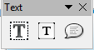
Figure 15: Text toolbar

Using AutoLayout text boxes
- Make sure Normal view is selected.
- Click in the text box that reads Click to add text.
- Type or paste your text in the text box.

Using text boxes
- Make sure Normal view is selected.
- Click on the Text icon on the Standard or Text toolbar or use the keyboard shortcut F2. If the Standard or Text toolbars are not visible, go to View > Toolbars on the Menu bar and select Standard or Text.
- Click and drag to draw a box for the text on the slide. Do not worry about the vertical size and position as the text box will expand if needed as you type.
- Release the mouse button when finished. The cursor appears in the text box, which is now in edit mode (a colored border shown in Figure 16).
- Type or paste your text in the text box.
- Click outside the text box to deselect it.
You can move, resize, and delete text boxes. For more information, see the Impress Guide Chapter 3 Adding and Formatting Text.

Vertical text
In addition to the normal text boxes where text is horizontally aligned, it is possible to insert text boxes where the text is aligned vertically. Vertical text is available only when Asian languages are enabled in Tools > Options > Language Settings > Languages. Click the Vertical Text icon in the Standard toolbar or Text toolbar to create a vertical text box.
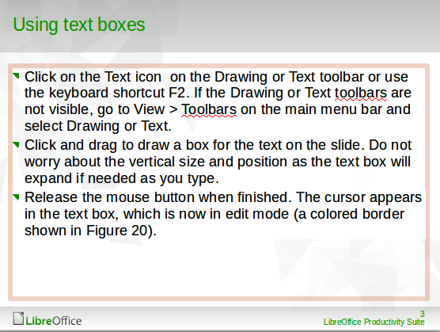
Figure 16: Creating and editing text boxes

Quick font resizing
Impress has an Increase Font icon and a Decrease Font icon on the Text Formatting toolbar (highlighted in Figure 17) to increase or decrease the font size of selected text. The amount by which the font size changes depends on the standard sizes available for the font in use.
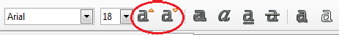
Figure 17: Quick font resizing on Text Formatting toolbar
Note
AutoLayout text boxes can automatically resize fonts to let the box contain all the text you insert. If you insert a long piece of text, the font size may shrink to fit into the box. Otherwise, the font keeps its default size.

Pasting text
Text may be inserted into the text box by copying it from another document and pasting it into Impress. However, pasted text will probably not match the formatting of the surrounding text on the slide or that of the other slides in the presentation. This may be what you want on some occasions; however, in most cases you want to make sure that the presentation style is consistent and does not become a patchwork of different paragraph styles, font types, bullet points and so on. There are several ways to ensure consistency in your presentation.

Pasting unformatted text
It is normally good practice to paste text without formatting and apply the formatting later. To paste text without formatting:
- Use the keyboard shortcut Ctrl+Shift+V and select Unformatted text from the Paste Special dialog that opens.
- Or click on the small triangle next to the Paste icon in the Standard toolbar and select Unformatted text from the context menu.
The unformatted text will be formatted with the outline or paragraph style at the cursor position in an AutoLayout text box or with the default graphic style in a normal text box.

Formatting pasted text
When formatting pasted text, you can use the tools available on the Text Formatting toolbar (Figure 18), or the tools available in the Character and Paragraph sections of the Properties deck in the Sidebar (Figure 19). If the Character and Paragraph sections do not automatically open after selecting some text, click on the Properties icon at the side of the Sidebar.
Figure 18: Text Formatting toolbar
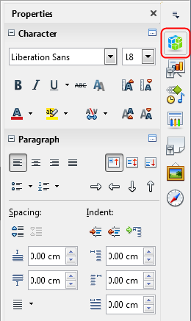
Figure 19: Sidebar Character section
If you are pasting the text into an AutoLayout text box, you need to apply the appropriate outline style to the text to give it the same look and feel as the rest of the presentation.
- Paste the text in the desired position.
- Select the text you have just pasted.
- Select Format > Default formatting on the Menu bar.
- Use the four arrow buttons on the Text Formatting toolbar (highlighted in Figure 5 on page 11) to move the text to the appropriate position and give it the appropriate outline level.
  - Left arrow promotes a list entry by one level (for example from Outline 3 to Outline 2). You can get the same result by placing the cursor at the beginning of the paragraph and pressing the Shift + Tab keys.
  - Right arrow button demotes a list entry by one level. Press the Tab key to get the same result after placing the cursor at the beginning of the paragraph.
  - Up arrow moves a list entry up in the list order.
  - Down arrow moves a list entry down in the list order.
- Apply any necessary manual formatting to the text to change font attributes, tabs, and so on.
If you are pasting text in a text box, you can still use styles to format the text quickly. Only one graphic style can be applied to the pasted text, as follows:
- Paste the text in the desired position.
- Select the text you have just pasted.
- Select the desired graphical style to format the text.
- Apply any necessary manual formatting to the text to change font attributes, tabs, and so on.

Creating bulleted and numbered lists
The procedure to create a bulleted or numbered list is quite different depending on the type of text box used, although the tools to manage the list and customize the appearance are the same. In AutoLayout text boxes, the outline styles available are, by default, bulleted lists. For normal text boxes an additional step is required to create a bulleted list.

AutoLayout text boxes
AutoLayout text boxes included in the available layouts are already formatted as a bulleted list. Create a slide with a bulleted list as follows:
- From the Layout pane, choose a slide design that contains a text box.
- In the text box, click on Click to add text.
- Type your text and press the Enter key to start a new bulleted point.
The default list type is a bulleted list. Methods for changing the appearance of a list are explained in “Changing list appearance” on page 23.
- Tip
Press Shift+Enter to start a new line without creating a new bullet point. The new line will have the same indentation as the previous line. To switch off bullets altogether, click the Bullets On/Off icon on the Text Formatting toolbar. If the Text Formatting toolbar is not displayed, go to View > Toolbar > Text Formatting on the Menu bar.

Text boxes
Create a bulleted list in a text box as follows:
- Click the Text icon on the Standard toolbar and draw a text box on your slide.
- Click the Bullets On/Off icon on the Text Formatting toolbar.
- Type the text and press Enter to start a new bulleted line.
The default list type is a bulleted list. Methods for changing the appearance of a list are explained in “Changing list appearance” on page 23.

Creating a new outline level
In AutoLayout text boxes, create a new outline level as follows:
- If necessary, press Enter to begin a new list entry.
- To demote a list entry (move it to the right), press the Tab key or click the Demote (right arrow) icon on the Text Formatting toolbar or use the keyboard shortcut Alt+Shift+Right. The list entry moves to the right and is indented to the next outline level.
- To promote a list entry (move it to the left), press Shift+Tab or click the Promote (left arrow) icon on the Text Formatting toolbar or use the keyboard shortcut Alt+Shift+Left. The list entry moves to the left and is indented at the next higher level.
- To create a new list entry at the same level as the previous one, press Enter again.
In the AutoLayout text boxes, promoting or demoting an item in the list corresponds to applying a different outline style. The second outline level corresponds to Outline 2 style, the third outline level to Outline 3 style, and so on. A change in level and style produces other changes, for example, to font size, bullet type, and so on.
In text boxes, a new outline level can only be created by using the Tab key to demote the list entry and the Shift+Tab key combination to promote the list entry.
Note
Do not try to change the outline level by selecting the text and then clicking the desired outline style as you would in Writer. Due to the way that presentation styles work in Impress, it is not possible to change the level in this way.

Changing list appearance
You can fully customize list appearance by changing the bullet type or numbering for the entire list or for only a single entry. All of the changes can be made using the Bullets and Numbering dialog (Figure 20), which is accessed by going to Format > Bullets and Numbering on the Menu bar or by clicking on the Bullets Icon or the Numbering icon on the Text Formatting toolbar.
For the entire list:
- Select the entire list or click on the border of the text box so that the resizing handles are displayed.
- Select Format > Bullets and Numbering on the Menu bar or click on the Bullets or Numbering icon on the Text Formatting toolbar.
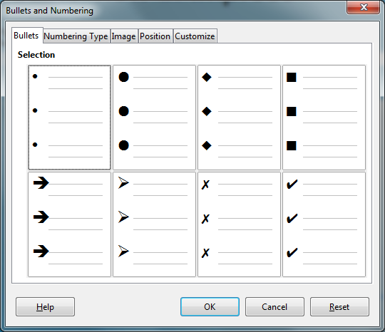
Figure 20: Bullets and Numbering dialog
- The Bullets and Numbering dialog (Figure 20) contains five pages: Bullets, Numbering type, Image, Position, and Customize.
  - If a bullet list is needed, select the desired bullet style from the default styles available on the Bullets page.
  - If a graphics style is needed, select one from those available on the Image page.
  - If a numbered list is needed, select one of the default numbering styles on the Numbering type page.
  - Use the Position page to set the indent and numbering spacing and alignment of your list.
  - Use the Customize page to customize the numbering, color, relative size, and character used for your list.
- For a single list entry, click anywhere in the text and then follow steps 2 and 3 above.
If the list was created in an AutoLayout text box, then an alternative way to change the entire list is to modify the Outline styles. Changes made to the outline style will apply to all the slides using them.

Adding pictures, tables, charts, and media
A contents box can contain pictures, tables, charts, or media as well as text. This section provides a quick overview of how to work with these objects. For more information on adding pictures, tables, charts, or media, please refer to the Impress Guide.

Adding pictures
To add a picture to a contents box:
- Go to Insert > Image on the Menu bar and then select either From file or Scan.
- Alternatively, after inserting a new slide, click the Insert Image icon (Figure 13 on page 17) on the new slide and select the file from the Insert Image dialog that opens. To see a preview of the picture, select Preview at the bottom of the Insert Image dialog.
- Move the picture to the desired location.
- The picture will automatically resize to fill the area of the content box. Follow the directions in the note below when manually resizing a graphic.
Note
When resizing a graphic, right-click the picture. Select Position and Size from the context menu and make sure that Keep ratio is selected. Then adjust the height or width to the size you need. As you adjust one dimension, both dimensions will change to keep the width and height ratio the same, ensuring that the picture will not become distorted. Remember also that resizing a bitmap image will reduce its quality; it is better to create an image of the desired size outside of Impress.

Adding tables
To add basic tables to a slide:
- Go to Insert > Table on the Menu bar, or click the Table icon on the Standard toolbar.
- If there is a table already on the slide and it is selected, click the Table icon on the Table toolbar. The Table toolbar is only visible after selecting View > Toolbars > Table on the Menu bar and when a table is selected.
- Alternatively, and after inserting a new slide into your presentation, click the Insert Table icon (Figure 13 on page 17).
- Select the number of rows and columns required from the Insert Table dialog that opens.
- Alternatively, click the small triangle to the right of the Table icon and select the number of rows and columns by dragging the cursor.
- Select a design style from the available options for your table in the Table Design deck in the Properties section of the Sidebar (Figure 21). If the Table Design section does not automatically open after inserting or selecting a table, click on the Properties icon at the side of the Sidebar.
Note
Selecting from any of the styles in the Table Design section in the Sidebar creates a table based on that style. If you create a table by another method, you can still apply a style of your choice later.
The Table toolbar in Impress offers the same functions as the Table toolbar in Writer, with the exception of the calculation functions Sort and Sum. To use Sum and Sort in your presentation, you have to insert a Calc spreadsheet.
After the table is created, you can modify it by adding and deleting rows and columns, adjusting width and spacing, adding borders, background colors and so on. For more information on working with tables see the Impress Guide Chapter 3 Adding and Formatting Text and the Writer Guide Chapter 9 Working with Tables.
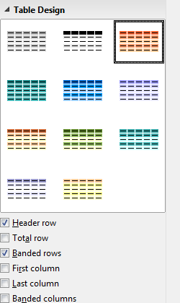
Figure 21: Sidebar Table Design section
Entering data into table cells is similar to working with text box objects. Click in the cell you wish to add data to and begin typing. To move around cells quickly, use the following keyboard options:
- Press the arrow keys to move the cursor to another cell if the cell is empty, or to the next character if the cell already contains text.
- Press the Tab key to move to the next cell on the right and press Shift+Tab to move to the next cell on the left.

Adding charts
To insert a chart in a slide:
- Go to Insert > Chart on the Menu bar or click on the Chart icon in the Standard toolbar.
- Alternatively and after inserting a new slide, click on the Insert Chart icon (Figure 13 on page 17).
- Impress will insert a default chart and open the Chart dialog. To modify the chart type, insert your own data and change the formatting, refer to the Impress Guide.

Adding media files
To insert media files, such as music and movie clips, in a slide:
- Go to Insert > Audio or Video on the Menu bar.
- Alternatively and after inserting a new slide, click on the Insert Audio or Video icon (Figure 13 on page 17).
- A media player will open at the bottom of the screen and you can preview the media.
- When an audio file is inserted, the contents box will show a loudspeaker image.

Adding graphics, spreadsheets, and other objects
Graphics, such as shapes, callouts, and arrows, are often useful to complement the text on a slide. These objects are handled much the same way as graphics in Draw. For more information, see the Draw Guide Chapter 7 Getting Started with Draw, or the Impress Guide Chapters 4, 5, and 6.
Spreadsheets embedded in Impress include most of the functionality of Calc spreadsheets and are capable of performing extremely complex calculations and data analysis. If you need to analyze your data or apply formulas, these operations are best performed in a Calc spreadsheet and the results displayed in an embedded Calc spreadsheet or even better in an Impress table.
Alternatively, go to Insert > Object > OLE Object on the Menu bar. You can select from options that include a LibreOffice 5.0 Spreadsheet. This opens a spreadsheet in the middle of the slide and the menus and toolbars change to those used in Calc. You can start adding data, though you may have to resize the visible area on the slide. You can also insert an existing spreadsheet and use the viewport to select the data that you want to display on your slide.
Impress offers the capability of inserting into a slide various other types of objects such as Writer documents, Math formulas, Draw drawings, or another presentation. For details on using these objects, refer to the Impress Guide Chapter 7 Including Spreadsheets, Charts, and Other Objects.

Working with slide masters and styles
A slide master is a slide that is used as the starting point for other slides. It is similar to a page style in Writer and it controls the basic formatting of all slides based on it. A slide show can have more than one slide master.
Note
LibreOffice uses three terms for a slide that is used to create other slides: master slide, slide master, and master page. This book uses the term slide master, except when describing the user interface.
A slide master has a defined set of characteristics, including background colors, graphics, gradients; and other objects (such as logos, decorative lines and so on), headers and footers, placement and size of text frames, and text format.

Styles
All of the characteristics of slide masters are controlled by styles. New slides that you create using a slide master have styles that are inherited from the slide master which was used. Changing a style in a slide master results in changes to all slides based on that slide master, but you can modify individual slides without affecting the slide master.
Note
Although it is highly recommended to use the slide masters whenever possible, there are occasions where manual changes are needed for a particular slide, for example to enlarge the chart area when the text and chart layout is used.
Slide masters have two types of styles associated with them: presentation styles and image styles. The prepackaged presentation styles can be modified, but new presentation styles cannot be created. For image styles, you can modify the prepackaged styles and also create new image styles.
Presentation styles affect three elements of a slide master: background, background objects (such as icons, decorative lines, and text frames), and text placed on the slide. Text styles are further divided into Notes, Outline 1 through Outline 9, Subtitle, and Title. The outline styles are used for the different levels of the outline to which they belong. For example, Outline 2 is used for the sub-points of Outline 1, and Outline 3 is used for the sub-points of Outline 2, and so on.
Image styles are not restricted and can affect many of the elements of a slide. Note that text styles exist in both the presentation and image style selections.

Slide masters
Impress comes with a collection of slide masters. These slide masters are shown in the Master Pages section of the Sidebar (Figure 22), which has three subsections: Used in This Presentation, Recently Used, and Available for Use. Click the + sign next to the name of a subsection to expand it to show thumbnails of the slides, or click the – sign to collapse the subsection to hide the thumbnails.
Each of the slide masters shown in the Available for Use list is from a template of the same name. If you have created your own templates, or added templates from other sources, slide masters from those templates will also appear in this list.

Creating a slide master
Creating a new slide master is similar to modifying the default slide master.
- Enable editing of slide masters by selecting View > Slide Master on the Menu bar and the Master View toolbar opens (Figure 23). If the Master View toolbar does not appear, go to View > Toolbars and select Master View.
- On the Master View toolbar, click the New Master icon .
- A new slide master appears in the Slides pane. Modify this slide master to suit your requirements.
- It is also recommended that you rename this new slide master. Right-click on the slide in the Slides pane and select Rename master from the context menu.
- When finished creating a slide master, click Close Master View on the Master View toolbar and return to normal slide editing mode.
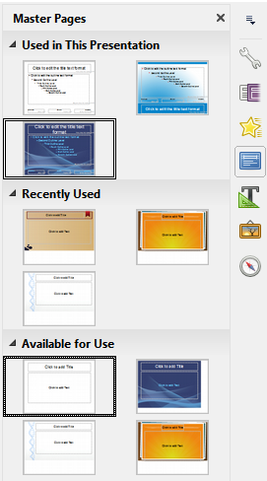
Figure 22: Sidebar Master Pages section
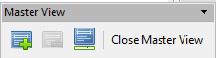
Figure 23: Master View toolbar

Applying a slide master
To apply a slide master to all the slides in your presentation:
- Click on the Master Pages icon in the Sidebar to open the Master Pages section (Figure 22).
- To apply one of the slide masters from the available selection to all slides in your presentation, right-click on it and select Apply to All Slides on the context menu.
To apply a different slide master to one or more selected slides:
- In the Slide Pane, select the slide or slides where you want to use a new slide master.
- In the Master Pages section on the Sidebar, right-click on the slide master you want to apply to the selected slides, and select Apply to Selected Slides on the context menu.

Loading additional slide masters
Sometimes, in the same set of slides, you may need to mix multiple slide masters that may belong to different templates. For example, you may need a completely different layout for the first slide of the presentation, or you may want to add to your presentation a slide from a different presentation (based on a template available on the hard disk).
- Go to Slide > Slide Design on the Menu bar or right-click on a slide in the Slides Pane and select Slide Design from the context menu to open the Slide Design dialog (Figure 24). This dialog shows the slide masters already available for use.
- To add more slide masters, click the Load button to open the Load Slide Design dialog (Figure 25).
- Select in the Load Slide Design dialog the template from which to load the slide master and click OK.
- Click OK again to close the Slide Design dialog.
- The slide masters in the template you selected to use are now shown in the Available for use subsection of Master Pages.
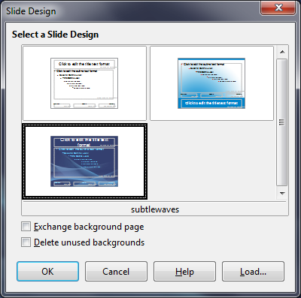
Figure 24: Slide Design dialog
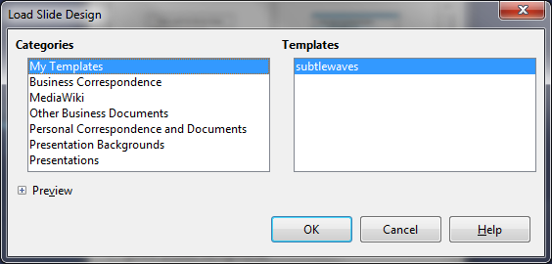
Figure 25: Load Slide Design dialog
Note
The slide masters you have loaded will also be available the next time you load the presentation. If you want to delete the unused slide masters, click the corresponding checkbox in the Slide Design dialog. If the slide master was not used in the presentation, it is removed from the list of available slide masters.
- Tip
To limit the size of the presentation file, you may want to minimize the number of slide masters used.

Modifying a slide master
The following items can be changed on a slide master:
- Background (color, gradient, hatching, or bitmap)
- Background objects (for example, a logo or decorative graphics)
- Size, placement, and contents of header and footer elements to appear on every slide
- Size and placement of default frames for slide titles and content
For more information on modifying slide masters, see the Impress Guide Chapter 2 Using Slide Masters, Styles, and Templates.
- Select View > Slide Master from the Menu bar. This unlocks the properties of a slide master so you can edit it.
- Select a slide master in Master Pages in the Slides pane.
- Select an object on the slide master in the Workspace and the Sidebar will display the property options that can be changed for the selected object. Figure 26 shows a graphic object selected with the Graphic properties section open on the Sidebar.
- Make all necessary changes to the slide master, then click the Close Master View icon on the Master View toolbar or go to View > Normal on the Menu bar to exit from editing slide masters.
- Save your presentation file before continuing.
- Caution
Any changes made to one slide when in Master View mode will appear on all slides using this slide master. Always make sure you Close Master View and return to Normal view before working on any of the presentation slides.
Note
The changes made to one of the slides in Normal view (for example, changes to the bullet point style, the color of the title area, and so on) will not be overridden by subsequent changes to the slide master. There are cases, however, where it is desirable to revert a manually modified element of the slide to the style defined in the slide master. To revert back to default formatting, select the element and select Format > Default Formatting from the Menu bar.
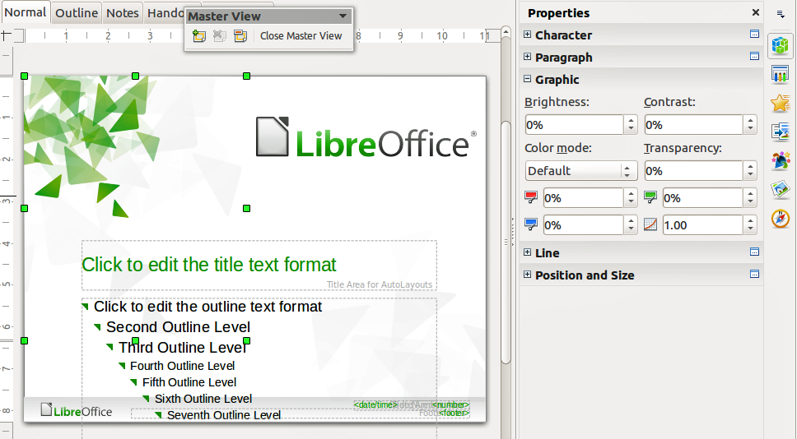
Figure 26: Editing a slide master

Adding text, footers, and fields to all slides
A slide master can have text, footers, or fields added so that they appear on every slide in your presentation. Headers are not normally added to slides.

Text
- Go to View > Slide Master on the Menu bar to open Master View (Figure 27).
- On the Drawing toolbar, select the Text icon or press the F2 key.
- Click and drag in the master page to draw a text object and then type or paste your text into the text object.
- Go to View > Normal on the Menu bar or click on Close Master View on the Master View toolbar when you have finished entering text objects that you want to appear on every slide in your presentation.

Footers
To add a footer to your slides:
- Go to View > Slide Master on the Menu bar to open Master View (Figure 27).
- Go to Insert > Field or Insert > Page Number on the Menu bar and time to open the Header and Footer dialog (Figure 28).
- Select the type of date and time and type in the footer text and slide number from the available options in the dialog.
- Click Apply to All to apply your changes to all the slide masters in your presentation, or click Apply to apply your changes to the selected slide master in your presentation.
- Alternatively, you can add the date/time, footer text and slide number directly into their respective areas as shown in Figure 27.
Note
Normally only footers are used on a slide. To create a header, you can use a text box as explained in “Text” on page 31.
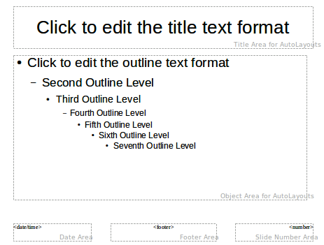
Figure 27: Example master view
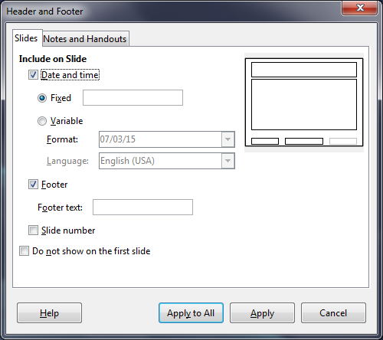
Figure 28: Footer dialog in Impress

Fields
To add a field into an object or as a separate object on a slide, select Insert > Fields on the Menu bar and select the required field from the submenu. If you want to edit this field in your slide, see the Impress Guide Chapter 3 Adding and Formatting Text for more information.
The fields you can use in Impress are as follows:
- Date (fixed)
- Date (variable): updates automatically when you reload a file
- Time (fixed)
- Time (variable): updates automatically when you reload a file
- Author: first and last names listed in the LibreOffice user data
- Page Number: the slide number in Impress
- Page Count: the number of slides in your presentation
- File Name
- Tip
To change the author information, go to Tools > Options > LibreOffice > User Data on the Menu bar.
To change the number format (1,2,3 or a,b,c or i,ii,iii, and so on) for the number field, go to Slide > Page/Slide Properties... on the Menu bar and then select a format from the Format list in the Layout Settings area.
To change a paragraph style throughout your presentation, open the Styles and Formatting dialog and modify the appropriate presentation style.

Adding comments to a presentation
Impress supports comments similar to those in Writer and Calc.
In Normal View, go to Insert > Comment on the Menu bar to open a blank comment (Figure 29). A small box containing your initials appears in the upper left-hand corner of the slide, with a larger text box beside it. Impress automatically adds your name and the current date at the bottom of the text box.
Type or paste your comment into the text box. You can optionally apply some basic formatting to the comment by selecting it, right-clicking, and choosing from the context menu that opens. This menu allows you to apply formatting to selected text, delete the current comment, delete all comments from the same author, or delete all comments in the presentation.
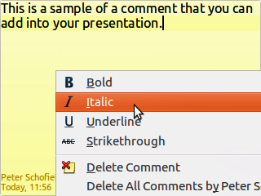
Figure 29: Inserting comments
You can move the small comment markers to anywhere you wish on the slide. Typically you might place it on or near an object you refer to in the comment.
To show or hide the comment markers, choose View > Comments.
Select Tools > Options > User Data to configure the name you want to appear in the comment.
If more than one person edits the document, each author is automatically allocated a different background color for their comments.

Creating a photo album
Impress can creat a photo album from a set of images, usually with one photo per slide. This photo album can source multimedia shows with graphics and images or even collect your latest vacation pictures into a presentation file.
To insert a photo album into your presentation
- Open an existing or blank presentation.
- Go to the slide that precedes the photo album.
- Choose Insert > Media > Photo Album.
- In the Create Photo Album dialog (Figure 30), click Add. A standard file browser opens.
- Locate the files you want to insert.
- Note
If several images are in the same folder, you can select a group of photos using the Shift or Ctrl keys while clicking on their filenames.
- Click Open to add the files to the Photo Album.
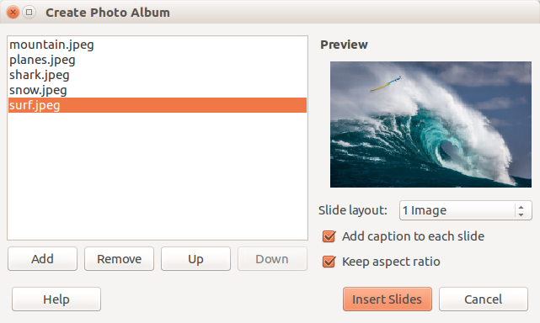
Figure 30: The photo album dialog box with photo preview
- Tip
Click on a file name to display it in the Preview area.
- Select the number of images per slide in the Slide layout list box.
- Select the Add caption to each slide option, if necessary, to insert a text box for the caption.
- Create the required sequence by removing images or moving them up or down in the list of images. When the sequence of images is ready, click Insert Slides. (You can change the sequence and remove or insert images later, as you can with any slides.)
Impress will create a presentation with as many pages as determined by the Slide layout number of slides per page. If you selected Add caption to each slide, there will be a placeholder for the image caption (title) on each slide.
- Tip
Use the slide sorter (see page 13) to reorder your photo album. Use slide transitions (page 35) to go smoothly to the following photo. Use audio resources (page 26) to insert a musical background.

Setting up a slide show
As mentioned in “Modifying the slide show” on page 18, Impress allocates reasonable default settings for slide shows, while at the same time allowing for customizing many aspects of the slide show experience. This section covers only some aspects; more advanced techniques are explained in the Impress Guide Chapter 9 Slide Shows.
Most of the tasks are best done in Slide Sorter view where you can see most of the slides simultaneously. Go to View > Slide Sorter on the Menu bar or click the Slide Sorter tab at the top of the Workspace.

One slide set – multiple presentations
In many situations, you may find that you have more slides than the time available to present them or you may want to provide a rapid overview without dwelling on the details. Rather than having to create a new presentation, you can use two tools that Impress offers: hiding slides and custom slide shows.

Hiding slides
- Select the slide you want to hide in the Slide Pane or Slide Sorter view on the Workspace area.
- Go to Slide > Hide Slide on the Menu bar or right-click on the slide thumbnail and select Hide Slide from the context menu. Hidden slides are marked by a diagonal bars across the slide.

Custom slide shows
If you want to create a custom slide show from the same presentation:
- Select the slides you want to use in your custom slide show.
- Go to Slide Show > Custom Slide Show on the Menu bar.
- Click on the New button to create a new sequence of slides and save it with a different name. You can have as many slide shows as you want from a single presentation.

Slide transitions
Slide transition is the animation that is played when a slide is changed for the next slide in your presentation. You can configure the slide transition from the Slide Transition section in the Tasks Pane.
- Go to Slide > Slide Transition on the Menu bar or click on the Slide Transition icon on the Sidebar to open the options available for slide transitions.
- Select the desired transition, the speed of the animation, and whether the transition should happen when you click the mouse (preferred) or automatically after a certain number of seconds.
- Click Apply to All Slides to apply the transition for all of your presentation or continue selecting transitions to place between each slide in your presentation.
- Tip
The Slide Transition section has a very useful choice: Automatic preview. Select its checkbox and when you make any changes in a slide transition, the new slide is previewed in the Slide Design area, including its transition effect.

Slide advance
You can set the presentation to advance automatically to the next slide after a set amount of time from the Slide Transition section in the Sidebar.
- Go to Advance slide and select the Automatically after option.
- Enter the required amount of time in seconds that each slide will be displayed.
- Click on the Apply to All Slides button to apply the same display time to all slides.
To apply a different display time to each slide in your presentation:
- Go to Slide Show > Rehearse Timings on the Menu bar and the slide show starts.
- When you are ready to advance to the next slide, mouse click on the display background or press the right arrow or space bar on your keyboard.
- Impress will memorize the timings for each slide and will advance to the next slide automatically using these timings when you run the slide show.
To restart a slide show automatically after the last slide has been displayed:
- Go to Slide Show > Slide Show Settings on the Menu bar.
- Select Auto and the timing of the pause between slide shows.
- Click OK when you have finished.

Running a slide show
To run a slide show, do one of the following:
- Click Slide Show > Start from first Slide on the Menu bar.
- Click the Start from first Slide icon on the Presentation toolbar.
- Press F5 on the keyboard.
If the slide advance is set to Automatically after X sec, let the slide show run by itself.
If the slide advance is set to On mouse click, do one of the following to move from one slide to the next:
- Use the arrow keys on the keyboard to go to the next slide or to go back to the previous one.
- Click the mouse to move to the next slide.
- Press the spacebar on the keyboard to advance to the next slide.
Right-click anywhere on the screen to open a context menu where you can navigate through the slides and set other options.
To exit the slide show at any time including when the slide show has ended, press the Esc key.

Presenter Console
LibreOffice Impress has a Presenter Console function that can be used when an extra display for presentation has been connected to your computer. The Presenter Console (Figure 31) provides extra control over slide shows by using different views on your computer display and on the display that the audience sees. The view you see on your computer display includes the current slide, the upcoming slide, any slide notes, and a presentation timer.
For more information and details about using the Presenter Console, see the Impress Guide Chapter 9 Slide Shows.
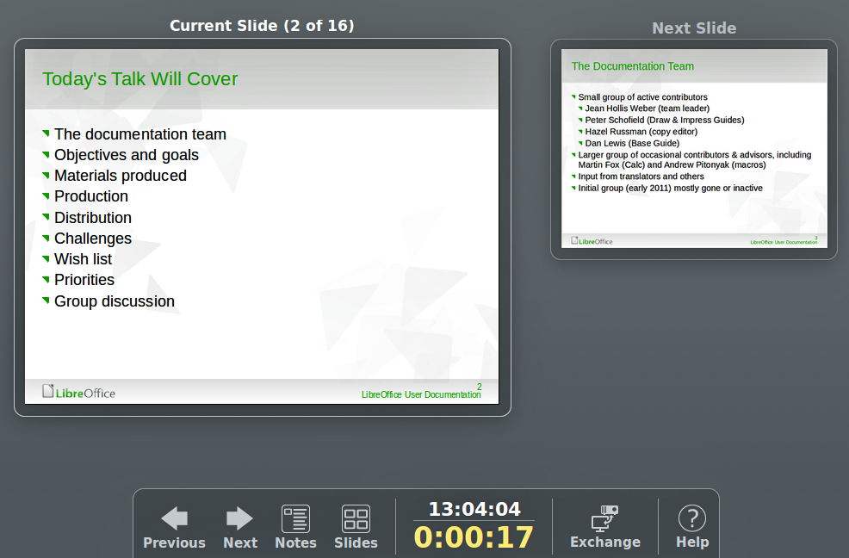
Figure 31: Impress Presenter Console

Using Impress Remote control
Impress Remote is a mobile application developed by the community for Android and iOS systems that allows you to control a live presentation with a mobile device such as a phone or tablet.
The connection between your mobile device and the computer running your presentation is made through a Bluetooth pairing or a local network connection between the two.

Getting Impress Remote
To get the software, access your mobile device application store, either Google Play Store for Android devices or Apple Store for IOs devices. Search for “Impress Remote” and select the one that is from The Document Foundation and install it in your device.

Connecting the mobile device to the computer
Activate Bluetooth on both devices, then pair the devices. (Refer to the manuals for your mobile device and computer operating system for instructions on enabling, setting up a Bluetooth identifier, and pairing.)
Once the pairing is established, your mobile device is ready to control your presentation.

Enabling remote control in Impress
An Impress slide show with remote control is not enabled by default. To enable it, go to Tools > Options > LibreOffice Impress > General and select Enable Remote Control checkbox in the Presentation area of the dialog (Figure 32).
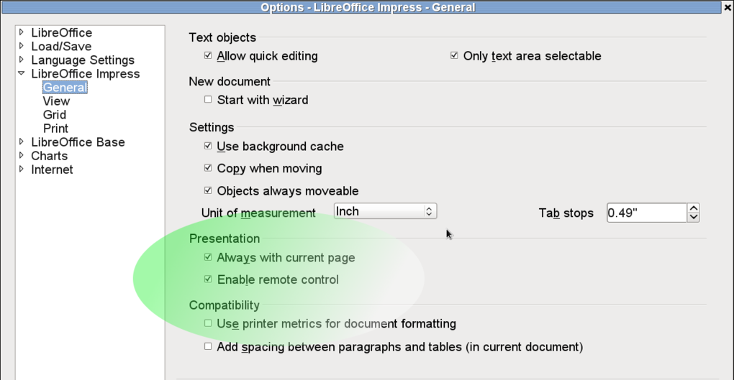
Figure 32: LibreOffice settings for Impress remote control

Running a slide show with Impress Remote
To run a slide show using Impress Remote, follow these steps:
- On both devices, make sure Bluetooth is already enabled and configured.
- On your computer, open the presentation you would like to present.
- On your phone:
- Open Impress Remote from the main menu (Figure 33).
- To select your computer, tap its name. The presentation opened on the computer begins automatically (Figures 34 and 35).
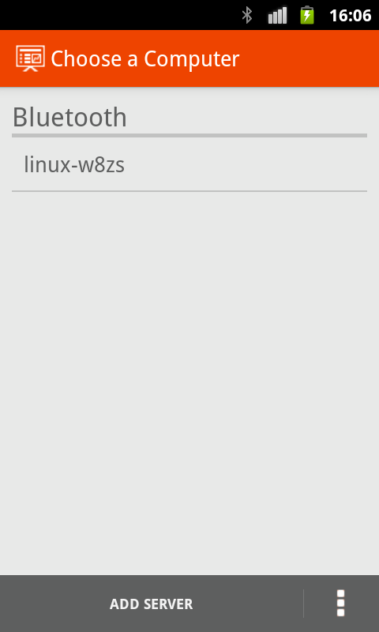  Figure 33: Bluetooth visible device | 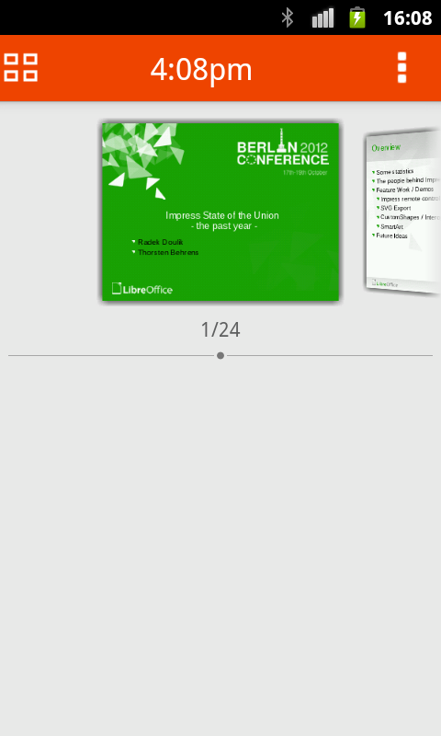  Figure 34: Impress presentation as seen in mobile device | 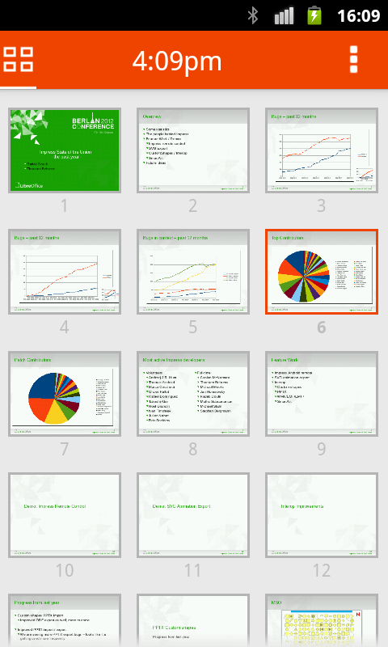  Figure 35: All slides
To advance the presentation
Tap the slide thumbnail or use the phone’s physical volume up button.
To go backwards
Double-tap the slide thumbnail or use the phone’s physical volume down button.
To skip slide animations and transitions
Swipe left to go to the next slide, or swipe right to go backwards.
To end the presentation, use the Back button of the phone, or open the menu and select Stop slide show.

