2019
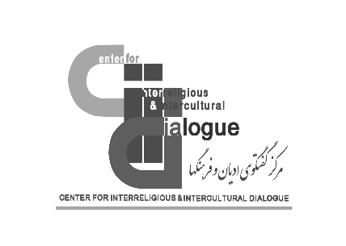
Dr. Mohammad Mehdi Taskhiri
Director General
Center for Interreligious & Intercultural Dialogue

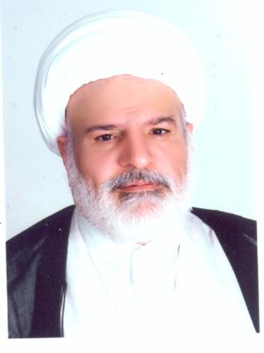

Name: | Mohammad Mehdi
Father’s Name: | Ali Akbar
Family Name: | Taskhiri
Place of Birth: | Najaf
Date and year of Birth: | 15/09/ 1959
Nationality: | Iranian
Mobile Number: | 0098 9127782280
Email: | cid@icro.ir
Education: | Islamic Seminary of Qom- Hawzah  Islamic Civilization University of Beirut, Ph.D. Major: Islamic thought
Books: | Approximation of Denomination  Purity Book  Approximation Mans
Papers: | Interreligious Dialogue, Commitment to Religious Values and Its Role in Establishment of Peace and Tranquility in the Society,…
Current Position: | Director General
Name of the Organization: | Center for Interreligious & Intercultural Dialogue
Website of the Organization: | http://en.cid.icro.ir http://fa.cid.icro.ir
Phone number of the Organization: | 0098 21 8815 3690,91

