Magufuli runs for Mosque’s fundraising construction, Church KKKT contributed
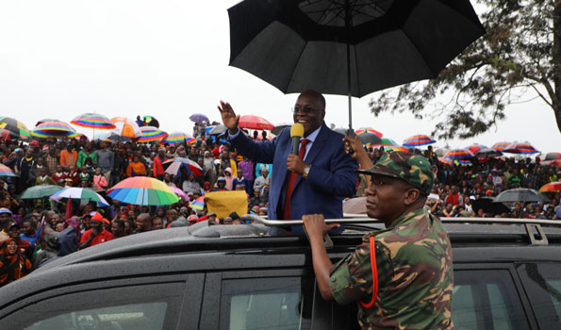

The President of Tanzania, John Magufuli has spent 20 minutes to make a donation to fund for the construction of a mosque, with government leaders, private sector, politicians, ordinary people and pastors of various denominations participated.

The President of Tanzania, John Magufuli has run a fundraising fund for the construction of the mosque and the clergy of various denominations are involved.

In this syringe more than Sh20 million was collected it was promised and cash
President Magufuli made the same move on Tuesday April 30 after he finished his speech at Mwakangale Stadium in Kyela district in Mbeya as part of his ongoing tour in the region.
There Sheikh here asked for a donation for the construction of the mosque, where is he will hand over Sh5 million to let us come here, and this money from going disappeared it must used for building a mosque the day will come, I will come to see it, my ministers all come here to say you goin to contribute how much?"said Magufuli.
With the ministers, who were also leaders on the visit of President Magufuli donated, including bishops and Evangelical Lutheran Church of Tanzania (ELCT) Kyela Sh240,000 contributed.

