The new system therapy for the network will simplify the EAC treatment

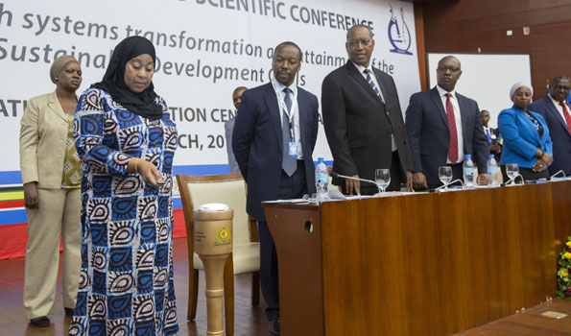
Vice President, Samia Hassan Settlement light a torch as a symbol of the opening of the 7th conference of the Health Sciences East Africa held at the International Conference Center of Mwalimu Julius Nyerere in Dar es Salaam yesterday.

Dar es Salaam. The new health care network system is expected to reduce public cost and improve the better treatment in East African countries

According to the system, citizens will benefit because they are not obliged to travel long distances to follow medical care because doctors will be able to communicate and help each other to provide treatment.
Launching the system in the city yesterday, Vice President, Samia Suluhu Hassan said the system will enable and increase the effectiveness of diagnosis, treatment and treatment for patients suffering from various diseases.
He said the system will reduce the cost of patients and travel agents to follow doctors because everything will be done that way.

Samia told the health ministers from East African countries were discussing the same services for achieving the goals of the United Nations.
Samia said East African countries could provide services for mutual cooperation, it would be the right way to achieve millennium goals and health services for all. “We have to achieve the goals we have set for Africa and East Africa,
The Minister of Health and Fight against HIV from Burundi, Dr Thaddee Ndikumana said, “The people of Burundi will be able to receive treatment by specialists from the National Muhimbili Hospital in their country without coming to Dar es Salaam.

“That is important, we will be sharing experiences, Burundian citizens were coming every day, now the trip will decrease, they will remain Bunjumbura and the service they receive
“In Tanzania three months ago doctors established a communication system through digital networks that enable specialist doctors to communicate directly with doctors on the margins, and have saved six mothers who were giving birth,”
Director of the National Institute for Human Disease Research (Nimr), Professor Yunus Mgaya said the system will reduce the cost of health care services and increase the effectiveness of health care workers in the implementation of their duties.

News from Mwananchi news paper

Know the rules and procedure of legal succession
Heritage property left by the deceased has its law and order. These laws and regulations guide the collection, monitoring, management, distribution and ownership of the property.
The main purpose of the rules of the inheritance is to avoid the impoverished or lost property. They also administer the right to legitimate heirs even claiming or claiming by the deceased.
There are several laws governing the allocation process and the management of the assets of the deceased in the country are the Government Act, Customary Law and Islamic Religious Law.

Government Act leads and manage the division of property of the deceased, who was not following Islamic law nor customary or for Muslims who don’t want to be used in the allocation of their assets.
According to this law, the widow gets a third of the children and two-thirds of the left property. If the deceased does not leave children, then the widow will receive half of the property and the remaining ones will go to the parents and the deceased relatives. This law does not recognize children outside marriage except for a will.

The government recognized the customary law of inheritance since 1963. It is recognized and satisfied the court that the deceased lived by the customs and customs of her tribe, then customary law will be used.
Inheritance according to customary law; The first male child is given the first grade followed by his younger siblings and his sisters who find a small portion of the property.

Regardless of what law you are following, there is a procedure that you should follow when you track the inheritance. You are required to submit an application letter to Rita or to the district administrator (Das) which the deceased has property. He will fill in the form and submit Rita. If it seems appropriate, it will ask the court to appoint a supervisor.

The claimant is required to pay the initial fee to manage according to the size of the property. Any person near the mayor may ask the court to appoint him as the administrator. The court will make an appointment as it considers appropriate.

Article from Mwananchi news paper

