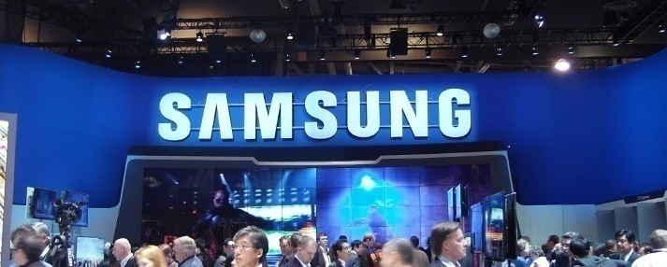
ADDRESS: 105 CHALLENGER ROAD, RIDGEFIELD PARK, NJ 07660, UK
EMAIL ID:
Ukprize.claim@mit.tc
CONTACT NUMBER: +447017045993/ +447017045992

Ticket Number: 011425896/2016
Serial Number: 3872/506
Lucky Numbers: 7/4/88/28/01/40.

Dear: Lucky Winner:

This is to inform you that your Email have won ($850,000 USA DOLLARS)from the Samsung Electronics Company UK which is organized by Samsung Electronics Company in conjunction with Chevron Texaco Oil and Gas Company, “Your Email Address" were selected through a computer ballot system drawn from Nine hundred thousand email from Canada, Australia, United States, Asia, Europe, Middle East, Africa and Oceanic as part of our international program which is conducted annually, 20 people’s was selected as our winners, Through electronic ballot System without the winner applying.

VERIFICATION AND FUNDS RELEASE FORM:-
KINDLY SEND YOUR DETAILS TO THIS EMAIL ID: (Ukprize.claim@mit.tc)FOR THE RELEASE
OF YOUR FUND IN TIME:

1. Full Name:
2. Contact Address:
3. Age:
4. Sex:
5. Contact Number:
6. Occupation:
7. Country:
8. State:
9. Winning E-mail Address:


SIR. KEN ROBERT
EVENT–MANAGER
SAMSUNG ELECTRONICS COMPANY
TEL: +447017045993
EMAIL: (Ukprize.claim@mit.tc)

