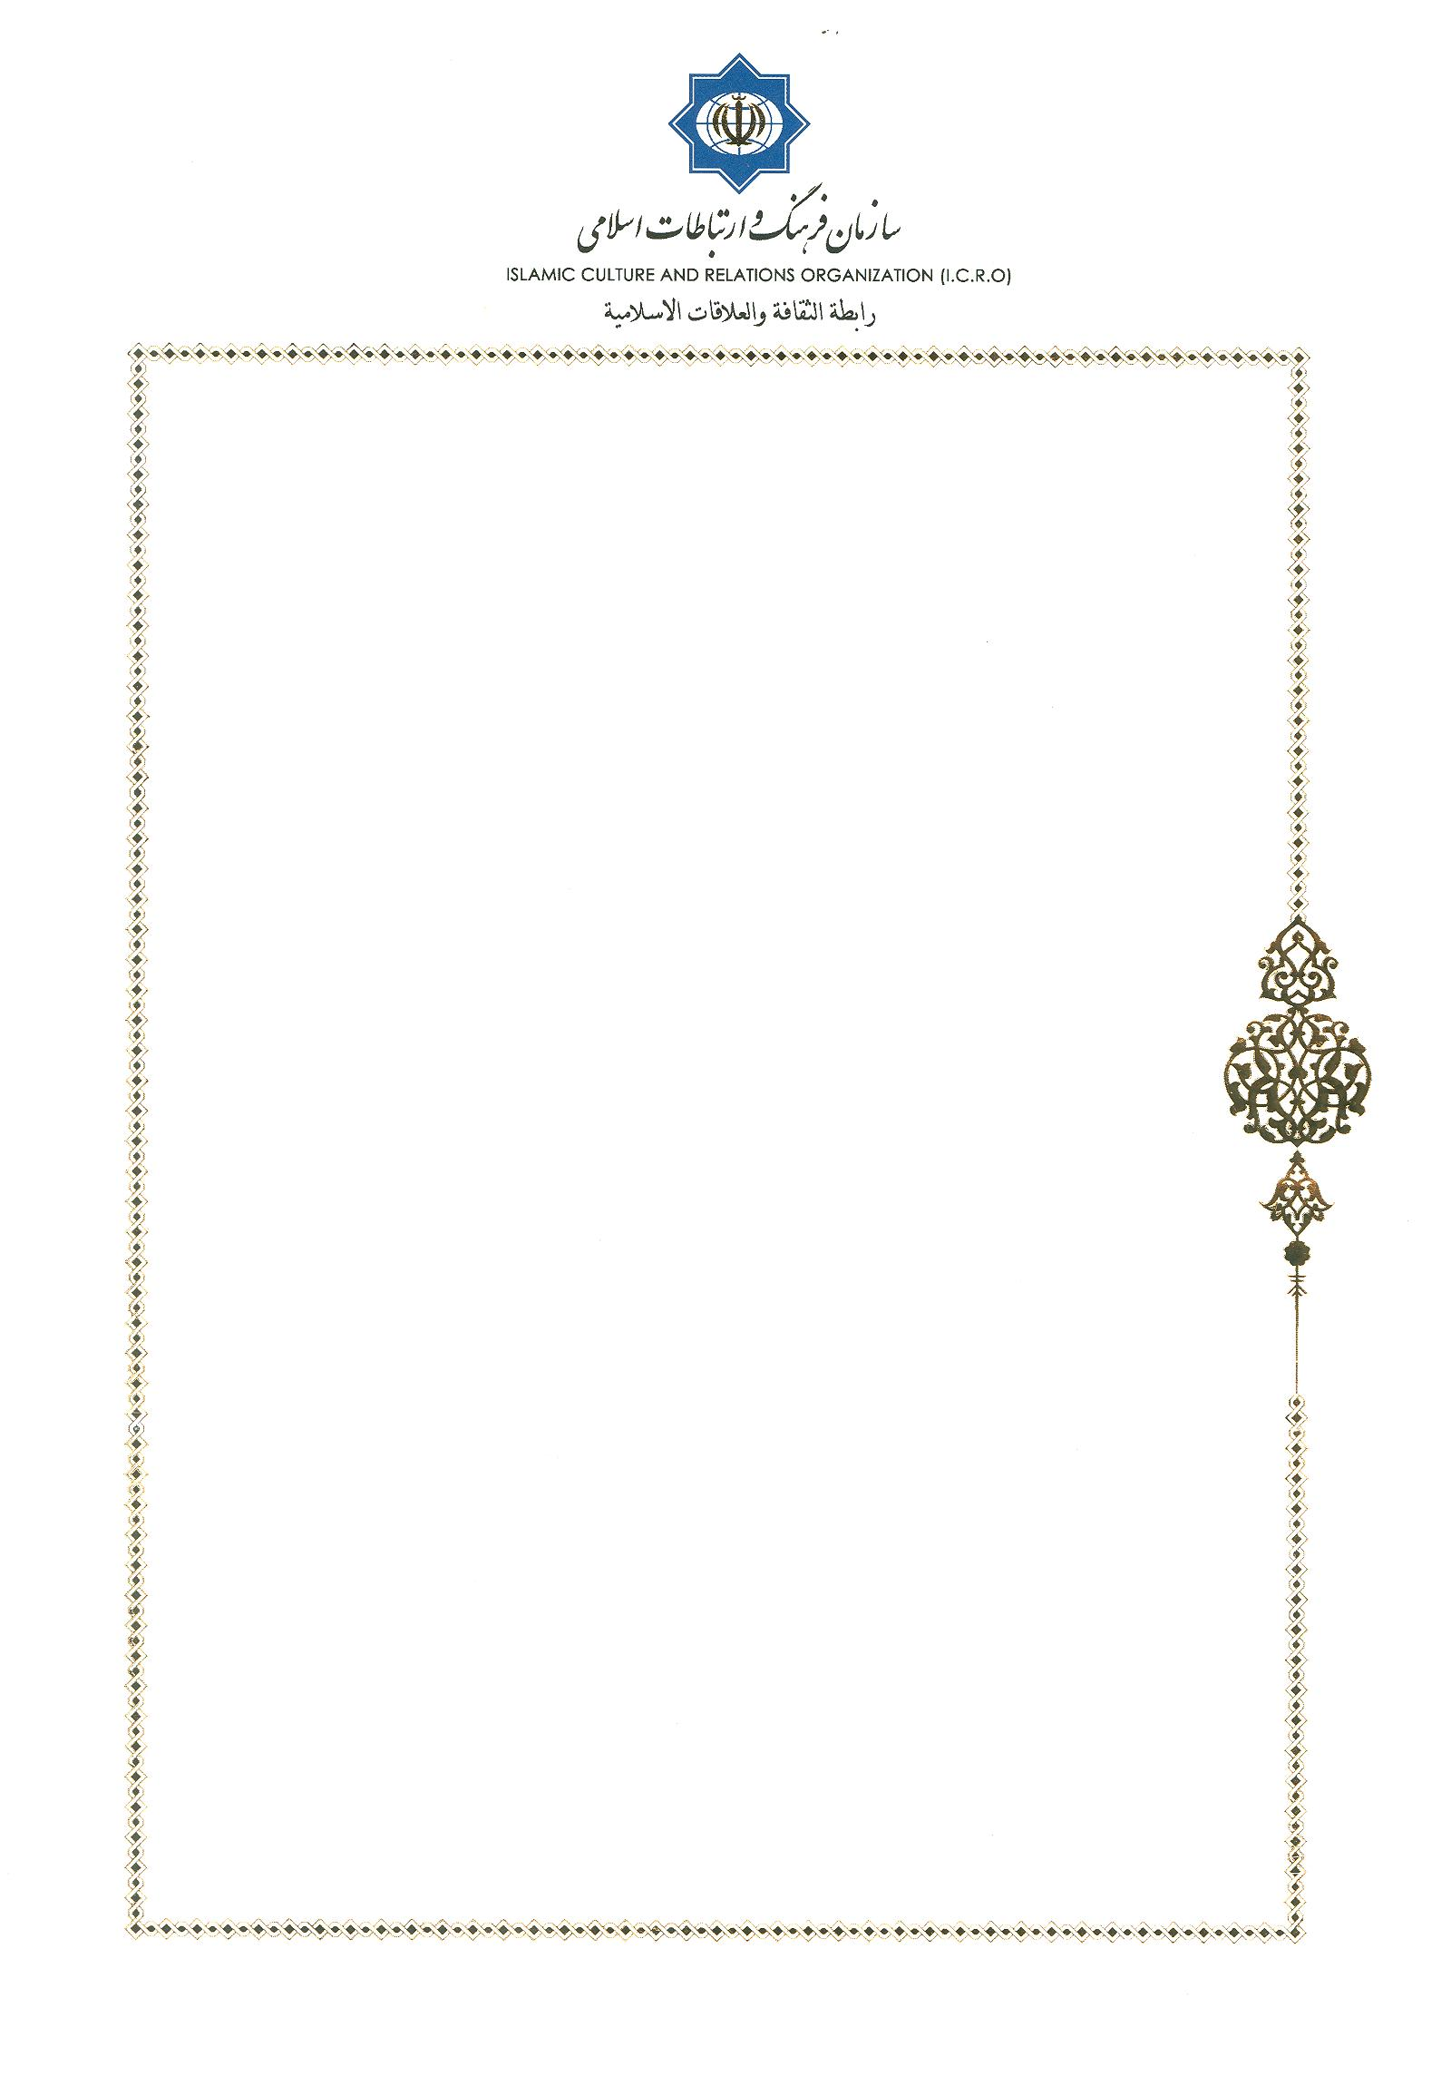
Invitation Letter

No: 64/11616
Tehran, Oct.30, 2019
Monsignor Khaled Akasheh
Bureau Chief for Islam
Pontifical Council for Interreligious Dialogue Vatican
Vatican

Dear Monsignor Khaled Akasheh
Warmest Greetings!
I am very pleased to invite you for 11th Interfaith Dialogue between Pontifical Council for Interreligious Dialogue (PCID) and Center for Interreligious and Intercultural Dialogue (CIID) on November 9 to 13, 2019 in Tehran, Islamic Republic of Iran.

I look forward to seeing you soon.
Sincerely yours,


Dr. Mohammad Mahdi Taskhiri

Director General
Center for Interreligious and Intercultural Dialogue

Office Phone: 0098 21 88153690, 91
Email: cid@icro.ir

