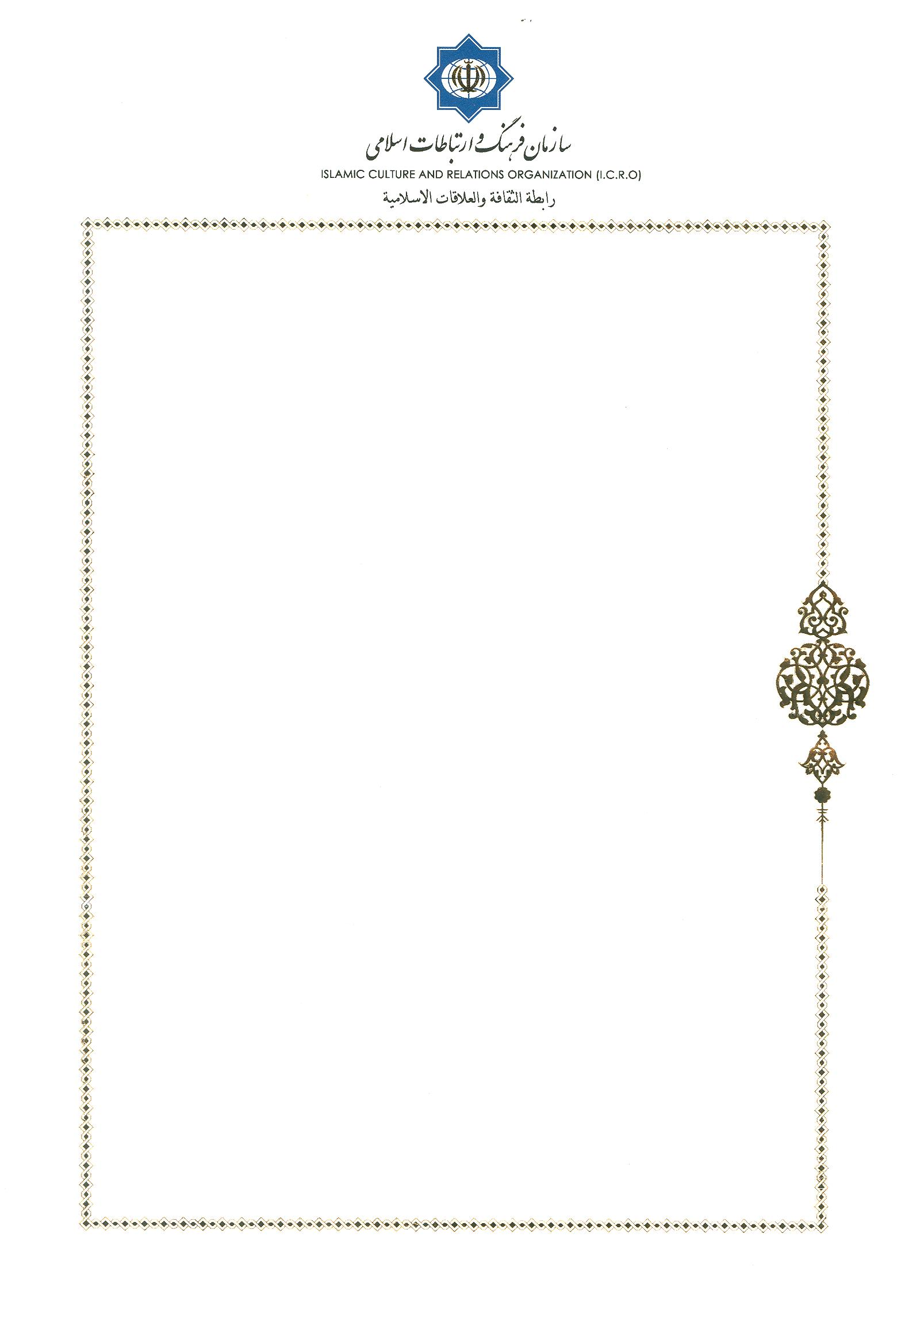
Invitation Letter

No: 64/11620
Tehran, Oct.30, 2019
Rev. Diego Sarrio Cucarella
President
Pontifical Institue of Study Arabic Islamic

Dear Rev. Diego Sarrio Cucarella
Warmest Greetings!
I am very pleased to invite you for 11th Interfaith Dialogue between Pontifical Council for Interreligious Dialogue (PCID) and Center for Interreligious and Intercultural Dialogue (CIID) on November 9 to 13, 2019 in Tehran, Islamic Republic of Iran.

I look forward to seeing you soon.
Sincerely yours,


Dr. Mohammad Mahdi Taskhiri,

Director General,
Center for Interreligious and Intercultural Dialogue
Office Phone: 0098 21 88153690, 91
Email: cid@icro.ir

