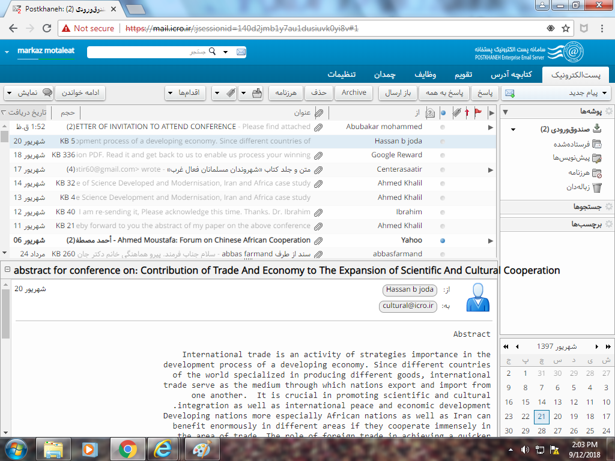
Abstract
International trade is an activity of strategies importance in the
development process of a developing economy. Since different countries
of the world specialized in producing different goods, international
trade serve as the medium through which nations export and import from
one another. It is crucial in promoting scientific and cultural
integration as well as international peace and economic development.
Developing nations more especially African nations as well as Iran can
benefit enormously in different areas if they cooperate immensely in
the area of trade. The role of foreign trade in achieving a quicker
pace of economic development is thus well recognized. Hence, planning
of foreign trade cannot be divorced from the strategy of overall
development. The disadvantage of international trade is that the
welfare of the people in nations that produce goods and services is
sometimes ignored for the sake of profits. In conclusion it can be
said that, international trade leads to economic growth provided the
policy measures and economic infrastructure are accommodative enough
to cope with the changes in social and financial scenario that result
from it. Therefore, this paper extensively looks at contribution of
trade and economy to the expansion of scientific and cultural
cooperation. It started by making clarification on what is
international trade, the need of international trade, the importance
of international trade, positive influence of international trade on
economic growth of a country, international trade and economic growth
, economic development and trade, disadvantages of international
trade, international trade and development of science and
international trade and international cultural exchange. The paper
recommends that in other to fully benefits from international trade,
developing nations need to; engage in effective war against
corruption, increase their capacity in trade, promote solidarity and
collective bargaining, regional integration as well as embark on
intensive development of infrastructure.
Keywords: Contribution of trade and economy to the expansion of
scientific and cultural cooperation

hbj4aia@gmail.com

