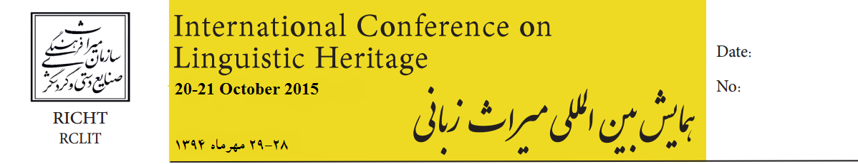
Abstract Submission Deadline: 6 July 2015
Full paper submission Deadline: 23 August 2015

Address:
Imam Khomeini Ave,
30 Tir St.
Opposite of the National
Museum of Iran,
The Research Center for
Linguistics, Inscriptions
And Texts
Tehran, Iran

Tel:
+982166736587-8
+989121968546
rclit.iran@gmail.com
www.richt.ir

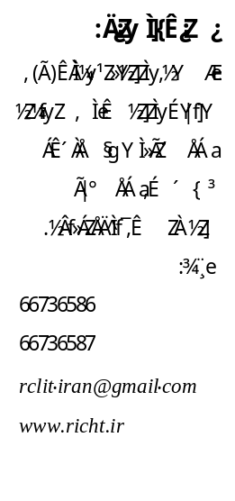

How to arrange references:
The heading of the References section must not be numbered.
All reference items must be in time new roman of font size 10. Please use Regular
and Italic bold styles to distinguish different fields. The sources should be in alphabetical order.
Registration:
Fill out the attached form. The registration fee will be in cash in the opening day. (€ :400 & participants from Asia $ 250 ). It includes: participation in the conference sessions, coffee break, lunch and extra programs.
For registration, please fill in the form and send it to the following email address: rclit.iran@gmail.com

Registration Form:
Family Name
Given Name
Affiliation
position
Title of your paper
Virtual
Address
Email
Tel
Fax

